Engineers have played a central role in the advancement of civilization for thousands of years. The profession of engineer can be traced as far back at 3000 B.C. Electrical engineering dates back to at least 600 B.C. with some primitive experiments on static electricity. In the past 200 years, the field has evolved dramatically and new specializations such as computer and biomedical engineering have emerged.
This evolution will continue as engineers face critical new challenges such as sustainable energy and transhumanism. Engineers are known for solving real world problems in real time and are often unsung heroes in the advancement of science. Therefore, even though the engineering profession is many centuries old, engineering remains vital to the science and technology interests of society.
Engineering is also becoming increasingly multidisciplinary as consumers demand products that are optimized for a broad range of real-world issues such as size, weight, power and environmental impact. Temple University, which is the 28th largest university in the country, and the 5th largest provider of professional education, is an ideal place to train for such a future. We are a small, focused college in which our three major departments – civil and environmental engineering, electrical and computer engineering, and mechanical engineering – collaborate extensively on both education and research.
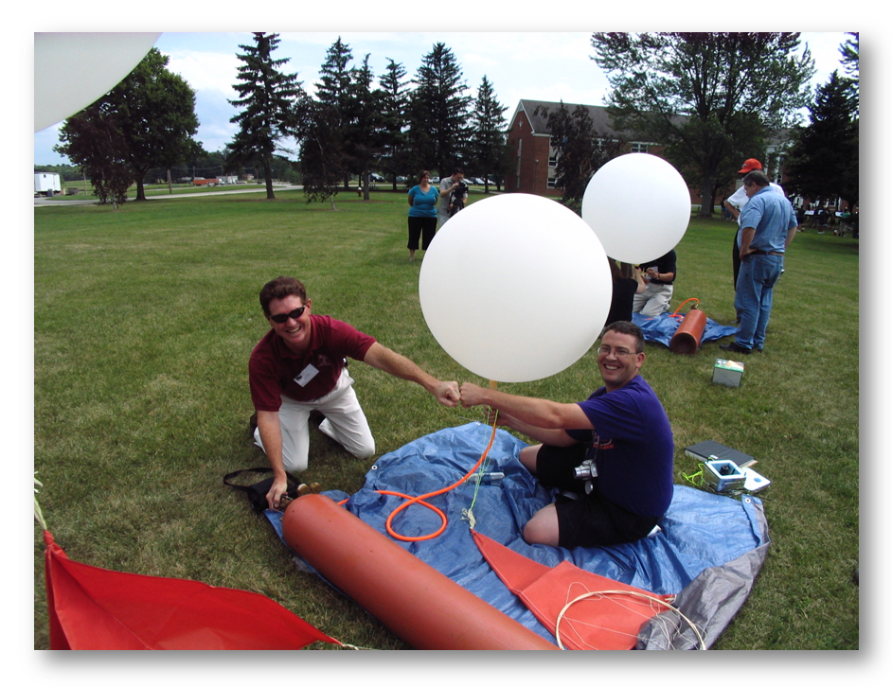
Our students enjoy personal attention and develop lifelong relationships with our faculty. We refer to this as the engineering education lifecycle. An education at Temple is not just coursework or research, but all about job opportunities, lifelong learning and professional development. Engineers enjoy the benefits of an intellectually stimulating job that also provides excellent compensation and quality of life. Rankings of the highest-paid jobs, both in terms of salary and fulfillment, are often dominated by engineering jobs. There is always a shortage of good, creative engineers who can make a difference.
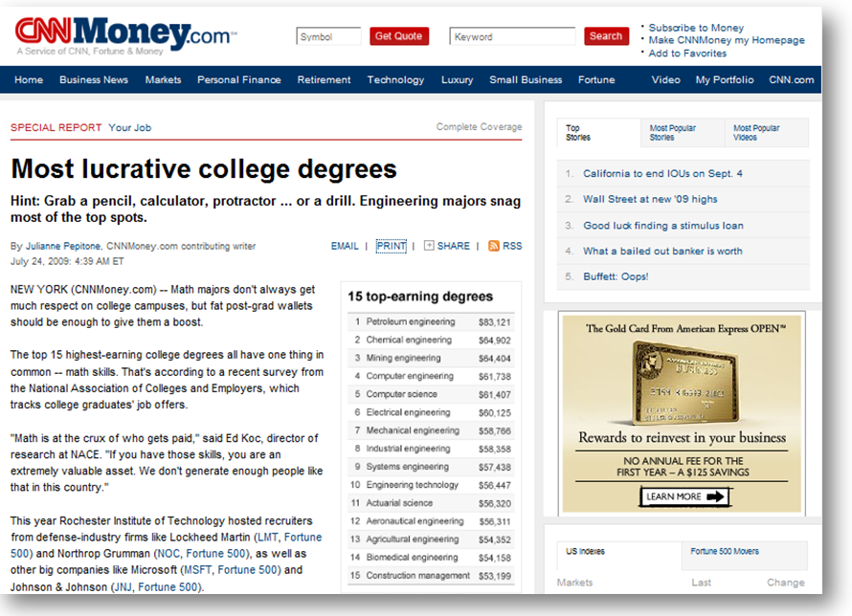
How do you know an engineering career is right for you? One of my favorite stories came from the parent of a student who was one of the most talented hardware engineers I have ever seen as an undergraduate. It turns out when he was 10 years old he burned a large hole in his mattress in his bedroom attempting to build a large capacitor out of aluminum foil. Many engineers are known to have disassembled their first computer much to the dismay of their parents. The only thing that will motivate you to persevere through the math, physics and electronics is your love of building cool things.
If you want to learn more about the innovative program we are building at Temple, follow us on Twitter, Facebook or Blogspot. I encourage you to visit us and meet our excellent faculty and staff. Give us a chance to convince you that Temple is the right university for you.
Joseph Picone, Ph.D.
Chair and Professor, Department of Electrical and Computer Engineering
Tel: 215-204-4841
Email: picone@temple.edu

