Name:

|  |  |  |
| --- | --- | --- |
| Problem | Points | Score |
| 1.29(b) | 10 |  |
| 1.29(c) | 10 |  |
| 1.29(e) | 10 |  |
| 2.29(a) | 15 |  |
| 2.29(b) | 15 |  |
| 2.29(d) | 15 |  |
| 3.13(a) | 10 |  |
| 3.13(b) | 10 |  |
| 3.13(c) | 5 |  |
| Total | 100 |  |

Notes:

1. The exam is closed books and notes except for one double-sided sheet of notes.
2. Please indicate clearly your answer to the problem.
3. The details of your solutions are more important than the answers. Please explain your solutions clearly and include as many details as possible.

**1.29.**Determine whether the following discrete-time systems are causal or noncausal, have memory or are memoryless, are linear or nonlinear, are time invariant or time-varying. Justify your answers (correct answers with no justification will not be given any credit). In the following parts, *x*[*n*] is an arbitrary input and *y*[*n*] is the response to *x*[*n*].

(b) 

Justify your answers:

|  |  |  |
| --- | --- | --- |
| Property: | Yes | No |
| Causal |  | x |
| Memory | x |  |
| Linear | x |  |
| Time Invariant | x |  |

This is a linear, constant-coefficient difference equation.  
It is not causal because the output depends on x[n+1], which occurs in the future (before y[n]). Because of this, the system also has memory. It is linear because scaling x[n], ax[n], will produce a scaled version of y[n], ay[n]. Superposition also holds. Finally, it is time invariant because the coefficients are constant.

(c) 

Justify your answers:

|  |  |  |
| --- | --- | --- |
| Property: | Yes | No |
| Causal | x |  |
| Memory |  | x |
| Linear | x |  |
| Time Invariant |  | x |

It is causal, because there is no dependence on the future.  
It is memoryless because there is no dependence on past or future values of the input or output.  
It is linear because ax[n] 🠢 ay[n].  
It is time-varying, however, because the weight “n”. For example, the output to u[n-1] and u[n-2] are different due to the weight “n”.

(e) 

Justify your answers:

|  |  |  |
| --- | --- | --- |
| Property: | Yes | No |
| Causal | x |  |
| Memory |  | x |
| Linear |  | x |
| Time Invariant | x |  |

It is causal (no dependence on the future); memoryless (no terms  
such as x[n-i]), and time invariant because there are no time-varying weights. However, it is nonlinear, because, for example, if you apply a sinewave to this system, you will not get a sinewave out (but instead will get a rectified sinewave).

**2.29.** Sketch the output for the convolution of x(t) and v(t). Your solutions should include the start time, stop time, peak value, location of the peak value, and any other critical points for which the output changes slope. You need not compute an analytic solution unless it helps you solve the problem.

(a)

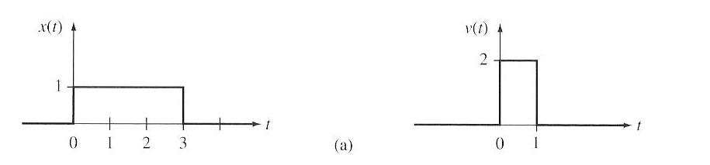

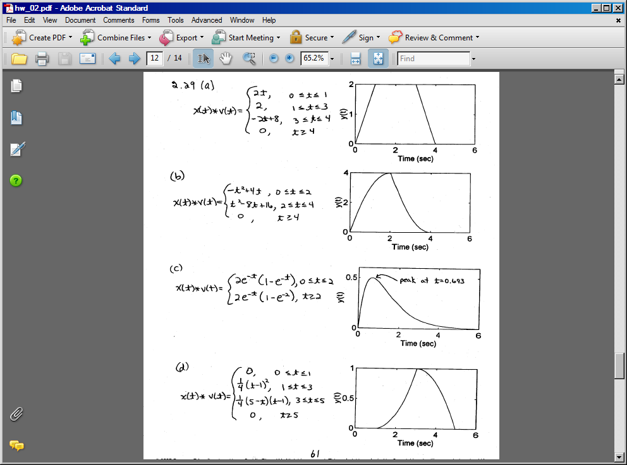

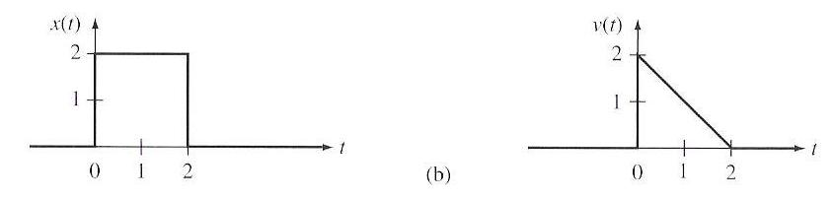



(d)

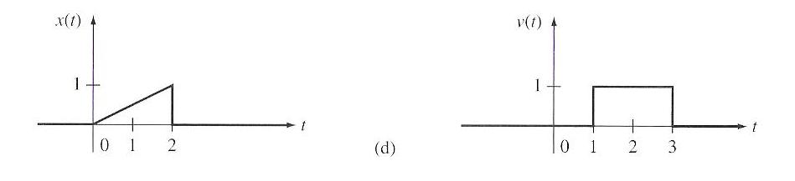



**3.13.** A periodic signal with period T has Fourier coefficients: . Compute the Fourier coefficients, , for the periodic signal v(t), where:

**See Lecture 9, slide 8 for a list of the properties of the Complex Fourier Series.**

(a) 

Apply the time-shifting property: . Therefore, .

(b) 

Apply the differentiation property: . Therefore, .

(c) 

Apply the frequency shifting property: . Therefore, . (Note that the signal was periodic with period T, so this is just an application of this property with M=1.)