Name:

|  |  |  |
| --- | --- | --- |
| Problem | Points | Score |
| 4.4(b) | 10 |  |
| 4.4(d) | 10 |  |
| 4.4(e) | 10 |  |
| 4.4(g) | 10 |  |
| 5.16(a) | 15 |  |
| 5.16(c) | 15 |  |
| 5.16(d) | 10 |  |
| 6.14(a) | 10 |  |
| 6.14(b) |  |  |
| 6.14(d) | 5 |  |
| Total | 100 |  |

Notes:

1. The exam is closed books and notes except for one double-sided sheet of notes.
2. Please indicate clearly your answer to the problem.
3. The details of your solutions are more important than the answers. Please explain your solutions clearly and include as many details as possible.

**4.4.**Compute the DTFT of the following discrete-time signals and sketch the magnitude spectrum:

(b) 

(d) 

(e) 

(g) 

**5.16.** A lowpass filter has the frequency response function shown to the right.

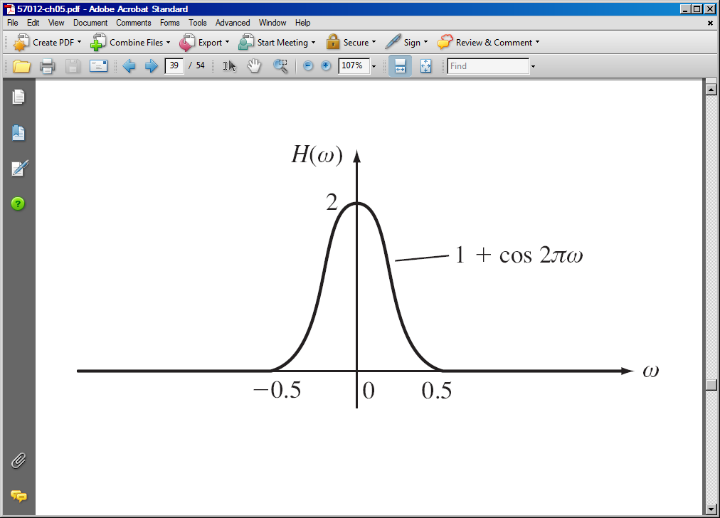

(a) Compute the impulse response, h(t):

(c) Compute the response, y(t), when 

(d) Compute the response, y(t), when 

**6.14.**  Use Laplace transforms to compute the solution to the following differential equations:

(a) 

(b) 

(d) 