Name:

|  |  |  |
| --- | --- | --- |
| Problem | Points | Score |
| 7.40(b) | 15 |  |
| 7.40(c) | 15 |  |
| 7.40(d) | 15 |  |
| 8.9(a)(i) | 15 |  |
| 8.9(a)(ii) | 10 |  |
| 8.9(a)(iii) | 10 |  |
| 9.1(a) | 10 |  |
| 9.1(c) | 10 |  |
| Total | 100 |  |

Notes:

1. The exam is closed books and notes except for one double-sided sheet of notes.
2. Please indicate clearly your answer to the problem.
3. The details of your solutions are more important than the answers. Please explain your solutions clearly and include as many details as possible.

**7.40.**For the following linear time-invariant discrete-time systems with unit-pulse response , determine if the system is BIBO stable.

(b) 

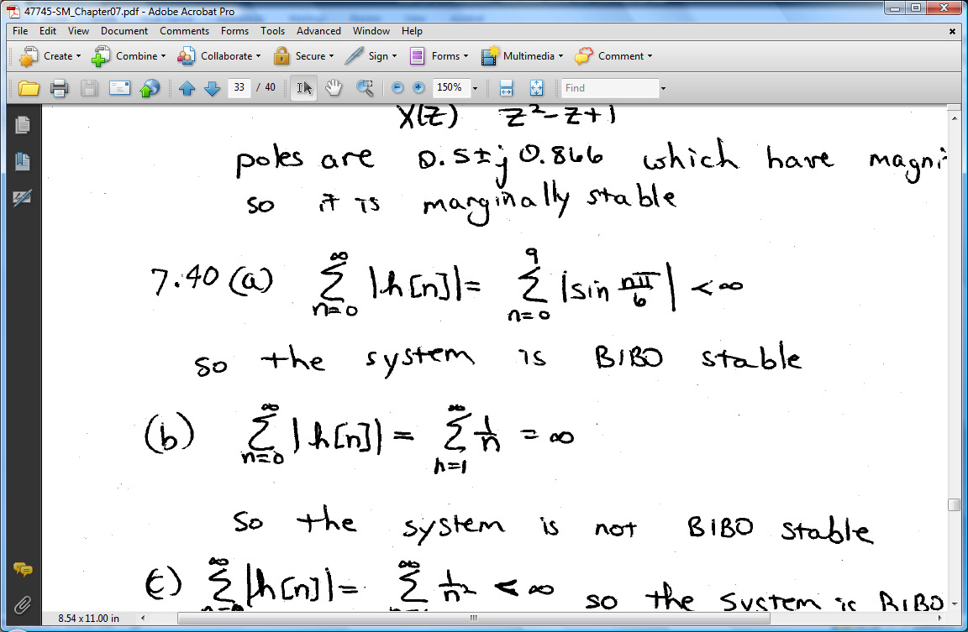

(c) 

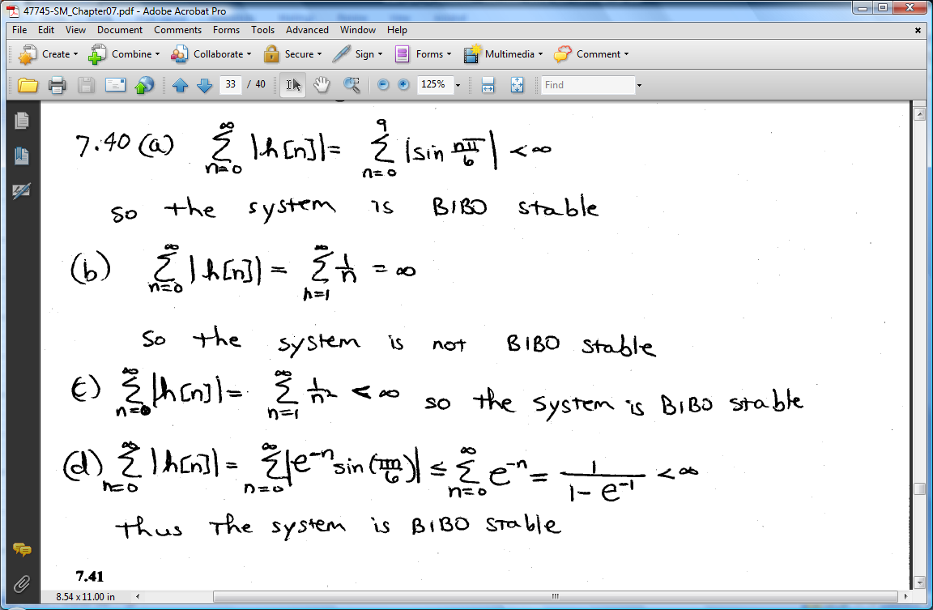

(d) 



**8.9(a).** Determine if the system is critically damped, underdamped, or overdamped.

(i) 

(ii) 

(iii) 

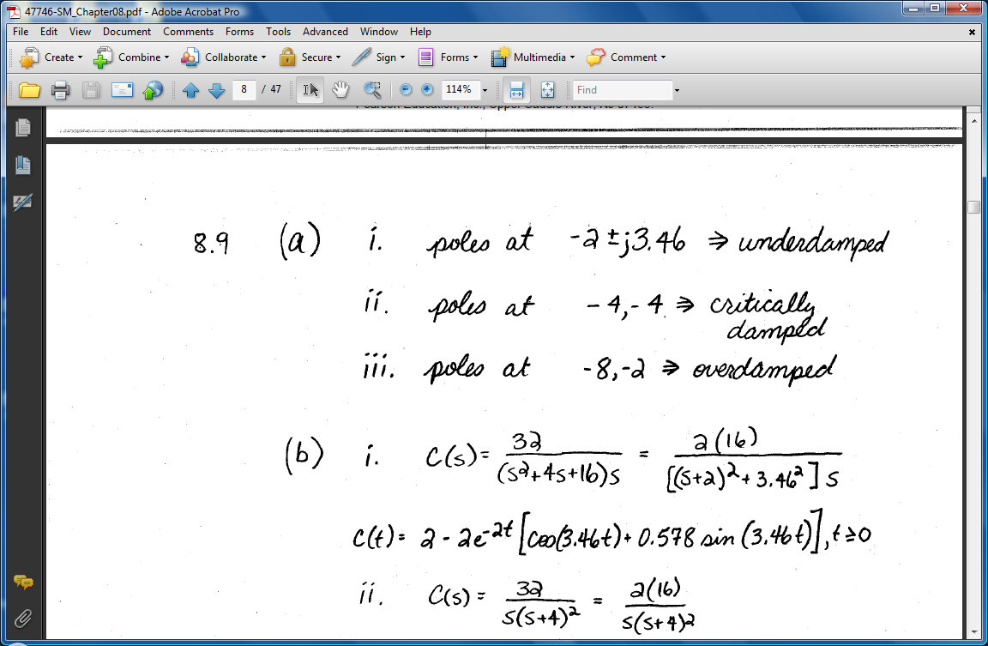

9.1. Consider the transfer function:

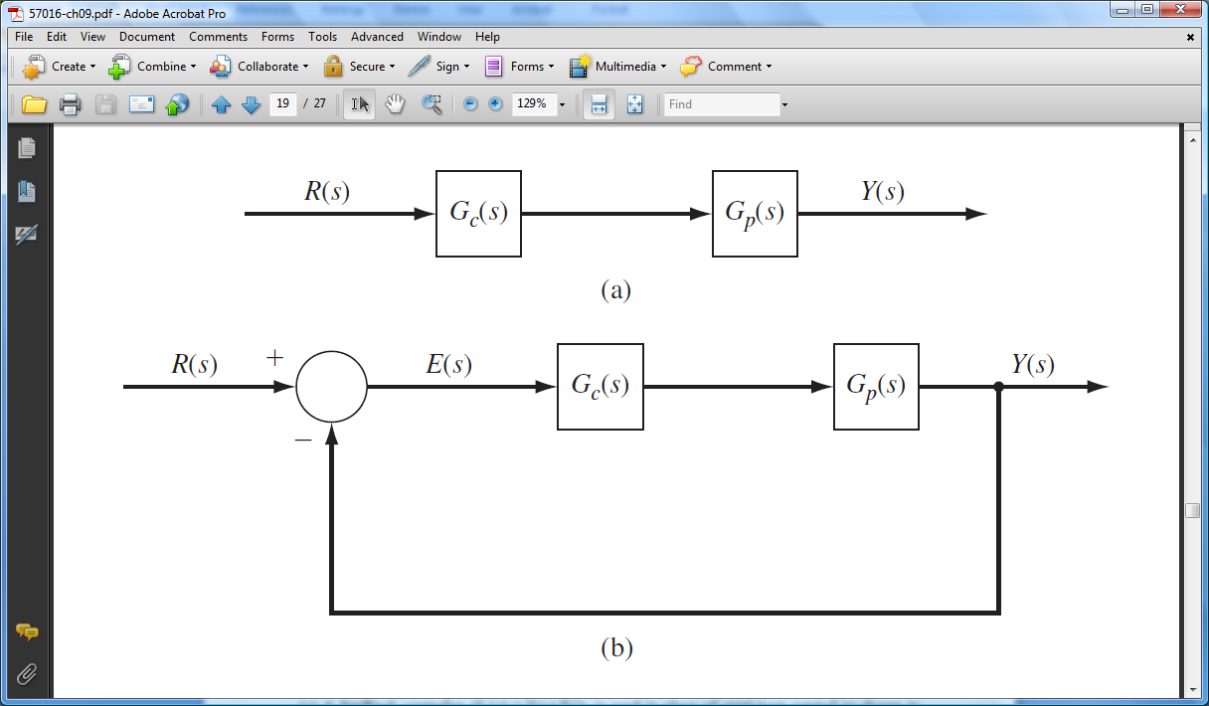



(a) An open-loop control is  
shown in Figure P9.1(a). Design  
the control system, , so  
that the combined plant and  
controller, , has a   
pole at 

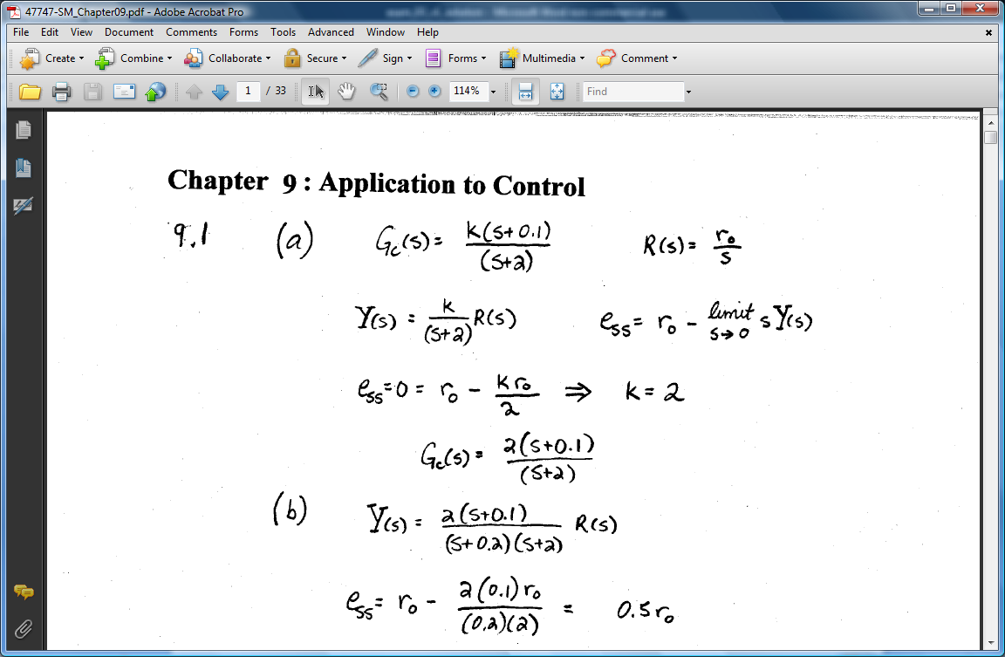

(c) A feedback controller  is used in place of open-loop control as shown in Figure P9.1b. Verify that the closed-loop pole of the nominal system is at p = -2.

