Name:

|  |  |  |
| --- | --- | --- |
| Problem | Points | Score |
| 1(a) | 10 |  |
| 1(b) | 10 |  |
| 1(c) | 10 |  |
| 1(d) | 10 |  |
| 1(e) | 10 |  |
| 2(a) | 10 |  |
| 2(b) | 10 |  |
| 2(c) | 10 |  |
| 2(d) | 10 |  |
| 3 | 10 |  |
| Total | 100 |  |

Notes:

1. The exam is open books and notes, and you are allowed to use your laptop as well.
2. By signing your name to this sheet, you are acknowledging you have abided by the MSU honor code, agreeing that the work presented in this exam is solely your own, and stating that you have not used email, text messaging, or other similar tools to discuss the solutions with others during the exam. Violation of this policy will result in a grade of 0 on this exam and possibly other disciplinary action by the university.
3. The details of your solutions are more important than the answers. Please explain your solutions clearly and include as many details as possible. You might consider drafting an outline of your solution to begin the problem, so that I can easily follow your logic.

**1.**Consider the circuit shown below:



(a) Plot the frequency response of the magnitude of the transfer function from 0 to 100 Hz using a log scale for the frequency axis. Explain why your plot makes sense.

(b) Plot the impulse response from 0 to 10 secs. Explain why your plot makes sense.

(c) Plot the step response.

(d) Plot the steady state response to an input that is a periodic square wave with a frequency of 1 Hz, a phase of 0°, and a 50% duty cycle, as shown below:

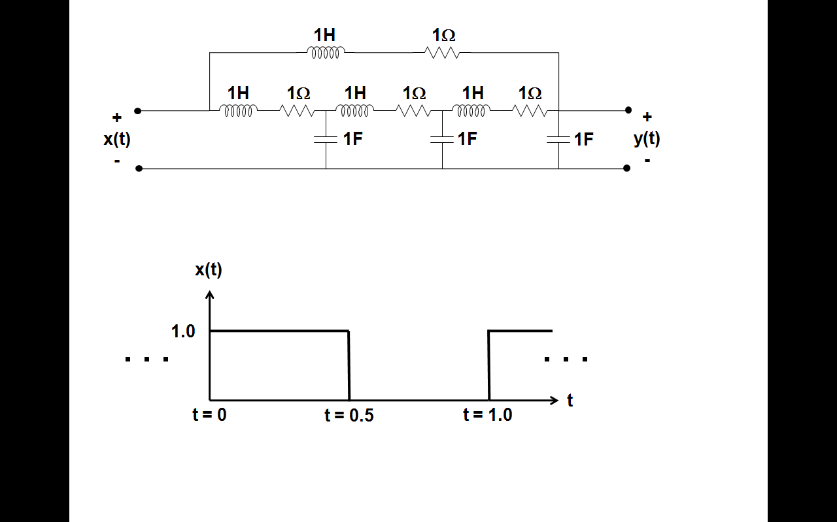

(e) Define an appropriate set of state variables and write the state equations.

**2.**Given the discrete-time system below:

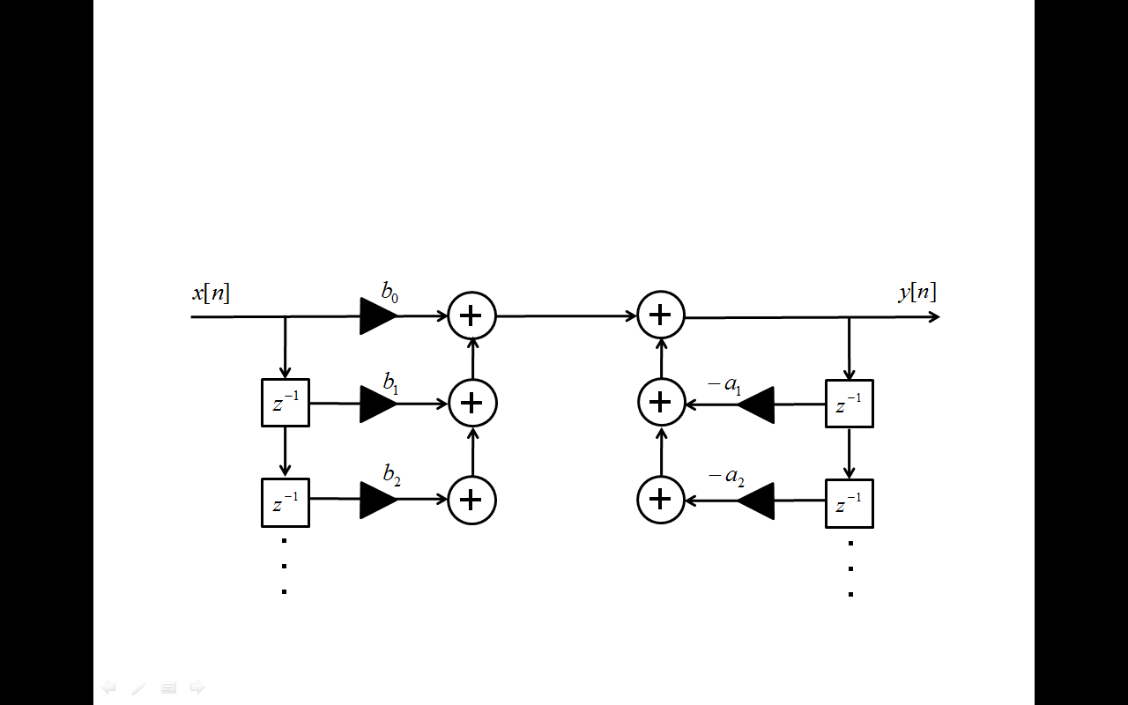

(a) Assume the following values for the coefficients (all other values are zero):



Plot the magnitude frequency response of the transfer function.

(b) Prove whether the system is stable or unstable.

(c) Assume the input signal is the sum of two sinewaves at 100 Hz and 200 Hz respectively, sampled at :



Write an expression for the output signal, . Be as specific as possible.

(d) Assume the following values for the coefficients (all other values are zero):



Plot the phase as a function of frequency. Explain why this makes sense and for what types of applications you might use this system.

**3.** There has been a lot of debate about global warming, particularly whether the recently observed climate changes are part of a natural cycle (e.g., the ice age in reverse) or the result of the environmental impact of modern civilization. It is difficult to estimate these things because one on hand, you have climate data over long periods of time (e.g., millions of years) that shows significant cycles, and on the other hand you have tremendous amounts of short-term data (e.g., temperature, wind, satellite images) collected that points to a global crisis.

You have recently been appointed as the President’s chief advisor on climate conditions. (I read this morning that Al Gore is potentially being considered for such a position ☺) You are preparing your first speech to the nation and finally have a chance to put your Signals and Systems knowledge to good use (using your book as a doorstop in your office doesn’t count ☺).

Using as many concepts from this course as possible, discuss the challenges of predicting climate change based on all the previous data available to you (e.g., time series prediction based on previous samples of multiple inputs). How can you accurately predict whether the change is permanent or transitory? What types of algorithms would you use to understand the observed changes? What types of models would you build? What types of factors would you measure? How would you estimate the parameters of these models?

When you use a concept, be sure to underline it or put the name in parentheses, so I can easily identify the concepts you are invoking. There is no right or wrong answer to this problem, so your answers will be judged by their technical correctness, creativity, and thoroughness relative to the answers of your peers in the class.