5.45 c)

Analytical:
Impulse response: h[n] = 1.9(-0.9)^{n}u[n]
H[Ω] = 1.9 * 1 / (1 + (0.9)e^{-jΩ}) = 1.9 * e^{jΩ} / (e^{jΩ} + 0.9)
|H(0)| = 1, ∠H(0) = 0
|H(π/4)| = 1.08, ∠H(π/4) = 21
|H(π/2)| = 1.4, ∠H(π/2) = 42
Input Signal: x[n]= 1 + sin(πn/4) + sin(πn/2)
X[Ω] = 2πδ(Ω) + j*π[δ(Ω+ π/4) – δ(Ω-π/4)] + j*π[δ(Ω+ π/2) – δ(Ω-π/2)]
Y[Ω] = H[Ω]X [Ω]
Multiplying:
Y[Ω] = A[Ω] + B[Ω] +C[Ω]
Where
A[Ω] = 1.9 * e^{jΩ} / (e^{jΩ} + 0.9) * 2πδ(Ω)
B[Ω] = 1.9 * e^{jΩ} / (e^{jΩ} + 0.9) * j*π[δ(Ω+ π/4) – δ(Ω-π/4)]
C[Ω] = 1.9 * e^{jΩ} / (e^{jΩ} + 0.9) * + j*π[δ(Ω+ π/2) – δ(Ω-π/2)]
Inverse transform:
Using 5.11 for B and C
b[n] = 1*1.08*cos(π /4*n + 21°)
c[n]= 1 * 1.4 * cos(π/2*n + 42°)
using 5.24 for A
a[n] = 1
so
y[n] = 1 + 1.08*cos(π /4*n + 21°) + 1.4 * cos(π/2*n + 42°)
plot of y[n] above:
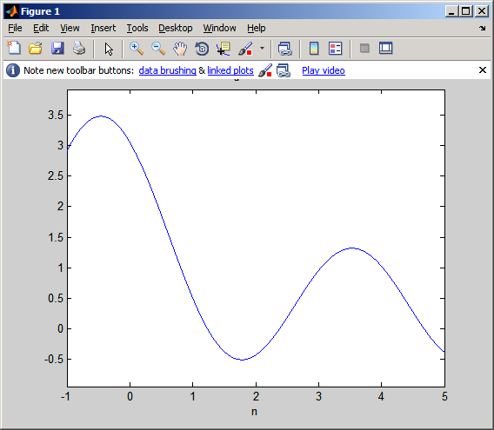

Plot of a numerical calculation using matlab
Solving the problem using matlab:
>> syms X H Y y w x n
>> x = 1 + sin(pi*n / 4) + sin(pi * n /2);
>> X = fourier(x)
X = pi*(2*dirac(w)-i*dirac(w-1/2*pi)+i*dirac(w+1/2*pi)-i*dirac(w-1/4*pi)+i*dirac(w+1/4*pi))
>> H = 1.9 / (1 + (0.9)*exp(-j*w));
>> Y = X.*H;
>> y = ifourier(Y);
>> syms y_an
>> y_an = 1 + 1.08*cos(pi/4 * n + 21*pi/180) + 1.4*cos(pi/2*n + 42*pi/180)
>> ezplot(y,[-1,5])
>> explot(y_an,[-1,5])

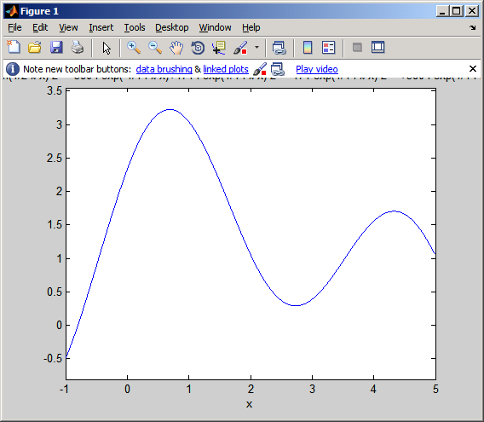

The plots are the same. Well very close at least, I can’t get them to plot on top of each other, but it looks like their phase is just slightly off, probably due to rounding of the analytical solution. Matlab validates the analytical solution.

