Name:

|  |  |  |
| --- | --- | --- |
| Problem | Points | Score |
| 1.4(b) | 10 |  |
| 1.17(b) | 10 |  |
| 1.29(f) | 10 |  |
| 2.7(b) | 15 |  |
| 2.7(c) | 20 |  |
| 3.17(a) | 15 |  |
| 3.17(c) | 20 |  |
| Total | 100 |  |

Notes:

1. The exam is closed books and notes except for one double-sided sheet of notes.
2. Please indicate clearly your answer to the problem.
3. The details of your solutions are more important than the answers. Please explain your solutions clearly and include as many details as possible.

**1.4(b).**Sketch the continuous-time signal:  Be sure to explain or demonstrate how you arrived at your solution.

**1.17(b).** Determine whether this CT system is causal/noncausal and memory/memoryless:

.

It is causal because it depends only on current values of time (it is an instantaneous system).

It is memoryless for the same reason.

**1.29(f).** Determine whether the following discrete-time system is causal/noncausal, memory/memoryless:

 .

The system is causal because it does not depend on past values of the input (e..g, x[n-1]) or output (e.g., y[n-1]).

The system is memoryless because y[n] is only a function of x[n].

**2.7(b).** For the signals shown, compute and plot the convolution: .

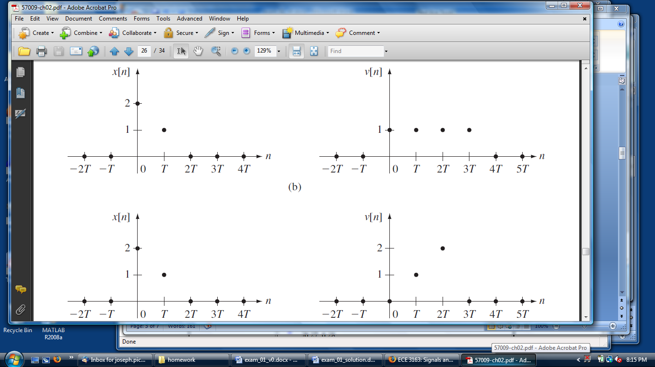

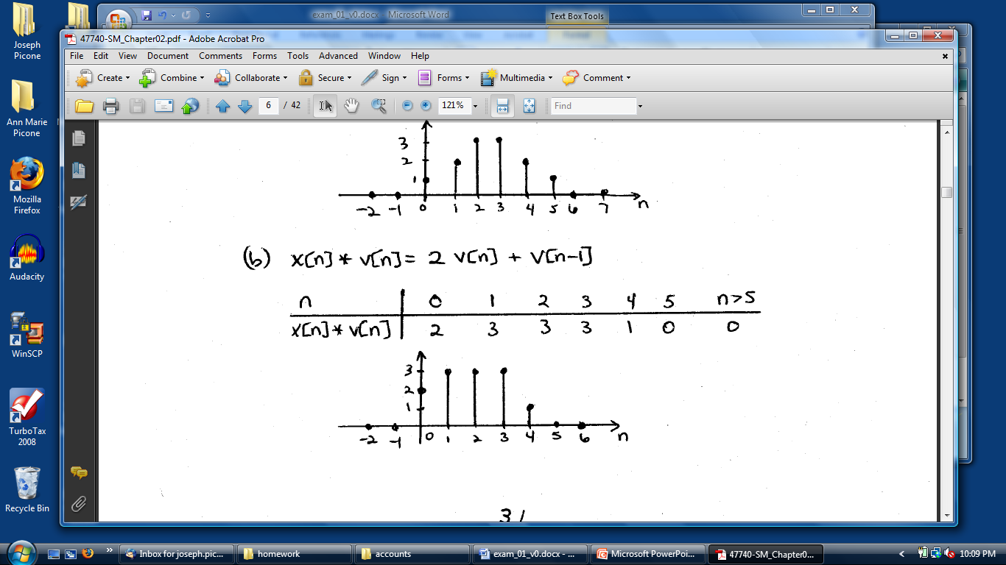

**2.7(c).**For the signals shown, compute and plot the convolution: .

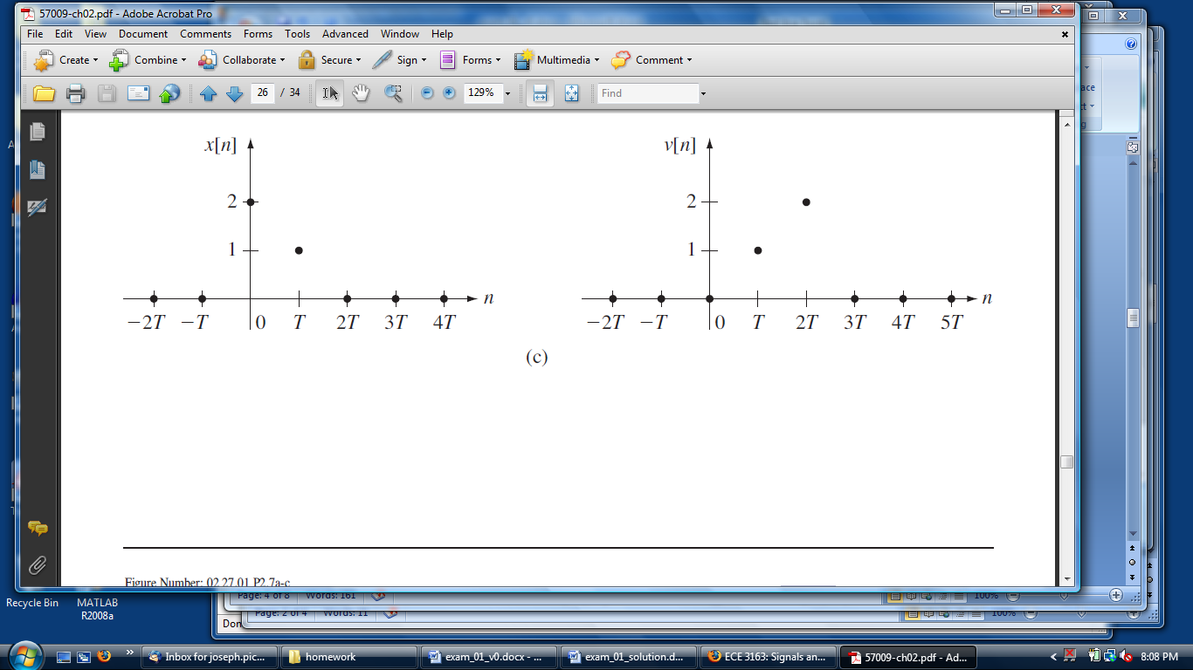

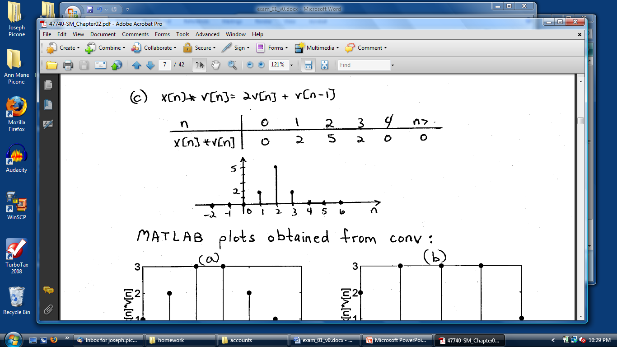

**3.17.** Compute the Fourier transform of the following signals:

**(a)** 

Use two properties:

       



**(c)** 

Use two properties:

       

