Name:

|  |  |  |
| --- | --- | --- |
| Problem | Points | Score |
| 1.4(b) | 10 |  |
| 1.17(b) | 10 |  |
| 1.29(f) | 10 |  |
| 2.7(b) | 15 |  |
| 2.7(c) | 20 |  |
| 3.17(a) | 15 |  |
| 3.17(c) | 20 |  |
| Total | 100 |  |

Notes:

1. The exam is closed books and notes except for one double-sided sheet of notes.
2. Please indicate clearly your answer to the problem.
3. The details of your solutions are more important than the answers. Please explain your solutions clearly and include as many details as possible.

**1.4(b).**Sketch the continuous-time signal:  Be sure to explain or demonstrate how you arrived at your solution.

**1.17(b).** Determine whether this CT system is causal/noncausal and memory/memoryless:

.

**1.29(f).** Determine whether the following discrete-time system is causal/noncausal, memory/memoryless:

 .

**2.7(b).** For the signals shown, compute and plot the convolution: .

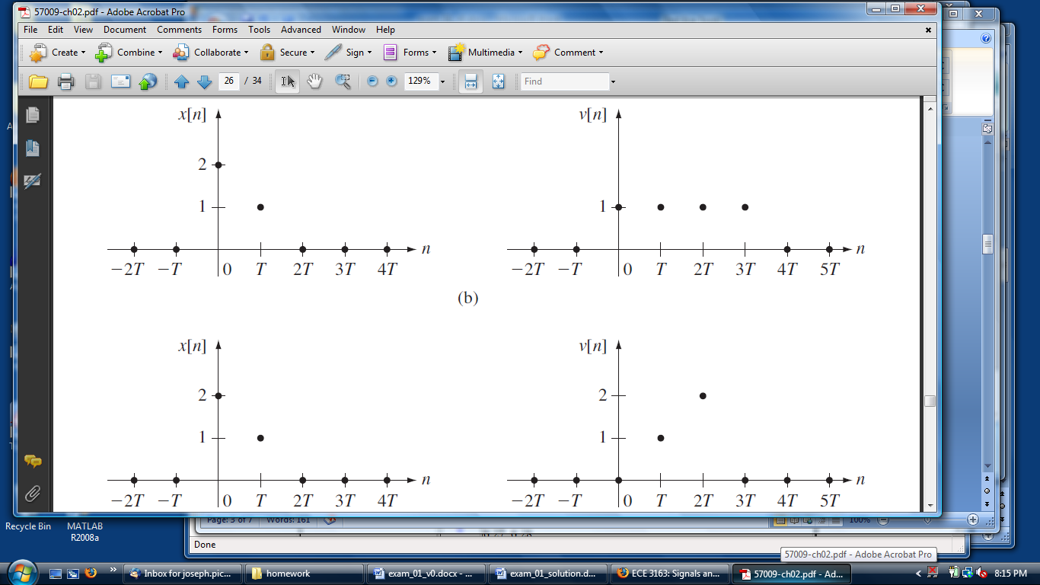

**2.7(c).**For the signals shown, compute and plot the convolution: .

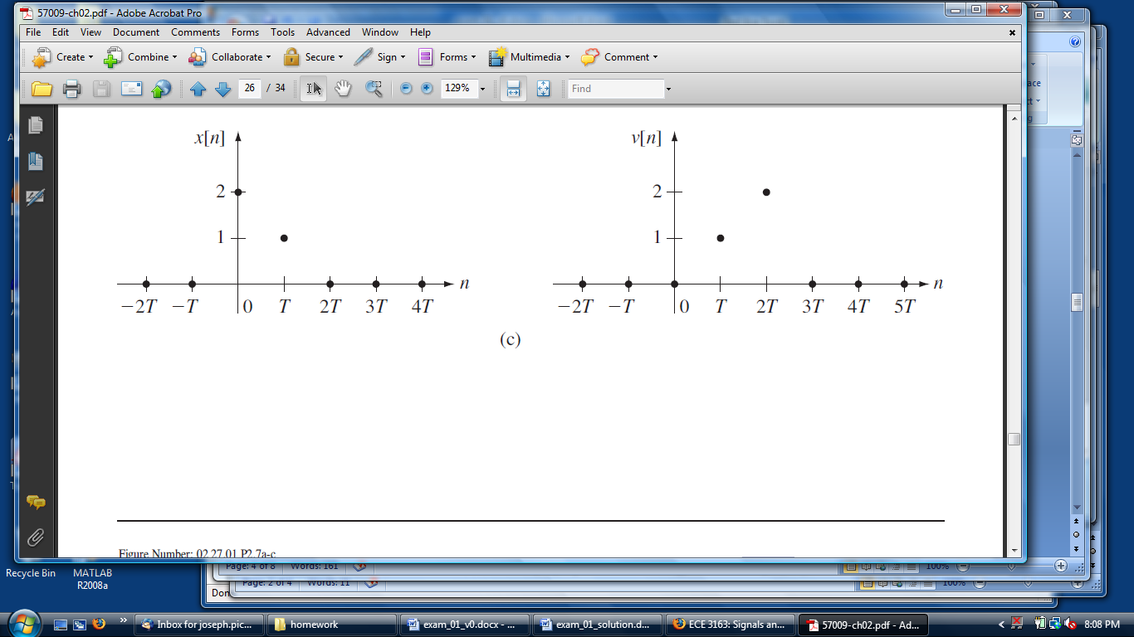

**3.17.** Compute the Fourier transform of the following signals:

**(a)** 

**(c)** 