Perriea Wiley

March 27, 2009

Signals and Systems

Dr. Picone

Exam 2

Extra Credit

I started how first by making sure that I knew the proper definition of Convolution. Convolution is the mathematical operation on two functions that produces a thrid function that is typically viewed as a modified version of one of the original function. Convolution is in a sense another operation such as multiplication. An operation that is use to examine the properties of smapled signals. Convulotion in the time domain is the equivalent of multiplication in the frequency domain. As in inverse the convolution in frequency is the equivalent of multiplication in the time domian. I have a much better understanding that convolving a function with an impulse generates a copy of the function at the location of the impulse. I understand that the outpt duration of a convolved signal is the sum of the duration of two inputs.

Within the problem I was confronted with the task and I had lost conscienceness on how to properly attempt the problem. I first within the extra credit I wanted properly introduce myself to convolution. I got the first part of the problem correct on the test and got lost to what step I should persue next. I knew I had to find H(п/4) and H(п /2). I also discover that h[n] was a real value and that the convolution of the x and h would be determine by those inputs. Also, I realized from discovering h[n] was a real value that |H(-Ω)|=|H(Ω)| and <H(-Ω) = -<H(Ω) . By determining that the transfer functions was real, some substitutions, and convolving I was able to successful complete the extra with a real understanding of convolution in the frequency and time domain.

The problem was rather tricky but with a better understanding, I feel I would have had a better chance at effectively finishing the problem. The more I grow the more I learn.

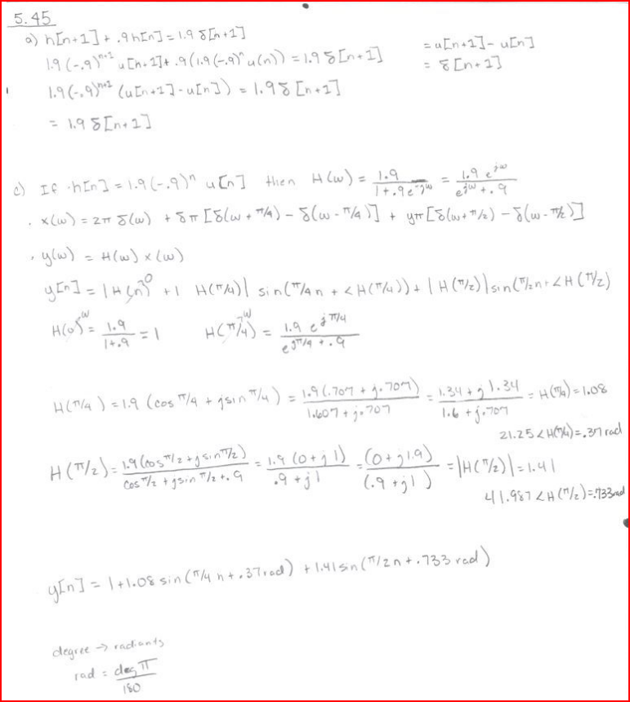

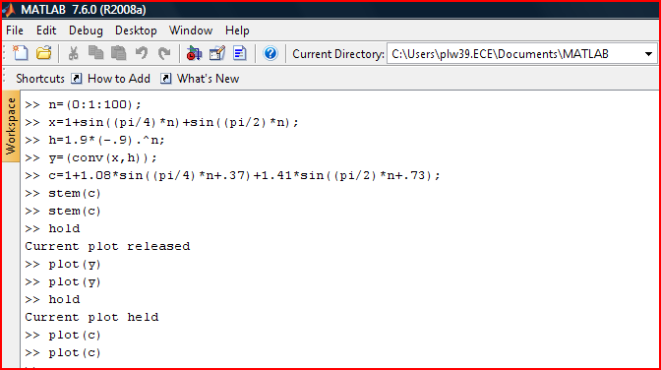MATLAB Code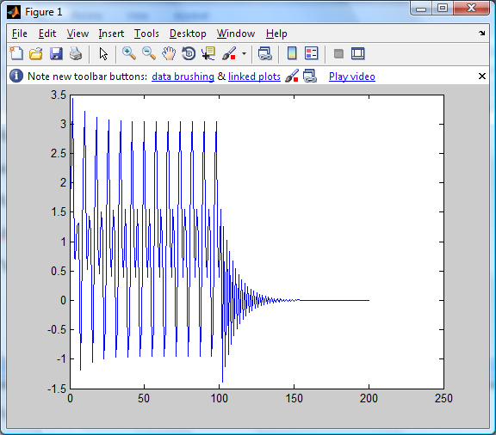
Plot Y
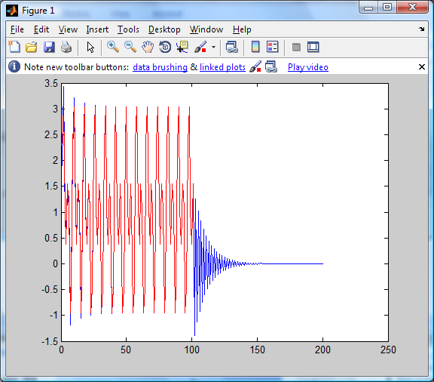
Plot Y and Plot C
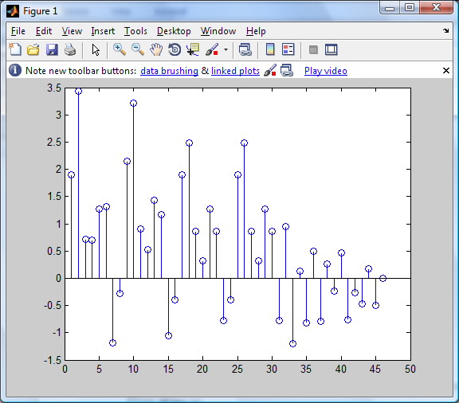
Stem Y

