Name:

|  |  |  |
| --- | --- | --- |
| Problem | Points | Score |
| 4.6(a) | 20 |  |
| 4.6(c) | 20 |  |
| 5.45(a) | 20 |  |
| 5.45(b) | 20 |  |
| 6.28(a) | 20 |  |
| Total | 100 |  |

Notes:

1. The exam is closed books and notes except for one double-sided sheet of notes.
2. Please indicate clearly your answer to the problem.
3. The details of your solutions are more important than the answers. Please explain your solutions clearly and include as many details as possible.

**4.6.**Use the properties of the DTFT to compute the inverse DTFT of the following frequency response functions:

(a)

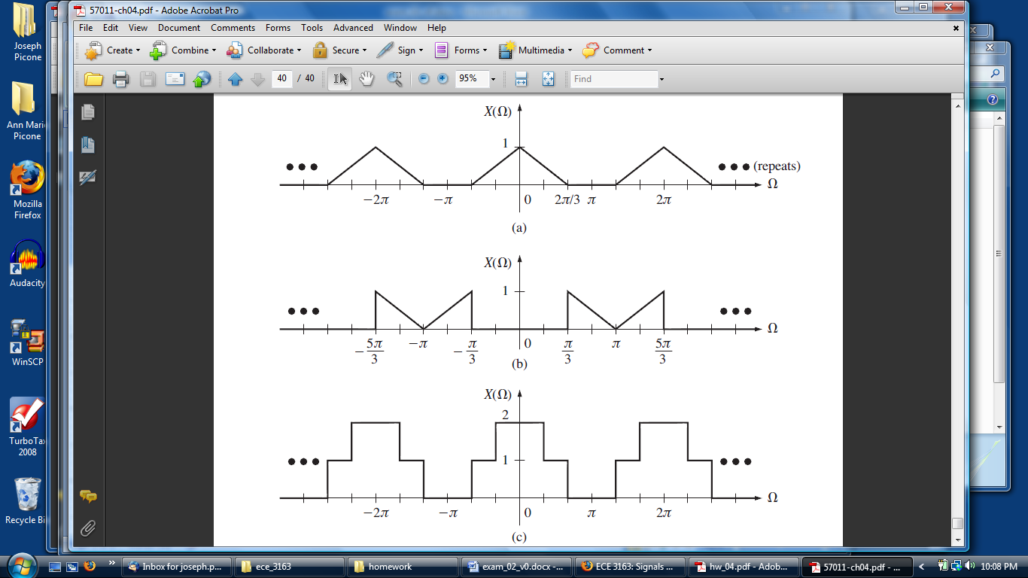

We need to combine several properties to solve this problem:

(1) Multiplication in the time domain: .

(2) Convolution and frequency-domain scaling:  (note the normalization so the amplitude of the spectrum as output from convolution is 1).

(3) Transform of a sinc function: , where in this case.

Combining these results gives:





(c)

First, decompose the spectrum into the sum of two signals: . The first term represents the pulse from , while the second term represents the sum of the first term and a pulse that extends from .

Now we can write the inverse transform using the transform pair: .



**5.45.** Consider the discrete-time system given by the input/output difference equation:



(a) Show that the impulse response is given by:.

**Method 1:** rewrite this equation as: 

Then simply apply  and compute :

|  |  |  |
| --- | --- | --- |
|  |  |  |
| 1 | -0.9(0)+1.9(1)=1.9 | 0 |
| 0 | -0.9(1.9)+1.9(0)=-0.9(1.9) | 1.9 |
| 0 | -0.9(-0.9)(1.9)+1.9(0)=1.9(-0.9)2 | -0.9(1.9) |
| … | 1.9(-0.9)n | … |

**Method 2:**



Combine these results:



Note that the l.h.s. is non-zero when . QED.

(b) Compute the output response  to an input of.

One way to compute the output would be to plug the input into the difference equation. In doing this, we realize that:

|  |  |
| --- | --- |
|  |  |
| 0 | 1 |
| 1 |  |
| 2 |  |
| 3 |  |
| 4 |  |
| 5 |  |
| 6 |  |

**6.28(a).**  Using the s-domain representation, compute the transfer function for the system shown:

