Name:

|  |  |  |
| --- | --- | --- |
| Problem | Points | Score |
| 4.6(a) | 20 |  |
| 4.6(c) | 20 |  |
| 5.45(a) | 20 |  |
| 5.45(b) | 20 |  |
| 6.28(a) | 20 |  |
| Total | 100 |  |

Notes:

1. The exam is closed books and notes except for one double-sided sheet of notes.
2. Please indicate clearly your answer to the problem.
3. The details of your solutions are more important than the answers. Please explain your solutions clearly and include as many details as possible.

**4.6.**Use the properties of the DTFT to compute the inverse DTFT of the following frequency response functions:

(a)

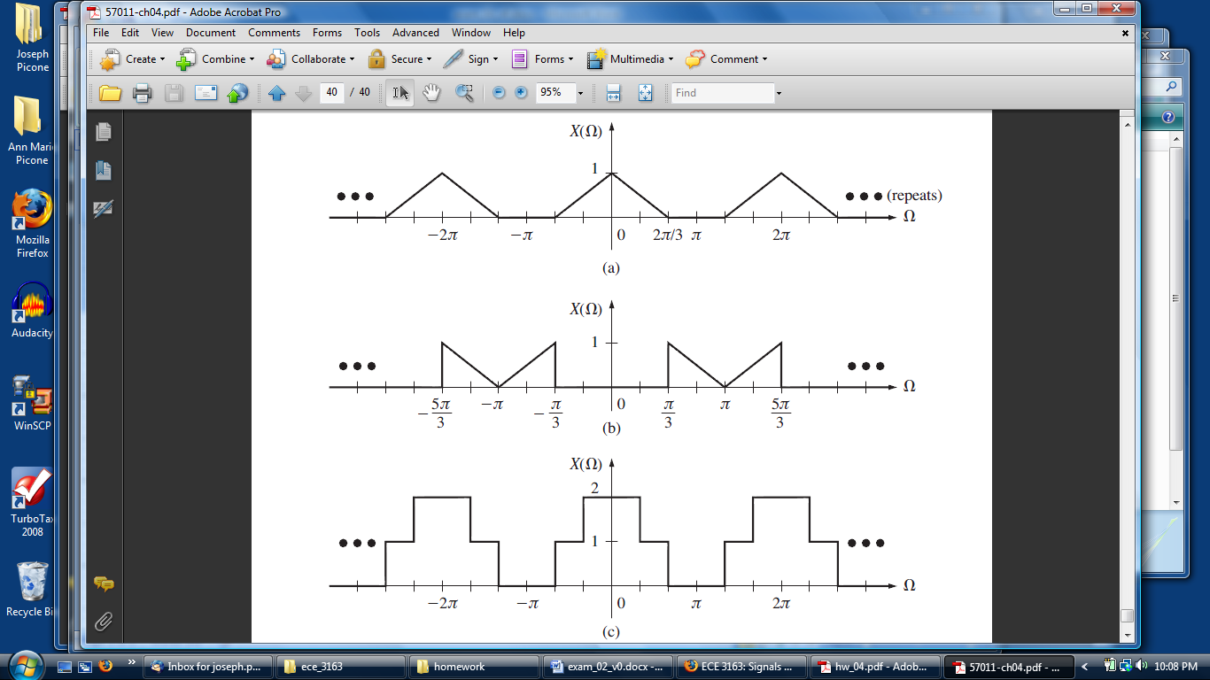

Start by noting that , where . Model the spectrum as the convolution of two frequency-scaled pulse functions:  (note the normalization so the amplitude is 1). Use the Fourier transform pair that states convolution in the frequency domain is equivalent to multiplication in the time domain: . Combining these results gives:



(c)



**5.45.** Consider the discrete-time system given by the input/output difference equation:



(a) Show that the impulse response is given by .

(b) Compute the output response  to an input of .

**6.28(a).**  Using the s-domain representation, compute the transfer function for the system shown:

