Name:

|  |  |  |
| --- | --- | --- |
| Problem | Points | Score |
| 7.34(a) | 20 |  |
| 7.34(b) | 15 |  |
| 8.1(a) | 20 |  |
| 8.1(b) | 10 |  |
| 9.4(a) | 20 |  |
| 9.4(b) | 15 |  |
| Total | 100 |  |

Notes:

1. The exam is closed books and notes except for one double-sided sheet of notes.
2. Please indicate clearly your answer to the problem.
3. The details of your solutions are more important than the answers. Please explain your solutions clearly and include as many details as possible.

**7.34.**A linear time-invariant discrete-time system is given by the feedback connection shown to the right. H1(z) and H2(z) are the transfer functions of the subsystems given by:



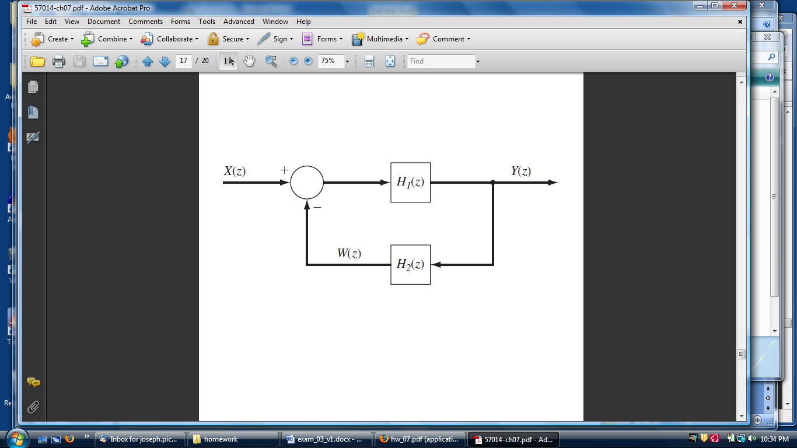

(a) Determine the unit-pulse response of the overall system.

To compute the inverse transform, we will us the identity: 



Therefore,



(b) Compute the step response of the overall system.



**8.1.** For the following linear time-invariant continuous-time systems, determine if the system is stable, marginally stable, or unstable:

(a) 

Using the quadratic equation: 

We can see that the term under the square root is always less than 7, so the roots are negative and real. Therefore the poles reside in the left-half plane and the system is STABLE.

(b) 

Again, using the quadratic equation: 

We see that the term under the square root is always negative, so the roots are imaginary. Therefore the poles are on the imaginary (*jω*) axis and the system is marginally stable.

**9.4.** Consider the feedback control system shown below:

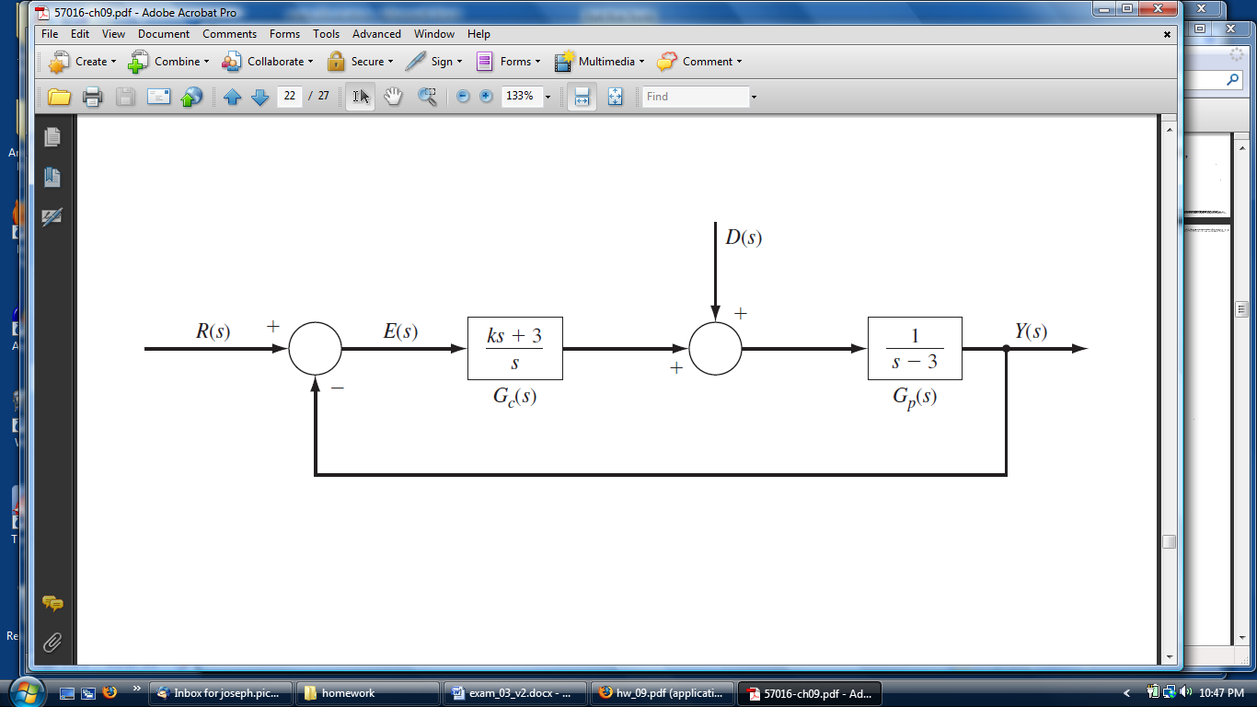

(a) Derive an expression for *E(s)* in terms of *D(s)* and *R(s)*, where *E(s)* is the Laplace transform of the error signal *e(t)* = *r(t)* – *y(t)*.



(b) Suppose that *r(t)* = *u(t)* and *d(t)* = *0* for all t. Determine all (real) values of K so that *e(t)* → 0 as *t* → ∞.



Poles locations are: 

When , the poles will be negative real (when , the poles are real), the signal will have an envelope that decays to zero (because of stability), and the error signal will go to zero as t → ∞.