Name:

|  |  |  |
| --- | --- | --- |
| Problem | Points | Score |
| 1(a) | 15 |  |
| 1(b) | 15 |  |
| 1(c) | 15 |  |
| 2(a) | 15 |  |
| 2(b) | 15 |  |
| 3(a) | 15 |  |
| 3(b) | 10 |  |
| Total | 100 |  |

Notes:

1. The exam is closed books and notes except for one double-sided sheet of notes.
2. Please indicate clearly your answer to the problem.
3. The details of your solutions are more important than the answers. Please explain your solutions clearly and include as many details as possible.

**1.** For the adaptive system shown to the right, assuming *f*(*n*) is a linear, time-invariant moving average filter:

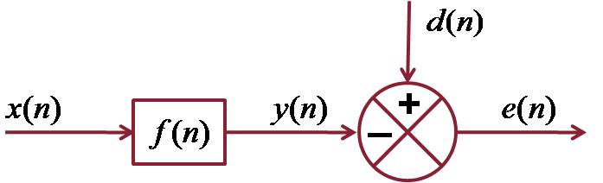



(a) Derive the normal equations for the minimum least squares error estimate of the filter coefficients.

See lecture no. 5.

(b) Develop the concept of a linear prediction filter based on this model (explain how this model is modified to produce a linear prediction estimate of the filter coefficients).

See lecture no. 3.

(c) Derive the expression for the autocorrelation estimate of the linear prediction coefficients.

See lecture no. 3.

**2.** Modify the block diagram shown above to produce the basic LMS adaptive filter.

(a) Derive an expression for estimation of the filter coefficients using an iterative-in-time approach.

See lecture no. 5.

(b) Compare and contrast this to the approach in Prob. 1.

See lecture no. 5.

**3.** Suppose the input signal to the adaptive filter shown above is as follows: Assume is zero-mean white Gaussian noise.

(a) Explain how successful the filter in no. 2 will be at correctly estimating the underlying parameters of this signal. Be as specific as possible and use terms such as the bias, variance, and convergence.

See lecture no. 10. This is a signal generated from an AR model (all-pole). The filter of no. 2 assumes an FIR (MA) structure (useful for applications like time-delay estimation, but not so useful for an AR signal). However, if we use a large number of filter coefficients, we can model an AR signal with an FIR filter. But, for a finite number of coefficients, there will be bias. This bias can be viewed a number of ways, including using an analysis based on the concepts of time-domain windowing.

If the AR model for the signal is stable, the equivalent FIR filter will be short since the filter coefficients will tend to zero quickly (proportional to a**n).

(b) Explain under what conditions we prefer approach no. 2 over approach no. 1. Again, be as specific as possible in your explanation, discussing issues such as, but not limited to, computational complexity.

A key point here is that the adaptive filter is better able to handle nonstationary conditions such as nonstationary noise and changes in the ambient environment.