Here are the required steps to install Python for VSCode on a Mac:
- Click the extensions tab on the left side of the program and search for Python. Install the Python extension verified by Microsoft.
- Ensure Homebrew is installed on your Mac. Homebrew is an easy to use and convenient package manager. Pasting “/bin/bash -c “$curl -fsSL https://raw.githubusercontent.com/Homebrew/install/HEAD/install.sh)” into your macOS terminal will begin the installation. You will be required to enter your password and hit return to start.
- Once that’s finished, you can install Python on your macOS using the command “brew install python3”. If permission problems occur, run the command “sudo chown -R "whoami":staff /usr/local/*” and try again. This can also be done in the terminal located within VSCode.
- Check the successful installation of Python by running the command “python3 --version”.
- Select the correct Python interpreter corresponding to your installed Python version. This can be done from the “Get started with Python development” guide. Your chosen Python interpreter version will display on the bottom left corner of the window.
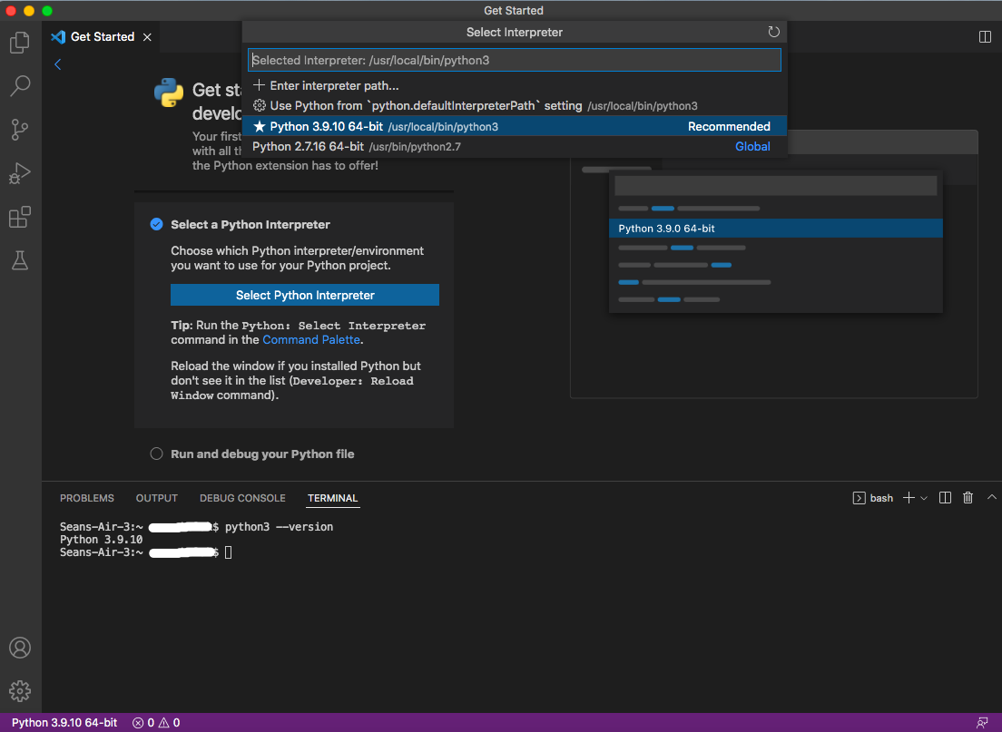
If you have any additional comments or questions about this process, please direct them to help@nedcdata.org. We will do our best to answer your questions promptly.

