Name:

Score: ____________________

Find an expression for v0 in terms of v1 and v2.

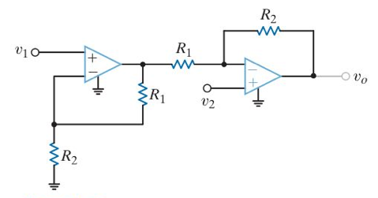

Compute I0.

