ECE 2313: Electrical Engineering Science I

Laboratory No. 2: Simulation and Debugging
The goal of this laboratory is to teach you two important debugging skills: (1) the use of a simulation tool, Multisim, to verify voltages at each node in a circuit, and (2) systematic debugging by stepping through a circuit node by node and exploring its behavior.
Task 1: Exploring Component Values
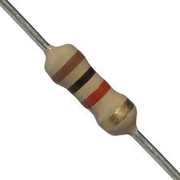
Figure 1. A standard 1/4 watt resistor is shown. Can you determine its value from the color code?

In your Digilent kit you have some components known as resistors. An example is shown to the right. The values are encoded using a color code that was developed in the early 1920s by the Radio Manufacturers Association (now part of Electronic Industries Alliance, and also now an IEEE standard). Research resistors in terms of their purpose, relation to current and voltage, color coding, and develop strategies to determine the value of an unknown resistor.
Once you understand the color coding system, review the values of the resistors in your parts kit using this code. (Those of you who are iPhone savvy might be aware of a nifty little application that automates this process!)
Task 2: Simulation in Multsim
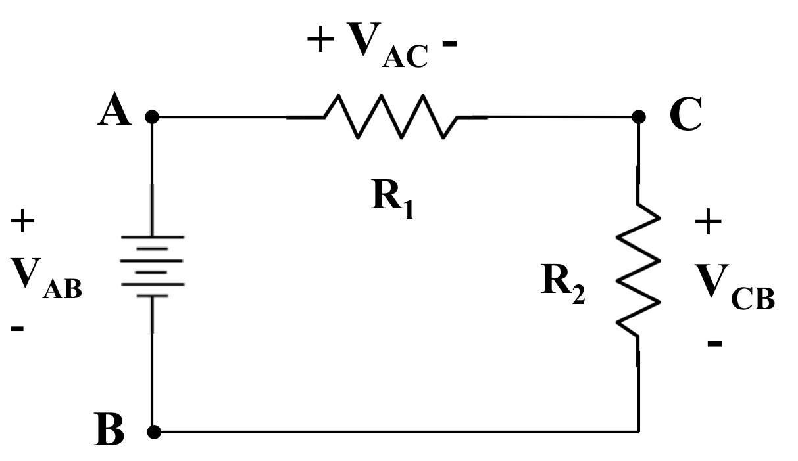
Figure 2. A simple circuit is shown that consists of a 1V DC source and two resistors connected in series. This is sometimes referred to as a voltage divider.

Create the circuit shown to the right in Figure 2 in Multisim. Set R₁ = 1 kΩ, and R₂ = 2 kΩ. Set the input voltage, V_{AB} to 1.0 VDC. Measure the three voltages shown (V_{AB}, V_{AC}, and V_{CB}). Justify their values based on simple equations that you can easily find on the Internet.
Task 3: Implementation on the Digilent Explorer Board
Implement your circuit on the Digilent Explorer board. Using the resistors found in your kit, set R₁ and R₂ to the values in Task 2. Measure the same three voltages from Task 2 and demonstrate that they match what you observe in Multisim. Discuss any differences.
Things to think about:
- Are your resistors exactly 1.00 KΩ? 2.00 KΩ?
- How precise are your function generator and multimeter? (Important: only report results using a number of significant digits that reflects the accuracy of your experiment.)
Now switch the input voltage on your simulation and your hardware to 1V AC at a frequency of 1000 Hz. Explain how your results change?
For the remainder of these experiments, revert to the 1 VDC input. Later in the course we will explain how we can model AC voltages and compute the corresponding voltages and currents.
Task 4: Optimization
In your Multisim simulation, vary the value of R₂ such that you maximize the power dissipated in R₂ (as discussed in class, for a DC signal, the power is simply the voltage, V_{CB}, multiplied by the current flowing through R₂, I_{CB}. Explain this using your prior research on voltage dividers. Try to incorporate a mathematical model in your explanation, such as equations describing voltages and currents in terms of the resistors, and calculus operations such as differentiation to perform the optimization.
Once you arrive at the optimal value, plug that value into your hardware implementation and verify that it produces maximum power. Explain any discrepancies, and again think about experimental precision.
Later in the course we will formally explain this concept of maximum power transfer. For now, note that many systems, including audio power amplifiers, exploit this principal to achieve high efficiency.
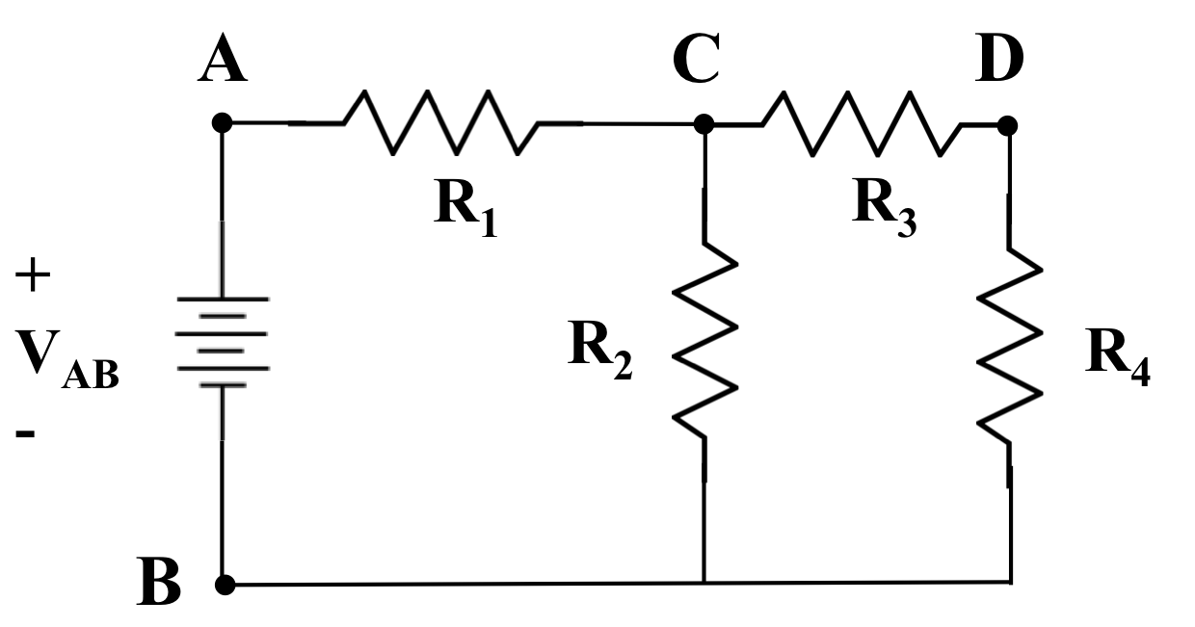
Figure 3. A slightly more complex voltage divider circuit is shown. Can you predict how V_{DB} and I_{DB} vary as a function of R₄?

Task 5: Analysis of a More Complicated Circuit
Implement the circuit shown in Figure 3 in Multisim and on your Digilent Explorer board. Set R₁ = 1 kΩ, and R₂ = 2 kΩ. Find the values of R₃ and R₄ that maximize the power dissipated in R₄. Explain your findings.
Task 6: The Mystery Resistor
Replace R₃ with the mystery resistor provided by your teaching assistant. Repeat Task 5, but this time only adjust R₄ to maximize the power dissipated in R₄. Explain your findings.
Task 7: Implementation
Please review the soldering videos posted on the course Facebook page. ALSO, PLEASE PAY ATTENTION TO THE SAFETY RULES POSTED IN THE LAB. The soldering iron you are about to use needs to be handled carefully since it is extremely hot.
Solder together the circuit you developed in Task 5 using the materials provided in the lab. Use the Digilent board to supply signals to your circuit. You simply need to solder the resistors together.
Using the multimeter capabilities of your Digilent board, probe the circuit at each node and demonstrate that the voltages at each node match what you found in Multsim.
Summary:
In this laboratory, we have shown you how to systematically debug a circuit. There are no shortcuts. You need to develop a good simulation of the circuit and step through the circuit one node at a time. Sometimes you will need to disconnect components to probe why a circuit isn’t behaving properly. Through the course of this semester you will have more opportunities to practice your debugging skills.
Your lab reports should include screen shots of your Multisim simulations and photographs of your hardware implementations (include the Digilent versions and the soldered version).

