ECE 2313: Electrical Engineering Science I

Laboratory No. 1: Instrumentation Introduction
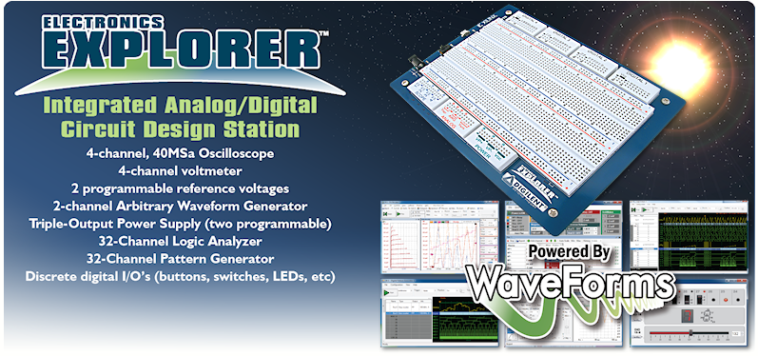
The goal of this laboratory is to familiarize you with the basic instrumentation you will use this semester. In this first lab, you will demonstrate installation of some basic software (e.g., National Instruments’ Multisim) and hardware (Digilent’s Electronics Explorer board).
The tasks to be accomplished in this lab are:
- Show proof of purchase that you have purchased the proper version of Multisim and have installed it on your laptop. Multisim can be purchased and downloaded from http://ni.onthehub.com/. We recommend you purchase both Multisim and Labview. You will use these throughout your UG program, including in senior design. This purchase gives you rights to upgrades throughout your UG program, so it is an excellent deal. It also gives you access to a professional copy of the tools.
- Watch this instructional video on Multisim: http://zone.ni.com/devzone/cda/tut/p/id/10710. Don't worry about the details of the components. The goal of the lab is to make sure you know how to run Multisim.
- MATLAB can be downloaded and installed from http://www.temple.edu/cs/catalog/download_software.html. This will direct you to log into the download server, which will provide instructions for how to access MATLAB from the Mathworks site. Please remember to use your Temple username and password when registering on the MATLAB site.
- Demonstrate that you have downloaded and installed MATLAB.
- Check out the Digital Electronics Explorer board (see your teaching assistant).
- Demonstrate you have downloaded and installed the necessary software to support the Digilent board. See: http://www.digilentinc.com/Products/Detail.cfm?NavPath=2,66,849&Prod=WAVEFORMS.
- Connect a simple circuit on the Digilent board, such as a DC battery and large-valued resistor (be careful not to drain the battery or heat the resistor). Show that you can measure voltages using
your laptop and the Digilent Waveform software. We will expand on this capability very soon. This is just a getting started step to demonstrate that you can run the software and connect to your laptop.
- Experiment with the Digilent board and software. Try implementing some simple circuits based on what you learned in Physics II. Show that you can apply signals and measure signals from your laptop. Explain your circuit to your TA.

