ECE 2313: Electrical Engineering Science I

Laboratory No. 3: instrumentation Challenge
The goal of this laboratory is to introduce you to the bench test equipment available in the laboratory. We will focus on three pieces of equipment: an oscilloscope, a voltmeter and a function generator. You will verify your measurements using Multisim and the Digilent board.
We have several types of oscilloscopes, voltmeters and function generators in the labs available for your use. However, they all are very similar in their operations. In fact, the instruments in Multisim are very similar to the equipment available at your bench. Instructions on how to use this equipment can be easily found on the web. Some examples of the user manuals available are located here: http://www.isip.piconepress.com/courses/temple/ece_2312/resources/lab_equipment/. There are also a number of excellent YouTube videos available.
For each of the tasks below, you will be expected to (1) simulate the circuit in Multisim, (2) prototype it on the Digilent board using the built-in signal generators and meters, and (3) interface the circuit to the bench instrumentation available in the lab and repeat your measurements. For (3), please remember to turn off the Digilent board, disconnect the inputs, outputs, and grounds, and then connect the remaining circuit to the bench equipment using the leads available in the lab.
You will then prepare a table of measured values that contains 5 columns: (1) the name of the quantity being measured, (2) the theoretical value predicted from a circuit analysis, (3) the predicted value from Multisim, (4) the value measured on the Digilent board using the built-in meters and (5) the value measured using the instrumentation available in the lab. For (5), be sure to use the exact name and model number of the instrumentation used (e.g., Tektronix CFG253) to label the column in your table. IMPORTANT: remember to report values using only the number of significant digits delivered by the equipment.
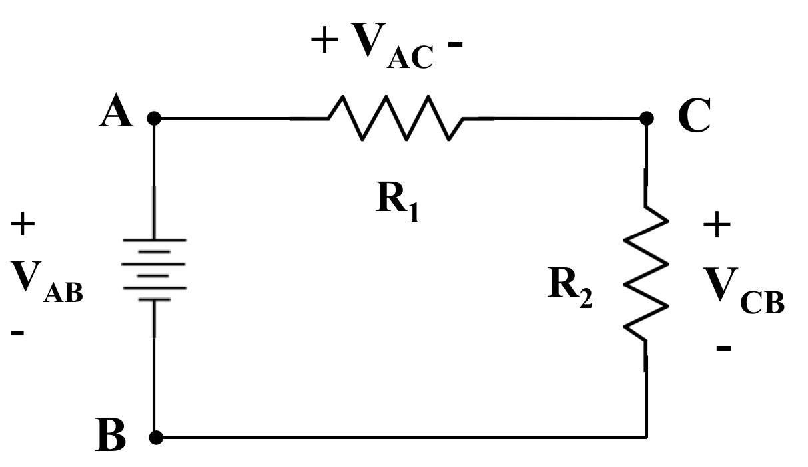
Figure 1. A simple circuit is shown that consists of a 1V DC source and two resistors connected in series.

Task 1: Verify Kirchoff’s Voltage Law
Create the circuit shown to the right in Figure 1. Set R₁ = 1 kΩ, and R₂ = 2 kΩ. Set the input voltage, V_{AB} to 1.0 VDC. Measure the three voltages shown (V_{AB}, V_{AC}, and V_{CB}). Verify that Kirchoff’s Voltage Law does in fact hold. Explain any discrepancies in your measurements.
Task 2: Verify Kirchoff’s Current Law
Create the circuit shown to the right in Figure 2. Set R₁ = 1 kΩ, R₂ = 1 kΩ, R₃ = 2 kΩ, and R₄ = 2 kΩ. Verify that Kirchoff’s Current Law holds at node C.
Task 3: More Complex Voltage Sources
For the circuit in Figure 1, replace the DC voltage source with a function generator. Use the function generator to create three inputs: (1) a sinewave at 1 kHz with an amplitude of 1V, (2) a square wave with a frequency of 1 kHz, a duty cycle of 50%, an average value of zero and an amplitude of 1V, and (3) a triangle wave with the same parameters as (2). Measure the peak positive voltage using the oscilloscope and report that in a table similar to Tasks 1 and 2. Do the nature of the results change because the input signal was changed from a DC value to a more complex waveform?
Task 4: Phase Shifts
For this task, you will compare the oscilloscope built into the Digilent board to the scope available at your lab bench. Replace R₄ with a 1 μF capacitor. Using the oscilloscope and the 1V sinewave input, display the voltage across R₂, V_{CB}, and the voltage across the capacitor, on the same screen. The voltage across the capacitor will be shifted in time relative to the voltage across the resistor. We refer to this as a phase shift. Adjust the value of the capacitor so that the voltage across the capacitor is shifted by 45º (1/8 of a cycle) relative to the voltage across the resistor. Provide a screen shot of this in your lab report.
Summary:
In this laboratory, we have shown you how to use dedicated instrumentation available in the lab. As you build more complex systems that operate at higher voltages, currents or frequencies, you will need to use more capable equipment to debug your circuits. For the remainder of the semester, you should be able to complete most of the labs using the Digilent board and its built-in meters. However, you are welcome to use the bench equipment at any time, particularly for the circuits you solder on the prototyping board.
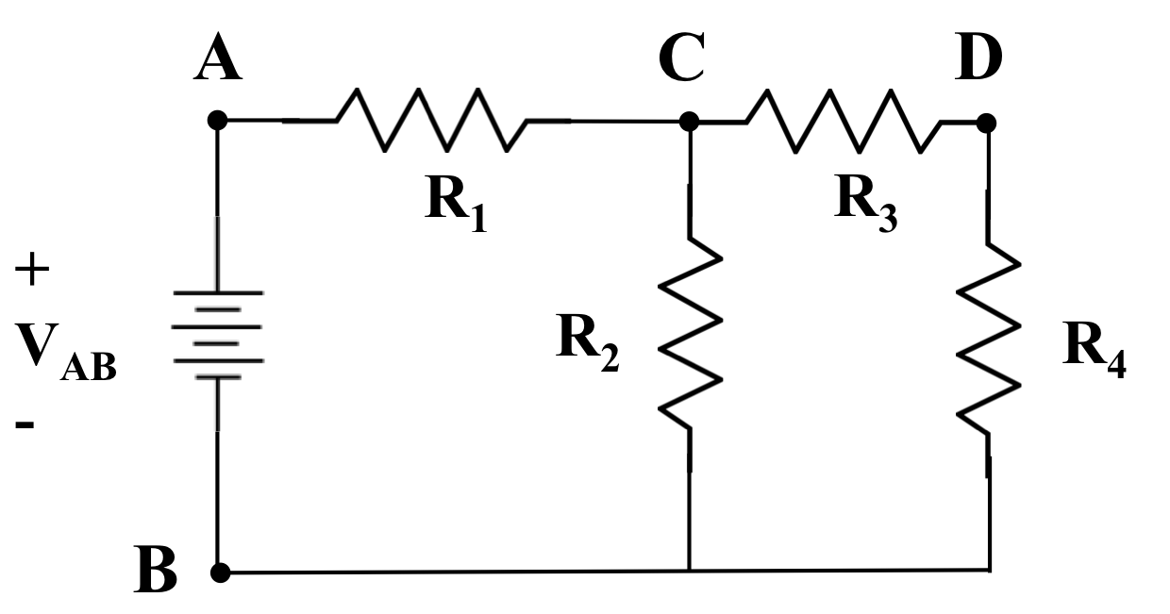
Figure 2. A slightly more complex voltage divider circuit is shown.

Your lab reports should include screen shots of your Multisim simulations and photographs of your hardware implementations, etc.

