ECE 2313: Electrical Engineering Science I

Laboratory No. 8: Thevenin Equivalent Circuits
The goal of this laboratory is two-fold: (1) reinforce your ability to model a circuit with a Thevenin equivalent and (2) demonstrate the Maximum Power Transfer Theorem.
Task 1: Analytic Solutions
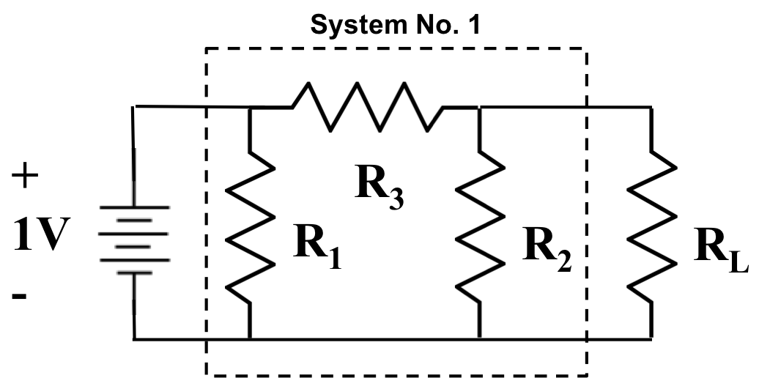
Figure 1. A resistive voltage divider is shown that can be replaced by a simpler Thevenin equivalent circuit.

Derive the Thevenin and Norton equivalent circuits for the circuit shown in Figure 1. Show all your calculations and motivate your solution starting with basic principles. You are free to select values for R₁, R₂ and R₃ as long as they are in the range of 1 kΩ to 10 kΩ. Justify your choices of the specific values based on the properties of the circuit. Verify that your calculations are correct using Multisim by demonstrating your open-circuit voltage and short-circuit current.
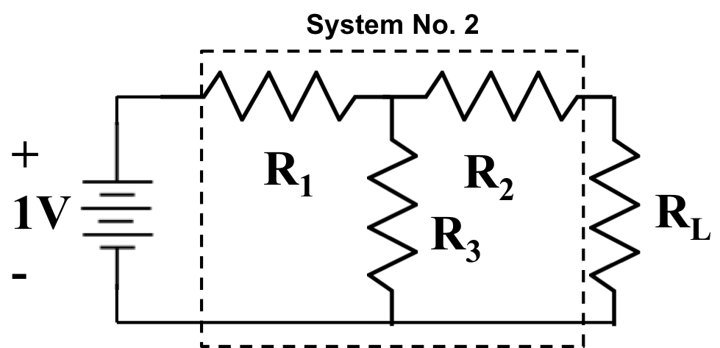
Figure 2. An alternative design is shown.

Next, adjust the load resistor, R_{L}, so that maximum power transfer to the load is achieved. Show that Multisim and your analytic solution agree on the value of R_{L} and the calculated value of the power dissipated in R_{L}.
Repeat the above steps for the circuit shown in Figure 2.
Task 2: Rapid Prototyping
Implement both circuits on the Digilent board and demonstrate that your simulations and analysis match your hardware.
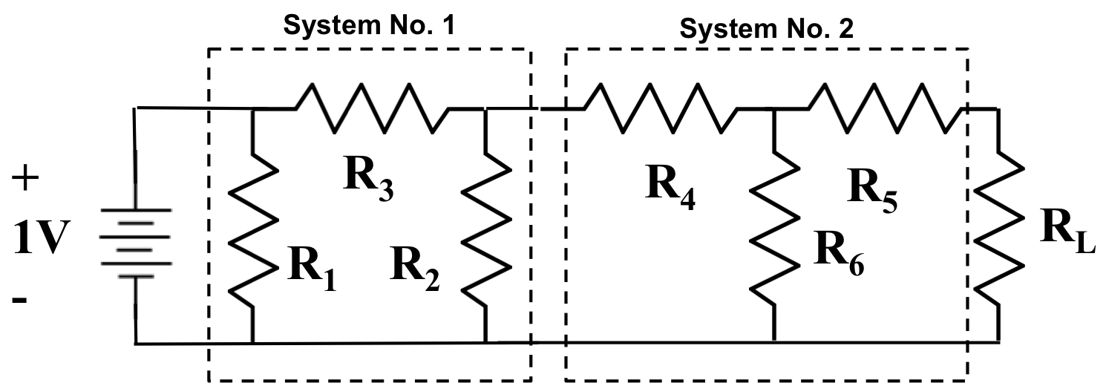
Figure 3. A differential amplifier is shown in which the gain for each channel can be controlled independently.

Task 3: Circuit Loading
Connect System No. 1 and System No. 2 in cascade as shown in Figure 3. Determine the optimal value of R_{L}, and demonstrate that this produces maximum power transfer (using both Multisim and your hardware implementation). Did the value of R_{L} for System No. 2 in Task No. 1 change? If so, explain.
To mitigate these effects, connect a buffer amplifier implemented using an op-amp between System No. 1 and System No. 2. Again determine the optimal value of R_{L} and the maximum power transferred. Explain why this value is similar or different to the previous value.
Summary:
In this laboratory, we have demonstrated the use of Thevenin and Norton equivalent circuits. We have demonstrated that cascading circuits can cause undesirable interactions and can impact your designs.
We further demonstrated that op-amps are extremely useful in mitigating these effects. This is one reason your PCB design uses three op-amps to implement a bandpass filter.

