ECE 2313: Electrical Engineering Science I

Laboratory No. 10: Basic AC Circuits
The goal of this laboratory is to reinforce your understanding of AC steady state circuit analysis. We will focus on using the Digilent board for these tasks, and compare the results to Multisim and your analytic solution.
Task 1: Series RC Circuit
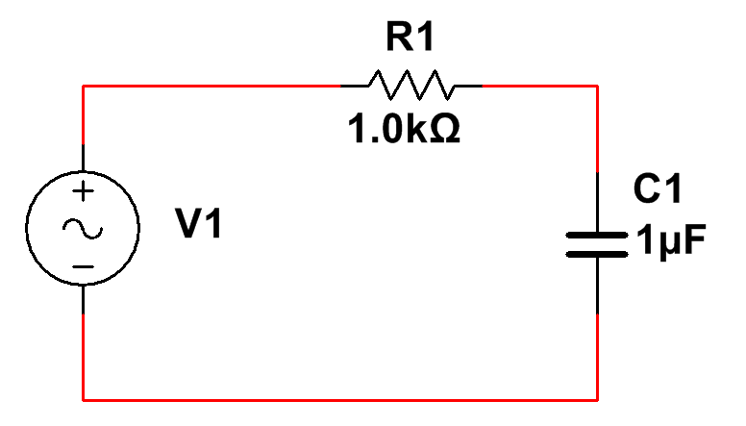
Figure 1. A series RC circuit is shown.

Implement the circuit shown in Figure 1 on the Digilent board. Use a 1V sinewave as input. Adjust the frequency of the sinewave such that the magnitude of the impedance of the capacitor is equal to the resistance. Using the 4-channel oscilloscope, display the input voltage, V₁, the current flowing through the capacitor, and the voltages across the resistor and the capacitor. Compare these to what you calculated using AC circuit analysis, and what you observed in Multisim.
Demonstrate the phase relationship between the voltage across the capacitor and the current flowing through the capacitor. Does the voltage lead or lag the current? By how much?
Plot the magnitude of the voltage as a function of the frequency of the input signal for the frequency range [10, 10000 Hz]. Use a log base 10 (log10) for both the amplitude and the frequency scales. Does this plot make sense?
Task 2: Series RL Circuit
Replace the capacitor with a 1 mH inductor and repeat Task 1. Again, demonstrate that the results you are observing make sense. How would these results change of the components were connected in parallel?
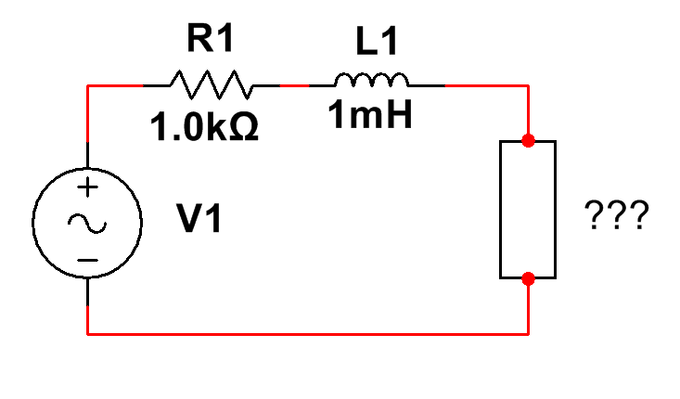
Figure 2. A series RL circuit with a mystery load.

Task 3: Maximum Power Transfer
A series RL circuit is shown in Figure 2 with a “mystery load.” Set the voltage source to a 1V sinewave with a frequency equal to the frequency you determined in Task 2 that made the magnitude of the impedance for R1 and L1 equal. Determine the value of the load that maximizes the power dissipated in the load. Connect this load to the circuit and demonstrate that maximum power transfer is achieved, including measurement of the maximum value of the power. Justify your findings through analysis and Multisim simulations.
Summary:
In this laboratory, we have demonstrated the concept of impedance and how impedance varies as a function of frequency. We have also introduced the concept of frequency response. The plot you created in Tasks 1 and 2 is often referred to as a Bode plot. These can be easily generated in MATLAB and Multisim. We have also introduced the concept of maximum power transfer for complex impedances. We will revisit this issue in Lab No. 12.

