**Department of Electrical and Computer Engineering**

lab report for

**Lab No. 1: Instrumentation Introduction**

submitted to:

John Smith

ECE 2313: Electrical Engineering Science I

Temple University

College of Engineering

1947 North 12th Street

Philadelphia, Pennsylvania 19122

September 1, 2012



prepared by:

J. Doe

ECE 2313: Electrical Engineering Science I

Temple University

College of Engineering

1947 North 12th Street

Philadelphia, Pennsylvania 19122



# ABstract

The abstract should be a 125 to 150 word summary of what you accomplished in the lab (including results).

# Introduction

In this section you describe what this lab is all about and the basic concepts you will be exploring.

Follow the formatting guidelines in this document. Some examples of equations and figures are shown below.

[Some filler text here … Some filler text here … Some filler text here … Some filler text here … Some filler text here … Some filler text here … Some filler text here … Some filler text here … Some filler text here … Some filler text here … Some filler text here … Some filler text here … Some filler text here …]

For example, below, in Figure 1, we can see some interesting experimental results. This results are supported by the all important equation of life:

 (1)

We can see in Equation (1) that the mystery of life is explained.

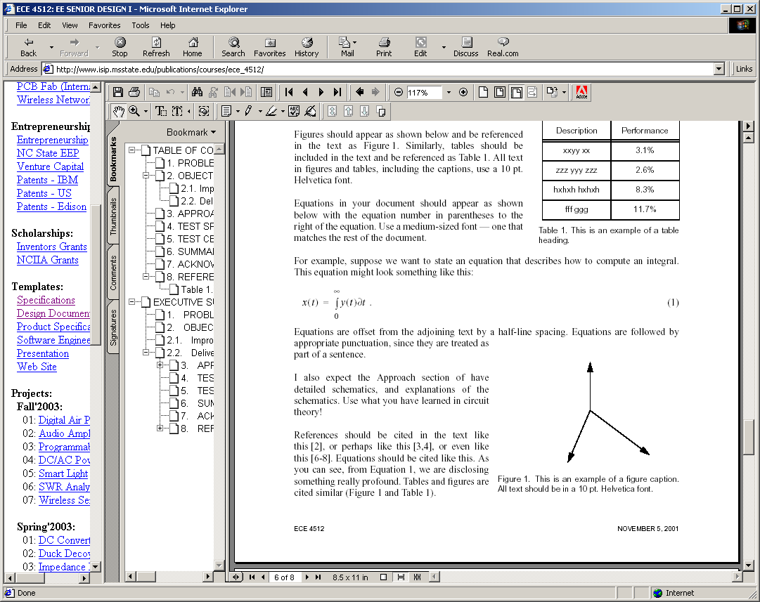

Figure 1. This is an example of a figure. Captions are justified when they are multiple lines, and centered if they are one line. Captions should be no more than about three lines.

# Description

This section contains a detailed description of the experiment including step-by-step instructions.

# Results

In this section, you describe your findings and present your data, along with simulation results, etc.

# Discussion and Conclusions

This section contains your analysis of the results and some conclusions about what was accomplished.

# REFERENCES

(Use APA format.)

Anderson, A. K. (2005). Affective influences on the attentional dynamics supporting awareness. *Journal of Experimental Psychology: General*, *154*, 258–281.

...

References must follow APA format. There are many good sites that describe these standards. Here are two that I find very useful:

<http://en.wikipedia.org/wiki/APA_style>

<http://flash1r.apa.org/apastyle/basics/index.htm>