Name:
Name:
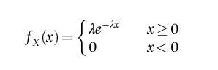
Assume that the length of phone calls made at a particular telephone booth is exponentially distributed with a mean of 3 minutes. If you arrive at the telephone booth just as Chris was about to make a call, find the probability that you will wait more than 5 minutes before Chris is done with the call.

