Rachel King
ECE 3512: Signals – Continuous and Discrete
Department of Electrical and Computer Engineering, Temple University, Philadelphia, PA 1912

Problem Statement
For this lab, the purpose is to examine data that is changing over time. It will be examined by graphing the raw data, finding the key points, and analyzing data by viewing it over specific windows and frames. The data given is not something of which we have prior knowledge, and will be computed using MATALB and some excel for organization.

Approach and Results
Questions 1 and 2 – Plot and analyze data
The following plots were created by simply loading the data into an array and then plotting. The mean, median, max, min, and variance were found using MATLAB functions. The method is reflected in the MATLAB code.
Google Stocks
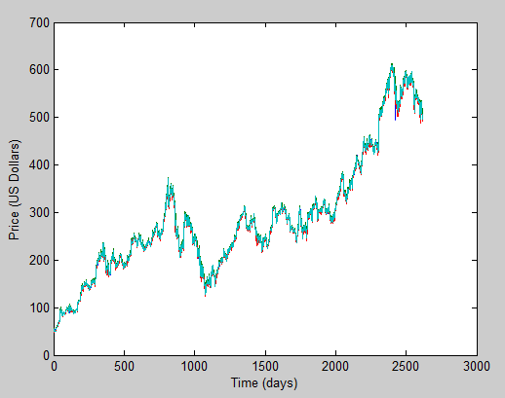
Figure 1 – Google stock prices
max | 609.47
min | 49.95
mean | 286.74
median | 264.83
variance | 1.62E+04

Table 1 – Global statistics on Google stock data
Audio File
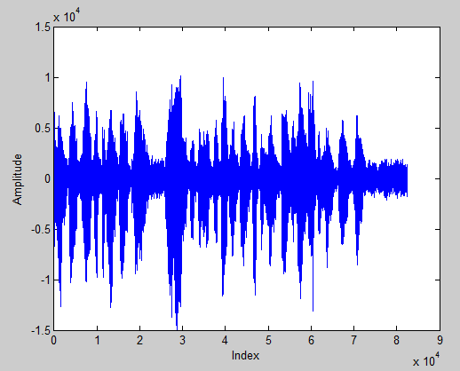
Figure 2 – Amplitude plot of raw audio file
max | 10104
min | -14493
mean | -0.3891
median | 83
variance | 4.14E+06
Table 2 – Global statistics for audio file
Question 3 – Windows and Frames
The window/frame analysis was completed using the provided MATLAB code, and simply changing the window and frame values. In the Google Stock analysis, the code was giving some errors in the compute_rms function, because it was trying to work with a decimal index. So, to solve the problem, I replaced all the off values with even values. To find the mean and variance values, I created to matrices and added the following lines in the nested for-loop:
mn = mean(rms(m,n,:))
vr = var(rms(m,n,:))

I worked closely with Anton Lekang on the third question, so our plots and values should be similar
Google Stock

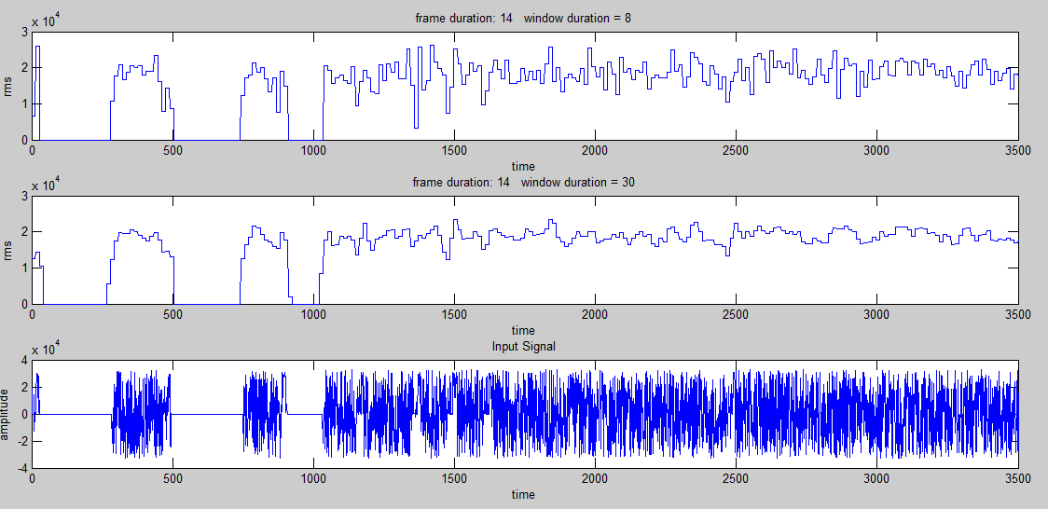
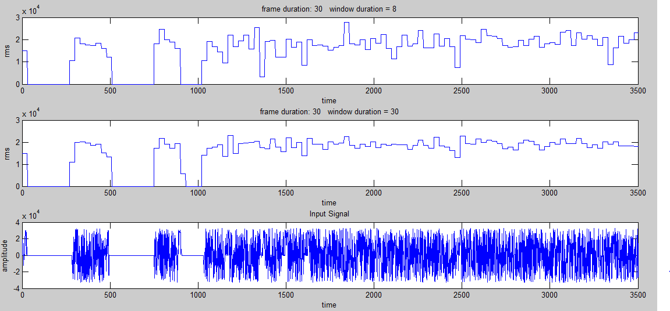
Figure 4 – Google Stock: M = 14, N = 8, 30
Figure 3 – Google Stock: M = 30, N = 8, 30
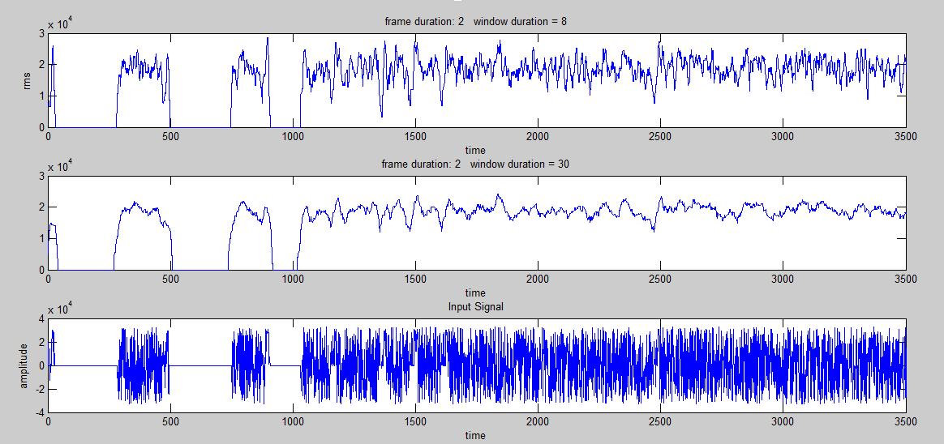
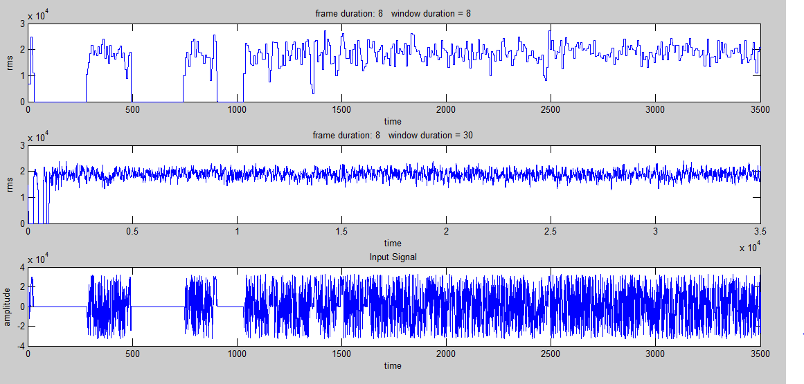
Figure 5 – Google Stock: M = 8, N = 8, 30

Figure 6 – Google Stock: M = 2, N = 8, 30
Google Stock Prices
N Value | M Value | Mean | Variance
8 | 2 | 1.83E+04 | 1.51E+07
8 | 8 | 1.84E+04 | 1.51E+07
8 | 14 | 1.83E+04 | 1.50E+07
8 | 30 | 1.84E+04 | 1.48E+07
30 | 2 | 1.86E+04 | 7.20E+06
30 | 8 | 1.86E+04 | 7.22E+06
30 | 14 | 1.86E+04 | 7.23E+06
30 | 30 | 1.86E+04 | 7.37E+06

Audio File
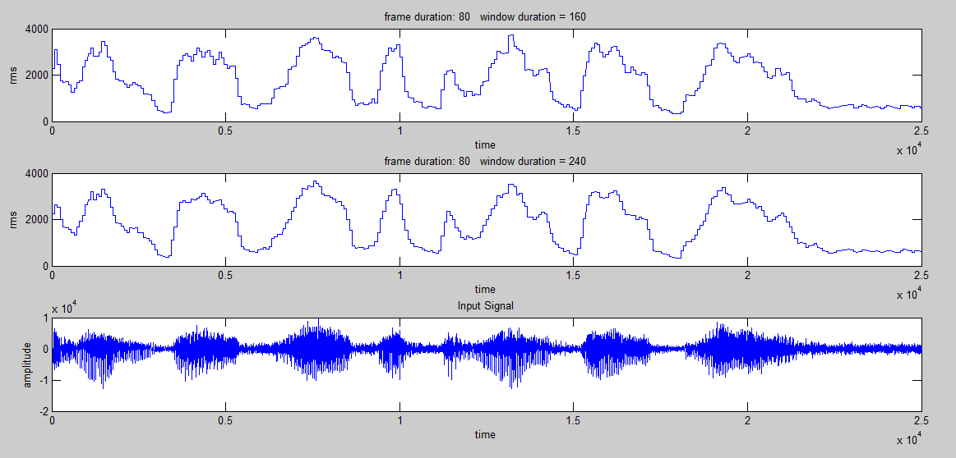
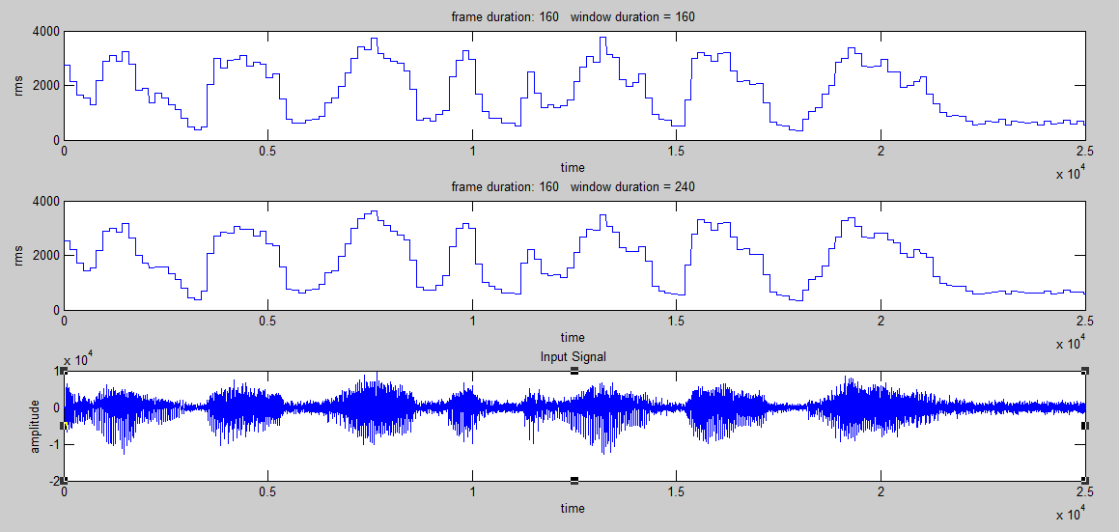
Figure 8 – Audio File: M = 80, N = 160, 240

Figure 7 – Audio File: M = 160, N = 160, 240

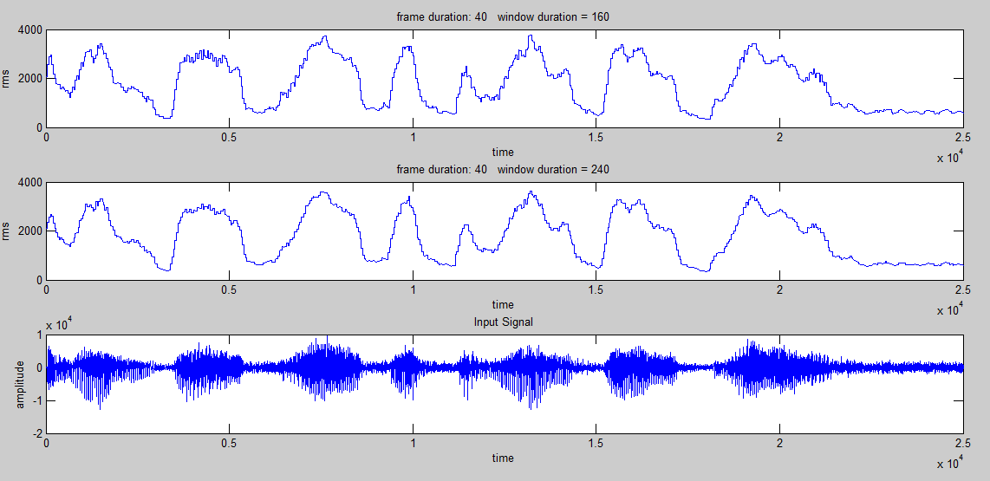
Figure 9 – Audio File: M = 40, N = 160, 240

Audio File
N Value | M Value | Mean | Variance
160 | 40 | 1.676E+03 | 1.329E+06
160 | 80 | 1.677E+03 | 1.328E+06
160 | 160 | 1.676E+03 | 1.330E+06
240 | 40 | 1.683E+03 | 1.305E+06
240 | 80 | 1.683E+03 | 1.306E+06
240 | 160 | 1.686E+03 | 1.311E+06

MATLAB Code
%% plot audio file
h = fopen('rec_01_speech.raw');
speech = fread(h, 'short');
[z, q] = size(speech);
y = linspace(0, z, z);
figure(1)
plot(y, speech);
ylabel('Amplitude') % x-axis label
xlabel('Index') % y-axis label

mx = max(speech)
mn = min(speech)
me = mean(speech)
md = median(speech)
vr = var(speech)

%% plot google stock prices
[num, txt, raw] = xlsread('google_v00.xlsx', 1);
figure(1)
plot(num)
ylabel('Price (US Dollars)') % x-axis label
xlabel('Time (days)') % y-axis label

mx = max(num)
mn = min(num)
me = mean(num)
md = median(num)
vr = var(num)

Question 3:
Same code as provided.

Conclusions
The most interesting part of this assignment was the window/frame analysis. In both data sets, the same thing occurred; as frame size decreased, the smoother the plot became. This is due to the increasing number of points that are being taken. Within one frame size, a larger window gave a smoother curve, but some information about the signal was lost; notice that at certain peaks, there are steps that are missed with a large window size. For both the stock prices and the audio signal, the mean increased as the number of windows and frames decreased. However, the variance was higher for a lower frame value on the stock prices, and lower for a lower frame value in the audio file. If I were to predict the next stock price, I would not look at the average; the slope of the graph would be the most useful tool because it shows the rate at which the stock price is changing. With that information, I could model the stock prices using some kind of regression that had a low variance or R² value.

