Tyler Castelli
ECE 3512: Signals – Continuous and Discrete
Department of Electrical and Computer Engineering, Temple University, Philadelphia, PA 1912

Problem Statement
In this assignment we were asked to generate a sum of independent random variables. Similar to previous assignments, we were asked to fit the pdf to a normal distribution, plot the “true” distribution over it, then find the RMS between the two. And plot it. Finally, we were asked to use Mueller’s transform to generate a Gaussian distribution from a uniform number generator, estimate the pdf again and compare the RMS plots between the two methods as well as the runtime of each.

Approach and Results
For part 1 of the assignment (tasks 1-3). I wrote a function to generate a sum of random variables. I hen looped this function for different numbers of random variables, and 10,000 samples of each variable. The pdf was estimated, plotted, and the RMS was found. The result of the pdf estimate as well as the “true” distribution is shown in figure 1. Figure 2 shows the RMS plot for each number of random variables.
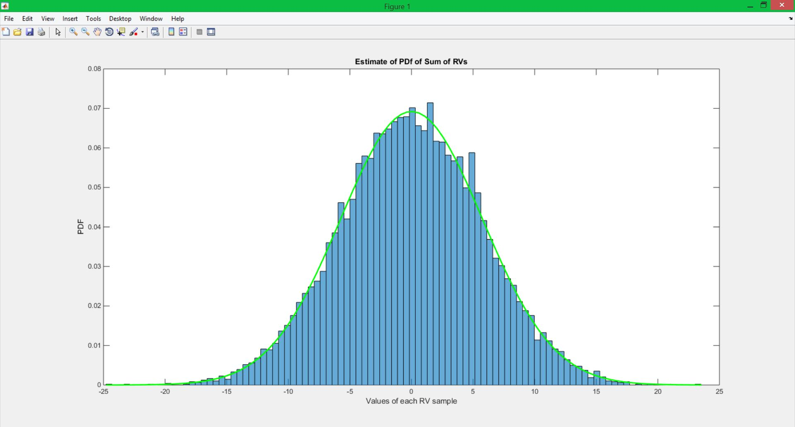
Figure 1: PDF of Normal Distribution of Sum of Random Variables
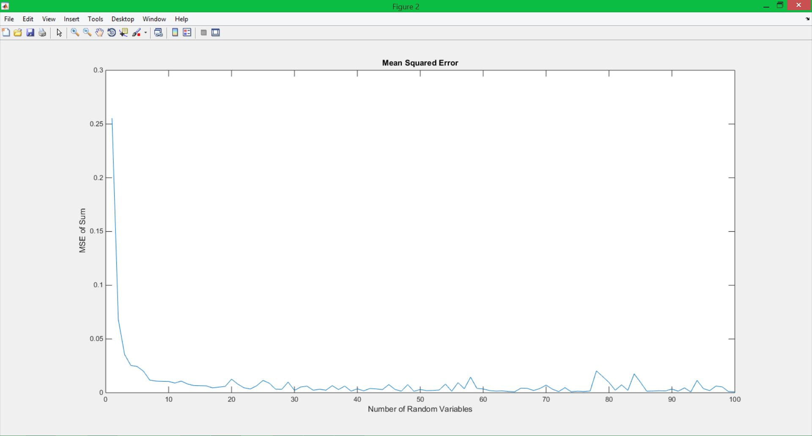
Figure2: RMS vs Number of Random Variables.
In part 2, I wrote another function that uses the Box Muller Transform. This function generates random variables that are sampled from a uniform number generator, but have a normal distribution. The result below in figure 3 shows the PDF against the true distribution of the values.
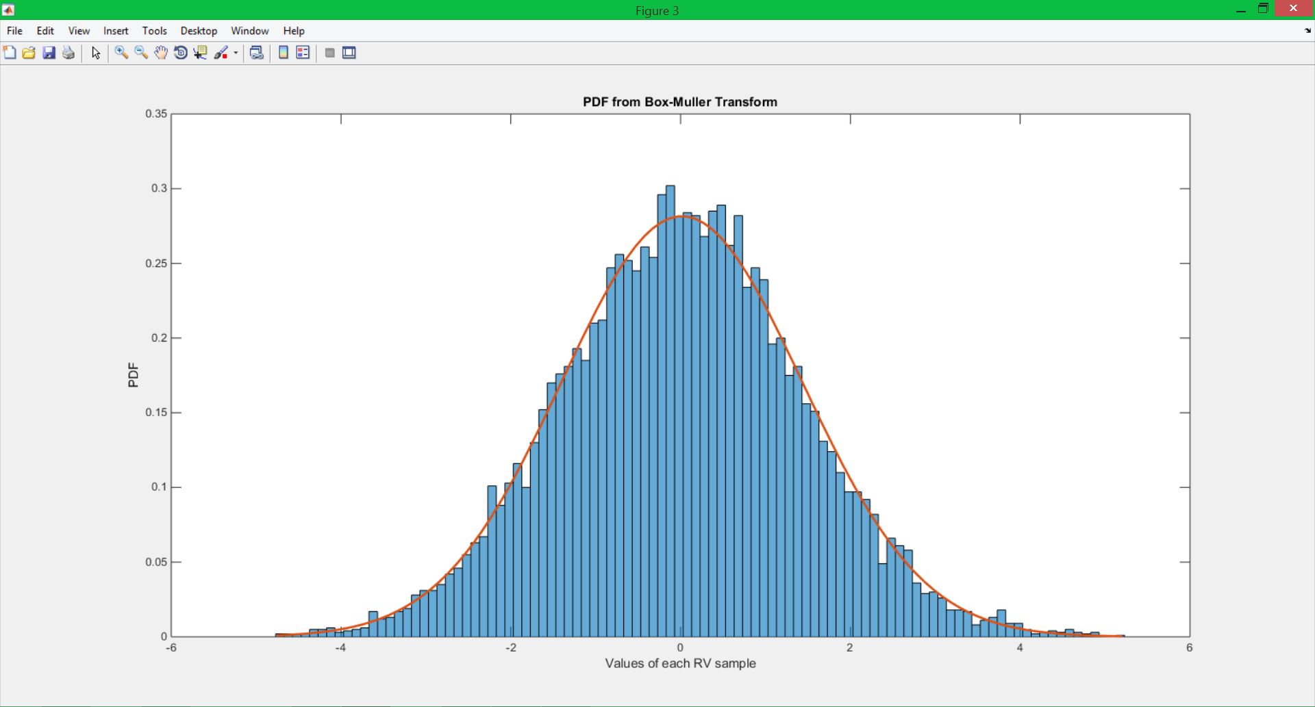
Figure 3: PDF using Box-Muller Transform.
Additional results show the runtime of each method and a comparison of the RMS. These results are shown in Table 1 below.

Sum of Random Variables |  | Box-Muller Method
Run Time | 26.409s | Run Time | 0.204s
RMS | 23.711 | RMS | 0.0057
Table 1: Comparison of RMS and Run Times

MATLAB Code
function castelli_tyler_ca08
clear all;clc;close all;
part1;
part2;
end

The main function simply calls the two sub-functions. This is for timing purposes

function part1
MSEs = zeros(1,100);
for n = 1:100
Sn = sum_of_RVs(n,10000,[-1 1]);
h1 = histogram(Sn,n);
h1.Normalization = 'pdf';
Ndist = fitdist(Sn,'Normal');
range = linspace(min(Sn),max(Sn),h1.NumBins);
PDF = pdf(Ndist,range);

MSEs(n) = meanSquaredE_v2(Sn,n);
end

figure(1);
hold on;
plot(range,PDF,'g','LineWidth',2);
title('Estimate of PDf of Sum of RVs');
ylabel('PDF');
xlabel('Values of each RV sample');

figure(2);
plot(MSEs);
title('Mean Squared Error');
ylabel('MSE of Sum');
xlabel('Number of Random Variables');

end

In part 1, I created a sum of random variables and looped it for using 1:100 random variables in the sum. 10,000 samples were taken in each random variable, and the range was form [-1 1]. The pdf was then found using the fitdist and pdf functions, then plotted to fid the true distribution. A histogram was used to estimate it. The RMS values were found using a function from a previous assignment.

function part2
N = 10000;
range = [0,1];

SnM = MullerTrans(N,range);
MSE2(1) = meanSquaredE_v2(SnM,2);
figure(3);
h2 = histogram(SnM,100);
h2.Normalization = 'pdf';
range = linspace(min(SnM),max(SnM),h2.NumBins);
MNdist = fitdist(SnM,'Normal');
Mpdf = pdf(MNdist,range);
Sn2 = sum_of_RVs(10,10000,[0,1]);
MSE2(2) = meanSquaredE_v2(Sn2,10);

hold on;
plot(range, Mpdf,'LineWidth',2);
title('PDF from Box-Muller Transform');
ylabel('PDF');
xlabel('Values of each RV sample');
end

In part 2 I wrote another sub function that found the Box Muller Transform of the random variables and returned it as a sum. The pdf and RMS of this was then found in a similar fashion to part 1.

Conclusions
This assignment enforced the central limit theorem. The theorem states that the pdf of the sum independent random variables will have a normal distribution as the number of random variables approaches infinity. This can be confirmed from the graph in figure 1, which uses 100 random variables. We can also see that the RMS will sloly approach 0 as the number of random variables increases. This is intuitive as the more samples one uses the better estimate of a true distribution one will have. In part 2 we see a much faster way to find the same distribution. Using the Box-Muller transform is significantly faster and yields the same distribution. This is because is only utilizes two random variables, rather than however many are being summed. The RMS is also significantly lower than the sum method when the number of random variables is low. This is because the random variables are converted into polar coordinates. Since the variance of the two random variables will be smaller due to the relationship of sine and cosine, the overall RMS will be smaller as well.

