Harish Boggarapu
ECE 3522: Stochastic Processes in Signals and Systems
Department of Electrical and Computer Engineering, Temple University, Philadelphia, PA 1912

Problem Statement
In this assignment we are asked to create a visual plots of the multivariate distribution pdf’s. For the first task, we have to generate uniformly distributed ransom numbers, estimate the pdf and plot the pdf in 3D. For the second task, we have to plot the 3D multivariate distributed numbers with mean of [6 6] for different covariance matrices.
- Approach and Results
For the first task, we generate uniform random distributed vector with 10,000 samples. Then estimate the pdf using histogram function on matlab. Then, create x and y vectors both spaces by increments of 0.01 and plot the estimated pdf along with the x and y vectors on 3D mesh plot.
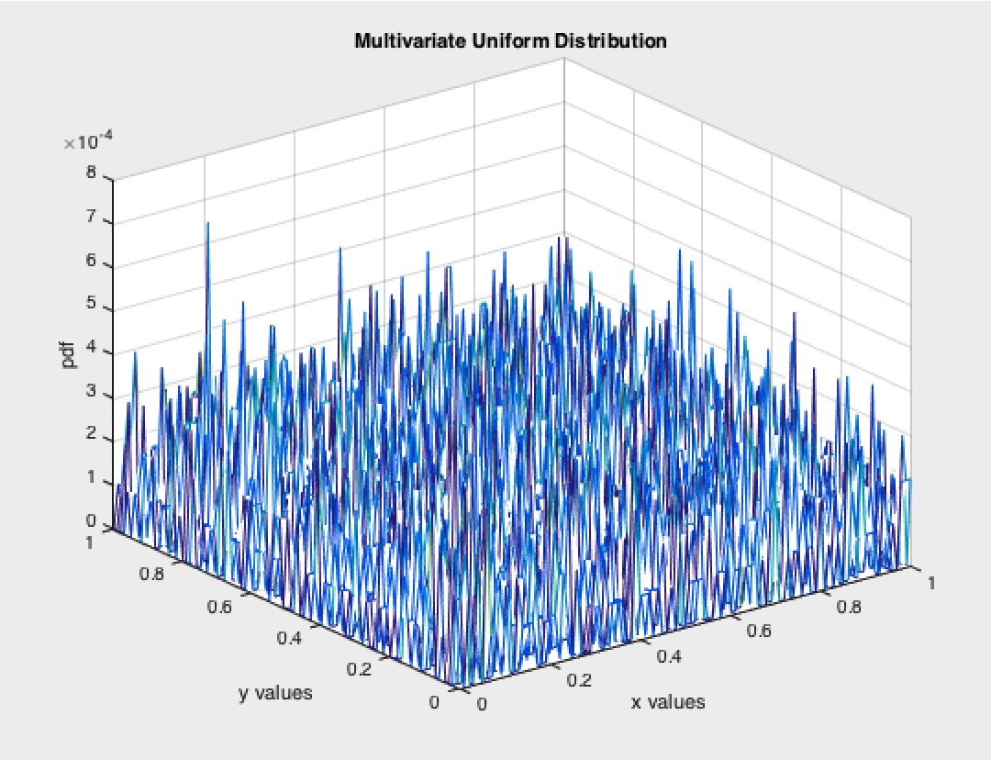
Figure 1: Multivariate Uniform PDF
For the second task, we load the 5 different covariance matrices into a 3D array and generate x and y vectors with mean of 6 for both vectors. Then, create multivariate uniform distribution pdf using mvnpdf () function of matlab. Then, we plot the pdf for different covariance matrices.
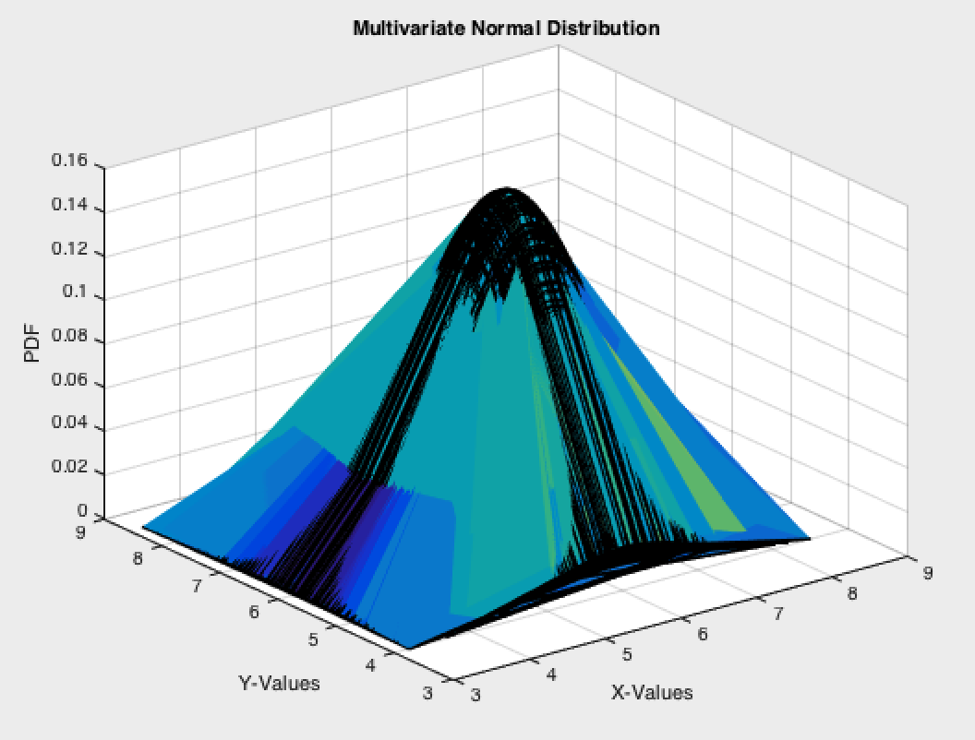
Figure 2: Multivariate distribution using cov1
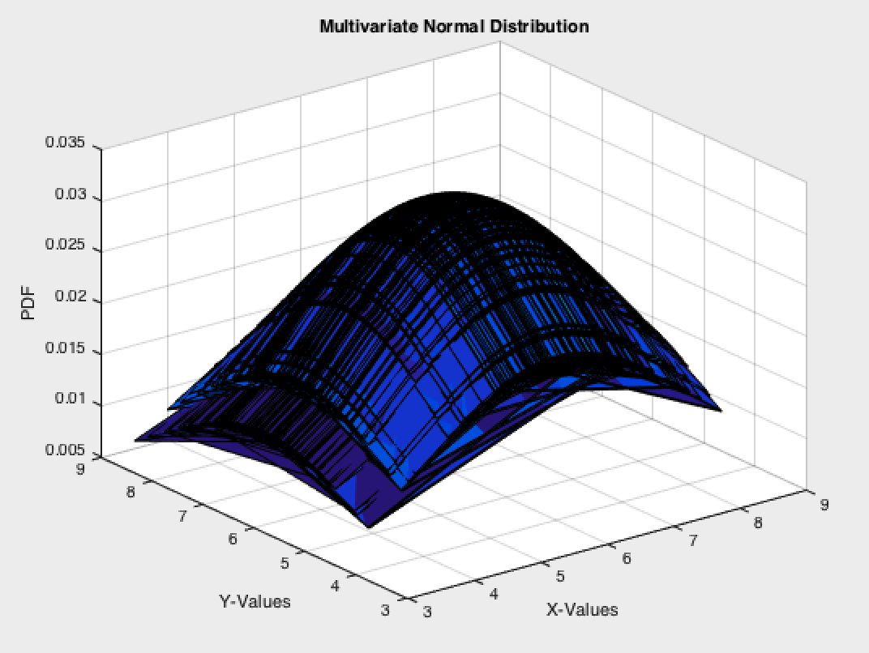
Figure 4: Multivariate distribution using cov2
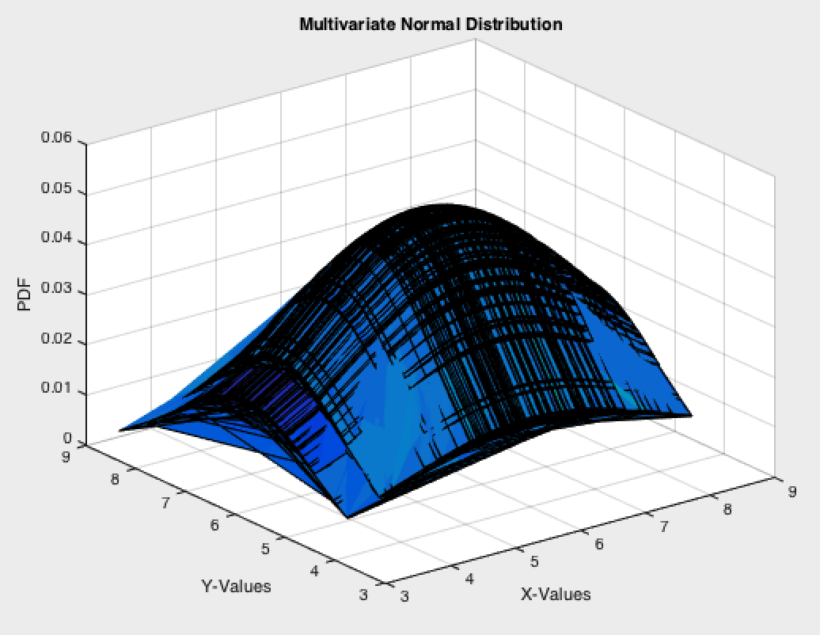
Figure 5: Multivariate distribution using cov3

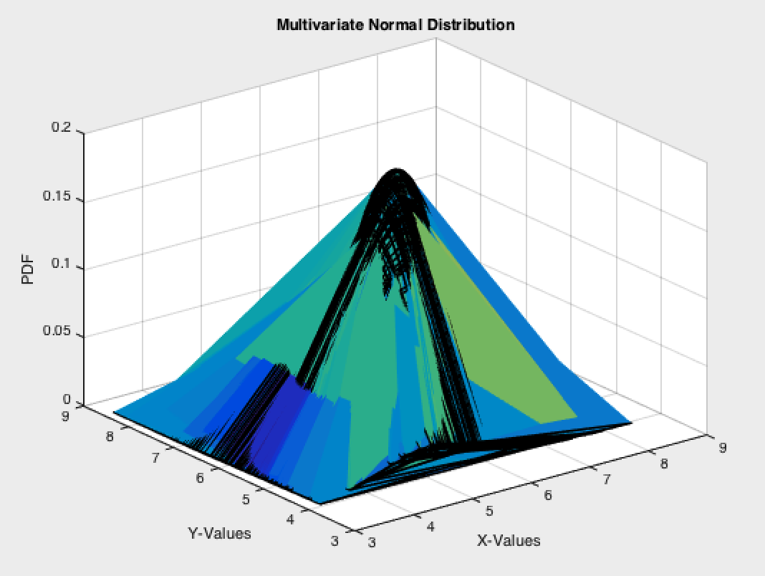
Figure 6: Multivariate distribution using cov4
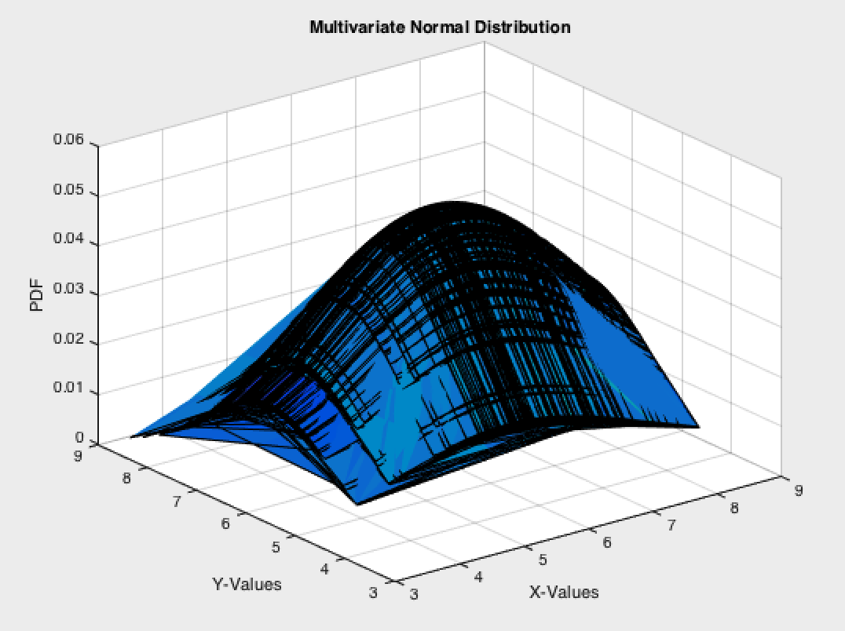
Figure 7: Multivariate distribution using cov5
- MATLAB Code
clear all;
close all;
clc;

N = 10000;
r = rand(N,2);

%create axis vectors and make and meshgrid
%to make a grid for plotting in 3D
x = 0:0.01:1;
y = 0:0.01:1;
[X,Y] = meshgrid(x,y);

%make a 3D histogram and normalize it to estimate the pdf
%plot usig mesh
h = hist3(r,[101 101]);
pdf = h./N;
mesh(X,Y,pdf);

title('Multivariate Uniform Distribution');
xlabel('x values');
ylabel('y values');
zlabel('pdf');

%find the multivariate pdf of the multivariate uniform distribution.
mu = [6 6];
cov1(:,:,1) = [1 0;0 1];
cov1(:,:,2) = [5 0;0 5];
cov1(:,:,3) = [5 0;0 2];
cov1(:,:,4) = [1 0.5;0.5 1];
cov1(:,:,5) = [5 0.5;0.5 2];

%create normally distributed random vectors use create a grid for 3D
%plotting
x2 = 6 + randn(1,100);
y2 = 6 + randn(1,100);
[X2,Y2] = meshgrid(x2,y2);

%for each covariace matrix, find the multivariate normal pdf of the data
%set and plot
for i = 1:length(cov1)
F = mvnpdf([X2(:),Y2(:)],mu,cov1(:,:,i));
F = reshape(F,length(y2),length(x2));
figure(i+1);
surf(x2,y2,F,gradient(F));
caxis([min(F(:))-.5*range(F(:)),max(F(:))]);
title('Multivariate Normal Distribution');
xlabel('X-Values');
ylabel('Y-Values');
zlabel('PDF');
end

Conclusions
This assignment shows the visualization of multivariate random distributions and their pdf’s. We can see that the pdf’s are 3-dimnesional with the z-axis showing the pdf values. The plot generated in the first task represents shape of a square, which is expected because the univariate graph of a pdf is a square. The graph also shows that the probabilities are very near to each other because numbers in univariate have same probabilities.
For the second task, we see the analysis of univariate normal distribution. The covariance matrix defines the support region for the Gaussian curves. The support region of the curves is the covariance matrix with similar probabilities. Different covariance matrices give different shapes to the Gaussian curves,

