[1]

**Mining Event-Related Brain Dynamics Review**

Alessandro Napoli

*Abstract*— In this paper a novel approach to study, process and analyze electroencephalographic (EEG) signals is presented. The authors propose to use Independent Component Analysis (ICA) combined with time/frequency analysis to find a better and new technique to characterize EEG signal features and their dynamics. The proposed method, aims at overcoming the usual flaws that can be identified in the traditional analysis approaches and that are tightly related to the EEG signal own characteristics.

# INTRODUCTION

Electroencephalographicsignals (EEG) are acquired on the scalp of a subject and they are the superficial reflection of the undergoing electrical activity of a multitude of neural population in the brain. EEG signals are really complex, since they are generated as superposition of different simultaneously acting dynamical systems that are also spatially distributed in a conductive volume composed of the brain itself, the scull and softer tissues like the skin. The main challenges in dealing with this kind of signals arise from the fact that with EEG we try to study neural signals, without accessing directly to the signal source, the brain and its structures. This implies that the signals we acquire and deal with are highly correlated with the overall brain activity, but they are not exclusively the expression of specific area activation or related to the contribution of specific cerebral activity. Moreover when EEG signals are acquired at different scalp locations, what we record at each electrode is the spatiotemporal summation of the overall neurons activation [2]. This leads us to the first challenge in EEG signals processing, in fact if we want to localize the real sources that generate the recorded activity we need to spatially discriminate the sources across the scalp. In other words, at each electrode we are recording the summation of different contributions, because of the distance between the sensor (electrode) and the signal source and because of the inhomogeneity of the tissues in between. What just said explains why we need a robust spatial filtering process, in order to be able to determine the specific location on the scalp of a specific neural activity.

In fact for decoding different event-related features from brain activity, we need essentially to be able to identify the different spatial locations of those specific features. Without an adequate spatial filtering, in some cases the oscillations we are looking for, can be completely masked by other greater components of the overall EEG signals.

To perform this spatial filtering, in the last years, researchers have come up with different techniques and algorithms, such as Laplacian Filters or Common Average Reference Filters, with the intent of de-blurring EEG signals.

Another main issue of EEG signals is that features generated by particular movements or mental tasks are always submerged in the general brain activity, that together with other artifacts increase the difficulties in extracting meaningful information.

# Event Related Brain dynamics

## General considerations

In order to obtain information related to a subject’s intent or mental task, we need to extract peculiar features from EEG that can be associated or correlated to the subject’s tasks.

In the last years, researchers have focused their attention on Event-related potential (ERP) techniques [1]; these consist in recording a subject’s EEG while having him perform some tasks in response to specific stimuli. These experiments allow scientists to observe human brain activity that reflects specific cognitive processes.

In this view, how to identify EEG brain sources and ERP dynamics, their locations, and their dynamics are really important questions yet to be answered. Especially by those scientists whose aim is to achieve a deeper understanding of the nature and origins of average scalp ERPs. To adequately address these questions, many analysis methods have been introduced and applied for years.

## ERP Techniques

Separating the recorded EEG activities into a set of activities originating within different spatial source domains is one of the main intents of ERP researchers. Unfortunately finding the appropriate spatial filters is difficult, in fact given the 3-D arrangement and number of sources there are so many possible configurations that several of them would produce the same scalp potentials.

In this view we are trying to solve an inverse problem that is highly undetermined, because we can only record scalp potentials that are the result of multiple source activities, while we would like to determine and study single source contributions. A solution to this problem might be simply derived, if we could obtain scalp potential maps where at each electrode we could identify the contribution of a single source.

ERP techniques suggest to operate in the time-domain and to average a set of data trials, in order to get averaged amplitude peaks of ERPs and deal with them as if they were a simple map, where an ERP waveform at each electrode represents a single and localized contribution.

This technique works under the assumption that raw EEG data was the combination of evoked potential peaks, generated in response to experimental events and a random background signal, also called “brain noise”.

In other words ERP averaging is used to spatial filter the EEG signal and to eliminate at each electrode those EEG components that are not directly involved in the brain response to a specific time-locking event.

Unfortunately the above procedure is not always successful in spatial filtering EEG signals because of the presence of many events that can rapidly perturb the statistics of the overall signal. Moreover if we consider that the EEG baseline is not flat and that it changes independently of the evoked potential that we are generating. The averaging procedure will result in the generation of ERP features that may be more related to the brain overall activity than to the actual stimulus response.

In general ERP maps methods sum the activity arising from many brain sources but they seem to be not really effective in representing the projection of single sources distribution responsible for EEG data.

## Event Related Spectral Perturbation

Another attempted approach to measure EEG dynamics and extract cognitive features is to operate in the frequency domain by averaging changes in the frequency power spectrum of the whole EEG data time locked to specific events. In other words rather than averaging the recorded (time-domain) event-related data epochs directly, one may average their time/frequency transforms.

This technique allows researchers to represent the whole set of data as a two-dimensional image, called event-related spectral perturbation (ERSP). This data representation allows identifying set of event-related features that might have not left trace in the ERPs average of the same data epochs.

## ERP and ERSP main issues

The authors of the paper claim that both ERP and ERSP methods disregard some important aspects of EEG dynamics, so even when used in combination they are not able to describe the full dynamics of the brain signals.

ERP averaging aims at removing the contribution of those source activities that are not “time-locked” to the using the principle of phase cancellation. In fact if a given source signal is highly uncorrelated to the time-locking events, and if the timing of the experimental events is not based on the ongoing EEG, the phase of the acquired signals at each latency and frequency will differ randomly across trials. The principle behind ERP averaging methods is really simple, in fact from a mathematical perspective, the sum of random-phase signals at a given frequency tends to become smaller and smaller (at that frequency) when the number of summed trials increases.

A simple example may be built just considering phase shifts of 180 degrees of our signals that is equivalent to dealing with the signs of the signals instead of their phases. If at a given latency the signs of a set of signals are randomly distributed, then when averaging these data sets, the positive-phase and negative-phase values in different data sets will partially cancel each other. In practice the magnitude of the averaged epochs at a specific latency will be small when we average signals that present great phase differences. This happens when we deal with signals that are highly uncorrelated to the time-locking events.

To better explain the above principles, we can use the following example. Let us assume that during some frequency analysis of our signals, at a given frequency, say for example at 10 Hz, the single-trial EEG signals show a random phase distribution when measured in a time window centered at some latency, let us assume equal to 200 ms after the time-locking event occurs. The vectors, that can be used to represent these signals, have amplitudes and phases at that frequency more or less evenly distributed around the phase circle. Now if we take the mean of these vectors, the vector that represents their average will have smaller and smaller amplitude as the number of trial vectors averaged is bigger.

In this example we assumed that we could exactly determine our signals latency, unfortunately when performing real EEG experiments, we cannot predict the exact timing of brain responses to experimental events. This suggests that we can only infer that, on average, the length of the average phase vector will decrease as the square root of the number of trials averaged.[7]

What presented above shows how averaging many trials tends to reduce all features of the data that are not totally nor partially *phase-locked* to the time-locking events.

In the previous sections we have used the expression time–locking events to indicate those signal features highly correlated to the experimental events or subject’s tasks.

Let us now focus on another issue related to time averaged ERP. In order to understand its implications, we should keep in mind that there is a great difference between event-related phase-locking and time-locking, as we can see in the following.

Let us try to observe this difference using a simple example, let us imagine to have a set of EEG trial epochs, time-locked to a particular type of event. Let us assume that each of them contains a burst of 20 Hz alpha band activities centered 300 ms after the time-locking event occurred, and let us assume that these μ-rhythm bursts, as they are usually called, are undeniably time-locked to the experimental events of interest but they exhibit any phase (ascending, descending) at 300 ms. These bursts, therefore, are not phase-locked to the events. In this specific case an ERP average of enough such epochs would therefore contain little trace of that 20 Hz original activity at 300 ms, even though this was a striking feature of the single-trial data. This is because trial averaging filters out all the activity that is either not time-locked or not phase-lockedto the time-locking event.

Thus, scalp ERPs do not seem to be able to identify all of the event-related brain dynamics in the averaged EEG epochs. In fact these methods seem to well describe only those dynamic characteristics that affect the phase distribution of the EEG signals at specific frequencies and trial latencies.

On the other hand, the ERSP model instead seems to be highly insensitive to EEG recordings polarity and to phase-resetting phenomenon. The latter is an effect seen both in mathematical models and in biological systems in which the phase of an ongoing periodicity is reset to a fixed value relative to the delivered perturbing stimulus. Thus even when combined these two presented techniques seem to neglect two important characteristic in brain signals dynamics:

* **Spatial mixing**: we have already said that the signals recorded at each electrode are the result of spatial and temporal summation across the volume conduction of multiple source activities;
* **Phase resetting**: applied to EEG dynamics it means that the signal contains only intermittent bursts of some oscillatory activity. In other words the phase statistics are transiently perturbed by some events of interest.

# Independent Component analysis

In view of the above issues, the authors propose a new approach to EEG processing: they suggest to apply ICA to single trial data sets, followed by a time/frequency analysis.

They propose to apply Independent Component Analysis as a spatial filtering method to overcome the usual issues related to EEG data sets and to obtain a separation of EEG multi-channel recordings into a set of maximally temporally and functionally independent brain and non-brain sources, otherwise linearly mixed in several sensors [4].

Independent component analysis (ICA) is a linear transformation method in which the goal is to find a linear representation of non-Gaussian data so that the resulting components are statistically independent, or at least as independent as possible. This technique originally gained popularity for applications in blind source separation (BSS), that is the process of extracting one or more unknown signals from noise, a typical example is the so called “cocktail party effect”.

Since its first implementations, ICA has been used in various applications where the main intent was to identify the essential structure of the data, in particular when feature extraction and signal separation were the main targets.

Before taking into consideration the advantages, the disadvantages and assumptions of ICA, when applied to EEG signal processing, it seems valuable to have a deeper look into the mathematical aspects of this method, to better analyze its strengths and flaws in the following.

## Mathematical Model

In this section we present some basic mathematical principles that help us understand how ICA works.

Let us define a signal as a sum of statistically independent signals:



Equation 1: Independent Component Analysis

If we can estimate the matrix **A**, then we can compute the vector **s** by inverting **A**:



Equation 2

Equivalently we can express this mixing model using the following equations:

$$x=As$$

Equation 3

Using the vector-matrix notation. Alternatively we can express the model as:

$$x=\sum_{i=1}^{n}{a_{i}s_{i}}$$

Equation 4

This is the basic principle behind a blind deconvolution or BBS. In Eq. 1 is shown the statistical model called Independent Component Analysis, this is a generative model, it means that this model is created to describe how the observed data are generated randomly by the model.

When dealing with ICA models the independent variables are called latent variables, because they cannot be observed directly. The mixing matrix is assumed to be unknown too, and everything we can observe of the model are the variables of the random vector **x**. So all we can do is to use the vector **x** to estimate the matrix **A** and the vector **s**. Of course we would like to do this in the most generic way possible, trying to use only very generic assumptions.

A technique that can be used to solve the ICA problem would be to use some information on the statistical properties of the signals to estimate the parameters of the mixing matrix **A**. In practice it turns out that to solve this model, is sufficient assuming the signals in the vector **s** to be statistically independent at each instant of time.[8] Even though this is a strong assumption, it may be plausible in some specific applications and moreover in some specific cases, ICA can be performed even though that assumption does not exactly hold. [8]

The fundamental assumption for ICA is that the components of the vector **s** be statistically independent. In practice we assume also that the independent components must have non-Gaussian distributions.

For simplicity, we can also assume the unknown mixing matrix to be square. Then, after estimating the matrix **A**, we can compute its inverse, say **W**, and obtain the independent components simply by:

***s*** *=W****x***

Equation 5

As we may notice from the previous equations, ICA is closely related to the method called blind source separation (BSS) or blind signal separation.

In ICA models when we mention a “source”, it means that we are looking for an original signal, which can be identified through an independent component, like a speaker in a cocktail party problem.

In this context, “blind” means that we know very little, if anything, on the mixing matrix, and make little assumptions on the source signals. ICA is one method, perhaps the most widely used, for performing blind source separation. [9]

In the model we have presented we have assumed that no noise was superimposed to the signals. Although this is not true in most real-world applications, for simplicity, we have omitted any noise terms, without losing in generality. In fact adding the noise term would not change in any way the mathematical principles of ICA that we want to present.

## Ambiguities of ICA

In the ICA model in Eq. 1, it is easy to see that the following ambiguities will hold:

1. *We cannot determine the variances (energies) of the independent components.*

As we have already mentioned, both **s** and **A** are unknown. This implies that any scalar multiplier in one of the sources *si* could always be cancelled by dividing the corresponding column **a***i* of **A** by the same scalar as it can be easily demonstrated using Eq. 4. The direct implication of what just said is that we may fix the magnitudes of the independent components and considering they are random variables, the most natural way to do this is to assume that each has unit variance: *E*{*s*2*i* } = 1. At that point we can adapt the matrix **A** in the ICA solution methods to take into account this restriction. It is important to underline in this context that we are still left with the ambiguity of determining the sign of the components. In fact we could multiply the an independent component by −1 without affecting the model. This ambiguity is, fortunately, insignificant in most applications.

2. *We cannot determine the order of the independent components.*

This second ambiguity is still related to the fact that both **s** and **A** are unknown. This means that we can freely change the order of the terms in the sum in Eq. 4, and we could just indicate any independent components as the first one. We can express what just said more rigorously, by considering a permutation matrix **P** and its inverse and substituting those in in the model:

$$x={AP}^{-1}Ps$$

Equation 6

At this point, the new elements of the product **Ps** can be considered as the original independent variables *sj*, but now they assume a different order. In performing all these permutations, we are actually modifying the ICA model, in fact the matrix **AP-1** is the unknown mixing matrix of a new model.

## Independence

The task of ICA is to transform the observed data **x**, using a linear transformation **W**, into some maximally independent components **s** measured by some function of independence.

To define what we mean for independence we can use the classical definition of independence: two scalar random variables *y*1 and *y*2 are said to be independent if information on the value of *y*1 does not give any information on the value of *y*2, and vice versa.

The previous definition may be applied to the independent components, but not to the mixture variables. In fact we need another definition when dealing with mixture variables, in this case in fact, independence may be defined using those variables probability density functions. Let us denote by *p*(*y*1,*y*2) the joint probability density function (pdf) of *y*1 and *y*2, let us further denote by *p*1(*y*1) the marginal pdf of *y*1, the pdf of *y*1 when it is considered alone:

$$p_{1}\left(y_{1}\right)=∫p\left(y_{1},y_{2}\right)dy_{2}$$

Equation 7

We can observe the same phenomenon for y2. Then we can define that y1 and y2 are independent if and only if the joint pdf is factorable in the following way:

$$p\left(y_{1},y_{2}\right)= p_{1}\left(y_{1}\right)p_{2}\left(y_{2}\right)$$

Equation 8

We can extend the previous definition for any number *n* of random variables with the only difference that we need to take into account that the joint density must be a product of *n* terms. What we have just said may be used to get an important property of independent random variables, in fact given two functions, h1 and h2, we can always write:

$$E\left\{h_{1}\left(y_{1}\right)h_{2}\left(y_{2}\right)\right\}= E\left\{h_{1}\left(y_{1}\right)\right\}E\left\{h_{2}\left(y_{2}\right)\right\}$$

Equation 9

Where simply by applying the given definition of independent variables we can get the above relationship.

When applying ICA we must consider what its fundamental restriction is: the independent components must be non-Gaussian for ICA to work. To show why Gaussian variables make ICA impossible, let us consider an example, and assume that the mixing matrix is orthogonal and the *si* areGaussian.

Then *x*1 and *x*2 are Gaussian, uncorrelated, of unit variance and their joint density is given by

$$p\left(x_{1},x_{2}\right)=\frac{1}{2π} e^{-\frac{x_{1}^{2}+x_{2}^{2}}{2}}$$

Equation 10

The shown distribution is completely symmetric, so it does not contain any information on the direction of the columns of the mixing matrix **A**. This is the reason why **A** cannot be estimated in such a case. More formally, it can be proved that the distribution of any orthogonal transformation of the Gaussian (*x*1, *x*2) has exactly the same distribution as (*x*1, *x*2), and that *x*1 and *x*2 are independent. Thus in the case of Gaussian variables, we can only estimate the ICA model up to an orthogonal transformation. In other words, the matrix **A** is not identifiable for Gaussian independent components. Actually, if just one of the independent components is Gaussian, the ICA model can still be estimated. [8]

## Principles of ICA estimation

In the previous section we have shown that a fundamental assumption for ICA model application is non-Gaussianity. This is probably one of the main reasons why ICA has always been considered a weak model, in fact, in most of the classical statistical theory, random variables are assumed to have Gaussian distributions, thus precluding any methods related to ICA.

The Central Limit Theorem, states that the distribution of a sum of independent random variables tends towards a Gaussian distribution, under certain conditions and, at the same way, a sum of two independent random variables usually has a distribution that is closer to Gaussian than any of the two original random variables.

In this section we are going briefly to describe the principles of ICA estimation.

Let us begin by assuming that the vector **x** is distributed according to the data model in Eq. 1. Moreover, let us assume that these independent components have all identical distributions. We can now calculate an independent component considering a linear combination of the *xi* (see Eq. 2). Let us denote this by

$$y=w^{T}x=\sum_{i}{w_{i}x_{i}}$$

Equation 11

Where **w** is a vector to be determined. We want to try to solve the ICA model using this vector. The approach we may follow is to use the Central Limit Theorem to evaluate **w** andifthis vector would equal a row of the inverse matrix of **A**, we could have a solution for the model, in fact this linear combination would exactly represent an independent component. In practice, we cannot determine **w** exactly, because we do not have any information on the matrix **A**, so the best we can do is to use an estimator that gives a good approximation.

To show how this leads to the basic principle of ICA estimation, let us make a change of variables, defining

$$z=A^{T}w$$

Equation 12

Then we have

$$y=w^{T}x=w^{T}As=z^{T}s$$

Equation 13

Where***y***, as shown in the above equation,is a linear combination of *si* and *zi* represent some weights. For our purposes, let us assume that *si* have identical distributions. At this point using again the Central Limit Theorem, we can state that even the sum of as few as two independent random variables is more Gaussian than the original variables. Then from what just said, the most right-hand side term of Eq. 13is more Gaussian than any of the *si.*. Furthermore we can also notice that the term $z^{T}s$ shows the least Gaussian distribution when it equals one of the *si*. In this specific situation, obviously, only one of the elements *zi* of **z** is nonzero.

Consequently, we could select as **w** a vector that maximizes the non-Gaussianityof $w^{T}x$ and this vector would necessarily correspond to a **z** that has only one nonzero component, in the transformed coordinate system. This means that one of the independent components is given by:

$$w^{T}x=z^{T}s$$

Equation 14

Thus maximizing the non-Gaussianity of $w^{T}x$ gives us one of the independent components. Now to generalize the solution just presented we should find *n* independent components, trying to optimize our system for non-Gaussianity in the *n*-dimensional vector space. In performing this operation, we can easily notice that we can find 2*n* local maxima, two for each independent component, corresponding to *s****i***and −*si*. This explains why the independent components can be estimated only up to a multiplicative sign. In order to find several independent components, we need to find all these local maxima. This can be easily done if we remember that the different independent components are uncorrelated and this always allows us to restrain our search to the space where we can find estimates that are uncorrelated with the previous ones. This process is equivalent to an orthogonalization process in a whitened transformed space.

In order to use non-Gaussianity in ICA estimation, we should use a quantitative measure of non-Gaussianity of random variables.

For simplicity, it is usually assumed that the random variableis centered, in other words that it has mean equal to zero and that it has variance equal to one. If this assumption does not hold for a specific application, there are some methods to preprocess the data before applying ICA algorithms that are used to make this simplification possible as briefly described in the following.

## Preprocessing for ICA: Centering and whitening

The first basic preprocessing is to center **x** and this consists in subtracting its mean vector **m**, in order to transform **x** into a zero-mean variable.

***m*** *= E{****x****}*

Equation 15

This implies that **s** is zero-mean as well, as can be seen by taking expectations on both sides of Eq. 3.

This preprocessing is made exclusively to simplify the ICA algorithms and it does not imply that the mean could not be estimated. Once we have completed the estimation of the mixing matrix **A** with centered data, the estimation can be completed just adding the mean vector of **s** back to the centered estimates of **s**. The mean vector of **s** is given by

$$A^{-1}m$$

Equation 16

Where **m** represents the mean that was subtracted in the preprocessing.

A further convenient preprocessing strategy in ICA is to first whiten the observed variables. This technique is performed after centering the data and before the application of the ICA, by transforming the observed vector **x** through a linear operationso that we can obtain a new whitened vector whose components are uncorrelated and whose variances are equal to unity.

## Objective functions: measures of non-Gaussianity

Unlike mean square error approaches, ICA attempts to optimize the parameters of the model based on a variety of information theoretic measures:

* **Kurtosis:** it is the classical measure of non-Gaussianity, usually defined as:

$$kurt\left(y\right)=E\left\{y^{4}\right\}- 3{\left(E\left\{y^{2}\right\}\right)}^{2}$$

Equation 17

* **Negentropy:** it is based on the information theoretic quantity of differential entropy. Where the entropy of a random variable can be seen as the degree of information that the observation of the variables gives. In such a context the more is unpredictable the variable behavior the larger is its entropy. For the discrete variables it is defined as:

$$H\left(Y\right)= -\sum_{i}{P\left(Y=a_{i}\right)logP\left(Y=a_{i}\right)}$$

Equation 18

where **ai** are the possible values of Y.

A fundamental result is that a Gaussian variable has the largest entropy among all random variables of equal variance. This means that entropy can be used as a measure of non-Gaussianity. To use a measure for Gaussian variables that is always non negative, negentropy defined as follows, is often used:

$$J\left(y\right)= H\left(Y_{gauss}\right)-H(y)$$

Equation 19

* **Mutual information:** Another approach for ICA estimation inspired by information theory is the minimization of mutual information. Using the above concept of differential entropy, we can define the mutual information I between m scalar random variables **yi**:

Equation 20

Mutual information is a good measure for independence in fact it takes into account the whole dependence structure of the variables, not only the covariance like in PCA and related methods. [8]

* **Maximum Likelihood Estimation:** this is a very popular approach for estimating the ICA model. This approach is equivalent to minimization of mutual information. We can define it as

$$L=\sum_{t=1}^{T}{\sum_{i=1}^{n}{\log{f_{i}\left(w_{i}^{T}x\left(t\right)\right)}+Tlog\left|detW\right|}}$$

Equation 21

Where **W** = (w1,...,wn)T is the matrix **A**-1 and fi are the density functions of the **si** and x(t) are the realization of **x**.

## Simple Example

We believe being valuable to conclude this mathematical overview on ICA, presenting in this section a simple numerical example that illustrates the ICA model in statistical terms.

For simplicity let us focus on a simple model with only two independent components that have the following uniform distributions:

$$p\left(s_{i}\right)=\left\{\begin{aligned}\frac{1}{2\sqrt{3}} &if \left|s_{i}\right|≤\sqrt{3} \\ 0 & otherwise\end{aligned}\right.$$

Equation 22

Where the values for this uniform distribution are chosen to have mean equal to zero and variance equal to one, for simplicity as in the previous sections.

If we apply the basic definition of two independent variables we can compute *s*1 and *s*2 joint probability density as the product of their marginal densities, as shown in Eq. 8. In this specific case their joint density is uniform on a square as illustrated in Figure 1 where data points randomly drawn from this distribution are presented.

From Figure 1 we can see that knowing the value of *s*1 does not help in guessing the value of *s*2 in any way or vice versa, being these two variables independent.

s2

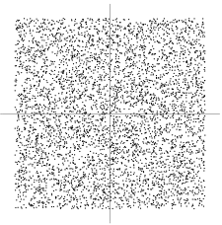

s1

Figure 1: Joint distribution of the independent components s1 and s2 with uniform distributions.

Now let us mix these two independent components, using the following mixing matrix:

$$A_{0}= \left(\begin{matrix}2 & 3 \\ 2 & 1\end{matrix}\right)$$

Equation 23

This gives us two mixed variables, *x*1 and *x*2 according to Eq. 3. It is easily computed that the mixed data has a uniform distribution on a parallelogram [3], as shown in Figure 2.

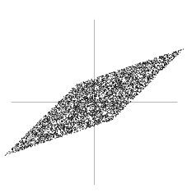

X2

X1

Figure 2: Joint distribution of the two observed mixtures x1 and x2

From the above graph it is easy to notice that the random variables *x*1 and *x*2 are not independent. A simple method to assess their independence is to verify whether one of the two can be estimated knowing the value of the other. For example, if *x*1 is at its maximum or minimum values, then this completely determines the value of *x*2. This shows that they are not independent.

In conclusion, the problem of estimating the ICA data model involves the evaluation of the mixing matrix **A**0 using only information contained in the mixtures *x*1 and *x*2. The above example, as can be seen in Figure 2, gives an intuitive way of estimating **A**, in fact the edges of the parallelogram are in the directions of the columns of **A** and this allows us to solve the problem. In fact we could estimate the ICA model by first evaluating the joint density of *x*1 and *x*2, and then locating its edges.

Of course this method represents just an example, because it works only with variables that have exactly uniform distributions and furthermore, in reality it would be computationally quite complicated. We need a method that works for any distributions of the independent components, and works fast and reliably.

# ICA Advantages

After having briefly presented ICA from a mathematical perspective, in this section we want to underline the advantages of using ICA in EEG signal processing.

ICA seems to be a good way to identify different sources because allows to separate the original data into maximally independent components. Thus ICA should allow separating raw EEG data into physiologically and functionally distinct sources, without using any physiological assumption on the head model (Blind Separation) [6].

For these reasons the authors claim that, when applied to sufficiently large and clean EEG data sets, ICA can actually produce scalp maps with optimal dipolar projections of EEG sources and at the same time this method should reduce the contributions of non-brain artifact signals, such as eye movements, main line noise and muscle activity.

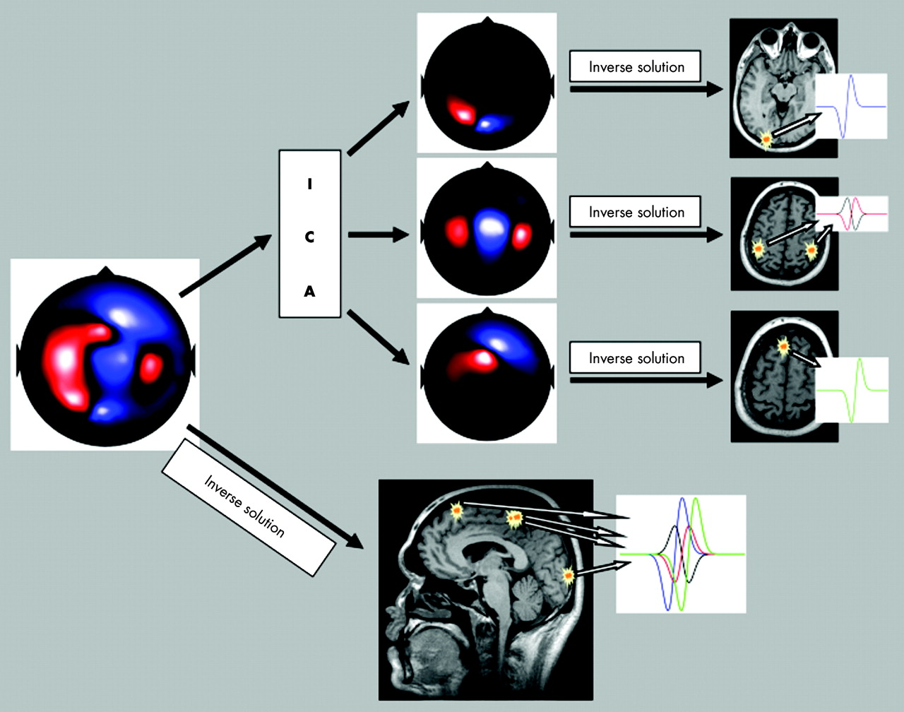

Figure 3: Example of ICA applied to EEG processing

As shown in Figure 3, we can see that performing ICA on the raw EEG signals allows us to separate the mixed and blurred brain signals sources into maximally independent components.

This gives researchers the opportunity to work with a new data set, where at each electrode there is a signal that should be only related to the specific activity of the underneath brain cortex. In practical this decomposition should guarantee a higher spatial resolution and a high rejection of the artifacts (non-brain components of EEG) at each channel.

## Further Processing

In order to get better features from raw EEG signals, after applying ICA to brain signals, the authors suggest performing a time/frequency analysis to characterize event-related perturbations in the oscillatory dynamics of ongoing brain signals.

The advantage of performing this kind of analysis after spatial filtering the data using ICA, is that the computed independent components measure the independent time activities of different sources, thus minimizing the issues present in traditional time/frequency analysis, when the potential fields from different sources are mixed together and when signals coming from distant brain areas are spatially summed and considered as single features.

At the end of this processing they suggest to characterize EEG features in response to specific stimuli, measuring their event-locked changes in spectral power and their inter-trial phase coherence (ITC), using both these pieces of information to create ERP-image visualizations that are really useful to study the event-related brain dynamics that are consistent across several trials.

In fact by observing these features it is possible to determine changes in event-related synchronization (ERS) or desynchronization (ERD) that are parameters strictly correlated to activation of specific cortical areas of the brain while performing a pre-determined task.

Sensory, cognitive and motor processing can result in changes of the ongoing EEG in form of an event-related desynchronization (ERD) or event-related synchronization (ERS), spatial mapping of ERD/ERS can be used to study the dynamics of cortical activation patterns.[5]

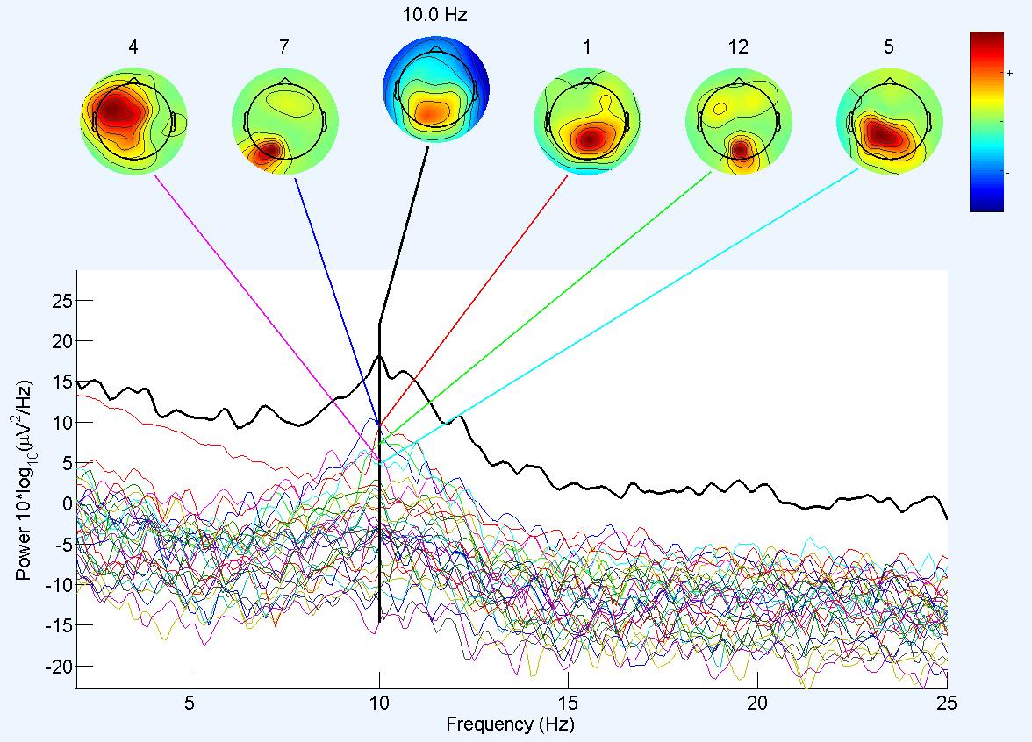

Figure 4: Example of spectral analysis of EEG data decomposition

In Figure 4 is shown an example of spectral and topological analysis of a data set of EEG data obtained after performing ICA decomposition. This graph has been generated in the Neural Instrumentation Lab, Temple University, using EEGLAB [10], an open source toolbox for analysis of single-trial EEG dynamics, with a sample data set.

In this data set event-related potentials were recorded, while a subject was required to perform several times an imagined movement task.

From Figure 4 we can see a maximum in the power spectrum corresponding to ERS (cortical activation) at a frequency of 10 Hz and we can see that this activation is mainly located around the motor cortex area of the brain activated during the repeated movement tasks made by the subjects, as expected.

In conclusion ICA seems to present a series of advantages in comparison with more traditional EEG processing techniques: ICA minimizes the influence of volume conduction on the acquired data, identifies the activities of the individual cortical sources and gives the most physiological plausible activity sources.

# CONCLUSIONS

After analyzing and studying ICA as a new approach to EEG processing, it seems that it could be a powerful tool to help researchers gain a deeper understanding of brain activities.

In the last few years many algorithms have been created to improve ICA results and processing speed, some of the most used are RUNICA, fastICA, BINICA[4].

On the other hand, ICA is based on some really strong assumptions that, in my opinion, cannot always be considered plausible. For example, ICA requires that the component source locations (and thereby their topographic projection patterns to the scalp sensors) are fixed throughout the data, and this may definitely not be true during a long EEG acquisition, especially if the subject is required to perform multiple tasks.

Furthermore ICA requires that the projected component source activities be summed linearly at the sensors and that there are no differential delays involved in projecting the source signals to the different sensors, hypotheses that may not always be true, given the high inhomogeneous means that signals travel through: our head.

Another important assumption is that the probability distributions of the individual component source activity values are not precisely Gaussian, in fact we have already seen that if our variables are Gaussian distributed ICA would not work.

Moreover to apply ICA successfully we should make sure that the component source activity waveforms are (maximally) temporally independent of one another, or in other words that the component source activity time patterns are maximally distinct from one another. More technically, a set of signals are temporally independent, in the sense used for ICA, if knowing the activity (μV) values of any subset of the signals at a given time point gives no clue about the activity values of any subset of remaining sources at the same time point. Thus each component source signal is, in a particular sense, an independent source of information in the data, contributing to a temporal pattern not in any way determinable from the values (at the same time point) of the other component source signals. Again this last assumption seems to be not really plausible; especially if we consider the high level of integration that the different parts of the brain show.

Finally we would like to underline that perhaps the greatest advantage of ICA techniques may represent its greatest weakness: ICA seems to give better results with respect to other methods that require larger amount of data on the head geometry and electrodes position in order to work. In these methods the difficulties of getting useful information on the head and brain models increase the difficulty in their application. ICA does not require any data on the model, because it performs a blind source separation, but this implies that if something goes wrong while applying ICA to EEG data, there is not a way to verify if the obtained decompositions are correct. So we might end up working with independent components that could be completely wrong and not representative at all of any EEG features. In other words we could be working with a model that is not physiologically and functionally correct, because we do not have any physiological data to drive our processing.

References

1. Pfurtscheller G, Lopes de Silva FH. “Event-related EEG/MEG synchronization and desynchronization: basic principles.” Clin Neurophysiol. 1999 Nov, 110(11):1842-57.
2. Jung, T.P., Makeig, S., Westerfield, M., Townsend, J., Courchesne, E., Sejnowski, T.J., 2000b. “Removal of eye activity artifacts from visual event-related potentials in normal and clinical subjects.”

Clin. Neurophysiol. 111, 1745.

1. Hany Farid and Edward H. Adelson. “Separating Reflections and Lighting Using Independent Components Analysis” Perceptual Science Group Massachusetts Institute of Technology Cambridge, MA 02139
2. Delorme A & Makeig S (2004). “EEGLAB: an open source toolbox for analysis of single-trial EEG dynamics”. *Journal of Neuroscience Methods* 134:9-21
3. G. Pfurtscheller. “Functional brain imaging based on ERD/ERS”. Department of Medical Informatics, Institute of Biomedical Engineering and Ludwig Boltzmann Institute for Medical Informatics and Neuroinformatics, University of Technology Graz, Inffeldgasse 16a/II, A-8010 Graz, Austria. Received 27 April 2000; revised 8 August 2000. Available online 4 June 2001.
4. A R Hobson, A Hillebrand. “Independent component analysis of the EEG: is this the way forward for understanding abnormalities of brain-gut signalling?”. Commentary. Gut 2006;55:597-600.
5. Julie Onton and Scott Makeig. “Information-based modeling of event-related brain dynamics”. Neuper & Klimesch (Eds.) Progress in Brain Research, Vol. 159 ISSN 0079-6123. Swartz Center for Computational Neuroscience, University of California at San Diego, La Jolla, CA
6. Aapo Hyvärinen and Erkki Oja. “Independent Component Analysis: Algorithms and Applications”. *Neural Networks, 13(4-5):411-430, 2000*
7. D. Malathi and N. Gunasekaran. “A Novel Neural Learning Algorithm for Separation of Blind Signals”. International Journal of Soft ComputingYear: 2009 | Volume: 4 | Issue: 1 | Page No.: 16-24
8. Arnaud Delorme, Scott Makeig. “EEGLAB: an open source toolbox for analysis of single-trial EEG dynamics including independent component analysis”. Received 17 June 2003; received in revised form 22 September 2003; accepted 16 October 2003

1.