Name:

Problem | Points | Score
1 | 35
2 | 30
3 | 35
Total | 100

Notes:
- The exam is closed books and notes except for one double-sided sheet of notes.
- Please indicate clearly your answer to the problem.
- If I can’t read or follow your solution, it is wrong and no partial credit will be awarded.
Problem No. 1:
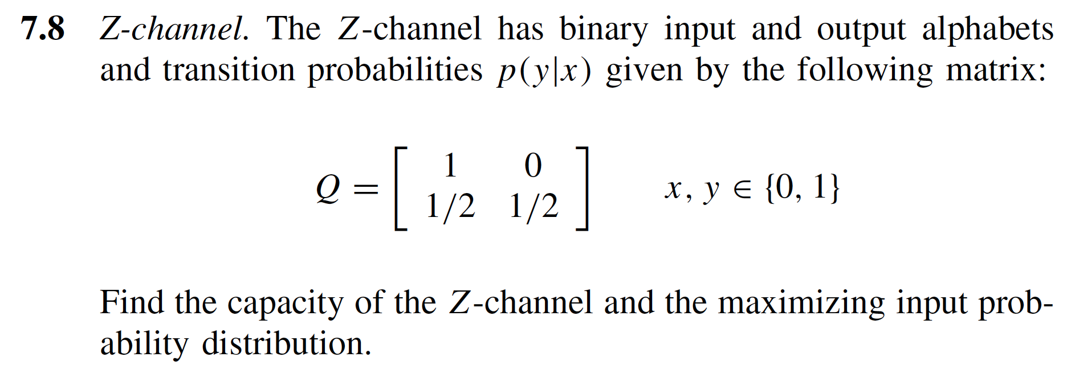

Problem No. 2:
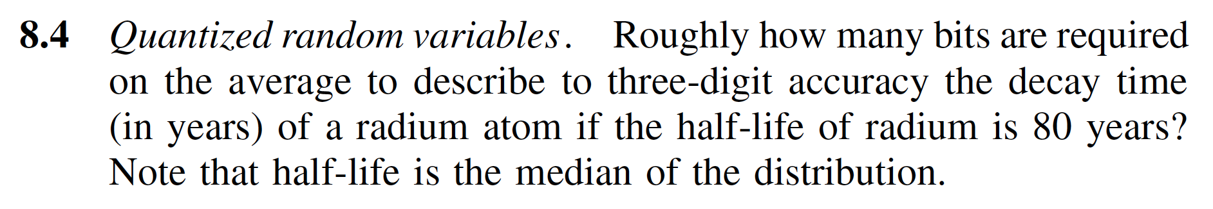

Problem No. 3:

