Barbara Cushing
Dr. Picone
Honors Intro to Engineering
22 March 2011

The Swing Bridge

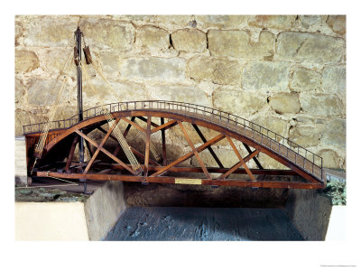
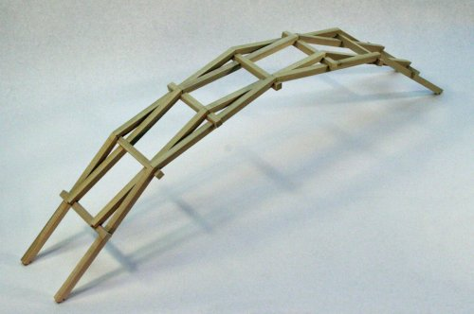
In a letter in 1482 that Leonardo Da Vinci wrote to Ludovico il Moro, the Duke of Milan and Da Vinci’s patron, he wrote “I will build extremely light and strong bridges, which will be easy to transport and will serve to chase enemies or run from them. And I will also build secure and invulnerable bridges, easy to be placed and removed” (Museo Scienza). Over the course of his career, Da Vinci designed a series of various styles of bridges, some of which were specifically to be used during wartime in order to guard the city from invaders. He designed a pontoon bridge that would be set on a series of boats and attached to a pin, using the current of the water to push the bridge, rotating it open to allow boats to enter. Though similar to the swing bridge, it was never built in real life according to Da Vinci’s specifications because there would not be enough room for the bridge to spin closed on the pin (Leonardo3). Nearly as popular as the swing bridge is Da Vinci’s interlocking bridge, which can be built out of logs and assembled or broken down quickly and easily when necessary. His most famous bridge and the one most in operation today, however, is the swing bridge. Though similar to the drawbridge, it is built on one bank of the river or canal surrounding a pole (called the pin) and swings open horizontally rather than vertically. Da Vinci’s original drawing called for it to be made out of wood, which would be the easiest and lightest material, but all of Da Vinci’s infrastructural designs allowed for variation in materials, depending on that which was available at the time and location. It looks like a standard parabolic bridge with handrails along the sides, but has an unusually sturdy bottom in order to support the weight that is only being distributed on one bank with no supports in the river. Though the bridge is movable, it is not temporary like some of Da Vinci’s other designs and thus requires ramps on either side of the bank in order to roll equipment up and over the bridge. Much like a ship’s anchor is pulled up onto its deck, the bridge is opened and closed by turning a wheel that draws in a series of ropes that are attached to the bridge. Da Vinci designed a series of pulleys to be built in between the wheel and the bridge in order to keep the rope moving on a straight path. On the other side of the bridge but on the same side of the bank is another wheel, pulley, and rope system that allows the bridge to be closed again.
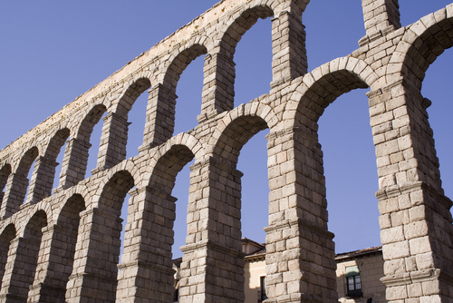
Though many of Da Vinci’s drawings depict objects from ancient and medieval times, people of his day knew very little of how the ancient Greeks and Romans actually designed and built such infrastructure. Growing up in Italy, aqueducts of the ancient Romans that surrounded him and the constant threat of war with neighboring cities sparked an interest in the design and protection of waterways. Though he struggled with geometry in grade school, Da Vinci came to be quite an expert on water, bridges, and hydraulics as an adult. He began studying the canals of Venice and Milan in the hopes of building a man-made waterway to create a direct path to the sea for his home city of Florence. Pisa and Florence were in an on-again, off-again war for much of Da Vinci’s life and so he looked to build a tributary of the Arno River that would not only bypass Pisa’s port and give Florence a direct path to the Mediterranean, but could also irrigate Tuscany. He spent a good period of his life studying the patterns of water flow to not just build the canals, but also to build a variety of bridges that could protect Florence’s waterways from invasion.

During much of the Renaissance period, various rulers commissioned artists and engineers like Da Vinci and Michelangelo to research such technologies in order to gain recognition for their cities. All were in competition with each other to make the best discoveries, build the most extravagant buildings, and make the most revelations in the world of science. Since the Romans and Greeks had already done much of the work, it was Da Vinci’s job to rediscover it and put it to use. In Da Vinci’s lifetime, there was a lot already known about the properties of water flow and bridge support, but there was a lot still to be discovered.

Inspired by the Pantheon in Rome, the Italian Renaissance displayed a huge interest in incorporating domes and arches in its architecture. After hundreds of years of trying to bury their pagan roots, Italian rulers became completely absorbed in the idea of a rebirth of Roman culture. While in Florence and Milan, Da Vinci was commissioned by local rulers to help draft and install the domes on their local cathedrals. Today, building a dome would be relatively simple with the use of modern-day cranes, but at the time, Da Vinci had to establish a sort of makeshift crane out of pulleys. Nearly all of his drawings contained various simple machines, including the wheel, lever, and screw, which allowed him to perform modern-day functions without the technologies that we have today. Simple machines were not uncommon at the time by any means, but Da Vinci’s designs were incredibly innovative nonetheless because of his knowledge of how they could work together. All of this came into play in the blueprints of his bridges. He managed to successfully combine wheels, pulleys, and well-supported arches into a movable bridge.

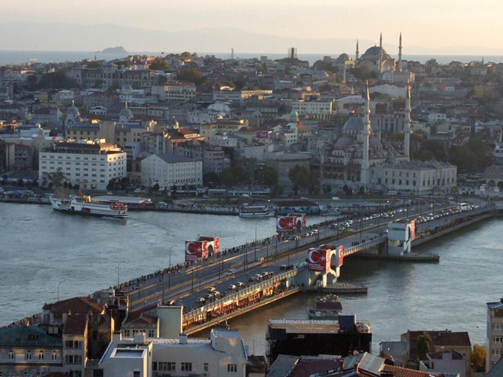
Relatively speaking, very few of Da Vinci’s drawings were actually commissioned and built, especially those from his Codex. In fact, most of his inventions were not even discovered and deciphered until after his death in 1519. While many of his inventions have been built as models, not a whole lot have been built and used in practice (like his flying machine, as a good example) because they would not actually function for their intended purpose in real life. His Golden Horn Bridge, for instance, was to be built in Constantinople for Sultan Bajazet II of the Ottoman Empire to separate “old” and “new” Istanbul, as it is called today. But at the time, because the sultan did not think it could withstand the elements, it was never built. A bridge has since been built across the river, but it looks nothing like the one that Da Vinci drew. The swing bridge, however, is quite physically accurate. Much like the Golden Horn Bridge, local rulers did not believe it would remain standing and function as it was intended due to its advanced layout. Da Vinci’s expertise in the physics of water and air flow allowed him to create a bridge that could withstand wind, rain, and flooding. The opening is made easier by stone on the permanent bank side to act as a counterweight when the bridge is suspended.

In order to open and close, the bridge must be built around a metal pole (called a pin) that allows it to rotate from side to side. Wheels (or cranks) with ropes attached to pulleys on either side of the bridge on the weight-supporting bank allow for it to be opened and closed by several people. Upon closure, it rests on the non-supporting bank, but must have most of its weight in the supporting bank so that it does not snap in half while being opened.

Looking at a model based on the original drawing, there are several constraints that we notice almost automatically. Most bridges are either attached on both banks, are supported by several bars extending to the bottom of the river, or are built into a cliff and are thus supported by the cliff’s walls. Da Vinci’s swing bridge, however, holds most of its weight on both sides. Even if it can rest some weight on the opposite bank while it is closed, it must still be able to hold itself up while open. Though the counterweight helps in this regard, it must still have an incredibly sound bottom in order to keep the arch from caving in.
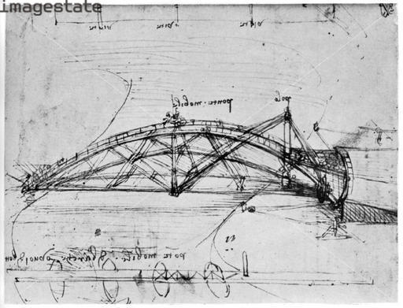
Friction along the pin has the potential to be a concern because of the strength of the pin and the weight that it is holding. Depending on how regularly the bridge is opened, it would need to be properly lubricated, but not so much to cause trouble while the bridge is closed, despite its stabilization on the opposing bank. The ropes would have to be strong enough not to break during closing, as that would defeat its purpose as a wartime bridge. The bridge itself would have to be light enough to be easily moved by a person or several people, but cannot be so light that it cannot support the weight of animals and machines crossing it.

Very few of Da Vinci’s inventions were actually built by him or during his time. In fact, this has made his Codex even more useful to the science community because is has been better preserved over time than wooden models would have been. As far as anyone knows, he was never commissioned to build such bridges, mostly because no one at the time believed they would stand up and work as they were intended.
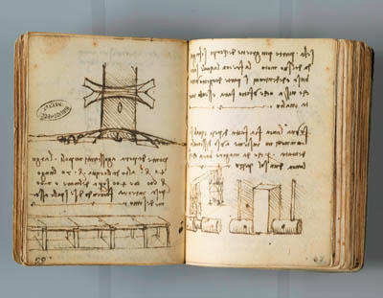
However, many of Da Vinci’s bridges have been built in the past one hundred or so years. As far as anyone knows, the interlocking bridge does not really exist outside of children’s toys and the traveling Da Vinci exhibits. Although, the swing bridge has since been adapted and has been built in all sizes in cities all over the world. Sometimes they are built with a pin on one bank and resting on the other, but more commonly modern-day swing bridges rotate on a central axis.
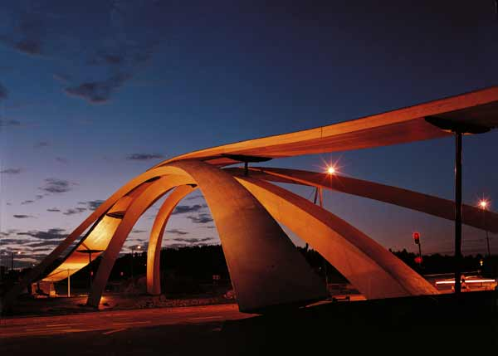
Though Da Vinci’s Golden Horn Bridge was never built in Istanbul, in 2003 a smaller footbridge version was erected in As, Norway, a town about a half an hour north of Oslo. A Norweigian architect named Vebjorn Sand founded the Leonardo Bridge Project and the bridge was finally built, though out of wood instead of Da Vinci’s original stone.

Leonardo Da Vinci remains well-known five centuries later as a groundbreaking painter, engineer, inventor, and architect. His contributions to science are incomparable to any others still to this day. Although no swing bridges that we know of were during his time, they are in frequently in use all over the world today. Others at the time may have thought his bridges would not stand, but his designs have proven to be innovative and timeless, defying the technology of the Italian Renaissance.
Works Cited
Kemp, Martin. Leonardo. New York: Oxford UP, 2004. Print.
Laurenza, Domenico. Leonardo's Machines: Da Vinci's Inventions Revealed. Ed. Mario Taddei and Edoardo Zanon. Newton Abbot: David & Charles, 2006. 147-51. Print.
Leonardo's Bridge to the Future (18 Feb. 2003). The Independent. Independent.co.uk. Web. <http://www.independent.co.uk/news/world/europe/leonardos-bridge-to-the-future-598054.html>.
"Leonardo Da Vinci's Workshop: Teacher's Guide." Leonardo Da Vinci's Workshop. Best of Broadway. Web. 20 Mar. 2011. <http://www.bestofbroadway.com/studyguide/DaVinciTeachersGSBO.pdf>.
"Leonardo's Design." Leonardo Bridge Project. Leonardo Bridge Project. Web. 21 Mar. 2011. <http://www.leonardobridgeproject.org/leonardo-design.htm>.
"Leonardo Engineer." Leonardo Da Vinci: Engineer and Architect. Ed. Paolo Galuzzi. Montreal: Montreal Museum of Fine Arts, 1987. 23-183. Print.
"Machines." Leonardo3. Leonardo3. Web. 20 Mar. 2011. <http://www.leonardo3.net/leonardo/acqua_eng.php>.
"Parabolic Bridge." Leonardo Da Vinci's Workshop. Museo Nationale Della Scienza E Della Tecnologia, 2011. Web. 21 Mar. 2011. <http://www.museoscienza.org/english/leonardo/invenzioni/pontegirevole.asp>.
Photograph. Web. 20 Mar. 2011. <http://images.imagestate.com/Watermark/2320662.jpg>.
Photograph. Web. 21 Mar. 2011. <http://cache2.allpostersimages.com/p/LRG/13/1346/BGES000Z/posters/leonardo-da-vinci-model-of-a-swing-bridge-made-from-one-of-leonardo-s-drawings.jpg>.
Photograph. Web. 21 Mar. 2011. <http://ecx.images-amazon.com/images/I/41ExcEIGhlL.jpg>.
Photograph. Web. 21 Mar. 2011. <http://www.bellydance.com.sg/wp-content/uploads/2011/02/Galata_bridge_2006_3.jpg>.
Photograph. Web. 21 Mar. 2011. <http://www.planetware.com/i/photo/roman-aqueduct-segovia-segaq3.jpg>.
Zammattio, Carlo, Augusto Marinoni, and Anna Maria Brizio. Leonardo the Scientist. New York: McGraw-Hill, 1980. Print.

