Andrew Park
Honors Intro to Engineering 1901
Dr. Joseph Picone
22 March 2011
“Protected Car”
One of Leonardo Da Vinci’s war machine ideas was a “protected car”(Vallentin 81). The idea was basically a tank. Built like a cone with overlapping sheets of wood, it offered high level protection for the people inside. The only open areas of the tank were at the top for air circulation and flaps circling the exterior of the shell for cannons to protrude out of. Da Vinci did not directly specify how many cannons would be in the tank but given the weight of cannons, weight of the tank itself, and the limitations of a man powered machine, it would not be prudent to build the tank too weight heavy. There are four wheels as the main source of movement for this tank. The wheels are powered through man power, “by means of crank handles attached to horizontal trundle wheels which turned the circular spindles of pinwheels that drove the wheels of the car” (Vallentin 81).
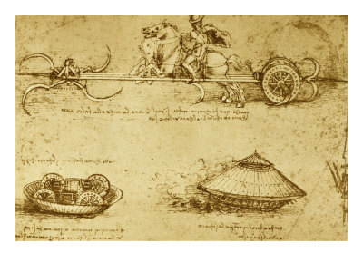
Although gunpowder and cannons have been around Europe for several hundred years, this invention was way ahead of its time in many aspects. First of all, it was man powered to “avoid the use of draught animals, which could easily be wounded” (Vallentin 81). His other idea which was drawn on the same page as his tank drawing was a scythe chariot. A horse would push along a cart which was equipped with four scythes in the front and wheels on the back and the scythes would spin in a circular motion through a method of a screw. However, if the horse were to be wounded in battle which it certainly will be, this weapon would become useless which was a problem the tank fixed which brings this to the second aspect of the invention of the tank being way ahead of its time. The amounts of exposure to the most vulnerable parts of the tank, the humans inside making it functional, were made minimal to maximize efficiency and endurance. A third aspect that made Da Vinci’s tank way ahead of its time was its ability to fire a cannon in multiple directions simultaneously given that more than one human would man the cannons. Many of Leonardo Da Vinci’s war machines were engineered with multiple firing mechanisms for the purpose of maximum efficiency. On a slightly unrelated note, Leonardo Da Vinci discovered steam power during his studies of guns. “In the course of his very thorough study of light and heavy guns Leronardo came into contact, almost by accident, with a power that was to revolutionize the world – steam” (Vallentin 82). If Da Vinci had spent more time with his discovery of steam power, he potentially could have created a steam engine on which his tank could run which would greatly maximize the efficiency of the tank. Were he to succeed in this area, his war machines would be hundreds of years ahead of his competition but unfortunately, “his experiments passed unnoticed, and the coming of the new world of which he had had a vision was deferred by the slumber of centuries” (Vallentin 82).
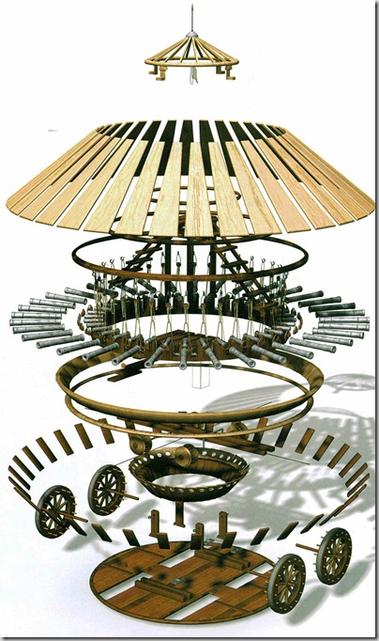
The movement of the tank was designed to be man powered. “The car was set in motion by man-power, by means of crank handles attached to horizontal trundle wheels which turned the circular spindles of pinwheels that drove the wheels of the car” (Vallentin 81). The hand cranks would be rotated manually which would result in the horizontal trundle wheels to spin. The spaces in between the trundle wheels allowed the spindles attached to the main wheels to lock in and move in the direction of the trundle wheel. The cranks were designed to operate two trundle wheels at the same time on both the left side and right side of the tank. This allowed the tank to be able to turn if one side were to be powered more heavily than the other side but this also required the two sides to be synchronized if the tank were to be moved in a straight line. The cannons could be easily manned by other humans by simply going to any cannon, peeking out to aim, and firing the cannon. The entire engineering concept of this tank was made simply but efficiently but whether or not it would work ideally outside of theory would be hard to determine because of the conditions of the terrain and perhaps the skepticism of his lords.
This invention had a major impact on future science and technology. This was the first time a machine had “new means of locomotion for it” (Vallentin 81).
“More than 500 years ago, a great artist and inventor named Leonardo Da Vinci drew the first automobile. But he was born too soon to be able to bring his drawing to life. He knew how it would be driven, but he did not know how to make it go. It would be several hundred years before the first car, called a ‘horseless carriage’ would be built.” (Fitzpatrick 6)
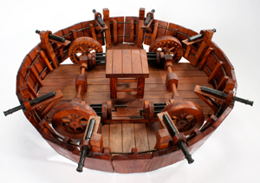
This machine’s movement was based on its internal ability to create its movement as opposed to having animals pushing or pulling it. If his studies of steam were more focused on, Da Vinci could have possibly skipped roughly two hundred years of history. “Apart from Leonardo da Vinci’s drawing of a round, tank-like armoured wagon, the first description of a tank-like vehicle and its usefulness in trench warfare is found in an H.G. Wells short story, ‘The Land Ironclads’…” (Andersen). Da Vinci is given credit for his tank idea to be the first ever tank idea and perhaps engineers in the future were inspired by Da Vinci’s idea of the tank.

Bibliography
Andersen, George. Tanks: A WikiFocus Book. WikiFocus Books Intl. Web. 22 Mar. 2011. <http://http://books.google.com/books?hl=en&lr=&id=DGLMxU6HcQYC&oi=fnd&pg=PT4&dq=history+of+tanks+leonardo+da+vinci&ots=R5pxcmIg-y&sig=au3w6s7zOZf0cfpEFQj9lGc2keE#v=onepage&q=history%20of%20tanks%20leonardo%20da%20vinci&f=false>.
Fitzpatrick, Anne. Automobiles. North Mankato, MN: Smart Apple Media, 2004. Print.
Vallentin, Antonina. Leonardo Da Vinci: The Tragic Pursuit of Perfection. New York: Viking, 1938. Print.
http://www.google.com/imgres?imgurl=http://www.thetoyzone.com/wp-content/uploads/2009/07/davincitank_thumb1.jpg&imgrefurl=http://www.thetoyzone.com/2009/15-da-vinci-war-machines/&usg=__PjMWzNRLNLzGxQiZgoUjPC24s-M=&h=682&w=404&sz=113&hl=en&start=0&sig2=KoHM5nYoQ42ZwBwWH1b0Rw&zoom=1&tbnid=oplYf0m48pNAzM:&tbnh=164&tbnw=97&ei=IFaITfP2LIGftwe425zsDQ&prev=/images%3Fq%3Dleonardo%2Bda%2Bvinci%2Btank%26um%3D1%26hl%3Den%26safe%3Doff%26biw%3D1366%26bih%3D643%26tbs%3Disch:1&um=1&itbs=1&iact=hc&vpx=317&vpy=246&dur=271&hovh=292&hovw=173&tx=110&ty=310&oei=IFaITfP2LIGftwe425zsDQ&page=1&ndsp=16&ved=1t:429,r:11,s:0
http://www.glogster.com/media/2/6/8/13/6081359.jpg
http://www.artistsofutah.org/15bytes/08july/images/79s.jpg

