John Shaw
Professor Joseph Picone
Honors Intro to Engineering
March 16, 2011
Da Vinci’s Dream of Flight
Since the dawn of time, man has dreamt of flying through the sky among the birds. Over the past two millennia, many thinkers and inventors designed, built, and tested various flying machines, usually with little success. Leonardo da Vinci, however, is one of the few to have had the right idea. While other designs found in historical records have usually contained some sort of flaw, Leonardo da Vinci successfully managed to design a machine which was, barring silly human constraints such as nobody having the ability to pilot the machine, able to fly. Da Vinci’s fascination with flight and advanced ability to model working flying machines shows a great understanding of physics and avian anatomy, and advanced the field of aeronautics more than anyone else had before and would do for many years.
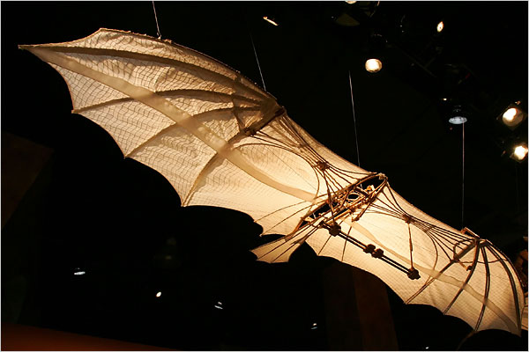
The Mechanical Bat is arguably the most famous of Leonardo Da Vinci’s experiments with flight. It has been featured in popular culture in various forms of media, including the video game Assassin’s Creed 2, as well as in television programs and museum exhibits. A contributing factor to this particular invention’s popularity probably has something to do with the fact that it can actually work- models that have been are able to at least glide. This definitely wasn’t an accident- Da Vinci’s notebooks have several studies of aerodynamics, the anatomy of birds, especially their wings, and prototype devices to test the physics of flight before he began designing a machine which could fly.

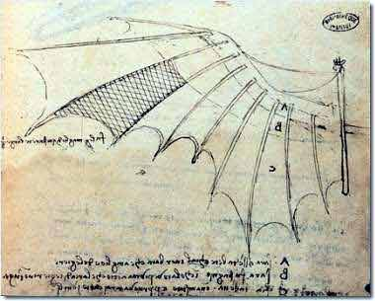
The Mechanical Bat is very much what it sounds like- a bat-shaped device which is obviously man-made. Unlike a bat, however, Da Vinci’s invention is large enough to carry a man. The wings are modeled after a bat’s, with the structure of the machine closely matching the structure of a bat’s skeletal system. In place of the webbing present on a bat’s wings naturally, Leonardo proposed using canvas to gain the same effect. In addition, a “tail wing” can be found on the machine, helping the pilot to steer correctly. All in all, Da Vinci’s Mechanical Bat is a striking mix between naturally occurring structures and modern human ingenuity designed to test the limits of both humanity and natural law.
Prior to Leonardo Da Vinci, no scientist had researched the phenomenon of flight; however, there were a few cases of humans flying earlier in history. In 4th century BC, the Chinese used giant kites to lift soldiers, allowing them to look down upon an area for reconnaissance. Later, in the 13th century, an English monk named Roger Bacon theorized that air has substance, and therefore a human may fly by the use of something lighter than air. Neither of these cases, however, indicate any research into the reason behind how flight is possible. Da Vinci’s extensive study of the anatomy of birds, bats, and flying insects was revolutionary and helped to provide the groundwork for modern aircraft. The design of the mechanical bat is, in fact, similar in appearance to some lightweight aircrafts used today. The basic principles that he developed, including the location of the center of gravity, maximizing lift while minimizing drag, and the preservation of stability through weight distribution and Because of Leonardo Da Vinci’s extensive study of natural flight, we have been able to master the skies today.
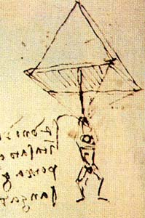
Aerodynamics was, by and large, not frequently discussed before Da Vinci’s studies. Birds and bugs flew because they had wings; humans did not fly because they had arms. There was no consideration into the concepts of lift and drag, or what it was about wings that enabled their owners to fly. Da Vinci, in an attempt to find an answer to these questions, began studying birds and creating concepts of flying machines. His notebooks show an iteration of designs, beginning with a simple setup consisting of shoulder mounted wings, and eventually designing a system akin to modern aircraft consisting of working wings, stabilization, and even basic landing gear. He also showed insight into the basic principles of aerodynamics, especially “aerodynamic reciprocity”; his parachute design demonstrated understanding of the effect that air resistance has on an object. Leonardo had planned to write an entire book solely on the subject of air resistance. However, like many of his ambitious projects, it was unfinished and combined with his other studies on flight.

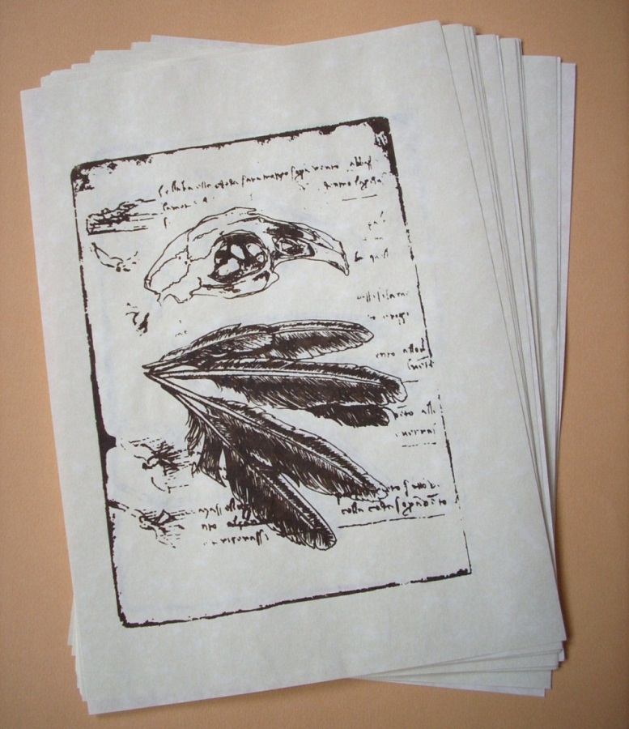
Another science that was revolutionized by Leonardo Da Vinci is anatomy; he performed in-depth studies of humans, cows, fish, and birds, among others. This study of birds and bats is what allowed him to progress so far ahead of his time on his flying machines. Curiously, he spent a large amount of time studying the flight of birds, despite a note from himself considering the flight of birds to be useless in regards to human flight, and that the focus should be placed on the flight of bats. Some of his flying machine designs clearly attempted to use bird wings, which are not included in the later designs. Nevertheless, his contributions to anatomy, useful to his flight work or not, are undeniably groundbreaking. He extensively studied the feathers of various birds, and even noticed and studied the hollow bone structure which birds have. By observing their anatomy and flight, he was able to determine the function of their wings, and differentiate it from the workings of the bat’s wings.
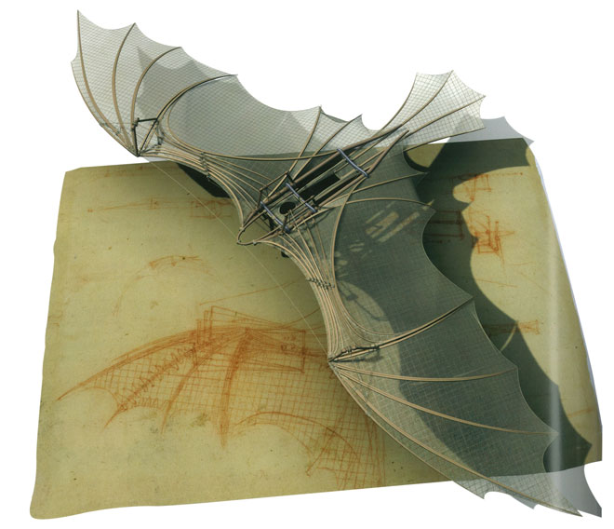
Da Vinci’s study of anatomy greatly affects us today. His ultra-detailed work changed the art and medical fields dramatically, as well as the veterinary field. He demonstrated an understanding of life that was unheard of at the time; the fact that he understood that an animal’s optic nerve was something important and drew it in detail is incredible, especially considering the conditions he had to work with. There were no x-rays or anything to allow a detailed view other than simply looking at it firsthand. The precision he demonstrates despite lacking the modern technology we would use is remarkable.
All of Da Vinci’s work was incredible, but his study of flight and flying machines was unprecedented. Through his elaborate studies of anatomy, he managed to find the reason why winged animals are able to fly, and how their bodies allowed and supported flight. He performed studies on aerodynamics, discovering concepts such as air resistance, leading to understanding of lift and drag. His Mechanical Bat represented a culmination of this knowledge and represented the first time in history that a man understood flight, which paved the way for the large airplanes we are familiar with today. In addition, his understanding of aerodynamics led to several other important aerial inventions- the parachute and the helicopter, for instance, are both based on Da Vinci’s designs. His intimate study of flight, flying creatures, and flying machines revolutionized the way we think of aerial travel today.

Works Cited

Cooper, Margaret Rice. The Inventions of Leonardo Da Vinci. Third ed. New York: Macmillan, 1965. Print.

Leonardo Da Vinci. 1956. Print.

Leonardo. Leonardo Da Vinci: Engineer and Architect. [Montreal]: Montreal Museum of Fine Arts, 1987. Print.

"LEONARDO3 - Leonardo Da Vinci | MACHINES COLLECTON - COLLEZIONE DELLE MACCHINE." LEONARDO3 - Leonardo Da Vinci | EXHIBITIONS | MACHINES COLLECTION | BOOKS | Mostre | Collezione Delle Macchine | Libri |. Web. 22 Mar. 2011. <http://www.leonardo3.net/leonardo/machines_eng.php#001>.

Ziegler, David, Jae Lee, and Hyun Jung Koo. "Pioneers: Leonard Da Vinci." Aeronet. 1999. Web. 21 Mar. 2011. <http://library.thinkquest.org/25486/english/pioneers/davinci.shtml>.

