James Swieson
Dr. Picone
Honors Intro to Engineering
21 March 2011

Leonardo da Vinci’s Robotic Knight
Figure 1. Leonardo3’s recreation of Leonardo da Vinci’s Robot Knight
When we visited the da Vinci exhibit at The Franklin Institute, I did not know what to expect. I did not know much about Leonardo da Vinci before going to the exhibit, so when we got there, I was amazed at all of the things he had designed, from the self-propelled cart to the giant mechanical lion to his multitude of different flying machines. Among all of these inventions, the one that stood out to me was da Vinci’s robotic knights (or soldier, or automata as it is sometimes referred to). Seeing the word robotic used at an exhibit for da Vinci, who lived over 500 years ago, was very intriguing to me because robotics is a recent invention that I did not know could even be attributed to something designed so long ago, so I naturally spent a good amount of time figuring out what this thing was. I soon found out that it was not as much a robotic knight, as a wooden skeleton whose appendages are powered by someone pulling a string. Still, for the time period it is a very impressive design, and about as close to a humanoid robot as da Vinci could have gotten.

Leonardo da Vinci was fascinated by the human body, and it showed in his notes; many of his notes were about the human body and how different parts of the body worked. Though we cannot be certain, it is believed that da Vinci’s interest in the human body was sparked when he was apprenticed to Andrea del Verrocchio, an Italian sculptor and painter, in 1467. Verrocchio wanted all of his pupils to study anatomy. Initially his study of anatomy was solely intended to make him a better artist but it later bloomed into more than that. Da Vinci soon became fascinated with the inner and physical workings of the body. Up until this point no one else had done much work into what made the body tick, so da Vinci did all the work himself. He was able to dissect and study corpses to learn the inner workings of them. All in all da Vinci dissected about 30 corpses. From these dissections he was able to study, draw, and write about many of the different workings of the body, like how muscles controlled different parts of the body, how the bones in the body were organized, and where the organs were in the body and what they did to name a few things he studied.

The study of anatomy was something that had not been done significantly since the death of Galen at the end of the second century as Anthony Merlin Jose from Yale said:

With the death of Galen at the end of the second century, the study of anatomy entered upon its dark days and for nearly thirteen centuries scarcely a single fact was added to the knowledge of the structure of the human body. During these years, people, for their knowledge of natural phenomena, were content to rely upon the writings of the Fathers, these statements in turn being based upon those of earlier writers, which were both corrupted and diluted as it was passed on down the generations. Under such circumstances, there was naturally no incitement to personal observation, and experiment and science languished.

During these times, for a physician, an intimate knowledge of anatomy unnecessary; if he knew the positions of the individual organs and their presumed functions, he had all that he required, and this he could obtain from a translation of an Arabic summary of Galen's anatomical treatises, such as is found in Avicenna's Canon. So the study of anatomy became conventionalized into the reading of a translation into Latin of an imperfect summary by an Arab of Galen's teaching. [1]

For this reason, when da Vinci started his study of anatomy it was revolutionary and different from anything that anyone had done for over 1200 years. One of the biggest advantages da Vinci had was that he was an amazing artist in addition to his inquisitiveness, so he was able to draw what he saw. This not only helped him in his ability to study the human body, but also helped people who later did research into the human body. Most of his drawings are so accurate that scientists nowadays are able to use them to aid in their own study of the human body.

From all of his studying into the human body, da Vinci came to the conclusion that all the components that made up the body were really just machines that could be replicated using simple machines. In fact, “in the extraordinary series of anatomical drawings from the first decade of the 1500s, Leonardo’s mechanical approach, influenced by the model of the ‘mechanical elements’, becomes strikingly evident. In essence, Leonardo’s study of human anatomy appears to a great extent to be an offshoot of his study of the ‘anatomy’ of machines”[2]. Da Vinci designed and built a simplified version of a human, which is now known as the Robot Knight. The knight was made as a way of da Vinci proving that humans could be imitated. It was shown off at parties where it amazed viewers as a human creation was able to sit, stand, and move its arms, wrists, and head [3][4].

Although it amazed its viewers, it was actually not the first ever automata. The origins of automata are rooted in Greek and Roman history, although all of those designs used falling weights or water to power them.

In one such description of these automated theatres, a three-wheeled cart (not unlike Leonardo’s in Codex Atlanticus), bearing a statue of Bacchus moved by itself, stopped and shot out a flame; steamed wine then flowed from a goblet onto a crouched panther, after which the cart and statue returned to its starting point. [5]

Automata also appeared in the Middle Ages, again, these automata were water powered. A book by Al-Jazari from the 13th century also included designs for automata, also powered by water. One of the biggest contributions to the automata was “the development of the mechanical escapement, the so-called verge and foliot in the 13th and 14th centuries” [5]. Not only did this enable the making of automated clocks, but it also enabled people to make objects perform very simplified human movements. The verge and foliot mechanism was a mechanism that converted rotational motion into oscillating motion. This was an early example of what would later become the pendulum that powers clocks.
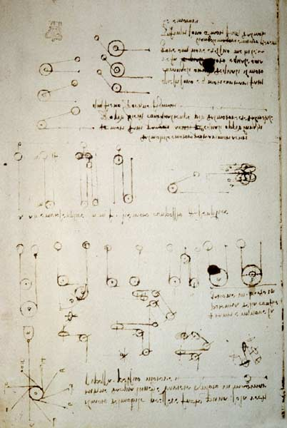
Unfortunately for us, not too much is known about da Vinci’s actually design and final product because none of his notebooks contain final designs for the knight, they only contain components of it scattered throughout his notebooks, two pages of which are shown to the right. Up until 1957, no one had paid any attention to these drawings, in fact, they were basically forgotten about until in 1957 Carlo Pedretti rediscovered these designs hidden among his numerous designs. Although they were discovered in 1957, nothing was actually done with them until 1996 when a man named Mark Rosheim published an independent study of the robot and in 2002 he created a working knight from da Vinci’s notes. [6] He also used da Vinci’s designs to help create robots for NASA. One of the biggest reasons Rosheim went to da Vinci’s notes was that he was interested in replicating the movement of the muscles and joints of humans so they could put them into humanoid robots, which was a major issue that scientists had encountered.

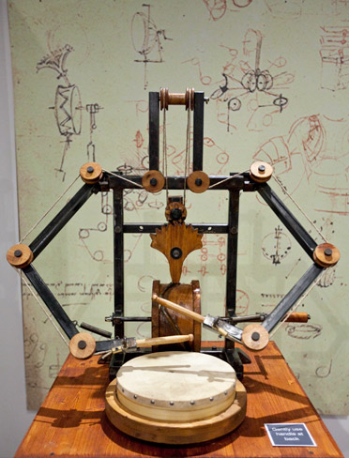
Since Rosheim first built da Vinci’s robot there have been many different people and groups who have built different recreations of the knight. Gabriele Niccolai was one of those engineers. He and his team worked for years poring over da Vinci’s notes trying to piece together the puzzle that was the knight. In all they used about 20 designs, and after 15 years they finally had a skeleton, but it did not move. After looking through more of da Vinci’s notes they found a part that they orignally thought to be a useless part, a drum, but when they made it and added it, it worked. This just shows how much thought da Vinci actually put into his designs; every piece mattered, even if it seemed unimportant. Figures 4 is a picture of Niccolai’s knight. The knight uses pulley systems to move the arms and legs. This pulley system is powered by a crank which, when spun, spins a cylinder with a groove in it that the back end of a gear rides in spinning the gear back and forth, and as the gear moves back and forth it pulls strings which move the arms and legs up and down, giving the knight the motion needed to walk and play a drum.
Figure 4. The torso of Niccolai’s recreation of da Vinci’s knight with the drum and internal workings
Figure 2 & 3. Pages from Leonardo da Vinci’s notebook showing possible designs for the interior of the knight.

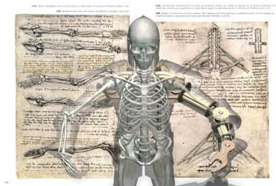
Another group that made da Vinci’s knight is Leonardo3 and this is the one that was on display at the da Vinci exhibit at The Franklin Institute. The people of Leonardo3 studied many of Leonardo’s manuscripts, and eventually found that most of the information needed to recreate the knight was found in the Codex Atlanticus, specifically 579r. They spent lots of time sorting through all the notes trying to decide which ones related to the knight and which were for a completely different design. In the end they had a total of 174 different drawings that went into their final design. The design of Leonardo3’s knight was, predicably, very similar to that of Niccolai’s, using pulley systems to move the joints.

Even though many people have never heard of Leonardo da Vinci’s robotic knight does not mean that it is not important, in fact, it may have been one of his more important inventions. The work that da Vinci put into planning out how to build the knight, more specifically all of his research into the anatomy of the human body and how it works has made and will continue to make a huge impact on the fields of science and engineering.
Figure 5. Part of Leonardo3’s design for their robot knight

References
- Jose, Antony Merlin. "Anatomy and Leonardo Da Vinci." YALE JOURNAL OF BIOLOGY AND MEDICINE 74 (2001): 185-95. Web. <http://www.ncbi.nlm.nih.gov/pmc/articles/PMC2588719/pdf/yjbm00012-0041.pdf>.

- Leonardo. Leonardo Da Vinci: Engineer and Architect. [Montreal]: Montreal Museum of Fine Arts, 1987. 103-09. Print.

- "Leonardo Da Vinci Robotic Expertise! And His Robots!" Leonardo Da Vinci Paintings, Inventions and His Complete Biography! Web. <http://www.leonardo-da-vinci-biography.com/da-vinci-robotic.html>.

- "Leonardo Da Vinci's Robotic Knight Invention." The Inventions of Leonardo Da Vinci. Web. <http://www.da-vinci-inventions.com/robotic-knight.aspx>.

- Moon, Francis C. "Leonardo in a Robot: Automata, Clocks and Controlled Machines." The Machines of Leonardo Da Vinci and Franz Reuleaux. Netherlands: Springer, 2007. 276-88. Print.

- "Leonardo Da Vinci's Robots - LEONARDO3 - Leonardo Da Vinci | BOOKS - LIBRI." LEONARDO3 - Leonardo Da Vinci | EXHIBITIONS | MACHINES COLLECTION | BOOKS | Mostre | Collezione Delle Macchine | Libri |. Web. <http://www.leonardo3.net/leonardo/books I robot di Leonardo - Taddei Mario - english Leonardo robots 1.html#5b>.

- Farquhar, Peter. "Key to Legendary Mechanical Lion Found in Code for Leonardo Da Vinci's Robot | News.com.au." News.com.au | News Online from Australia & the World | NewsComAu. Web. <http://www.news.com.au/technology/da-vicnis-robot/story-e6frfro0-1225869918564>.

