Dylan Connelly
Hon. Intro to Engineering
Shipyards Analysis

Electromagnetic Signatures of Ships
Stealth refers to the act of trying to hide or evade detection. Stealth technology is ever increasingly becoming a paramount tool in battle especially in today’s high technology wars. In battle, invincibility means invincibility. Able to strike with impunity, stealth aircraft, missiles and warships are virtually invisible to most types of military sensors. The experience gained at the warfront emphasizes the need to incorporate stealth features at the design stage itself. According to conventional military wisdom, surprise is the best form of attack. Even with evermore sophisticated methods of detection, however, catching the enemy unaware has become increasingly difficult. Thus paving way to the development of increasingly sophisticated technologies that help in evading the enemy's ever-vigilant eyes.
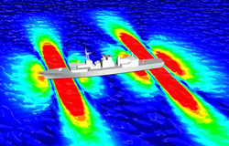
The way to drop off the grid, especially for naval vessels, is to eliminate the ship’s electromagnetic signature. This fingerprint is merely a magnetic attraction between the earth and the large hull made of ferromagnetic metals, that can be measured by enemies who can then identify the ship. It is easy to see how this is dangerous. Not only can other ships sense who and where you are, but they can also alter their magnetic fields to trick someone detecting them. This is why electromagnetic signatures of naval ships need to be kept below safe levels. The main source of the static magnetic field of a ship is ferromagnetic material, materials that form permanent magnets or are attracted to magnets. If this magnetic signature is measurable in the local earth magnetic field, then several threats are present: detection and classification by and subsequent detonation of sea mines. Because of increasing sensitivity of magnetic sensors and smart signal processing, signature reduction is as important ever these days. Its goal is the decrease of the detection range by complying with the strict design requirements.
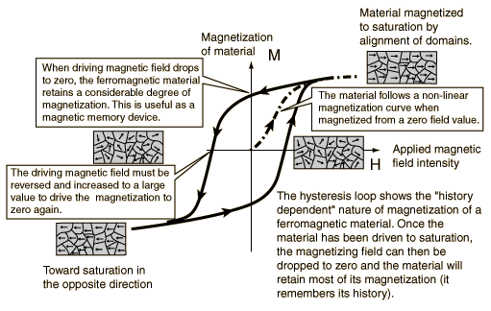
Due to the external magnetic field of the earth, ferromagnetic materials get magnetized. The relationship between the magnetic field and the magnetization is described by the so called hysteresis. Analogous loops are obtained for magnetic induction versus field. Due to this behavior, the instantaneous magnetization depends not on typical hysteresis loop only on the present magnetic field, but also on the history of the field. In addition, stress and temperature influence magnetization. The hysteresis curve of any ferromagnetic material can be obtained through measurements.
Throughout history the detection and measurement of magnetic fields of ships have been used since submarines and battleships were first deployed. Apart from radar and radio communications, electromagnetic field measurement is a major form of vessel identification. Throughout World War II battles in the Atlantic and in the West Pacific, these methods of detection were frequently used to locate and destroy submarines, battleships, and even carriers. Though a submarine can completely immerse itself to become invisible, the presence of this ship does not fade away. Even more dangerous than your enemies knowing where you are is their bombs knowing where you are. Underwater mines are constructed to detonate when a trace of a certain magnetic signature is detected, not just when they strike a hull. The sensitivity and destructive capabilities of these mines makes even the bravest sailor a bit uneasy.
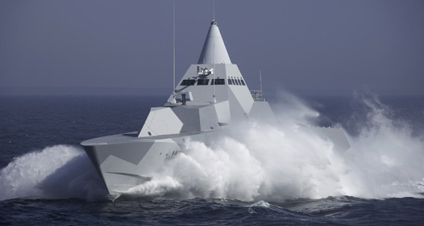
The most obvious inquiry for an engineer is to ask how to eliminate or mask the effects of electromagnetic signatures. Not only does this task exploit mechanical engineering but also the electrical and industrial engineering aspects of producing a truly stealthy naval submarine. Since ferromagnetic materials like iron are the main cause of magnetism in the hull, the incorporation of nonmagnetic materials into the design of a vessel is crucial, while still maintaining the strength and durability of the battleship. Essentially, the ship cannot be made of metal, but still needs to withstand immense damage. This is where some engineers experiment in changing the angles of the ship’s hull, to alter the way magnetic fields are created, and how radar reflects off of the exterior of the ship. If a ship does not show up on radar and has no electromagnetic fingerprint, then enemies cannot know it’s location. This image is a perfect example of how true stealth can be achieved. Similar technology is used across the military board with stealth fighters and bombers.
There are two general ways to camouflage against magnetic detection. Some vessels have on-board degaussing coils that are supplied with a current to generate their own magnetic fields. These coils are designed to oppose the Earth’s magnetic field at the ship’s location. Modern degaussing systems are very sophisticated but they still rely on the assumption that the permanent magnetization of a ship or submarine is negligible. This tactic negates the magnetic pull of the earth, making the ship magnetically invisible. The other way to eliminate the electromagnetic field of a vessel is through a mass demagnetizing process called ‘deperming,’ a similar tactic that uses three sets of coils to neutralize the magnetic fields of the ship.
A ship is made from a great number of metallic elements with distinct magnetization, which in the moment of the launch into sea give the ship’s magnetic signature. The study of the ship’s magnetic signature is made at a certain measurement depth. This depth is different for each class of vessels and depends on the latitude of the navigation area and even more on the ship’s geometry. From the simulation resulted that the main coil is very useful for reducing the values of the field’s strength. The currents through the outer coils are higher than the ones through the middle coils. From simulations of CAD and other programs, one can see that this alone is not sufficient the magnetic treatment of the ship. It is necessary to combine all proceedings for the local and global compensation and demagnetization of the ship.

Resources

Images courtesy of Google Images

http://www.wrdavis.com/docs/pub/electromagnetic_signature_modeling_and_reduction.pdf Electromagnetic signature Modeling and Reduction by Holtam, Jeffrey, Brooking, Richards

http://www.tno.nl/downloads/def_alg_platformsig_S050173_Magnetic_signatures_ships.pdf, Magnetic Signatures of Ships by TNO: Defense, Security, and Safety

http://snet.elth.pub.ro/snet2004/Cd/camp/camp_P2.pdf METHODS OF REDUCING SHIP’S MAGNETIC SIGNATURE by A. RAZICHEANU, V. IONITA, H. GAVRILA

