Matthew Rieger

Dr. Joseph Picone

Honors Intro to Engineering

25 April 2011

Launching a Satellite into Orbit

Launching a satellite into orbit is, by no means, an easy process. It requires a huge budget, a dedicated crew, a myriad of parts to build with and a carefully engineered and designed plan in order to get the satellite to orbit. Launching a satellite into orbit is something that is often overlooked by the common man. Satellites are something that people take for granted, even though they provide so many different services for us in everyday life. Many don’t realize the dedication put into getting these satellites into space and getting them to obit the earth in a specific shape and at a specific altitude. Launching a satellite is something that has to be extremely carefully planned. The designers get only one shot to launch it and if they fail, they lose millions of dollars. This means that everything must be engineered to perfection in designing launch machines and during that launch, everything must go as planned. Launching a satellite into orbit is therefore one of the greatest spectacles of engineering. There is no room for error and no test runs, so everything must be overlooked tenfold and constraints must be met and assuredly taken care of before launch. The science and engineering that goes into these launches is quite complex and interesting.
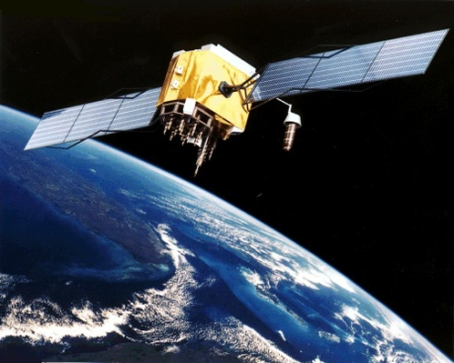
Putting a satellite into an orbit requires a huge amount of energy. The process can be divided into two phases, the launch phase and the orbit injection phase. The satellite can be launched by either an expendable rocket or a space shuttle. An expendable rocket is a rocket that falls to pieces through several phases while travelling through the atmosphere. The final phase leaves just the satellite and the remnants fall to earth. A space shuttle launches with the satellite attached. It loses several parts when setting the satellite into its correct orbital slot but returns to Earth to be refurbished for another trip. The satellite must be put into a geosynchronous orbit, meaning that it must be within range of orbiting the earth. This means that a satellite must be between the farthest point of the orbit, apogee, and the closest point of the orbit, perigee. Apogee is approximately 22,000 miles and perigee is approximately 100 miles. If the satellite is not in this range, then it will likely not stay in orbit, which is a huge problem. When the satellite is first put into orbit, it is in an elliptical transfer orbit. In order to get from an elliptical transfer orbit to a geosynchronous orbit, some energy is needed. This energy is provided by the Satellite Apogee Kick Motor (AKM). The AKM is a vital part of the orbit injection phase and assures that the satellite begins to orbit correctly. All of these processes must be precisely engineering in order to have a satellite successfully be launched into orbit.
Satellite in orbit
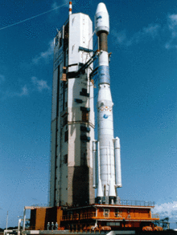
Expendable rockets are most commonly used to put satellites into orbit. They can take many forms, but are most commonly used with liquid or solid fuel. They use multiple stages to propel their cargoes into outer space. In addition to carrying satellites, they can also carry probes or spaceships. Each of the rocket’s stages consists of a self-contained engine or motor. The fuel tanks contain hydrogen, kerosene, or a solid fuel that looks somewhat like the eraser on a pencil. In addition to the engine and fuel, there are tanks to hold the materials, lines and pumps, and electrical systems to move the engine while in flight. When the fuel for one staged is completely used up, the stage is dropped away and the next stage is ignited. This means that it is very important to fill the fuel tanks with the exact amount of fuel needed for a stage. The rockets continue to burn stage by stage until the right altitude or speed for its designated mission has been reached. Expendable Rockets are typically capable of launching satellites 120 miles above the Earth’s surface. The satellite’s Apogee Kick Motor will take it further into orbit if need be.
Expendable Rocket
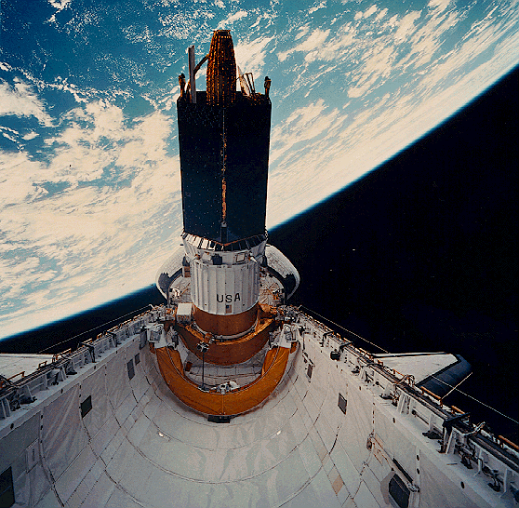
Today, expendable rockets are used by countries such as the Unites States, Russia and China to place satellites into orbit around the Earth. These rockets evolved from missile usage during World War II. A German missile called the V-2, was created to carry large, high-energy explosives to hit cities or encampments. Later, the United States and Soviet Union developed large bomb-carrying missiles and missiles were created to carry nuclear weapons to targets on the other side of the Earth. In the Soviet Union, a man named Sergei Korolev was designated as the “Chief Designer” of human-carrying and large expendable rockets. He managed to create a series of large and advanced liquid-powered expendable rockets. The purpose of these rockets was to serve as very large missiles that could fly from Russian bases and attack U.S. targets. However, the missile version of this rocket was never developed and it served primarily as a launching rocket for heavy payloads and space probes to the planets. The United States countered these rocket advancements with improvements of their own. The space race during the Cold War between the U.S. and U.S.S.R. led to rapid improvement and evolution of both space shuttles and expendable rockets. Expendable rockets began being used almost solely for launching satellites, as they are used today.
Satellite in space shuttle cargo bay
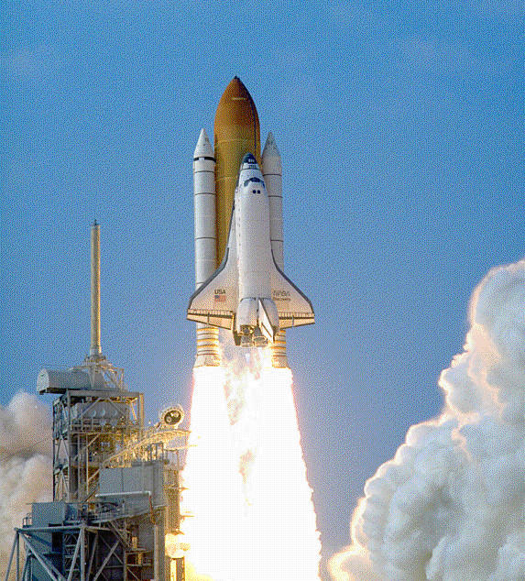
Space shuttles are capable of carrying up to three or four satellites. They are certainly more costly to build than expendable rockets, but can be reused if the process goes well. When a space shuttle releases a satellite into space, it can push the satellite into orbit by a space arm or gently push it out into orbit while spinning. This reduces the need for an AKM, but can be a difficult process. Spacecrafts are often used to carry heavier satellites that need to be lifted most of the distance from the ground to reach their orbits. Satellites are fit snugly into the cargo bay of the spaceship and are deployed at a certain height. Additional small rockets are sometimes used to further propel the satellite. Setting satellites into orbit through use of space shuttles seems much more sensible and efficient than using expendable rockets. This is an area of debate, as many things can go wrong when using space shuttle satellite deployment. Despite this, it is an often used method and will continue to be used for years.
These methods of launching a satellite into orbit are most often not sufficient enough to set the satellite into the exact orbit that it has to be in. The Apogee Kick Motor takes care of the final step in getting the satellite to orbit the Earth correctly. AKM’s are used to transfer a satellite into a geosynchronous orbit. Most rockets are launched from spaceports that are a significant distance away from the equator. This results in the satellite being on an inclination when it is released into orbit, approximately equal to the latitude of the launch site. This initial orbit is known as a geosynchronous transfer orbit and an additional force is needed to reach the geosynchronous orbit. The AKM takes care of this. When a satellite reaches its orbit’s apogee position, the AKM is ignited. The AKM both puts the satellite into a circular orbit and brings the inclination of the satellite to zero degrees. Both are necessary for the satellite to work properly. This whole process is known as an “apogee kick”. Usually AKMs use either a bipropellant engine, with a solid fuel and a liquid oxidizer, or a monopropellant engine with both the fuel and the oxidizer in the solid state. Occasionally, propellant systems use a liquid fuel as well. The amount of fuel carried on a satellite will directly affect its lifetime. This means that the apogee kick process must be as efficient as possible, as it can affect the operational life of the satellite itself. The apogee kick process, much like the other processes, must be carefully engineered and mistake free so that the satellite functions properly and for a long amount of time.
Space Shuttle
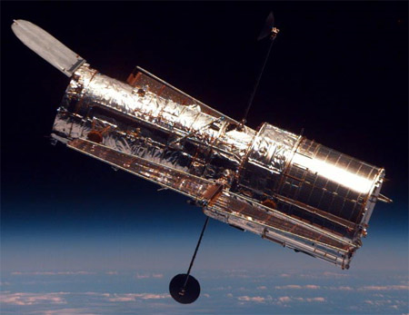
A variety of different man-made satellites can be put into orbit around the Earth. Communication satellites are the most common type of satellite. They capture different radio waves and send them to different spots in the world. Resource satellites are used for scientific observation. They monitor natural resources by taking pictures that help in map making. Navigation satellites are used to help pilots and sailors to know where they are going. When they are in distress, they can send out a signal that will be captured by the satellite. The first navigation satellite was put into orbit in 1960 by the U.S. Navy and was quite effective. Military satellites are used to help armed forces navigate, communicate and spy by taking pictures and picking up radio waves that are sent from other countries. Scientific satellites are used to help scientist study the earth and outer space. They take pictures that help scientists study planets, asteroids, other solar systems and deep space. The Hubble Space Telescope is a prime example of a scientific satellite. Finally, weather satellites help scientist study weather patterns. This satellite has a special type of camera that takes pictures that show on earth where it is raining, snowing or sleeting. These various satellites show that satellites serve many important purposes and affect our everyday lives. This makes it all the more important for the launch process to be as successful as possible.
Hubble Space Telescope
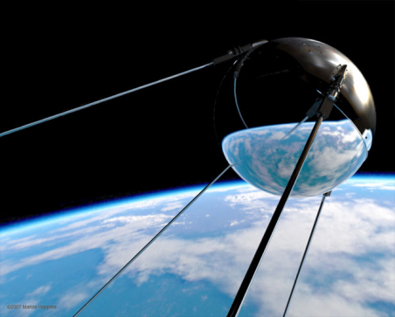
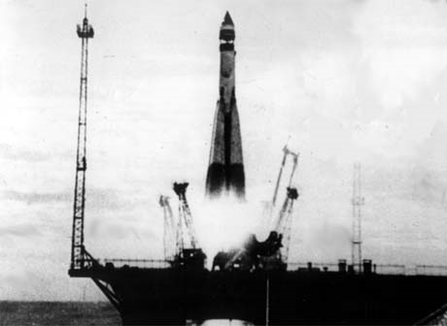
The first ever successful satellite launch was conducted by the Soviet Union on October 4th, 1957. The satellite was known as “Sputnik 1” and was the spark in the space race between the United States and Soviet Union. Sputnik was only about the size of a beach ball and weighed only around 180 pounds. The satellite itself was not the only revolutionary part of
Sputnik
Launching of sputnik
the process. The rocket used to propel Sputnik into orbit became significant in future space exploration. The rocket, known as the R-7, was originally intended to be a ballistic missile. The rocket was successful in launching sputnik into orbit and fell to pieces, much like a modern expendable rocket. The launching started a very rapid revolution for satellites and space exploration itself. It was a vital point in history and is remembered to this day.
Launching satellites into orbit is certainly a spectacle in engineering. Everything must be engineered to perfection, as there is only one shot in launching a satellite. Either expendable rockets or space shuttles are used to launch. They both have their pros and cons. Rockets are usually easier to control and have a surer chance of getting the satellite into orbit, however they cannot be reused. Space shuttles can carry up to four satellites and can be refurbished for use again, but it is a difficult process to get the satellite into its correct orbit. Apogee Kick motors take care of the rest of the job. They are attached to the satellite and use fuel to reduce any inclination of the satellite and force it into a geosynchronous orbit. The first ever successful satellite launch was the launching of Sputnik by the Soviet Union in 1957. What was originally a large missile was transformed into a rocket and used to propel the small satellite into orbit. Ever since, satellite launching has been revolutionized and used quite often. Satellites have proven to be vital for both science and everyday tasks that we take for granted such as using our cell phones. We take for granted that launching a satellite into space is an enormous task that must be engineered to perfection. Launching a satellite into its exact correct orbit is therefore quite a spectacle and contains multiple components.
Works Cited

"Apogee Kick Motor." Wikipedia, the Free Encyclopedia. Web. 26 Apr. 2011. <http://en.wikipedia.org/wiki/Apogee_kick_motor>.
Computer, Main. "Launching Satellites." Saint Mary's Roman Catholic Church. Web. 26 Apr. 2011. <http://www.stmary.ws/highschool/physics/97/KDEUTSCH.HTM>.
"Expendable Launch System." Wikipedia, the Free Encyclopedia. Web. 26 Apr. 2011. <http://en.wikipedia.org/wiki/Expendable_launch_system>.
"How Do We Put Spacecraft into Orbit?" Welcome to QRG. Web. 26 Apr. 2011. <http://www.qrg.northwestern.edu/projects/vss/docs/navigation/1-how-put-into-orbit.html>.
"HowStuffWorks "How Satellites Work"" Howstuffworks "Science" Web. 26 Apr. 2011. <http://science.howstuffworks.com/satellite2.htm>.
"The Launch of Sputnik." Needham Public Schools. Web. 26 Apr. 2011. <http://www2.needham.k12.ma.us/nhs/cur/Baker_00/03-04/Baker-LM-MB-3-04/the_launch_of_sputnik.htm>.
"Launch Vehicles, Expendable Summary | BookRags.com." BookRags.com | Study Guides, Lesson Plans, Book Summaries and More. Web. 26 Apr. 2011. <http://www.bookrags.com/research/launch-vehicles-expendable-spsc-01/>.
"Launching Satellites Into Orbit." William Cook's Home Page. Web. 26 Apr. 2011. <http://www.williamcraigcook.com/satellite/launch.html>.
Rowe, Aaron. "SpaceX Launch Successfully Delivers Satellite Into Orbit | Wired Science | Wired.com." Wired.com. Web. 26 Apr. 2011. <http://www.wired.com/wiredscience/2009/07/spacexlaunch/>.
"Satellite." Wikipedia, the Free Encyclopedia. Web. 26 Apr. 2011. <http://en.wikipedia.org/wiki/Satellite>.
"Sputnik." History Home. Web. 26 Apr. 2011. <http://history.nasa.gov/sputnik/>.

