James Swieson
Honors Introduction to Engineering
Professor Picone
11 May 2011

Magnetic Signatures of Naval Vessels
Everyone has most likely seen a movie in which marine mines are used, whether it is a submarine navigating a minefield, or a ship on the water hitting a mine that explodes. A common misconception is that mines are detonated when they are hit, or that they are magnetically attracted to the ship itself, but this is not true. Most marine mines are actually designed to be triggered when the magnetic field around them is disrupted which occurs when large amounts of steel in the form of ships or submarines pass by the mines. This is obviously a threat to navies so a goal is to decrease the magnetic fields that emanate from ships and submarines. These magnetic fields are not only dangerous because they can set off mines, but enemy navies can also detect and localize ships and be able to tell which ships it actually is, these fields are called the ship’s electromagnetic signature.
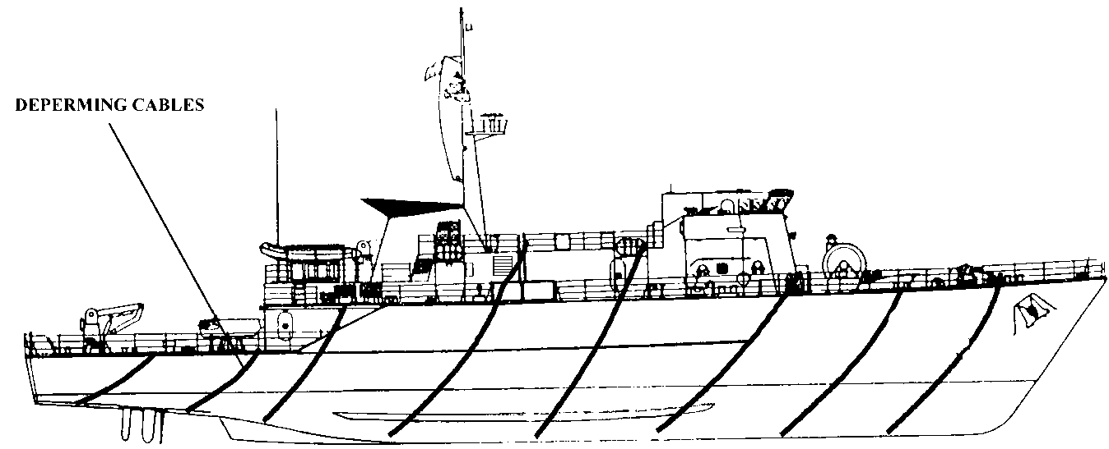
There are multiple sources for the magnetic fields that emanate from the ships, but the two main ones are Static Magnetic Signatures and Alternating Magnetic and Alternating Electric Signatures. Static magnetic signatures originate from the inherent magnetism of metals. The static magnetic signature changes depending on the geographic location of the ship within the earth’s magnetic field [1]. Other factors that affect the static field are mechanical stress that results from movement through the ocean, and impacts and shocks to the ship. There are two methods navies use to counteract this static magnetic field, degaussing and deperming. Degaussing is an on ship measure that utilizes degaussing coils that generate a magnetic field that opposes the magnetic field put out by the Earth. This way, ships can put out “known” signals so that mines and enemy ships do not register the ship as an enemy. Degaussing was first used in World War II by Commodore Charles F Goodeve as a means to counter German magnetic mines. The original degaussing system used coils installed on the ships that would create the counteracting magnetic field that would essentially camouflage the ship. Degaussing was expensive and it would have been difficult to apply it to all the ships that would need it, so another method of counteracting the magnetic field was invented called deperming. Instead of having coils on each individual ship to counteract the magnetic field, deperming uses electrical cables dragged along the hull of the ship with pulses of about 2000 amps flowing through it to create the counteracting field (Figure 1). Since deperming is a onetime treatment, it wears off and ships have to be redepermed regularly. During World War II, degaussing and deperming in this way were enough, but as time went on the marine mine’s capabilities significantly increased enabling them not to just detect the field, but a change in the field as well. Not only do new mines look for change in magnetic field, but they also monitor the precision orientation of the field making a simple degaussing camouflage not as effective. This meant that even ships that were degaussed could now be easily detected by mines, so a new method of degaussing was designed to counteract the new capabilities of the mines. This new method uses three different coils to demagnetize the ship on all three axes thus counteracting the orientation of the field problem [2].
Figure 1: Deperming Cables
Degaussing is not only used in the military, it is also used commercially in cathode ray tube (CRT) based televisions and computer monitors. Many CRT monitors have metal plates at the front of the screen which are used to focus the electronic beam from the back; unfortunately these plates can cause discoloration in the display. This is where degaussing comes in; degaussing the monitor creates a magnetic field similar to the ones for ships, though much less powerful. It uses the magnetic field to remove the discoloration from the screen. Typically, when a CRT monitor is turned on is when the degaussing occurs.
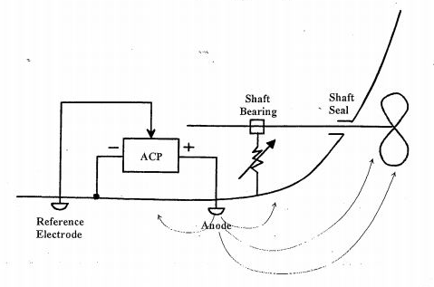
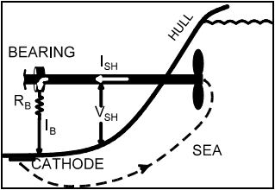
The other main source of magnetic fields emanating from ships are alternating magnetic (AM) and alternating electric (AE) signatures. One of the sources for alternating magnetic and alternating electric signatures is the electric current that flows through the ship. Ships are made using dissimilar metals and when these dissimilar metals are exposed to seawater the different electrochemical potentials causes an electrical current to flow. This electrical current causes corrosion to the ship. The most significant of these current flows exists between the steel hull and the bronze propeller of a ship. When this current flows, it sets up an electric field dipole between the hull and the propeller. To counter this dipole cathodic protection systems are used; both passive and active ones. For the passive protection, the hull of the ship is coated in zinc which encourages current flow from the zinc to the hull and the propeller. That current that flows through the propeller is then led down a shaft that grounds the current on the hull of the ship. This whole process (Figure 2) also corrodes the useless zinc instead of the much more necessary hull of the ship. The active protection utilizes one or more positively charged terminals that have high currents, low voltages and are connected to an anode attached to the exterior of the hull of the ship. A negative charged terminal is mounted directly on the hull of the ship [3]. Just like the passive protection, the active protection reduces corrosion on the hull. While it is good that these protections significantly reduce corrosion, there is a downside to them, and that is that the electric currents they create are detectable by sensors and used to identify the ship and are called a ship’s electromagnetic signature.
Figure 3: Active Cathodic Protection System
Figure 2: Passive Cathodic Protection System
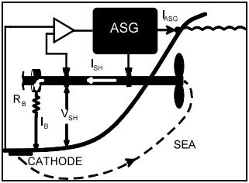
These electromagnetic signatures allow for the detection of otherwise undetectable naval vessels, so obviously it is a goal to significantly reduce or eliminate this signature. A way of reducing this is by passive shaft grounding which uses a system consisting of a brush and slip ring connecting the shaft directly to the hull of the ship. Doing this lowers the resistance of grounding the current that flows through the shaft, eliminating variations, which lowers the electromagnetic signature. Unfortunately, since this is a passive system it is not a permanent fix because the system degrades over time. A more permanent fix is using an active shaft grounding system. This system utilizes electronics to counteract the resistance between the shaft and the hull. “By determining the variations in the current on the shaft, electronics in the ASG [active shaft grounding] make use of a high current power supply to draw a proportional current through a second slip ring assembly. The ASG device therefore acts as a current bypass for the shaft bearings and seals. The fluctuations in the shaft current are therefore eliminated and the AE and AM portions of the electromagnetic signature due to shaft current modulation disappear” [1].
Figure 4: Active Shaft Grounding
As time goes on, the technology on each side will continue to improve, and as it does the other side will have to do something to counteract it; as sensors become more sensitive, ships will have to become more invisible, as ships become more invisible, sensors will have to become more sensitive.

References
- Jeffrey, I., and B. Brooking. "A Survey of New Electromagnetic Stealth Technologies." W.R. Davis Engineering Lt. Web. 20 Apr. 2011. <http://www.wrdavis.com/docs/pub/New_Electromagnetic_Stealth.pdf>.
- RAZICHEANU, A., V. IONITA, and H. GAVRILA. "METHODS OF REDUCING SHIP’S MAGNETIC SIGNATURE." Web. 20 Apr. 2011. <http://snet.elth.pub.ro/snet2004/Cd/camp/camp_P2.pdf>.
- Holtham, Peter, Ian Jeffrey, Brett Brooking, and Troy Richards. "Electromagnetic Signature Modelling and Reduction." W.R. Davis Engineering Lt. Web. 20 Apr. 2011. <http://www.wrdavis.com/docs/pub/electromagnetic_signature_modeling_and_reduction.pdf>.

Figure 1: http://www.fas.org/man/dod-101/navy/docs/swos/eng/62B-303.html
Figure 2: http://www.wrdavis.com/docs/pub/New_Electromagnetic_Stealth.pdf
Figure 3: http://www.wrdavis.com/docs/pub/electromagnetic_signature_modeling_and_reduction.pdf
Figure 4: http://www.wrdavis.com/docs/pub/New_Electromagnetic_Stealth.pdf

