Name:
Score: ____________________

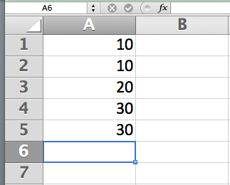
- Explain in sufficient detail the commands you would use in Microsoft Excel to compute the average of the numbers shown and store the result in cell B6. Implement this in a way that if I were to add a row between rows 2 and 3, your result would be automatically updated.
(2) Explain how you would sort rows 1 to 5 into ascending order.

