Name:
Score: ____________________

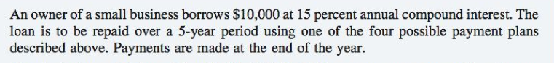
Compute the amount of the annual payment assuming 5 equal payments are made.

