Name:
Score: ____________________

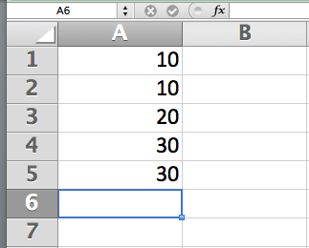
- Explain in sufficient detail the commands you would use in Microsoft Excel to manually compute the sum of the squares of the numbers shown and store the result in cell B6. Implement this in a way that if I were to add a row between rows 2 and 3, your result would be automatically updated.
(2) Explain how you would plot a bar chart graph of rows 1 to 5.

