Name:
Score: ____________________

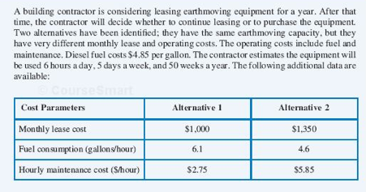
- What is the least costly alternative?

