Name:
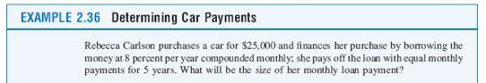
Score: ____________________

