Name:
Score: ____________________

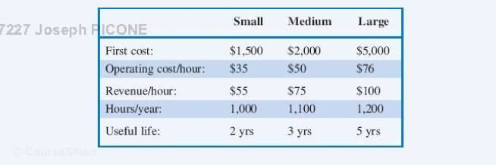
Three industrial mowers (small, medium and large) are being evaluated by a company that provides lawn care service. At the end of its useful life, each mower will have a salvage value that is equal to 10% of its original cost. Suppose a planning horizon of 5 years is to be used. Determine the economic choice based on annual worth.

