Its Not Just PCs
Dennis Silage, PhD
System Chip Design Laboratory
www.temple.edu/scdc
Department of Electrical and Computer Engineering
College of Engineering
Temple University
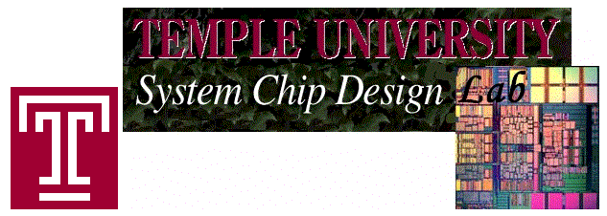

1977: Apple II Computer
with the Microprocessor from Norrristown

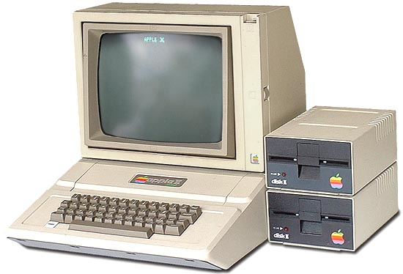
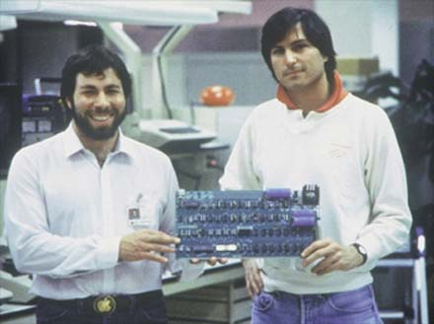
The Apple II was a home computer, one of the first highly successful mass-produced microcomputer product and designed primarily by Steve Wozniak. Steve Jobs was the marketing genius behind Apple’s success. The Apple II was manufactured by Apple Computer and introduced in 1977.

The Apple II used the MOS Technology 6502 microprocessor designed in Norristown and had 16 Kbytes of memory, expandable to 48 Kbytes, limited color graphics and a 1 MHz clock frequency.
1981: IBM Personal Computer Model 5150
The Big Name in Business
Comes to Personal Computing
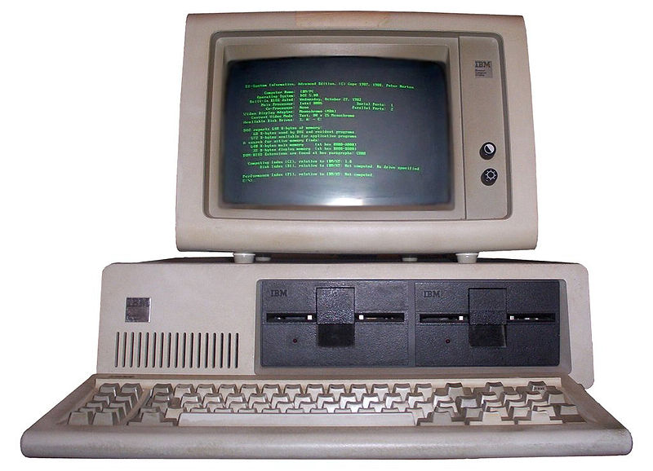
The IBM Personal Computer Model 5150 is the original version of the IBM PC compatible hardware platform. The Model 5150 was created by a team of engineers under the direction of Don Estridge of the IBM Entry Systems Division in Boca Raton, Florida.
Because of the success of the IBM Personal Computer, the term PC came to mean more specifically a microcomputer compatible with IBM's PC products. Shown here is the Model 5150 motherboard which had a 5 MHz clock frequency (about 400 times slower than today’s PCs), audio cassette port for program storage and retrieval (because 5.25 inch floppy disks were expensive), 48 Kbytes of memory, BASIC in read-only memory (ROM) and a price of $1560.
1982: Timex/Sinclair ZX81
Personal Computing for less than $100

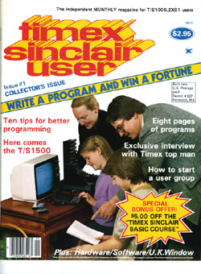
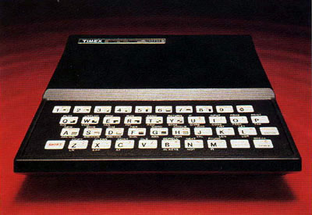
British inventor Sir Clive Sinclair introduced the ZX80 in 1980, an inexpensive computer designed to bring computing to the masses. The tiny machine output black and white video and had a built-in RF modulator to display on a TV channel. In July 1982 watch maker Timex began selling the Timex Sinclair 1000 clone of the ZX81 at their dealership network in the United States. At a retail price of $99.95, this was the first fully assembled computer for less than $100.

1976: MOS Technology/Commodore Computer
KIM-1 Microprocessor Trainer
Teaching the Next Generation of EEs
with the Norristown-West Chester Connection
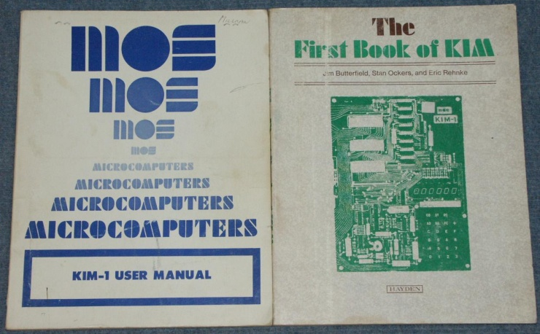
The KIM-1, short for Keyboard Input Monitor, was a small 6502 microprocessor based single-board computer developed and produced by MOS Technology and in 1976. It was very successful because of its low price and expandability. The KIM-1 had 1 Kbyte of memory and a 1 MHz clock frequency. Programming was entirely in machine language using a hexadecimal (base-16) keypad for address, data and instructions. MOS Technology later was absorbed by Commodore Computer in West Chester.
The Electrical Engineering Department (as it was known then) at Temple University was the first local institution to offer a microprocessor technology and design course for undergraduates.
1984: IBM PC/AT
The PC Grows Up
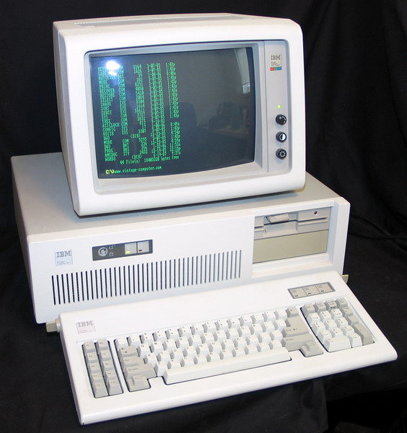
The IBM Personal Computer/AT, more commonly known as the PC/AT, was IBM's second-generation PC, designed around the 6 MHz, 16-bit Intel 80286 microprocessor and released in 1984. AT stood for Advanced Technology, and was chosen because the AT offered various technologies that were then new in personal computers.
Shown here is the motherboard which had a 5 MHz clock frequency (about 400 times slower than today’s PCs), 512 Kbytes of memory, 5.25 floppy drive, a 10 Mbyte hard drive and a price of $3250. The PC/AT also features the Intel 80287 floating point coprocessor which gave it the capability to do some engineering design and analysis.
2008: Microchip Technology
32-bit Embedded Processor
Doing a Lot with Less
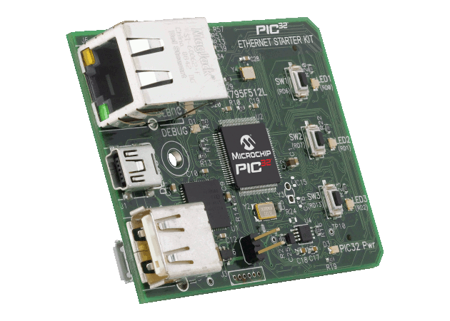
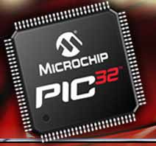
Electrical and computer engineers have moved away from the PC and have embraced embedded system design because microprocessors are everywhere and in everything. The Microchip Technology PIC 32-bit microprocessor is the current architecture being taught to undergraduate ECE students. Although microprocessor machine and assembly language was once taught, the C language is now used in course work coupled with wired Ethernet and wireless technology.
The Microchip Technology Ethernet Starter board shown runs at 80 MHz (80 times faster than the Apple II) and has USB and Ethernet connectors for embedded data communication.
2010: Texas Instrument eZ430 Chronos Watch
Its Not Just a PC!
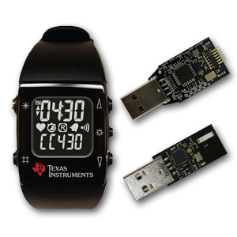
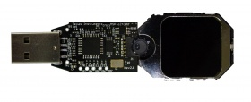
There are plenty of iPods, MP3 players, digital cameras, PDAs, GPS and cell phones but a reprogrammable wrist watch? The Texas Instruments eZ430 Chronos Watch is priced at $60, is fully user programmable with its own microprocessor based computer and can be controlled by a Bluetooth wireless interface.
The eZ430 Chronos Watch can form a wireless personal network with a 3-axis accelerometer, pressure, temperature and battery voltage sensors. Users have turned the eZ430 Chronos Watch in a golf swing analyzer, home automation controller for lighting and security, Theremin musical instrument, heart rate monitor, bicycle speed and distance meter and a Wii-like game and computer mouse interface.

