wThe Temple University Hospital Digital Pathology Corpus
Nabila Shawkiª, M. Golam Shadinª, Tarek Elseifyª, Luke Jakielaszekª,
Tunde Farkas^{b}, Yuri Persidsky^{b}, Nirag Jhala^{b}, Iyad Obeidª, and Joseph Piconeª
ª The Neural Engineering Data Consortium, Temple University, Philadelphia, Pennsylvania, USA
^{b} Department of Pathology and Lewis Katz School of Medicine, Temple University, Phil., PA, USA
Abstract
Pathology is a branch of medical science focused on the cause, origin, and nature, of disease. A typical pathology laboratory workflow involves the preparation of a tissue specimen on a glass slide using a stain designed to enhance imaging and analysis by a board-certified pathologist using a conventional light microscope. Digital pathology is the process of digitizing an analog image so that it can be manipulated by a computer. Digitizing pathology slides into whole slide images provides many benefits including realtime, remote analysis of the specimen. Digital pathology is creating an enormous opportunity for the application of machine learning techniques to automate and accelerate the diagnostic process. Over ten million pathology slides are produced and interpreted by experts annually in the United States alone. This suggests that there is an ample supply of data to support machine learning research if it can be acquired and curated in a cost-effective manner.
In this chapter, we discuss the development of the world’s largest open source corpus of digitized pathology images and review the process being used to collect the digital images along with associated standards for annotation and archival. These images are currently being collected at Temple University Hospital and are facilitating the development of automated interpretation technology. This corpus, known as the Temple University Hospital Digital Pathology Corpus (TUHDP), is expected to reach one million images, or one Petabyte of data, over the next decade. Though this corpus is currently being collected using a single digital scanner at one institution, we hope over time we can include data from other hospitals and scanning equipment. The initial phase of the project, which is described here, focuses on generating 100,000 images that will be released by December 2020. The first installment of this release, over 20,000 images, is now publicly available.
The performance of deep learning systems is heavily dependent on the breadth and quality of the data used. In this chapter, we also introduce some pilot experiments on classifying various types of images using a deep learning system that is based on a combination of convolutional neural networks and long short-term memory networks. We show that performance on relatively simple tasks, such as artifact classification, exceeds 95% sensitivity. We discuss several approaches to memory management and computational complexity issues for these ultra-high-resolution images. We demonstrate that the field of pathology is sufficiently rich to support the development of high-performance classification systems. These systems enable a new generation of decision support technology for pathologists. This directly addresses a future industry need for efficient workflows in response to the projected decline in the number of board-certified pathologists.
Corresponding Author: Joseph Picone, The Neural Engineering Data Consortium, ENGR 703A, Temple University, 1947 North 12th Street, Philadelphia, Pennsylvania, 19122, USA, Tel: 215-204-4841, Fax: 215-204-5960, Email: joseph.picone@gmail.com.
Keywords— Digital Pathology, Deep Learning, Big Data, Convolutional Neural Networks, CNN, Long Short-Term Networks, LSTM

Introduction
Pathology is a branch of medical science focused on the cause, origin, and nature, of disease (Sattar, 2017). It involves the examination of tissues, organs, and bodily fluids, to diagnose disease. A typical pathology laboratory workflow involves the preparation of a very thin tissue specimen mounted on a glass slide using either a frozen section or a paraffin wax agent (Rolls, 2018). A stain designed to enhance imaging and facilitate analysis by a board-certified pathologist is also applied (Anderson, 2019). Though hospitals are required by legislation such as the Clinical Laboratory Improvement Amendments (https://www.cdc.gov/clia/law-regulations.html) to archive these slides for a minimum period of time ranging from two years to 10 years, most major hospitals house them for 10 years or more (Eiseman & Haga, 2000; American Cancer Society, 2019). Unfortunately, these extensive archives, which are organized only by case numbers, often exist offsite, making it extremely difficult for pathologists to query the available data for routine decision support. The slides also tend to degrade over time, which is another argument for the archival of high-resolution digital images (Kapila et al., 2016).
Pathology laboratories are a vital, behind the scenes, round-the clock operation that play a critical role in a hospital’s surgical mission. They provide an analysis of various samples (e.g., surgical biopsies) in real-time and contribute to a large percentage of the medical decisions made at a hospital that involve surgery or emergency care (Hallworth, 2011). Interpretation skills take years to develop (4 years of college, 4 years of medical school, 4 years of residency and 1-2 years of fellowship). Each diagnosis can be life-altering, so accuracy is critical. Hence, skilled professionals trained to perform this task with precision and accuracy are in short supply. This pool is expected to decrease in the next two decades (Jhala, 2017), increasing the need for decision support technology that can increase a pathologist’s productivity.
An example of a typical pathology slide is displayed in Figure 1. A textbook case of low-grade prostate cancer is shown (Barry et al., 2008). This slide was determined to be cancerous because approximately 10% of the core from the left base (A) and about 1% of the core from the right mid-portion of the gland (B), both highlighted with arrows in Figure 1, were cancerous. Because pathologists must look for extremely small and subtle abnormalities in these slides, they have traditionally relied on a conventional analog optical microscope that can be adjusted to a variety of magnification levels and focus points (The Medical Futurist, 2018). It has been difficult for pathologists to embrace digital technology because they require scanned slides which can be viewed at ultra-high-resolutions. Digital technology has only recently made this feasible. However, this technology provides a much different user experience than they are accustomed to, and there are concerns that diagnostic skills developed for microscopic inspection may not carry over to the inspection of digital slides (Stathonikos et al., 2013).
Digital Pathology refers to the process of digitizing an analog image so that images can be retrieved, manipulated, and evaluated by computers. It is rapidly gaining momentum as a proven and essential technological tool now that the cost of digital storage has dropped significantly. In addition to enabling a broad array of research agendas, digital imaging is impacting primary diagnosis, diagnostic consultation, medical student training, peer review, and tumor boards. The latter two are important parts of a pathologist’s workflow – regular evaluation and review play a crucial role in their ability to maintain certification.
Scanning slides at resolutions acceptable to pathologists can be problematic. There are currently two dominant vendors in the commercial marketplace: the Leica Biosystems Aperio AT2 used in this study (Leica, 2019) and the Philips IntelliSite Pathology Solution (Philips, 2019). Images are routinely scanned at a resolution of $50K x 50K$ pixels per slice, and often these slices are stacked to produce a 3D image, a process known as z-stacking (Hanna et al., 2017). These digitized slides, which can exceed the limits of a JPEG representation (Joint Photographic Experts Group, 2019) due to the large pixel count, can require gigabytes of disk space to store a single image. Large archives of these images can require petabytes of storage. Fortunately, creating a file server to host this amount of disk space is relatively inexpensive (Campbell et al., 2018), enabling a transition to digital imaging.
Digital pathology can also have a positive impact on the practitioner’s lifestyle. Pathologists spend a significant amount of their time on call and must travel to their worksite, often at inopportune hours or peak traffic periods, to review slides for emergencies (e.g., organ transplants). Digital pathology allows slides to be reviewed remotely, thereby reducing the need for lengthy commutes and lifestyle disruptions while also lowering labor costs. This form of telemedicine is becoming increasingly popular in low resource countries where there are no alternatives (Mahar et al., 2018).
This growing demand for digital pathology is creating an enormous opportunity for the application of machine learning techniques to accelerate diagnostics. Digital pathology is one of several healthcare-related imaging fields poised to embrace a new generation of artificial intelligence-based decision support technology (Beam & Kohane, 2016; Janowczyk & Madabhushi, 2016; Hamilton et al., 2014). Over ten million pathology slides are produced and interpreted by experts annually in the United States alone. This suggests that there is an ample supply of data to support machine learning research if it can be acquired and curated cost-effectively. This digitization process offers long-term benefits which include the prevention of physical slide decay, e.g., stain discoloration and tissue degradation (Bauer et al., 2018). Many medical arenas have adopted digital pathology in tissue-based research because it offers the convenience of image analysis techniques such as detection, segmentation, and classification (Janowczyk & Madabhushi, 2016). Cancer research has applied digital pathology techniques along with machine learning and deep learning systems to yield very promising results (Litjens et al., 2017; Kourou et al. 2014).
Though computer science research on this application currently focuses on simple problems such as a cancer/no-cancer decision (Barker et al., 2016), pathologists can diagnose thousands of conditions over the course of their career. Further, the severity of a disease, often quantified using a scale such as Gleason’s index (Gleason, 1992) or the more recent International Society of Urological Pathologists (ISUP) Grade Group (Gordetsky & Epstein, 2016), is part of a typical diagnosis. The pathology that triggers such a diagnosis can often result from the observations collected from a small percentage of the overall image. This type of unbalanced data set, where one class assignment is much more likely than the rest, causes problems for machine learning algorithms (He & Garcia, 2009). In cases such as these, where one class occurs a disproportionately high number of times (e.g., the non-event class occurs 99% of the time while the event classes occur 1% of the time), machine learning algorithms tend to learn to guess the most frequently occurring class. This is the obvious way to maximize performance, especially if the level of performance (e.g., 50%) is significantly lower than the prior probability of the most frequently occurring class (e.g. 99%). It is not unusual that guessing based on priors outperforms a machine learning algorithm in the early stages of technology development.
We often use the analogy of finding a “needle in a haystack” to describe these kinds of problems since the entire image must be searched for these small, localized events that occur infrequently. Though pathologists can do this effortlessly, it is extremely challenging for a machine learning system. The ability to accurately segment the image plays a crucial role in high performance classification. Reduction of false alarms, which we will discuss in detail later, is a very significant part of the algorithm design in these kinds of applications, since the system must be pressured to not always guess the most likely class.
Machine learning approaches for digital pathology, specifically deep learning approaches, are still in their infancy, lacking the necessary data to support complex model development. Hence, the goal of this chapter is two-fold. First, we will discuss the development of a digital pathology corpus that will support clinical decision support and medical student training. This corpus is also being created to energize deep learning research on automatic interpretation of images. It is part of a National Science Foundation Major Research Instrumentation (NSF MRI) grant (Picone et. al, 2017) focused on the development of digital pathology resource. Second, we present some preliminary findings on the development of deep learning architectures to classify high-resolution digital pathology images.
  - Digital Pathology
Annotation of a large archive of whole slide images (WSI) on a cloud-based server provides an opportunity for pathologists to quickly retrieve WSIs through simple natural language queries that integrate both image data and electronic medical records. We have been developing such technology for many years in related areas of human language and medicine such as speech (Harabagiu, Picone & Moldovan, 2002) and electroencephalograms (Capp et al., 2018; Picone, Obeid & Harabagiu, 2018). The ability to query data representing physical signals (e.g., digital images) symbolically, can be quite powerful as both a decision support and teaching tool.
The workflow of a pathologist begins with fixation of biological tissue in order to prevent their deterioration via autolysis (Ross, 2019). Fixation is the chemical process by which biological tissues are preserved from decay, either through autolysis or putrefaction. Tissue fixation is a critical step in the preparation of histological sections since it allows for the assembly of thin, stained sections. Though the details of this process vary depending on the type of specimen, the general process for creating the samples can be summarized as follows. The tissues are trimmed with a scalpel and transferred to a cassette where they are processed following these steps: (1) dehydration with increasing concentrations of alcohol, (2) clearing with an organic solvent such xylene, and (3) embedding with paraffin wax. Next, the embedded tissue is cut into thin slices, known as sections, about the thickness of a piece of paper (~5 μm for light microscopy). Finally, each section is transferred to a glass slide where a stain is applied to the sections, and a cover is placed on them to generate a specimen sample. At the end of this process, a board-certified pathologist inspects the specimen sample through an analog optical microscope to generate a diagnosis. The glass slides containing the sample are then sorted by their specimen type and archived at an offsite location.
In digital pathology, an image of an analog specimen is captured as a whole slide image (WSI) using a laser scanner that produces an image with a resolution of 0.2 μm/pixel. Though a large number of slides can often be scanned automatically, approximately 5% of our slides require selecting manual focus points to help the scanner properly focus. WSIs can contain one or more specimens, which further complicates the machine learning problem. In Figure 2, several examples of WSIs from the breast specimen type are shown. The first (top) specimen was obtained from a lumpectomy of the right breast and exhibits a condition known as atypical lobular hyperplasia. The second (middle) specimen, obtained from an excision of the right breast duct, is an example of intraductal papilloma with ductal hyperplasia. The third (bottom) specimen, obtained from a biopsy of the right breast, exhibits fibroepithelial lesions consistent with fibroadenoma. These examples demonstrate that in real clinical data the number of specimens per slide ranges from one to six. These types of WSIs warrant additional time to study as the focal points and scanning area need manual adjustments. Such data requires the machine learning system to segment that data and determine the number of specimens as part of the classification process. This significantly complicates the problem.
Despite the existence of a large volume of pathology data in private institutions, there is no existing comprehensive public WSI corpus. Currently available resources, such as The Cancer Genome Atlas (TCGA) (Gutman, 2013), contain only hundreds of slides per cancer type. Barker et al. (2016) utilized the TCGA Corpus to create an automated classification system for types of brain tumors and claimed that the machine’s performance surpassed human execution. This study utilized a subset of the TCGA Corpus that consisted of 604 WSIs of two types of brain cancer (240 lower grade glioma and 364 glioblastoma multiforme slides were used). These types of limited studies can commonly be found in digital pathology literature. Performance estimates based on such small corpora can often be overly optimistic.
Private corpora, on the other hand, contain WSIs on the scale of hundreds of thousands. One such example is a dataset of approximately 300,000 WSIs developed by Philips and LabPON (Drissen, 2017). These private corpora, however, are built and maintained for the development of proprietary commercial software and are not available to the general public as open source resources. Open source access usually requires release of the data in such a way that licenses or data sharing agreement are not mandatory. This creates an added level of complexity since unencumbered sharing of data in the bioengineering community is less common than one might imagine. The Neural Engineering Data Consortium (www.nedcdata.org) and the Institute for Signal and Information Processing (www.isip.piconepress.com), both at Temple University (TU), have a history of delivering such data (and related resources such as software) for research and commercial use that dates back to the early 1980’s.
NEDC currently has over 2,000 bioengineering researchers subscribed to its EEG resources (https://www.isip.piconepress.com/projects/tuh_eeg). These corpora are one of the only resources of this scale that is truly available in an open source manner (Obeid & Picone, 2018). No licensing or data agreements are required to download the data. No research-only restrictions have been placed on the data. The data is freely available for research and commercial use. The corpus described in this paper, known as the TUH Digital Pathology Corpus (TUDP), is being developed and released in a similar unencumbered manner (see https://www.isip.piconepress.com/projects/nsf_dpath for more details). The near-term goal of this project is to release 100,000 slides by the end of 2020. Our ultimate goal is to release one million slides by the end of the decade.
  - Deep Learning
Due to its success in diverse areas such as speech recognition, machine translation, and computer vision. Deep learning has enjoyed great popularity in recent years. Previous neural network systems based on proven technologies such as a multilayer perceptron traditionally used three layers. A deep learning system (de Freitas et al., 2017) typically consists of a much larger number of layers, or nonlinear learning modules, that successively abstract the data until a final classification is made. These abstractions formed at one layer become the input to the next layer and are trained using a combination of supervised and unsupervised learning. Supervised training requires annotated data, which is often difficult to acquire. Unsupervised training is attractive because it does not require detailed annotations of the data. The goal of our corpus is to lessen the burdens of supervised training by providing consistent and correctly annotated digital pathology slides to further develop the machine learning and health care fields. In this chapter, we will discuss the challenges of annotating large amounts of pathology data.
Deep learning architectures are notoriously sensitive to minor changes in the input data and must often be optimized for a specific application. Hence, a second goal in this chapter is to provide a baseline architecture for classification of high-resolution pathology images. We leverage our previous work on developing deep learning systems for electroencephalograms (EEGs) (Golmohammadi et al., 2019). Our work on EEGs and WSIs share a common theme – both applications require spatial context to achieve high performance. The framework we introduce can easily accommodate a large variety of deep learning algorithms.
Applications that require spatial or temporal context typically use an architecture based on Convolutional Neural Networks (CNNs) (LeCun & Bengio, 1995). These have proven useful in many applications including EEG event detection (Golmohammadi et al., 2018), speech recognition (Saon et al. 2016), and image recognition (Simonyan and Zisserman 2015). CNN architectures have made great advances in the field of image classification. For example, in Ghiasi et al. (2018), state-of-the-art object recognition was achieved at Google using CNNs by introducing an approach, DropBlock, which selectively deletes features. Regular dropout discards features regardless of their spatial correlation among layers. This can result in overfitting. In Chen et al. (2018), Facebook achieved state-of-the-art performance on facial recognition by introducing a “double attention block” that “aggregates and propagates informative global features from the entire spatio-temporal space of input images/videos, enabling subsequent convolution layers to access features from the entire space efficiently.”
Deep CNN architectures have also been applied to the field of digital pathology. Cireşan et al. (2013) employed deep CNN networks for detection of mitosis within breast cancer histology images on a centralized pixel basis. Cruz-Roa et al. (2014) applied patch-based CNNs that automatically derived hierarchical features and showed them to be superior to hand-crafted counterparts in detecting invasive ductal carcinoma. Hua et al. (2015) demonstrated that machine learning techniques based on CNNs and deep belief networks outperformed traditional computer-aided diagnosis schemes in lung nodule classification. Sirinukunwattana et al. (2016) demonstrated that spatially constrained CNNs can be used not only to classify a nucleus in a cell, but also to analyze the nuclei’s localities in the image. Litjens et al. (2017) concluded in their survey that state-of-the-art machine learning methods are now pervasive in the medical field, providing a convenient and effective solution for a variety of classification problems. Bejnordi et al. (2017) recently used stacked convolutional neural networks to effectively classify whole slide images of breast tissue. Finally, Wang et al. (2016) showed that deep learning systems, combined with professional pathologist classification, reduce the human error rate in diagnosis by approximately 85%. Integrating human knowledge into deep learning systems is a major focus for the next generation of machine learning approaches.
High-resolution WSIs introduce some unique challenges with respect to deep learning systems because these images cannot be processed as a whole. They must be segmented and scanned using a process similar to what is used for temporal signals. Hence, in this chapter, we also discuss some preliminary results on deep learning architectures, developed for these high-resolution images, that sequentially scan images using small frames and classify the entirety of the image by integrating a series of local decisions.

The TUH Digital PAthology Corpus (TUDP)
An overview of the major components of our NSF MRI project is provided in Figure 3. These kinds of corpus-centric projects often require a significant number of iterations before we can arrive at a final corpus design and implementation strategy. Hence, we often follow a concurrent design process that includes frequent input from our subject matter experts – the Temple University Hospital (TUH) Department of Pathology in this case – and the community of researchers who will consume this data. We include researchers in the design process by maintaining a community-wide listserv that facilitates discussions about the data. Further, we run concurrent machine learning experiments on the data to ensure that it is useful to machine learning researchers. Concurrent experimentation on the data is particularly important in guiding the data development and annotation processes since we can identify and avoid systematic biases or inconsistencies in the data.
A long-term goal of our digital pathology project is to integrate digital imaging into TUH’s clinical operation. This will give us continuous access to data generated at the hospital and allow us to continue augmenting the corpus over the next decade. There are five major components to this goal: (1) computing infrastructure, (2) image digitization, (3) data organization, (4) data anonymization, and (5) data annotation. We briefly describe each of these in this section.
  - Computing Infrastructure
The implementation of a cost-effective storage architecture to accommodate the 1 Petabyte (PB) of storage required to hold one million pathology images was an important goal in this project. The architecture developed for this project is described in detail in Campbell et al. (2018). Although cloud computing is an enticing technology for many problem spaces, it does not come without its drawbacks, including, most notably, data privacy and security issues. In addition to its virtualization overhead, the cost of cloud storage at scale can be exorbitant. One example would be Amazon’s S3 storage which was priced at $ 0.021 per Gigabyte-month (using their US East Coast pricing) (Obeid & Picone, 2016), or approximately $35K/month/PB. For the cost of one month of storage, we were able to build dedicated hardware from low-cost commercial components that cost roughly $45K/TB. This is an order of magnitude lower in cost than most high-end commercial solutions using proprietary hardware.
For the pathology corpus, it was essential that the operations performed on the data, particularly viewing and annotation, did not experience low throughput and high latency. Latency, in particular, would result in the system failing to meet the needs of clinicians. Another essential requirement for the infrastructure housing the corpus, especially in clinical settings, was its robustness with respect to physical hardware failure. This was because the data stored in the corpus would have to be Health Insurance Portability and Accountability Act (HIPAA) protected for clinical or diagnostic purposes, hence any loss in data due to disk or hardware failure would be disastrous. Therefore, it was imperative that the system be capable of withstanding hardware failure events and preserving the integrity of the data.
The computing infrastructure had to address two issues: computation and storage. For this reason, several improvements and expansions to our high-performance computing (HPC) cluster, known as Neuronix (Campbell et al., 2017), were implemented. To manage the increased computational capacity and job throughput, Slurm, an open source workload manager, was employed as the scheduler and resource manager (Yoo et al., 2003). For storage, a multilayer filesystem based on Gluster (Red Hat Inc., 2019) and a Zetabyte File System (ZFS) (Bonwick et al., 2003) was implemented to distribute a filesystem across numerous machines.
Slurm provides numerous features for handling a number of diverse situations. Its most notable feature is the built-in capability to support Graphics Processing Unit (GPU) scheduling, including jobs that use multiple GPUs simultaneously. Moreover, Slurm’s general resources (GRES) feature allows the support of resources along with those provided by traditional HPCs such as memory and wall clock time. Additionally, Slurm performs meticulous enforcement of resource allocation, providing the necessary resources to satiate increasing computational data as the number of jobs increases and preventing resources from other jobs being taken. In GPU-enabled frameworks, it is common to query the CUDA runtime library/drivers and iterate over a list of GPUs in order to institute a context on every GPU. Slurm has the ability to influence the hardware discovery process of such jobs, facilitating them to operate simultaneously even if the GPUs are in exclusive-process mode (Campbell et al., 2018).
For the storage architecture of the corpus, a robust and extensible distributed storage device was devised which employed numerous open source tools for the creation of a single filesystem. This filesystem can be mounted by any machine on the network. Figure 4 shows the file server architecture that has been developed for the corpus. The lowest abstraction level of the infrastructure consisted of the hard drives, which were split into four 60-disk chassis. Each disk chassis contained 8 TB drives. These systems are maintained by two server units, each of which were equipped with Intel Xeon CPUs and 128 GB of RAM. One server serves as the primary server, while the second serves as the backup, mirroring the primary. A multilayer file solution was implemented that provides the entire disk farm over 2 TB from a single mount point. The distribution of the storage among a network of machines provides the benefit of a fault tolerant and extensible system. Each machine provides an independent copy of the data by taking advantage of ZFS’s disk-level awareness. The ZFS RAID implementation (Bonwick et al., 2003) protects data from corruption as well as the RAID write-hole bug by utilizing copy-on-write functionality and a journaling scheme (the ZFS intent log or ZIL). The mirrored configuration enables data written to one machine to be automatically copied to another machine without running explicit backup software. This is a necessary feature given the amount of disk space involved.
Ensuring data security and privacy are major issues for a project of this nature. Figure 5 provides an overview of the physical implementation of the systems. Networking issues are quite significant here since the scanner resides on the hospital’s secure HIPAA network (TUHS-HIPPA), while the file servers reside on a university HIPAA network (TUMC-HIPPA). The latter can accommodate researchers and the computing cluster that resides on the university’s main campus network (TUSecure). It is interesting to note that even though the latter two networks are geographically separated from TUHS-HIPPA by about 2 miles in North Philadelphia, they do not pose serious issues in terms of bandwidth and latency. These machines were not allowed to sit on the same physical network due to concerns about the impact they would have on hospital operations. Creating the ability for these systems to communicate with one another in a secure but transparent way without burdening pathologists with complex VPN interfaces was no easy feat, requiring modification of several router tables and firewalls.
  - Image Digitization
We are using a Lecia Biosystems Aperio AT2 high volume scanner (Leica Biosystems, 2019), as shown in Figure 6, to digitize our slides. This scanner is an industry leading unit that includes an autoloader consisting of 10 trays that can hold 40 slides each, resulting in a total capacity of 400 slides. The AT2 can scan slides at magnifications of 20X and 40X. It also provides a z-stacking feature that can stack a maximum of 25 layers. The AT2 has a throughput of 50 slides per hour at 20X resolution which allows it to scan 400 slides within a period of eight hours. The operation of the scanner is controlled via the Aperio’s Scanscope Console software. The images and their metadata are managed by a web-based application called eSlide Manager (eSM). A typical scanned specimen slide, as shown in Figure 7, requires approximately 200 Megabytes (MB) of storage. However, this size can increase to 1 Gigabyte (GB) for slides containing multiple specimens, as shown in Figure 2, and up to 5 GB for z-stacked images. Since scanning 400 slides requires about eight hours to complete, the scanning operation is run overnight, and the resulting images are then organized using eSM the next day.
Pre-scan snapshots must be taken before the scanner is set to perform full scans overnight, prohibiting complete automation of the scanning operation. An overview of the process is given in Figure 8. The process begins with the scanner taking a low-resolution image of the specimen by placing several focus points on the image and marking a region of scanning using a green rectangular box. This automated process takes around two hours for the 400 slides loaded and allows the user to complete a quick review of the snapshot. The number of pixels in the final image will vary depending on the size of the bounding box identified during this snapshot process.
There are some cases where the scanner makes errors in its placement of the focus points and in determining the area of the scanning region. Both cases will cause a failure in the image processing of the specimen, thus causing a failure in scanning. Another error modality occurs when the scanning region is too large, which can cause unnecessary white space to be included in the WSI. In this case, the scanner might produce an image that is larger than necessary. Similarly, there is a risk of producing invalid images if the scanning region only partially encloses the specimen of interest. These events tend to occur with slides that are lightly stained or slides with a significant amount of white space between tissue samples. In such cases, the focus points must be manually placed. This makes the pre-scan snapshot phase of the scanning procedure labor-intensive. Among the 400 slides set to scan overnight, we find about 2% are likely to experience a scanning failure. However, this number varies according to the quality of the stain applied to the slides. These failed slides are reviewed, readjusted, and scanned again the next morning.
The scanned image produced from the Aperio AT2 is stored in a file format known as ScanScope Virtual Slides (SVS) (Satyanarayanan et al., 2013). A discussion of imaging file formats is beyond the scope of this paper because this is a fairly complex and well-developed area of science in the medical imaging community (Clunie, 2019). The SVS file produced by the AT2 can be stored in one of many user-defined formats (Leica Biosystems, 2008). Each pixel is represented as a red, green and blue (RGB) triplet using 8 bits per color. An SVS file is layered image representation that includes several thumbnails and the original source image. The source image is stored using JPEG compression with a quality factor of 70. (The specific image type in the Aperio ImageScope software is “SVS/JPEG 2”. The parameter “Image Depth” is set to 1 and “Image Channels” is set to 3.) These parameters result in roughly an order of magnitude of compression over lossless compression with minimal image degradation.
A full resolution image is stored as the baseline image using a tile size of $240 x 240$ pixels (an image is represented as a series of adjacent tiles, or blocks). The following three layers contain downsampled version of the image at resolutions of 4:1, 16:1 and 32:1. The final layer is a low-resolution thumbnail. Each of these layers is an image encoded using lossy JPEG encoding. An SVS file also contains a low-resolution picture of the slide’s label as metadata and stores other information such as the downsample and offset information. The number of layers generated depends on the size of the original image. Smaller images (e.g., the maximum dimension is less than 50K pixels) will generally have only two layers.
These files can be viewed and edited in the Aperio ImageScope software (Leica Biosystems, 2018). Other open source software tools are also available that can view and manipulate SVS files (Rojo et al., 2006). SVS files are used as the primary file type for the pathology corpus due to its efficiency and its ability to handle full resolution images. The number of pixels in the original image exceeds the limits of the JPEG standard, and hence these images are collected and distributed using the SVS format.
Our primary software for viewing SVS files is Aperio ImageScope. This software features a wide variety of tools for image editing, adjusting, and annotation. The image adjustment tools include brightness and contrast controls, color balance, and color curve adjustment. These can be applied to all channels or for individual red, green, or blue (RGB) channels. These adjustments only apply to the viewed image and do not modify or overwrite the stored image. The settings applied to the current session can be saved and applied to other scanned images. The default presets for ImageScope are always applied to the scanned images. Then, the image adjustment tools can be utilized to calibrate the image features according to the pathologist’s preferences. The stains applied on specimen images cause a specific structure to adopt a distinct color, and this color can be enhanced by adjusting the brightness, contrast, and the color channels of the image via the image adjustment tools. This is a beneficial tool for pathology diagnosis as it can be used to allow specific areas of investigation (such as cancerous tissue) to be more focused or to enhance quality of lightly stained specimens.
As mentioned earlier, the Aperio AT2 scanner features a z-stacking option. The scanner can produce multiple images of a slide tissue that were scanned at different focal depths. This generates a 3D image that allows navigation of the image through different focal depths, which is analogous to the process pathologists use with an analog microscope. ImageScope features a tool that can adjust the focal depth that is similar to using the objective fine and coarse adjustments of a focus slider in a microscope. This feature has yet to be explored in the Department of Pathology at the Temple University Hospital but is being used by other hospitals. The z-stacked images are very large in size, often several gigabytes, which poses additional challenges for machine learning research.
  - Data Organization
The Aperio AT2 scanner is configured to scan images directly to the petabyte file server. These images are organized and added to Leica Aperio eSlide Manager (eSM) database which is hosted on a Windows application server. The eSM software is a web-based application that provides a management system for digital pathology information. Scanned images (eSlides using eSM terminology) can be viewed, managed, and analyzed. In eSM, there are three types of data hierarchies:
- Research: data is ordered with projects at the top followed by the deidentified specimens and then eSlides.
- Clinical: data is ordered with the cases at the top followed by deidentified specimens and then eSlides.
- Educational: data is ordered with courses at the top followed by lessons, deidentified specimens, and eSlides.
We are using the “Research” hierarchy for our project where the top level is organized by case, which includes terms such as breast (breast), gastrointestinal (gastro), gynecology (gyneco) and lymph (lymphn). There is also a category miscellaneous (miscel) for special cases do not have adequate documentation to be classified into one of the above categories. Each case consists of more specific specimens which are characterized by a clinical case number called the specimen ID. The eSlides are stored using the specimen ID along with an associated report for that specimen.
The images and reports are stored on the file server using a file naming convention that is best explained by the example shown in Table 1. The file naming convention is designed so that every file in the corpus has a unique filename, and simple UNIX commands can be used to locate data. The full filename of a standard image in the digital pathology corpus includes the case of the specimen image (e.g., “gastro”), the 8-digit Medical Record Number (MRN), specimen type (e.g., “0s”), and the type of block cut (e.g., “lvl”). The list of cases is the same as that used to organize slides in eSM. The list of valid block cut types includes deep level cut (dep), decal (dec), frozen (frz), immunohistochemistry (ihc), recut (rct), and standard (lvl).
The lvl code is a general code for the site that is applied to isolate these slides from samples of the same tissue site. The dep code is intended for deep slides which are created when the initial cut used on the sample was not adequately comprehensible, and hence a deeper cut had to be used. If the deeper tissue cut was not enough to create a cut with the intended level of detail, then another cut would be applied. These slides are given a code of rct. The rct code is also used for specimens that were cut from previously cut blocks. Slides created from the specimens extracted from tissues that were frozen are given the frz code. It should be noted that the lvl, dep, and rct slides provide a higher quality of image than frz slides because the tissue from which the lvl, dep, and rct slides are extracted from paraffin embedded tissues rather than frozen tissues.
The lvl, dep, frz, and rct codes are intended for slides that have hematoxylin and eosin (H&E) stains which is the most common staining procedure employed in pathology (Rolls, 2018). For slides where immunohistochemistry stains were applied, the naming convention is changed to include the code ihc followed by a 4-letter code that depicts the type of stain applied. For example, if the immunohistochemistry stain iron wet was applied, the image naming convention will be “0s19_12345_0a001_ihc0irw_s000.svs”, where 0irw is the code for this particular stain. Our current list of codes has grown to over 200 in number, and includes these frequently occurring codes:
- 0irw: an iron stain kit is used in the detection of ferric iron in tissues, blood smears or bone marrow;
- 0tcw: a trichrome stain is a three-color staining protocol which is used to distinguish cells from connective tissue;
- “00er”: an estrogen receptor (ER) antibody stain kit used to recognize protein and strongly stains the nucleus of epithelial cells in breast carcinoma.
The information regarding the patient’s MRN and specimen ID are extracted from the patient’s medical records. Reports are stored as Microsoft Word documents (*.docx) and as plain text files (*.txt) to facilitate command line searches of the latter for content in UNIX. MRNs and sample identifiers are, of course, randomized before the images are released to the public domain in order to protect the patient’s private information.
The data regarding the specimens are also recorded in a spreadsheet that includes the dates when the specimen was collected and scanned, the patient’s name, MRN, the specimen ID, the specimen’s case, and other notes made by our technicians. Since this spreadsheet contains confidential data regarding patient identity, it is only available on the TUHS-HIPPA network.
  - Data Anonymization
Any information regarding the patient’s identity must be kept anonymous under the Health Insurance Portability and Accountability Act (HIPPA) (Brzezinski, 2016). Protocol No. 24943 was approved by TU’s Institutional Review Board to aid in this process. This protocol ensures that all the essential measures are taken to ensure the anonymity of the research subject information. For example, due to this protocol, the scanner must physically reside at TUH on the TUHS-HIPPA network. The slides never physically leave the hospital. The scanned digital images are stored on the TUHS-HIPPA network where they reside until the data is ready to be anonymized.
The process of removing patients’ identification data from the scanned images and slides is referred to as deidentification or anonymization. For this process, we utilized a similar process that the Temple University Hospital EEG Seizure Corpus applies for the same purpose (Obeid & Picone, 2018). Each patient is assigned a unique randomized 8-digit MRN. The specimen ID is also randomized. The mapping file that links the anonymized data to the original is stored in a secure location on the TUHS-HIPPA network. Although there is no encryption security enabled, this information never leaves the hospital and is not transmitted via email, phones or laptops, or viewed via VPN, videoconference, or other forms of remote access. Only student workers who physically work at the hospital see this mapping file. The hospital, like most hospitals in the U.S., do not encrypt the raw data at rest. Access to the data is controlled via computer account privileges.
The report accompanying each clinical case provides information regarding the patient from which the specimen was extracted. An example of a report is shown in Figure 9. The report contains information such as the patient’s name, sex, age, MRN and the collection date of the sample. This report includes more specific details such as the clinical history of the patient, a gross and microscopic description of the specimen being investigated, the stain applied on the tissue and a medical diagnosis completed by the pathologist. The reports are originally created using a third-party medical records software product known as Epic (Epic Systems Corporation, 2019), which is used throughout TUH. These reports are extracted from Epic and deidentified manually. A number of novel software tools are used to analyze these documents and ensure that no words appear that could compromise patient privacy. The anonymized reports are converted to text files and exported with the image files when the data is prepared for release.
As stated previously, SVS files contain a low-resolution tiled image of the slide label. An example is shown in Figure 10, which contains a visualization of an SVS file in the Aperio ImageScope software. This label, highlighted in the upper right of the figure, also has to be manually removed as the label contains data such as the patient’s initials and the specimen ID. Other metadata, such as the collection date and case information, remain in the released files.
  - Annotation
The eSM software plays a critical role in the integration of the digital pathology corpus into the TUH workflow. The eSM software is a web-based tool that connects to a back-end SQL database. Since it is web-based, no additional software needs to be downloaded and installed by the pathologists to access the scanned images (eSlides). The images are automatically uploaded to eSM after they are scanned by the Aperio AT2 scanner and can be accessed using the Leica Web Viewer tool that is included with eSM. This tool allows pathologists to view multiple slides at once, which is particularly useful when making comparisons between the different types of cuts or the features displayed by various stains applied.
Another advantage of eSM is its ability to establish user groups and assign workflows. This is particularly important because we use eSM to schedule and track annotation of data – a task that is shared across a group of pathologists. We can coordinate community reviews and inter-rater agreement studies using this tool as well.
The Leica Web Viewer is also an annotation tool that pathologists are using to annotate images. It provides an assortment of shapes such as rectangles, circles, and ellipses that can be used to identify a region of interest. Among these tools, the pen tool is the most advantageous as the features to be annotated are usually irregular in their structure. The pen tool allows the most precise types of labels to be generated.
The SVS files created and stored in the petabyte server can also be viewed and annotated using ImageScope, which is free, proprietary software provided by Leica Biosystems (Leica Biosystems, 2018). Similar to Leica Web Viewer, ImageScope allows multiple SVS files to be viewed simultaneously and possesses the same tools for selecting the areas of annotation such as the rectangle, ellipses, and pen tools. In addition, ImageScope provides a few more tools for adjusting and inspecting the annotations implemented by the pathologists. One such tool is the negative pen tool, which complements the pen tool, and allow a selected area to be ignored (not considered for annotation). This is particularly useful for annotating specimens that contain lumens, inside spaces of tubular structures, as this area should not be included in the annotation region. A few other useful tools available in ImageScope include the ruler tool, which is used for measuring the size of a feature, and the counter tool, which is useful for numbering annotations. A full list of the tools available for annotation is shown in Figure 11.
Additionally, ImageScope provides a detailed view window which consists of the following sections: Layers (records the layers of the eSlide), Layer Attributes (used to add and delete attributes for the layers), and Layer Regions (used to add and delete attributes for an annotation). The Layers and Layer Attributes list the layers in ascending order, but also allow the user to add a description, which is especially useful for z-stacked images as they are generated with multiple image layers at different focal lengths. Attributes in the Layer Attribute and Layer Region sections are text fields that are used to describe the layer or annotation. For the annotation window, both the Layers pane and the Layer Region have the Description attribute where comments regarding the slide layer or the annotation can be added. Further attributes could be added or deleted depending on the needs of the pathologist.
The Layer Region provides additional details about the annotation such as the length and area of the region covered by the general annotation tool and displays their value in pixels. If the resolution of the image is known, then sizes will be displayed in microns rather than pixels. A Text attribute can also be added to the Layer Region section where further details about the annotations can be added. For example, if the object enclosed by the annotated area describes a cancer type ductal carcinoma in situ (DCIS), then the pathologist would input DCIS in the Text attribute dialog box. These annotations will allow prospective users to narrow their search in the corpora. The details of the annotations are written in the deidentified pathology reports that are also included among the dataset. Additional details, such as the nuclear grade of the cancer or whether it is benign or malignant, can be added to the Description attribute of the Layer Region section.
After an image has been annotated, an XML file is generated which contains the annotation details. For the annotation region, the XML file lists vertices that define the annotated region along with the number of vertices associated with that region. The number of vertices varies depending on the shape and type of the annotation region. For example, the rectangle region generates four vertices, the ellipses region generates two vertices, and the free form region generates a number that depends on the complexity of the free form region created. It should be noted that in order for the annotation to appear on the image, the XML file must be present in the same folder as the original image and must have the same image name as well.
Annotation is naturally a tedious process. According to federal regulations, the maximum number of slides that can be viewed and analyzed in an 8-hour workday is 100, i.e., an approximate rate of 5 minutes per slide (Cornell Law School, 2018). Hence, annotation of the proposed one million image corpus is a daunting task due to the large amount of labor (e.g., over 800,000 hours of labor). Additional methods are being explored to reduce this time and make the process more efficient. Unsupervised learning, which will be described in the next section, will play a key role ultimately in making effective use of this corpus.
Exactly how we release the metadata and annotations associated with this corpus will be the subject of future community-wide discussions. We are still early in the process of deciding how to annotate the data, how to represent information in a way that is meaningful to researchers and clinicians, and how to release the data in some form that makes it easy to query.

Deep Learning Experiments
The fundamental motivation behind developing the TUDP Corpus is to provide adequate amounts of data for training sophisticated deep learning systems. Most research to date has been conducted on small datasets. For example, Cruz-Roa et al. (2014) developed a system that can detect Invasive Ductal Carcinoma (IDC), which is the most common phenotypic subtype of breast cancer. The system uses a CNN to train on WSIs using a database of 162 images. The images were sampled using $100 x 100$ pixel image patches and were manually annotated using a threshold to identify each patch as positive or negative. A three-layer CNN system (DL-CNN) was constructed to classify these patches. A slight improvement over a baseline machine learning algorithm based on random forests (ML-RF) (Breiman, 2001) was reported, as shown in Table 2. The F-ratio (F1) used in this table is computed as (2 x precision x recall / (precision + recall). Balanced Accuracy (BAC) is measured as (sensitivity + specificity) / 2.
Lung cancer can be detected and treated if small and potentially cancerous lung nodules can be detected early. Hua et al. (2015) developed two deep learning systems that can classify pulmonary nodules. Chest computed tomography (CT) images were analyzed from a publicly available corpus known as the Lung Image Database Consortium and Image Database Resource Initiative (IDRI) dataset (Armato et al., 2011). The first system was based on a Deep Belief Network (DBN) while the second system uses multiple CNN layers. Both systems outperformed a manual identification procedure. The dataset consists of 1,018 thoracic CT scans.
In other related work, Sirinukunwattana et al. (2016) introduced a variant of CNN, named a spatially constrained CNN (SC-CNN), that achieved better results than existing CNNs in classifying tumor nuclei in routine colon cancer for a dataset consisting of 100 H&E stained images. Cireşan et al. (2013) developed a method for mitosis detection in breast cancer using 50 images from the MITOS dataset (Roux & Capron, 2014). However, these studies were conducted on a small number of images and did not contain the variety of image types included in TUDP.
For our initial baseline system development, we selected a preliminary dataset of 1,000 pathology slides averaging around $5,000 x 2,500$ pixels in size. These slides were selected based on an initial screening process which determined whether a mark from a stray marker (a grease pen) existed on the pathology slide. These visible marks served as the event to be classified. An example of a typical image is shown in Figure 12. Every $50 x 50$ pixel patch was annotated by a team of nine annotators. Each image was classified as having a mark if at least 2% of a given patch contained a mark artifact. Of these 1,000 pathology slides, 500 slides were identified as having one or more marks while the other 500 did not have any marks.
A control set of 10 marker slides was annotated by all nine annotators throughout the annotation process to track their corresponding inter-rater agreements. Agreements between annotators were calculated as the number of matched frames divided by the total number of identified frames. This creates an accuracy calculation that penalizes mismatched annotated frames between annotators. Overall, the average inter-rater agreement between all annotators was 91.1% (at the patch level) with each annotator labeling an average of 51.2 cells per pathology slide.
This artifact corpus was used in all experiments described in this section. It was designed to allow us to quickly tune key system parameters such as the frame and window sizes, model complexity, and learning rates. It also allowed us to experiment with postprocessing strategies to convert frame-level classifications into an overall image classification.
  - Baseline System Architecture
An overview of the baseline system architecture is shown in Figure 13. We leveraged our work on EEGs (Golmohammadi et al., 2019). Perhaps the single biggest challenge in processing these high-resolution images is that they must be segmented into small sections as the entire image will not fit into memory. For example, a NVIDIA GTX 1070 with 8 GB of RAM can hold batches of a slide viewed at level 1 magnification, which is approximately $5K x 5K$ in size. However, as the magnification level increases, the RAM requirements become much severe with slides averaging around $50K x 50K$ in size. Our cluster currently has 16 GPUs with a combined memory of 184 GB. For the baseline system, we trained each model on a single NVIDIA RTX 2080 GPU with 8 GB of memory. For ultra-high-resolution images, we plan on training the models in parallel using multiple GPUs.
Though it is also possible to convert the entire image to a feature vector, it is more common today to process pixels directly, and let the initial levels of the deep learning system discover the best way to convert pixels into features. The segmentation of these images involved using a frame and window size to partition the images. Frames are non-overlapping regions of the image that determine the number of computations to be performed. Windows are regions that are larger than or equal to the size of a frame which determine the amount of data to be used for each analysis. The pixel dimensions of a frame (width x height), which we denote as F, and a window, W, are independent parameters that must be optimized through a grid search process. This is described in Section 3.2. We typically scan images sequentially in a left-to-right fashion. However, deep learning systems often prefer inputs, in this case windows, to be randomly selected from the entire corpus. Care must be taken to balance I/O and processing time so that computational issues do not prevent large-scale experiments from taking excessive amounts of time. We do not find a significant difference in performance between randomly selecting windows and sequentially scanning images to compose a batch of data to be processed. However, sequential scanning of the images significantly reduces I/O requirements.
In the architecture shown in Figure 13, there are a total of five convolutional layers along with a fully connected hidden-layer, and an output layer. All of the images are preprocessed to strip the last layer of RGBA (red, green, blue, and alpha) channels which is common in standard SVS files. This reduces the computational complexity slightly and does not impact performance because the alpha channel is always opaque. A batch size of 1,500, which is equivalent to 1,500 windows, is passed through the network. The first layer of the model consists of 32 kernels of size (3, 3) and a stride length of (2, 2). Having a larger stride length prevents the first layer from becoming unnecessarily deep as this would drastically increase the memory requirements and processing time for the system. This layer outputs 32 filters for each of the 1,500 window inputs. Since a stride length of (2, 2) was chosen, each filter will have a size of $49 x 49$ since the kernel size is not a multiple of the window size. Next, a max-pooling layer is applied, and the batch is normalized, essentially halving the dimensions of the filters from the previous layer to $24 x 24$ by choosing the maximum value in each $2 x 2$ region of a filter. This three-step process – a convolutional layer followed by a max pooling layer followed by a batch normalization layer – is repeated for the first two layers. The remaining layers use a convolutional layer followed by a batch normalization layer. All of the convolution layers use a Rectified Linear Unit (ReLU) activation function.
The convolutional layers of the network are responsible for feature extraction. This is done by convolving multiple sliding kernels to create a feature map. The outputs of one layer are used as the inputs to the next in a feed-forward fashion. Max-pooling layers help reduce the dimensionality of the feature maps, mitigate the computational complexity, and reduce the number of system parameters. A dropout layer was added that randomly drops 20% of the nodes in the system to prevent overfitting. Finally, the inputs are flattened and are propagated through the hidden layer to the final output layer which classifies the frame as a mark or a no-mark class.
Batch normalization layers allow neural networks to converge quickly. This is accomplished by normalizing each batch by both the mean and variance thereby keeping the mean activation close to zero and the standard deviation activation close to one. This prevents large variances for inputs at each layer of the system, greatly improving the time it takes for the network to converge and simultaneously improving the system’s performance (Ioffe et al., 2015).
To prevent the network from diverging, a low learning rate of 0.005 was used for an Adam optimizer. Adam was selected due to its memory and computational efficiency (Ba et al., 2014). As suggested by the authors, and based on our previous experiences with EEG signals, β₁, β₂, and ε were set to 0.9, 0.999, and 1e-08, respectively. A softmax activation function was used to convert the logits into probabilities that sum to one. Since we ultimately want to be able to classify multiple types of events, the softmax function is the most suitable conversion function. We chose to combine the softmax activation with a categorical cross-entropy loss for the same reason.
Because we are initially scoring at the frame level, we must convert these frame scores to an overall image score. In our initial baseline system, which is intended to establish a simple and replicable baseline, we used a heuristic approach that involved finding the optimal number of frames (N) containing the class with a specific confidence level (C). If an image has at least N frames classified with a confidence of at least C, the image would be identified as belonging to that class. The parameters N and C were experimentally optimized as explained below in Section 3.2.
Pathology images tend to contain a large number of frames classified as null, meaning the frame does not contain an event of interest (often referred to as the background class). This type of unbalanced data set creates problems for machine learning algorithms since the obvious thing to do to maximize performance is to always guess the most likely class assignment. This is often referred to as Bayesian guessing based only on priors, or intelligent guessing. In practice, when priors are extremely unbalanced, it is difficult to train a machine learning system that outperforms Bayesian guessing for a variety of very practical issues. Special care must be taken to train the system to avoid this type of degenerate behavior. To detect this pattern of guessing, the baseline system outputs a confidence for its hypothesis for every frame of the slide that can be later reviewed by the system developer. In addition, each slide and its corresponding annotation and hypothesis files can be loaded into our developed annotation viewing tool. The frames that are classified as marked will be highlighted in the GUI of the tool for easy detection and analysis of anomalies in the classification system. For both null and non-null classes, the hypothesis files contain the confidence of each prediction so pathologists can inspect the model’s output.￼
To combat this, class weights are created for the dataset. Class weights are a mapping of each class to its corresponding assigned weight value (Chollet, 2017; Fukunaga, 1990). This value represents the factor at which to penalize the loss function when the model misclassifies a given class. To fairly assign this value, the largest recorded occurrence of all the classes is divided by each class’s occurrence in the dataset. For example, if the dataset contained three classes with the occurrences $\{X_{0}:10, X_{1}:100, X_{2}:20\}$, then the class weights would be inversely proportional to the frequency of occurrence: $\{W_{0}:10, W_{1}:1, W_{2}:5\}$. This method of weighting the loss function prevents the model from ignoring under-represented classes.
Since this pilot corpus has a small number of images, we used a cross-validation approach to build and evaluate models. We created a 5-fold validation test by randomly splitting the data into five training and five evaluation lists containing 800 and 200 pathology slides respectively. Five independent models using the same algorithm were trained on each of the five training lists and performance was averaged across these sets. Because we did not have a large amount of data for these pilot experiments, we did not create a held-out set. An independent evaluation would be required to go further in this process. However, we conducted these tuning experiments as a way to determine some important basic parameters for the system. Once we have a model capable of accurately classifying real pathology data, we will release the software as open source from the project web site (https://www.isip.piconepress.com/projects/nsf_dpath).
The models were trained on an NVIDIA RTX 2080 GPU with 8 GB of memory. Training each model for 15 epochs took an average of 7 minutes per epoch. The average peak memory usage of the network was 7.3 GB. At the end of an epoch, the model outputs the weights of the system. Since there is no certain way to know which set of weights will perform best on the evaluation set, we decoded and evaluated on each set of weights generated for every model. This also allows us to see if overfitting occurs and approximately at what epoch it began.
Scoring of the deep learning system was done using both a frame-level and a whole-slide methodology. Each of these techniques has its strengths as a performance metric. Frame-level scoring of the model allows for a strong visualization and understanding of the features that the system is learning. On the other hand, whole-slide scoring provides a more generalized view of the model’s performance over the dataset. This, in turn, presents an opportunity to understand if the system is struggling during classification, and identify the combinations of features and images which are posing challenges to the system. We adapted our standard open source scoring approach that we have used across a wide range of applications (Shah et al., 2019). This scoring approach accounts for spatial alignments between the hypothesis and reference annotations and computes a large number of performance metrics.
It should be noted that we were not able to get our best hybrid system for EEGs, which is based on a combination of CNNs and long short-term memory (LSTM) networks, to converge on this small training data set. We expect that as we annotate more data that includes clinically relevant artifacts, we will need to revisit this hybrid architecture.
  - Experimental Results
For a system to function as intended, the frame and window sizes are perhaps the most important parameters that must be optimized. Windows that are larger than the frame allow the model to gather contextual information of a given frame. However, the optimal values of the frame and window are a function of a number of operational conditions such as the typical size of the artifact to be detected. Furthermore, the computational requirements for the system are directly proportional to these parameters. To optimize these parameters, we performed an extensive sweep of reasonable values for these parameters. To find the optimal thresholds of these parameters, we split the data into 800 slides for training and 200 slides for evaluation for a held-out evaluation set. We used a cross-validation process on the training set to adjust parameters. We randomly selected five partitions of 700 training slides (train) and 100 development set slides (dev_test) out of the 800 training slides. This was done to ensure that none of the evaluation data was used to determine the best parameters while also demonstrating performance on a held-out set.
A summary of the results for this frame-level classification experiment is shown in Table 3. We considered frame and window sizes of $50 x 50$, $100 x 100,$ $200 x 200$and $400 x 400$ pixels based on the results of a number of pilot experiments on the corpus. We have chosen sensitivity as our performance measure as opposed to error rate. For a few combinations, the system could not detect the mark class effectively, but it performed well on the null class. In such conditions, error rate fails to provide the appropriate insight into the system’s performance. Fortunately, for reasonable operating points, performance based on sensitivity tracks error rate fairly well.
The best performing system had a frame size, F, of $50 x 50$ pixels and a window size, W, of $100 x 100$ pixels. This combination achieved 99.40% sensitivity for the mark class in the training set, 99.48% in the dev test set, and 99.82% in the evaluation set. The worst performing system had $F=50 x 50$ pixels and $W=400 x 400$ pixels, achieving 0% sensitivity on the mark class for all data sets. In general, the systems with smaller frame sizes outperformed those with larger frame sizes. This is somewhat due to the relationship between the size of pen marks and the number of pixels in an image. Since computation time varies quadratically with the frame and window sizes, a reasonable tradeoff between computational complexity and performance is a frame and window combination of $100 x 100$ pixels and $200 x 200$ pixels respectively. However, for our subsequent experiments, we used the combination of $F=50 x 50$ and $W=100 x 100$ since computational efficiency is not a huge issue for this limited data set.
Next, we conducted a parameter sweep on the threshold parameters N (1, 2, 4, 6, 8, 10) and C (0.80, 0.85, 0.90. 0.95) for all combinations of F and W for classification of whole slide images. We used the dev test set only for this purpose. A few of the selected results of this experiment are shown in Table 4. We found that $N=6$ and $C=0.95$ yielded the best results for $F=50 x 50$ and $W=100 x 100$. This combination of parameters achieved 100% sensitivity for the mark class. Performance began to sharply decrease as we increased the value of N and decreased the value of C for this combination. Again, the optimal value of N is somewhat dependent on the size of the mark artifacts relative to the size of the frame and window.
In Table 4, we also verify that the overall system performance is optimal by evaluating a few combinations of F, W, N and C in the neighborhood of our optimal operating point. Since the relationships between these parameters is nonlinear, there is no guarantee that a sequential optimization process will find the globally best operating point. We explored two other combinations: $F=100 x 100$, $W=100 x 100$ with $N=4$ and $C=0.85$, and $F=200 x 200$, $W=200 x 200$ with $N=2$ and $C=0.80$. We see that the $F=50 x 50$ pixels and $W=50 x 50$ pixels, $N=2$ and $C=0.80$ and $F=100 x 100$, $W=200 x 200$ with $N=4$ and $C=0.90$yield a 98.0% sensitivity for the mark class.
Then, we postprocessed the whole slide images in all data sets using the highlighted parameters in Table 4. Considering the data shown in Table 5 and computational complexity, we find that the combination, at $F=50 x 50$, $W=100 x 100$ with $N=6$ and $C=0.95$, is indeed the best combination of parameters for the overall data set. One of the other candidates for the optimal combination, $F=200 x 200$, $W=200 x 200$ with $N=2$ and $C=0.80$, achieved the same results as our best combination. One other combination, $F=100 x 100$, $W=100 x 100$ with $N=4$ and $C=0.85$ obtained only 96.9% on the training set and 94.0% sensitivity on the evaluation set.
Finally, in Table 6 and Table 7, we show performance as a function of the cross-validation set for frame-level and whole slide image classification respectively. This provides some insight into the variance of the performance. The mean sensitivity rate for the mark class was 99.3% on WSI classification. On the evaluation set, our system obtained 99.4% for the mark class and 99.0% sensitivity for the null class. For the same set, the unprocessed frame-level predictions had a mean sensitivity of 99.37% for the mark class and 99.73% for the null class. Error analysis shows that the postprocessor, as expected, rejected images with very small marks. Since the minimum number of classified frames, $N$, was set to 6, the system ignored images with less than six marked frames even if the classification had a high confidence. This is essentially a tradeoff between accuracy and false alarms due to small artifacts. The model also failed to distinguish marks of different colors. In the dataset, almost all the marks are either blue, green, or black. The model failed to identify the only image in the dataset with a red mark. Obviously, this is something that can be easily fixed with a significantly larger training corpus.

Summary
Histology slides are required to be kept for a minimum of 10 years after their date of examination as stated by the Clinical Laboratory Improvement Amendments (CDC, 1988). Hence, these slide archives are substantial and constitute an extremely valuable resource for research and technology development. Digitizing pathology slides, annotating these slides for clinically relevant events, and organizing this data in a database that includes patient medical history is clearly beneficial. In this chapter, we have introduced an open source corpus being developed to enable research and clinical use of pathology data. The physical transfer of the slides to separate sites in order to share data regarding clinical cases among pathologists is a time consuming and expensive endeavor that impedes the use of the slides for research and clinical decision support.
Using a single Leica Biosystems Aperio AT2 scanner, we are able to scan about 2,000 slides per week with a small team of undergraduate student workers. On an evening shift, workers prep the slides by cleaning them with lens paper or alcohol prep pads to remove fingerprint marks, dust particles, or stain marks on the coverslip. The slides are trimmed to remove overhanging labels or protruding parts of the coverslip. The slides are then loaded onto racks and placed, two racks at a time, into the AT2 scanner carousel. To streamline the pre-scan snapshot process, we snapshot one rack while loading the other. This saves time because it takes around 40 minutes to load all eight racks, around 70 minutes to snapshot all racks, and around 20 minutes to adjust the snapshots. Workers on the morning shift review the status of the scanned slides, adjust focus points for those slides that failed, and re-scan them. The slides are scanned to disk, renamed, and then added to the eSM database.
We have currently scanned over 20,000 slides. The statistics for this pilot corpus are summarized in Table 8. The majority of the slides fall under the Breast, Gastrointestinal, and Urinary Prostate cases. Among them, urinary prostate cases comprise the highest slide count (5,254 slides) followed by breast cases (3,747 slides) and gastrointestinal cases (2,375 slides). To date, we have scanned slides from 1,900 patients and 2,125 cases with an average of 10.94 slides per patient and 9.78 slides per case. Although the WSIs usually consist of single specimen, there have been cases where two, three and six specimens were observed in a single image. The images of the scanned specimens usually occupy around 200 MB of space but depending on the complexity of the specimen this amount can increase to 1 GB. Each of these slide images possesses an image resolution of 0.502 micron per pixel and is in a single – file pyramidal tiled TIFF format, where the tile height and width is 240 pixels and the image height varies from 20,000 to 50,000 pixels and the width varies from 40,000 to 100,000 pixels.
We have also presented a baseline deep learning system to validate the data being collected and ensure that the annotation process serves the needs of researchers. This system classifies whole slide pathology images by decomposing these ultra-high-resolution images into a sequence of frames and windows. It performs frame-level classification and then postprocesses those frame hypotheses into an overall image hypothesis. We achieved a mean sensitivity of 99.4% on the classification of slides containing a pen mark artifact using a frame/window combination of $50 x 50$ pixels and $100 x 100$ pixels respectively (the corresponding error rate was 0.08%). We have optimized a number of important run-time parameters of this system, including I/O and memory usage, so that it will be feasible to process large numbers of detailed slides.
Our near-term goal for the TUDP Corpus is to release 100,000 slides by December 2020. We hope to continue data collection over the next decade until we reach one million slides. To reach this very ambitious goal, we hope to incorporate data from other hospitals and scanning equipment. However, it has been extremely difficult to find sites willing to release unencumbered data.
Those interested in the corpus should join our listserv at www.nedcdata.org to be kept informed about the status of the project.

AcknowledgmentS
This material is supported by the National Science Foundation under grants nos. CNS-1726188 and 1925494. Any opinions, findings, and conclusions or recommendations expressed in this material are those of the author(s) and do not necessarily reflect the views of the National Science Foundation.
Opensource libraries that were used to develop the deep learning model presented in this chapter are: Shapely v1.6.4, OpenSlide v1.1.1, Abstract Syntax Library, OpenCV-Python v3.4.1, NumPy v1.14.2, PIL v4.2.1, TensorFlow v1.9.0, and Keras v2.2.4.

ReferenceS
American Cancer Society (2019). What happens to biopsy and cytology specimens? Retrieved August 19, 2019, from https://www.cancer.org/treatment/understanding-your-diagnosis/tests/testing-biopsy-and-cytology-specimens-for-cancer/what-happens-to-specimens.html.
Anderson, J. (2019). An Introduction to Routine and Special Staining. https://www.leicabiosystems.com/pathologyleaders/an-introduction-to-routine-and-special-staining/.
Armato 3rd, S. G., McLennan, G., Bidaut, L., McNitt-Gray, M. F., Meyer, C. R., Reeves, A. P., … Croft, B. Y. (2011). The Lung Image Database Consortium (LIDC) and Image Database Resource Initiative (IDRI): a completed reference database of lung nodules on CT scans. Medical Physics, 38(2), 915–931. https://doi.org/10.1118/1.3528204.
Ba, J., & Kingma, D. (2014). Adam: A Method for Stochastic Optimization. In International Conference on Learning Representations (pp. 1–15). Banff, Canada. https://doi.org/arXiv:1412.6980.
Barker, J., Hoogi, A., Depeursinge, A., & Rubin, D. (2016). Automated classification of brain tumor type in whole-slide digital pathology images using local representative tiles. Medical Image Analysis, 30(1), 60–71. https://doi.org/10.1016/j.media.2015.12.002.
Barry, M. J., Kaufman, D. S., & Wu, C.-L. (2008). Case 15-2008 :2008: A 55-Year-Old Man with an Elevated Prostate-Specific Antigen Level and Early-Stage Prostate Cancer. The New England Journal of Medicine, 358(20), 2161–2168. https://doi.org/10.1056/NEJMcpc0707057.
Bauer, D. R., Otter, M., & Chafin, D. R. (2018). A New Paradigm for Tissue Diagnostics: Tools and Techniques to Standardize Tissue Collection, Transport, and Fixation. Current Pathobiology Reports, 6(2), 135–143. https://doi.org/10.1007/s40139-018-0170-1.
Beam, A., & Kohane, I. S. (2016). Translating artificial intelligence into clinical care. JAMA, 316(22), 2368–2369. http://dx.doi.org/10.1001/jama.2016.17217.
Bejnordi, B. E., Zuidhof, G., Balkenhol, M., Hermsen, M., Bult, P., van Ginneken, B., … van der Laak, J. (2017). Context-aware stacked convolutional neural networks for classification of breast carcinomas in whole-slide histopathology images. Journal of Medical Imaging, 4(4), 44504. https://doi.org/10.1117/1.JMI.4.4.044504.
Bongaerts, O., Clevers, C., Debets, M., Paffen, D., Senden, L., Rijks, K., … Nap, M. (2018). Conventional Microscopical versus Digital Whole-Slide Imaging-Based Diagnosis of Thin-Layer Cervical Specimens: A Validation Study. Journal of Pathology Informatics, 9(1), 29–37. https://doi.org/10.4103/jpi.jpi_28_18
Bonwick, J., Ahrens, M., Henson, V., Maybee, M., & Shellenbaum, M. (2003). The Zettabyte File System. In Proceedings of the 2nd Usenix Conference on File and Storage Technologies (pp. 1–13). San Francisco, California, USA. http://citeseerx.ist.psu.edu/viewdoc/download?doi=10.1.1.184.3704&rep=rep1&type=pdf.
Breiman, L. (2001). Random Forests. Machine Learning, 45(1), 5–32. https://doi.org/10.1023/A:1010933404324.
Brzezinski, R. (2016). HIPAA Privacy and Security Compliance - Simplified: Practical Guide for Healthcare Providers and Managers 2016 Edition (3rd ed.). Seattle, Washington, USA: CreateSpace Independent Publishing Platform.
Campbell, C., Mecca, N., Duong, T., Obeid, I., & Picone, J. (2018). Expanding an HPC Cluster to Support the Computational Demands of Digital Pathology. In I. Obeid & J. Picone (Eds.), IEEE Signal Processing in Medicine and Biology Symposium (pp. 1–2). Philadelphia, Pennsylvania, USA: IEEE. ﻿https://ieeexplore.ieee.org/document/8615614.
Capp, N., Campbell, C., Elseify, T., Obeid, I., & Picone, J. (2018). Optimizing EEG Visualization Through Remote Data Retrieval. In IEEE Signal Processing in Medicine and Biology Symposium (pp. 1–2). Philadelphia, Pennsylvania, USA. https://ieeexplore.ieee.org/document/8615613.
Chen, Y., Kalantidis, Y., Li, J., Yan, S., & Feng, J. (2018). A^2-Nets: Double Attention Networks. In S. Bengio, H. Wallach, H. Larochelle, K. Grauman, N. Cesa-Bianchi, & R. Garnett (Eds.), Advances in Neural Information Processing Systems 31 (pp. 352–361). Red Hook, New York, USA.: Curran Associates, Inc. http://papers.nips.cc/paper/7318-a2-nets-double-attention-networks.pdf.
Chollet, F. (2017). Xception: Deep Learning with Depthwise Separable Convolutions. In IEEE Conference on Computer Vision and Pattern Recognition (CVPR) (pp. 1–8). Honolulu, Hawaii, USA. https://doi.org/10.1109/CVPR.2017.195.
Clunie, D. (2019). DICOM Whole Slide Imaging: Acquire, Archive, View, Annotate, Download and Transmit. Bangor, Pennsylvania, USA. https://www.dclunie.com/papers/HIMA_2017_DICOMWSI_Clunie.pdf.
Cireşan, D. C., Giusti, A., Gambardella, L. M., & Schmidhuber, J. (2013). Mitosis detection in breast cancer histology images with deep neural networks. In International Conference on Medical Image Computing and Computer-assisted Intervention. Haspolat, Turkey: Signal Processing and Communications Applications Conference. https://doi.org/10.1109/SIU.2013.6531502.
Cruz-Roa, A., Basavanhally, A., Gonzalez, F., Gilmore, H., Feldman, M., Ganesan, S., … Madabhushi, A. (2014). Automatic detection of invasive ductal carcinoma in whole slide images with Convolutional Neural Networks. In Medical Imaging 2014: Digital Pathology (pp. 1–15). https://doi.org/10.1117/12.2043872.
de Freitas, N., Reed, S., & Vinyals, O. (2017). Deep Learning: Practice and Trends. In Neural Information Processing Systems. Long Beach, California, USA. https://nips.cc/Conferences/2017/Schedule?showEvent=8730.
Drissen, H. (2017). Philips and LabPON plan to create world’s largest pathology database of annotated tissue images for deep learning. https://www.philips.com/a-w/about/news/archive/standard/news/press/2017/20170306-philips-and-labpon-plan-to-create-worlds-largest-pathology-database-of-annotated-tissue-images-for-deep-learning.html.
Eiseman, E., & Haga, S. (2000). A Handbook of Human Tissue Sources: A National Resource of Human Tissue Samples. (E. Eiseman, Ed.) (1st ed.). Washington, D.C., USA: Rand Publishing. https://www.rand.org/pubs/monograph_reports/MR954.html.
Epic Systems Corporation. (2019). EPIC Outcomes. https://www.epic.com/.
Ferrell, S., von Weltin, E., Obeid, I., & Picone, J. (2018). Open Source Resources to Advance EEG Research. In IEEE Signal Processing in Medicine and Biology Symposium (pp. 1–3). Philadelphia, Pennsylvania, USA. https://ieeexplore.ieee.org/document/8615622.
Fukunaga, K. (1990). Introduction to Statistical Pattern Recognition. Computer Science and Scientific Computing (2nd ed.). San Diego, California, USA: Academic Press, Inc. https://www.elsevier.com/books/introduction-to-statistical-pattern-recognition/fukunaga/978-0-08-047865-4.
Ghiasi, G., Lin, T.-Y., & Le, Q. V. (2018). DropBlock: A regularization method for convolutional networks. In S. Bengio, H. Wallach, H. Larochelle, K. Grauman, N. Cesa-Bianchi, & R. Garnett (Eds.), Advances in Neural Information Processing Systems 31 (pp. 10727–10737). Red Hook, New York, USA.: Curran Associates, Inc. http://papers.nips.cc/paper/8271-dropblock-a-regularization-method-for-convolutional-networks.pdf.
Gleason, D. F. (1992). Histologic grading of prostate cancer: a perspective. Human Pathology, 23(3), 273–279. https://www.ncbi.nlm.nih.gov/pubmed/1555838.
Golmohammadi, M., Shah, V., Obeid, I., & Picone, J. (2019). Deep Learning Approaches for Automatic Analysis of EEGs. In S.-M. Chan & W. Pedrycz (Eds.), Deep Learning: Algorithms and Applications (1st ed.). New York, New York, USA: Springer-Verlag. https://isip.piconepress.com/publications/book_sections/2019/springer/deep_learning/.
Golmohammadi, M., Ziyabari, S., Shah, V., Obeid, I., & Picone, J. (2018). Deep Architectures for Spatio-Temporal Modeling: Automated Seizure Detection in Scalp EEGs. In Proceedings of the IEEE International Conference on Machine Learning and Applications (ICMLA) (pp. 1–6). Orlando, Florida, USA. http://dx.doi.org/10.1109/ICMLA.2018.00118.
Gordetsky, J., & Epstein, J. (2016). Grading of prostatic adenocarcinoma: current state and prognostic implications. Diagnostic Pathology, 11, 25. https://doi.org/10.1186/s13000-016-0478-2.
Gutman, D., Cobb, J., Somanna, D., Park, Y., Wang, F., Kurc, T., … Kong, J. (2013). Cancer Digital Slide Archive: an informatics resource to support integrated in silico analysis of TCGA pathology data. Journal of the American Medical Informatics Association, 20(6), 1091–1098. https://doi.org/10.1136/amiajnl-2012-001469.
Hallworth, M. J. (2011). The ‘70% claim’: what is the evidence base? Annals of Clinical Biochemistry: International Journal of Laboratory Medicine, 48(6), 487–488. https://doi.org/10.1258/acb.2011.011177.
Hamilton, P. W., Bankhead, P., Wang, Y., Hutchinson, R., Kieran, D., McArt, D. G., … Salto-Tellez, M. (2014). Digital pathology and image analysis in tissue biomarker research. Methods, 70(1), 59–73. https://doi.org/10.1016/j.ymeth.2014.06.015.
Hanna, M. G., Monaco, S. E., Cuda, J., Xing, J., Ahmed, I., & Pantanowitz, L. (2017). Comparison of glass slides and various digital-slide modalities for cytopathology screening and interpretation. Cancer Cytopathology, 125(9), 701–709. https://doi.org/10.1002/cncy.21880.
Harabagiu, S., Picone, J., & Moldovan, D. (2002). Voice Activated Question Answering. In Proceedings of the International Conference on Computational Linguistics (pp. 1–7). Taipei, Taiwan. http://www.isip.piconepress.com/publications/conference_proceedings/2002/coling/vaqa/.
He, H., & Garcia, E. A. (2009). Learning from Imbalanced Data. IEEE Transactions on Knowledge and Data Engineering, 21(9), 1263–1284. https://doi.org/10.1109/TKDE.2008.239
Hua, K. L., Hsu, C. H., Hidayati, S. C., Cheng, W. H., & Chen, Y. J. (2015). Computer-aided classification of lung nodules on computed tomography images via deep learning technique. OncoTargets and Therapy, 8, 2015–2022. https://doi.org/10.2147/OTT.S80733.
Ioffe, S., & Szegedy, C. (2015). Batch normalization: accelerating deep network training by reducing internal covariate shift. In Proceedings of the 32nd International Conference on International Conference on Machine Learning (ICML) (pp. 448–456). Lille, France. https://arxiv.org/abs/1502.03167.
Janowczyk, A., & Madabhushi, A. (2016). Deep learning for digital pathology image analysis: A comprehensive tutorial with selected use cases. Journal of Pathology Informatics, 7. http://www.jpathinformatics.org/text.asp?2016/7/1/29/186902.
Jhala, N. (2017). Digital pathology: Advancing frontiers. In IEEE Signal Processing in Medicine and Biology Symposium (SPMB). Philadelphia, Pennsylvania, USA. https://ieeexplore.ieee.org/document/8257013/.
Joint Photographic Experts Group. (2019). Overview of JPEG. https://jpeg.org/jpeg/.
Kapila, S. N., Boaz, K., & Natarajan, S. (2016). The post-analytical phase of histopathology practice: Storage, retention and use of human tissue specimens. International Journal of Applied & Basic Medical Research, 6(1), 3–7. https://doi.org/10.4103/2229-516X.173982.
Kourou, K., Exarchos, T. P., Exarchos, K. P., Karamouzis, M. V., & Fotiadis, D. I. (2014). Machine learning applications in cancer prognosis and prediction. Computational and Structural Biotechnology Journal, 13, 8–17. https://doi.org/10.1016/j.csbj.2014.11.005.
Leica Biosystems (2019). Aperio AT2 – High Volume, Digital Whole Slide Scanning. https://www.leicabiosystems.com/digital-pathology/scan/aperio-at2/.
Leica Biosystems (2018). Aperio ImageScope - Pathology Slide Viewing Software. https://www.leicabiosystems.com/digital-pathology/manage/aperio-imagescope/.
Leica Biosystems. (2008). Digital Slides and Third-Party Data Interchange (MAN-0069, Revision B). Wetzlar, Germany. Retrieved from http://web.archive.org/web/20120420105738/http://www.aperio.com/documents/api/Aperio_Digital_Slides_and_Third-party_data_interchange.pdf (last accessed August 22, 2019).
LeCun, Y., & Bengio, Y. (1998). Convolutional Networks for Images, Speech, and Time Series. In M. A. Arbib (Ed.), The Handbook of Brain Theory and Neural Networks (pp. 255–258). Cambridge, Massachusetts, USA: MIT Press. http://dl.acm.org/citation.cfm?id=303568.303704.
Litjens, G., Kooi, T., Bejnordi, B. E., Setio, A. A. A., Ciompi, F., Ghafoorian, M., … Sánchez, C. I. (2017). A survey on deep learning in medical image analysis. Medical Image Analysis, 42(December 2012), 60–88. https://doi.org/10.1016/j.media.2017.07.005.
Mahar, J. H., Rosencrance, J. G., & Rasmussen, P. A. (2018). Telemedicine: Past, present, and future. Cleveland Clinic Journal of Medicine, 85(12), 938–942. https://www.mdedge.com/ccjm/article/189759/practice-management/telemedicine-past-present-and-future.
Obeid, I., & Picone, J. (2018). The Temple University Hospital EEG Data Corpus. In Augmentation of Brain Function: Facts, Fiction and Controversy. Volume I: Brain-Machine Interfaces (1st ed., pp. 394–398). Lausanne, Switzerland: Frontiers Media S.A. https://doi.org/10.3389/fnins.2016.001967.
Philips. (2019). Clinical Digital Pathology System. Retrieved August 19, 2019, from https://www.usa.philips.com/healthcare/resources/landing/philips-intellisite-pathology-solution.
Picone, J., Farkas, T., Obeid, I., & Persidsky, Y. (2017). MRI: High Performance Digital Pathology Using Big Data and Machine Learning. Major Research Instrumentation (MRI), Division of Computer and Network Systems, January 11, 2017. https://www.isip.piconepress.com/proposals/2017/nsf/mri/.
Picone, J., Obeid, I., & Harabagiu, S. (2018). Automated Cohort Retrieval from EEG Medical Records. In 26th Conference on Intelligent Systems for Molecular Biology (pp. 1–7). Chicago, Illinois, USA. https://www.isip.piconepress.com/publications/conference_presentations/2018/ismb/cohort_retrieval/.
Red Hat Inc. (2019). What is Gluster? https://doi.org/https://docs.gluster.org/en/v3/Administrator Guide/GlusterFS Introduction/.
Rojo, M. G., Garcia, G. B., Mateos, C. P., Garcia, J. G., & Vicente, M. C. (2006). Critical comparison of 31 commercially available digital slide systems in pathology. International Journal of Surgical Pathology, 14(4), 285–305. https://doi.org/10.1177/1066896906292274.
Rolls, G. (2018). An Introduction to Specimen Preparation. Retrieved from https://www.leicabiosystems.com/pathologyleaders/an-introduction-to-specimen-preparation/.
Ross, M. H., & Pawlina, W. (2019). Histology: a text and atlas: with correlated cell and molecular biology (8th ed.). Philadelphia, Pennsylvania, USA: Wolters Kluwer Health. Retrieved from https://www.lww.co.uk/9781975115364/histology-a-text-and-atlas/.
Roux, L., & Capron, F. (2014). MITOS Atypia 2014 Grand Challenge. Retrieved April 22, 2019, from https://mitos-atypia-14.grand-challenge.org/.
Saon, G., Sercu, T., Rennie, S., & Kuo, H.-K. J. K. J. (2016). The IBM 2016 English Conversational Telephone Speech Recognition System. In Proceedings of the Annual Conference of the International Speech Communication Association (Vol. 08–12–Sept, pp. 7–11). https://doi.org/10.21437/Interspeech.2016-1460.
Sattar, H. (2017). Fundamentals of Pathology: Medical Course and Step 1 Review (8th ed.). Chicago, Illinois, USA: Pathoma, LLC. https://www.pathoma.com/fundamentals-of-pathology.
Satyanarayanan, M., Goode, A., Gilbert, B., Harkes, J., & Jukic, D. (2013). OpenSlide: A vendor-neutral software foundation for digital pathology. Journal of Pathology Informatics, 4(1), 27. https://doi.org/10.4103/2153-3539.119005.
Shah, V., von Weltin, E., Ahsan, T., Obeid, I., & Picone, J. (2019). On the Use of Non-Experts for Generation of High-Quality Annotations of Seizure Events. Journal of Clinical Neurophysiology (in review). https://www.isip.piconepress.com/publications/unpublished/journals/2019/elsevier_cn/ira.
Simonyan, K., & Zisserman, A. (2015). Very Deep Convolutional Networks for Large-Scale Image Recognition. In Proceedings of the International Conference on Learning Representations (ICLR) (pp. 1–14). San Diego, California, USA. https://doi.org/10.1016/j.infsof.2008.09.005.
Sirinukunwattana, K., Raza, S. E. A., Tsang, Y. W., Snead, D. R. J., Cree, I. A., & Rajpoot, N. M. (2016). Locality Sensitive Deep Learning for Detection and Classification of Nuclei in Routine Colon Cancer Histology Images. IEEE Transactions on Medical Imaging, 35(5), 1196–1206. https://doi.org/10.1109/TMI.2016.2525803.
Stathonikos, N., Veta, M., Huisman, A., & van Diest, P. J. (2013). Going fully digital: Perspective of a Dutch academic pathology lab. Journal of Pathology Informatics, 4, 15. https://doi.org/10.4103/2153-3539.114206.
The Cornell Law School. (2019). 42 CFR 493.1274 - Standard: Cytology. https://www.law.cornell.edu/cfr/text/42/493.1274.
The Medical Futurist (2018). The Digital Future of Pathology. Retrieved August 19, 2019, from https://medicalfuturist.com/digital-future-pathology.
Wang, D., Khosla, A., Gargeya, R., Irshad, H., & Beck, A. H. (2016). Deep learning for identifying metastatic breast cancer. ArXiv Preprint ArXiv:1606.05718.
Yoo, A. B., Jette, M. A., & Grondona, M. (2003). SLURM: Simple Linux Utility for Resource Management. In D. Feitelson, L. Rudolph, & U. Schwiegelshohn (Eds.), Job Scheduling Strategies for Parallel Processing (pp. 44–60). Berlin, Heidelberg: Springer Berlin Heidelberg.

Tables
Table 1. TUDP filename conventions
Table 2. A comparison of RF to CNN for IDC
Table 3. Performance (sensitivity of the mark and null classes) as a function of the frame and window sizes for frame-level classification
Table 4. Performance (sensitivity of the mark and null classes) for a selected combination of tunable parameters
Table 5. Performance (sensitivity of the mark and null classes) as a function of the frame and window sizes for whole slide image classification
Table 6. Performance for the frame-level classification on the cross-validation sets
Table 7. Performance for the whole slide image classification on the cross-validation sets
Table 8. Preliminary statistics for the pilot corpus
Full Pathname: tudp/v1.0.0/svs/gastro/001234/00123456/2015_03_05/0s19_12345/
0s19_12345_0a001_00123456_lvl0001_s000.svs
Directory Components:
Field | Description | Template | Example
database name | 4-letter acronym | NNNN | tudp
version | v<major>.<minor>.<sub> | vx.x.x | v1.0.0
file type | type of data stored | fff | svs
case | 6-letter code for the type of specimen | cccccc | gastro
sequential ID | 6-digit directory ID (zero-padded) | ###### | 001234
patient ID | 8-digit (zero-padded) patient ID | ######## | 00123456
date | date specimen was collected | yyyy_mm_dd | 2015_03_05
specimen type | 4-digit code for the specimen type | tt##_ | 0s19_
sequence number | 5-digit sequence number | ##### | 12345
Filename Components:
Field | Description | Template | Example
specimen type | 4-digit code for the specimen type | tttt_ | 0s19_
sequence number | 5-digit sequence number | ##### | 12345
block level ID | 2-letter code followed by 3-digit sequence | ll### | 0a001
patient ID | 8-digit (zero-padded) patient ID | ######## | 00123456
block cut type | 3-letter code followed by a 4-digit sequence | bbb#### | lvl0001
sequence number | 3-digit sequence | s### | s000
file extension | three-letter filename extension | .ext | .svs
Table 1. TUDP filename conventions

Metric | Machine Learning  (RF) | Deep Learning  (CNN)
F-ratio (F1) | 71.80% | 67.53%
Balanced Accuracy (BAC) | 84.23% | 78.74%
Table 2. A comparison of RF and CNN on classification of IDC

Analysis Parameters |  | Frame-Level Classification
Frame | Window | Train |  | Dev Test |  | Eval
 |  | Mark | Null | Mark | Null | Mark | Null
50 x 50 | 50 x 50 | 96.77% | 99.78% | 98.09% | 99.37% | 97.75% | 99.88%
 | 100 x 100 | 99.40% | 99.61% | 99.48% | 99.45% | 99.82% | 99.75%
 | 200 x 200 | 98.53% | 99.48% | 99.52% | 99.45% | 99.21% | 99.67%
 | 400 x 400 | 0.00% | 100.00% | 0.00% | 100.00% | 0.00% | 100.00%
100 x 100 | 100 x100 | 97.11% | 99.59% | 99.12% | 99.41% | 98.02% | 99.78%
 | 200 x 200 | 98.97% | 99.57% | 99.60% | 99.42% | 99.45% | 99.78%
 | 400 x 400 | 99.25% | 98.07% | 99.68% | 96.53% | 99.94% | 98.55%
200 x 200 | 200 x 200 | 90.56% | 99.47% | 95.93% | 98.62% | 91.18% | 99.61%
 | 400 x 400 | 98.99% | 99.25% | 99.29% | 99.06% | 99.31% | 99.41%
400 x 400 | 400 x 400 | 92.65% | 99.01% | 95.97% | 98.62% | 91.54% | 99.17%
Table 3. Performance (sensitivity of the mark and null classes) as a function of the frame and window sizes for frame-level classification

Analysis Parameters |  |  |  | Whole Slide Image Classification
Frame | Window | N | C | Dev Test
 |  |  |  | Mark | Null
50 x 50 | 50 x 50 | 4 | 0.95 | 98.0% | 100.0%
 |  | 6 | 0.90 | 96.0% | 100.0%
 |  | 6 | 0.95 | 98.0% | 100.0%
 |  | 8 | 0.95 | 94.0% | 100.0%
 |  | 10 | 0.90 | 92.0% | 100.0%
50 x 50 | 100 x 100 | 4 | 0.95 | 100.0% | 96.0%
 |  | 6 | 0.90 | 100.0% | 98.0%
 |  | 6 | 0.95 | 100.0% | 100.0%
 |  | 8 | 0.95 | 98.0% | 98.0%
 |  | 10 | 0.90 | 96.0% | 98.0%
50 x 50 | 200 x 200 | 4 | 0.95 | 100.0% | 98.0%
 |  | 6 | 0.90 | 100.0% | 98.0%
 |  | 6 | 0.95 | 100.0% | 98.0%
 |  | 8 | 0.95 | 96.0% | 100.0%
 |  | 10 | 0.90 | 100.0% | 96.0%
50 x 50 | 400 x 400 | 10 | 0.95 | 0.0% | 100.0%
100 x100 | 100 x100 | 2 | 0.95 | 100.0% | 100.0%
 |  | 4 | 0.85 | 100.0% | 100.0%
 |  | 6 | 0.90 | 96.0% | 100.0%
100 x 100 | 200 x 200 | 2 | 0.95 | 96.0% | 100.0%
 |  | 4 | 0.90 | 98.0% | 100.0%
 |  | 6 | 0.90 | 94.0% | 100.0%
100 x 100 | 400 x 400 | 8 | 0.90 | 0.00% | 100.00%
200 x 200 | 200 x 200 | 2 | 0.80 | 98.0% | 100.00%
 |  | 4 | 0.85 | 88.0% | 100.0%
 |  | 6 | 0.90 | 76.0% | 100.0%
200 x 200 | 400 x 400 | 2 | 0.80 | 100.0% | 100.0%
 |  | 6 | 0.85 | 74.0% | 100.0%
 |  | 8 | 0.90 | 56.0% | 100.0%
400 x 400 | 400 x 400 | 2 | 0.85 | 92.0% | 100.0%
 |  | 4 | 0.90 | 60.0% | 100.0%
Table 4. Performance (sensitivity of the mark and null classes) for a selected combination of tunable parameters

Analysis Parameters |  | Whole Slide Image Classification
Frame | Window | Train |  | Dev Test |  | Eval
 |  | Mark | Null | Mark | Null | Mark | Null
50 x 50 | 50 x 50 | 98.9% | 99.1% | 100.0% | 98.0% | 99.0% | 100.0%
 | 100 x 100 | 98.9% | 98.9% | 100.0% | 100.0% | 99.0% | 100.0%
 | 200 x 200 | 99.4% | 98.9% | 98.0% | 100.0% | 99.0% | 100.0%
 | 400 x 400 | 0.0% | 100.0% | 0.0% | 100.0% | 0.0% | 100.0%
100 x 100 | 100 x100 | 96.9% | 98.6% | 100.0% | 100.0% | 94.0% | 100.0%
 | 200 x 200 | 98.9% | 98.3% | 100.0% | 100.0% | 99.0% | 99.0%
 | 400 x 400 | 96.0% | 96.3% | 98.0% | 100.0% | 98.0% | 99.0%
200 x 200 | 200 x 200 | 96.6% | 99.1% | 98.0% | 98.0% | 96.0% | 100.0%
 | 400 x 400 | 99.1% | 98.3% | 100.0% | 100.0% | 99.0% | 98.0%
400 x 400 | 400 x 400 | 91.7% | 98.9% | 90.0% | 94.0% | 92.0% | 100.0%
Table 5. Performance (sensitivity of the mark and null classes) as a function of the frame and window sizes for whole slide image classification

Set | Frame-Level Classification
 | Train |  | Dev Test |  | Eval
 | Mark | Null | Mark | Null | Mark | Null
T1 | 99.40% | 99.61% | 99.48% | 99.45% | 99.82% | 99.75%
T2 | 98.96% | 99.52% | 99.39% | 99.58% | 99.37% | 99.74%
T3 | 99.02% | 99.60% | 98.81% | 99.78% | 99.23% | 99.77%
T4 | 99.06% | 99.69% | 99.02% | 99.51% | 99.33% | 99.67%
T5 | 98.89% | 99.64% | 99.29% | 99.46% | 99.11% | 99.72%
Mean | 99.07% | 99.61% | 99.20% | 99.56% | 99.37% | 99.73%
Table 6. Performance for the frame-level classification on the cross-validation sets

Set | Whole Slide Image Classification
 | Train |  | Dev Test |  | Eval
 | Mark | Null | Mark | Null | Mark | Null
T1 | 98.9% | 98.9% | 100.0% | 100.0% | 99.0% | 100.0%
T2 | 99.1% | 97.1% | 100.0% | 100.0% | 100.0% | 99.0%
T3 | 98.3% | 99.7% | 100.0% | 100.0% | 99.0% | 98.0%
T4 | 99.7% | 99.7% | 100.0% | 100.0% | 99.0% | 99.0%
T5 | 99.1% | 99.1% | 98.0% | 100.0% | 100.0% | 99.0%
Mean | 99.0% | 98.9% | 99.6% | 100.0% | 99.4% | 99.0%
Table 7. Performance for the whole slide image classification on the cross-validation sets

Tissue Type | Patients | Cases | Slides | Avg. Slides Per Patient | Avg. Slides Per Case
Breast | 303 | 398 | 3747 | 12.37 | 9.41
Gastrointestinal | 148 | 254 | 2375 | 16.05 | 9.35
Gynecology | 35 | 34 | 581 | 16.60 | 17.09
Head and Neck | 6 | 6 | 83 | 13.83 | 13.83
Lymph Nodes | 33 | 33 | 1293 | 39.18 | 39.18
Pulmonary | 10 | 10 | 128 | 12.80 | 12.80
Soft Tissue | 10 | 10 | 51 | 5.10 | 5.10
Spinal Epidural | 1 | 4 | 67 | 67.00 | 16.75
Urinary Prostate | 188 | 210 | 5254 | 27.95 | 25.02
Miscellaneous | 1166 | 1166 | 6924 | 5.94 | 5.94
Total | 1900 | 2125 | 20789 | 10.94 | 9.78
Table 8. Preliminary statistics for the pilot corpus

Figures
Figure 1. A textbook case of low-grade prostate cancer
Figure 2. A range of WSIs of breast specimens
Figure 3. The three phases of our NSF MRI corpus development project
Figure 4. The file server architecture used to develop the TUDP Corpus
Figure 5. An overview of the HIPPA-compliant network architecture
Figure 6. The Aperio AT2 high volume scanner
Figure 7. A typical WSI for a specimen from a breast case
Figure 8. An overview of the scanning process
Figure 9. A typical clinical case report
Figure 10. An overview of the anonymization process
Figure 11. Annotation tools available in ImageScope
Figure 12. A typical example from the artifact corpus showing a grease pen mark
Figure 13. An overview of our baseline deep learning architecture

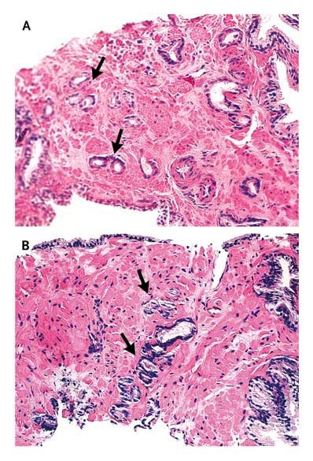
Figure 1. A textbook case of low-grade prostate cancer

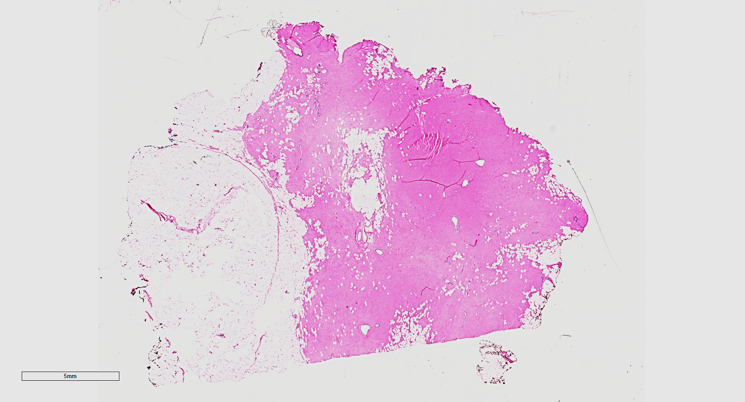
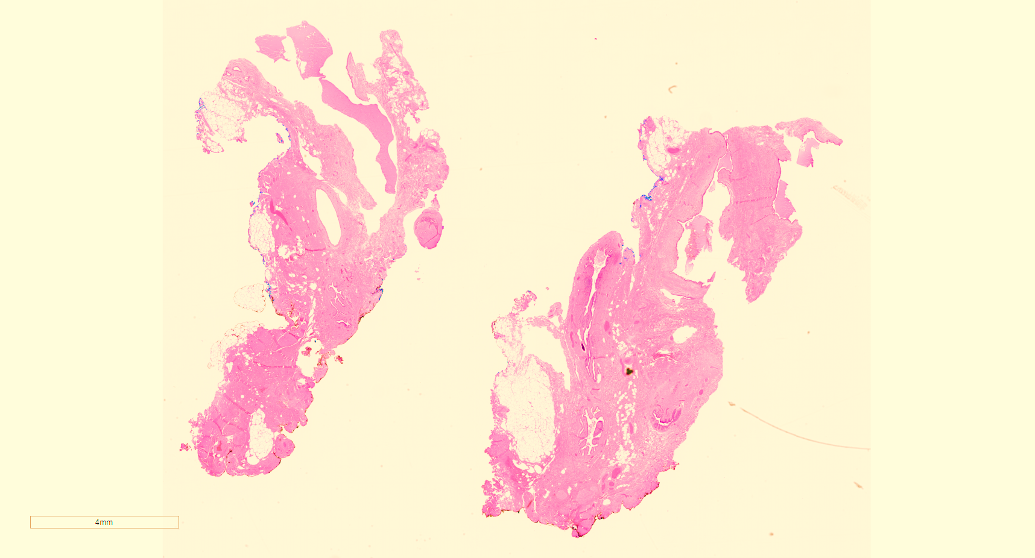
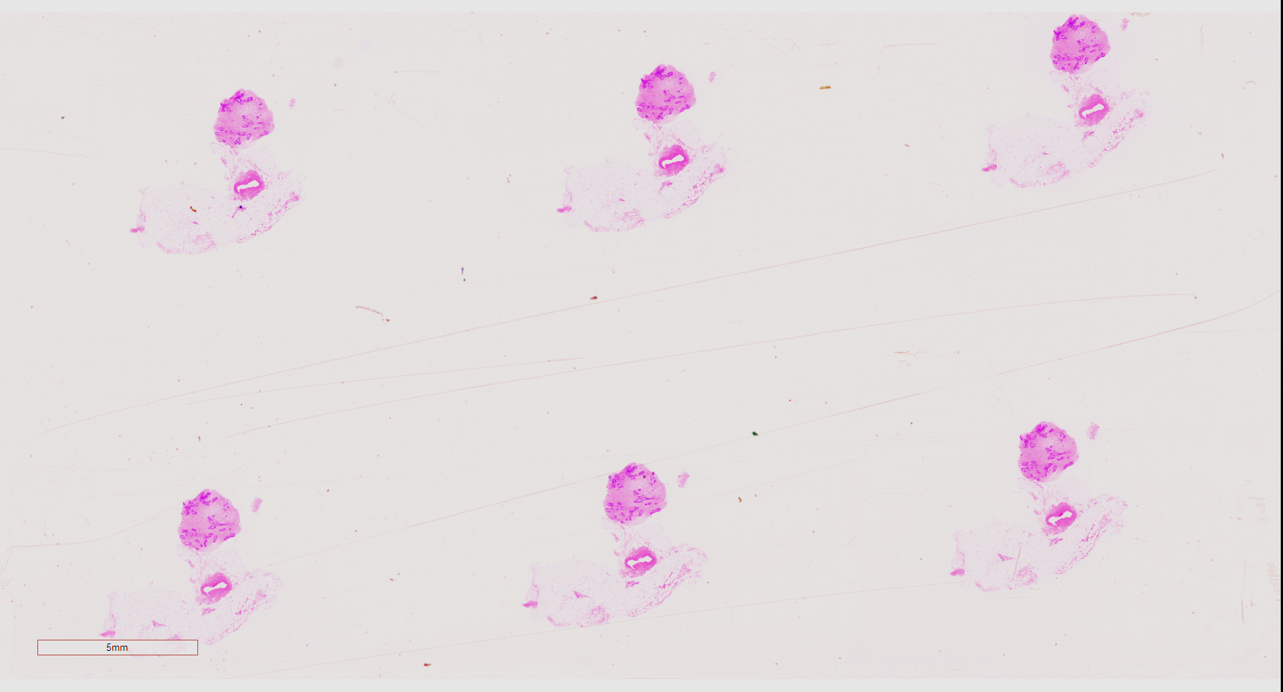
Figure 2. A range of WSIs of breast specimens

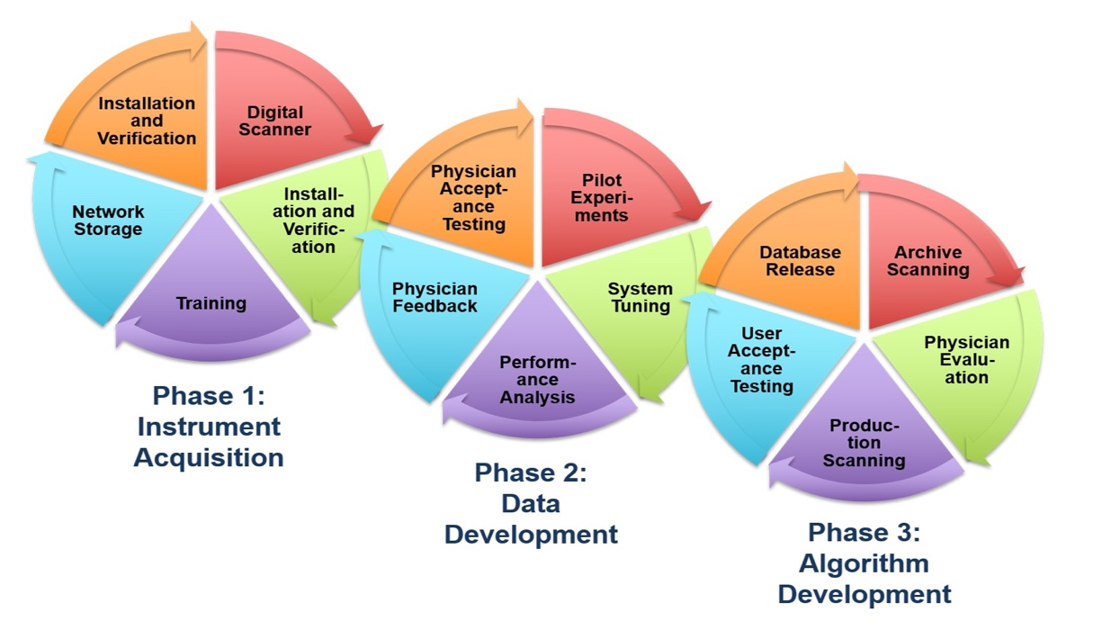
Figure 3. The three phases of our NSF MRI corpus development project

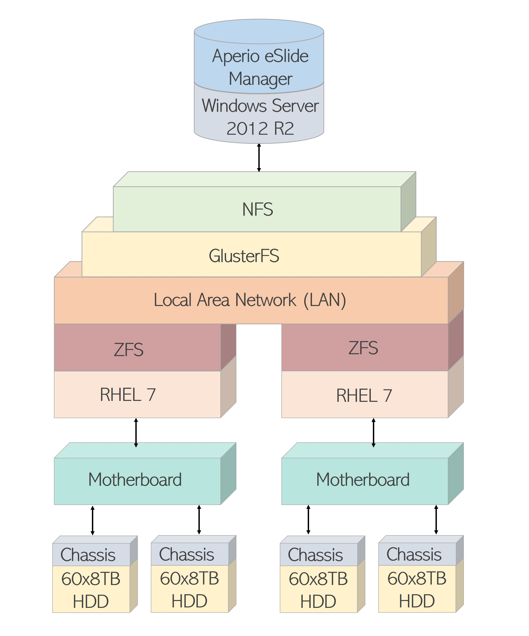
Figure 4. The file server architecture used to develop the TUDP Corpus

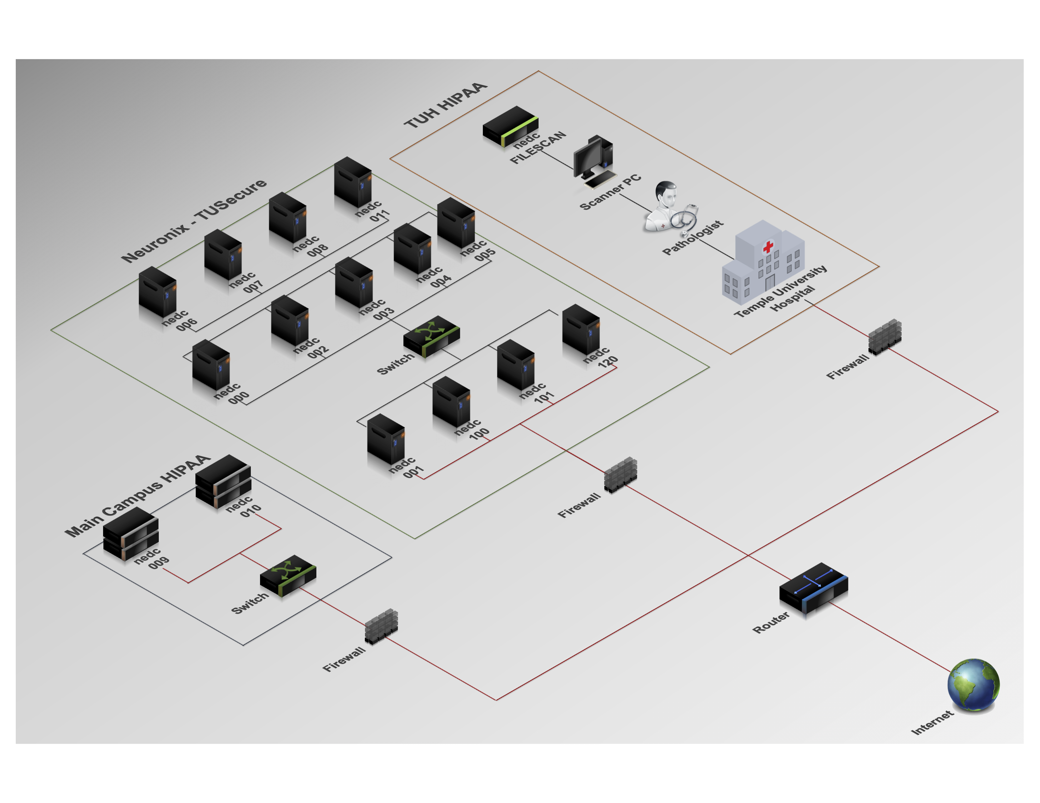
Figure 5. An overview of the HIPPA-compliant network architecture

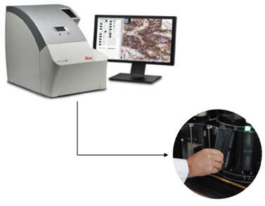
Figure 6. The Aperio AT2 high volume scanner

Figure 7. A typical WSI for a specimen from a breast case

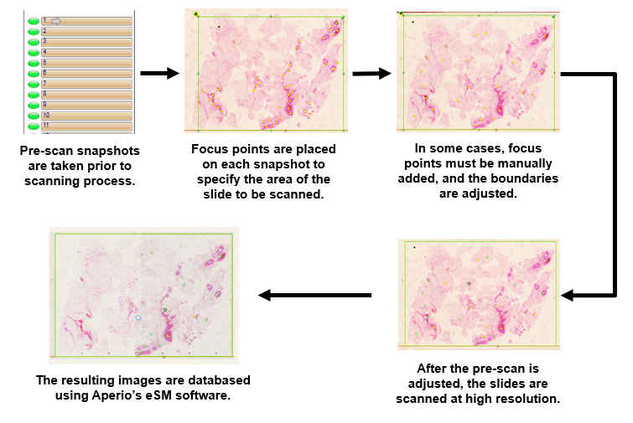
Figure 8. An overview of the scanning process

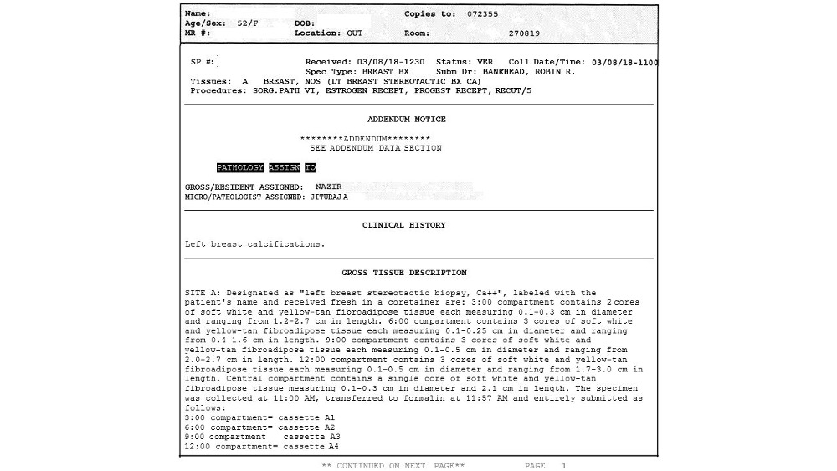
Figure 9. A typical clinical case report

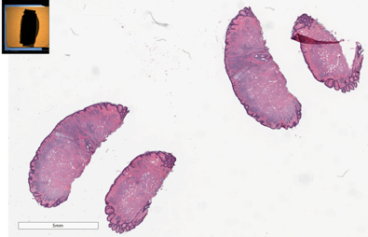
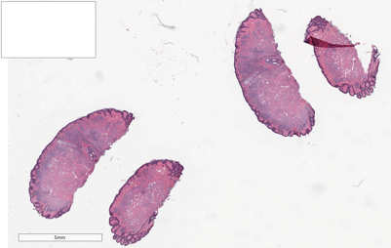
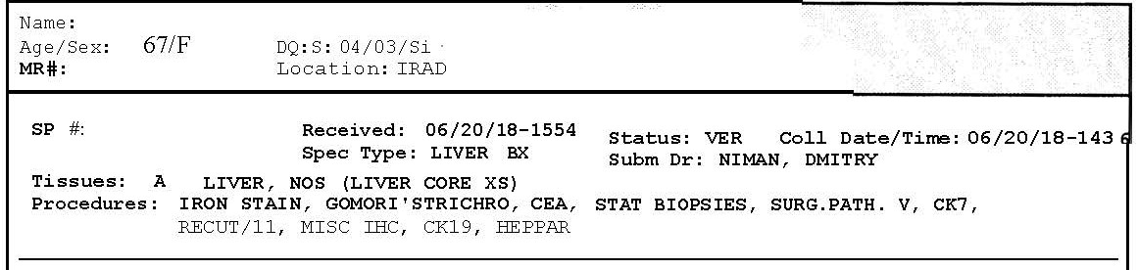
Data Anonymization
Case Reports
Digital Slides
Patient’s name
MRN
Specimen ID
Anonymizing slide labels’ information

Figure 10. An overview of the anonymization process

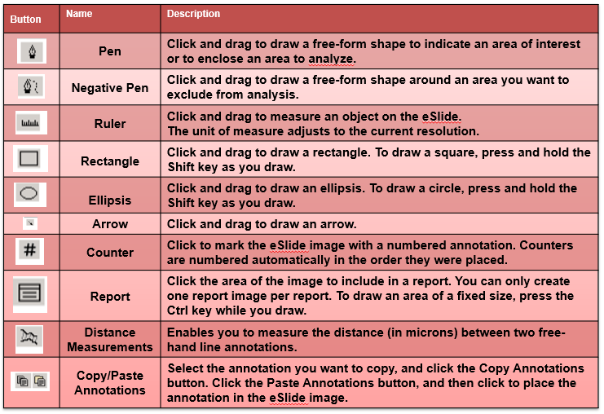
Figure 11. Annotation tools available in ImageScope

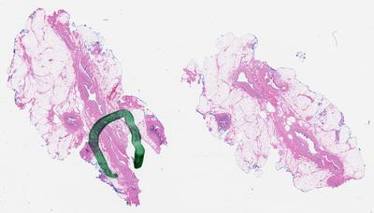
Figure 12. A typical example from the artifact corpus showing a grease pen mark

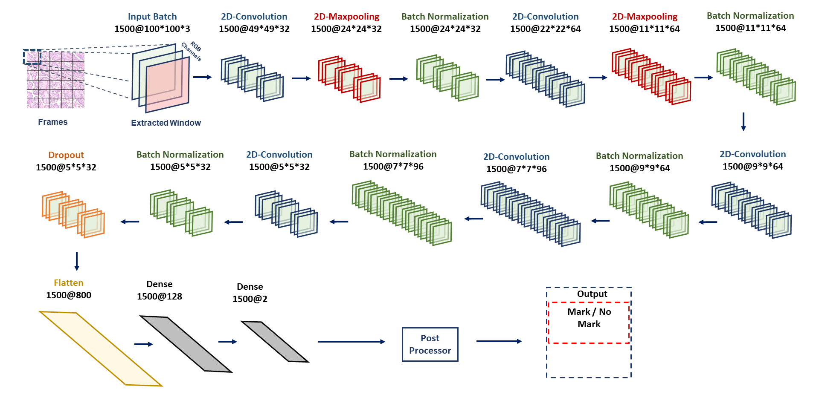
Figure 13. An overview of our baseline deep learning architecture

