# LIST OF FIGURES

# Figures

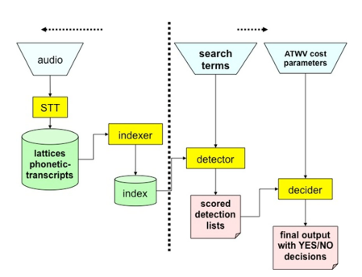

Figure . Spoken term detection can be partitioned into two tasks: indexing and search. One common approach to indexing is to use a speech to text system (after Fiscus et al., 2007).

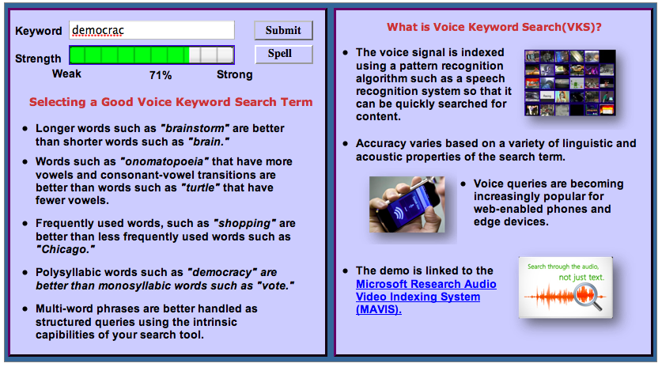

Figure . A prototype of a web-based application that predicts voice keyword search term reliability is shown. The search term reliability is automatically updated as the user types a search term. A demonstration is available at *http://www.isip.piconepress.com/projects/ks_prediction/demo/current/*.

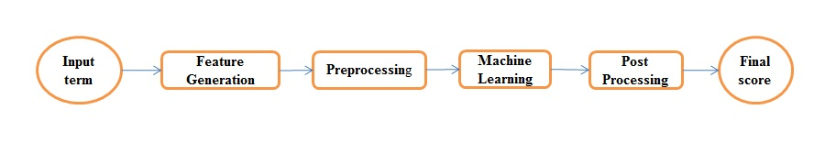

Figure . In our approach to predicting search term reliability, we decompose terms into features, such as N‑grams of phonemes and the number of phonemes, and apply these features to a variety of machine-learning algorithms.

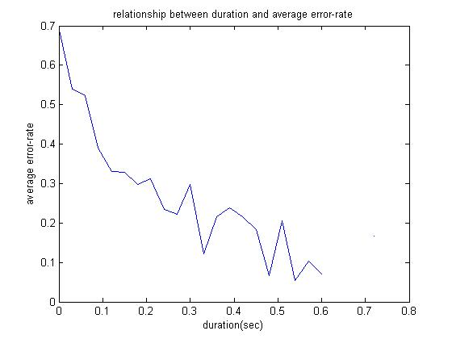

Figure . The relationship between duration and error rate shows that longer words generally result in better performance, but the overall variance of this measure is high.

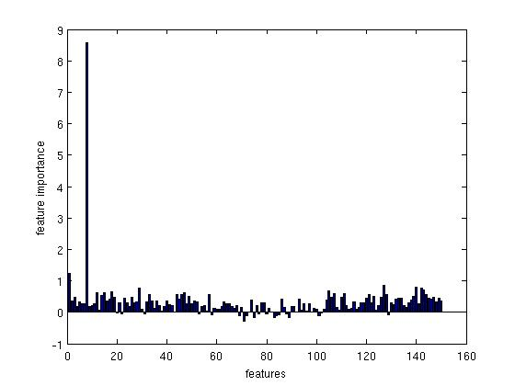

Figure . Feature importance based on the RF algorithm is shown. The feature ”count,” which represents the frequency of occurrence of a word, is by far the singlemost valuable feature since it is not correlated with any of the other features.

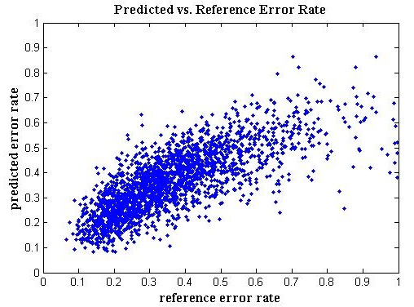

Figure . The predicted error rate is plotted against the reference error rate, demonstrating good correlation between the two.