# LIST OF FIGURES

Figure 1. An overview of the (a) GMM and (b) MixAR approaches. The MixAR model is a weighted sum of Gaussian autoregressive models with time-dependent weights.

Figure 3. DET curves are shown for a simulated speaker verification task. MixAR performance in the presence of noise exceeds GMM performance.

Figure 4. A DET curve is shown for a 1-speaker detection task based on the NIST-2001 development database. MixAR with 4 mixture components and only static features performs better than a GMM with 16 mixture components and static+delta features.

# Figures

(a)

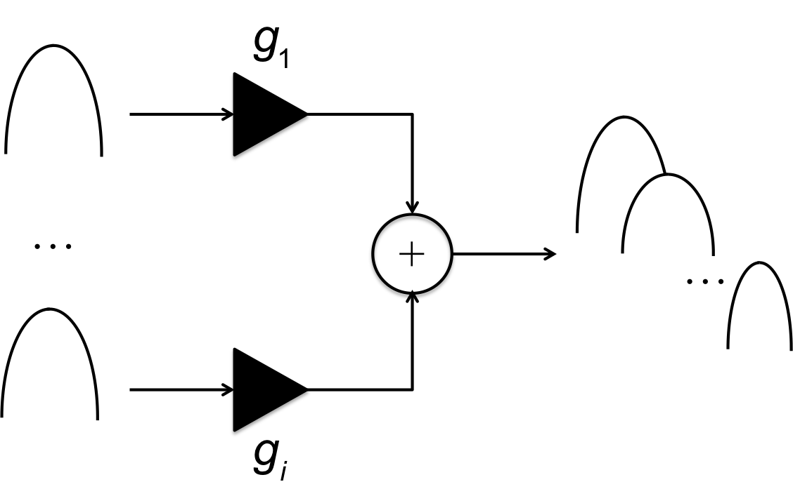

(b)

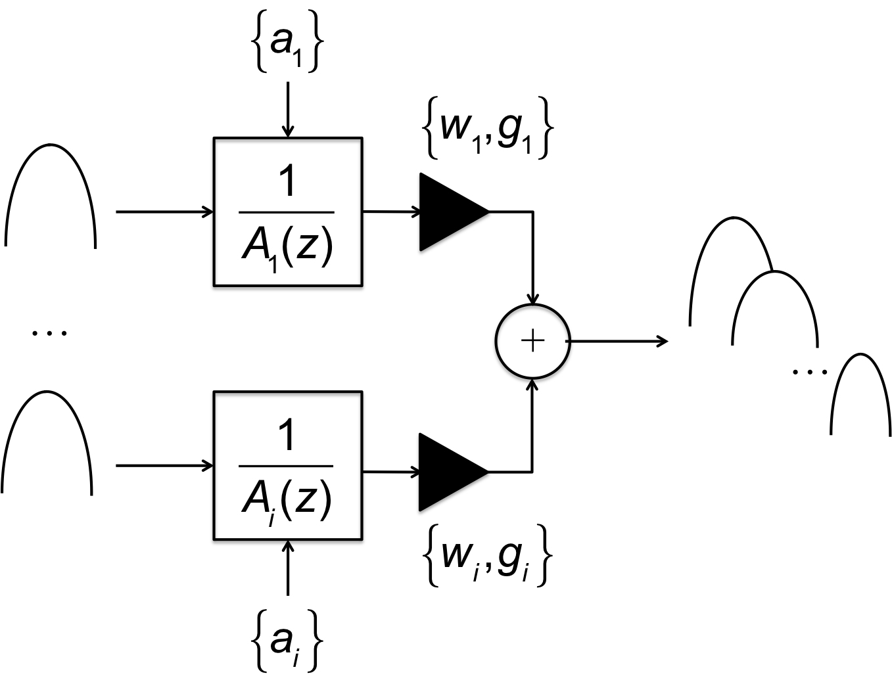

Figure . An overview of the (a) GMM and (b) MixAR approaches. The MixAR model is a weighted sum of Gaussian autoregressive models with time-dependent weights.

.

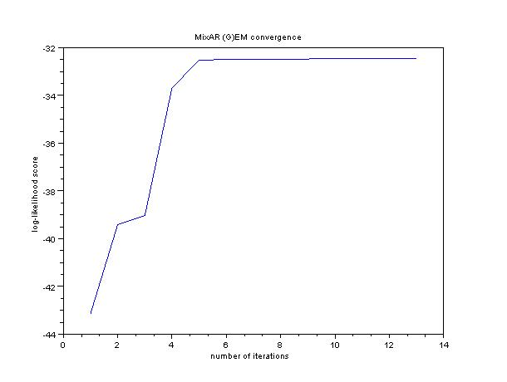

Figure . Performance of (Generalized) EM using the secant method as a function of the number of iterations for an 8-mixture MixAR model is shown (speaker *4516* from the NIST-2001 database).

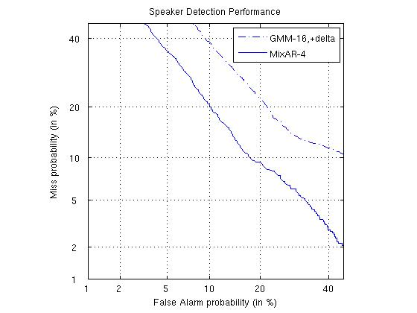

Figure . DET curves are shown for a simulated speaker verification task. MixAR performance in the presence of noise exceeds GMM performance.



Figure . A DET curve is shown for a 1-speaker detection task based on the NIST-2001 development database. MixAR with 4 mixture components and only static features performs better than a GMM with 16 mixture components and static+delta features.

(c)

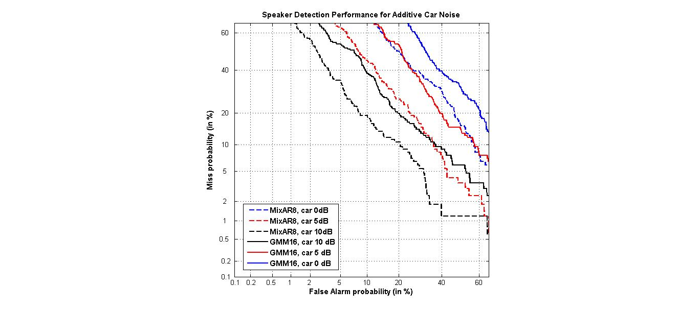

(b)



(a)



Figure . DET curves for GMM and MixAR models are shown for noisy TIMIT data with three types of additive noise: a) white, b) babble and c) car noise. A variety of SNRs are used.



Figure . DET curves for GMM and MixAR models on TIMIT and NTIMIT are shown. MixAR performance exceeds GMM performance while using a fewer number of parameters.