DISSOCIATED NEURONAL NETWORKS AND MICRO ELECTRODE ARRAYS FOR INVESTIGATING BRAIN FUNCTIONAL   
EVOLUTION AND PLASTICITY

A Dissertation

Submitted to

the Temple University Graduate Board

In Partial Fulfillment

of the Requirements for the Degree

DOCTOR OF PHILOSOPHY

by

Alessandro Napoli

November, 2013

Examining Committee Members:

Iyad Obeid, Advisory Committee Chair, Department of ECE

Joseph Picone, Department of ECE

Saroj Biswas, Department of ECE

Edward Gruberg, Department of Biology

©

Copyright

2014

by



# ABSTRACT

DISSOCIATED NEURONAL NETWORKS AND MICRO ELECTRODE ARRAYS FOR INVESTIGATING BRAIN FUNCTIONAL

EVOLUTION AND PLASTICITY

Alessandro Napoli

Doctor of Philosophy

Temple University, November, 2013

Adviser: Dr. Iyad Obeid

For almost a century, the electrical properties of the brain and the nervous system have been investigated to gain a better understanding of their mechanisms and to find cures for pathological conditions. Despite the fact that today’s advancements in surgical techniques, research, and medical imaging have improved our ability to treat brain disorders, our knowledge of the brain and its functions is still limited. Although, it is well known that electrical activity can modulate the growth and behavior of neurons both in-vitro and in-vivo, and that electrical stimuli can induce changes in the electrical responses of neuronal ensembles. In order to investigate such phenomena, different experimental techniques have been devised over the years. In the past, the electrical properties of neurons in cultures were studied using glass micropipette electrodes. Experiments performed with this technique were often difficult to set up and difficult to reproduce because each electrode had to be manually positioned using some mechanical manipulator. Also, when using micropipette electrodes, it is difficult to record from more than a couple of neurons at a time. Therefore with such technology it is not feasible to study the behavior of neuron networks. In order to overcome these limitations, a new experimental tool capable of monitoring activity of electrically excitable cells was introduced in 1972, when Thomas et al. [xx] introduced the use of Micro Electrode Array technology. Culturing dissociated cortical neurons on Micro-Electrode Array (MEA) dishes is a powerful experimental tool for investigating functional and structural characteristics of in-vitro neuronal networks. Over the past few decades, MEAs have been used frequently to investigate the mechanisms that take place at the network level among cultured neurons and to answer fundamental questions regarding the cellular basis of brain learning, memory and synaptic developmental plasticity. MEAs allow researchers to carry out long-term (up to a few months), non-invasive neural recordings using experimental setups that are easier to control and less complex than similar in-vivo systems.

This dissertation focuses in particular on combining MEAs with novel electrophysiology experimental paradigms and statistical data analysis to investigate the mechanisms that regulate brain development at the level of synaptic formation and growth cones. The goal is to use a mathematical approach and ad-hoc designed experiments to investigate whether dissociated neuronal networks can dependably display long and short-term plasticity. Such phenomena are thought to be the building blocks of memory formation in the brain.

Even though several studies have investigated spontaneous electrical activity and stimulus-evoked activity in dissociated neuronal cultures, many questions still need to be answered before these neuronal networks can be fully understood and integrated into larger and more complex systems. For example: (1) how does a culture react if stimulated at various stages of development; (2) what are the mechanisms that allow such cultures to consistently respond to stimulation; and (3) what are the real effects of stimulation on cultures stimulated repeatedly over time as compared to “never-stimulated” control cultures. There have been no quantitative studies that assess how the development of dissociated cortical neurons can be affected by chronic external stimulation

In this work, the objective is to investigate two specific questions:

1) Can a mathematical technique capable of reliably quantifying and emphasizing the physiological evolution of dissociated neuronal networks be developed? Such a technique would need to be able to account for the high variability and background noise that are characteristic of MEA recordings.

2) Are dissociated neurons capable of displaying memory formation phenomena? In this context, memory is defined at the neuronal level as synaptic plasticity, namely the ability of such cells to form, modify and delete connections based on the delivered electrical stimuli. It is known that plasticity effects are responsible for driving neuronal processing such as memory formation and “intelligence”. The goal here is to test whether these preparations of dissociated neurons adapt to stimuli and respond to the external inputs through plasticity and synaptic modification in a stable way.

To address these two important MEA recording questions that are still unanswered, a new experimental paradigm and a new statistical analysis were designed to investigate: 1) the functional evolution of dissociated neuronal networks during in-vitro development, using a statistical analysis tool to quantify network activity; 2) how long-term and short-term memory mechanisms take place in dissociated cortical neurons when presented with external voltage stimuli.

To my family,

Cristina, Anna & Salvatore

I would not be here without their unconditional love and support. More importantly, without them I would not be who I am today, for which I am so thankful.

To my friends,

The ones who have always been there for me and those I met more recently. In the hope that they will always be there.

# ACKNOWLEDGMENTS

I would like to thank my adviser, Dr. Iyad Obeid for everything he has done for me over the past four years. He has been more than just a mentor; he has been an example to follow. He has always been there for me and especially when I was going through difficult times he has always listened to my problems and had a word of advice. He helped me become a better engineer, a better researcher and (maybe) a better man.

I would like to thank the other members of my committee, Dr. Biswas, Dr. Gruberg and Dr. Picone who with different roles have been very important for my professional and cultural development over the past few years.

I would like to thank my two mentors at Temple School of Medicine, Dr. Fischer-Smith and Dr. Langford for their availability, help and constant support.

Special thanks go to Dr. Antonio Giordano, who has always supported and guided me. Without him I would not be here.

Finally, I would like to thank all the people that I met at Temple University and who have shared this wonderful adventure with and have been my second family during these past few years.

TABLE OF CONTENTS

ABSTRACT iii

ACKNOWLEDGMENTS viii

TABLE OF CONTENTS ix

LIST OF FIGURES xi

INTRODUCTION 1

1.1 Electrical Properties of the Nervous System: Early Studies 1

1.2 Electrophysiology Experiments 2

1.3 New Frontiers in in-vitro Electrophysiology 5

1.4 Dissertation Organization 6

MICRO ELECTRODE ARRAY (MEA) RECORDINGS 7

2.1 MEA History 7

2.2 MEA Experiments 10

2.2.1 Closed-Loop Experiments and Hybrid Systems 11

2.2.2 Realistic Brain Models 13

2.3 MEA Acquisition System 15

2.4 MEA Applications 18

2.5 Research Questions 19

2.6 MEA Recordings: Neural Spikes, Local Field Potentials and Spike Bursts 20

2.6.1 Neural Spikes 27

2.6.2 Local Field Potentials (LFPs) 30

2.6.3 Bursting Activity 32

AIM 1: QUANTYFYING DISSOCIATED NEURONAL NETWORK TEMPORAL EVOLUTION 34

3.1 Introduction 34

3.2 Methods 36

3.2.1 Data Collection 36

3.2.2 Signal Processing 37

3.2.3 Statistical Analysis 39

3.2.4 Statistical Significance Test: FDR 39

3.3 Results 42

3.4 Discussion 49

3.5 Conclusions 53

AIM 2: INVESTIGATING LONG AND SHORT-TERM MEMORY FORMATION IN DISSOCIATED NEURONAL NETWORKS 55

4.1 Methods 58

4.1.1 Cell Culture Preparation 58

4.1.2 Data Collection 58

4.2 Experimental Paradigm 59

4.2.1 Data Acquisition Sessions 62

4.3 Stimulation Protocol 63

4.3.1 Stimulation: Voltage Pulse Characteristics 63

4.3.2 Stimulation: Electrode Pattern 64

4.4 Signal Processing 66

4.4.1 Spike Detection 66

4.4.2 Feature Extraction 66

4.4.3 Data Analysis 67

4.4.4 Temporal Statistical Analysis: Temporal firing stability 67

4.4.5 Spatial Statistical Analysis: Stimulation evoked variability 69

CONCLUSION 70

TIMELINE 72

6.1 Plan for Completing the Dissertation 72

o January 2013 72

o February 2013 73

o March 2013 73

o April 2013 73

REFERENCES 74

# LIST OF FIGURES

Figure 2.1: Amplifier first stage followed by a first-order band-pass filter. Reprinted from [21] 9

Figure 2.2: Scheme of a hybrid system. 13

Figure 2.3: MEA 1060-Inv Amplifier. 16

Figure 2.4: Block Diagram of a complete MEA Acquisition System. 17

Figure 2.5: Action Potential Mechanisms. 21

Figure 2.6: Spatial Summation of neural inputs. 22

Figure 2.7: Temporal Summation of neural inputs. 23

Figure 2.8: Example of Multi-Unit Spike Trains. 24

Figure 2.9: Patch-clamp technique. 24

Figure 2.10: Example of extracellular multi-unit recording. 25

Figure 2.11: The two main components of MEA recordings 26

Figure 2.12: Example of MEA signal recording 28

Figure 2.13: Standard Electrode Grid 8x8 and dimensions. 29

Figure 2.14: MEA recordings of synchronous activity 33

Figure 3.1: Block Diagram of the Implemented Neuronal Spike Statistical Analysis. 40

Figure 3.2: Connectivity Graphs for dense neuronal cultures on different days after plating.. 43

Figure 3.3: Connection Lengths averaged across cultures harvested from the same neuron batch.. 45

Figure 3.4: Incoming supernode number averaged across different cultures harvested from the same neuron batch.. 46

Figure 3.5: Outgoing supernode number averaged across different cultures harvested from the same neuron batch.. 46

Figure 3.6: Average Correlation Coefficients. 47

Figure 3.7: Average Supernode Count Correlation Coefficients.. 48

Figure 4.1: Different Experimental Phases 61

Figure 4.2: Delivered Stimulus Pulses 63

Figure 4.3: Electrode Grid 65

Figure 6.1: Dissertation Completion Timeline 72

Chapter 1

# INTRODUCTION

## Electrical Properties of the Nervous System: Early Studies

The idea of recording electrical activity from cells of the nervous system dates back to the 1660s, when a Dutch scientist, Jan Swammerdam, developed a system capable of electrically stimulating the thigh nerve of a frog and the connected thigh muscle contractions [1]. Although Swammerdam was the first to observe muscle contraction due to electrical stimulus delivery, it was Isaac Newton who was the first to hypothesize the electrical nature of signal propagation between nerves and muscles. It was 80 years later though, in 1791, that Luigi Galvani for the first time produced experimental support proving the electric nature of nerve impulse. Galvani also introduced the concept of ion channels and proved the relationship between electrical impulse and muscle contraction strength.

Over the next few centuries, several scientists investigated this phenomenon that was referred to as “the animal electricity” [xx]. Their studies led to the characterization of most phenomena that regulate action potential propagation, nerve signal conduction speed and the fact that nerve conduction was related to ion propagation. By the mid-1930s, the structure of the cell membrane was finally understood and the presence of ion channels was suggested, even though direct physiological evidence was still missing. Such evidence arrived in 1936 when John Z. Young for the first time introduced into the scientific world the use of the squid axon to carry out electrophysiology experiments. But it was in 1949, when the voltage-clamp technique was designed by Kenneth Cole [2] and George Marmont [3] that modern electrophysiology was born. A few years later such a technique was employed by Alan Hodgkin and Andrew Huxley to propose the ionic theory of membrane excitation. Most importantly, Hodgkin and Huxley proposed the first mathematical model to describe the action potential formation and propagation in 1952 [4]. Their model is still used today and represents one of the best examples of how electrophysiology phenomena can be elegantly and accurately described in an efficient mathematical model even before they can be directly (experimentally) observed.

In this work we will focus mainly on a particular set of in-vitro neural experiments, referred to as Micro Electrode Array (MEA) recordings, in which live neurons can be cultured for weeks to months in special Petri dishes whose substrate embeds recording and stimulating electrodes. Since the pioneering work of Jerome Pine, who first proposed the use of MEAs to carry out electrophysiology stimulations and recordings of dissociated neuron networks [5], this type of technology has rapidly become a valuable tool to investigate neural functions and synaptic evolution at a network level.

## Electrophysiology Experiments

For almost a century, scientists have been investigating the electrical characteristics of the brain and the nervous system in order to achieve a better understanding of their mechanisms and to find cures for pathological conditions. Despite the fact that today’s advancements in surgical techniques, research, and medical imaging have improved our ability to treat brain disorders, our knowledge of the brain and its functions is still limited. The reasons are manifold, and they are all related to the structural and functional brain complexity that is the result of millennia of evolution. The difficulty in understanding the brain derives from the fact that its properties and the way it processes information depend on how billions of neurons are arranged, connected and how electrical signals are transferred. Furthermore, the fact that functional and physical connectivity of different brains are rarely the same, even within the same species, makes investigating brain mechanisms even more challenging. One main reason why it is so arduous to understand brain mechanisms is our inability to record from large numbers of neurons simultaneously to investigate how the network functions.

For many years, researchers have used electrophysiology experimental setups to investigate the electrical and functional behavior of brain regions and large neuronal populations. Their objective was to shed some light on the intricacy of neuronal connectivity and information propagation in the nervous system. Such experiments can be generally divided into two categories: 1) in-vivo experiments, in which the recordings are performed on live subjects; and? 2) in-vitro experiments, in which the electrical recordings are carried out on brain tissue, neurons or other tissue preparations grown in special cell culture incubators.

Choosing between these two experimental categories is a difficult task. For instance, in-vivo techniques are usually more complex and expensive to implement. They usually require sophisticated acquisition systems. The experiments are challenging to run because they involve recording from live and behaving?? subjects. Moreover data quality and experimental results may be heavily influenced by experimental conditions or parameters not under the direct control of the investigators. Despite these limitations, these experiments are more complete and allow for better insights into the properties of fully functional nervous systems.

On the contrary, in-vitro experiments are easier to manage, simpler to run and to reproduce given the reduced number of variables that investigators have to deal with. Conversely, in-vitro models are often an over-simplified version of the nervous system regions under investigation and therefore inferences derived from such work are not always applicable to intact nervous system functions. One of the main advantages of in-vitro experiments is that they allow investigators to limit the number of variables and to carry out experiments in more controlled environments. Given the numerous variables that play an important role in biological systems’ functions, reducing the number of experimental variables becomes of vital importance when dealing with biological samples.

In this view, MEA technology represents a valuable compromise. It allows investigators to run experiments and test experimental conditions that would not be feasible to implement using traditional in-vitro or in-vivo techniques.

## New Frontiers in in-vitro Electrophysiology

Technology has advanced to where it is possible to design and grow living networks of neurons in culture dishes with predefined geometry and remarkably good reliability [6]–[11][12]. Cortical neural cells in culture preserve many of the properties found in their in-vivo context, but important differences also exist. Therefore, the development of neuronal cultures in-vitro must be carefully investigated and documented if we want to generalize the results obtained from such cultures to entire nervous systems or clinical applications. In this respect, culturing neurons in-vitro gives the investigators the opportunity to derive parameters and mathematical models that could then be used to build new and more realistic computer simulations of neuron networks, which would be based on biologically derived neural patterns.

Furthermore, this technology has offered researchers the opportunity of studying neurons and their interactions in confined and highly controlled experimental conditions. This has improved our ability to control the numerous variables involved in such experiments and design experimental paradigms aimed at emphasizing specific aspects of neurons’ functionality and connectivity. The idea behind this technology is that stimulation and recording of large networks of neurons, glial cells and astrocytes with a large number of electrodes can lead to a better understanding of the mechanisms behind the brain functions of learning, memory, neural signal coding and modulation.

## Dissertation Organization

After having briefly described the basic research challenges that are faced when investigating the brain, the remainder of this document will proceed as follows:

* Chapter 2 will address MEA technology in detail, along with its applications, advantages and limitations. It will conclude by identifying the two basic MEA recording problems being addressed in this dissertation, namely, (1) inadequate statistical tools available and (2) the question of whether external stimulation can generate neuronal plasticity.
* Chapter 3 will deal with the first of those problems. The aim is to demonstrate an adequate statistical tool that can be applied to MEA recordings to study their functional evolution without making restrictive assumptions on the data.
* Chapter 4 will deal with the second problem. The aim is to study the short and long-term plasticity effects induced by a select stimulation protocol.
* In Chapter 5 will discuss the implications and present the conclusions.

chapter 2

# MICRO ELECTRODE ARRAY (MEA) RECORDINGS

## MEA History

In the past, the electrical properties of neurons in cultures were studied using glass micropipette electrodes. Experiments carried out with this technique were often difficult to set up and difficult to reproduce because each electrode had to be manually positioned using some mechanical manipulator. Also, when using micropipette electrodes, it is difficult to record from more than a couple of neurons at a time. Therefore with such technology it is not feasible to study the behavior of neuron networks. Despite these limitations, micropipette electrodes were, for years, the main tools that neurophysiologists had to investigate single neuron characteristics, ion channels, pharmacology and synaptic plasticity in-vitro.

In order to overcome these limitations, a new experimental tool capable of monitoring activity of electrically excitable cells was introduced in 1972, when Thomas et al., introduced the use of Micro Electrode Arrays [13]. They were able to record field potentials from cultured sheets of cardiac tissue harvested from chicks. After these first experiences with MEA technology, in 1979, Gross and Pine independently developed arrays for chronic multi-unit neuron recording and stimulation [5], [14]. For a few years, these experimental tools were custom-made and each lab involved in this research field utilized their own proprietary hardware and software [5], [15]–[22].

For instance, in [15] the authors ran electrophysiology experiments on myocardial cells plated on custom-made MEA dishes. Instead of using traditional intracellular glass micropipettes, they were able to embed 25 recording and 6 stimulating electrodes onto the dish. Their experimental setup allowed them to successfully record extracellular potentials and emphasize the importance of the electrode array biocompatibility and longevity. In [16], Novak and Wheeler built a passive MEA and used it to record the abdominal ganglion of the marine mollusk *Aplysia californica*. Their MEA consisted of 32 gold electrodes laid on a glass substrate. The electrodes were arranged in a 4x8 grid with 200 μm spacing, and each electrode was 25 μm in diameter. Their main contribution to MEA fabrication was the fact that their dishes were durable, reusable and could be safely autoclaved. In [17], the authors set off to build their own MEA dishes, with the goal to develop biocompatible MEA recording devices that could combine extracellular recording capabilities with guidance of cells during growth, using surface topography techniques. This work represents one of the first attempts to influence cell development while simultaneously recording their electrical activity.

When the use of digital systems became more accessible, the first digital MEA recording systems started to be designed and built. For instance, in [19] Borroni et al., introduced one of the first integrated systems for recording and analyzing electrophysiological data from multiple channels. Their system was composed of an MS-DOS microcomputer, a 16-channel amplifier and electrode arrays with multiple tips that could be used both in intact and slice tissue preparations. Furthermore, their in-house developed acquisition software allowed for data collection and on-line analysis of multiple-channel recordings. The real-time capabilities comprised averaging and current source density computation. In addition, their software had off-line capabilities, such as computing power spectra, peak amplitudes, area, latency and slope of user selected signal segments. A further example of a PC-based system for acquisition and processing of MEA data was presented in [21], where Martinoia et al. introduced a simple and relatively inexpensive general-purpose acquisition system. Their system was able to acquire simultaneously up to 16 channels and store data directly on the computer hard-drive. The main components of the complete MEA system an instrumentation amplifier (AD521), followed by an inverting stage (implemented using an LF356 operational amplifier), for additional gain (see Figure 2.1), an acquisition computer, with in-house developed acquisition software (written in C) and a National Instruments 16-MIO-F5 A/D board to digitize the data. The system presented in this work is worth noting, because it represents the first complete digital MEA acquisition system.

Figure 2.1: Amplifier first stage followed by a first-order band-pass filter. Reprinted from [21]



Finally, it is important to mention the first complete closed flow chamber for long-term multichannel recordings, that was presented in [22]. This paved the way for a new class of more accurate experiments, in which the investigators could precisely and easily control the cultured cells’ environmental conditions.

At present, MEA is a commercially available technology comprising various plug-and-play components and capable of recording from at least 60 electrodes. For instance, a few systems available on the market are produced: by Multichannel Systems (Germany), Panasonic (Japan), Center for Network Neuroscience (University of North Texas), and Plexon Inc. (Texas, USA).

## MEA Experiments

Culturing dissociated cortical neurons on Micro-Electrode Array (MEA) dishes is a powerful experimental tool for investigating functional and structural characteristics of in-vitro neuronal networks. Over the few past decades, MEAs have been frequently used to investigate the mechanisms that take place at the network level among cultured neurons and to answer fundamental questions regarding the cellular basis of brain learning, memory and synaptic developmental plasticity. MEAs allow researchers to carry out long-term (up to a few months), non-invasive neural recordings using experimental setups that are easier to control and less complex than similar in-vivo systems. In general, MEA research falls in one of two categories: hybrid systems, in which artificial and natural intelligence are merged to exploit the benefits deriving from their combined use; and realistic brain models that can be used to investigate how the brain works and how it forms structural and functional connections.

### Closed-Loop Experiments and Hybrid Systems

MEA technology is commonly used to carry out real-time electrophysiology experiments both on in-vitro dissociated neurons and brain tissue slice preparations. The main characteristic of these experiments is that they are closed-loop experiments in which a feedback loop is implemented by delivering electrical stimuli to the electrodes while simultaneously recording from them. Electrical stimulation allows researchers to modulate neural activity in real-time in order to induce network plasticity or to simulate the effects of sensory input [23]–[26]. In [25], [27]–[30] the authors investigated how to use electrical stimulation to evoke and modulate neural responses. For instance, in [29] the authors demonstrated selective learning in a network of real cortical neurons by implementing a closed-loop stimulation protocol that allowed them to map evoked neuronal responses to known stimuli. These responses were used to generate learning curves that described how the repeated stimulation protocols were inducing changes in the functional connections of the neuronal network.

A seminal work on the efficacy of closed-loop systems is presented in [27], in which Bakkum et al. developed an adaptive training algorithm to investigate whether in-vitro neocortical networks could learn how to modulate their responses to achieve pre-determined activity states. They exploited the advantages of working with a feedback loop to continuously improve the system performance by effectively selecting stimulus sequences that led to system performance improvement. Furthermore, they emphasized that the use of a closed-loop system allowed them to improve over time the ability of the MEA networks to respond with the desired responses, without inferring with the network’s functional connectivity. In other words, they showed that cultured neuronal networks could be used as a black box, if combined with a system that is capable of correctly mapping all their electrical responses to a select set of stimuli.

Other examples of MEA recordings integrated in a closed-loop system are presented in [25], [30], [31]. In these studies the investigators used external stimulation and feedback loops to build complex hybrid systems in which cortical neuronal cultures were used to control computer simulations through artificial sensory-motor loops. Specifically, Dr. Potter and his group have created a computer animation of a freely moving animal and aimed to control its movements using neuronal responses recorded in real-time from a network of dissociated rat cortical neurons [28]. In Figure 2.1 a scheme for implementing the hybrid system is shown?. Their long-term goal was to use this closed-loop system to study learning in such in-vitro preparations. Despite the importance of their findings and the good performance they were able to achieve with their system, they could not quantify in detail how the complex network activity patterns were affected by stimulation and thus they could not precisely assess the effects of stimulation on network behavior. They were able to find that their hybrid system, thanks to the implemented feedback loop, could successfully map the range of electrical responses that the networks could display. This gave them the opportunity to improve system performance over time and show that MEA experiments are a promising tool to integrate natural and artificial “intelligence”.

Figure 2.2: Scheme of a hybrid system. The goal of this system is to control computer simulation of the movement of a "virtual" rat. Reprinted from [28]



In conclusion, the goal of hybrid systems is to integrate dissociated neural networks into advanced systems in which the network is used as a black box whose output controls the behavior of the next component of the system. Feedback loops are generally used to select which neural network inputs have to be used to achieve a predetermined experimental task and to increase the system performance.

### Realistic Brain Models

Since the first studies of Santiago Ramón y Cajal [32] dating back over a century ago, scientists have been interested in investigating how neurons are physically connected in our nervous system and what these connections mean from a functional neuronal network perspective. To date, we know that functional connectivity modulates cognitive and behavioral states in the brain, but very little is known about functional networks and complex neuronal ensembles involving overlapping or multiple anatomical structures [33], [34]. One limiting factor of this line of research is that most studies require the use of expensive and ad-hoc imaging tools such special MRI systems combined with tightly controlled experiments and powerful image processing techniques [34]. In contrast, MEA recordings represent an innovative tool to build a simplified and yet realistic neuronal model able to simulate the functions and properties of brain layers [30]. Starting from these simple brain layer models, the long-term goal is to increase the system complexity, trying to combine multiple layers and eventually building 3-D neuronal structures.

Neural network models have long been used to provide quantitative characterizations of neural processes. Combining MEA recordings with appropriate statistical analysis techniques will offer an even more valuable tool to link electrophysiology experiments and computational modeling, by using the information from experiments to better identify parameters for more complex models. Alternatively, computational models can lead to the discovery of new statistical methods that may enhance our ability to extract features from experimental data.

Although the objective of most current MEA experiments is to connect external stimuli to induce network activity, the importance of developing appropriate statistical techniques to analyze neuron activity should be emphasized. This will require innovative mathematical approaches to integrate information derived from artificial and natural neural models. The advantages will be manifold???; more reliable data analyses will provide more accurate constraints and parameter values for dynamical models of neural systems. Finally, the improved skill to interpret neural activity, i.e. spike detection and sorting, will significantly expand the ability to design and build brain computer interface systems [35],[36].

Another relevant research study, in which the authors compared the electrical responses recorded from in-vitro dissociated cultured neurons to those obtained from a simulated neural network was presented in [37]. The goal of this research work was to investigate the network mechanisms of learning and memory using standard firing rate statistics. Specifically, they used a well-known neural model, called integrate-and-fire neural network and data recorded from live neurons to evaluate the performance of six statistical methods in detecting lasting functional changes in functional network connectivity. It is worth noting that their statistical method yielded comparable results when applied to both simulated network responses and MEA recordings. This process proves that MEA experiments can be used to improve our ability to build more realistic neural network models. [... this section is a little weak ... not sure what the goal of the section was... I thought it was an overview of brain models...]

## MEA Acquisition System

A complete MEA acquisition system is composed of five main components:

1. An MEA dish with live neurons cultured on it;
2. A specific MEA amplifier, to amplify signals coming from the MEA electrodes, see Figure 2.3;
3. A stimulus generator, to generate the voltage or current pulses necessary to deliver external stimulation to the MEA electrodes;
4. An acquisition computer, where the acquisition software runs and the necessary acquisition hardware is installed, such as A/D card, I/O ports and amplifier power supply.
5. A cell culture incubator, to preserve the best environmental conditions for the cells during long experiments;

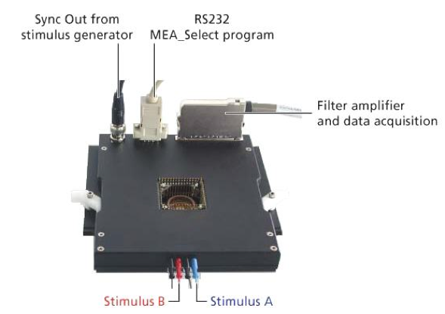

Figure 2.3: MEA 1060-Inv Amplifier. Reprinted from [70]

In our experiments we used an MEA acquisition system called MEA1060-INV-BC, produced by Multichannel Systems (MCS, Reutlingen, Germany). We combined this system with MEA dishes called 60-MEA-200/30-Ti produced by the same manufacturer. The characteristics of the MEA dishes and acquisition system that we present in the following are representative of other systems that are present on the market as well.

Raw signals from up to 60 MEA electrodes are amplified by a 60-channel pre-amplifier and band-pass filtered. The pre-amplifier gain is generally set to 1200 V/V while its bandwidth ranges between 10 Hz and 3KHz. The MEA dish is placed directly into the MEA preamplifier with blanking circuit (MEA1060-BC-PA). Contact pins are embedded in the amplifier lid are and are directly in contact with the MEA contact pads. Positioning the pre-amplifier close to the recording sites (electrodes) is important to keep the signal-to-noise-ratio of the system as high as possible. The amplifier is connected to the data acquisition computer via a single standard 68-pin MCS scable. The analog output signals of the MEA amplifier are then acquired and digitized by a dedicated A/D card, called MC_Card ( see Figure 2.4, MEA-System) or an USB based data acquisition device (USB-MEA-System) or even a custom data acquisition system. The MC_Card and the acquisition software are also responsible for controlling the MEA stimulus generator (STG-1002), which is a configurable 2-channel pulse generator. The block diagram of the complete system is shown in Figure 2.4

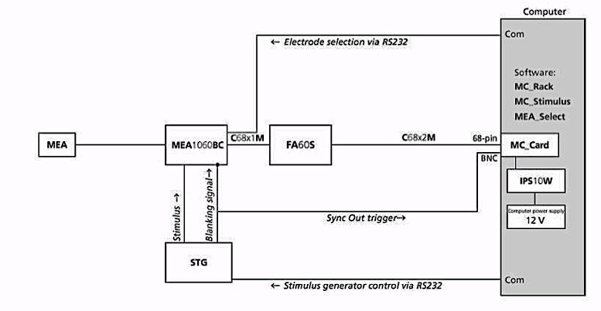

Figure 2.4: Block Diagram of a complete MEA Acquisition System. Reprinted from [70]

## MEA Applications

Current MEA acquisition techniques show superior accessibility and flexibility compared to other electrophysiology models in terms of electrical recording and stimulation, pharmacological manipulation and imaging [34]. One future goal of investigators in this area is to use MEA technology to build a “brain-on-a-chip” that would allow investigators to recreate various nervous system structures. These in-vitro systems would then be able to accurately mimic the behavior and characteristics of real brain structures and could be used to experiment and assess novel treatments for brain disorders, test the effects of new drugs, and better understand the connectivity, structure, and function of the brain [12],[38], [39]. [... note sure you need to discuss future goals in a literature search ...]

From this perspective, MEA technology can be used to investigate how living neurons could interact with artificial systems with the goal of building hybrid systems where artificial and natural intelligence coexist. These hybrid systems could also be used to simulate and study different pathological situations or neurological disorders, such as epilepsy and stroke [12]. For instance, MEA technology can be used to investigate brain structures at the network level and to study the causes for most brain disorders such as Parkinson’s disease, Alzheimer’s and neuropathic pain. Furthermore, MEA technology can also represent a test bed for screening the effects of drugs during neuronal development. In this sense, MEA technology provides an electrophysiological platform that researchers can use to study the structural, biochemical or electrical events that take place in nervous system disorders.

This dissertation focuses in particular on combining MEAs with novel electrophysiology experimental paradigms and statistical data analysis to investigate the mechanisms that regulate brain development at the level of synaptic formation and growth cones. The goal is to use a mathematical approach and ad-hoc designed experiments to investigate whether dissociated neuronal networks can dependably display long and short-term plasticity. Such phenomena are thought to be the building blocks of memory formation in the brain.

## Research Questions

Despite the innovative approaches and findings of MEA research studies carried out over the past few decades, functional plasticity of dissociated neurons during different phases of their in-vitro development still needs to be fully investigated. Even though some studies have investigated spontaneous electrical activity in dissociated cultures [10], [40]–[44], many questions still need to be answered before these neuronal networks can be integrated into larger and more complex systems. For example: (1) how does a culture react if stimulated at various stages of development; (2) what are the mechanisms that allow such cultures to consistently respond to stimulation; and (3) what are the real effects of stimulation on cultures stimulated repeatedly over time as compared to “never-stimulated” control cultures. There have been no quantitative studies that assess how the development of dissociated cortical neurons can be affected by chronic external stimulation [45].

In this work, the objective is to investigate two specific questions:

1) Can a mathematical technique capable of reliably quantifying and emphasizing the physiological evolution of dissociated neuronal networks be developed? Such a technique would need to be able to account for the high variability and background noise that are characteristic of MEA recordings.

2) Are dissociated neurons capable of displaying memory formation phenomena? In this context, memory is defined at the neuronal level as synaptic plasticity, namely the ability of such cells to form, modify and delete connections based on the delivered electrical stimuli. It is known that plasticity effects are responsible for driving neuronal processing such as memory formation and “intelligence”. The goal here is to test whether these preparations of dissociated neurons adapt to stimuli and respond to the external inputs through plasticity and synaptic modification in a stable way.

To address these two important MEA recording questions that are still unanswered, a new experimental paradigm and a new statistical analysis were designed to investigate: 1) the functional evolution of dissociated neuronal networks during in-vitro development, using a statistical analysis tool to quantify network activity; 2) whether and how long-term and short-term memory mechanisms take place in dissociated cortical neurons when presented with external voltage stimuli.

[... not sure why the research questions are put in the middle of a chapter. shouldn’t they be the end of this chapter? ...]

## MEA Recordings: Neural Spikes, Local Field Potentials and Spike Bursts

it seems to me this should be a separate chapter... this is important stuff!

Neurons are electrical excitable cells that are the basic functional units of the nervous system. They are responsible for modulating and transferring information through electrical and chemical signals. From an electrophysiology perspective, their behavior is defined as all-or-nothing, meaning that the electrical signal they use to communicate with each other only has two possible states, it is either on or off. These electrical signals are known as action potentials and they represent voltage variations generated by changes in ion concentrations between the extracellular and intracellular environment see Figure 2.5. Neural information is transferred every time a neuron receives an input that is above the threshold. More interestingly, neurons can generate action potentials even if the single inputs they receive are not above the depolarization threshold. It is well-known that neurons modulate and process information by temporal and spatial summation of stimuli [xx]. In other words, if the incoming stimuli are not able to generate an action potential individually, a neuron can sum all the incoming inputs spatially and temporally and if their summed depolarization is above the threshold then an action potential is generated. Figure 2.6 and Figure 2.7 respectively show the mechanisms of spatial and temporal summation. Specifically, the net influx of positive ions generates depolarization of the cell membrane. This event is also known as Excitatory Postsynaptic Potential (EPSP). A single EPSP is usually not enough to generate a postsynaptic action potential. In order to generate an action potential the simultaneous arrival of a large number of local depolarizations (temporal summation) in the *dendrites* is normally necessary. Furthermore, these multiple depolarizations are summed on the axon hillock, this phenomenon is known as spatial summation.

Figure 2.5: Action Potential Mechanisms. Reprinted from [71]

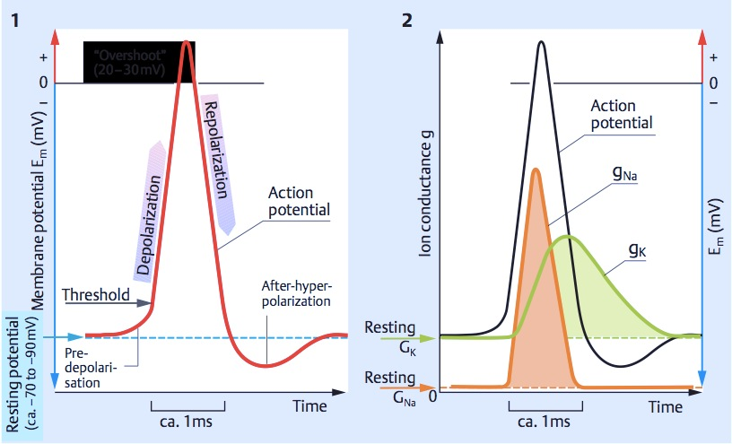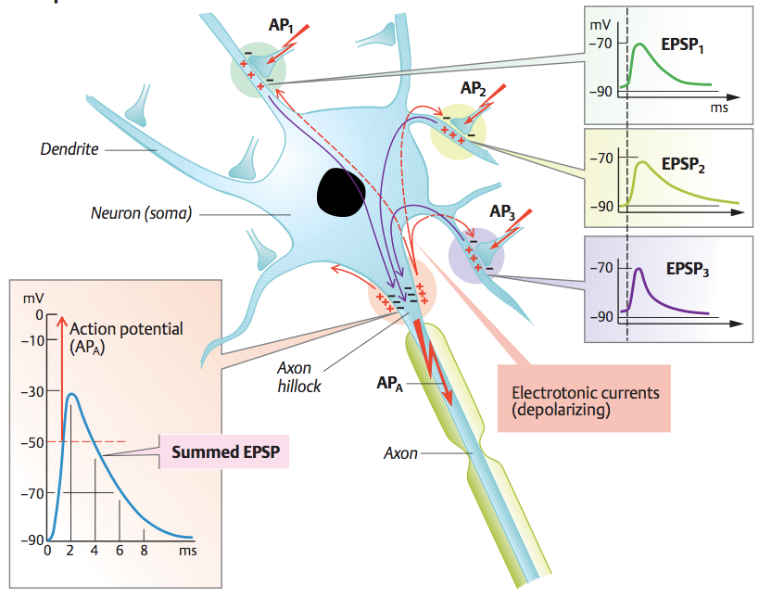

Figure 2.6: Spatial Summation of neural inputs. Reprinted from [71]

Over the past few decades several recording and stimulating techniques have been devised to investigate neuron electrical activity. These techniques range from single-cell intracellular recordings, such as patch-clamp approaches (see Figure 2.9), to multi-unit recording techniques, in which tiny electrodes are used to record the extracellular voltage variations. MEAs fall into the second category and utilize an electrode array to carry out simultaneous multi-unit extracellular recordings. When recording neural activity from MEA dishes, each electrode records the average extracellular field potential, namely the total electrical activity generated by the various (ranging from tens to hundreds) neural processes taking place in the extracellular environment that surrounds the electrode. An example of MEA device with dissociated neurons plated on is shown in Figure 2.10.

Figure 2.7: Temporal Summation of neural inputs. Reprinted from [71]

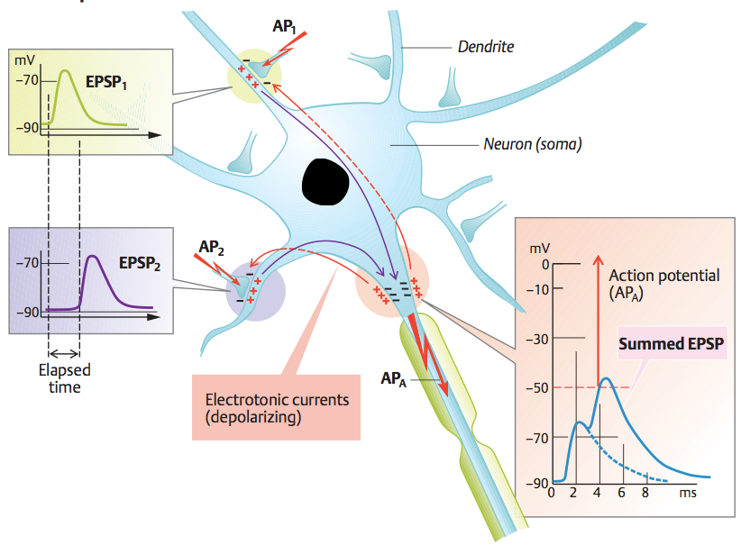

Figure 2.8 shows an example of how multi-unit spike trains and Local Field Potentials can be extracted from continuous voltage recordings carried out from multiple neurons.

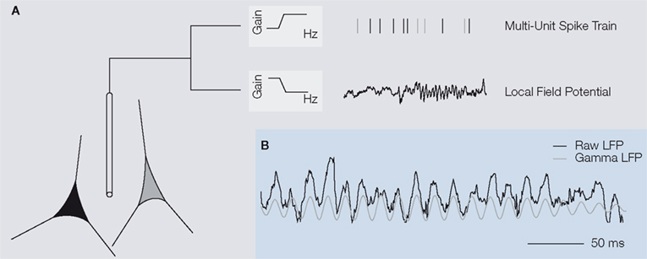

Figure 2.8: Example of Multi-Unit Spike Trains. Reprinted from [72]

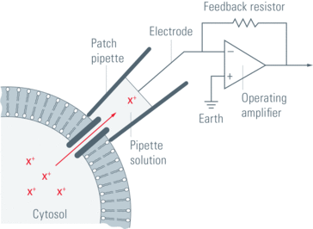

Figure 2.9: Patch-clamp technique. Reprinted from [73]

The neural extracellular potential is usually considered to be composed of two main components (Figure 2.8): 1) High frequency voltage fluctuations, ranging between 300 Hz and 3 kHz, usually called neural spikes; 2) Low frequency voltage fluctuations, less than 200 Hz, generally referred to as Local Field Potentials. These two components have usually been considered related to different aspects of neural activity, but the full extent of the link between them and the underlying brain activity remains yet to be investigated. [46] Figure 2.11 shows an example of neural spikes and LFPs and how these can be derived from raw MEA recordings, simply by bandpass-filtering the raw data.

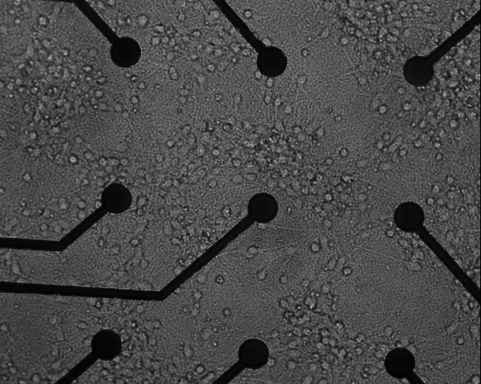

Figure 2.10: Example of extracellular multi-unit recording. MEA dish.



Figure 2.11: The two main components of MEA recordings: Neural Spikes (bottom left panel) and Local Field Potentials (bottm right panel)

Another important characteristic of MEA recordings is the bursting activity that dissociated cultured neurons display in-vitro. Although in the literature there are several definitions for such bursts, this work defines an activity burst as an activity pattern consisting of a train of high frequency spikes, usually involving most active channels of a MEA dish. It is well-documented [23], [41] that these bursting activity patterns begin to appear a few days after plating the neurons and continue to develop over the course of in-vitro neuronal growth and are considered a natural (normal) characteristic of dissociated neuronal networks. Interestingly, during in-vitro development, the vast majority of the cultures respond to delivery of electrical stimuli by significantly increasing the bursting activity. A widespread stabilization of electrical activity is usually observed after the culture’s third week of age.

### Neural Spikes

Neurons form synaptic connections with several other neurons through their *axons* and *dendrites*. Typically, a neuron consists of the soma or cell body and two types of processes: the axon and *dendrites*. The neuron receives afferent signals, which could be either excitatory or inhibitory, from up to a few thousand other neurons via its *dendrites* and sums the signals along the cell membrane of the soma. The axon stems from the axon hillock of the soma and it is along this process that the transmission of efferent neural signals occurs. *Axons* often have branches that further divide and terminate in multiple swellings called synaptic buttons. A synapse is the site where the axon of a neuron communicates with other neurons. With very few exceptions, synaptic transmission in mammals is mediated by chemicals (i.e neurotransmitter release), not by electrical signals. (what does it mean “mediated”? that is jargon an ECE person might not understand)

Neurons form large networks (ranging from thousands to millions of cells) in the nervous system and use action potentials, also called neural spikes to communicate with each other and process information. Recording individual spikes can be technically challenging, especially when trying to record activity from large neuron populations. In practice, in order to be able to record single spikes, it is typically necessary that the recording electrode size be comparable in size to the neuron being recorded. On the other hand, this implies that such electrodes will not be able to record activity from many other cells, meaning that the number of neurons which can simultaneously be observed is limited by the number of electrodes. [simplify the logic here... what are you contrasting with???...] On the contrary, if the goal is to record from a large population of neurons, the recording electrode size will usually be larger. This implies that a single electrode is capable of recording neural activity from tens or hundreds of cells simultaneously. Each MEA electrode is designed to record extracellular activity as generated by multiple neurons. In fact, MEA electrodes are typically laid out in a planar 8x8 grid (with missing corners); further details and dimensions of standard MEA dishes are shown in Figure 2.13. Briefly, the electrode size is 30 μm in diameter and they are spaced by 200 μm. In comparison, the typical neuron soma???what is a soma? is in the range of 4-100 μm in diameter. Therefore, given its size, the MEA electrode can record activity generated by tens or hundreds of cells, and hence these types of recordings are also called multi-unit recording (MU) and usually reflect the spatially averaged activity of local neural populations. Figure 2.12 shows a typical MEA experimental setup.

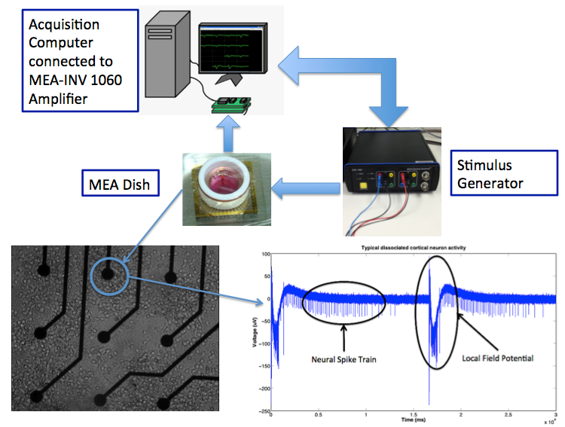

Figure 2.12: Example of MEA signal recording

Over the years, several signal processing techniques have been used to detect spikes and isolate them from other neural signal components. These spike detection techniques can be based on simple voltage thresholding approaches or they can be based on more complex processing based on template matching or adaptive approaches. Typically, spike detection algorithms use some kind of signal preprocessing to enhance spikes and reduce noise before using a threshold to detect spikes. The threshold can be static or dynamic, according to the specific application requirements. An alternative approach consists of detecting spikes using their specific waveforms to train template matching algorithms. Examples of threshold spike detectors are presented in [47], [48], while examples of template matching spike detectors are presented in [36], [49].

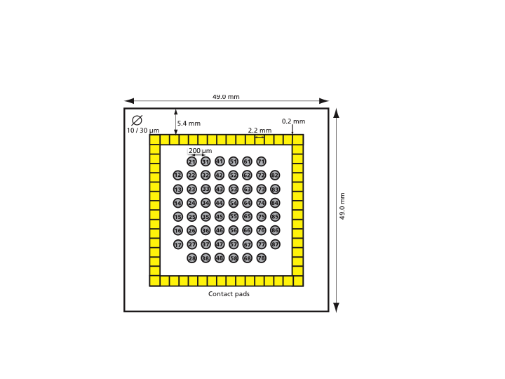

Figure 2.13: Standard Electrode Grid 8x8 and dimensions. Reprinted from [70]

### Local Field Potentials (LFPs)

Local Field Potentials (LFPs) are commonly related to the inputs of a neural ensemble and its processes within the neuronal network. In this view, LFPs are primarily associated with synchronized synaptic signals, sub-threshold membrane oscillations and spike after-potentials. Understanding LFPs is important because there are some studies suggesting that LFPs could be responsible for some very specific aspects of neural signal modulation. LFPs have different characteristics depending on which brain region they are recorded from. In the hippocampus(define this), for example, LFPs are usually characterized by strong theta(define?) oscillations, between 4 and 10 Hz. These oscillations are believed to be critical for temporal coding of information and synaptic plasticity in the hippocampus region. In most applications, as well as in clinical studies, LFPs are usually divided into different frequency components. These are the same oscillations that are associated with EEG recordings: delta (< 4 Hz), theta (4-8 Hz), alpha (8-12 Hz), beta (12-30 Hz), gamma (30-80 Hz) and high gamma (> 80 Hz).

In common traces of quiescent(define???) networks, most of the signal power is found at low frequencies, indicating that rhythms like delta(define?) and theta(define?) are predominant. Studies have shown that when a network is stimulated, gamma band oscillations are enhanced and activity at lower frequencies is suppressed [50]. On the contrary, increased power in the gamma band means that the neural network is engaged in some kind of processing activity. At a given recording site, gamma rhythms are stronger for some stimuli than others, generally displaying selectivity and a preference similar to that of nearby neuronal spiking activity. For instance, in higher cortex, gamma power is prominent during working memory and learning. Interestingly, irregular gamma activity has been observed in neurological disorders such as Alzheimer’s disease, Parkinson’s disease, schizophrenia, and epilepsy [51].

The main motivation for measuring LFPs is that they provide a measure of local neuron population activity, which, despite being less direct than neural spikes, is nonetheless practical for studying the overall behavior of select brain region [52], [53]. This information is complementary to that provided by action potentials since it relates to events that eventually might lead to the generation of action potentials, but may not clearly manifest in action potential patterns in cases where excitatory inputs are subthreshold or offset by concurrent inhibition.

It is worth noting that extracellular recordings are bipolar recordings. In a bipolar recording, signals are measured as the voltage difference that occurs between two electrodes (this sounds more like a differential recording). One of the electrodes is usually called active or recording electrode and it is placed in proximity of the neurons we want to measure action potentials from. The other electrode is commonly called the reference or ground electrode, and as its name suggests it is used as a voltage reference level. MEA dishes can have different ground electrode configurations, but the most common experimental choice is to use as reference and ground electrode a specific electrode on the dish that is hundreds of time larger than the recording electrodes. Such a setup has a relevant flaw when recording LFPs, because of the fact that using a distant reference electrode prevents the investigators from having accurate information on the activity source location. Attempts to provide a general solution to this problem have not been successful, because, as discussed above, the factors that impact LFP recordings, both physiological (e.g., strength, spatial extent and symmetry of activation in the neuronal substrate), and technical (e.g., electrode characteristics and reference site) are difficult to assess. In this view, all that can be said with certainty for MEA recordings, is that the source of the LFP is generated somewhere in the conductive medium. This implies that identifying the sources of activity becomes even more challenging, because of volume conduction effects.

### Bursting Activity

Over the past decade, one of the most heavily investigated phenomenon in MEA applications is the bursting activity of dissociated neuronal networks. These bursts are defined as brief periods during which the spike rate of many cells or electrodes exceeds the baseline rate several fold. Previous studies of neural development in-vitro all agreed that population bursts are a major component of cultures' activity patterns. Figure 2.14 shows an example of MEA recordings displaying synchronized activity on most electrodes. These activity bursts have been investigated in several studies [10], [23], [24], [41], [54]–[57], and they have been mainly associated with the lack of external inputs in MEA neuronal preparations. Given their regular presence in MEA experiments, they are often used to measure the network developmental stage and maturation. The reasons why this bursting activity is such a predominant feature of in-vitro brain preparations and not of in-vivo studies is not yet understood. Therefore, such activity patterns are important parameters to be investigated and analyzed. Indeed, these periodic bursts represent a relatively stable activity characteristic in networks of cortical neurons. They offer the opportunity to study basic mechanisms of network firing, such as how synchronization is achieved and how connectivity determines patterns of activity in the neural population during different stages of in-vitro development.

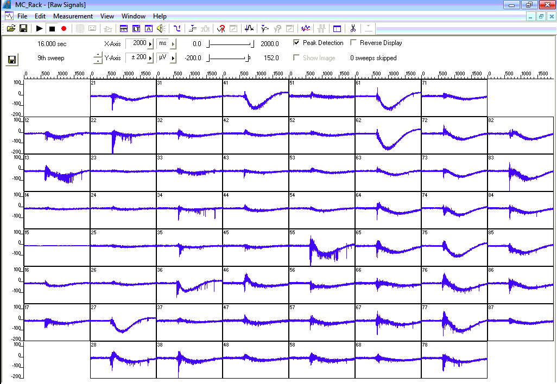

Figure 2.14: MEA recordings of synchronous activity

chapter 3

# AIM 1: QUANTYFYING DISSOCIATED NEURONAL NETWORK TEMPORAL EVOLUTION

## Introduction

Although hybrid neural-electrical circuits have been demonstrated, their functionality is inherently limited when the neuronal network is treated as a black box. An understanding of how dissociated neuronal networks evolve with respect to specific stimuli (or lack thereof) will lead to hybrid systems with greater functionality and robustness. Our long-term goal is to understand how these systems respond and evolve when presented with external stimulation. More in detail, we want to investigate how and why dissociated cortical neurons vary their electrical activity over time [44], [58], [59]. Such an investigation requires new mathematical tools to provide us with better approaches to quantifying functional activity evolution in dissociated cortical networks.

In the literature, there is a general lack of adequate statistical tools for processing and quantifying large spike-based data sets. [21] This deficit hinders investigators’ ability to identify significant changes in network connectivity amid populations of weakly tuned neurons with high spontaneous activity. As a result, the ultimate goal of exploring the relationship between neural circuit topology and behavior is compromised. Existing tools such as activity task neuroimaging are (inadequate?)insufficiently sensitive both temporally and spatially [45]. Although various approaches have been presented for analyzing spike behavior in MEA recordings, these methods have tended to focus on raw statistical correlations without necessarily yielding meaningful insights into the physiological network topology. For instance, in [60] the authors use Hidden Markov Models (HMMs) to estimate the number of states the neurons in the network can have. The authors assumed that neuronal networks only adopt three different firing patterns. This simplification was necessary to implement the HHM technique, but at the same time such an approach fails to capture the high variability and variety of neuronal network electrical responses.

Others [61] have proposed to use dynamic Bayesian networks to discover excitatory relationships in MEA recordings. In this work the authors tested a computer algorithm capable of emphasizing the excitatory statistical connections in discrete-time networks. Their main assumption is that in the network only excitatory connections are important, while inhibitory connections are neglected. With respect to neuronal networks, such an assumption cannot be considered valid, thus their mathematical approach cannot capture the full complexity of live neuron interactions. In both of these studies, the authors realize the importance of applying statistical techniques to identify sequences of firing neurons and find the functional network connectivity. However, despite the recognition of the relevance of statistical methods, there is a lack of literature investigating the physiological aspects of neuronal development [34], [35].

It is proposed here to use a well-known statistical technique that has been proven successful in separating the non-null from null cases in multiple hypothesis testing. For the first time, this work will statistically quantify the temporal dynamics of dissociated cultured neuronal networks, without simplifying the underlying biological model. This is achieved by applying the False Discovery Rate (FDR) statistical analysis technique to MEA recordings and using its results to quantify biological and electro-physiological properties of dissociated neuronal networks during their first five weeks in-vitro. FDR identifies significant stimulus-response pairs among the numerous spontaneous spikes from the cultured neurons. Moreover, the FDR technique has been proven to be a valuable tool to overcome the traditional issues in multiple hypotheses testing problems, namely controlling the probability of erroneously rejecting even one of the true null hypotheses, otherwise known as the family wise error-rate (FWE) [62]. This allowed an investigation of the temporal evolution of cultured neural networks as they are presented with electrical stimulation during early development.

## Methods

### Data Collection

The statistical analyses presented here were performed on neural spike data made available by Dr. Steve Potter in the Laboratory for Neuroengineering at Georgia Institute of Technology and Emory University School of Medicine. They comprise a series of MEA recordings from cultures of dissociated rat cortical neurons with bursting activity patterns, recorded over the first five weeks of their in-vitro development. Details of the cell culture methodology and electrophysiology can be found in [41].

### Signal Processing

To investigate network changes, we analyzed a large MEA data set composed of neuron spikes recorded from cultures of dissociated rat cortical neurons plated on MEA dishes with 59 recording electrodes each. There were 15 high-density high-volume (“dense”) cultures, as well as 7 high-density small-volume (“small”) and 6 low-density high-volume (“sparse”) ones. The culture density was chosen when plating the dissociated cortical neurons onto the MEAs, as described in [41]. Further details on different plating densities can be found in Table 1. Some neuron cultures were dissociated from the same original brain tissue; such cultures were defined as belonging to the same “batch” of brain tissue. The number of neuronal cultures dissociated from each batch is shown in Table 1.

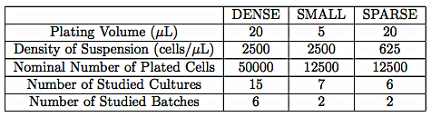

Table 1: Information on different densities of dissociated cortical neurons

Neural network activity was recorded during the first five weeks of each culture’s in-vitro development. During this period, stimulation sessions (typically occurring daily) were comprised of 50 electrical stimulus pulses delivered to each of the 59 electrodes. These stimuli were delivered sequentially to every electrode on the MEA, once every 300 ms while neural responses were recorded from all other electrodes. Although it is well-known that neuronal network responses elicited during such stimulation sessions are complex and may last longer than 300 ms [63], [64], we only focused on the network responses that occurred within 100 ms after stimulus onset. This allowed us to study the network responses known as the early phase stimulus-evoked responses [27]–[29], [37], [43], which are thought to be the most representative of the stimulation effects.

The stimulus-evoked spike count was normalized by subtracting the average spontaneous spike count averaged over 100 ms time windows. The spontaneous spikes were recorded on the same experimental day as the stimulus-evoked spikes, from the same neural network. This technique allowed us to account for the natural variability in neuron firing activity that occurs as a result of axonal growth and network changes over time. The same stimulation protocol was delivered to every culture. [41]

Each culture yielded a 59x59x50 data matrix (stimulated electrodes x recording electrodes x number of trials) of normalized spike counts on each day. We then averaged across trials to produce a 59x59 matrix of stimulus-response pairs (Zkj) per day per culture. These matrices were then interpreted for statistical significance (see Section “Statistical Analysis“). Only those stimulus-response pairs determined to be statistically significant were used in the subsequent quantitative connectivity analysis.

In order to be able to quantify changes in the connectivity graphs with respect to time, we used two measures per experimental day: the average length of significant pairwise stimulus-response connections and the number of connections that every node displays. The former is a measure of how physically far the neurons can extend their connectivity pathways. The latter is a measure of how many significant connections every node can either generate or receive. In other words, this is a measure of how many significant hubs the network displays on any specific experimental day. We defined “supernodes” to be those nodes that display at least three significant connections, either incoming or outgoing.

### Statistical Analysis

In order to identify statistically significant stimulus-response pairs, we implemented the False Discovery Rate (FDR) analysis technique. The FDR technique is a multiple hypothesis testing procedure whose objective is to control the expected proportion of incorrectly rejected null hypotheses, as shown by Equation 1. We chose to use FDR because it has been proven to be effective when testing multiple hypotheses [62] in high dimensionality data sets. In our case the null hypothesis is that a given stimulus-response pair is not statistically significant. We applied the FDR to the average number of evoked spikes relative to the average number of spikes recorded when no stimulation was delivered, (Zkj) as shown in Figure 3.1.

### Statistical Significance Test: FDR

The False Discovery Rate is defined as:

$$FDR=E \left[\frac{V}{R}\right]$$

Equation 1: Formal definition of False Discovery Rate Analysis

where:

* V is the number of false discoveries
* R is the total number of discoveries

FDR procedures are designed to control the expected proportion of incorrectly rejected null hypotheses, also called false discoveries V. In this work we chose $FDR=5\%$. The null hypothesis was defined as:

H{0,kj} : While stimulating electrode k, electrode j does not respond.(formatting)

Therefore, the FDR guarantees that no more than 5% of the stimulus-response pairs identified as being significant will actually be insignificant. The FDR was applied to each of the 59x59 elements of the matrix Zkj (stimulus-response activity pairs, normalized by the network spontaneous activity) recorded for every experimental session and for every culture. The implemented mathematical analysis is shown in Figure 3.1.

Figure 3.1: Block Diagram of the Implemented Neuronal Spike Statistical Analysis. The raw neural spikes are divided into two groups, evoked activity and spontaneous activity, respectively stimulated and non-stimulated experimental sessions. Then the raw spikes were divided into 100 ms time windows (100 ms after stimulus onset for evoked spikes) and averaged across repetitions (time windows). The average spontaneous activity was subtracted from the average evoked activity and fed into the False discovery Rate (FDR) statistical analysis technique. The output of the FDR is the significant stimulus-response pairs. Using these significant pairs we computed their average connection lengths and the number of supernodes.

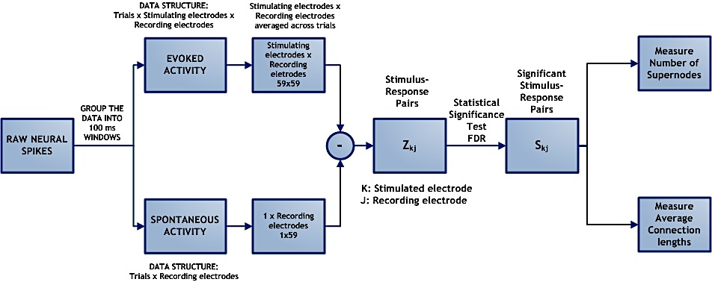

Mathematically, the FDR technique defines the two hypotheses as follows:

H{0,kj} : Zkj ~ N(µ0=0, σ2) = f0(Z*kj*)

H{1,kj} : Zkj ~ f1()

Equation 2: Formal definition of Null and Alternative Hypotheses (style???)

The statistic Tkj, referred to as “local FDR” is then defined as:

$$T_{kj}=\frac{\left(1-ϵ\right)f_{0}\left(Z_{kj}\right)}{ϵ f_{1}\left(Z_{kj}\right)+\left(1-ϵ\right)f_{0}(Z_{kj})}=\frac{\left(1-ϵ\right)f_{0}\left(Z_{kj}\right)}{f(Z_{kj})}$$

Equation 3: Local FDR

In other words, the local FDR function quantifies the relative likelihood of H0; values of Tkj close to 1 indicate a high likelihood of H0 whereas values closer to 0 indicate a low likelihood. In other words, the local FDR function is a measure of how similar the two distributions f0(Zkj) and f(Zkj) are, where f0(Zkj) is the null distribution density function and f(Zkj) is the alternative distribution function [65]. The parameter $ϵ$ is called the non-null proportion [62], [65] and represents the number of expected significant stimulus-response pairs. In our analysis we expect $ϵ$ to always assume small values because we expect the number of significant connections to be lower than the number of possible pairwise connections in the network. The value of the parameter $ϵ$ is estimated from the data before computing the local FDR functions [62]. If $T_{kj}$ is close to 1, then the two distributions defined in the hypotheses are similar and the null hypothesis is selected. This indicates no significant relation between the stimulus, delivered to electrode k, and the neural response recorded at electrode j.

Next, the 59x59 $T_{kj}$’sare ranked from the smallest to the largest. The ordered local FDR functions are called $T_{1}, …, T_{p}$ where p = 59x59. Significant local FDR functions are therefore Ti, for $i ≤k$, such that:

$$k=\max\left(I:\frac{\sum_{I=1}^{k}{T_{I}}}{k}\right)≤FDR$$

Equation 4: Null Hypothesis Rejection Threshold

This technique therefore guarantees that the average false positive rate over all significant stimulus-response pairs will be less than 5%.

## Results

Figure 3.2 shows typical connectivity graphs for two different cultures harvested from different brain tissues, on three separate days. Each red arrow indicates a statistically significant connection between a stimulated electrode and a recording one, as identified by the FDR analysis. Figure 3.2 suggests that neuronal connectivity tends to evolve over time, with increases in both the number of statistically significant stimulus/recording pairs as well as the average length of connections and the number of connections per active node.

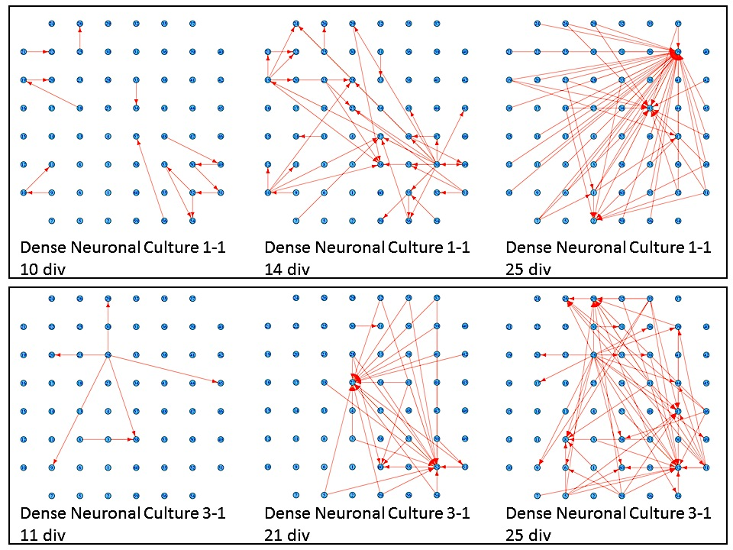

Figure 3.2: Connectivity Graphs for dense neuronal cultures on different days after plating. The top Panel shows results for culture 1-1, on days in-vitro (div) 10, 14 and 25. The bottom panel shows results for culture 3-1, on days in-vitro 11, 21 and 25.

In order to better analyze the changes in electrical activity versus time (and among different plating densities and neuron batches), we averaged the connection lengths and the supernode counts across cultures harvested from the same batch. The resulting graphs are shown in Figure 3.3, Figure 3.4 and Figure 3.5 where average connection distances and average supernode counts are shown respectively for dense, small and sparse cultures. For every cell density, the number of cultures that we used to compute the average within batches is different and it is indicated in the figures with n. From these graphs, it is noticeable how the average connectivity pair lengths increase over time, then reach a plateau, and then fall to values close to zero. Moreover, this behavioral trend seems to be consistent across cultures different densities. An increase in average connection length means that stimulus-evoked responses are recorded from electrodes that are physically further from the stimulated electrode; evoked electrical activity is propagated more easily in the dish and for longer distances. The functional evolution in the studied neuronal networks seems to perfectly reflect the natural temporal evolution of neural circuit formation. In fact, neural circuit formation occurs in three distinct stages: 1) Immature synapses form between *axons* and *dendrites*. 2) Synapses undergo maturation, which involves the conversion of silent synapses to active ones. 3) Excess synapses are eliminated or pruned to refine the neuronal connections within the circuit [66].

Figure 3.3, Figure 3.4 and Figure 3.5 reveal consistent neural development within batches, with more variable trends across batches. To quantify this, we computed the correlation coefficients for both connection lengths and number of supernodes within and across batches. Then we averaged these correlation coefficients to concisely measure similarities in the data. To test the statistical significance of the average correlation coefficients we performed a one-way ANOVA test within batches and across batches. Our results suggest that the average correlation coefficient variability within batches is not statistically significant (p>=0.05). On the contrary, cross-batch variability was statistically significant for connection lengths (p=0.0034), and incoming (p=0.0013) and outgoing (p=0.0057) supernode counts. Figure 3.6 and Figure 3.7 explore the within- and cross-batch variability further, showing the average correlation coefficients for connection lengths (Figure 3.6) and supernode numbers (Figure 3.7), as derived from three of the dense batches. (Other batches were omitted since population sizes were too small to yield meaningful statistical results). These figures emphasize that the cultures’ average connection lengths and supernode numbers are similar when computed within batches, whereas the average correlation coefficients across batches are lower and their variations are statistically significant. This underscores the finding that there are larger differences between cultures derived from different batches than those observed within batches.



Figure 3.3: Connection Lengths averaged across cultures harvested from the same neuron batch. A) shows results derived from 6 dense culture batches. B) Results derived from 2 sparse density batches and C) displays results for 2 small density batches. Each panel shows results with respect to a different batch. The blue solid line represents the average connection length within batches, while red vertical lines are the corresponding standard errors. n represents the population size for each batch.

Figure 3.4: Incoming supernode number averaged across different cultures harvested from the same neuron batch. A) shows results for 6 dense culture batches. B) shows results for 2 sparse density culture batches and C) for 2 small density cultures. Blue solid lines represent the average supernode number within batches, while red vertical lines are the corresponding standard errors. n represents the population size for each batch.



Figure 3.5: Outgoing supernode number averaged across different cultures harvested from the same neuron batch. A) shows results for 6 dense culture batches. B) shows results for 2 sparse density culture batches and C) for 2 small density cultures. Blue solid lines represent the average supernode number within batches, while red vertical lines are the corresponding standard errors. n represents the population size for each batch.

Figure 3.6: Average Correlation Coefficients. The first 3 bars are the average correlation coefficients measured within 3 dense culture batches. The bar on the right-hand side represents the average correlation coefficient when measured across these 3 batches. The statistical significance of these distributions was tested using one-way ANOVA test. The p values are the results of the implemented statistical tests.





Figure 3.7: Average Supernode Count Correlation Coefficients. The first 3 bars are the average correlation coefficients measured within 3 dense culture batches. The bar on the right-hand side represents the average correlation coefficient when measured across these 3 batches. The statistical significance of these distributions was tested using one-way ANOVA test. The p values are the results of the implemented statistical tests.

## Discussion

This work has adopted a statistical technique for identifying significant neuronal connectivity between pairs of electrodes in a Micro Electrode Array dish. This work has furthermore developed two metrics for describing connectivity in the MEA dish: (1) the average distance between stimulus and recording electrodes, and (2) the existence of “supernode” electrodes, which form functional hubs connecting to a large number of other electrodes. Finally, this work has used these metrics to quantify connectivity trends in MEA cultures of dissociated rat cortical neurons, including culture preparations characterized as “Dense”, “Sparse” and “Small”. In all cases, the MEA dishes showed three phases of development with respect to neuronal connectivity over a period of 40 days. The first phase was characterized by relatively little significant neuronal connectivity within the MEA dish, this phase typically lasted five days. The second phase, lasting 10-15 days, is characterized by a rapid growth in the sophistication of network connectivity, both in terms of average connection length and number of supernodes. At the end of the second phase, network growth tends to plateau. In the third and final phase, network connectivity falls off dramatically, often in as little as one or two days, before the culture either dies or becomes functionally disconnected.

It is interesting to notice that towards the end of the experiments (35 div) our statistical results show an evident decrease in the number of significant connections. This might be caused for several reasons including changes in neuron density, glial cell proliferation or the fact that the networks might become less sensitive to stimulation over time. We observed that after 35 div the spontaneous firing rate and stimulus evoked responses decreased. This is in agreement with what found in [41], where the authors found that after one month in-vitro, the network’s overall firing rate was lower while its bursting activity increased. Furthermore, our findings suggest that the observed neuronal networks display similar behavioral trends within neuron cultures derived from the same brain tissue with non-significant variations in both their connection lengths and number of supernodes. On the contrary, temporal evolution seems to display statistically significant differences when analyzing cultures harvested from different brain tissues, as quantified by the ANOVA test results.

Two plausible explanations can justify the observed behaviors: 1) Cultures derived from the same brain tissues were grown, fed and recorded from at the same time and exposed to the same experimental conditions. On the contrary, experimental conditions might have been slightly different for cultures derived from different batches because they were grown during different periods of time. In this view the different experimental conditions could explain the high variability across batches. 2) Despite these neurons having been dissociated before plating, they could still retain characteristics and properties originating from the brain tissue they were derived from. The former explanation is more plausible, considering neuron sensitivity to experimental conditions. However, the latter is intriguing because it suggests that dissociated neurons retain essential properties of the original brain cortical tissue they were harvested from. If so, then electrical activity may be determined by genetic factors to a much larger extent than previously thought.

In previous studies, the gold standard to quantify the electrical activity of neuronal networks cultured on MEA dishes was to measure the overall network activity by summing the number of spikes detected per unit time over all electrodes [41]. Although this metric has proven beneficial when assessing the total network activity or network bursting activity, it is not specific or accurate enough to quantify the networks’ temporal evolution. Furthermore, given the randomness and variability associated with the spontaneous activity of such networks, it also lacks the statistical features that are valuable to minimize the effects of randomness in MEA recording results. Our findings suggest that FDR analysis is a valuable technique to investigate and quantify dissociated cortical networks’ temporal evolution when combined with more physiological metrics that can track changes in network activity.

It is worth noting that the MEA electrode grid used in this work is directly connected to the underlying neuron network. However, given the limited number of electrodes and their size and spacing, this electrode grid cannot capture the full extent and complexity of the actual neuron connectivity. Consequently, every electrode (or node) is actually simultaneously recording from (and stimulating) multiple neurons. Considering the high neuronal connectivity, a single stimulus pulse is therefore potentially able to induce stimulus-evoked responses across the whole network either directly or through one or more synapses. As a result, when we identify connections and connectivity graphs, we are actually measuring connections between electrodes (nodes) and not single cells. Although it is not easy to quantify the exact number of neurons involved, it is reasonable to assume that each supernode connection comprises about 20 or 30 main neurons.

One last consideration regarding the statistically significance of the FDR connectivity graphs. It is important to notice that the identified connections are not necessarily direct connections between two nodes, but they can hide intermediate hops and more complex activity patterns. This issue gets even more complex if we keep in mind that the electrode connections are an overall and over-simplified representation of the neuron network connectivity. Unfortunately, with this kind of MEA dishes it is arduous to track the real neuronal connections that underlie electrode activation.

Despite the results presented in this work, further studies will be necessary to understand the role of chronic external stimulation in dissociated cortical neuron development. Specifically, while this work identifies characteristic phases of MEA network development, it is not known whether those changes are occurring spontaneously or in response to the daily stimulation protocol. Further investigation is needed in which the neuronal connectivity of unstimulated MEA arrays is compared to that of chronically stimulated ones. Preliminary evidence [5] suggests that electrical activity may shape network functional properties.

Our findings are consistent with previous results in the literature. For instance in [28], the authors investigate the presence and the importance of “brain hubs” in functional brain organization. These brain hubs seem to play a key role in global information integration between different parts of the brain connections.

In the future, we will develop this work by investigating the specific role of electrical stimulation in regulating neuronal development. Specifically, we will implement associative learning protocols in MEA dishes such as those described in [30]. Protocols will use two different sets of external electrical stimuli. The Unconditional Stimulus (US) will be chosen from those stimuli that do not produce any evoked network response, whereas the Conditional Stimulus (CS) will be chosen from among those stimuli that produce a distinctive network activity. By comparing the network responses to the different stimuli and characterizing their temporal evolution, we will be able to study in greater detail the learning processes that take place in dissociated cortical neurons.

## Conclusions

In this chapter we investigated how dissociated cortical neurons respond to chronic electrical stimulation. In particular we investigated the temporal evolution of neuronal activity in response to a constant electrical stimulation protocol over the first 5 weeks of neuronal development. Our goal was to quantify changes in neuronal network functional connectivity, in dissociated cortical neurons. We hypothesized that both external stimuli and network functional evolution were fundamental in neuronal development. In fact our results show an evolution in network activity in two ways. Neuronal connectivity tends to evolve over time, with changes in both the number of statistically significant stimulus/recording pairs as well as the average length of connections and the number of connections per active node. We therefore propose that the FDR analysis combined with two metrics, the average connection length and the number of highly connected “supernodes” are valuable techniques for describing neuronal connectivity in MEA dishes. Furthermore, our results indicate that cultures dissociated from the same brain tissue display trends in their temporal evolution that are more similar than those obtained with respect to different batches, as quantified by the average correlation coefficients within and across batches. We suggest two hypotheses that could help explain the observed phenomena: 1) Cultures derived from the same brain tissues were cultured and exposed to experiments in the same time periods and under very similar experimental conditions, this could have induced the similarities in the observed results. 2) Our findings could indicate that even after dissociation, these neurons preserved some of the properties and characteristics of the original brain tissue they were harvested from. This would indicate that genetic information and genetic programs control neural development and neural firing more than previously hypothesized [59].

chapter 4

# AIM 2: INVESTIGATING LONG AND SHORT-TERM MEMORY FORMATION IN DISSOCIATED NEURONAL NETWORKS

It is a well-known phenomenon that external electrical stimulation can affect the functional activity of dissociated neuron networks [10]. The ability to drive the network to respond in a desired way provides a valuable approach to study changes in functional connectivity induced by external stimuli. For instance, in [43] and [67] Jimbo et al. demonstrated that local tetanic stimulation induces long-lasting (longer than 30 min) changes in network responses. They used the number of spikes recorded across all the electrodes to measure network responses. The most relevant aspect of this work is that for a given tetanic stimulation, activated neurons showed similar changes in activity level, as quantified by the overall network activity. In other words, all the activated neurons either increase their responsiveness or decrease to the stimulus. The result is interesting because it proves that despite the large number of neurons and synapses involved in the network response phenomena, potentiation or depression are pathway-specific and not neuron-specific. In the literature, several studies have shown that these networks exhibit a variety of recurring activity patterns that can be modified by electrical stimulation [68] [41]. Therefore, many research labs have designed experiments whose goal is to utilize stimulation to modify the behavior of such neuronal preparations and interact with them. The most common issues with such experimental setups are the high variability in the network responses and the randomness in background activity, thus making the neuronal activity difficult to interpret. The observed variability has often been attributed to the natural plasticity of the nervous system, but there are no studies that have specifically investigated to what extent this plasticity can be associated to in-vitro memory formation.

The aim of this chapter is to investigate whether dissociated neuron networks can exhibit memory phenomena, defined as the ability to learn and remember the applied stimulus paradigm. In order to answer this question, a set of experiments is proposed in which the MEA electrode grid is divided into four quadrants, two of which are chronically stimulated (Q1 and Q3, see Figure 4.3), three times a week for 1 hour. This stimulation paradigm is applied for two weeks, while the remaining two quadrants (Q2 and Q4, see Figure 4.3) are never stimulated and can then be used as an on-dish control. After two weeks of chronic stimulation, the stimulus delivery is suspended in Q3 for a week; Q3 is therefore the “experimental” quadrant. During this period only Q1, defined as the “test” quadrant, is stimulated. After a week, stimulation delivery is resumed into both quadrants (Q1 and Q3) and their responses are compared to quantify what level of plasticity has taken place in the network and how this relates to the stimulation interruption.

One of three possible outcomes is expected:

1. The experimental quadrant responds to the resumed stimulation with a lower activity compared to the test quadrant to which chronic stimulation was regularly applied.

2. The experimental quadrant responds with higher activity compared to the test quadrant.

3. The experimental quadrant shows no significant difference from the always-stimulated quadrant.

Moreover, our experimental paradigm will allow us to study differences in the test quadrant’s stimulus-evoked activity, once the chronic stimulation is resumed, and find out if the activity in the experimental and test quadrants eventually goes back to the activation levels they displayed before suspending the stimulation.

Even though we are dividing the electrode grid in different areas, such a division does not apply to the underlying neuronal networks. In fact, the cultured neurons are capable of generating connections that spread out across any area of the MEA dish. This implies that stimulation, even if localized to a specific site, will evoke responses and modifications in different locations of the dish. As a result, the observed spatial changes in the neuron activity might not be exclusively contained in a quadrant. Nonetheless the effects of the applied stimulation should be stronger or more lasting in proximity of the delivered stimulus pulses. In order to be sure to identify spatial changes in network activity evoked by local stimulation, we will quantify both the total activity (entire electrode grid) and activity in every single quadrant. This will allow us to detect statistically significant local changes (across quadrants) with respect to the induced spatial activity changes in the networks.

## Methods

### Cell Culture Preparation

Primary neuronal cultures will be obtained from BrainBits, LLC (IL, USA). Cortical tissue from embryonic Sprague–Dawley rats at day 18 of gestation will be harvested by caesarian section from anesthetized pregnant dams. MEA dish preparation and neuron dissociation will proceed as previously described in [41]. Briefly, rat embryonic cerebral cortices are dissected from the brain and dissociated first by enzymatic digestion in papain solution (20 min at 37 °C) and subsequently by mechanical dissociation with a fine tipped Pasteur pipette. The resulting tissue is re-suspended in Neurobasal medium supplemented with 2% B-27 and 1% Glutamax-I (NbActiv4, BrainBits, IL, USA) at the final concentration of 4000 cells/ul. The dissociated neurons are then plated onto MEAs previously coated with poly-D-lysine and laminin to promote cell adhesion. Cultures are kept in an incubator at 5% CO2 at 37°C and transferred to a dedicated acquisition incubator with the same environmental conditions during the experimental sessions. To reduce thermal stress of the cells, MEAs are kept at 37°C by means of a controlled thermostat (MCS, Reutlingen, Germany). Half of the culture medium is changed twice per week, immediately after the recording sessions.

### Data Collection

Microelectrode arrays (Multichannel systems, MCS) consist of 59 TiN/SiN planar round electrodes (30 um diameter; 200 um center-to-center inter-electrode intervals) arranged in a square grid (without corners; see Figure 4.3), with the only exception of a larger ground electrode replacing one of the recording electrodes. All dish chambers are sealed with a gas permeable Teflon membrane to prevent contamination and evaporation [8]. The activity of all cultures is recorded using a MEA1060-INV System, from Multi Channel Systems (MCS, Runtgen, Germany). Voltage signals are amplified after 1200x, sampled at 20 kHz and acquired through the data acquisition card and MCRack software (MCS). During stimulation sessions, electrical stimuli were delivered through a two-channel stimulator MCS STG1004. Data analysis is performed off-line using MCRack software, (MCS) and MATLAB© (The Mathworks, Natick, MA, USA).

## Experimental Paradigm

The stimulation protocol implemented in this work was designed to investigate whether localized electrode stimulation affects the stimulus-evoked responses in the two stimulated quadrants (Q1 and Q3). Dividing the electrode grid into quadrants allows for a comparison of network responses between regions and a quantification of how localized evoked-responses are (see Figure 4.3).

It is hypothesized that chronic stimulation affects the responses of the local neurons either by potentiation or depression, and that such phenomena are mostly seen in the experimental quadrants given the higher levels of stimulation they are subjected to due to spatial summation effects. To verify whether electrical stimuli generate short- or long-term potentiation and/or depression in local neurons, a set of experiments was designed to elucidate both the temporal and spatial aspects of network activity. The goal is to use localized stimulation to investigate local and global changes within a single neuronal network with respect to the electrode grid location. The choice to divide the stimulation protocol into four stages will determine whether plasticity mechanisms are evoked, either in the short or long-term.

In summary, the experimental paradigm consists of dividing the MEA electrode grid into four quadrants (two test quadrants and two control quadrants) and delivering voltage stimuli to eight electrodes in each of the two test quadrants for three hours a week while simultaneously recording the network electrical responses. Furthermore, the experimental sessions are grouped into four distinct phases, in which different stimulation paradigms are delivered:

Phase 1: Lasting from plating until the network displays clear spontaneous activity, defined as a steady firing activity exhibited from most electrodes. During this period, the acquisitions consist of spontaneous activity recordings with no stimulation delivery. Based on the results of the preliminary experiments run on human neurons, this phase usually lasts between five and seven weeks in-vitro;

Phase 2: Training Phase, lasting ten days. During this phase the network undergoes one hour of stimulation, eight electrodes in Q1 and eight electrodes in Q3 are used to deliver the stimuli.. During this phase the acquisitions are composed of:

1. a 30–minute long spontaneous activity before stimulus delivery;
2. followed by a 1-hour long evoked activity recording during stimulus delivery;
3. a 30-minute long spontaneous activity recording following the stimulus delivery.

Phase 3: Test Phase, following the training phase, lasting for ten days. The network is subjected to stimulated, but this time only the eight electrodes in Q1 are used to deliver the stimuli. No stimuli are delivered to Q3.

Phase 4: The acquisition paradigm used in training phase is resumed for ten more days (Q1 and Q3 stimulated). This phase should expose differences between the two quadrants with respect to temporal changes in the stimulation delivery and help emphasize the memory mechanisms in neural network.

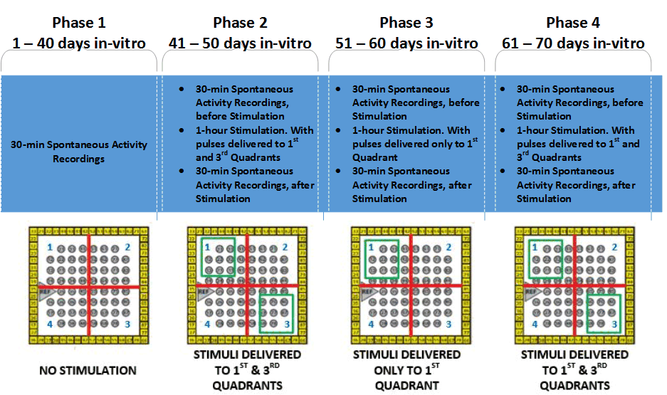

Dividing the experiments into four distinct phases allows us to emphasize differences in functional responses between the test quadrant and the experimental quadrant, due to stimulus delivery interruption. The temporal organization of the implemented experimental approach is shown in Figure 4.1.

Figure 4.1: Different Experimental Phases

### Data Acquisition Sessions

Every experimental session is composed of three separate recordings:

* 30 minutes of spontaneous activity recording, three times per week. Every recording starts 20 minutes after placing the dish onto the amplifier, thereby giving the neurons enough time to recover from mechanical stress due to movement.
* 1 hour of Stimulated Activity Recording, during the one-hour chronic stimulation, in which the neuronal cultures are simultaneously stimulated and recorded. The chronic stimulation will be delivered for ten days to both test quadrants. After this phase the stimulation delivery to the experimental quadrant will be suspended for ten days and then resumed for ten more days.
* 30 minutes of Spontaneous Activity Recording, recorded immediately after the electrical stimulation is completed.

## Stimulation Protocol

### Stimulation: Voltage Pulse Characteristics

The stimulation paradigm consists of a simultaneous paired pulse stimulus delivery to two electrodes in the two test quadrants. The paired-pulse stimulation approach is important to maximize the probability of excitation without over stimulating the cultures. This is based on previous studies in which it has been shown that the use of paired pulses allows one to decrease the amount of current/voltage necessary to evoke meaningful network responses. The reason why a paired-pulse paradigm evokes higher responses with lower voltages is that the first pulse activates presynaptic voltage-gated calcium channels, allowing for calcium influx into the neurons. If the second pulse quickly follows the first one (by a few milliseconds) when the second pulse arrives, it raises the calcium concentration even further before the calcium released by the first pulse is reabsorbed. This generates higher neuronal responses [24]. Every stimulus pulse consists of two voltage square waves (negative phase first) with amplitude respectively of -700 μV and 700 μV and duration 400 μs per phase. In addition, we choose to deliver bipolar pulses between one electrode and a distant large electrode used as ground to minimize the effects of electrolysis. These effects can easily damage the MEA electrodes and the cultured neurons. It has been shown that utilizing charge-balanced stimuli, especially for long-term applications, drastically reduces the risk of generating electrolysis. Another important parameter to take into consideration is the pulse time duration. Pulse width has to be kept short, because during stimulus delivery, large artifacts hide neuronal signals, making it hard to record during stimulation [68]. To increase the probability of neuron excitation, without over-stimulating the network, [69] the stimulus pulses are always delivered in pairs with an inter-pulse interval of 50 ms and with an inter-pair interval of 4 s. The temporal characteristics of the implemented stimuli are shown in Figure 4.2.



Figure 4.2: Delivered Stimulus Pulses

### Stimulation: Electrode Pattern

Eight electrodes in either quadrant are stimulated sequentially one by one, and the stimulation is delivered for one hour in each experimental session. During stimulus delivery, two electrodes, one per each quadrant, will be simultaneously stimulated. The stimulus pulses are always delivered between a stimulating electrode and the ground electrode. Our experimental design involves the delivery of eight pulses per cycle to two quadrants in the following order:

Pulse 1: Ch1: 21 & Ch2: 66

Pulse 2: Ch1: 31 & Ch2: 76

Pulse 3: Ch1: 12 & Ch2: 86

Pulse 4: Ch1: 22 & Ch2: 67

Pulse 5: Ch1: 32 & Ch2: 77

Pulse 6: Ch1: 13 & Ch2: 87

Pulse 7: Ch1: 23 & Ch2: 68

Pulse 8: Ch1: 33 & Ch2: 78

The electrodes that we plan to use to deliver the stimulus pulses are shown in Figure 4.3

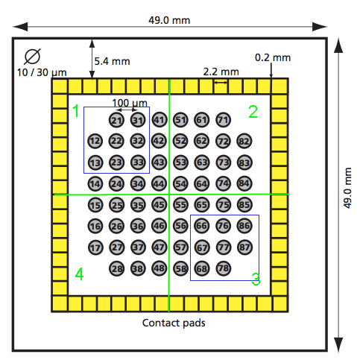

Figure 4.3: Electrode Grid, the blue rectangles show the 8 electrodes, for each quadrant, that are used to deliver stimulus pulses

## Signal Processing

### Spike Detection

Continuous voltage traces will be band-pass filtered to enhance the spiking components of the signals. In order to implement a band-pass filter we will feed our signals into the cascade of a high-pass(low pass???) 2nd order Butterworth filter with cutoff frequency set at 180 Hz and a high-pass 2nd order Butterworth, whose cutoff frequency was 3 kHz.

The spike detection threshold will be individually set for each channel. The threshold is chosen as -6 times each band-pass filtered signal’s standard deviation, as measured by MC_Rack software, within a 500 ms time window. To reduce the possibility of detecting duplicated spikes, a detection refractory period of 1 ms is used, during which no multiple detection events are accepted.

### Feature Extraction

Raw voltage signals were sampled at 20 kHz and amplified 1200x before being digitized and stored onto the acquisition computer. In order to perform off-line analysis significant parameters such as neural spikes and LFPs are extracted from the raw acquired signals. The overall spike rate is also recorded.

Given their importance in characterizing the behavior of cultured neuronal networks, bursting activity patterns are characterized according to the number of bursts occurring in each recording session, the number of spikes in bursts, and the frequency of burst occurrence. Bursts are detected using MCRack software, which allows investigators to select a series of parameters to perform burst detection. To detect the bursts, the software searches for instances where the interspike interval between spike trains is less than 10 ms. Events are included in a detected burst until the interspike interval becomes larger than 100 ms. A single bursting event includes all the detected events whose interspike interval is less than 15 ms. A burst is not counted if its duration is less than 50 ms or if it contains four or fewer spikes. Also important is the study of network bursting behavior. Even though, human hippocampal neurons don’t seem to display any bursting activity, this is the best way to measure it.

### Data Analysis

Given the high variability and randomness associated with the MEA recording features described in section 2.2, we plan to implement a statistical analysis procedure to investigate the network responses to the stimulation protocol described in section 4.3. Briefly, we aim to compensate for temporal spontaneous variability and spatial spontaneous variability that MEA experiments display. In summary, temporal variability will be controlled by dividing every acquisition in 5-minute time windows and implementing statistical analysis on these time bins. The results will be used to take into account the time course variations of network activity during the experiments. Spatial variability will be controlled by computing the mean firing activity and bursting parameters with respect to every quadrant in each experimental condition (pre-stimulus and post-stimulus). These values will be statistically analyzed and the results will be used as metrics of network local activity evoked by the delivered stimulation pulses.

### Temporal Statistical Analysis: Temporal firing stability

In order to quantify the temporal stability of our dissociated neuron networks during data acquisitions, we propose to divide every recording into 5-minute time windows and calculate the network spike statistics (firing parameters) across and within time bins. This stability will be then considered as a natural characteristic of the network during a specific experimental session and it will be used as a baseline measure of variability. Specifically, to test whether stimulation has an effect on spontaneous activity, we will measure a series of firing paramters, such as the number of bursts, the array-wide spike detection rate (ASDR) and spike rate. Such parameters will be computed with respect to recordings immediately before the stimulation sequence (Nbase), as well as in the recordings after stimulation (Npost). Next, we will divide these 30-min long spontaneous recording sessions in 5-minute bins. Then we will measure bursts, ASDR and firing rate within these time windows, for both pre- and post-stimulation recording sessions, (Nctrl). We will compute the absolute value of the change induced by the stimulation sequence, ΔNind = |Npost - Nbase|, as well as the spontaneous change in consecutive time bins (within the same recording session), i.e., the change attributable to drift, ΔNspont = |Nbase - Nctrl|.

For the purpose of comparing results between cultures with widely varying firing parameters, we will normalize the changes by the previously computed baseline parameters Nbase, and will calculate the averages of |ΔNind|/Nbase and |ΔNspont|/Nbase across all experiments with a given stimulation protocol. This will help us reveal the detected changes not statistically significantly larger than spontaneous changes.

### Spatial Statistical Analysis: Stimulation evoked variability

Each MEA electrode grid was divided into four quadrants, each composed of 15 channels/electrodes, with the only exception of Q4 that has 14 electrodes due to the presence of the ground electrode. The average firing parameters as measured from the electrodes within each quadrant will be used as a metric of the overall neuronal activity in each dish region, also called local activity.

In addition to changes induced by the 4 different experimental phases, we also want to investigate whether the spatial distribution of the delivered stimuli could play an important role in shaping the spatial patterns of network responses. Furthermore, given the high network connectivity, we aim to study how distributed responses of the networks relate to the division in electrode quadrants we plan to use to deliver stimulation pulses.

Hence, we will measure ASDR, firing rate and burst number in the network responses in each quadrant before and after stimulation delivery and to look for significant changes in spatial response patterns. To have an activity baseline of the network electrical behavior, we will also compute the ASDR, firing rate and burst parameters in each quadrant within spontaneous recording sessions and propose to use these activities as representative of spontaneous spatial variations or pattern drifts in the network.

Our goal is to identify the effects that the applied stimulation has on the network behavior and emphasize functional changes in activity due to the specific electrode pattern of stimulation protocol. Thus we propose to compute every local activity metric before and after the 1-hour stimulus delivery session (pre-stimulus and post- stimulus recordings), to identify changes in network behavior due to stimulation.

chapter 5

# CONCLUSION

We studied how dissociated cortical neurons respond to chronic electrical stimulation. In particular we investigated the temporal evolution of neuronal activity in response to a constant electrical stimulation protocol over the first 5 weeks of neuronal development. Our goal was to quantify changes in neuronal network functional connectivity, in dissociated cortical neurons. We hypothesized that both external stimuli and network functional evolution were fundamental in neuronal development as shown in [1]. In fact our results show an evolution in network activity in two ways. Neuronal connectivity tends to evolve over time, with changes in both the number of statistically significant stimulus/recording pairs as well as the average length of connections and the number of connections per active node. We therefore propose that the FDR analysis combined with two metrics, the average connection length and the number of highly connected “supernodes” are meaningful techniques for describing neuronal connectivity in MEA dishes.

Furthermore, our results indicate that cultures dissociated from the same brain tissue display trends in their temporal evolution that are more similar than those obtained with respect to different batches, as quantified by the average correlation coefficients within and across batches. We suggest two hypotheses that could help explain the observed phenomena: 1) Cultures derived from the same brain tissues were cultured and exposed to experiments in the same time periods and under very similar experimental conditions, this could have induced the similarities in the observed results. 2) Our findings could indicate that even after dissociation, these neurons preserved some of the properties and characteristics of the original brain tissue they were harvested from. This would indicate that genetic information and genetic programs control neural development and neural firing more than previously hypothesized. [19]

In future work, the experiments proposed in Chapter 4 (Aim 2) will be carried out and their results used to answer the second experimental question object of this dissertation work. The experimental timeline, with a description of the experiment schedule is presented in the next chapter.

# TIMELINE

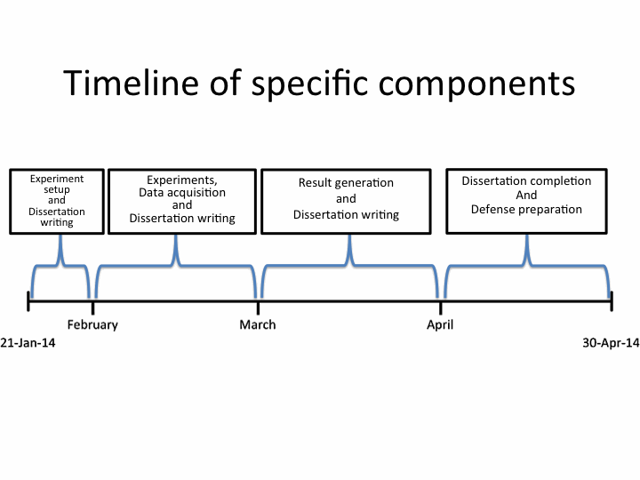

Figure 6.1: Dissertation Completion Timeline

## Plan for Completing the Dissertation

## January 2013

The final eight dissociated cortical neuronal cultured will be plated on MEA dishes and grown in-vitro. These cultures will be used to record spontaneous electrical activity twice a week for 40 days. I will also work at the dissertation document, with particular focus on the methods section.

## February 2013

After one month in-vitro, the neuronal cultures will begin to display spontaneous activity. At this time, they will be ready to be electrically stimulated, using the stimulation protocols presented in section 4.3. During this period, stimulation and recording will be performed twice a week. This phase will require forty days.

I will continue working on the dissertation document, focusing on results and conclusion sections.

## March 2013

The experiments will be completed, since the stimulation protocol is designed to last forty days. After this period, the experimental results will be analyzed and used to draw conclusions on the research work. Then appropriate statistical results will be generated and used to complete the last dissertation chapters, namely Experimental Results and Conclusion.

## April 2013

I will complete my Dissertation document and prepare the presentation for my defense that will be scheduled by the end of April 2013.

REFERENCES

[1] M. Cobb, “Timeline: exorcizing the animal spirits: Jan Swammerdam on nerve function.,” *Nat. Rev. Neurosci.*, vol. 3, no. 5, pp. 395–400, May 2002.

[2] C. Kenneth, S., *Membranes, Ions and Impulses*, Biophysics. Berkley, CA: Science, 1968.

[3] G. Marmont, “Studies on the axon membrane. I. A new method,” *J. Cell. Comp. Physiol.*, vol. 34, no. 3, pp. 351–382, 1949.

[4] A. L. Hodgkin and F. Huxley, A., “A quantitative description of membrane current and its application to conduction and excitation in nerve,” *J. Physiol.*, vol. 117, no. 4, pp. 500–544, 1952.

[5] J. Pine, “Recording by means of a large number of extracellular electrodes embedded in the b o t t o m of the culture dish . Such electrodes could be part of a micro- circuit , fabricated by utilizing techniques which are now widely used in the semiconductor elect,” *Neuroscience*, vol. 2, pp. 19–31, 1980.

[6] Y. Nam, J. Chang, and D. Khatami, “Patterning to enhance activity of cultured neuronal networks,” *Nanobiotechnology, IEEE Proc.*, vol. 151, no. 3, pp. 109–115, 2004.

[7] C. Lesuisse and L. Martin, “Long‐term culture of mouse cortical neurons as a model for neuronal development, aging, and death,” *J. Neurobiol.*, 2002.

[8] S. M. Potter and T. B. DeMarse, “A new approach to neural cell culture for long-term studies.,” *J. Neurosci. Methods*, vol. 110, no. 1–2, pp. 17–24, Sep. 2001.

[9] G. M. J. Beaudoin, S.-H. Lee, D. Singh, Y. Yuan, Y.-G. Ng, L. F. Reichardt, and J. Arikkath, “Culturing pyramidal neurons from the early postnatal mouse hippocampus and cortex.,” *Nat. Protoc.*, vol. 7, no. 9, pp. 1741–54, Sep. 2012.

[10] S. Marom and G. Shahaf, “Development, learning and memory in large random networks of cortical neurons: lessons beyond anatomy.,” *Q. Rev. Biophys.*, vol. 35, no. 1, pp. 63–87, Feb. 2002.

[11] M. Dichter, “Rat cortical neurons in cell culture: culture methods, cell morphology, electrophysiology, and synapse formation,” *Brain Res.*, vol. 149, pp. 279–293, 1978.

[12] B. Wheeler and G. Brewer, “Designing neural networks in culture,” *Proc. IEEE*, vol. 98, no. 3, pp. 398–406, 2010.

[13] C. a Thomas, P. a Springer, G. E. Loeb, Y. Berwald-Netter, and L. M. Okun, “A miniature microelectrode array to monitor the bioelectric activity of cultured cells.,” *Exp. Cell Res.*, vol. 74, no. 1, pp. 61–6, Sep. 1972.

[14] G. Gross, “Simultaneous single unit recording in vitro with a photoetched laser deinsulated gold multimicroelectrode surface,” *Biomed. Eng. IEEE Trans.*, no. 5, pp. 273–279, 1979.

[15] D. a Israel, W. H. Barry, D. J. Edell, and R. G. Mark, “An array of microelectrodes to stimulate and record from cardiac cells in culture.,” *Am. J. Physiol.*, vol. 247, no. 4 Pt 2, pp. H669–74, Oct. 1984.

[16] J. L. Novak and B. C. Wheeler, “Recording from the Aplysia abdominal ganglion with a planar microelectrode array.,” *IEEE Trans. Biomed. Eng.*, vol. 33, no. 2, pp. 196–202, Feb. 1986.

[17] P. Connolly, P. Clark, a S. Curtis, J. a Dow, and C. D. Wilkinson, “An extracellular microelectrode array for monitoring electrogenic cells in culture.,” *Biosens. Bioelectron.*, vol. 5, no. 3, pp. 223–34, Jan. 1990.

[18] V. Janossy, A. Toth, L. Bodocs, P. Imrik, E. Madarasz, and A. Gyevai, “Multielectrode culture chamber: a device for long-term recording of bioelectric activities in vitro,” *Acta Biol Hung.*, vol. 41, no. 4, pp. 309–320, 1990.

[19] a Borroni, F. M. Chen, N. LeCursi, L. M. Grover, and T. J. Teyler, “An integrated multielectrode electrophysiology system.,” *J. Neurosci. Methods*, vol. 36, no. 2–3, pp. 177–84, Feb. 1991.

[20] Y. Jimbo and A. Kawana, “Electrical stimulation and recording from cultured neurons using a planar electrode array,” *Bioelectrochemistry Bioenerg.*, vol. 29, no. 2, pp. 193–204, Dec. 1992.

[21] S. Martinoia, M. Bove, G. Carlini, C. Ciccarelli, M. Grattarola, C. Storment, and G. Kovacs, “A general-purpose system for long-term recording from a microelectrode array coupled to excitable cells.,” *J. Neurosci. Methods*, vol. 48, no. 1–2, pp. 115–21, Jun. 1993.

[22] G. W. Gross and F. U. Schwalm, “A closed flow chamber for long-term multichannel recording and optical monitoring,” *J. Neurosci. Methods*, vol. 52, no. 1, pp. 73–85, Apr. 1994.

[23] L. L. Bologna, T. Nieus, M. Tedesco, M. Chiappalone, F. Benfenati, and S. Martinoia, “Low-frequency stimulation enhances burst activity in cortical cultures during development.,” *Neuroscience*, vol. 165, no. 3, pp. 692–704, Feb. 2010.

[24] a N. Ide, a Andruska, M. Boehler, B. C. Wheeler, and G. J. Brewer, “Chronic network stimulation enhances evoked action potentials.,” *J. Neural Eng.*, vol. 7, no. 1, p. 16008, Feb. 2010.

[25] J. D. Rolston, R. E. Gross, and S. M. Potter, “NeuroRighter: closed-loop multielectrode stimulation and recording for freely moving animals and cell cultures.,” *Conf. Proc. IEEE Eng. Med. Biol. Soc.*, vol. 2009, pp. 6489–92, Jan. 2009.

[26] J. D. Rolston, D. a Wagenaar, and S. M. Potter, “Precisely timed spatiotemporal patterns of neural activity in dissociated cortical cultures.,” *Neuroscience*, vol. 148, no. 1, pp. 294–303, Aug. 2007.

[27] D. J. Bakkum, Z. C. Chao, and S. M. Potter, “Spatio-temporal electrical stimuli shape behavior of an embodied cortical network in a goal-directed learning task.,” *J. Neural Eng.*, vol. 5, no. 3, pp. 310–23, Sep. 2008.

[28] T. B. Demarse, D. a Wagenaar, A. W. Blau, and S. M. Potter, “The Neurally Controlled Animat: Biological Brains Acting with Simulated Bodies.,” *Auton. Robots*, vol. 11, no. 3, pp. 305–310, Jan. 2001.

[29] G. Shahaf and S. Marom, “Learning in networks of cortical neurons.,” *J. Neurosci.*, vol. 21, no. 22, pp. 8782–8, Nov. 2001.

[30] Z. C. Chao, D. J. Bakkum, and S. M. Potter, “Shaping embodied neural networks for adaptive goal-directed behavior.,” *PLoS Comput. Biol.*, vol. 4, no. 3, p. e1000042, Mar. 2008.

[31] J. D. Rolston, R. E. Gross, and S. M. Potter, “Closed-loop, open-source electrophysiology.,” *Front. Neurosci.*, vol. 4, no. September, pp. 1–8, Jan. 2010.

[32] M. Bentivoglio, “Life and discoveries of Santiago Y Cajal,” *The Official Web Site of the Nobel Price*. [Online]. Available: http://www.nobelprize.org/nobel_prizes/medicine/laureates/1906/cajal-article.html.

[33] A. W. Toga, K. a Clark, P. M. Thompson, D. W. Shattuck, and J. D. Van Horn, “Mapping the human connectome.,” *Neurosurgery*, vol. 71, no. 1, pp. 1–5, Jul. 2012.

[34] M. P. van den Heuvel and O. Sporns, “Rich-club organization of the human connectome.,” *J. Neurosci.*, vol. 31, no. 44, pp. 15775–86, Nov. 2011.

[35] E. N. Brown, R. E. Kass, and P. P. Mitra, “Multiple neural spike train data analysis: state-of-the-art and future challenges.,” *Nat. Neurosci.*, vol. 7, no. 5, pp. 456–61, May 2004.

[36] I. Obeid and P. Wolf, “Evaluation of spike-detection algorithms fora brain-machine interface application,” *Biomed. Eng. IEEE Trans. …*, vol. 51, no. 6, pp. 905–911, 2004.

[37] Z. Chao, D. Bakkum, and S. Potter, “Region-specific network plasticity in simulated and living cortical networks: comparison of the center of activity trajectory (CAT) with other statistics,” *J. Neural Eng.*, vol. 4, no. 3, pp. 294–308, 2007.

[38] A. K. H. Achyuta, A. J. Conway, R. B. Crouse, E. C. Bannister, R. N. Lee, C. P. Katnik, A. a Behensky, J. Cuevas, and S. S. Sundaram, “A modular approach to create a neurovascular unit-on-a-chip.,” *Lab Chip*, vol. 13, no. 4, pp. 542–53, Feb. 2013.

[39] Y. Huang, J. C. Williams, and S. M. Johnson, “Brain slice on a chip: opportunities and challenges of applying microfluidic technology to intact tissues.,” *Lab Chip*, vol. 12, no. 12, pp. 2103–17, Jun. 2012.

[40] G. Shahaf and S. Marom, “Learning in networks of cortical neurons.,” *J. Neurosci.*, vol. 21, no. 22, pp. 8782–8, Nov. 2001.

[41] D. a Wagenaar, J. Pine, and S. M. Potter, “An extremely rich repertoire of bursting patterns during the development of cortical cultures.,” *BMC Neurosci.*, vol. 7, p. 11, Jan. 2006.

[42] J. van Pelt, P. S. Wolters, M. a Corner, W. L. C. Rutten, and G. J. a Ramakers, “Long-term characterization of firing dynamics of spontaneous bursts in cultured neural networks.,” *IEEE Trans. Biomed. Eng.*, vol. 51, no. 11, pp. 2051–62, Nov. 2004.

[43] Y. Jimbo, a Kawana, P. Parodi, and V. Torre, “The dynamics of a neuronal culture of dissociated cortical neurons of neonatal rats.,” *Biol. Cybern.*, vol. 83, no. 1, pp. 1–20, Jul. 2000.

[44] L. I. Zhang and M. M. Poo, “Electrical activity and development of neural circuits.,” *Nat. Neurosci.*, vol. 4 Suppl, pp. 1207–14, Nov. 2001.

[45] M. Carandini, “From circuits to behavior: a bridge too far?,” *Nat. Neurosci.*, vol. 15, no. 4, pp. 507–9, Apr. 2012.

[46] P. Berens, G. A. Keliris, A. S. Ecker, M. E. Debakey, and V. Affairs, “Feature selectivity of the gamma-band of the local fi eld potential in primate primary visual cortex,” vol. 2, no. 2, pp. 199–207, 2008.

[47] S. Gozani and J. Miller, “Optimal discrimination and classification of neuronal action potential waveforms from multiunit, multichannel recordings using software-based linear filters,” *Biomed. Eng. IEEE …*, vol. 41, no. 4, 1994.

[48] R. N. McDonough and A. D. Whalen, *Detection of signals in Noise*, 2nd Editio. San Diego, CA: Academic, 1995.

[49] I. N. Bankman, K. O. Johnson, and W. Schneider, “Optimal Detection, Classification, and Superposition Resolution in Neural Waveform Recordings,” *IEEE Trans. Biomed. Eng.*, vol. 40, no. 8, 1993.

[50] A. Manuscript, “phase-locked to gamma frequencies,” vol. 9, no. 2, pp. 1–20, 2013.

[51] X. Jia and A. Kohn, “Gamma rhythms in the brain.,” *PLoS Biol.*, vol. 9, no. 4, p. e1001045, Apr. 2011.

[52] C. E. Schroeder, a D. Mehta, and S. J. Givre, “A spatiotemporal profile of visual system activation revealed by current source density analysis in the awake macaque.,” *Cereb. Cortex*, vol. 8, no. 7, pp. 575–92, 1998.

[53] N. F. Ince, R. Gupta, S. Arica, A. H. Tewfik, J. Ashe, and G. Pellizzer, “High Accuracy Decoding of Movement Target Direction in Non-Human Primates Based on Common Spatial Patterns of Local Field Potentials,” *PLoS One*, vol. 5, no. 12, p. e14384, Jan. 2010.

[54] E. Maeda, H. P. Robinson, and a Kawana, “The mechanisms of generation and propagation of synchronized bursting in developing networks of cortical neurons.,” *J. Neurosci.*, vol. 15, no. 10, pp. 6834–45, Oct. 1995.

[55] J. Van Pelt, I. Vajda, P. S. Wolters, M. A. Corner, and G. J. A. Ramakers, “Structure and Dynamics in Neurons and Neuronal Networks,” *Prog. Brain Res.*, vol. 147, pp. 173–188, 2005.

[56] J. M. Beggs and D. Plenz, “Neuronal avalanches in neocortical circuits.,” *J. Neurosci.*, vol. 23, no. 35, pp. 11167–77, Dec. 2003.

[57] M. Chiappalone, M. Bove, A. Vato, M. Tedesco, and S. Martinoia, “Dissociated cortical networks show spontaneously correlated activity patterns during in vitro development.,” *Brain Res.*, vol. 1093, no. 1, pp. 41–53, Jun. 2006.

[58] M.-G. Liu, X.-F. Chen, T. He, Z. Li, and J. Chen, “Use of multi-electrode array recordings in studies of network synaptic plasticity in both time and space.,” *Neurosci. Bull.*, vol. 28, no. 4, pp. 409–22, Aug. 2012.

[59] N. C. Spitzer, “Electrical activity in early neuronal development.,” *Nature*, vol. 444, no. 7120, pp. 707–12, Dec. 2006.

[60] A.-C. Camproux, F. Saunier, G. Chouvet, J.-C. Thalabard, and G. Thomas, “A Hidden Markov Model Approach,” *Biophys. J.*, vol. 71, no. November, pp. 2404–2412, 1996.

[61] D. Patnaik, S. Laxman, and N. Ramakrishnan, “Discovering excitatory relationships using dynamic Bayesian networks,” *Knowl. Inf. …*, vol. 29, no. 2, pp. 273–303, Sep. 2011.

[62] Y. Benjamini and D. Yekutieli, “The control of the false discovery rate in multiple testing under dependency,” *Ann. Stat.*, vol. 29, no. 4, pp. 1165–1188, 2001.

[63] D. Eytan, N. Brenner, and S. Marom, “Selective adaptation in networks of cortical neurons.,” *J. Neurosci.*, vol. 23, no. 28, pp. 9349–56, Oct. 2003.

[64] P. Baljon, M. Chiappalone, and S. Martinoia, “Interaction of electrically evoked responses in networks of dissociated cortical neurons,” *Phys. Rev. E*, vol. 80, no. 3, p. 031906, Sep. 2009.

[65] J. Jin and T. T. Cai, “Estimating the Null and the Proportion of Nonnull Effects in Large-Scale Multiple Comparisons,” *J. Am. Stat. Assoc.*, vol. 102, no. 478, pp. 495–506, Jun. 2007.

[66] L. E. Clarke and B. a Barres, “Emerging roles of astrocytes in neural circuit development.,” *Nat. Rev. Neurosci.*, vol. 14, no. 5, pp. 311–21, May 2013.

[67] Y. Jimbo, T. Tateno, and H. P. Robinson, “Simultaneous induction of pathway-specific potentiation and depression in networks of cortical neurons.,” *Biophys. J.*, vol. 76, no. 2, pp. 670–8, Feb. 1999.

[68] D. a Wagenaar, J. Pine, and S. M. Potter, “Effective parameters for stimulation of dissociated cultures using multi-electrode arrays.,” *J. Neurosci. Methods*, vol. 138, no. 1–2, pp. 27–37, Sep. 2004.

[69] G. J. Brewer, M. D. Boehler, A. N. Ide, and B. C. Wheeler, “Chronic electrical stimulation of cultured hippocampal networks increases spontaneous spike rates.,” *J. Neurosci. Methods*, vol. 184, no. 1, pp. 104–9, Oct. 2009.

[70] “MEA Amplifier with Blanking Circuit for Inverse Microscopes.” Multi Channel Systems, Reutlingen, Germany, 2012.

[71] A. Despopoulus and S. Silbernagl, *Color atlas of physiology*, 5th Editio. Stuttgart, Germany: Georg Thieme Verlag, 2003.

[72] P. Berens and G. Keliris, “Feature selectivity of the gamma-band of the local field potential in primate primary visual cortex,” *Front. …*, vol. 2, no. 2, pp. 199–207, 2008.

[73] G. Wilcox, “Electrical Signaling in the Nervous System.” 2013.