DEEP ARCHITECTURES FOR SPATIO-TEMPORAL SEQUENCE RECOGNITION
WITH APPLICATIONS IN AUTOMATIC SEIZURE DETECTION
A Dissertation Proposal
Submitted to the
Department of Electrical and Computer Engineering
In Partial Fulfillment of the Requirements for
the Degree of Doctor of Philosophy
in Electrical Engineering
by
Meysam Golmohammadi
December 2019
Examining Committee Members:
Dr. Joseph Picone, Advisory Committee Chair, Department of Electrical and Computer Engineering, College of Engineering, Temple University
Dr. Iyad Obeid, Committee Member, Department of Electrical and Computer Engineering, College of Engineering, Temple University
Dr. Chang-Hee Won, Committee Member, Department of Electrical and Computer Engineering, College of Engineering, Temple University
Dr. Pallavi Chitturi, Committee Member, Department of Statistics, Fox School of Business, Temple University

©
Copyright
2019

By
Meysam Golmohammadi
–––––––––––––––––––
All Rights Reserved

ABSTRACT
Scalp electroencephalograms (EEGs) are used in a broad range of health care institutions to monitor and record electrical activity in the brain using electrodes placed on the scalp. EEGs are essential in diagnosis of clinical conditions such as epilepsy, seizure, coma, encephalopathy, and brain death. Manual scanning and interpretation of EEGs is time-consuming since these recordings may last hours or days. It is also an expensive process as it requires highly trained experts. Therefore, high performance automated analysis of EEGs can reduce time to diagnosis and enhance real-time applications by identifying sections of the signal that need further review.
Automatic analysis of clinical EEGs is a very difficult machine learning problem due to the low fidelity of a scalp EEG signal. Commercially available automated seizure detection systems suffer from unacceptably high false alarm rates. Many methods have been developed over the years including time-frequency processing, wavelet analysis, and autoregressive spectral analysis of scalp EEG. Though there has been significant progress in machine learning technology in recent years, use of automated technology in clinical settings is limited, mainly due to unacceptably high false alarm rates. Further, state of the art machine learning algorithms that employ high dimensional models have not previously been utilized in EEG analysis because there has been a lack of large databases that accurately characterize clinical operating conditions.
Deep learning approaches can be viewed as a broad family of neural network algorithms that use a large number of layers of nonlinear processing units to learn a mapping between inputs and outputs. Deep learning-based systems have generated significant improvements in performance for sequence recognitions tasks for temporal signals such as speech and for image analysis applications that can exploit spatial correlations. The primary goal of our proposed research is to develop deep learning-based architectures that capture spatial and temporal correlations in an EEG signal. We apply these architectures to the problem of automated seizure detection for adult EEGs. The main contributions of this work are anticipated to be a high-performance automated EEG analysis system based on principles of machine learning and big data that approaches levels of performance required for clinical acceptance of the technology.
In the proposed work, we will explore a combination of deep learning-based architectures. First, we will explore a hybrid architecture that integrates hidden Markov models (HMMs) for sequential decoding of EEG events with deep learning-based postprocessing that incorporates temporal and spatial context. This system automatically processes EEG records and classifies three patterns of clinical interest in brain activity that might be useful in diagnosing brain disorders: spike and/or sharp waves, generalized periodic epileptiform discharges and periodic lateralized epileptiform discharges. It also classifies three patterns used to model the background EEG activity: eye movement, artifacts and background. Our approach delivers a sensitivity above 90% while maintaining a specificity below 5%.
Next, we will replace the HMM component of the system with a deep learning architecture that exploits spatial and temporal context. We study how effectively these architectures are able to model context. We will introduce a novel hybrid system that integrates convolutional neural networks with recurrent neural networks to model both spatial relationships (e.g., cross-channel dependencies) and temporal dynamics (e.g., spikes). This doubly deep recurrent convolutional structure delivers 30% sensitivity at 6 false alarms per 24 hours.
In this study, we use the Temple University EEG (TUEG) Corpus, supplemented with data from Duke University, to evaluate the performance of these hybrid deep structures. We will demonstrate that performance of a system trained only on TUEG data transfers to a blind evaluation set consisting of the Duke University Seizure Corpus. This type of generalization is very important since complex high-dimensional deep learning systems have a tendency to overtrain. We will introduce methods to improve generalization and robustness of performance. We will also analyze performance to gain additional insight into what aspects of the signal are being modeled adequately and where the models fail. A major outcome of this work will be a better understanding of the limitations of deep learning approaches for automated seizure detection.
Dedication
… to be completed later …

ACKNOWLEDGMENTS
… to be completed later …

Table of Contents
ABSTRACT 2
ACKNOWLEDGMENTS 5
CHAPTER 1 11
INTRODUCTION 11
1.1 Leveraging Recent Advances in Deep Learning 12
1.2 Leveraging Recent Advances in Big Data 15
CHAPTER 2 18
TEMPORAL PATTERN RECOGNITION USING HMM 18
2.1 First Pass: Sequential Modeling with Hidden Markov Models 21
2.2 Second Pass: Temporal and Spatial Context Analysis Based on Deep Learning 25
2.3 Statistical Language Modeling 29
CHAPTER 3 32
CNNs FOR SPATIO-TEMPORAL SEQUENCE RECOGNITION 32
3.1 Key Building Blocks of CNN Architectures 32
3.1.1. Convolution Layers 33
3.1.2. Pooling Layers 34
3.1.3. Activation Function 35
3.1.4. Loss Function Layers 38
3.1.5. Regularization 39
3.2 Deep Two-Dimensional Convolutional Neural Networks 40
3.3 Augmenting CNNs with Deep Residual Learning 41
3.4 Unsupervised Learning Using Deep Convolutional Generative Adversarial Networks 44
CHAPTER 4 49
LEARNING TEMPORAL DEPENDENCIES USING RECURRENT NETWORKS 49
4.1 On the Vanishing and Exploding Gradient Problem in Recurrent Neural Networks 49
4.2 Integration of Incremental Principal Component Analysis with LSTMs 54
4.3 End-to-End Sequence Labeling Using Deep Architectures 56
CHAPTER 5 59
Data 59
5.1 Temple University Hospital EEG (TUEG) Corpus 60
5.2 TUEG Six-Way Event Classification Corpus 63
5.3 TUEG Seizure Corpus (TUSZ) 67
CHAPTER 6 74
EXPERIMENTS AND RESULTS 74
6.1 The Results of 6-way Classification 75
6.1.1. The Results of Sequential Modeling with HMM for 6-way Classification 76
6.1.2. The Results of Temporal and Spatial Context Analysis 77
6.1.3. The Results of Statistical Language Modeling for 6-way Classification 79
6.2 The Results of Automatic Seizure Detection 82
6.3 Optimization of Core Components 86
CHAPTER 7 92
FUTURE WORK 92
7.1 Problem Statement 93
7.2 Related Work 93
7.3 Proposed Approach 95
CHAPTER 8 98
Research plan 98
REFERENCES 99

LIST OF TABLES
Table 1. A bigram probabilistic language model for the third pass of processing which models all possible transitions from one of the six classes to the next. 29
Table 2. An overview of the distribution of events in the subset of the TUEG Corpus used in our experiments. 66
Table 3. An overview of TUSZ and DUSZ 73
Table 4. The results of feature extraction experiments 75
Table 5. The 6-way classification results for the three passes of processing 76
Table 6. The 4-way classification results for the three passes of processing 77
Table 7. The 2-way classification results for the three passes of processing 77
Table 8. Specificity and sensitivity for each pass of processing. 81
Table 9. Performance of the proposed architectures on TUSZ 83
Table 10. A comparison of CNN and LSTM architectures on DUSZ and TUSZ 86
Table 11. Comparison of optimization algorithms 87
Table 12. A comparison of activation functions 87
Table 13. A comparison of initialization methods 88
Table 14. A comparison of performance for different regularizations 89
LIST OF FIGURES
Figure 1. The design cycle for machine learning typically involves an iterative process where everything from data to the evaluation paradigm are tweaked to improve the overall performance and generalization of the system. 18
Figure 2. Base features are calculated using linear frequency cepstral coefficients based on frame and window durations of 0.1 and 0.2 seconds respectively. A novel differential energy term is added to the feature vector, and then first and second derivatives are computed. 19
Figure 3. A left-to-right HMM is used for sequential decoding in the first pass of processing. 23
Figure 4. A hybrid architecture based on HMMs that integrates temporal and spatial context for sequential decoding of EEG events is shown. Two levels of postprocessing are used. 24
Figure 5. In a stacked denoising autoencoder the input, x, is corrupted to x ̃. The autoencoder then maps it to y and attempts to reconstruct x. 26
Figure 6. An overview of the second pass of processing 27
Figure 7. A two-dimensional decoding of EEG signals using a CNN/MLP hybrid architecture that consists of six convolutional layers, three max pooling layers and two fully-connected layers is shown. 41
Figure 8. A deep residual learning framework, ResNet, is shown that consists of 14 layers of convolution followed by a fully connected layer and a sigmoid as the last layer. The deep residual learning structure mitigates two important problems: vanishing/exploding gradients and saturation of accuracy when the number of layers is increased. 43
Figure 9. An unsupervised learning architecture is shown that uses deep convolutional generative adversarial networks (DCGANs). GANs have emerged as a powerful learning paradigm technique for learning generative models for high-dimensional unstructured data. 46
Figure 10. An RNN unrolled in time 51
Figure 11. An example of feedforward neural network 50
Figure 12. Vanishing gradient problem in RNNs 51
Figure 13. Long Short-Term Memory (LSTM) memory cell 52
Figure 14. Preserving the gradient information in LSTM 53
Figure 15. An architecture that integrates IPCA for spatial context analysis and LSTM for learning long-term temporal dependencies 55
Figure 16. A deep recurrent convolutional architecture for two-dimensional decoding of EEG signals that integrates 2D CNNs, 1-D CNNs and LSTM networks 56
Figure 17. Directory and file structure of the TUEG database. Data is organized by patient (orange) and then by session (yellow). Each session contains one or more signal (edf) and physican report (txt) files. To accommodate filesystem management issues, patients are grouped into sets of about 100 (blue). 62
Figure 18. Metrics describing the TUEG corpus. [top left] histogram showing number of sessions per patient; [top right] histogram showing number of sessions recorded per calendar year; [bottom left] histogram of patient ages; [bottom right] histogram showing number of EEG-only channels (purple) and total channels (green) 63
Figure 19. An example demonstrating that the reference data is annotated on a per-channel basis 66
Figure 20. Histograms of seizure types in the TUEG Seizure Corpus for the evaluation and training sets 70
Figure 21. Histograms of age and duration 72
Figure 22. DET curves are shown for each pass of processing. The “zero penalty” operating point is also shown since this was used in Table 3 – Table 5. 81
Figure 23. A DET curve comparison of the proposed architectures on TUSZ 83
Figure 24. An expanded comparison of performance in a region where the FP rate is low 84
Figure 25. A performance comparison of TUSZ and DUSZ 86
Figure 26. A comparison of different initialization methods for CNN/LSTM 88
Figure 27. A comparison of different regularization methods for CNN/LSTM 90
Figure 28. Synthetic EEG waveforms generated using DCGAN 91

CHAPTER 1
INTRODUCTION
An EEG records the electrical activity along the scalp and measures spontaneous electrical activity of the brain. The signals measured along the scalp can be correlated with brain activity, which makes it a primary tool for diagnosis of brain-related illnesses (Ilmoniemi, & Sarvas, J., 2019; Biasiucci et al., 2019). Electroencephalograms (EEGs) are used in a broad range of health care institutions to monitor and record electrical activity in the brain. EEGs are essential in the diagnosis of clinical conditions such as epilepsy, depth of anesthesia, coma, encephalopathy, brain death and even in the progression of Alzheimer’s disease (Yamada and Meng, 2017; Ercegovac & Berisavac, 2015). Despite the emergence of new technologies, such as Magnetic Resonance Imaging (MRI), the noninvasive nature and relative low cost of an EEG make this technique a popular choice as a diagnostics tool among physicians (Biasiucci et al., 2019). A typical routine outpatient EEG has a duration of about 20 minutes. This duration is not always adequate to record ictal (or interictal activity) in patients with seizure disorders. As a matter of fact, only 50% of patients with epilepsy show interictal epileptiform discharges (IED) in their first recording (Biasiucci et al., 2019). The diagnosis and characterization of epilepsy, which is a life-altering diagnosis, usually requires multiple EEG sessions and/or a long-term monitoring (LTM) recording. LTMs are typically many hours to several days in duration and are administered as an in-patient service, which makes them extremely expensive.
EEG records are manually interpreted by board certified physicians. Manual interpretation of EEGs is time-consuming since these recordings may last hours or days. It is also an expensive process as it requires highly trained experts. Therefore, high performance automated analysis of EEGs can reduce time of diagnosis and enhance real-time applications by flagging sections of the signal that need further review. Many methods have been developed over the years (Ney et al., 2016) including time-frequency digital signal processing techniques (Boashas, 2015; Gotman, 1999), autoregressive spectral analysis (Li et al., 2015), wavelet analysis (Li et al., 2016), nonlinear dynamical analysis (Rodrıguez-Bermudez & Garcıa-Laencina, 2015), multivariate techniques based on simulated leaky integrate-and-fire neurons (Eichler et al., 2017) and expert systems that attempt to mimic a human observer (Mathieson et al., 2016). In spite of recent research progress in this field, the transition of automated EEG analysis technology to commercial products in operational use in clinical settings has been limited, mainly because of unacceptably high false alarm rates (Baumgartner & Koren, 2018; Haider et al., 2016).
In recent years, progress in machine learning and big data resources has enabled a new generation of technology that is approaching acceptable levels of performance for clinical applications. The main challenge in this task is to operate with an extremely low false alarm rate because even 5 false alarms per 24 hours per patient means healthcare staff will be overwhelmed servicing these events in a typical critical care unit with 12 to 24 beds, especially when one considers the amount of other equipment that frequently trigger alerts (Cho et al., 2016). In this dissertation, we will discuss the application of deep learning technology to the automated EEG interpretation problem and introduce several promising architectures that deliver performance close to the requirements for operational use in clinical settings.

Leveraging Recent Advances in Deep Learning
Machine learning has made tremendous progress over the past three decades due to rapid advances in low-cost highly parallel computational infrastructure, powerful machine learning algorithms, and, most importantly, big data. Although contemporary approaches for automatic interpretation of EEGs have employed more modern machine learning approaches such as neural networks (Ahmedt et al., 2019) and support vector machines (Raghu et al., 2019), state-of-the-art machine learning algorithms have not previously been utilized in EEG analysis because of a lack of big data resources. A significant big data resource, known as the TUEG Corpus (TUEG) is now available creating a unique opportunity to evaluate high performance deep learning approaches (Obeid & Picone, 2016). This database includes detailed physician reports and patient medical histories, which are critical to the application of deep learning. However, transforming physicians’ reports into meaningful information that can be exploited by deep learning paradigms is proving to be challenging because the mapping of reports to underlying EEG events is nontrivial.
Though modern deep learning algorithms have generated significant improvements in performance in fields such as speech and image recognition, it is far from trivial to apply these approaches to new domains, especially applications such as EEG analysis that rely on waveform interpretation. Deep learning approaches can be viewed as a broad family of neural network algorithms that use a large number of layers of nonlinear processing units to learn a mapping between inputs and outputs. These algorithms are usually trained using a combination of supervised and unsupervised learning. The best overall approach is often determined empirically and requires extensive experimentation for optimization. There is no universal theory on how to arrive at the best architecture, and the results are almost always heavily data dependent. Therefore, in this dissertation we will present a variety of approaches and establish some well-calibrated benchmarks of performance. We explore two general classes of deep neural networks in detail.
The first class is a Convolutional Neural Network (CNN), which is a class of deep neural networks that have revolutionized fields like image and video recognition, recommender systems, image classification, medical image analysis, and natural language processing through end to end learning from raw data (LeCun et al., 2015). An interesting characteristic of CNNs that was leveraged in these applications is their ability in learning local patterns in data by using convolutions, more precisely cross-correlation, as their key component. This property makes them a powerful candidate for modeling EEGs which are inherently multichannel signals. Each channel in an EEG possesses some spatial significance with respect to the type and locality of a seizure event (Shah et al., 2017). EEGs also have an extremely low signal to noise ratio and events of interest such as seizures are easily confused with signal artifacts (e.g., eye movements) or benign variants (e.g., slowing) (von Weltin et al., 2017). The spatial property of the signal is an important cue for disambiguating these types of artifacts from seizures. These properties make modeling EEGs more challenging compared to more conventional applications like image recognition of static images or speech recognition using a single microphone. In this study, we adapt well-known CNN architectures to be more suitable for automatic seizure detection. Leveraging a high-performance time-synchronous system that provides accurate segmentation of the signal is also crucial to the development of these kinds of systems. Hence, we use a hidden Markov model (HMM) based approach (Picone, 1990) as a non-deep learning baseline system (Golmohammadi et al., 2018).
Optimizing the depth of a CNN is crucial to achieving state-of-the-art performance. Best results are achieved on most tasks by exploiting very deep structures (e.g., thirteen layers are common) (Szegedy et al., 2015). However, training deeper CNN structures is more difficult since they are prone to degradation in performance with respect to generalization and suffer from convergence problems. Increasing the depth of a CNN incrementally often saturates sensitivity and also results in a rapid decrease in sensitivity. Often increasing the number of layers also increases the error on the training data due to convergence issues, indicating that the degradation in performance is not created by overfitting. We address such degradations in performance by designing deeper CNNs using a deep residual learning framework (ResNet) (He et al., 2016).
We also extend the CNN approach by introducing an alternate structure, a deep convolutional generative adversarial network (DCGAN) (Radford et al., 2015) to allow unsupervised training. Generative adversarial networks (GANs) (Goodfellow, 2016) have emerged as powerful techniques for learning generative models based on game theory. Generative models use an analysis by synthesis approach to learn the essential features of data required for high performance classification using an unsupervised approach. We introduce techniques to stabilize the training of DCGAN for spatio-temporal modeling of EEGs.
The second class of network that we discuss is a Long Short-Term Memory (LSTM) network (Cheng et al., 2016). LSTMs are a special kind of recurrent neural network (RNN) architecture that can learn long-term dependencies. This is achieved by introducing a new structure called a memory cell and by adding multiplicative gate units that learn to open and close access to the constant error flow (Cheng et al., 2016). It has been shown that LSTMs are capable of learning to bridge minimal time lags in excess of 1,000 discrete time steps. To overcome the problem of learning long-term dependencies in modeling of EEGs, we describe a few hybrid systems composed of LSTMs that model both spatial relationships (e.g., cross-channel dependencies) and temporal dynamics (e.g., spikes). In an alternative approach for sequence learning of EEGs, we propose a structure based on gated recurrent units (GRUs) (Cho et al., 2016). A GRU is a gating mechanism for RNNs that is similar in concept to what LSTMs attempt to accomplish. Researchers demonstrated that GRUs can outperform many other RNNs, including LSTM, in several datasets (Cho et al., 2016).

Leveraging Recent Advances in Big Data
Recognizing that deep learning algorithms require large amounts of data to train complex models, especially when one attempts to process clinical data with a significant number of artifacts using specialized models, we have developed a large corpus of EEG data to support this kind of technology development. The TUEG Corpus is the largest publicly available corpus of clinical EEG recordings in the world. The most recent release, v1.1.0, includes data from 2002 – 2015 and contains over 23,000 sessions from over 13,500 patients – over 1.8 years of multichannel signal data in total (Obeid & Picone, 2016). This dataset was collected at the Department of Neurology at Temple University Hospital. The data includes sessions taken from outpatient treatments, Intensive Care Units (ICU) and Epilepsy Monitoring Units (EMU), Emergency Rooms (ER) as well as several other locations within the hospital. Since TUEG consists entirely of clinical data, it contains many real-world artifacts (e.g., eye blinking, muscle artifacts, head movements). This makes it an extremely challenging task for machine learning systems and differentiates it from most research corpora currently available in this area. Each of the sessions contains at least one EDF file and one physician report. These reports are generated by a board-certified neurologist and are the official hospital record. These reports are comprised of unstructured text that describes the patient, relevant history, medications, and clinical impression. The corpus is publicly available from the Neural Engineering Data Consortium (www.nedcdata.org).
EEG signals in TUEG were recorded using several generations of Natus Medical Incorporated’s NicoletTM EEG recording technology (Natus, 2019). The raw signals consist of multichannel recordings in which the number of channels varies between 20 and 128 channels (Shah et al., 2017; Harati et al., 2014;). A 16-bit A/D converter was used to digitize the data. The sample frequency varies from 250 Hz to 1024 Hz. In our work, we resample all EEGs to a sample frequency of 250 Hz. The Natus system stores the data in a proprietary format that has been exported to EDF with the use of NicVue v5.71.4.2530. The original EEG records are split into multiple EDF files depending on how the session was annotated by the attending technician. For our studies, we use the 19 channels associated with a standard 10/20 EEG configuration and apply a Transverse Central Parasagittal (TCP) montage (Lopez et al., 2016; American Clinical Neurophysiology Society, 2012).
A portion of TUEG was annotated manually known as the TUEG Seizure Detection Corpus (TUSZ) (Shah et al., 2018). TUSZ is also the world’s largest publicly available corpus of annotated data for seizure detection that is unencumbered. No data sharing or IRB agreements are needed to access the data. TUSZ contains a rich variety of seizure morphologies. Variation in onset and termination, frequency and amplitude, and locality and focality protect the corpus from a bias towards one type of seizure morphology. TUSZ, which reflects a seizure detection task, will be the focus of the experiments presented in this dissertation.
We have also included an evaluation on a held-out data set based on the Duke University Seizure Corpus (DUSZ) (Swisher et al., 2015). The DUSZ database is collected solely from the adult ICU patients exhibiting non-convulsive seizures. These are continuous EEG (cEEG) records (Kubota et al., 2018) where most seizures are very focal and slower in frequency. TUSZ in contrast contains records from a much broader range of patients and morphologies. A comparison of these two corpora will be discussed in Chapter 5. The evaluation sets are comparable in terms of the number of patients and total amount of data, but TUSZ contains many more sessions collected from each patient.
It is important to note that TUSZ was collected using several generations of Natus Incorporated EEG equipment (Natus, 2019), while DUSZ was collected at a different hospital, Duke University, using a Nihon Kohden system (Nihon Kohden, 2019). Hence, using DUSZ as a held-out evaluation set is an important benchmark because it tests the robustness of the models to variations in the recording conditions. Deep learning systems are notoriously prone to overtraining, so this second data set represents important evidence that the results presented here are generalizable and reproducible on other tasks.

CHAPTER 2

TEMPORAL PATTERN RECOGNITION USING HMM
The classic approach to machine learning, shown in Figure 1, involves an iterative process that begins with the collection and annotation of data and ends with an open set, or blind, evaluation. Data is usually sorted into training, development test set and evaluation. Evaluations on the development set, or dev data as it is often referred to, is used to guide system development. One cannot adjust system parameters based on the outcome of the open set evaluations but can use these results to assess overall system performance. We typically iterate on all aspects of this approach, including expansion and repartitioning of the training and dev data, until overall system performance is optimized.
We often leverage previous stages of technology development to seed, or initialize, models used in a new round of development. Further, there is often a need to temporally segment the data, for example automatically labeling events of interest, to support further explorations of the problem space. Therefore, it is common when exploring new applications to begin with a familiar technology. As previously mentioned, EEG signals have a strong temporal component. Hence, a likely candidate for establishing good baseline results is an HMM approach, since this algorithm is particularly strong at automatically segmenting the data and localizing events of interest.
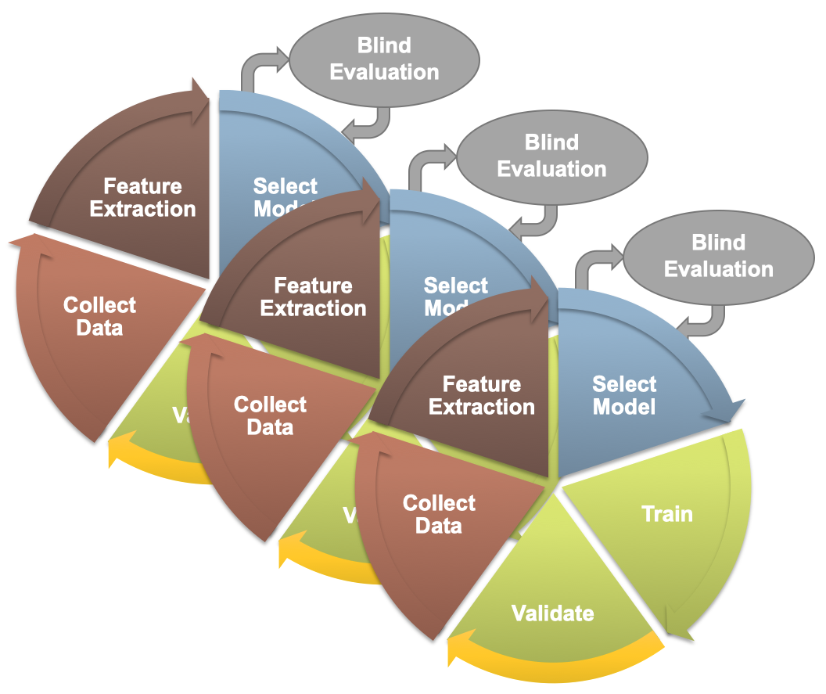
Figure 1. The design cycle for machine learning typically involves an iterative process where everything from data to the evaluation paradigm are tweaked to improve the overall performance and generalization of the system.

Figure 1. The design cycle for machine learning typically involves an iterative process where everything from data to the evaluation paradigm are tweaked to improve the overall performance and generalization of the system.

Figure 1. The design cycle for machine learning typically involves an iterative process where everything from data to the evaluation paradigm are tweaked to improve the overall performance and generalization of the system.

Figure 1. The design cycle for machine learning typically involves an iterative process where everything from data to the evaluation paradigm are tweaked to improve the overall performance and generalization of the system.
The first step in our machine learning systems consists of converting the signal to a sequence of feature vectors (Picone, 1993). Common EEG feature extraction methods include temporal, spatial and spectral analysis (Thodoroff et al., 2016). In this study, we use a methodology based on mel-frequency cepstral coefficients (MFCC) which has been successfully applied to many signal processing applications including speech recognition (Picone, 1993). In our systems, we use linear frequency cepstral coefficients (LFCCs) since a linear frequency scale provides some slight advantages over the mel scale for EEG signals (Harati et al., 2015). A block diagram summarizing the feature extraction process used in this work is presented in Figure 2. We did an extensive exploration of many of the common parameters associated with feature extraction and optimized the process for six-way event classification (Harati et al., 2015). We have found this approach, which leverages a popular technique in speech recognition, is remarkably robust across many types of machine learning applications. The LFCCs are computed by dividing raw EEG signals into shorter frames using a standard overlapping window approach. A high-resolution Fast Fourier Transform (FFT) is computed next. The spectrum is downsampled with a filter bank composed of an array of overlapping bandpass filters. Finally, the cepstral coefficients are derived by computing a discrete cosine transform of the filter bank’s output (Picone, 1990). In our experiments, we discarded the zeroth-order cepstral coefficient, and replaced it with a frequency domain energy term which is calculated by adding the output of the oversampled filter bank after they are downsampled:
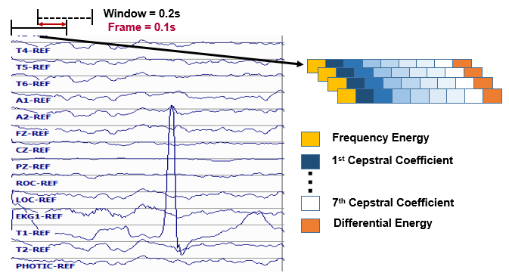
Figure 2. Base features are calculated using linear frequency cepstral coefficients based on frame and window durations of 0.1 and 0.2 seconds respectively. A novel differential energy term is added to the feature vector, and then first and second derivatives are computed.

Figure 2. Base features are calculated using linear frequency cepstral coefficients based on frame and window durations of 0.1 and 0.2 seconds respectively. A novel differential energy term is added to the feature vector, and then first and second derivatives are computed.

Figure 2. Base features are calculated using linear frequency cepstral coefficients based on frame and window durations of 0.1 and 0.2 seconds respectively. A novel differential energy term is added to the feature vector, and then first and second derivatives are computed.

Figure 2. Base features are calculated using linear frequency cepstral coefficients based on frame and window durations of 0.1 and 0.2 seconds respectively. A novel differential energy term is added to the feature vector, and then first and second derivatives are computed.
$E_{t}=\log{(\frac{1}{N}\sum_{k=0}^{N-1}{{\left|(x(n)\right|}^{2}})}$.
We also introduce a new feature, called differential energy, that is based on the long term differentiation of energy. Differential energy can significantly improve the results of spike detection, which is a critical part of seizure detection, because it amplifies the differences between transient pulse shape patterns and stationary background noise. To compute the differential energy term, we compute the energy of a set of consecutive frames, which we refer to as a window, for each channel of an EEG:
$E_{d}=\max_{m}\left(E_{f}(m)\right)-\min_{m}\left(E_{f}(m)\right)$.
We have used a window of 9 frames which is 0.1 secs in duration, corresponding to a total duration of 0.9 secs, to calculate differential energy term. Even though this term is a relatively simple feature, it resulted in a statistically significant improvement in spike detection performance (Harati et al., 2015).
Our experiments have also shown that using regression-based derivatives of features, which is a popular method in speech recognition (Lyons et al., 2015; Huang et al., 2001; Picone, 1993), is effective in the classification of EEG events. We use the following definition for the derivative:
$d_{t}=\frac{\sum_{n=1}^{N}{n\left(c_{t+n}-c_{t-n}\right)}}{2\sum_{n=1}^{N}{n^{2}}}$ .
Eq. (3) is applied to the cepstral coefficients, $c_{t}$ to compute the first derivatives, which are referred to as delta coefficients. Eq. (3) is then reapplied to the first derivatives to compute the second derivatives, which are referred to as delta-delta coefficients. Again, we use a window length of 9 frames (0.9 secs) for the first derivative and a window length of 3 (0.3 secs) for the second derivative. The introduction of derivatives helps the system discriminate between steady-state behavior, such as that found in a periodic lateralized epileptiform discharges (PLED) event, and impulsive or nonstationary signals, such as that found in spikes (SPSW) and eye movements (EYEM).
Through experiments designed to optimize feature extraction, we found best performance can be achieved using a feature vector length of 26. This vector includes nine absolute features consisting of seven cepstral coefficients, one frequency-domain energy term, and one differential energy term. Nine deltas are added for these nine absolute features. Eight delta-deltas are added because we exclude the delta-delta term for differential energy (Harati et al., 2015).

First Pass: Sequential Modeling with Hidden Markov Models
In this section, a high-performance automated EEG analysis system based on principles of machine learning and big data is presented. This hybrid architecture integrates hidden Markov models (HMMs) for sequential decoding of EEG events with deep learning-based postprocessing that incorporates temporal and spatial context. We present the design and performance of this system for two kinds of pattern recognition tasks. First, we have developed a system that automatically processes EEG records and classifies three patterns of clinical interest in brain activity that might be useful in diagnosing brain disorders: (1) spike and/or sharp waves, (2) generalized periodic epileptiform discharges, (3) periodic lateralized epileptiform discharges. It also classifies three patterns used to model the background EEG activity: (1) eye movement, (2) artifacts and (3) background. Our approach delivers a sensitivity above 90% while maintaining a specificity below 5%. We also demonstrate that this system delivers a low false alarm rate, which is critical for any spike detection application. Clinicians have indicated that a sensitivity of 95% with specificity below 5% was the minimum requirement for clinical acceptance.
Second, we have adapted the system for a task involving automated seizure detection. Automated seizure detection using clinical electroencephalograms is a challenging machine learning problem because the multichannel signal often has an extremely low signal to noise ratio. Events of interest such as seizures are easily confused with signal artifacts (e.g., eye movements) or benign variants (e.g., slowing). Commercially available systems suffer from unacceptably high false alarm rates. Deep learning algorithms that employ high dimensional models have not previously been effective due to the lack of big data resources. In this task, we use the Temple University Hospital Seizure Detection Corpus (TUSZ). The main challenge in this task is to operate with an extremely low false alarm rate because even 5 false alarms per 24 hours per patient means healthcare staff will be overwhelmed servicing these events in a typical critical care unit with 12 to 24 beds, especially when one considers the amount of other equipment that frequently trigger alerts (Cho et al., 2016).
Hidden Markov Models (HMMs) are one of the most important machine learning models available today for sequential machine learning problems that require both temporal and spectral modeling (Yu et al., 2016; Picone, 1990). HMMs can be considered as a class of doubly stochastic processes that are able to model discrete state sequences as Markov chains. HMMs have been used broadly in speech recognition where a speech signal can be decomposed into an energy and frequency profile in which particular events in the frequency domain can be used to identify the sound spoken.
The challenge of interpreting and finding patterns in EEG signal data is very similar to that of speech related projects. There is one distinct difference, however. In a typical speech signal, speech comprises about 50% of the signal and speech events occur frequently. In EEG signals, key events such as seizures occur less than 7% of the time. This disparity in prior probabilities of these events makes training somewhat of a challenge, since there is overwhelming pressure for the system to simply ignore the events of interest.
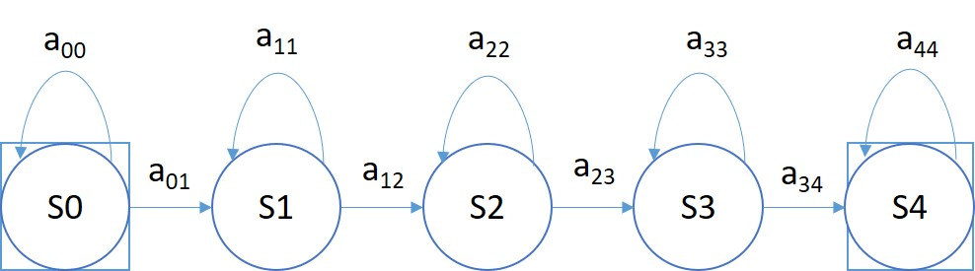
Figure 3. A left-to-right HMM is used for sequential decoding in the first pass of processing.

Figure 3. A left-to-right HMM is used for sequential decoding in the first pass of processing.

Figure 3. A left-to-right HMM is used for sequential decoding in the first pass of processing.

Figure 3. A left-to-right HMM is used for sequential decoding in the first pass of processing.
For automatic analysis of EEGs, we consider EEG signals to be composed of a chain of encoded messages as a sequence of one or more symbols. We model an EEG as a sequence of one of six symbols: SPSW, PLED, GPED, EYEM, ARTF and BCKG. We assume that each one of these patterns is represented by a sequence of feature vectors or observations O, defined as:
$O=o_{1},o_{2}, …,o_{T}$
Here $o_{T}$ is the feature vector observed at time t. If we define $S_{i}$ as the i-th event in our dictionary of K events, and S as a sequence of events from this dictionary, then the EEG pattern recognition problem can be considered as finding the most probable sequence of events that maximize the posterior probability $P\left(O | S\right)$. We train one HMM model for each event in our dictionary using manually annotated data.
A simple left-to-right GMM-HMM, illustrated in Figure 3, was used for sequential decoding of EEG signals. A GMM-HMM is characterized by N states where each state consists of an L-component Gaussian mixture model. The transition probability matrix which describes how the states are interconnected consists of a set of probabilities $a_{ij}$ which denotes the probability of a transition from state i to j. Considering $α\left(i,t\right)$ as the forward probability where (i = 1, 2,…,N; t = 1, 2, …, T) , $β\left(j,t\right)$ as the backward probability where (j = 1, 2, …, N; t = T-1, …,0), and P(O|M) as the probability that model M generates symbol series O, the probability that there will be a transition from state i to state j at time t can be defined as:
$γ_{i}\left(i,j\right)=\frac{α\left(i,t-1\right)a_{ij}b_{ij}(O_{t},μ_{ij},Σ_{ij})β\left(j,t\right)}{P(O|M)}$ .
The reestimation formulae for the transition probabilities are:
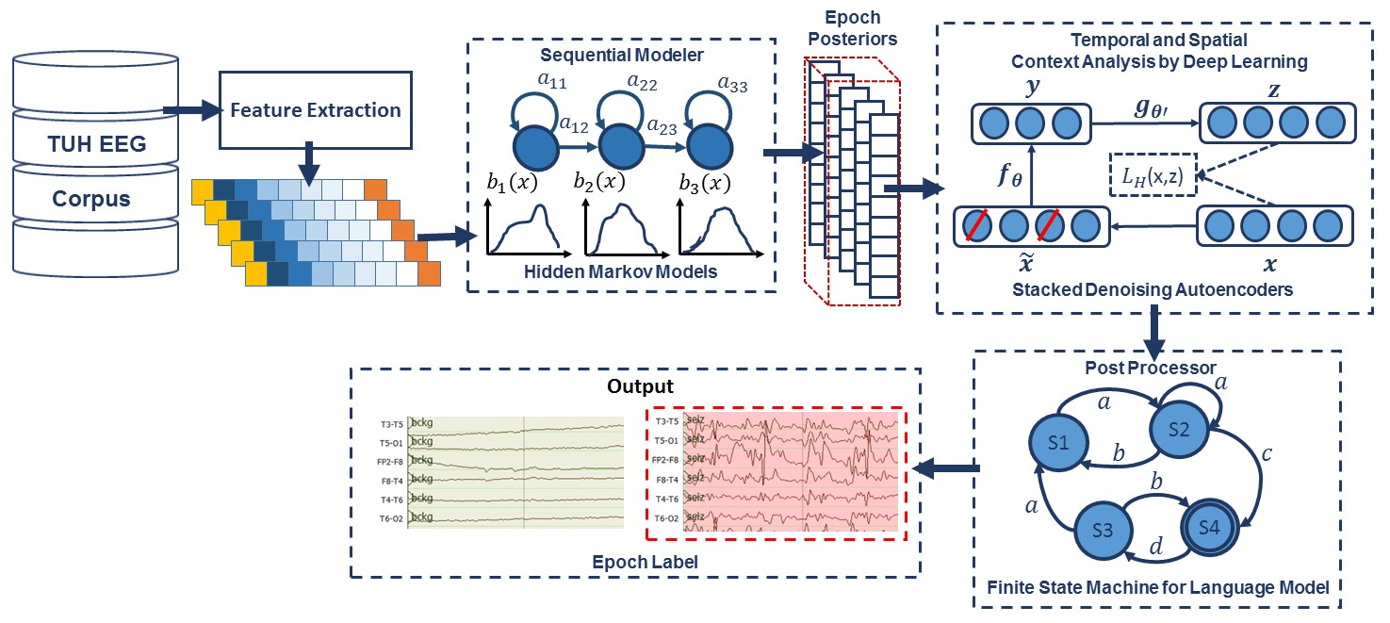
Figure 4. A hybrid architecture based on HMMs that integrates temporal and spatial context for sequential decoding of EEG events is shown. Two levels of postprocessing are used.

Figure 4. A hybrid architecture based on HMMs that integrates temporal and spatial context for sequential decoding of EEG events is shown. Two levels of postprocessing are used.

Figure 4. A hybrid architecture based on HMMs that integrates temporal and spatial context for sequential decoding of EEG events is shown. Two levels of postprocessing are used.

Figure 4. A hybrid architecture based on HMMs that integrates temporal and spatial context for sequential decoding of EEG events is shown. Two levels of postprocessing are used.
$a_{ij}=\frac{\sum_{t}{γ_{i}\left(i,j\right)}}{\sum_{t}{\sum_{j}{γ_{i}\left(i,j\right)}}}$ .
We can calculate the output density function using the output vector, $O_{t}$, if it follows an n-dimensional normal distribution as:
$b_{ij}(o_{t},μ_{ij},Σ_{ij})=\frac{exp⁡\{-{(o_{t}-μ_{ij})}^{t}\sum_{ij}^{-1}{(o_{t}-μ_{ij})/2}}{({2π)}^{n/2}{\left|Σ_{ij}\right|}^{1/2}}$ .
where $μ_{ij}$ is the mean and $Σ_{ij}$ is the covariance matrix. The mean and covariance for each Gaussian mixture component can be estimated by:
$μ_{ij}=\frac{\sum_{t}{γ_{i}\left(i,j\right)o_{t}}}{\sum_{t}{γ_{i}\left(i,j\right)}} ,$
$Σ_{ij}=\frac{\sum_{t}{γ_{i}\left(i,j\right){(o}_{t}-μ_{ij}){{(o}_{t}-μ_{ij})}^{t}}}{\sum_{t}{γ_{i}\left(i,j\right)}}$ .
In the first pass of signal modeling shown in Figure 3, we divide each channel of the EEG signal into epochs. Each epoch is represented by a sequence of frames where each frame is represented by a feature vector. During training, we estimate the parameters of the K models ({$a_{ij}\},{\{b}_{ij}\},{\{μ}_{ij}\} and \{Σ_{ij}\})$from the training dataset by iterating over all epochs using Eqs. (5-9). To determine these parameters in an iterative fashion, it is first necessary to initialize them with a carefully chosen value (Picone, 1990). Once this is done, more accurate parameters, in the maximum likelihood sense, can be found by applying the so-called Baum-Welch reestimation algorithm (Picone, 1990). Decoding is typically performed using the Viterbi algorithm (Alphonso et al., 2004). Using one HMM model per label, we generate one posterior probability for each model, and we select the label that corresponds to the highest probability. Rather than use the best overall output from the HMM system, we let the HMM system output probabilities for each event for each epoch for each channel, and we postprocess these probabilities using a second pass consisting of a deep learning-based system.

Second Pass: Temporal and Spatial Context Analysis Based on Deep Learning
The goal of the second pass of processing in Figure 3 is to integrate spatial and temporal context to improve decision-making. Therefore, the output of the first pass of processing, which is a vector of six posterior probabilities for every epoch of each channel, is postprocessed by a deep learning system. This system extracts knowledge in a data-driven manner and learn representations of data that involve multiple levels of abstraction (LeCun, et al., 2015).
In the second pass of processing, we are using a specific type of deep leaning network known as a Stacked denoising Autoencoder (SdA) (Vincent et al., 2010). SdAs have proven to perform well for applications where we need to emulate human knowledge (Bengio et al., 2007). Since interrater agreement for annotation of seizures tends to be relatively low and somewhat ambiguous, we need a deep learning structure that can deal with noisy inputs. From a structural point of view, SdAs are composed of multiple layers of denoising autoencoders in a way that the input to each layer is the latent representation of the denoising autoencoder found in the layer below. The most important feature of denoising autoencoders that make them appropriate for automatic analysis of EEGs is their ability in reconstructing a repaired input from a corrupted version of it.
Denoising Autoencoders are themselves an extension of a classical autoencoder (Vincent et al., 2008). The input vector to an autoencoder is $x∈{[0, 1]}^{d}$. Then using a deterministic mapping, autoencoder maps the input to a hidden representation$y∈{[0, 1]}^{d'}$as:
Figure 5. In a stacked denoising autoencoder the input, $x$, is corrupted to$\tilde{ x}$. The autoencoder then maps it to $y$ and attempts to reconstruct $x$.

Figure 5. In a stacked denoising autoencoder the input, $x$, is corrupted to$\tilde{ x}$. The autoencoder then maps it to $y$ and attempts to reconstruct $x$.

Figure 5. In a stacked denoising autoencoder the input, $x$, is corrupted to$\tilde{ x}$. The autoencoder then maps it to $y$ and attempts to reconstruct $x$.

Figure 5. In a stacked denoising autoencoder the input, $x$, is corrupted to$\tilde{ x}$. The autoencoder then maps it to $y$ and attempts to reconstruct $x$.

$y=f_{θ}\left(x\right)=s(Wx+b)$
where $W$ is a $d’ × d$ weight matrix, $b$ is a bias vector, $s$ is a nonlinearity such as sigmoid function and $θ = \{W, b\}.$
A decoder maps this latent representation y to a reconstruction z of the same shape as x:
$z=g_{θ'}\left(y\right)=s\left(W^{'}y+b^{'}\right)$
It is common to constrain this mapping using a technique by applying a constraint on these equations such as $W’ = W^{T}$. This particular constraint is known as tied weights. The parameters of this model are optimized to minimize the average reconstruction error using a loss function, L, such as reconstruction cross-entropy:
$θ^{*},{θ'}^{*}=\underset{θ,θ'}{arg min}{\frac{1}{n}\sum_{i=1}^{n}{L(x^{\left(i\right)}, }}g_{θ'}\left(f_{θ}\left(x^{\left(i\right)}\right)\right))$
To implement a denoising autoencoder, we train an autoencoder on partially corrupted and destroyed input data in a way that it learns to reconstruct a repaired version of the input. To implement this methodology, we use a stochastic mapping function as $\tilde{x}=q_{D}(\tilde{x}|x)$ for mapping the input x to a partially destroyed version $\tilde{x}$. We use the corrupted data $\tilde{x}$ as the input of a typical autoencoder to calculate the latent representation by means of $y=f_{θ}\left(\tilde{x}\right)=s(W\tilde{x}+b)$. We reconstruct a repaired version of the input using $y=f_{θ}\left(\tilde{x}\right)=s(W\tilde{x}+b)$. The schematic representation of the process is presented in Figure 5. In the training process, the goal is to find parameters that minimize the loss function which in this case is the average reconstruction error on the training dataset. Note that in these equations, unlike basic autoencoders, reconstruction of $z$ is not a function of $x$, but it is a deterministic function of $\tilde{x}$ and thereby the result of a stochastic mapping of $x$.
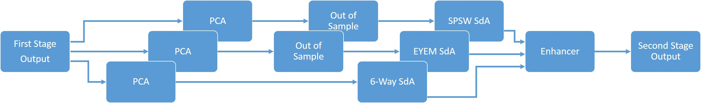
Figure 6. An overview of the second pass of processing

Table 1. A bigram probabilistic language model for the third pass of processing which models all possible transitions from one of the six classes to the next.
Figure 6. An overview of the second pass of processing

Table 1. A bigram probabilistic language model for the third pass of processing which models all possible transitions from one of the six classes to the next.
i | j | P(i,j) | j | P(i,j) | j | P(i,j) | j | P(i,j) | j | P(i,j) | j | P(i,j)
SPSW | SPSW | 0.40 | PLED | 0.00 | GPED | 0.00 | EYEM | 0.10 | ARTF | 0.20 | BCKG | 0.30
PLED | SPSW | 0.00 | PLED | 0.90 | GPED | 0.00 | EYEM | 0.00 | ARTF | 0.05 | BCKG | 0.05
GPED | SPSW | 0.00 | PLED | 0.00 | GPED | 0.60 | EYEM | 0.00 | ARTF | 0.20 | BCKG | 0.20
EYEM | SPSW | 0.10 | PLED | 0.00 | GPED | 0.00 | EYEM | 0.40 | ARTF | 0.10 | BCKG | 0.40
ARTF | SPSW | 0.23 | PLED | 0.05 | GPED | 0.05 | EYEM | 0.23 | ARTF | 0.23 | BCKG | 0.23
BCKG | SPSW | 0.33 | PLED | 0.05 | GPED | 0.05 | EYEM | 0.23 | ARTF | 0.13 | BCKG | 0.23

Table 1. A bigram probabilistic language model for the third pass of processing which models all possible transitions from one of the six classes to the next.
Figure 6. An overview of the second pass of processing

Table 1. A bigram probabilistic language model for the third pass of processing which models all possible transitions from one of the six classes to the next.
Figure 6. An overview of the second pass of processing

The application of deep learning networks like SdAs generally involves three steps: design, training and implementation. In the design step, the number of inputs and outputs, the number of layers, and the function of nodes are defined. During training, the weights of the nodes are determined through a deep learning process. In the last step, the statistical model is implemented using the fixed parameters of the network determined during training. Preprocessing of the input data is an additional step that is extremely important to various aspects of the deep learning training process.
A block diagram for the second stage of processing is depicted in Figure 6. This stage consists of three parallel SdAs designed to integrate spatial and temporal context to improve decision-making. These SdAs are implemented with varying window sizes to effectively perform a multi-time-scale analysis of the signal and map event labels onto a single composite epoch label vector. A first SdA, referred to as an SPSW-SdA, is responsible for mapping labels into one of two classes: epileptiform and non-epileptiform. A second SdA, EYEM-SdA, maps labels onto the background (BCKG) and eye movement (EYEM) classes. A third SdA, 6W-SdA, maps labels to any one of the six possible classes. The first two SdAs use a relatively short window context because SPSW and EYEM are localized events and can only be detected when we have adequate temporal resolution.
Training of these three SdA networks is done in two steps: pre-training and fine-tuning. SdAs are deep learning networks that are composed of multiple layers of denoising autoencoders. Pre-training is an unsupervised approach that minimizes the reconstruction error. During pre-training, we train each layer of the SdA separately using an unsupervised approach in which we train the first level of a denoising autoencoder to minimize the error in reconstructing of its input. Next, using the output code of the first layer, we train the second layer denoising autoencoder to learn a second level encoding function. This process is repeated for all layers.
Following completion of pre-training, we perform fine-tuning using a supervised training procedure. In fine-tuning the goal is to minimize a loss function that represents the classification error. First, we compose a network with just the encoding parts of each denoising auto-encoder and then we add a logistic regression layer as the last layer of a SdA deep learning network. We initialize this network using weights that we obtained during pre-training and train the entire network to minimize the prediction error (Bengio et. al., 2007).
As shown in Figure 6, we also preprocess the data using a global principal components analysis (PCA) to reduce dimensionality before application of these SdAs (Bonaccorso, 2017). PCA is applied to each individual epoch by concatenating each channel output into a supervector and then reducing its dimensionality. For rare and localized events (e.g., SPSW and EYEM), we use an out-of-sample technique to increase the number of training samples (Bonaccorso, 2017).
Finally, using a block called an enhancer (Golmohammadi et al., 2018), the outputs of these three SdAs are then combined to obtain the final decision. To add the three outputs together, we initialize our final probability output with the output of the 6-way classifier. For each epoch, if the other two classifiers detect epileptiform or eye movement and the 6-way classifier was not in agreement with this, we update the output probability based on the output of 2-way classifiers. The overall result of the second stage is a probability vector of dimension six containing a likelihood that each label could have occurred in the epoch. It should also be noted that the outputs of these SdAs are a probability vector. A soft decision paradigm is used because this output will be smoothed in the third stage of processing.
Table 1. A bigram probabilistic language model for the third pass of processing which models all possible transitions from one of the six classes to the next.
i | j | P(i,j) | j | P(i,j) | j | P(i,j) | j | P(i,j) | j | P(i,j) | j | P(i,j)
SPSW | SPSW | 0.40 | PLED | 0.00 | GPED | 0.00 | EYEM | 0.10 | ARTF | 0.20 | BCKG | 0.30
PLED | SPSW | 0.00 | PLED | 0.90 | GPED | 0.00 | EYEM | 0.00 | ARTF | 0.05 | BCKG | 0.05
GPED | SPSW | 0.00 | PLED | 0.00 | GPED | 0.60 | EYEM | 0.00 | ARTF | 0.20 | BCKG | 0.20
EYEM | SPSW | 0.10 | PLED | 0.00 | GPED | 0.00 | EYEM | 0.40 | ARTF | 0.10 | BCKG | 0.40
ARTF | SPSW | 0.23 | PLED | 0.05 | GPED | 0.05 | EYEM | 0.23 | ARTF | 0.23 | BCKG | 0.23
BCKG | SPSW | 0.33 | PLED | 0.05 | GPED | 0.05 | EYEM | 0.23 | ARTF | 0.13 | BCKG | 0.23

Table 1. A bigram probabilistic language model for the third pass of processing which models all possible transitions from one of the six classes to the next.
i | j | P(i,j) | j | P(i,j) | j | P(i,j) | j | P(i,j) | j | P(i,j) | j | P(i,j)
SPSW | SPSW | 0.40 | PLED | 0.00 | GPED | 0.00 | EYEM | 0.10 | ARTF | 0.20 | BCKG | 0.30
PLED | SPSW | 0.00 | PLED | 0.90 | GPED | 0.00 | EYEM | 0.00 | ARTF | 0.05 | BCKG | 0.05
GPED | SPSW | 0.00 | PLED | 0.00 | GPED | 0.60 | EYEM | 0.00 | ARTF | 0.20 | BCKG | 0.20
EYEM | SPSW | 0.10 | PLED | 0.00 | GPED | 0.00 | EYEM | 0.40 | ARTF | 0.10 | BCKG | 0.40
ARTF | SPSW | 0.23 | PLED | 0.05 | GPED | 0.05 | EYEM | 0.23 | ARTF | 0.23 | BCKG | 0.23
BCKG | SPSW | 0.33 | PLED | 0.05 | GPED | 0.05 | EYEM | 0.23 | ARTF | 0.13 | BCKG | 0.23

Table 1. A bigram probabilistic language model for the third pass of processing which models all possible transitions from one of the six classes to the next.
i | j | P(i,j) | j | P(i,j) | j | P(i,j) | j | P(i,j) | j | P(i,j) | j | P(i,j)
SPSW | SPSW | 0.40 | PLED | 0.00 | GPED | 0.00 | EYEM | 0.10 | ARTF | 0.20 | BCKG | 0.30
PLED | SPSW | 0.00 | PLED | 0.90 | GPED | 0.00 | EYEM | 0.00 | ARTF | 0.05 | BCKG | 0.05
GPED | SPSW | 0.00 | PLED | 0.00 | GPED | 0.60 | EYEM | 0.00 | ARTF | 0.20 | BCKG | 0.20
EYEM | SPSW | 0.10 | PLED | 0.00 | GPED | 0.00 | EYEM | 0.40 | ARTF | 0.10 | BCKG | 0.40
ARTF | SPSW | 0.23 | PLED | 0.05 | GPED | 0.05 | EYEM | 0.23 | ARTF | 0.23 | BCKG | 0.23
BCKG | SPSW | 0.33 | PLED | 0.05 | GPED | 0.05 | EYEM | 0.23 | ARTF | 0.13 | BCKG | 0.23

Table 1. A bigram probabilistic language model for the third pass of processing which models all possible transitions from one of the six classes to the next.
i | j | P(i,j) | j | P(i,j) | j | P(i,j) | j | P(i,j) | j | P(i,j) | j | P(i,j)
SPSW | SPSW | 0.40 | PLED | 0.00 | GPED | 0.00 | EYEM | 0.10 | ARTF | 0.20 | BCKG | 0.30
PLED | SPSW | 0.00 | PLED | 0.90 | GPED | 0.00 | EYEM | 0.00 | ARTF | 0.05 | BCKG | 0.05
GPED | SPSW | 0.00 | PLED | 0.00 | GPED | 0.60 | EYEM | 0.00 | ARTF | 0.20 | BCKG | 0.20
EYEM | SPSW | 0.10 | PLED | 0.00 | GPED | 0.00 | EYEM | 0.40 | ARTF | 0.10 | BCKG | 0.40
ARTF | SPSW | 0.23 | PLED | 0.05 | GPED | 0.05 | EYEM | 0.23 | ARTF | 0.23 | BCKG | 0.23
BCKG | SPSW | 0.33 | PLED | 0.05 | GPED | 0.05 | EYEM | 0.23 | ARTF | 0.13 | BCKG | 0.23

Statistical Language Modeling
Neurologists generally impose certain restrictions on events when interpreting an EEG. For example, PLEDs and GPEDs don’t happen in the same session. None of the previous stages of processing address this problem. Even the output of the second stage accounts mostly for channel context and is not extremely effective at modelling long-term temporal context. The third pass of processing addresses this issue and improves the overall detection performance by using a finite state machine based on a statistical language model. In general, for problems such as EEG event detection in which infrequently occurring events play a significant role, postprocessing based on domain knowledge tends to provide large gains in performance. Automating this using deep learning is not trivial.
As is shown in Figure 3, the third stage of postprocessing is designed to impose some contextual restrictions on the output of the second stage. These contextual relationships involve long-term behavior of the signal and are learned in a data-driven fashion. This approach is also borrowed from speech recognition where a probabilistic grammar is used that combines the left and right contexts with the labels (Yu et al., 2016). This is done using a finite state machine that imposes specific syntactic constraints.
In this study, a bigram probabilistic language model that provides the probability of transiting from one type of epoch to another (e.g. PLED to PLED) is prepared using the training dataset and also in consultation with neurologists in Temple Hospital University. The bigram probabilities for each of the six classes are shown in Table 1, which models all possible transitions from one label to the next. The remaining columns alternate between the class label being transitioned to and its associated probability. The probabilities in this table are optimized on a training database that is a subset of TUEG. For example, since PLEDs are long-term events, the probability of transitioning from one PLED to the next is high – approximately 0.9. However, since spikes that occur in groups are PLEDs or GPEDs, and not SPSWs, the probability of transitioning from a PLED to SPSW is 0.0. Therefore, these transition probabilities emulate the contextual knowledge used by neurologists.
After compiling the probability table, a long window is centered on each epoch and the posterior probability vector for that epoch is updated by considering left and right context as a prior (essentially predicting the current epoch from its left and right context). A Bayesian framework is used to update the probabilities of this grammar for a single iteration of the algorithm:
$P_{gprior}=\frac{\sum_{i=1}^{L}{P_{i}+ϵ_{prior}M}}{L+M}$ ,
$RPP(k)=\frac{β_{R}\sum_{i=1}^{N}{\exp\left(-iλ\right)P_{k+i}+αP_{gprior}}}{1+α}$ ,
$LPP(k)=\frac{β_{L}\sum_{i=1}^{N}{\exp\left(-iλ\right)P_{k-i}+αP_{gprior}}}{1+α}$ ,
$P_{C_{k}|LR}=β_{C}P_{C_{k}}{(\sum_{i=1}^{k}{\sum_{j=1}^{k}{LPP\left(i\right)RPP\left(j\right)Prob\left(i,k\right)Prob(k,j))}}}^{\frac{γ}{n}} .$
In these equations, $k = 1, 2… K$ where $K$ is the total number of classes (in this study $K = 6$), $L$ is number of epochs in a file, $ϵ_{prior}$ is the prior probability for an epoch (a vector of length $K$) and $M$ is the weight. $LPP$ and $RPP$ are left and right context probabilities respectively. $λ$ is the decaying weight for window, α is the weight associated with $P_{gprior}$ and $β_{R}$ and $β_{L}$ are normalization factors. $P_{C_{k}}$ is the prior probability, $P_{C_{k}|LR}$is the posterior probability of epoch $C$ for class $k$ given the left and right contexts, $y$ is the grammar weight, $n$ is the iteration number (starting from 1) and $β_{C}$ is the normalization factor. $Prob\left(i,j\right)$is a representation of the probability table shown in Table 1. The algorithm iterates until the label assignments, which are decoded based on a probability vector, converge. The output of this stage is the final output and what was used in the evaluations described in Section 6.1.

CHAPTER 3

CNNs FOR SPATIO-TEMPORAL SEQUENCE RECOGNITION
Convolutional Neural Networks (CNNs) are a variant of a standard neural networks that, instead of having fully connected hidden layers, present a network structure that alternates convolution and pooling layers. These networks are characterized by the use of convolution instead of general matrix multiplication in at least one of their layers (Goodfellow et al., 2016). CNNs have delivered state of the art performance on highly challenging tasks such as speech (Saon et al., 2016) and image recognition (Szegedy et al., 2015), and these successes played a vital role in stimulating interest in deep learning approaches. In this section we explore modeling of spatial information in the multichannel EEG signal to exploit our knowledge that seizures occur on a subset of channels (Biasiucci, 2019). The identity of these channels also plays an important role in localizing the seizure and identifying the type of seizure (Golmohammadi et al., 2018).

Key Building Blocks of CNN Architectures
CNN networks are usually composed of convolutional layers and subsampling layers followed by one or more fully connected layers. Consider an image of dimension $W × H × N$, where $W$ and $H$ are the width and height of the image in pixels, and $N$ is the number of channels (e.g. in an RGB image, $N = 3$ since there are three colors). Two-dimensional (2D) CNNs commonly used in sequential decoding problems such as speech or image recognition typically consist of a convolutional layer that will have $K$ filters (or kernels) of size $M × N × Q$ where $M$ and $N$ are smaller than the dimension of the data and $Q$ is smaller than the number of channels. The image can be subsampled by skipping samples as you convolve the kernel over the image. This is known as the stride, which is essentially a decimation factor. CNNs have a large learning capacity that can be controlled by varying their depth and breadth to produce $K$ feature maps of size $(W-M+1) × (H-N+1)$ for a stride of 1, and proportionally smaller for larger strides. Each map is then subsampled using a technique known as max pooling (LeCun et al., 2015), in which a filter is applied to reduce the dimensionality of the map. An activation function, such as a rectified linear unit (ReLU), is applied to each feature map either before or after the subsampling layer to introduce nonlinear properties to the network. Nonlinear activation functions are necessary for learning complex functional mappings. The key building blocks of CNN architectures are explained in this section.

Convolution Layers
The convolution is an operation on two functions of a real valued argument and is defined as the integral of the product of the two functions after one is reversed and shifted:
$y\left(t\right)=\left(x*w\right)\left(t\right)=\int_{-∞}^{∞}{x\left(r\right)w\left(t-r\right)dr}$ .
The convolution operation is typically denoted with an asterisk. In convolutional network terminology, $x$ argument is often referred to as the input and w argument as the kernel. The output $y$ is sometimes referred to as the feature map. When the index $t$ is discretized, we can define the discrete convolution as:
$y\left(t\right)=\left(x*w\right)\left(t\right)=\sum_{-∞}^{∞}{x\left(r\right)w\left(t-r\right)dr}$ .
In machine learning applications, the input and kernel are multidimensional arrays known as tensors. Because each element of the input and kernel must be explicitly stored separately, we usually assume that these functions are zero everywhere but the finite set of points for which we store the values. Additionally, we often use convolutions over more than one axis at a time. For example, two-dimensional convolution is defined as:
$Y\left(i,j\right)=\left(X*W\right)\left(i,j\right)=\sum_{m}{\sum_{n}{X\left(m,n\right)K\left(i-m,j-n\right)}}$ .
Since convolution is commutative, we can write the above equation as:
$Y\left(i,j\right)=\left(X*W\right)\left(i,j\right)=\sum_{m}{\sum_{n}{X\left(i-m,j-n\right)K\left(m,n\right)}}$ .
We prefer the latter formula in machine learning, since there is less variation in the range of valid values of m and n. Additionally, in many neural network libraries, computer scientists use a slightly different formula, which is the same as convolution but without flipping the kernel:
$Y\left(i,j\right)=\left(X*W\right)\left(i,j\right)=\sum_{m}{\sum_{n}{X\left(i+m,j+n\right)K\left(m,n\right)}}$ .
While usually this function is called the cross-correlation of two functions, researchers still call it convolution in context of neural networks. In a convolutional neural network, there are three main hyperparameters that need to be tweaked to modify the behavior of a convolutional layer. These parameters are filter size, stride and zero padding. The size of output feature map is controlled by these hyperparameters. Size of the filters play an important role in finding the key features. A larger size kernel can overlook at the features and could skip the essential details in images whereas a smaller size kernel could provide more information leading to more confusion. Stride controls the number of steps that filter moves over the input image. When the stride is 1, we move the filter one pixel at a time. When we set the stride to 2 or 3, we move the filter 2 or 3 pixels at a time depending on the stride. The value of the stride also controls the size of the output volume generated by the convolutional layer. Bigger stride results in smaller output volume size. For example, if the input tensor is 7 × 7 and stride is 1, the output volume will be 5 × 5. On the other hand, if we increase the stride to be 2, the output volume reduces to 3 × 3. Stride is normally set in a way so that the output volume is an integer and not a fraction. Last important hyperparameter is zero padding. Zero padding refers to padding the input volume with zeros around the border. The zero padding also allows us to control the spatial size of the output volume. The output of a convolution layer is computed based on these hyperparameters. If we assume that input is a two-dimensional array of $W × H$, and the size of filter is M × N with padding size of $P$ and stride of $S$, then the output size is $((W–M+2P)/S+1)×(H–N+2P)/S+1))$. If we have $K$ filters, then we have $K$ layers with size of $((W–M+2P)/S+1)×(H–N+2P)/S+1))$.

Pooling Layers
In CNN structure, it is common to periodically insert a pooling layer in between successive convolutional layer. Pooling layers decrease the spatial size of the representation to reduce the number of parameters and computation in the network, and hereby it can also control overfitting. Two famous pooling layers are average pooling and max pooling. Average pooling uses the average of all the elements in the pooling window as the sampling value. Max pooling uses the largest element in the pooling window as the sampling value. Average pooling has recently lost its popularity in comparison with the max pooling operation, which has been shown to work better in practice (Goodfellow et al., 2016).
In a convolutional neural network, there are two main hyperparameters that need to be tweaked to modify the behavior of a pooling layer: pool size and stride. Pool size is the size of max pooling window. Stride is a factor by which the input is downscaled. The output of a pooling layer is computed based on these hyperparameters. If we assume that input is a three-dimensional array of $W × H × D$, and the size of max pooling layer is $M × M$ with stride of $S$, then the output size is $((W-M)/S+1) × (H-M)/S+1)) × D$. For pooling layers, it is not common to pad the input using zero-padding.

Activation Function
In neural networks, activation function of a node is a nonlinear function that defines the output of that node, given an input or set of inputs. In this section, we overview nine different type of activation functions that are used in this study (Goodfellow et al., 2016).
A linear activation function is a straight-line function where activation is proportional to input and is defined by:
$f\left(x\right)=mx$ .
The derivative of linear activation function is:
$\acute{f}\left(x\right)=m$ .
Using this activation function, we can definitely connect a few neurons together and if more than one fires, we could take the max and decide based on that. The derivative of linear activation function is a constant. That means, the gradient has no relationship to $x$.
A sigmoid is a popular activation function in the last layer of neural networks. It takes a real value as input and outputs another value between 0 and 1. It is easy to work with and has all the nice properties of activation functions: it is nonlinear, continuously differentiable, monotonic, and has a fixed output range. A sigmoid is defined by this equation:
$f\left(x\right)= \frac{1}{1+e^{-x}}$ .
The derivative of a sigmoid is:
$\acute{f}\left(x\right)=f\left(x\right).(1-f\left(x\right))$ .
The output of sigmoid activation function is always in range of $(0,1)$ compared to linear function with the output in range of $(-∞, ∞)$. Unfortunately, the output of a sigmoid isn’t zero-centered. This makes the optimization harder since the gradient updates go too far in different directions (Goodfellow et al., 2016).
The tanh activation function squashes the output to the range of $(-1, 1)$, since it is defined as:
$f\left(x\right)= \frac{e^{x} - e^{-x}}{e^{x} + e^{-x}}$ .
The derivative of tanh activation function is:
$\acute{f}\left(x\right)=1-{\tanh{(x)}}^{2}$ .
Unlike a sigmoid, the output of tanh is zero-centered. Therefore, in practice the tanh non-linearity is usually preferred to the sigmoid nonlinearity.
An alternative to tanh is an activation function that is defined by:
$f\left(x\right)= \frac{x}{1+\left|x\right|}$ ,
and known as a softsign function. The derivative of softsign activation function is:
$\acute{f}\left(x\right)= \frac{1}{{(1+\left|x\right|)}^{2}}$ .
The main difference between the Softsign function and the tanh function is that the Softsign converges in polynomial form.
One of the most popular activation functions is a Rectified Linear Unit (ReLU). This function returns 0, if it receives any negative input, but for any positive value $x$, it returns that value back (Goodfellow et al., 2016). So, it can be written as:
$f\left(x\right)=\left\{\begin{aligned}x x >0 \\ 0 x ≤0\end{aligned}\right.$ .
The derivative of ReLU is:
$\acute{f}\left(x\right)=\left\{\begin{aligned}1 x >0 \\ 0 x ≤0\end{aligned}\right.$ .
ReLU is less computationally expensive than tanh and sigmoid because it involves simpler mathematical operations. It also has a better gradient propagation and it shows fewer vanishing gradient problems compared to sigmoidal activation functions that saturate in both directions (Goodfellow et al., 2016). One of ReLU’s limitation is that it should only be used within hidden layers of a neural network. ReLU should not be used in output layer, since the outputs of ReLU for negative inputs are zero.
An Exponential Linear Unit (ELU) is an activation function that tends to converge to zero faster than ReLU and produces more accurate results (Clevert et al., 2017). ELU is very similar to ReLU except for negative inputs. They are both in identity function form for non-negative inputs. ELU delivers a small but measurable increase in sensitivity, and more importantly, a reduction in false alarms. The ELU activation function is defined as:
$f\left(x\right)=\left\{\begin{aligned}x x >0 \\ α.\left(e^{x}-1\right) x ≤0\end{aligned}\right.$ ,
where $α$ is slope of negative section. The derivative of ELU is:
$\acute{f}\left(x\right)=\left\{\begin{aligned}1 x >0 \\ α.e^{x} x ≤0\end{aligned}\right.$ .
ELU is very similar to ReLU except for negative inputs. ReLUs and ELUs accelerate learning by decreasing the gap between the normal gradient and the unit natural gradient (Clevert et al., 2017). ELUs push the mean towards zero but with a significantly smaller computational footprint. In the region where the input is negative ($x<0$), since ReLU’s gradient is zero, the weights will not get adjusted. Those neurons which connect into that state will stop responding to variations in error or input. This is referred to as the dying ReLU problem. But unlike ReLUs, ELUs have a clear saturation plateau in their negative region, allowing them to learn a more robust and stable representation gradient (Clevert et al., 2017).

Loss Function Layers
A loss function is an important part in artificial neural networks. As part of the optimization algorithm in the training process of neural networks, the error for the current state of the model must be estimated repeatedly. This requires the choice of an error function, conventionally called a loss function, that can be used to estimate the loss of the model so that the weights can be updated to reduce the loss on the next evaluation. In other word, Loss function is used to measure the inconsistency between predicted value $\hat{y}$ and actual label $y$. In this section, we go through common loss functions in machine learning that are used in this study.
Mean Square Error (MSE) is the most commonly used regression loss function. It is measured as the average of the squares of the difference between predictions and target observations:
$L= \frac{\sum_{i=1}^{n}{{(y_{i}-{\hat{y}}_{i})}^{2}}}{n}$ .
MSE measures the magnitude of error without considering its direction. However, due to squaring, predictions which are far away from actual values are penalized heavily in comparison to less deviated predictions.
Mean absolute error, on the other hand, is measured as the average of sum of absolute differences between predictions and actual observations:
$L= \frac{\sum_{i=1}^{n}{\left|y_{i}-{\hat{y}}_{i}\right|}}{n}$ .
Similar to MSE, MAE is only concerned with the average magnitude of error, irrespective of their direction. Unlike MSE that is easy to calculate its gradient, MAE needs more complicated tools such as linear programming to compute the gradient. Additionally, MAE is more robust to outliers since it does not make use of square.
Binary cross entropy is commonly used in binary classification tasks using deep learning. Cross-entropy loss increases as the predicted probability diverges from the actual label:
$L= -{(y}_{i}\log\left({\hat{y}}_{i}\right)+(1-y_{i})log⁡(1-{\hat{y}}_{i}))$ .
For multi-classification problems, we can use categorial cross entropy:
$L= -\frac{1}{N}\sum_{1}^{N}{{(y}_{i}\log\left({\hat{y}}_{i}\right)+(1-y_{i})log⁡(1-{\hat{y}}_{i}))}$ .
Cross entropy measures the divergence between two probability distribution. If the cross entropy is large, it means that the difference between two distribution is large. If the cross entropy is small, it means that two distribution are similar to each other.

Regularization
Overfitting is a serious problem in deep neural nets with many parameters. We have explored five popular regularization methods to address this problem: $L1, L2 and L1/L2$, Dropout and Gaussian Noise.
The techniques collectively known as $L1, L2 and L1/L2$ (Goodfellow et al., 2016) prevent overfitting by adding a regularization term to the loss function. The $L1$ regularization technique, also known as Lasso regression, is defined as adding the sum of weights to the loss function:
$Cost Function=Loss Function+ λ\sum_{i=1}^{k}{\left|w_{i}\right|}$ ,
where $w$ is the weight vector and $λ$ is a regularization parameter. The $L2$ technique, also known as ridge regression, is defined as adding the sum of the square of the weights to the loss function:
$Cost Function=Loss Function+ λ\sum_{i=1}^{k}{w_{i}^{2}}$ .
The $L1/L2$ technique is a combination of both techniques:
$Cost Function=Loss Function+λ\sum_{i=1}^{k}{\left|w_{i}\right|}+λ\sum_{i=1}^{k}{w_{i}^{2}}$ .
In an alternative approach, we used dropout (Srivastava et al., 2010) to prevent units from co-adapting too much by randomly dropping units and their connections from the neural network during training.
Also, we studied the impact of introducing zero-centered Gaussian noise to the network. In this regularization method, which is considered a random data augmentation method, we add zero-centered Gaussian noise with a standard deviation of 0.2 to all hidden layers in the network as well as the visible or input layer.

Deep Two-Dimensional Convolutional Neural Networks
In Figure 7, a hybrid architecture for automatic analysis of EEGs that combines CNN and a multi-layer perceptron (MLP) (Szegedy et al., 2015) is shown. Drawing on our image classification analogy discussed in 3.1, each image is a signal where the width of the image (W) is the window length multiplied by the number of samples per second, the height of the image (H) is the number of EEG channels and the number of image channels (N) is the length of the feature vector. This architecture includes six convolutional layers, three max pooling layers and two fully-connected layers. A rectified linear unit (ReLU) nonlinearity is applied to the output of every convolutional and fully-connected layer (Hara et al., 2015).
In our optimized version of this architecture, a window duration of 7 secs is used. The first convolutional layer filters the input of size of 70 × 22 × 26 using 16 kernels of size 3 × 3 with a stride of 1. The input feature vectors have a dimension of 26, while there are 22 EEG channels. The window length is 70 because the features are computed every 0.1 secs, or 10 times per second, and the window duration is 7 sec. These kernel sizes and strides were experimentally optimized (Golmohammadi et. al., 2018).
The second convolutional layer filters its input using 16 kernels of size 3 × 3 with a stride of 1. The first max pooling layer takes as input the output of the second convolutional layer and applies a pooling size of 2 × 2. This process is repeated two times with kernels of size 32 and 64. Next, a fully-connected layer with 512 neurons is applied and the output is fed to a 2-way sigmoid function which produces a two-class decision. This two-class decision is the final label for the given epoch, which is 1 sec in duration. Neurologists usually review EEGs using 10 sec windows, so we attempt to use a similar amount of context in this system. Pattern recognition systems often subdivide the signal into small segments during which the signal can be considered quasi-stationary. A simple set of preliminary experiments determined that a reasonable tradeoff between computational complexity and performance was to split a 10 sec window, which is what neurologists use to view the data, into 1 sec epochs (Harati et al., 2015).
In our experiments, we found structures that are composed of two consecutive convolutional layers before a pooling layer perform better than structures with one convolutional layer before a pooling layer. Pooling layers decrease the dimensions of the data and thereby can result in a loss of information. Using two convolutional layers before pooling mitigates the loss of information. We find that using a very small fields throughout the architecture (e.g., 3 x 3) performs better than larger fields (e.g. 5 × 5 or 7 × 7) in the first convolutional layer.
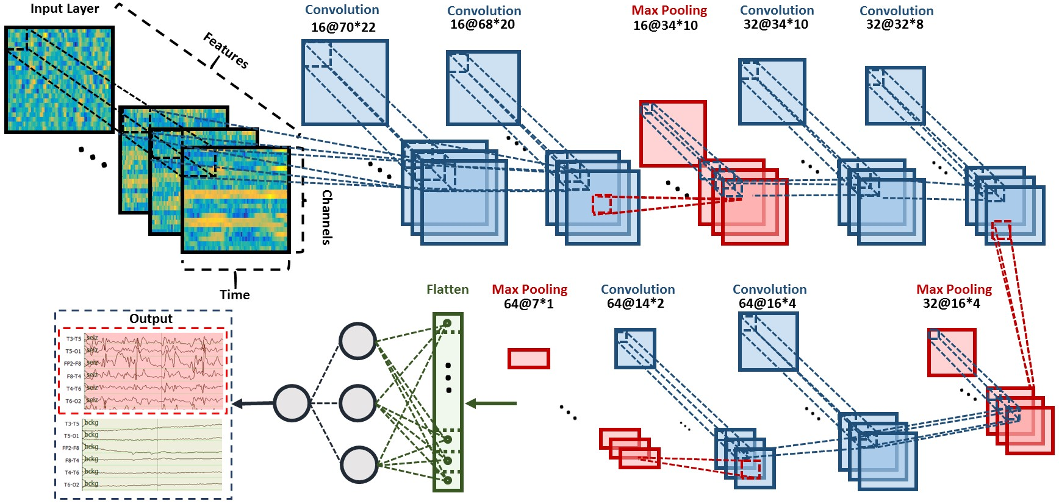
Figure 7. A two-dimensional decoding of EEG signals using a CNN/MLP hybrid architecture that consists of six convolutional layers, three max pooling layers and two fully connected layers is shown.

Figure 7. A two-dimensional decoding of EEG signals using a CNN/MLP hybrid architecture that consists of six convolutional layers, three max pooling layers and two fully connected layers is shown.

Figure 7. A two-dimensional decoding of EEG signals using a CNN/MLP hybrid architecture that consists of six convolutional layers, three max pooling layers and two fully connected layers is shown.

Figure 7. A two-dimensional decoding of EEG signals using a CNN/MLP hybrid architecture that consists of six convolutional layers, three max pooling layers and two fully connected layers is shown.

Augmenting CNNs with Deep Residual Learning
The depth of a CNN plays an instrumental role in its ability to achieve high performance (Szegedy et al., 2015). As many as thirteen layers are used for challenging problems such as speech and image recognition. However, training deeper CNN structures is more difficult since convergence and generalization become issues. Increasing the depth of CNNs, in our experience, tends to increase the error on evaluation dataset. As we add more convolutional layers, sensitivity first saturates and then degrades quickly. We also see an increase in the error on the training data when increasing the depth of a CNN, indicating that overfitting is actually not occurring. Such degradations in performance can be addressed by using a deep residual learning framework known as a ResNet (He et al., 2016). ResNets introduce an “identity shortcut connection” that skips layers. Denoting the desired underlying mapping as $H(x)$, we map the stacked nonlinear layers using $F(x) = H(x) – x$, where $x$ is the input. The original mapping is recast into $F(x) + x$. It can be shown that it is easier to optimize the residual mapping than to optimize the original, unreferenced mapping (He et al., 2016).
The deep residual learning structure mitigates two important problems: vanishing/exploding gradients and saturation of accuracy when the number of layers is increased. As the gradient is backpropagated to earlier layers, repeated multiplication of numbers less than one often makes the gradient infinitively small. Performance saturates and can rapidly degrade due to numerical precision issues. Our structure addresses these problems by reformulating the layers as learning residual functions with reference to the layer inputs instead of learning unreferenced functions.
An architecture for our ResNet approach is illustrated in Figure 8. The shortcut connections between the convolutional layers make training of the model tractable by allowing information to propagate effectively through this very deep structure. The network consists of 6 residual blocks with two 2D convolutional layers per block. These convolutional layers are followed by a fully connected layer and a single dense neuron as the last layer. This brings the total number of layers in this modified CNN structure to 14. The 2D convolutional layers all have a filter length of (3, 3). The first 7 layers of this architecture have 32 filters while the last layers have 64 filters. We increment the number of filters from 32 to 64, since the initial layers represent generic features, while the deeper layers represent more detailed features. In other words, the richness of the data representations increases because each additional layer forms new kernels using combinations of the features from the previous layer.
Figure 8. A deep residual learning framework, ResNet, is shown that consists of 14 layers of convolution followed by a fully connected layer and a sigmoid as the last layer. The deep residual learning structure mitigates two important problems: vanishing/exploding gradients and saturation of accuracy when the number of layers is increased.

Figure 8. A deep residual learning framework, ResNet, is shown that consists of 14 layers of convolution followed by a fully connected layer and a sigmoid as the last layer. The deep residual learning structure mitigates two important problems: vanishing/exploding gradients and saturation of accuracy when the number of layers is increased.

Figure 8. A deep residual learning framework, ResNet, is shown that consists of 14 layers of convolution followed by a fully connected layer and a sigmoid as the last layer. The deep residual learning structure mitigates two important problems: vanishing/exploding gradients and saturation of accuracy when the number of layers is increased.

Figure 8. A deep residual learning framework, ResNet, is shown that consists of 14 layers of convolution followed by a fully connected layer and a sigmoid as the last layer. The deep residual learning structure mitigates two important problems: vanishing/exploding gradients and saturation of accuracy when the number of layers is increased.

Except for the first and last layers of the network, before each convolutional layer we apply a Rectified Linear Unit (ReLU) as an activation function (Hara et al., 2015). ReLU is the most commonly used activation function in deep learning models. The function returns 0 if it receives any negative input, but for any positive value it returns that value (e.g., $f\left(x\right)=\max\left(0,x\right)$). To overcome the problem of overfitting in deep learning structures with a large number of parameters, we use dropout (Srivastava et al., 2010) as our regularization method between the convolutional layers and after ReLU. Dropout is a regularization technique for addressing overfitting by randomly dropping units along with their connections from the deep learning structures during training. We use the Adam optimizer (Kingma et al., 2015) which is an algorithm for first-order gradient-based optimization of stochastic objective functions, based on adaptive estimates of lower-order moments. After parameter tuning, we apply Adam optimization (Kingma et al., 2015) using the following parameters (according to the notation in their original paper): $α = 0.00005, β_{1}= 0.9$, $β_{2 }=0.999$, $ε = {10}^{-8}$, and $decay = 0.0001$.
The deep learning systems described thus far have incorporated fully supervised training and discriminative models. Next, we introduce a generative deep learning structure based on convolutional neural networks that leverages unsupervised learning techniques. These are important for biomedical applications where large amounts of fully annotated data are difficult to find.

Unsupervised Learning Using Deep Convolutional Generative Adversarial Networks
Machine learning algorithms can generally be split into two categories: generative and discriminative. A generative model learns the joint probability distribution of $P\left(X,Y\right)$ where $X$is an observable variable and $Y$is the target variable. These models learn the statistical distributions of the input data rather than simply classifying the data as one of $C$ output classes. Hence the name, generative, since these methods learn to replicate the underlying statistics of the data. GMMs trained using a greedy clustering algorithm or HMMs trained using the Expectation Maximization (EM) algorithm (Yu et al., 2016) are well-known examples of generative models. A discriminative model, on the other hand, learns the conditional probability of the target $Y$, given an observation $X$, which we denote $P(Y|X)$ (Bonaccorso, 2017). Support Vector Machines (Bonaccorso, 2017) and Maximum Mutual Information Estimation (MMIE) (Hjelm et al., 2019) are two well-known discriminative models.
Generative adversarial networks (GANs) (Goodfellow, 2016) have emerged as a powerful learning paradigm technique for learning generative models for high-dimensional unstructured data. GANs use a game theory approach to find the Nash equilibrium between a generator and discriminator network (Goodfellow, 2016). A basic GAN structure consists of two neural networks: a generative model $G$ that captures the data distribution, and a discriminative model $D$ that estimates the probability that a sample came from the training data rather than $G$. These two networks are trained simultaneously via an adversarial process. In this process, the generative network, $G$, transforms the input noise vector $z$ to generate synthetic data $G(z)$. The training objective for $G$ is to maximize the probability of $D$ making a mistake about the source of the data.
The output of the generator is a synthetic EEG – data that is statistically consistent with an actual EEG but is fabricated entirely by the network. The second network, which is the discriminator, $D,$takes as input either the output of $G$ or samples from real world data. The output of $D$ is a probability distribution over possible input sources. The output of the discriminator in GAN determines if the signal is a sample from real world data or synthetic data from the generator.
The generative model, $G,$and the discriminative model, $D,$compete in a two-player minimax game with a value function, $V\left(G;D\right),$in a way that $D$ is trained to maximize the probability of assigning the correct label to both the synthetic and real data from $G$ (Goodfellow, 2016). The generative model $G$ is trained to fool the discriminator by minimizing $log(1-D(G(z)))$:
$\min_{G}{\max_{D}{V\left(D,G\right)=E_{x\sim p_{data}(x)}\left[\log{D\left(x\right)}\right]+}}E_{z\sim p_{z}(z)}\left[\log{(1-D\left(G(z)\right)}\right]$ .
During the training process, our goal is to find a Nash equilibrium of a non-convex two-player game that minimizes both the generator and discriminator’s cost functions (Goodfellow, 2016).
A deep convolutional generative adversarial network (DCGAN) is shown in Figure 9. The generative model takes 100 random inputs and maps them to a matrix with size of [21, 22, 250], where 21 is the window length (corresponding to a 21 sec duration), 22 is number of EEG channels and 250 is number of samples per sec. Recall, in our study, we resample all EEGs to a sample frequency of 250 Hz (Harati et al., 2015). The generator is composed of transposed CNNs with upsamplers. Transposed convolution, also known as fractionally-strided convolution, can be implemented by swapping the forward and backward passes of a regular convolution (Goodfellow, 2016). We need transposed convolutions in the generators since we want to go in the opposite direction of a normal convolution. For example, in this case we want to compose the vector of [21, 22, 250] from 100 random inputs. Using transposed convolutional layers, we can transform feature maps to a higher-dimensional space. Leaky ReLUs (Hara et al., 2015) are used for the activation function and dropout layers are used for regularization. Adam is used as the optimizer and binary cross-entropy (Goodfellow et al., 2016) is used as the loss function.
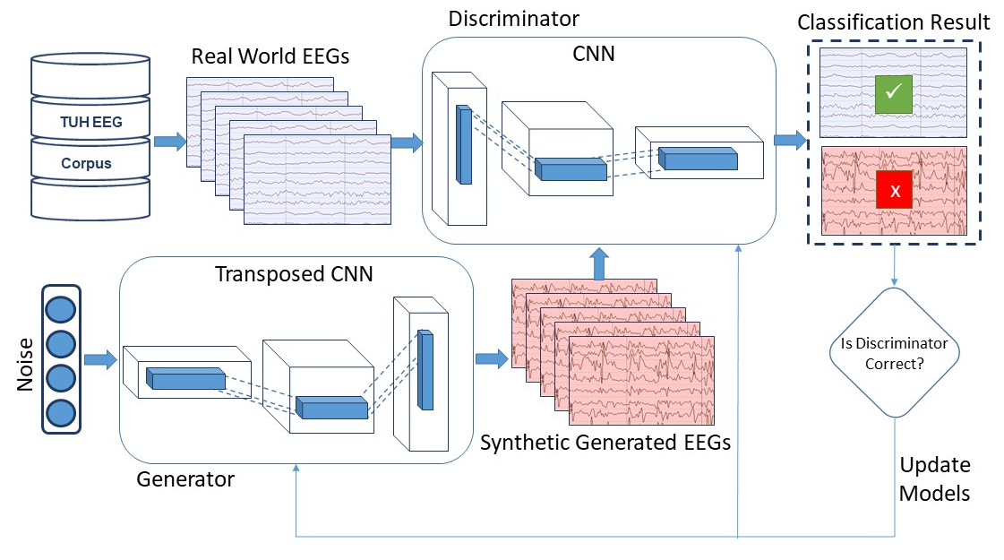
Figure 9. An unsupervised learning architecture is shown that uses deep convolutional generative adversarial networks (DCGANs). GANs have emerged as a powerful learning paradigm technique for learning generative models for high-dimensional unstructured data.

Figure 9. An unsupervised learning architecture is shown that uses deep convolutional generative adversarial networks (DCGANs). GANs have emerged as a powerful learning paradigm technique for learning generative models for high-dimensional unstructured data.

Figure 9. An unsupervised learning architecture is shown that uses deep convolutional generative adversarial networks (DCGANs). GANs have emerged as a powerful learning paradigm technique for learning generative models for high-dimensional unstructured data.

Figure 9. An unsupervised learning architecture is shown that uses deep convolutional generative adversarial networks (DCGANs). GANs have emerged as a powerful learning paradigm technique for learning generative models for high-dimensional unstructured data.
In this architecture, the discriminative model accepts vectors from two sources: synthetic data generators and real data (raw EEGs in this case). It is composed of strided convolutional neural networks (Goodfellow et al., 2016). Strided convolutional neural networks are like regular CNNs but with a stride greater than one. In the discriminator we replace the usual approach of convolutional layers with max pooling layers with strided convolutional neural networks. This is based on our observations in pilot experiments that using convolutional layers with max pooling makes the training of DCGAN unstable. This is due to the fact that using strided convolutional layers, the network learns its own spatial downsampling, and convolutional layers with max pooling tend to conflict with striding.
Finding the Nash equilibrium, which is a key part of the GAN approach, is a challenging problem that impacts convergence during training. Several recent studies address the instability of GANs and suggest techniques to increase the training stability of GANs (Salimans et al., 2016; Radford et al., 2015). We conducted a number of preliminary experiments and determined that these techniques were appropriate:
In the discriminator:
- pretraining of the discriminator;
- one-sided label smoothing;
- eliminating fully connected layers on top of convolutional features;
- replacing deterministic spatial pooling functions (such as max pooling) with strided convolutions.
In the generator:
- using an ReLU activation for all layers except for the output;
- normalizing the input to [-1, 1] for the discriminator;
- using a $tanh() a$ctivation in the last layer except for the output;
- using leaky ReLU activations in the discriminator for all layers except for the output;
- freezing the weights of discriminator during adversarial training process;
- unfreezing weights during discriminative training;
- eliminating batch normalization in all the layers of both the generator and discriminator.
The GAN approach is attractive for a number of reasons including creating an opportunity for data augmentation. Data augmentation is common in many state-of-the-art deep learning systems today (Yang et al., 2016), allowing the size of the training set to be increased as well as exposing the system to previously unseen patterns during training. The results of proposed architecture will be discussed in Section 6.2.

CHAPTER 4

LEARNING TEMPORAL DEPENDENCIES USING RECURRENT NETWORKS
The duration of events such as seizures can vary dramatically from a few seconds to minutes. Further, neurologists use significant amounts of temporal context and adaptation in manually interpreting EEGs. They are very familiar with their patients and often can identify the patient by examining the EEG signal, especially when there are certain types of anomalous behaviors. In fact, they routinely use the first minute or so of an EEG to establish baseline signal conditions (Lopez, 2017), or normalize their expectations, so that they can more accurately determine anomalous behavior. Recurrent neural networks (RNN) have been proposed as a way to learn such dependencies. Prior to this, successful systems were often based on approaches such as hidden Markov models, or used heuristics to convert frame-level output into longer-term hypotheses. In this section, we introduce several architectures that model long-term dependencies.

On the Vanishing and Exploding Gradient Problem in Recurrent Neural Networks
Generally, there are two kinds of neural networks which are feedforward neural networks and recurrent neural networks (RNN). A feedforward neural network is an artificial neural network where connections between the units do not form a cycle like Figure 10. In other word in feedforward networks processing of information is piped through the network from input layers to output layers. CNNs are another of example of feedforward neural network.
In contrast, a recurrent neural network (RNN) is an artificial neural network where connections between units form cyclic paths. RNNs are called recurrent because they receive inputs, update the hidden states depended on the previous computations, and make predictions for every element of a sequence. By unrolling an RNN in time, it can be considered as a deep neural network (DNN) with indefinitely many layers as it is shown in Figure 10.
RNNs can be considered as neural networks with memory that can keep information of what has been processed so far. RNNs are very powerful dynamic systems for sequence tasks, such as speech recognition, handwritten recognition (Cheng et al., 2016). They are powerful because they can maintain a state vector that implicitly contains information about the history of all the past elements of the sequence.
Figure 10. An example of feedforward neural network

Figure 10. An example of feedforward neural network

Figure 10. An example of feedforward neural network

Figure 10. An example of feedforward neural network
The RNN depicted in Figure 11 network makes predictions by matrix multiplications as follows:
$s_{t}=f\left(Ux_{t}+Ws_{t-1}\right)$ .
$y=g(Vs_{t})$ .
In these equations $x_{t}$is the input at time step t and $s_{t}$ is the hidden state at time step t which is in fact the memory of network. This parameter is calculated based on the input at the current step and the previous hidden state. $f$ is an activation function which transforms the inputs of the layer into its outputs. Common choices for $f$ are tanh and ReLUs. The initial activation, $s_{-1}$, which is required to initialize the first hidden state, is typically set to all zeroes. The output of the network is $y$ which is calculated by a nonlinear function of matrix multiplication of $V$ and $s_{t}$. In fact, this nonlinear function, $g$, is the activation function for the output layer and usually it is a sigmoid or a softmax function. Note that unlike feed forward neural networks, which have different parameters at each layer, an RNN shares the same parameters $(U, V, W)$ across all steps.
Figure 11. An RNN unrolled in time

Figure 11. An RNN unrolled in time

Figure 11. An RNN unrolled in time

Figure 11. An RNN unrolled in time
While RNNs are powerful structures, practically they are hard to train. The main reason is “vanishing gradient problem” (Jastrz et al. 2018; Pascanu et al., 2013). Researchers found that in theory RNNs can make use of information in arbitrarily long sequences, but in practice they are limited to looking back only a few steps. In conclusion, the range of contextual information that standard RNNs can access are limited. The vanishing gradient problem is illustrated schematically in Figure 12. It is proved that the influence of a given input on the hidden layer, and therefore on the network output, either decays or blows up exponentially as it pipes through RNN. In fact, it is hard for an RNN to bridge gaps of more than about ten time steps between relevant input and target events (Cheng et al., 2016).
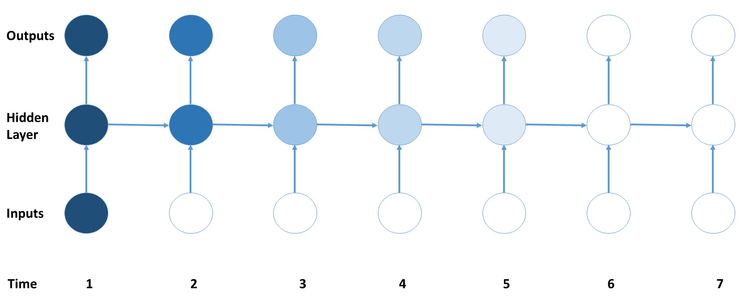
Figure 12. Vanishing gradient problem in RNNs

Figure 12. Vanishing gradient problem in RNNs

Figure 12. Vanishing gradient problem in RNNs

Figure 12. Vanishing gradient problem in RNNs
Fortunately, there are a few approaches to overcome this shortcoming of RNNs. For example, $W$ matrix can be initialized properly to combat the vanishing gradient problem. In an alternative approach, using ReLU instead of tanh or sigmoid activation function can reduce the effect of vanishing gradients. However, the most successful solution is using Long Short-Term Memory (LSTM) network. LSTMs are a special kind of RNN architecture that are capable of learning long-term dependencies (Cheng et al., 2016). LSTM can learn to bridge time intervals in excess of 1000 steps even in case of noisy, incompressible input sequences, without loss of short time lag capabilities (Cheng et al., 2016). This is achieved by multiplicative gate units that can learn to open and close access to the constant error flow. LSTM networks can outperform alternative RNNs and Hidden Markov Models (HMM) and other sequence learning methods in numerous applications such as speech recognition and handwriting recognition.
A block diagram of LSTM is illustrated in Figure 13. LSTM network introduces a new structure called a memory cell. Each memory cell contains four main elements: the input gate, forget gate, output gate and a neuron with a self-recurrent. These gates allow the cells to keep and access information over long periods of time.
Figure 13. Long Short-Term Memory (LSTM) memory cell

Figure 13. Long Short-Term Memory (LSTM) memory cell

Figure 13. Long Short-Term Memory (LSTM) memory cell

Figure 13. Long Short-Term Memory (LSTM) memory cell
The most commonly LSTM architecture is formulated as (Cheng et al., 2016):
$i_{t}= σ\left({U^{i}x}_{t}+W^{i}s_{t-1}+p^{i}∘c_{t-1}+b^{i}\right)$ ,
$f_{t}= σ\left({U^{f}x}_{t}+W^{f}s_{t-1}+p^{f}∘c_{t-1}+b^{f}\right)$ ,
$c_{t}=f_{t}∘c_{t-1}+i_{t}∘g({U^{c}x}_{t}+W^{c}s_{t-1}+b^{c})$ ,
$o_{t}= σ\left({U^{o}x}_{t}+W^{o}s_{t-1}+p^{o}∘c_{t}+b^{o}\right)$ ,
$s_{t}= o_{t}∘g(c_{t})$ ,
where $i_{t}$, $f_{t}$, $c_{t}$, $o_{t}$, and $s_{t}$ are the input gate, forget gate, cell state, output gate and block output at time instance $t$, respectively;$x_{t}$ is the input at time t; $U^{*}$, and $W^{*}$are the weight matrices applied on input and recurrent hidden units, respectively; $σ$ and $g$ are the sigmoid and tangent activation functions, respectively; $p^{*}$ and $b^{*}$ are the peep-hole connections and biases, respectively; and $∘$ means element-wise product.
Figure 14 presents a schematic of an LSTM unrolled in time to show how LSTM can preserve the gradient information. The input, forget, and output gate activations are respectively displayed below, to the left and above the memory block. For simplicity, the gates are either entirely open (‘o’) or entirely closed (‘-’).
Note that traditional RNNs can be considered a special case of LSTMs. If we set the input gate all ones (passing all of the new information), the forget gate all zeros (forgetting all of the previous memory) and the output gate to all ones (exposing the whole memory), we almost get standard RNN with just a small difference which is the tanh term that squeezes the output. In fact, by training the parameters of the gates, an LSTM learns to handle the long-term dependencies. Also note that there are several variants of the LSTMs architecture and equations which we pick the popular one among them in this study.
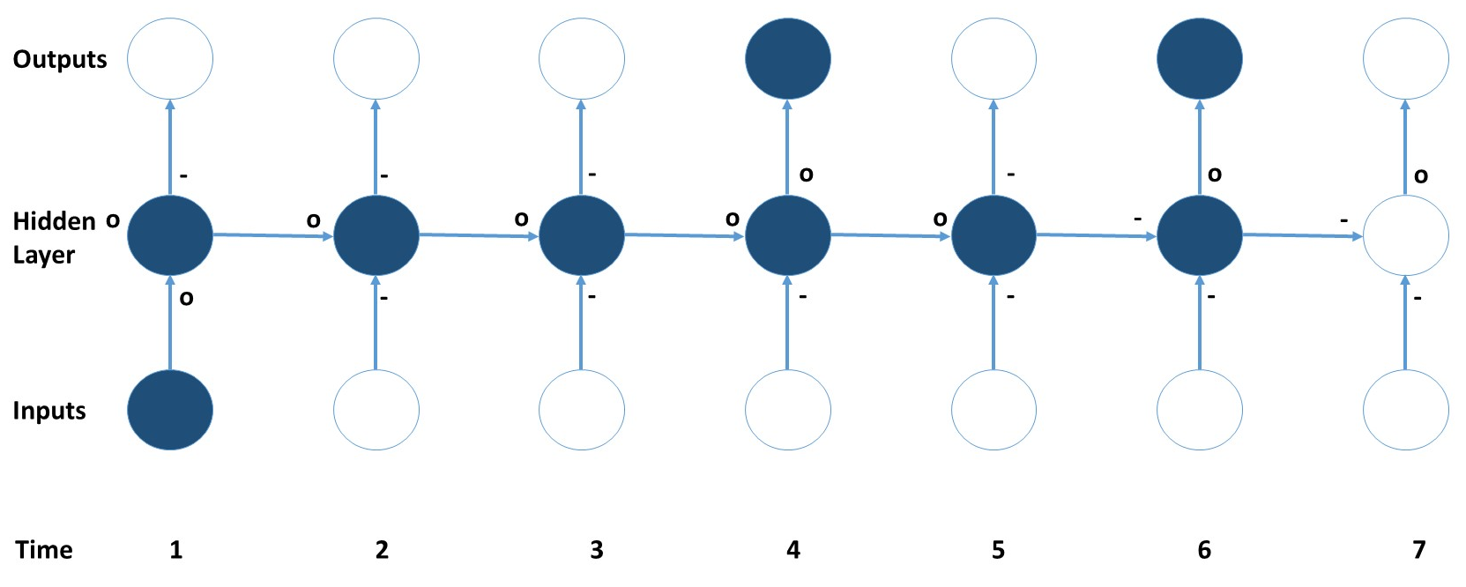
Figure 14. Preserving the gradient information in LSTM

Figure 14. Preserving the gradient information in LSTM

Figure 14. Preserving the gradient information in LSTM

Figure 14. Preserving the gradient information in LSTM

Integration of Incremental Principal Component Analysis with LSTMs
In the HMM/SdA structure proposed in Section 2.2, PCA was used prior to SdA for dimensionality reduction. Unlike HMM/SdA, applying LSTM networks directly to features requires more memory efficient approaches than PCA, or the memory requirements of the network can easily exceed the available computational resources (e.g., low-cost graphics processing units such as the Nvidia 1080ti have limited amount of memory – typically 8Gbytes). Incremental principal components analysis (IPCA) is an effective technique for dimensionality reduction (Cardot et al., 2017). This algorithm is often more memory efficient than PCA. IPCA has constant memory complexity proportional to the batch size, and it enables use of large datasets without a need to load the entire file or dataset into memory. IPCA builds a low-rank approximation for the input data using an amount of memory which is independent of the number of input data samples. It is still dependent on the dimensionality of the input data features but allows more direct control of memory usage by changing the batch size.
In PCA, the first $k$ dominant principal components, $y_{1}\left(n\right), y_{2}\left(n\right), ...,y_{k}\left(n\right),$are computed directly from the input, $x\left(n\right)$ as follows.
$$For n = 1, 2, . . ., do the following:$$
- $x_{1}\left(n\right) = x\left(n\right).$
- $For i = 1, 2, . . . , min⁡(k, n), do:$
$$a) if i = n, initialize the i principal component as y_{i}\left(n\right)= x_{i}\left(n\right);$$
$$b) otherwise compute:$$
$y_{i}\left(n\right)=\frac{n-1-p}{n}y_{i}\left(n-1\right)+\frac{1+p}{n}x_{i}(n)x_{i}^{T}(n)\frac{y_{i}\left(n-1\right)}{||y_{i}\left(n-1\right)||}$ ,
$x_{i+1}\left(n\right)=x_{i}\left(n\right)-x_{i}^{T}(n)\frac{y_{i}\left(n\right)}{||y_{i}\left(n\right)||}\frac{y_{i}\left(n\right)}{||y_{i}\left(n\right)||}$ ,
where the positive parameter $p$ is called the amnesic parameter. Typically, $p$ ranges from 2 to 4. Then the eigenvector and eigenvalues are given by:
Figure 15. An architecture that integrates IPCA for spatial context analysis and LSTM for learning long-term temporal dependencies.

Figure 15. An architecture that integrates IPCA for spatial context analysis and LSTM for learning long-term temporal dependencies.

Figure 15. An architecture that integrates IPCA for spatial context analysis and LSTM for learning long-term temporal dependencies.

Figure 15. An architecture that integrates IPCA for spatial context analysis and LSTM for learning long-term temporal dependencies.
$e_{i}=\frac{y_{i}\left(n\right)}{||y_{i}\left(n\right)||} and λ_{i}=||y_{i}\left(n\right)||$ .
In Figure 15, we present an architecture that integrates IPCA and LSTM (Golmohammadi et al., 2018). In this system, samples are converted to features and the features are delivered to an IPCA layer that performs spatial context analysis and dimensionality reduction. The output of the IPCA layer is delivered to a one-layer LSTM for seizure classification task. The input to the IPCA layer is a vector whose dimension is the product of the number of channels, the number of features per frame and the number of frames of context. Preliminary experiments have shown that 7 seconds of temporal context performs well. The corresponding dimension of the vector input to IPCA is 22 channels × 26 features × 7 seconds × 10 frames/second, or a total of 4,004 elements. A batch size of 50 is used in IPCA and the dimension of its output is 25 elements per frame at 10 frames/second. In order to learn long-term dependencies, one LSTM with a hidden layer size of 128 and batch size of 128 is used along with Adam optimization and a cross-entropy loss function.

End-to-End Sequence Labeling Using Deep Architectures
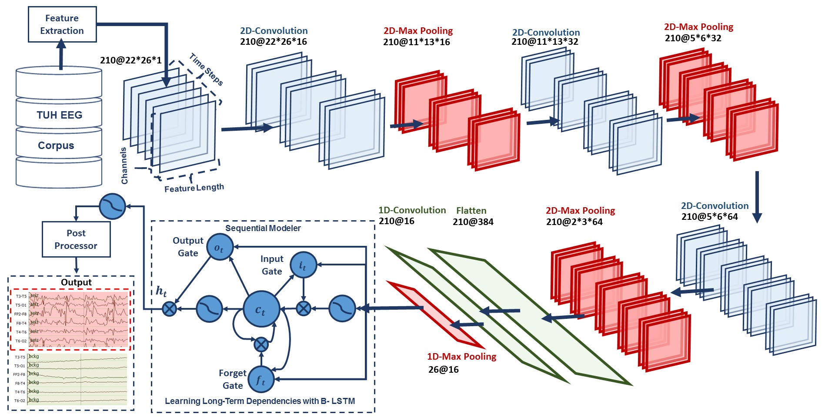
Figure 16. A deep recurrent convolutional architecture for two-dimensional decoding of EEG signals that integrates 2D CNNs, 1-D CNNs and LSTM networks.

Figure 16. A deep recurrent convolutional architecture for two-dimensional decoding of EEG signals that integrates 2D CNNs, 1-D CNNs and LSTM networks.

Figure 16. A deep recurrent convolutional architecture for two-dimensional decoding of EEG signals that integrates 2D CNNs, 1-D CNNs and LSTM networks.

Figure 16. A deep recurrent convolutional architecture for two-dimensional decoding of EEG signals that integrates 2D CNNs, 1-D CNNs and LSTM networks.

In machine learning, sequence labeling is defined as assigning a categorial label to each member of a sequence of observed values. In automatic seizure detection, we assign one of two labels: seizure or non-seizure. This decision is made every epoch, which is typically a 1 sec interval. The proposed structures are trained in an end-to-end fashion, requiring no pre-training and no pre-processing, beyond the feature extraction process that was explained in Section 2.1. For example, for an architecture composed of a combination of CNN and LSTM, we do not train CNN independently from LSTM, but we train both jointly. This is challenging because there are typically convergence issues when attempting this.
In Figure 16, we integrate 2D CNNs, 1-D CNNs and LSTM networks, which we refer to as a CNN/LSTM, to better exploit long-term dependencies (Golmohammadi et al., 2018). Note that the way that we handle data in CNN/LSTM is different from the CNN/MLP system presented in Figure 7. The input EEG features vector sequence can be thought of as being composed of frames distributed in time where each frame is an image of width ($W$) equal to the length of a feature vector. The height ($H$) equals the number of EEG channels and the number of image channels ($N$) equals one. The input to the network consists of T frames where T is equal to the window length multiplied by the number of frames per second. In our optimized system, where features are available 10 times per second, a window duration of 21 seconds is used. The first 2D convolutional layer filters 210 frames ($T = 21 × 10$) of EEGs distributed in time with a size of $26 × 22 × 1 (W = 26, H = 22, N = 1)$ using 16 kernels of size 3 × 3 with a stride of 1. The first 2D max pooling layer takes as input a vector which is 260 frames distributed in time with a size of 26 × 22 × 16 and applies a pooling size of 2 × 2. This process is repeated two times with two 2D convolutional layers with 32 and 64 kernels of size 3 × 3 respectively and two 2D max pooling layers with a pooling size 2 × 2.
The output of the third max pooling layer is flattened to 210 frames with a size of 384 × 1. Then a 1D convolutional layer filters the output of the flattening layer using 16 kernels of size 3 which decreases the dimensionality in space to 210 × 16. Next, we apply a 1D max pooling layer with a size of 8 to decrease the dimensionality to 26 × 16. This is the input to a deep bidirectional LSTM network where the dimensionality of the output space is 128 and 256. The output of the last bidirectional LSTM layer is fed to a 2-way sigmoid function which produces a final classification of an epoch. To overcome the problem of overfitting and force the system to learn more robust features, dropout and Gaussian noise layers are used between layers (Srivastava et al., 2010). To increase nonlinearity, ELUs are used. Adam is used in the optimization process along with a mean squared error loss function.
More recently, Cho et al. (2014) proposed another type of recurrent neural network, known as a gated recurrent unit (GRU). A GRU is formulated as:
$r_{t}= σ\left({U^{r}x}_{t}+W^{r}s_{t-1}+b^{r}\right)$ ,
$z_{t}= σ\left({U^{z}x}_{t}+W^{z}s_{t-1}+b^{z}\right)$ ,
${\tilde{s}}_{t}= g({U^{s}x}_{t}+r_{t}∘\left(W^{s}s_{t-1}\right)+b^{s}$ ,
$s_{t}= z_{t}∘s_{t-1}+\left(1- z_{t}\right)∘ {\tilde{s}}_{t}$ .
A GRU architecture is similar to an LSTM but without a separate memory cell. Unlike LSTM, a GRU does not include output activation functions and peep hole connections. It also integrates the input and forget gates into an update gate, $z_{t}$, to balance between the previous activation, $s_{t-1}$, and the candidate activation, ${\tilde{s}}_{t}$. The reset gate, $r_{t}$, allows it to forget the previous state (Wu et al., 2016). It has been shown that the performance of a GRU is on par with an LSTM, but a GRU can be trained faster (Golmohammadi et al., 2017). The architecture is similar to that in Figure 16, but we simply replace LSTM with GRU, in a way that the output of 1D max pooling is the input to a GRU where the dimensionality of the output space is 128 and 256. The output of the last GRU is fed to a 2-way sigmoid function which produces a final classification of an epoch. These two approaches, LSTM and GRU, are evaluated as part of a hybrid architecture that integrates CNNs with RNNs (Golmohammadi et al., 2017). The results of these structures are reported in Section 6.2.

CHAPTER 5

Data
The electroencephalogram (EEG) is an excellent tool for probing neural function, both in clinical and research environments, due to its low cost, non-invasive nature, and pervasiveness. In the clinic, the EEG is the standard test for diagnosing and characterizing epilepsy and stroke, as well as a host of other trauma and pathology related conditions (Wolf et al., 2017; Yamada and Meng, 2017). In research laboratories, EEG is used to study neural responses to external stimuli, motor planning and execution, and brain-computer interfaces (Liu et al., 2016; Lazarou et al., 2018). While human interpretation is still the gold standard for EEG analysis in the clinic, a host of software tools exist to facilitate the process or to make predictive analyses such as seizure prediction.
In all these applications, there is a need for robust signal processing tools to analyze the EEG data. Historically, EEG signal processing tools have been devised using either ad hoc heuristic methods, or by training pattern recognition engines on small data sets (Gotman, 1982). These methods have yielded limited results, owing mostly to the fact that brain signals (and EEG in particular) are characterized by great variability, which can only be properly interpreted by building statistical models using massive amounts of data (Raghu et al., 2019). Unfortunately, despite EEG being perhaps the most pervasive modality for acquiring brain signals, there is a severe lack of data in the public domain. For example, the “EEG Motor Movement/Imagery Dataset” (http://www.physionet.org/pn4/eegmmidb/) contains approximately 1500 recordings of one or two minutes duration apiece from 109 subjects (Goldberger et al., 2000). The CHB-MIT database contains data from 22 subjects, mostly pediatric (Shoeb, 2010). A database from Karunya University contains 175 16-channel EEGs of duration 10 seconds (Selvaraj et al., 2014). One of the most extensive databases for supporting epilepsy research is the European Epilepsy Database (http://epilepsy-database.eu/), which contains 250 datasets from 30 unique patients, but sells for €3,000. Other databases, such as ieeg.org, contain a wealth of data from more invasive modalities such as electrocorticogram, but little or no EEG (Obeid and Picone, 2016).
This lack of publicly available data is ironic considering that hundreds of thousands of EEGs are administered annually in clinical settings around the world. Relatively little of this data is publicly available to the research community in a form that is useful to machine learning research. Massive amounts of EEG data would allow the use of state-of-the-art machine learning algorithms to discover new diagnostics and validate clinical practice. Furthermore, it is desirable that such data be collected in clinical settings, as opposed to tightly controlled research environments, since ‘clinical-grade’ data is inherently more variable with respect to parameters such as electrode location, clinical environment, equipment and noise. Capturing this variability is critical to the development of robust, high performance technology that has real-world impact.
In this work, we used a new corpus, the TUEG Corpus, which is an ongoing data collection effort that has recently released 14 years of clinical EEG data collected at Temple University Hospital. The records have been curated, organized, and paired with textual clinician reports that describe the patients and scans. The corpus is publicly available from the Neural Engineering Data Consortium (www.nedcdata.org).

Temple University Hospital EEG (TUEG) Corpus
Clinical EEG data were collected from archival records at Temple University Hospital (TUH). All work was performed in accordance with the Declaration of Helsinki and with the full approval of the Temple University IRB. All personnel in contact with privileged patient information were fully trained on patient privacy and were certified by the Temple IRB.
Archival EEG signal data were recovered from CD-ROMs. Files were converted from their native proprietary file format (Nicolet’s NicVue) to an open format EDF standard. Data was then rigorously de-identified to conform to the HIPAA Privacy Rule by eliminating 18 potential identifiers including patient names and dates of birth. Patient medical record numbers were replaced with randomized database identifiers, with a key to that mapping being saved to a secure off-line location. Importantly, our process captured instances in which the same patient received multiple EEGs over time and assigned database IDs accordingly. Data de-identification was performed by combining automated custom-designed software tools with manual editing and proofreading. All storage and manipulation of source files was conducted on dedicated non-network connected computers that were physically located within the TUH Department of Neurology.
We also manually paired each retrieved EEG with its corresponding clinician report. These reports are generated by the neurologist after analyzing the EEG scan and are the official hospital summary of the clinical impression. These reports are comprised of unstructured text that describes the patient, relevant history, medications, and clinical impression. Reports were mined from the hospital’s central electronic medical records archives and typically consisted of image scans of printed reports. Various levels of image processing were employed to improve the image quality before applying optical character recognition (OCR) to convert the images into text. A combination of software and manual editing was used to scrub protected health information (PHI) from the reports and to correct errors in OCR transcription. Only sessions with both an EEG and a corresponding clinician report were included in the final corpus.
The corpus was defined with a hierarchical Unix-style file tree structure.Each of these patient folders contains sub-folders that correspond to individual recording sessions. Those folder names reflect the session number and date of recording. Finally, each session folder includes one or more EEG (.edf) data files as well as the clinician report in .txt format. Figure 17 summarizes the corpus file structure and gives examples of text and signal data.
The completed corpus comprises 23,002 sessions from 13,539 unique subjects. Each of these sessions contains at least one EDF file (more in the case of long-term monitoring sessions that were broken into multiple files) and one physician report. Corpus metrics are summarized in Figure 18. Subjects were 51% female and ranged in age from less than one year to over 90 (average 51.6, stdev 55.9; see Figure 18 bottom left). The average number of sessions per patient was 1.56, although as many as 37 EEGs were recorded for a single patient over an eight-month period (Figure 18 top left). The number of sessions per year varies from approximately 1,000-2,500 (with the exception of years 2000-2002, and 2005, in which limited numbers of complete reports were found in the various electronic medical record archives; see Figure 18 top right).
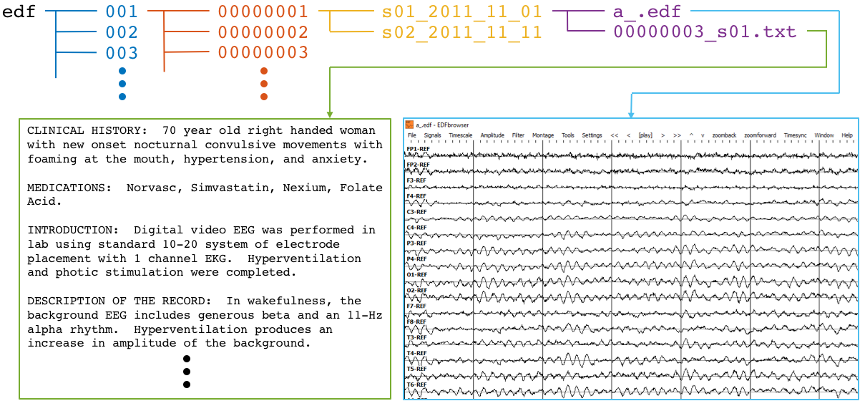
Figure 17. The directory and file structure of the TUEG database is shown. Data is organized by patient (orange) and then by session (yellow). Each session contains one or more signal (edf) and physician report (txt) files. To accommodate filesystem management issues, patients are grouped into sets of about 100 (blue).

Figure 17. The directory and file structure of the TUEG database is shown. Data is organized by patient (orange) and then by session (yellow). Each session contains one or more signal (edf) and physician report (txt) files. To accommodate filesystem management issues, patients are grouped into sets of about 100 (blue).

Figure 17. The directory and file structure of the TUEG database is shown. Data is organized by patient (orange) and then by session (yellow). Each session contains one or more signal (edf) and physician report (txt) files. To accommodate filesystem management issues, patients are grouped into sets of about 100 (blue).

Figure 17. The directory and file structure of the TUEG database is shown. Data is organized by patient (orange) and then by session (yellow). Each session contains one or more signal (edf) and physician report (txt) files. To accommodate filesystem management issues, patients are grouped into sets of about 100 (blue).

There was a substantial degree of variability with respect to the number of channels included in the corpus (see Figure 18 bottom right). EDF files typically contained both EEG-specific channels as well as supplementary channels such as detected bursts, EKG, EMG, and photic stimuli. The most common number of EEG-only channels per EDF file was 31, although there were cases with as few as 20. A majority of the EEG data was sampled at 250Hz (87%) with the remaining data being sampled at 256Hz (8.3%), 400Hz (3.8%), and 512Hz (1%).
An initial analysis of the physician reports reveals a wide range of medications and medical conditions. Unsurprisingly, the most common listed medications were anti-convulsants such as Keppra and Dilantin, as well as blood thinners such as Lovenox and heparin. Approximately 87% of the reports included the text string ‘epilep’, and about 12% included ‘stroke’. Only 48 total reports included the string ‘concus’. The TUEG corpus v1.1.0 has been released and is freely available online at www.nedcdata.org.
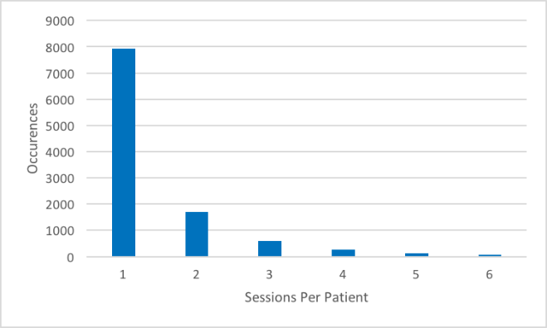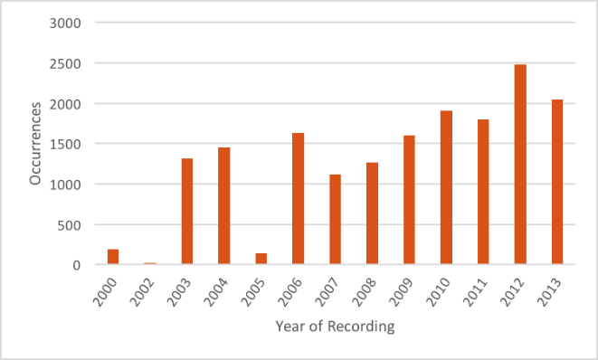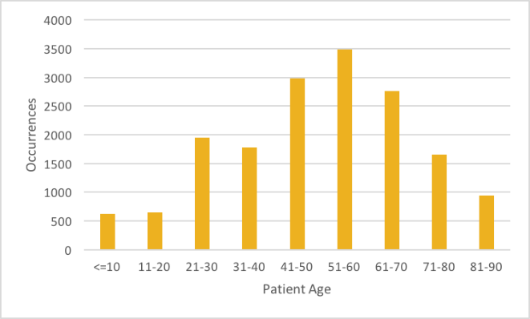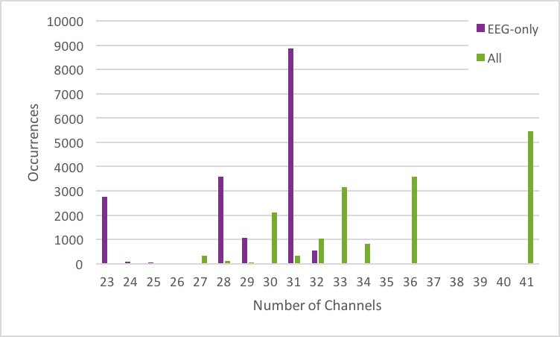
Figure 18. Metrics describing the TUEG corpus. [top left] histogram showing number of sessions per patient; [top right] histogram showing number of sessions recorded per calendar year; [bottom left] histogram of patient ages; [bottom right] histogram showing number of EEG-only channels (purple) and total channels (green).

Figure 18. Metrics describing the TUEG corpus. [top left] histogram showing number of sessions per patient; [top right] histogram showing number of sessions recorded per calendar year; [bottom left] histogram of patient ages; [bottom right] histogram showing number of EEG-only channels (purple) and total channels (green).

Figure 18. Metrics describing the TUEG corpus. [top left] histogram showing number of sessions per patient; [top right] histogram showing number of sessions recorded per calendar year; [bottom left] histogram of patient ages; [bottom right] histogram showing number of EEG-only channels (purple) and total channels (green).

Figure 18. Metrics describing the TUEG corpus. [top left] histogram showing number of sessions per patient; [top right] histogram showing number of sessions recorded per calendar year; [bottom left] histogram of patient ages; [bottom right] histogram showing number of EEG-only channels (purple) and total channels (green).

TUEG Six-Way Event Classification Corpus
A portion of TUEG was annotated manually during a study conducted with Temple University Hospital neurologists (Harati et al., 2014) contains events including periodic lateralized epileptiform discharge, generalized periodic epileptiform discharge, spike and slow wave discharges, artifact, and eye movement. We selected the data based more on the presence of the events of interest described below than the type of EEG since it is difficult to locate examples of spikes. We have analyzed performance as a function of the type/location of the EEG recording for a specific application, seizure detection, using similar technology to that presented in this dissertation, and not found a significant correlation. The error profiles are similar for EEGs collected in the ICU and EMU from a machine learning perspective.
The annotations we developed comprise six patterns of clinical interest. The first three patterns that might be useful in diagnosing brain disorders are:
- Spike and/or sharp waves (SPSW): patterns of EEGs observed during epileptic seizures.
- Periodic lateralized epileptiform discharges (PLED): patterns observed in the context of destructive structural lesions of the cortex. PLED events manifest themselves by presence of a pattern of repetitive periodic, focal, or hemispheric epileptiform discharges like sharp waves, spikes, spike and waves and polyspikes, at intervals of between 0.5 to 3 seconds.
- Generalized periodic epileptiform discharges (GPED): manifest themselves as periodic short-interval diffuse discharges, periodic long-interval diffuse discharges and suppression-burst patterns. GPEDs are encountered in metabolic encephalopathy and cerebral hypoxia and ischemia. They are similar to PLEDs. In fact, if periodic complexes are limited to a focal brain area they are called as PLEDs, but if periodic complexes are observed over both hemispheres in a symmetric, diffuse and synchronized manner, they are defined as GPEDs.
The other three patterns were used by our machine learning technology to model background noise are:
- Eye movement (EYEM): spike-like signals that occur during patient eye movement.
- Artifacts (ARTF): recorded electrical activity that is not of cerebral origin including physiologic artifacts generated from sources other than brain. This class also includes extraphysiologic artifacts arising from outside the body such as noise generated from the recording equipment.
- Background (BCKG): a class used to denote all other data that does not fall in the five classes above. This class usually plays an instrumental role in machine learning systems and needs to include a rich variety of artifacts that are not events of clinical interest.
Note that standard terminology in this field has changed somewhat. PLEDs are now referred to as lateralized periodic discharges (LPDs), GPEDs are now referred to as generalized periodic discharges (GPDs) and spike and sharp waves are referred to as spike and wave (SW) (ACNS, 2012). However, we will retain the older terminology because this aligns with the way the corpus was annotated and is what was used in our machine learning experiments.
There are over 10 different electrode configurations and over 40 channel configurations represented in the corpus. This poses a serious challenge for machine learning systems since for a system to be practical it must be able to adapt to the specific type of EEG being administered. However, for this initial study, we focused on a subset of the data in which signals were recorded using the Averaged Reference (AR) electrode configuration (Lopez et al., 2016).
We collaborated with several neurologists and a team of undergraduate annotators (Shah et al., 2018) to manually label a subset of TUEG for the six different kinds of EEG patterns. This subset, known as the TUH EEG Six-Way Event Classification Corpus (TUEV), is available from our project web site at the URL: https://www.isip.piconepress.com/projects/tuh_eeg/downloads/ tuh_eeg_events. The training set is designed to include segments from 359 sessions and the evaluation dataset contains segments from 159 sessions. This data is designed in a way that every patient appears just once in the dataset.
Note that the annotations were created on a channel basis – the specific channels on which an event was observed were annotated. This is in contrast to many open source databases that we have observed which only mark events in time and do not annotate the specific channels on which the events occurred. In general, with EEG signals, events such as SPSW do not appear on all channels. The subset of channels on which the event appears is relevant diagnostic information. Our annotations are demonstrated in Figure 19.
A summary of TUEV is presented in Table 2. The dataset is divided into a training and evaluation set in a way that it includes sufficient number of observations to train machine learning models such as HMMs and evaluate these models on unseen examples from new patients. An overview of the distribution of six types of events for both of training and evaluation set demonstrates that some events occur much less frequently in the actual corpus than other common events. For example, while just less than 1% of the subset is assigned to SPSW more than 60% is assigned to BCKG. Also notice that 99% of TUEV is composed of three classes for modeling background which are EYEM, ARTF and BCKG. This distribution of data makes the design of robust classifiers for the detection of non-background classes even more challenging. High performance automatic analysis of EEGs requires dealing with infrequently occurring events since much of the data is uninformative. This is often referred to as an unbalanced data problem, and it is quite common in many biomedical applications. Hence, the evaluation set was designed to contain a reasonable representation of all classes. All of EEGs in this subset were recorded using standard 10–20 system and processed using a TCP montage (Lopez et al., 2016), resulting in 22 channels of signal data per EEG.
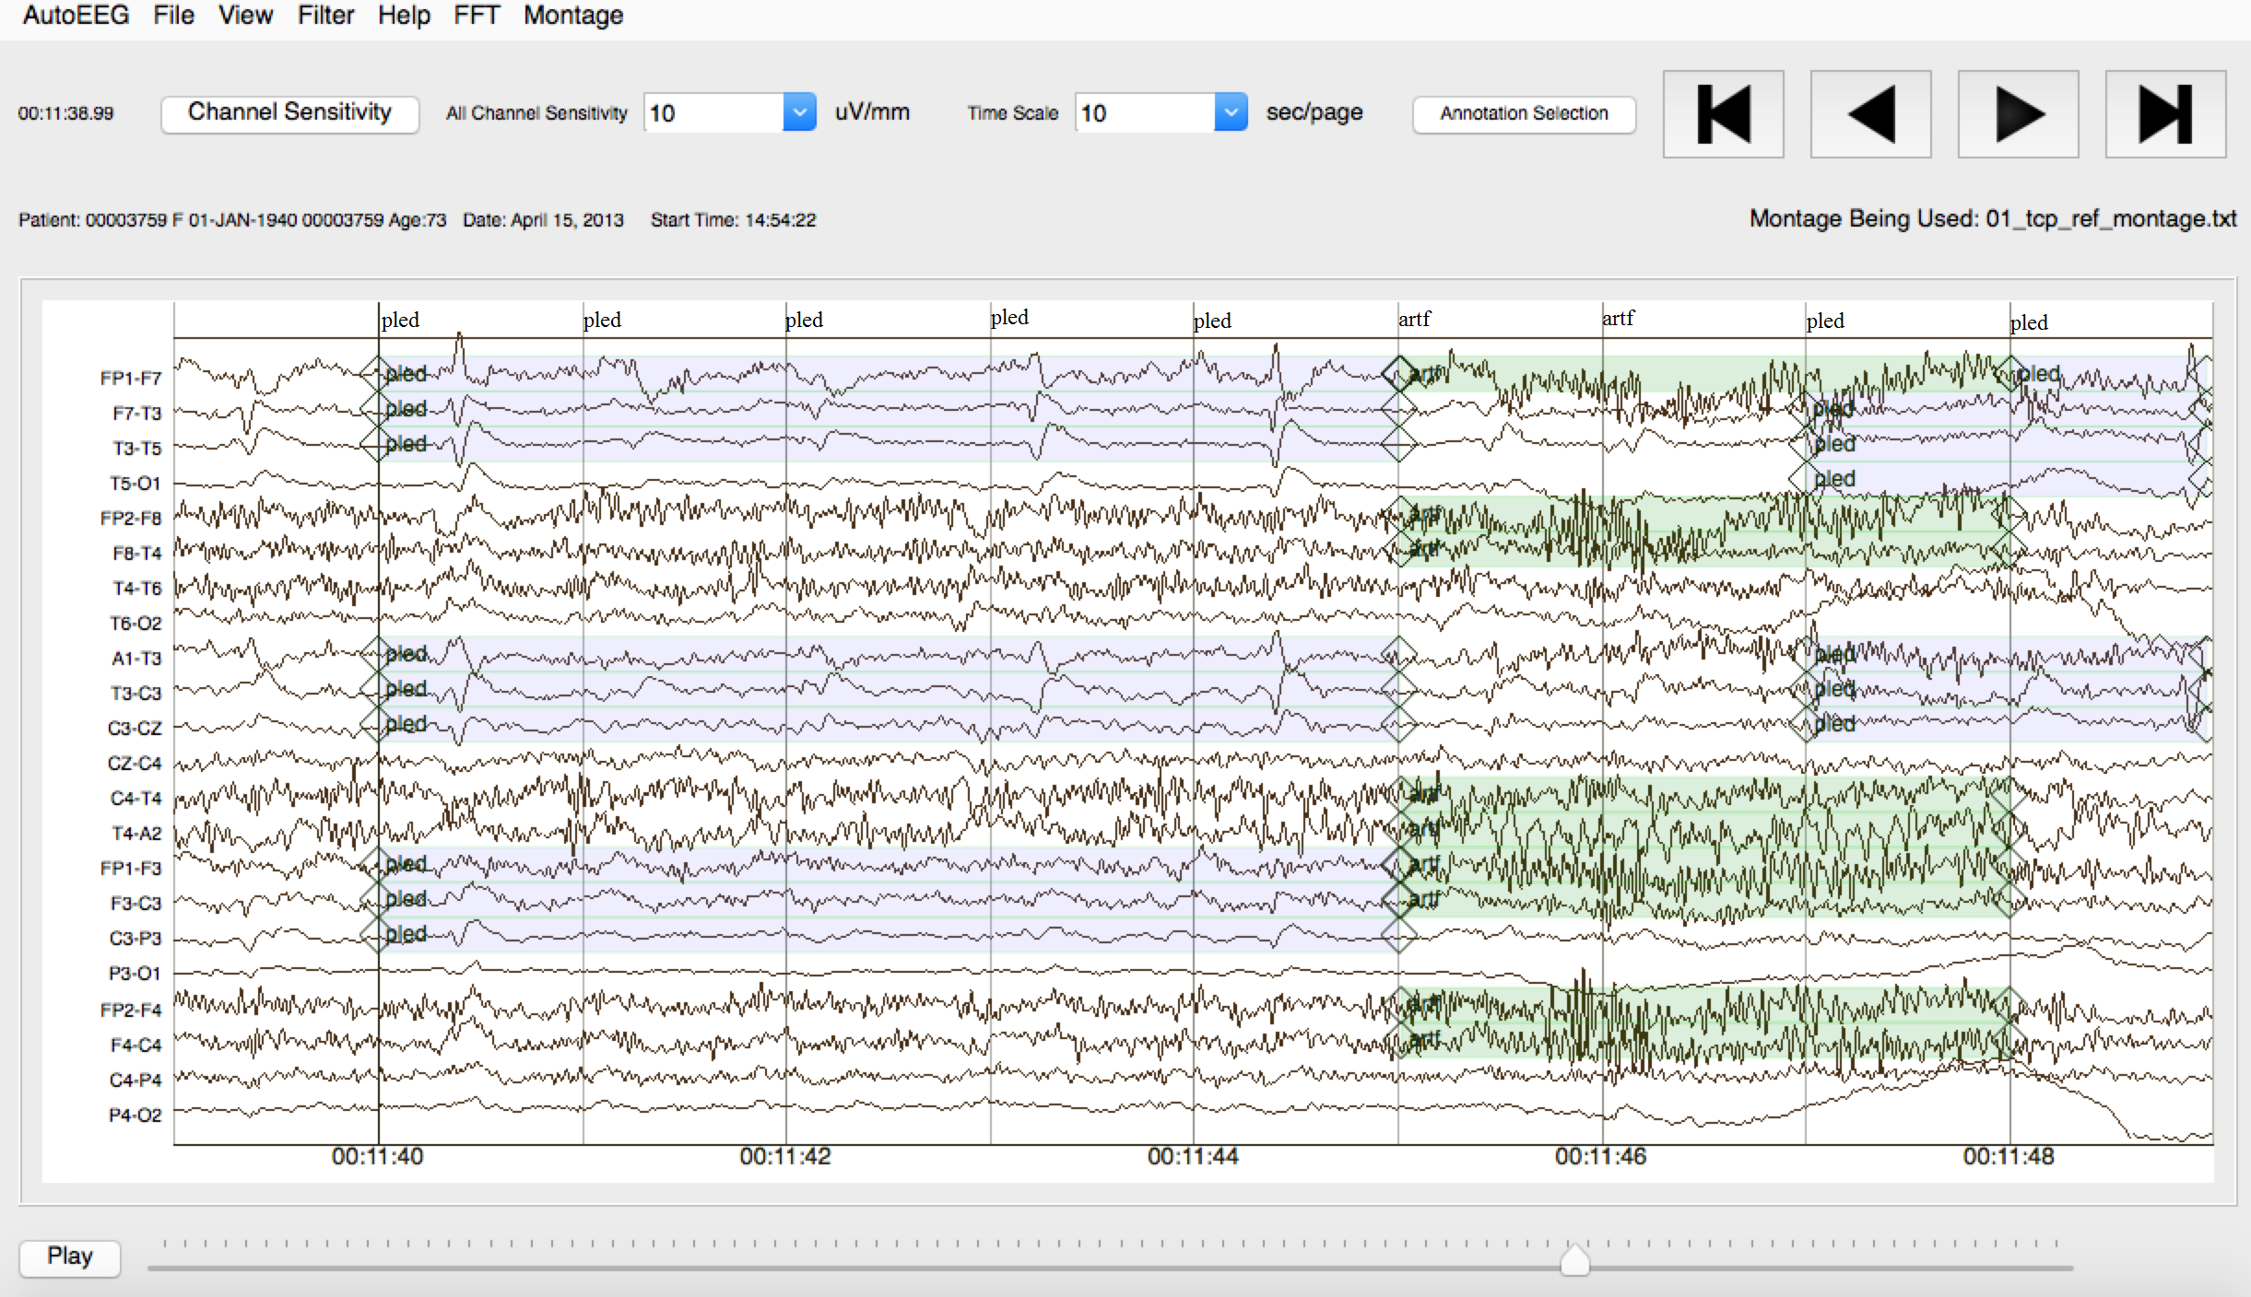
Figure 19. An example demonstrating that the reference data is annotated on a per-channel basis.

Table 2. An overview of the distribution of events in TUEV
Figure 19. An example demonstrating that the reference data is annotated on a per-channel basis.

Table 2. An overview of the distribution of events in TUEV
Event | Train | Train % (CDF) | Eval | Eval % (CDF)
SPSW | 645 | 0.8% ( 1%) | 567 | 1.9% ( 2%)
GPED | 6,184 | 7.4% ( 8%) | 1,998 | 6.8% ( 9%)
PLED | 11,254 | 13.4% (22%) | 4,677 | 15.9% (25%)
EYEM | 1,170 | 1.4% (23%) | 329 | 1.1% (26%)
ARTF | 11,053 | 13.2% (36%) | 2,204 | 7.5% (33%)
BCKG | 53,726 | 63.9% (100%) | 19,646 | 66.8% (100%)
Total: | 84,032 | 100.0% (100%) | 29,421 | 100.0% (100%)

Table 2. An overview of the distribution of events in TUEV
Figure 19. An example demonstrating that the reference data is annotated on a per-channel basis.

Table 2. An overview of the distribution of events in TUEV
Figure 19. An example demonstrating that the reference data is annotated on a per-channel basis.

Table 2. An overview of the distribution of events in TUEV
Event | Train | Train % (CDF) | Eval | Eval % (CDF)
SPSW | 645 | 0.8% ( 1%) | 567 | 1.9% ( 2%)
GPED | 6,184 | 7.4% ( 8%) | 1,998 | 6.8% ( 9%)
PLED | 11,254 | 13.4% (22%) | 4,677 | 15.9% (25%)
EYEM | 1,170 | 1.4% (23%) | 329 | 1.1% (26%)
ARTF | 11,053 | 13.2% (36%) | 2,204 | 7.5% (33%)
BCKG | 53,726 | 63.9% (100%) | 19,646 | 66.8% (100%)
Total: | 84,032 | 100.0% (100%) | 29,421 | 100.0% (100%)

Table 2. An overview of the distribution of events in TUEV
Event | Train | Train % (CDF) | Eval | Eval % (CDF)
SPSW | 645 | 0.8% ( 1%) | 567 | 1.9% ( 2%)
GPED | 6,184 | 7.4% ( 8%) | 1,998 | 6.8% ( 9%)
PLED | 11,254 | 13.4% (22%) | 4,677 | 15.9% (25%)
EYEM | 1,170 | 1.4% (23%) | 329 | 1.1% (26%)
ARTF | 11,053 | 13.2% (36%) | 2,204 | 7.5% (33%)
BCKG | 53,726 | 63.9% (100%) | 19,646 | 66.8% (100%)
Total: | 84,032 | 100.0% (100%) | 29,421 | 100.0% (100%)

Table 2. An overview of the distribution of events in TUEV
Event | Train | Train % (CDF) | Eval | Eval % (CDF)
SPSW | 645 | 0.8% ( 1%) | 567 | 1.9% ( 2%)
GPED | 6,184 | 7.4% ( 8%) | 1,998 | 6.8% ( 9%)
PLED | 11,254 | 13.4% (22%) | 4,677 | 15.9% (25%)
EYEM | 1,170 | 1.4% (23%) | 329 | 1.1% (26%)
ARTF | 11,053 | 13.2% (36%) | 2,204 | 7.5% (33%)
BCKG | 53,726 | 63.9% (100%) | 19,646 | 66.8% (100%)
Total: | 84,032 | 100.0% (100%) | 29,421 | 100.0% (100%)

Table 2. An overview of the distribution of events in TUEV
Event | Train | Train % (CDF) | Eval | Eval % (CDF)
SPSW | 645 | 0.8% ( 1%) | 567 | 1.9% ( 2%)
GPED | 6,184 | 7.4% ( 8%) | 1,998 | 6.8% ( 9%)
PLED | 11,254 | 13.4% (22%) | 4,677 | 15.9% (25%)
EYEM | 1,170 | 1.4% (23%) | 329 | 1.1% (26%)
ARTF | 11,053 | 13.2% (36%) | 2,204 | 7.5% (33%)
BCKG | 53,726 | 63.9% (100%) | 19,646 | 66.8% (100%)
Total: | 84,032 | 100.0% (100%) | 29,421 | 100.0% (100%)

TUEG Seizure Corpus (TUSZ)
Well-known applications of EEGs include identification of epilepsy and epileptic seizures. One of the most popular transcribed seizure databases available to the research community, the CHB-MIT Corpus (Goldberger et al., 2000), only consists of 23 subjects. Though high performance has been achieved on this corpus (Shoeb, 2010), these results have not been representative of clinical performance (Golmohammadi, et al., 2018). Therefore, we introduce the TUEG Seizure Corpus (TUSZ), which is the largest open source corpus of its type and represents an accurate characterization of clinical conditions.
Since seizures occur only a small fraction of the time in this type of data, and manual annotation of such low-yield data would be prohibitively expensive and unproductive, we developed a triage process for locating seizure recordings. We automatically selected data from the much larger TUEG Corpus (Obeid and Picone, 2016) that met certain selection criteria. Three approaches were used to identify files with a high probability that a seizure event occurred: (1) keyword search of EEG reports for sessions that were likely to contain seizures (e.g., reports containing phrases such as “seizure begins with” and “evolution”), (2) automatic detection of seizure events using commercially available software (Persyst, 2017), and (3) automatic detection using an experimental deep learning system (Golmohammadi et al., 2018). Data for which approaches (2) and (3) were in agreement were given highest priority.
Accurate annotation of an EEG requires extensive training. For this reason, manual annotation of EEGs is usually done by board-certified neurologists with many years of post-medical school training. Consequently, it is difficult to transcribe large amounts of data because such expertise is in short supply and is most often focused on clinical practice. Previous attempts to employ panels of experts or use crowdsourcing strategies were not productive. However, we have demonstrated that a viable alternative is to use a team of highly trained undergraduates at the Neural Engineering Data Consortium (NEDC) at Temple University. These students have been trained to transcribe data for seizure events (e.g. start/stop times; seizure type) at accuracy levels that rival expert neurologists at a fraction of the cost (Shah et al., 2018). In order to validate the team’s work, a portion of their annotations were compared to those of expert neurologists and shown to have a high inter-rater agreement. In this section, we describe the techniques used to develop TUSZ, evaluate their effectiveness, and present some descriptive statistics on the resulting corpus.
To build an annotated seizure dataset, we first needed an abundant source of EEG data. Our work here utilized a subset which includes approximately 90% of v0.6.0 of TUEG. The data is organized by patient and by session. Each session contains EEG signal data stored in a standard European Data Format (EDF) (Kemp, 2013) and a de-identified report written by a board-certified neurologist. The EDF files contain a variable number of channels (Obeid & Picone, 2016) but during the annotation process only 19 EEG channels plus two supplementary channels (heart rate and photic stimulation) were used. The data were annotated using our open source annotation tool (Capp et al., 2017).
Since less than 0.1% of the original data contains actual seizure events, annotating the entire database would be costly and inefficient. Therefore, we used three independent approaches to identify sessions that were likely to contain actual seizure events. First, we applied natural language processing (NLP) techniques to identify reports that had keywords related to ictal patterns. The reports were preprocessed using filters that normalized (e.g., removed punctuation and misspellings) and stemmed the text (Rosgen et al., 2018). Machine learning experiments were conducted that utilized term frequency-inverse document frequency (TF-IDF) features (Qaiser et al., 2018). Popular machine learning approaches such as NegEx (Mehrabi et al., 2015), Naïve Bayes and Support Vector Machines with linear kernel functions (SVM) (Bonaccorso, 2017) were trained to recognize documents with that were most likely to contain seizure terms. The Naïve Bayes and Support Vector Machines algorithms used tf-idf features while the NegEx algorithm used raw features (e.g., words) for classification of reports as ictal or non-ictal. These algorithms were seeded from 197 reports describing the occurrence of a seizure and 2,471 reports describing non-occurrence of a seizure. All three algorithms were tested on 100 reports (50 ictal and 50 non-ictal), with NegEx performing slightly better than the Naïve Bayes and SVM classifiers.
The classification of reports using NegEx was performed using a regular expression rule-based approach. The regular expression labels were selected based on negation (NEG), context (CNTX) and affirmation (AFFR). The negation labels were selected based on three different types of negations: pre-negation (PREN) (i.e. did not experience), post-negation (POST) (i.e. infiltrates were not shown) and pseudo-negation (PSEU). NegEx correctly classified 99% of the reports used in our pilot study of 100 reports. When applied to 18,000 sessions in TUEG, 844 sessions were identified as likely to have a seizure. Of these 844 sessions, manual annotation determined that 174 sessions had actual seizures.
The second method used to triage the data was to process the data through a state-of-the-art commercial software tool, P13 rev. B from Persyst Development Corporation (https://www.persyst.com/ technology/seizure-detection/) (Persyst, 2017). We determined that 1,388 files out of 34,698 files contained seizure events. Our third method used an experimental seizure detection system known as AutoEEG (Golmohammadi et al., 2018). This system detected seizures with high confidence in 1,466 files out of 31,645 files. Files for which both systems agreed on a seizure were given the highest priority for annotation. These automated tools agreed on 146 files, or 0.42%, of the corpus. The total number of sessions that were identified as having at least one seizure by either tool was 28.
Using these three approaches, we identified 872 sessions containing 2,582 files from the original 16,168 sessions as high-yield data, meaning they were likely to contain seizures. Our annotation team then manually annotated all the data in these sessions and found that 280 of these sessions contained actual seizure events. It is interesting to note that of the three approaches for identifying high yield data, keyword search proved to be most effective. Automated seizure detection algorithms still suffer from poor performance, especially on short duration seizure events.
TUSZ is v1.2.0 contains 315 subjects with a total of 822 sessions, of which 280 sessions contain seizures. Each file is completely transcribed in two ways: channel-based and term-based. A channel-based annotation refers to labeling of the start and end time of an event on a specific channel. A term-based annotation refers to a summarization of the channel-based annotations – all channels share the same annotation, which is an aggregation of the per-channel annotations.
Based on the neurologist’s report and careful examination of the signal, our annotation team was able to identify the type of seizures (e.g., absence, tonic-clonic). A list of these labels is shown below:
SEIZ: Seizure
GNSZ: Generalized Non-Specific Seizure TNSZ: Tonic Seizure
FNSZ: Focal Non-Specific Seizure CNSZ: Clonic Seizure
SPSZ: Simple Partial Seizure TCSZ: Tonic Clonic Seizure
CPSZ: Complex Partial Seizure ATSZ: Atonic Seizure
ABSZ: Absence Seizure MYSZ: Myoclonic Seizure
If there was insufficient evidence to classify the type of seizure, then an event was defined as either “generalized non-specific” or “focal non-specific” depending on the focality. Histograms of the frequency of occurrence for these seizure types are shown in Figure 20. We then segmented the data into a training and evaluation set to support technology development. The evaluation set was designed to provide a representative sampling of all conditions found in the training set under the constraint that it included 50 patients. Approximately 34% of the evaluation dataset files contain seizures, which is much higher than typical clinical EEG data. The evaluation set was designed to be compact and yet provide representative results so that it would support rapid turnaround of experiments using a moderate amount of computational resources.
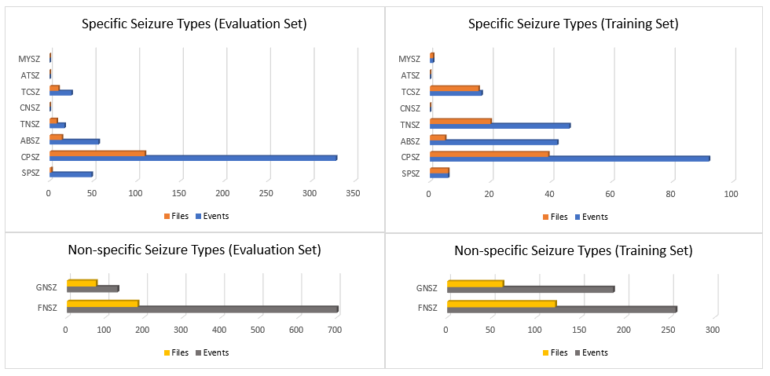
Figure 20. Histograms of seizure types in TUEG for the evaluation and training sets

Figure 20. Histograms of seizure types in TUEG for the evaluation and training sets

Figure 20. Histograms of seizure types in TUEG for the evaluation and training sets

Figure 20. Histograms of seizure types in TUEG for the evaluation and training sets

The entire seizure database has been divided into training and evaluation sets to support machine learning research. All files in this corpus are pruned versions of the original EEG recordings. The duration of a single pruned file is no more than one hour. The training and evaluation sets contain 265 and 50 subjects respectively. The patients in the evaluation set were selected based on gender (56% of the patients in the evaluation set are female; 50% female in the training set) and selected to maximize a number of demographic features, as shown in Figure 21.
In addition to providing the raw signal data and annotations of seizure events, TUSZ contains metadata such as patient demographics, seizure type, and the type of EEG study. The EDF files contain the following metadata:
patient id (anonymized)
gender (male or female)
age (measured in years due to privacy issues)
recording data (DD-MMM-YYYY)
per-channel information:
labels, sample frequency, channel physical dimension, channel physical min, channel physical max,
channel digital min, channel physical max, channel prefiltering conditions
We also have released a spreadsheet with the data that describes each patient and session in terms of the following fields:
patient id (anonymized)
session id
EEG type / subtype:
EMU / EMU (Epilepsy Monitoring Unit)
ICU (Intensive Care Unit) /
BURN (Burn Unit)
CICU (Cardiac Intensive Care)
ICU (Intensive Care Unit)
NICU (Neuro-ICU Facility_
NSICU (Neural Surgical ICU)
PICU (Pediatric Intensive Care Unit)
RICU (Respiratory Intensive Care Unit)
SICU (Surgical Intensive Care Unit)
Inpatient /
ER (Emergency Room)
OR (Operating Room)
General
Outpatient / Outpatient
Unknown / Unknown (location cannot be determined)
LTM or Routine
Normal or Abnormal
Number of Seizures per Session and File
Start Time, Stop Time
Seizure Type
The EEG Type and EEG Subtype fields are used to identify the general location of the EEG session with the hospital. A qualitative assessment of the duration of the recording is indicated a field that indicated whether the EEG was a routine recording (typically an outpatient session lasting 30 minutes) or an extended long-term monitoring (LTM). The normal/abnormal classification follows the clinical criteria described by Lopez (2017).
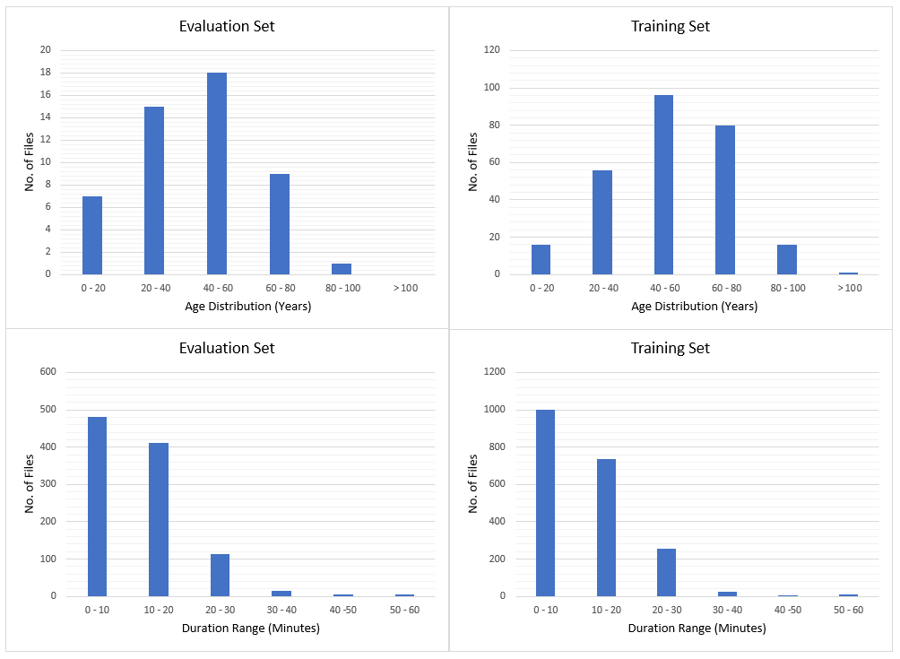
Figure 21. Histograms of age and duration

Table 3. A comparison of TUSZ and DUSZ
Figure 21. Histograms of age and duration

Table 3. A comparison of TUSZ and DUSZ
Description | TUSZ |  | DUSZ
 | Train | Eval | Eval
Patients | 64 | 50 | 45
Sessions | 281 | 229 | 45
Files | 1,028 | 985 | 45
Seizure (secs) | 17,686 | 45,649 | 48,567
Non-Seizure (secs) | 596,696 | 556,033 | 599,381
Total (secs) | 614,382 | 601,682 | 647,948

Table 4. A summary of feature extraction experimentsTable 3. A comparison of TUSZ and DUSZ
Figure 21. Histograms of age and duration

Table 3. A comparison of TUSZ and DUSZ
Figure 21. Histograms of age and duration

While most researchers can work with the information about seizure events provided in the above spreadsheet, we also provide a series of label files that allow display of seizure labels in a time-aligned manner using an open source visualization and annotation tool (Capp et al., 2017).
In this study, we are reporting results on TUSZ and a comparable corpus, the Duke University Seizure Corpus (DUSZ) (Swisher et al., 2015). TUSZ was used as the training and test set corpus, while DUSZ was used as a held-out evaluation set. It is important to note that TUSZ was collected using several generations of Natus EEG equipment, while DUSZ was collected using Nihon Kohden equipment. This is a true open-set evaluation since the data were collected under completely different recording conditions. A comparison of these corpora is shown in Table 3. The results of automatic analysis of EEGs on these datasets are reported in Chapter 6.
Table 3. A comparison of TUSZ and DUSZ
Description | TUSZ |  | DUSZ
 | Train | Eval | Eval
Patients | 64 | 50 | 45
Sessions | 281 | 229 | 45
Files | 1,028 | 985 | 45
Seizure (secs) | 17,686 | 45,649 | 48,567
Non-Seizure (secs) | 596,696 | 556,033 | 599,381
Total (secs) | 614,382 | 601,682 | 647,948

Table 4. A summary of feature extraction experimentsTable 3. A comparison of TUSZ and DUSZ
Description | TUSZ |  | DUSZ
 | Train | Eval | Eval
Patients | 64 | 50 | 45
Sessions | 281 | 229 | 45
Files | 1,028 | 985 | 45
Seizure (secs) | 17,686 | 45,649 | 48,567
Non-Seizure (secs) | 596,696 | 556,033 | 599,381
Total (secs) | 614,382 | 601,682 | 647,948

Table 4. A summary of feature extraction experiments
No. | System Description | Dims. | 6-Way | 4-Way | 2-Way
1 | Cepstral | 7 | 59.3% | 33.6% | 24.6%
2 | Cepstral + Ef | 8 | 45.9% | 33.0% | 24.0%
3 | Cepstral + Et | 8 | 44.9% | 33.7% | 24.8%
4 | Cepstral + Ed | 8 | 55.2% | 32.8% | 24.3%
5 | Cepstral + Ef +Ed | 9 | 39.2% | 30.0% | 20.4%
6 | Cepstral + Δ | 14 | 56.6% | 32.6% | 23.8%
7 | Cepstral + Ef + Δ | 16 | 43.7% | 30.1% | 21.2%
8 | Cepstral + Et + Δ | 16 | 42.8% | 31.6% | 22.4%
9 | Cepstral + Ed + Δ | 16 | 51.6% | 30.4% | 22.0%
10 | Cepstral + Ef +Ed + Δ | 18 | 35.4% | 25.8% | 16.8%
11 | Cepstral + Δ + ΔΔ | 21 | 53.1% | 30.4% | 21.8%
12 | Cepstral + Ef + Δ + ΔΔ | 24 | 39.6% | 27.4% | 19.2%
13 | Cepstral + Et + Δ + ΔΔ | 24 | 39.8% | 29.6% | 21.1%
14 | Cepstral + Ed + Δ + ΔΔ | 24 | 52.5% | 30.1% | 22.6%
15 | Cepstral + Ef +Ed + Δ + ΔΔ | 27 | 35.5% | 25.9% | 17.2%
16 | (15) but no ΔΔ for Ed | 26 | 35.0% | 25.0% | 16.6%

Table 5. The 6-way classification results for the three passes of processingTable 4. A summary of feature extraction experimentsTable 3. A comparison of TUSZ and DUSZ
Description | TUSZ |  | DUSZ
 | Train | Eval | Eval
Patients | 64 | 50 | 45
Sessions | 281 | 229 | 45
Files | 1,028 | 985 | 45
Seizure (secs) | 17,686 | 45,649 | 48,567
Non-Seizure (secs) | 596,696 | 556,033 | 599,381
Total (secs) | 614,382 | 601,682 | 647,948

Table 4. A summary of feature extraction experimentsTable 3. A comparison of TUSZ and DUSZ
Description | TUSZ |  | DUSZ
 | Train | Eval | Eval
Patients | 64 | 50 | 45
Sessions | 281 | 229 | 45
Files | 1,028 | 985 | 45
Seizure (secs) | 17,686 | 45,649 | 48,567
Non-Seizure (secs) | 596,696 | 556,033 | 599,381
Total (secs) | 614,382 | 601,682 | 647,948

CHAPTER 6

EXPERIMENTS AND RESULTS
In this chapter, we present the results of proposed structures for automatic analysis of EEGs. In our experiments, we have used TUEG and DUSZ.
Researchers in biomedical fields typically report performance in terms of sensitivity and specificity. True positives (TP) are defined as the number of epochs identified as a seizure in the reference annotations and correctly labeled as a seizure by the system. True negatives (TN) are defined as the number of epochs correctly identified as non-seizures. False positives (FP) are defined as the number of epochs incorrectly labeled as seizure while false negatives (FN) are defined as the number of epochs incorrectly labeled as non-seizure. Sensitivity is computed as TP/(TP+FN). Specificity is computed as TN/(TN+FP). The false alarm rate is the number of FPs per 24 hours.
The feature extraction results are presented in detail in (Harati et al., 2015). In summary, we have used a subset of TUEG that has been manually labeled for the six types of events described in Section 5.2. We refer to the 6 classes as the 6-way classification problem. It makes more sense to collapse the 3 background classes into one category. We refer to this second evaluation paradigm as a 4-way classification task: SPSW, GPED, PLED and BCKG. The latter class contains an enumeration of the 3 background classes. Finally, we also report a 2-way classification task in which we collapse the data into a target class (TARG) and a background class (BCKG). The first series of experiments were run on a simple combination of features. A second set of experiments were run to evaluate the benefit of using differential features. These experiments are summarized in Table 4.
The feature extraction results show that traditional feature extraction methods used in other fields such as speech recognition are relevant to EEGs. The use of a novel differential energy feature improved performance for absolute features (system nos. 1-5), but that benefit diminishes as first and second order derivatives are included (system nos. 6-16). We have shown there is benefit to using derivatives and there is a small advantage to using frequency domain energy.
Table 4. A summary of feature extraction experiments
No. | System Description | Dims. | 6-Way | 4-Way | 2-Way
1 | Cepstral | 7 | 59.3% | 33.6% | 24.6%
2 | Cepstral + Ef | 8 | 45.9% | 33.0% | 24.0%
3 | Cepstral + Et | 8 | 44.9% | 33.7% | 24.8%
4 | Cepstral + Ed | 8 | 55.2% | 32.8% | 24.3%
5 | Cepstral + Ef +Ed | 9 | 39.2% | 30.0% | 20.4%
6 | Cepstral + Δ | 14 | 56.6% | 32.6% | 23.8%
7 | Cepstral + Ef + Δ | 16 | 43.7% | 30.1% | 21.2%
8 | Cepstral + Et + Δ | 16 | 42.8% | 31.6% | 22.4%
9 | Cepstral + Ed + Δ | 16 | 51.6% | 30.4% | 22.0%
10 | Cepstral + Ef +Ed + Δ | 18 | 35.4% | 25.8% | 16.8%
11 | Cepstral + Δ + ΔΔ | 21 | 53.1% | 30.4% | 21.8%
12 | Cepstral + Ef + Δ + ΔΔ | 24 | 39.6% | 27.4% | 19.2%
13 | Cepstral + Et + Δ + ΔΔ | 24 | 39.8% | 29.6% | 21.1%
14 | Cepstral + Ed + Δ + ΔΔ | 24 | 52.5% | 30.1% | 22.6%
15 | Cepstral + Ef +Ed + Δ + ΔΔ | 27 | 35.5% | 25.9% | 17.2%
16 | (15) but no ΔΔ for Ed | 26 | 35.0% | 25.0% | 16.6%

Table 5. The 6-way classification results for the three passes of processingTable 4. A summary of feature extraction experiments
No. | System Description | Dims. | 6-Way | 4-Way | 2-Way
1 | Cepstral | 7 | 59.3% | 33.6% | 24.6%
2 | Cepstral + Ef | 8 | 45.9% | 33.0% | 24.0%
3 | Cepstral + Et | 8 | 44.9% | 33.7% | 24.8%
4 | Cepstral + Ed | 8 | 55.2% | 32.8% | 24.3%
5 | Cepstral + Ef +Ed | 9 | 39.2% | 30.0% | 20.4%
6 | Cepstral + Δ | 14 | 56.6% | 32.6% | 23.8%
7 | Cepstral + Ef + Δ | 16 | 43.7% | 30.1% | 21.2%
8 | Cepstral + Et + Δ | 16 | 42.8% | 31.6% | 22.4%
9 | Cepstral + Ed + Δ | 16 | 51.6% | 30.4% | 22.0%
10 | Cepstral + Ef +Ed + Δ | 18 | 35.4% | 25.8% | 16.8%
11 | Cepstral + Δ + ΔΔ | 21 | 53.1% | 30.4% | 21.8%
12 | Cepstral + Ef + Δ + ΔΔ | 24 | 39.6% | 27.4% | 19.2%
13 | Cepstral + Et + Δ + ΔΔ | 24 | 39.8% | 29.6% | 21.1%
14 | Cepstral + Ed + Δ + ΔΔ | 24 | 52.5% | 30.1% | 22.6%
15 | Cepstral + Ef +Ed + Δ + ΔΔ | 27 | 35.5% | 25.9% | 17.2%
16 | (15) but no ΔΔ for Ed | 26 | 35.0% | 25.0% | 16.6%

Table 5. The 6-way classification results for the three passes of processing
Pass | Event | ARTF | BCKG | EYEM | GPED | PLED | SPSW
First | ARTF | 41.24 | 45.19 | 2.18 | 3.81 | 2.77 | 4.81
 | BCKG | 7.02 | 71.93 | 2.59 | 7.37 | 2.28 | 8.81
 | EYEM | 2.13 | 0.61 | 82.37 | 2.13 | 8.51 | 4.26
 | GPED | 7.46 | 4.85 | 2.39 | 53.32 | 20.42 | 11.55
 | PLED | 0.70 | 1.85 | 4.70 | 17.62 | 54.80 | 20.32
 | SPSW | 4.41 | 8.29 | 9.17 | 33.33 | 4.59 | 40.21
Second | ARTF | 27.49 | 61.73 | 7.28 | 0.00 | 1.08 | 2.43
 | BCKG | 7.00 | 82.03 | 5.79 | 0.97 | 0.36 | 3.86
 | EYEM | 4.21 | 16.84 | 77.89 | 0.00 | 0.00 | 1.05
 | GPED | 0.60 | 14.69 | 0.00 | 59.96 | 10.26 | 14.49
 | PLED | 1.40 | 22.65 | 0.80 | 13.83 | 52.30 | 9.02
 | SPSW | 7.69 | 35.90 | 2.56 | 28.21 | 0.00 | 25.64
Third | ARTF | 14.04 | 72.98 | 10.18 | 0.00 | 0.00 | 2.81
 | BCKG | 3.42 | 81.40 | 8.93 | 0.30 | 0.00 | 5.95
 | EYEM | 2.30 | 17.24 | 79.31 | 0.00 | 0.00 | 1.15
 | GPED | 0.30 | 3.65 | 0.00 | 65.05 | 13.37 | 17.63
 | PLED | 0.00 | 10.76 | 0.49 | 9.78 | 65.28 | 13.69
 | SPSW | 10.00 | 33.33 | 13.33 | 10.00 | 0.00 | 33.33

Table 6. The 4-way classification results for the three passes of processingTable 5. The 6-way classification results for the three passes of processingTable 4. A summary of feature extraction experiments
No. | System Description | Dims. | 6-Way | 4-Way | 2-Way
1 | Cepstral | 7 | 59.3% | 33.6% | 24.6%
2 | Cepstral + Ef | 8 | 45.9% | 33.0% | 24.0%
3 | Cepstral + Et | 8 | 44.9% | 33.7% | 24.8%
4 | Cepstral + Ed | 8 | 55.2% | 32.8% | 24.3%
5 | Cepstral + Ef +Ed | 9 | 39.2% | 30.0% | 20.4%
6 | Cepstral + Δ | 14 | 56.6% | 32.6% | 23.8%
7 | Cepstral + Ef + Δ | 16 | 43.7% | 30.1% | 21.2%
8 | Cepstral + Et + Δ | 16 | 42.8% | 31.6% | 22.4%
9 | Cepstral + Ed + Δ | 16 | 51.6% | 30.4% | 22.0%
10 | Cepstral + Ef +Ed + Δ | 18 | 35.4% | 25.8% | 16.8%
11 | Cepstral + Δ + ΔΔ | 21 | 53.1% | 30.4% | 21.8%
12 | Cepstral + Ef + Δ + ΔΔ | 24 | 39.6% | 27.4% | 19.2%
13 | Cepstral + Et + Δ + ΔΔ | 24 | 39.8% | 29.6% | 21.1%
14 | Cepstral + Ed + Δ + ΔΔ | 24 | 52.5% | 30.1% | 22.6%
15 | Cepstral + Ef +Ed + Δ + ΔΔ | 27 | 35.5% | 25.9% | 17.2%
16 | (15) but no ΔΔ for Ed | 26 | 35.0% | 25.0% | 16.6%

Table 5. The 6-way classification results for the three passes of processingTable 4. A summary of feature extraction experiments
No. | System Description | Dims. | 6-Way | 4-Way | 2-Way
1 | Cepstral | 7 | 59.3% | 33.6% | 24.6%
2 | Cepstral + Ef | 8 | 45.9% | 33.0% | 24.0%
3 | Cepstral + Et | 8 | 44.9% | 33.7% | 24.8%
4 | Cepstral + Ed | 8 | 55.2% | 32.8% | 24.3%
5 | Cepstral + Ef +Ed | 9 | 39.2% | 30.0% | 20.4%
6 | Cepstral + Δ | 14 | 56.6% | 32.6% | 23.8%
7 | Cepstral + Ef + Δ | 16 | 43.7% | 30.1% | 21.2%
8 | Cepstral + Et + Δ | 16 | 42.8% | 31.6% | 22.4%
9 | Cepstral + Ed + Δ | 16 | 51.6% | 30.4% | 22.0%
10 | Cepstral + Ef +Ed + Δ | 18 | 35.4% | 25.8% | 16.8%
11 | Cepstral + Δ + ΔΔ | 21 | 53.1% | 30.4% | 21.8%
12 | Cepstral + Ef + Δ + ΔΔ | 24 | 39.6% | 27.4% | 19.2%
13 | Cepstral + Et + Δ + ΔΔ | 24 | 39.8% | 29.6% | 21.1%
14 | Cepstral + Ed + Δ + ΔΔ | 24 | 52.5% | 30.1% | 22.6%
15 | Cepstral + Ef +Ed + Δ + ΔΔ | 27 | 35.5% | 25.9% | 17.2%
16 | (15) but no ΔΔ for Ed | 26 | 35.0% | 25.0% | 16.6%

The results of these experiments determined that a reasonable tradeoff between computational complexity and performance was to split the 10 sec window of EEG into 1 sec epochs, and to further subdivide these into 0.1 sec frames. Hence, features were computed every 0.1 sec using a 0.2 sec overlapping analysis window. The output of the feature extraction system is 22 channels of data, where in each channel, a feature vector of dimension 26 corresponds to every 0.1 secs.

The Results of 6-way Classification
In this section, we present results on a series of experiments designed to optimize and evaluate each stage of processing for 6-way classification.

The Results of Sequential Modeling with HMM for 6-way Classification
A 6-way classification experiment was conducted using the models described in Figure 4. Each state uses 8 Gaussian mixture components and a diagonal covariance assumption (drawing on our experience with speech recognition systems and balancing dimensionality of the models with the size of the training data). Models were trained using all events on all channels resulting in what we refer to as channel independent models. Channel dependent models have not proven to provide a boost in performance and add considerable complexity to the system.
Table 5. The 6-way classification results for the three passes of processing
Pass | Event | ARTF | BCKG | EYEM | GPED | PLED | SPSW
First | ARTF | 41.24 | 45.19 | 2.18 | 3.81 | 2.77 | 4.81
 | BCKG | 7.02 | 71.93 | 2.59 | 7.37 | 2.28 | 8.81
 | EYEM | 2.13 | 0.61 | 82.37 | 2.13 | 8.51 | 4.26
 | GPED | 7.46 | 4.85 | 2.39 | 53.32 | 20.42 | 11.55
 | PLED | 0.70 | 1.85 | 4.70 | 17.62 | 54.80 | 20.32
 | SPSW | 4.41 | 8.29 | 9.17 | 33.33 | 4.59 | 40.21
Second | ARTF | 27.49 | 61.73 | 7.28 | 0.00 | 1.08 | 2.43
 | BCKG | 7.00 | 82.03 | 5.79 | 0.97 | 0.36 | 3.86
 | EYEM | 4.21 | 16.84 | 77.89 | 0.00 | 0.00 | 1.05
 | GPED | 0.60 | 14.69 | 0.00 | 59.96 | 10.26 | 14.49
 | PLED | 1.40 | 22.65 | 0.80 | 13.83 | 52.30 | 9.02
 | SPSW | 7.69 | 35.90 | 2.56 | 28.21 | 0.00 | 25.64
Third | ARTF | 14.04 | 72.98 | 10.18 | 0.00 | 0.00 | 2.81
 | BCKG | 3.42 | 81.40 | 8.93 | 0.30 | 0.00 | 5.95
 | EYEM | 2.30 | 17.24 | 79.31 | 0.00 | 0.00 | 1.15
 | GPED | 0.30 | 3.65 | 0.00 | 65.05 | 13.37 | 17.63
 | PLED | 0.00 | 10.76 | 0.49 | 9.78 | 65.28 | 13.69
 | SPSW | 10.00 | 33.33 | 13.33 | 10.00 | 0.00 | 33.33

Table 6. The 4-way classification results for the three passes of processingTable 5. The 6-way classification results for the three passes of processing
Pass | Event | ARTF | BCKG | EYEM | GPED | PLED | SPSW
First | ARTF | 41.24 | 45.19 | 2.18 | 3.81 | 2.77 | 4.81
 | BCKG | 7.02 | 71.93 | 2.59 | 7.37 | 2.28 | 8.81
 | EYEM | 2.13 | 0.61 | 82.37 | 2.13 | 8.51 | 4.26
 | GPED | 7.46 | 4.85 | 2.39 | 53.32 | 20.42 | 11.55
 | PLED | 0.70 | 1.85 | 4.70 | 17.62 | 54.80 | 20.32
 | SPSW | 4.41 | 8.29 | 9.17 | 33.33 | 4.59 | 40.21
Second | ARTF | 27.49 | 61.73 | 7.28 | 0.00 | 1.08 | 2.43
 | BCKG | 7.00 | 82.03 | 5.79 | 0.97 | 0.36 | 3.86
 | EYEM | 4.21 | 16.84 | 77.89 | 0.00 | 0.00 | 1.05
 | GPED | 0.60 | 14.69 | 0.00 | 59.96 | 10.26 | 14.49
 | PLED | 1.40 | 22.65 | 0.80 | 13.83 | 52.30 | 9.02
 | SPSW | 7.69 | 35.90 | 2.56 | 28.21 | 0.00 | 25.64
Third | ARTF | 14.04 | 72.98 | 10.18 | 0.00 | 0.00 | 2.81
 | BCKG | 3.42 | 81.40 | 8.93 | 0.30 | 0.00 | 5.95
 | EYEM | 2.30 | 17.24 | 79.31 | 0.00 | 0.00 | 1.15
 | GPED | 0.30 | 3.65 | 0.00 | 65.05 | 13.37 | 17.63
 | PLED | 0.00 | 10.76 | 0.49 | 9.78 | 65.28 | 13.69
 | SPSW | 10.00 | 33.33 | 13.33 | 10.00 | 0.00 | 33.33

Table 6. The 4-way classification results for the three passes of processing
Pass | Event | BCKG | SPSW | GPED | PLED
First | BCKG | 82.30 | 8.35 | 6.94 | 2.42
 | SPSW | 21.87 | 40.21 | 33.33 | 4.59
 | GPED | 14.71 | 11.55 | 53.32 | 20.42
 | PLED | 7.26 | 20.32 | 17.62 | 54.80
Second | BCKG | 95.60 | 3.24 | 0.62 | 0.54
 | SPSW | 46.15 | 25.64 | 28.21 | 0.00
 | GPED | 15.29 | 14.49 | 59.96 | 10.26
 | PLED | 24.85 | 9.02 | 13.83 | 52.30
Third | BCKG | 95.11 | 4.69 | 0.19 | 0.00
 | SPSW | 56.67 | 33.33 | 10.00 | 0.00
 | GPED | 3.95 | 17.63 | 65.05 | 13.37
 | PLED | 11.25 | 13.69 | 9.78 | 65.28

Table 7. The 2-way classification results for the three passes of processingTable 6. The 4-way classification results for the three passes of processingTable 5. The 6-way classification results for the three passes of processing
Pass | Event | ARTF | BCKG | EYEM | GPED | PLED | SPSW
First | ARTF | 41.24 | 45.19 | 2.18 | 3.81 | 2.77 | 4.81
 | BCKG | 7.02 | 71.93 | 2.59 | 7.37 | 2.28 | 8.81
 | EYEM | 2.13 | 0.61 | 82.37 | 2.13 | 8.51 | 4.26
 | GPED | 7.46 | 4.85 | 2.39 | 53.32 | 20.42 | 11.55
 | PLED | 0.70 | 1.85 | 4.70 | 17.62 | 54.80 | 20.32
 | SPSW | 4.41 | 8.29 | 9.17 | 33.33 | 4.59 | 40.21
Second | ARTF | 27.49 | 61.73 | 7.28 | 0.00 | 1.08 | 2.43
 | BCKG | 7.00 | 82.03 | 5.79 | 0.97 | 0.36 | 3.86
 | EYEM | 4.21 | 16.84 | 77.89 | 0.00 | 0.00 | 1.05
 | GPED | 0.60 | 14.69 | 0.00 | 59.96 | 10.26 | 14.49
 | PLED | 1.40 | 22.65 | 0.80 | 13.83 | 52.30 | 9.02
 | SPSW | 7.69 | 35.90 | 2.56 | 28.21 | 0.00 | 25.64
Third | ARTF | 14.04 | 72.98 | 10.18 | 0.00 | 0.00 | 2.81
 | BCKG | 3.42 | 81.40 | 8.93 | 0.30 | 0.00 | 5.95
 | EYEM | 2.30 | 17.24 | 79.31 | 0.00 | 0.00 | 1.15
 | GPED | 0.30 | 3.65 | 0.00 | 65.05 | 13.37 | 17.63
 | PLED | 0.00 | 10.76 | 0.49 | 9.78 | 65.28 | 13.69
 | SPSW | 10.00 | 33.33 | 13.33 | 10.00 | 0.00 | 33.33

Table 6. The 4-way classification results for the three passes of processingTable 5. The 6-way classification results for the three passes of processing
Pass | Event | ARTF | BCKG | EYEM | GPED | PLED | SPSW
First | ARTF | 41.24 | 45.19 | 2.18 | 3.81 | 2.77 | 4.81
 | BCKG | 7.02 | 71.93 | 2.59 | 7.37 | 2.28 | 8.81
 | EYEM | 2.13 | 0.61 | 82.37 | 2.13 | 8.51 | 4.26
 | GPED | 7.46 | 4.85 | 2.39 | 53.32 | 20.42 | 11.55
 | PLED | 0.70 | 1.85 | 4.70 | 17.62 | 54.80 | 20.32
 | SPSW | 4.41 | 8.29 | 9.17 | 33.33 | 4.59 | 40.21
Second | ARTF | 27.49 | 61.73 | 7.28 | 0.00 | 1.08 | 2.43
 | BCKG | 7.00 | 82.03 | 5.79 | 0.97 | 0.36 | 3.86
 | EYEM | 4.21 | 16.84 | 77.89 | 0.00 | 0.00 | 1.05
 | GPED | 0.60 | 14.69 | 0.00 | 59.96 | 10.26 | 14.49
 | PLED | 1.40 | 22.65 | 0.80 | 13.83 | 52.30 | 9.02
 | SPSW | 7.69 | 35.90 | 2.56 | 28.21 | 0.00 | 25.64
Third | ARTF | 14.04 | 72.98 | 10.18 | 0.00 | 0.00 | 2.81
 | BCKG | 3.42 | 81.40 | 8.93 | 0.30 | 0.00 | 5.95
 | EYEM | 2.30 | 17.24 | 79.31 | 0.00 | 0.00 | 1.15
 | GPED | 0.30 | 3.65 | 0.00 | 65.05 | 13.37 | 17.63
 | PLED | 0.00 | 10.76 | 0.49 | 9.78 | 65.28 | 13.69
 | SPSW | 10.00 | 33.33 | 13.33 | 10.00 | 0.00 | 33.33

The results for the first pass of processing are shown in Table 5, in the first pass section. A more informative performance analysis can be constructed by collapsing the three background classes into one category. We refer to this second evaluation paradigm as a 4-way classification task: SPSW, GPED, PLED and BACKG. The latter class contains an enumeration of the three background classes. The 4-way classification results for the first pass of processing are presented in Table 6, in the first pass section. Finally, in order that we can produce a detection error tradeoff (DET) curve (Martin et al., 1997) we also report a 2-way classification result in which we collapse the data into a target class (TARG) and a background class (BCKG). The 2-way classification results for the first pass of processing are presented in Table 7, in the first pass section. Note that the classification results for all these tables are measured by counting each epoch for each channel as an independent event. We refer to this as forced-choice event-based scoring because every epoch for every channel is assigned a score based on its class label.
Table 6. The 4-way classification results for the three passes of processing
Pass | Event | BCKG | SPSW | GPED | PLED
First | BCKG | 82.30 | 8.35 | 6.94 | 2.42
 | SPSW | 21.87 | 40.21 | 33.33 | 4.59
 | GPED | 14.71 | 11.55 | 53.32 | 20.42
 | PLED | 7.26 | 20.32 | 17.62 | 54.80
Second | BCKG | 95.60 | 3.24 | 0.62 | 0.54
 | SPSW | 46.15 | 25.64 | 28.21 | 0.00
 | GPED | 15.29 | 14.49 | 59.96 | 10.26
 | PLED | 24.85 | 9.02 | 13.83 | 52.30
Third | BCKG | 95.11 | 4.69 | 0.19 | 0.00
 | SPSW | 56.67 | 33.33 | 10.00 | 0.00
 | GPED | 3.95 | 17.63 | 65.05 | 13.37
 | PLED | 11.25 | 13.69 | 9.78 | 65.28

Table 7. The 2-way classification results for the three passes of processingTable 6. The 4-way classification results for the three passes of processing
Pass | Event | BCKG | SPSW | GPED | PLED
First | BCKG | 82.30 | 8.35 | 6.94 | 2.42
 | SPSW | 21.87 | 40.21 | 33.33 | 4.59
 | GPED | 14.71 | 11.55 | 53.32 | 20.42
 | PLED | 7.26 | 20.32 | 17.62 | 54.80
Second | BCKG | 95.60 | 3.24 | 0.62 | 0.54
 | SPSW | 46.15 | 25.64 | 28.21 | 0.00
 | GPED | 15.29 | 14.49 | 59.96 | 10.26
 | PLED | 24.85 | 9.02 | 13.83 | 52.30
Third | BCKG | 95.11 | 4.69 | 0.19 | 0.00
 | SPSW | 56.67 | 33.33 | 10.00 | 0.00
 | GPED | 3.95 | 17.63 | 65.05 | 13.37
 | PLED | 11.25 | 13.69 | 9.78 | 65.28

Table 7. The 2-way classification results for the three passes of processing
Pass | Event | TARG | BCKG
First | TARG | 86.92 | 13.08
 | BCKG | 18.20 | 81.80
Second | TARG | 78.94 | 21.06
 | BCKG | 4.40 | 95.60
Third | TARG | 90.10 | 9.90
 | BCKG | 4.89 | 95.11

Table 8. Specificity and sensitivity for each pass of processingTable 7. The 2-way classification results for the three passes of processingTable 6. The 4-way classification results for the three passes of processing
Pass | Event | BCKG | SPSW | GPED | PLED
First | BCKG | 82.30 | 8.35 | 6.94 | 2.42
 | SPSW | 21.87 | 40.21 | 33.33 | 4.59
 | GPED | 14.71 | 11.55 | 53.32 | 20.42
 | PLED | 7.26 | 20.32 | 17.62 | 54.80
Second | BCKG | 95.60 | 3.24 | 0.62 | 0.54
 | SPSW | 46.15 | 25.64 | 28.21 | 0.00
 | GPED | 15.29 | 14.49 | 59.96 | 10.26
 | PLED | 24.85 | 9.02 | 13.83 | 52.30
Third | BCKG | 95.11 | 4.69 | 0.19 | 0.00
 | SPSW | 56.67 | 33.33 | 10.00 | 0.00
 | GPED | 3.95 | 17.63 | 65.05 | 13.37
 | PLED | 11.25 | 13.69 | 9.78 | 65.28

Table 7. The 2-way classification results for the three passes of processingTable 6. The 4-way classification results for the three passes of processing
Pass | Event | BCKG | SPSW | GPED | PLED
First | BCKG | 82.30 | 8.35 | 6.94 | 2.42
 | SPSW | 21.87 | 40.21 | 33.33 | 4.59
 | GPED | 14.71 | 11.55 | 53.32 | 20.42
 | PLED | 7.26 | 20.32 | 17.62 | 54.80
Second | BCKG | 95.60 | 3.24 | 0.62 | 0.54
 | SPSW | 46.15 | 25.64 | 28.21 | 0.00
 | GPED | 15.29 | 14.49 | 59.96 | 10.26
 | PLED | 24.85 | 9.02 | 13.83 | 52.30
Third | BCKG | 95.11 | 4.69 | 0.19 | 0.00
 | SPSW | 56.67 | 33.33 | 10.00 | 0.00
 | GPED | 3.95 | 17.63 | 65.05 | 13.37
 | PLED | 11.25 | 13.69 | 9.78 | 65.28

The Results of Temporal and Spatial Context Analysis
The output of the first stage of processing is a vector of six scores, or likelihoods, for each channel at each epoch. Therefore, if we have 22 channels and six classes, we will have a vector of dimension 6 x 22 = 132 scores for each epoch. This 132-dimension epoch vector is computed without considering similar vectors from epochs adjacent in time. Information available from other channels within the same epoch is referred to as “spatial” context since each channel corresponds to a specific electrode location on the skull. Information available from other epochs is referred to as “temporal” context. The goal of this level of processing is to integrate spatial and temporal context to improve decision-making.
Table 7. The 2-way classification results for the three passes of processing
Pass | Event | TARG | BCKG
First | TARG | 86.92 | 13.08
 | BCKG | 18.20 | 81.80
Second | TARG | 78.94 | 21.06
 | BCKG | 4.40 | 95.60
Third | TARG | 90.10 | 9.90
 | BCKG | 4.89 | 95.11

Table 8. Specificity and sensitivity for each pass of processingTable 7. The 2-way classification results for the three passes of processing
Pass | Event | TARG | BCKG
First | TARG | 86.92 | 13.08
 | BCKG | 18.20 | 81.80
Second | TARG | 78.94 | 21.06
 | BCKG | 4.40 | 95.60
Third | TARG | 90.10 | 9.90
 | BCKG | 4.89 | 95.11

Table 8. Specificity and sensitivity for each pass of processing
Pass | Sensitivity | Specificity
1 (HMM) | 86.78 | 17.70
2 (SdA) | 78.93 | 4.40
3 (SLM) | 90.10 | 4.88

Table 8. Specificity and sensitivity for each pass of processingTable 7. The 2-way classification results for the three passes of processing
Pass | Event | TARG | BCKG
First | TARG | 86.92 | 13.08
 | BCKG | 18.20 | 81.80
Second | TARG | 78.94 | 21.06
 | BCKG | 4.40 | 95.60
Third | TARG | 90.10 | 9.90
 | BCKG | 4.89 | 95.11

Table 8. Specificity and sensitivity for each pass of processingTable 7. The 2-way classification results for the three passes of processing
Pass | Event | TARG | BCKG
First | TARG | 86.92 | 13.08
 | BCKG | 18.20 | 81.80
Second | TARG | 78.94 | 21.06
 | BCKG | 4.40 | 95.60
Third | TARG | 90.10 | 9.90
 | BCKG | 4.89 | 95.11

To integrate context, the input to the second pass deep learning system is a vector of dimension 6 x 22 x window length, where we aggregate 132-dimension vectors in time. If we consider a 41second window, then we will have a 5,412-dimension input to the second pass of processing. This input dimensionality is high even though we have a considerable amount of manually labeled training. To deal with this problem we follow a standard approach of using Principal Components Analysis (PCA) (Bonaccorso, 2017) before every SdA. The output of PCA is a vector of dimension 13 for SdA detectors that look for SPSW and EYEM and 20 for 6-way SdA classifier.
Further, since we do not have enough SPSW and EYEM events in the training dataset, we must use an out-of-sample technique (Bonaccorso, 2017) to train SdA. Three consecutive outputs are averaged, so the output is further reduced from 3 x 13 to just 13, using a sliding window approach to averaging. Therefore, the input for SPSW SdA and EYEM SdA decreases to 13 x window length and 20 x window length for 6-way SdA.
We used an open source toolkit, Theano (Bastien et al., 2012; Bergstra et al., 2010), to implement the SdAs. The parameters of the models are optimized to minimize the average reconstruction error using a cross-entropy loss function. In the optimization process, a variant of stochastic gradient descent is used, referred to as minibatches. Minibatch stochastic gradient descent is similar to stochastic gradient descent, but we use more than one training example to calculate each estimate of the gradient. Using this optimization method, we will have less variance in the estimate of the gradient. Additionally, this framework makes better use of the hierarchical memory organization in modern computers.
SPSW SdA uses a window length of 3 which means it has 39 inputs and 2 outputs. It has three hidden layers with corruption levels of 0.3 for each layer. The number of nodes per layer are: first layer = 100, second layer = 100, third layer = 100. The parameters for pre-training are: learning rate = 0.5, number of epochs = 200, batch size = 300. The parameters for fine-tuning are: learning rate = 0.2, number of epochs = 800 and batch size = 100.
EYEM SdA uses a window length of 3 which means it has 39 inputs and 2 outputs. It has three hidden layers with corruption levels of 0.3 for each layer. The number of nodes per layer are: first layer = 100, second layer = 100, third layer = 100. The parameters for pre-training are: learning rate = 0.5, number of epochs = 200, batch size = 300. The parameters for fine-tuning are: learning rate = 0.2, number of epochs = 100 and batch size = 100.
Six-way SdA uses a window length of 41 which means it has 820 inputs and 6 outputs. It has three hidden layers with corruption levels of 0.3 for each layer. The number of nodes per layer are: first layer = 800, second layer = 500, third layer = 300. The parameters for pre-training are: learning rate = 0.5, number of epochs = 150 and batch size = 300. The parameters for fine-tuning are: learning rate = 0.1, number of epochs = 300 and batch size = 100.
The 6-way, 4-way and 2-way classification results for the second stage of processing are presented in Table 5, Table 6, and Table 7 in the second pass section, respectively. Note that unlike the tables for the first pass of processing, the classification results in each of these tables are measured once per epoch – they are not per-channel results. We refer to these results as epoch-based.

The Results of Statistical Language Modeling for 6-way Classification
The output of the second stage of processing is a vector of six scores, or likelihoods, per epoch. This serves as the input for the third stage of processing. The optimized parameters for the third pass of processing are: prior probability for an epoch, $ϵ_prior$, is 0.1; the weight, $M$, is 1; the decaying weight, $λ$, is 0.2; the weight associated with $P_gprior$, $α$, is 0.1; the grammar weight, $y$, is 1; the number of iterations, $n$, is 20, and the window length to calculate the left and right prior probabilities is 10. The 6-way, 4-way and 2-way classification results are presented in in Table 5, Table 6, and Table 7, in the third pass section, respectively. Note that these results are also epoch-based.
The 6-way classification task can be structured into several subtasks. Of course, due to the high probability of the signal being background, the system is heavily biased towards choosing the background model. Therefore, in Table 6 in the first pass section, we see that performance on BACKG is fairly high. Not surprisingly, BCKG is most often confused with SPSW. SPSW events are short in duration and there are many transient events in BCKG that resemble an SPSW event. This is one reason we added ARTF and EYEM models, so that we can reduce the confusions of all classes with the short impulsive SPSW events. As we annotate background data in more detail, and identify more commonly occurring artifacts, we can expand on our ability to model BCKG events explicitly.
GPEDs are, not surprisingly, most often confused with PLED events. Both events have a longer duration than SPSWs and artifacts. From the first pass section of Table 6, we see that performance on these two classes is generally high. The main difference between GPED and PLED is duration, so we designed the postprocessing to learn this as a discriminator. For example, in the second pass of processing, we implemented a window duration of 41 seconds so that the SdA system would be exposed to long-term temporal context. We also designed three separate SdA networks to differentiate between short-term and long-term context. In Table 6 in the second pass section, we see that the performance of GPEDs and PLEDs improves with the second pass of postprocessing. More significantly, the confusions between GPEDs and PLEDs also decreased. Note that also in Table 6 in the second pass section, performance of BCKG increased significantly. Confusions with GPEDs and PLEDs dropped dramatically to below 1%.
While performance across the board increased, performance for SPSW dropped by adding the second pass of postprocessing. This is a reflection on the imbalance of the data. Less than one percent of data is annotated as SPSWs, while we have ten times more training samples for GPEDs and PLEDs. Note that we used an out-of-sample technique to increase the number of training samples for SPSWs, but even this technique could not solve the problem of a lack of annotated SPSW data. By comparing the first pass results of Table 5 to Table 7, we saw a similar behavior with the EYEM class because there are also fewer EYEM events.
A summary of the results for different stages of processing is shown in Table 8. The overall performance of the multi-pass hybrid HMM/deep learning classification system is promising: more than 90% sensitivity and less than 5% specificity. Because the false alarm rate in these types of applications varies significantly with sensitivity, it is important to examine performance using a DET curve. A DET curve for the first, second and third stage of processing is given in Figure 22. Note that the tables previously presented use the unprocessed likelihoods output from the system. They essentially correspond to the point on the DET curve where a penalty of 0 is applied. This operating point is identified on each of the curves in Figure 22. We see that the raw likelihoods of the system correspond to different operating points in the DET curve space. From Figure 22 it is readily apparent that postprocessing significantly improves our ability to maintain a low false alarm rate as we increase the detection rate. In virtually all cases, the trends shown in Table 5 to Table 7 hold up for the full range of the DET curve. This study demonstrates that a significant amount of contextual processing is required to achieve a specificity of 5%.
Table 8. Specificity and sensitivity for each pass of processing
Pass | Sensitivity | Specificity
1 (HMM) | 86.78 | 17.70
2 (SdA) | 78.93 | 4.40
3 (SLM) | 90.10 | 4.88

Table 8. Specificity and sensitivity for each pass of processing
Pass | Sensitivity | Specificity
1 (HMM) | 86.78 | 17.70
2 (SdA) | 78.93 | 4.40
3 (SLM) | 90.10 | 4.88

Table 8. Specificity and sensitivity for each pass of processing
Pass | Sensitivity | Specificity
1 (HMM) | 86.78 | 17.70
2 (SdA) | 78.93 | 4.40
3 (SLM) | 90.10 | 4.88

Table 8. Specificity and sensitivity for each pass of processing
Pass | Sensitivity | Specificity
1 (HMM) | 86.78 | 17.70
2 (SdA) | 78.93 | 4.40
3 (SLM) | 90.10 | 4.88

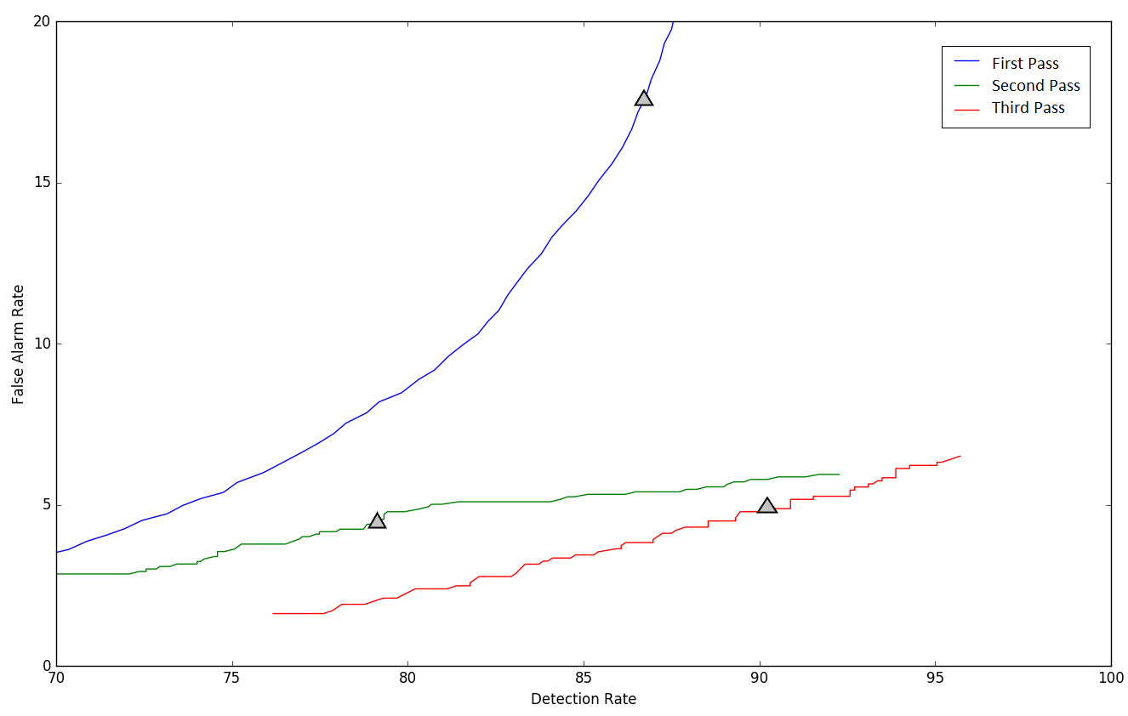
Figure 22. DET curves are shown for each pass of processing. The “zero penalty” operating point is also shown since this was used in Table 3 – Table 5.

Figure 22. DET curves are shown for each pass of processing. The “zero penalty” operating point is also shown since this was used in Table 3 – Table 5.

Figure 22. DET curves are shown for each pass of processing. The “zero penalty” operating point is also shown since this was used in Table 3 – Table 5.

Figure 22. DET curves are shown for each pass of processing. The “zero penalty” operating point is also shown since this was used in Table 3 – Table 5.
In this section, we have presented a three-pass system that can achieve high performance classifying EEG events of clinical relevance. The system uses a combination of HMMs for accurate temporal segmentation and deep learning for high performance classification. In the first pass, the signal is converted to EEG events using an HMM-based system that models the temporal evolution of the signal. In the second pass, three stacked denoising autoencoders (SDAs) with different window durations are used to map event labels onto a single composite epoch label vector. We demonstrated that both temporal and spatial context analysis based on deep learning can improve the performance of sequential decoding using HMMs. In the third pass, a probabilistic grammar is applied that combines left and right context with the current label vector to produce a final decision for an epoch.
Our hybrid HMM/deep learning system delivered a sensitivity above 90% while maintaining a specificity below 5%, making automated analysis a viable option for clinicians. This framework for automatic analysis of EEGs can be applied in other classification tasks such as seizure detection or abnormal detection. There are many straightforward extensions of this system that can include more powerful deep learning networks such as Long Short-Term Memory Networks or Convolutional Neural Networks.

The Results of Automatic Seizure Detection
We evaluated several architectures using the features as inputs on TUSZ. These results are presented in Table 9. The related DET curve is illustrated Figure 23. An expanded version of this plot, that compares the performance of these architectures in a region of the DET curve where the false positive rate, also known as the false alarm (FA) rate, is low is presented in Figure 24. Since our focus is achieving a low false alarm rate, behavior in this region of the DET curve is very important. As previously mentioned, these systems were evaluated using the OVLP method, though results are similar for a variety of these metrics.
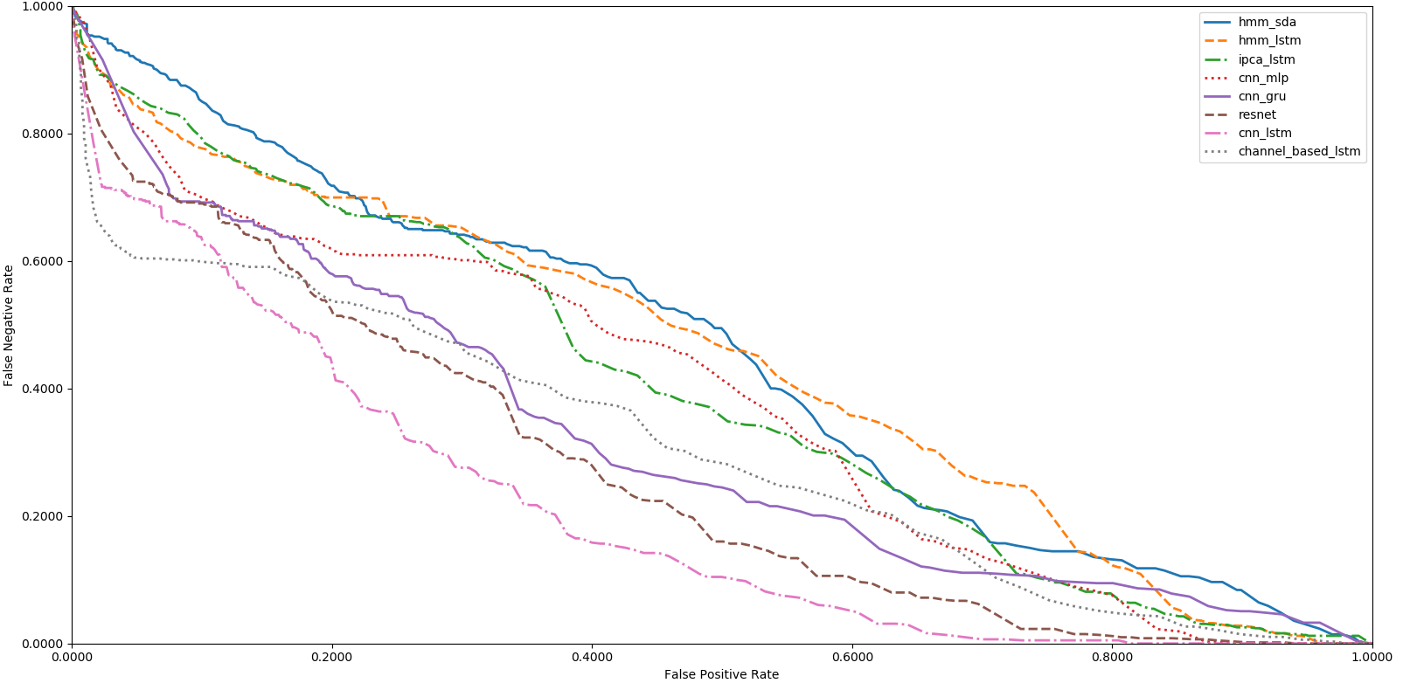
Figure 23. A DET curve comparison of the proposed architectures on TUSZ

Table 9. Performance of the proposed architectures on TUSZ
Figure 23. A DET curve comparison of the proposed architectures on TUSZ

Table 9. Performance of the proposed architectures on TUSZ
System | Sensitivity | Specificity | FA/24 Hrs.
HMM | 30.32% | 80.07% | 244
HMM/SdA | 35.35% | 73.35% | 77
HMM/LSTM | 30.05% | 80.53% | 60
IPCA/LSTM | 32.97% | 77.57% | 73
CNN/MLP | 39.09% | 76.84% | 77
CNN/GRU | 30.83% | 91.49% | 21
ResNet | 30.50% | 94.24% | 13
CNN/LSTM | 30.83% | 97.10% | 6

Table 9. Performance of the proposed architectures on TUSZ
Figure 23. A DET curve comparison of the proposed architectures on TUSZ

Table 9. Performance of the proposed architectures on TUSZ
Figure 23. A DET curve comparison of the proposed architectures on TUSZ
Table 9. Performance of the proposed architectures on TUSZ
System | Sensitivity | Specificity | FA/24 Hrs.
HMM | 30.32% | 80.07% | 244
HMM/SdA | 35.35% | 73.35% | 77
HMM/LSTM | 30.05% | 80.53% | 60
IPCA/LSTM | 32.97% | 77.57% | 73
CNN/MLP | 39.09% | 76.84% | 77
CNN/GRU | 30.83% | 91.49% | 21
ResNet | 30.50% | 94.24% | 13
CNN/LSTM | 30.83% | 97.10% | 6

Table 9. Performance of the proposed architectures on TUSZ
System | Sensitivity | Specificity | FA/24 Hrs.
HMM | 30.32% | 80.07% | 244
HMM/SdA | 35.35% | 73.35% | 77
HMM/LSTM | 30.05% | 80.53% | 60
IPCA/LSTM | 32.97% | 77.57% | 73
CNN/MLP | 39.09% | 76.84% | 77
CNN/GRU | 30.83% | 91.49% | 21
ResNet | 30.50% | 94.24% | 13
CNN/LSTM | 30.83% | 97.10% | 6

Table 9. Performance of the proposed architectures on TUSZ
System | Sensitivity | Specificity | FA/24 Hrs.
HMM | 30.32% | 80.07% | 244
HMM/SdA | 35.35% | 73.35% | 77
HMM/LSTM | 30.05% | 80.53% | 60
IPCA/LSTM | 32.97% | 77.57% | 73
CNN/MLP | 39.09% | 76.84% | 77
CNN/GRU | 30.83% | 91.49% | 21
ResNet | 30.50% | 94.24% | 13
CNN/LSTM | 30.83% | 97.10% | 6

Table 9. Performance of the proposed architectures on TUSZ
System | Sensitivity | Specificity | FA/24 Hrs.
HMM | 30.32% | 80.07% | 244
HMM/SdA | 35.35% | 73.35% | 77
HMM/LSTM | 30.05% | 80.53% | 60
IPCA/LSTM | 32.97% | 77.57% | 73
CNN/MLP | 39.09% | 76.84% | 77
CNN/GRU | 30.83% | 91.49% | 21
ResNet | 30.50% | 94.24% | 13
CNN/LSTM | 30.83% | 97.10% | 6

It is important to note that the accuracy reported here is much lower than what is often published in the literature on other seizure detection tasks. This is due to a combination of factors including (1) the neuroscience community has favored a more permissive method of scoring that tends to produce much higher sensitivities and lower false alarm rates; and (2) TUSZ is a much more difficult task than any corpus previously released as open source. The evaluation set was designed to be representative of common clinical issues and includes many challenging examples of seizures. We have achieved much higher performance on other publicly available tasks such as the Children’s Hospital of Boston MIT (CHB-MIT) Corpus and demonstrated that the performance of these techniques exceeds that of published or commercially available technology. TUSZ is simply a much more difficult task and one that better represents the clinical challenges this technology faces.
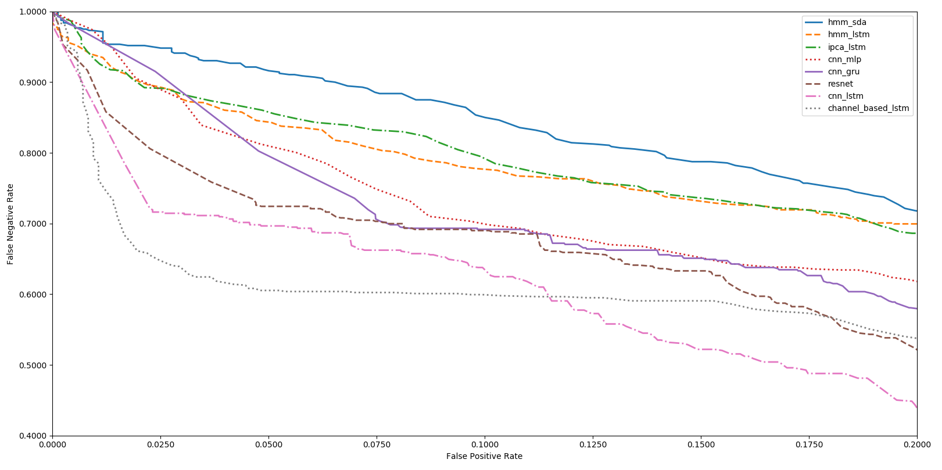Figure 24. An expanded comparison of performance in the low FP region

Figure 24. An expanded comparison of performance in the low FP region

Figure 24. An expanded comparison of performance in the low FP region

Figure 24. An expanded comparison of performance in the low FP region
Also, note that the HMM baseline system, which is shown in the first row of Table 9, operates on each channel independently. The other methods consider all channels simultaneously by using a supervector that is a concatenation of the feature vectors for all channels. The baseline HMM system only classifies epochs (1 sec in duration) using data from within that epoch. It does not look across channels or across multiple epochs when performing epoch-level classification.
From Table 9 we can see that adding a deep learning structure for temporal and spatial analysis of EEGs can decrease the false alarm rate dramatically. Further, by comparing the results of HMM/SdA with HMM/LSTM, we find that a simple one-layer LSTM performs better than 3 layers of SdA due to LSTM’s ability to explicitly model long-term dependencies. Note that in this case the complexity and training time of these two systems is comparable.
The best overall system shown in Table 9 is CNN/LSTM. CNN/LSTM is a doubly deep recurrent convolutional structure that models both spatial relationships (e.g., cross-channel dependencies) and temporal dynamics (e.g., spikes). For example, CNN/LSTM does a much better job rejecting artifacts that are easily confused with spikes because these appear on only a few channels, and hence can be filtered based on correlations between channels. The depth of the convolutional network is important since the top convolutional layers tend to learn generic features while the deeper layers learn dataset specific features. Performance degrades if a single convolutional layer is removed. For example, removing any of the middle convolutional layers results in a loss of about 4% in the sensitivity. However, it is important to note that the computational complexity of the channel-based systems is significantly higher than the systems that aggregate channel-based features into a single vector, since the channel-based systems are decoding each channel independently.
As shown in Figure 23 and Figure 24, we find that CNN/LSTM has a significantly lower FA rate than CNN/GRU. We speculate that this is due to the fact that while a GRU unit controls the flow of information like the LSTM unit, it does not have a memory unit. LSTMs can remember longer sequences better than GRUs. Since seizure detection requires modeling long distance relationships, we believe this explains why there is a difference in performance between the two systems.
The time required for training for CNN/GRU was 10% less than CNN/LSTM. The training time of these two systems is comparable since most of the cycles are spent training the convolutional layers. We also observe that the ResNet structure improves the performance of CNN/MLP, but the best overall system is still CNN/LSTM.
We have also conducted an open-set evaluation of the best system, CNN/LSTM, on a completely different corpus – DUSZ. These results are shown in Table 10. The related DET curve is shown in Figure 25. This is an important evaluation because this system was not exposed to DUSZ data during training or development testing. Parameter optimizations were performed only on TUSZ data. At high false positive rates, performance between the two systems is comparable. At low false positive rates, false positives on TUSZ are lower than on DUSZ. This suggests there is room for additional optimization on DUSZ.
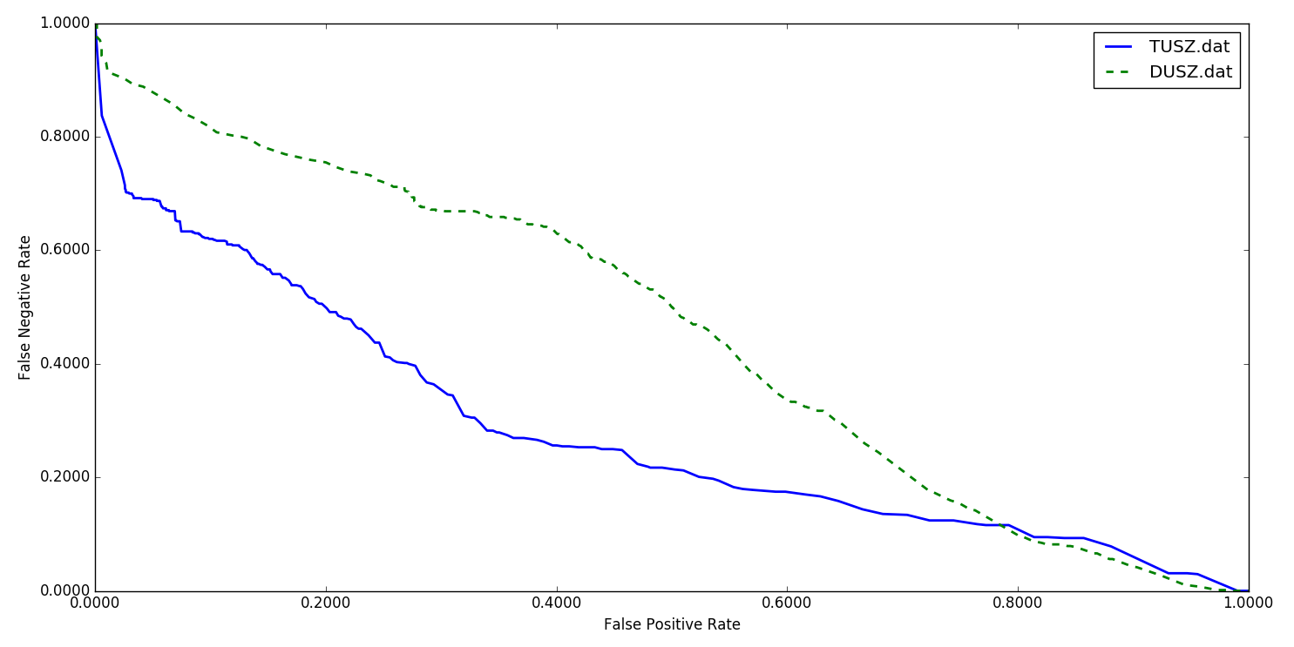Figure 25. A performance comparison of TUSZ and DUSZ

Table 10. A comparison of CNN and LSTM architectures on DUSZ and TUSZFigure 25. A performance comparison of TUSZ and DUSZ

Table 10. A comparison of CNN and LSTM architectures on DUSZ and TUSZ
System | Data | Sensitivity | Specificity | FA/24 Hrs.
CNN/LSTM | TUSZ | 30.83% | 97.10% | 6
CNN/LSTM | DUSZ | 33.71% | 70.72% | 40

Table 11. Comparison of optimization algorithmsTable 10. A comparison of CNN and LSTM architectures on DUSZ and TUSZFigure 25. A performance comparison of TUSZ and DUSZ

Table 10. A comparison of CNN and LSTM architectures on DUSZ and TUSZFigure 25. A performance comparison of TUSZ and DUSZ

Optimization of Core Components
Throughout these experiments, we observed that the choice of optimization method had a considerable impact on performance. The CNN/LSTM system was evaluated using a variety of optimization methods, including Stochastic gradient descent (SGD) (Kingma et al., 2015), RMSprop (Zaheer et al., 2018), Adagrad (Wilson et al., 2017), Adadelta (Zaheer et al., 2018), Adam (Kingma et al., 2015), Adamax (Kingma et al., 2015) and Nadam (Zaheer et al., 2018). These results are shown in Table 11. The best performance is achieved with Adam, a learning rate of $α=0.0005$, a learning rate decay of 0.0001, exponential decay rates of $β_{1}=0.9 and β_{2}=0.999$for the moment estimates and a fuzz factor of $ϵ={10}^{-8}$. The parameters follow the notation described in (Kingma et al., 2015). Table 11 also illustrates that Nadam delivers comparable performance to Adam. Adam combines the advantages of AdaGrad which works well with sparse gradients, and RMSProp which works well in non-stationary settings.
Table 10. A comparison of CNN and LSTM architectures on DUSZ and TUSZ
System | Data | Sensitivity | Specificity | FA/24 Hrs.
CNN/LSTM | TUSZ | 30.83% | 97.10% | 6
CNN/LSTM | DUSZ | 33.71% | 70.72% | 40

Table 11. Comparison of optimization algorithmsTable 10. A comparison of CNN and LSTM architectures on DUSZ and TUSZ
System | Data | Sensitivity | Specificity | FA/24 Hrs.
CNN/LSTM | TUSZ | 30.83% | 97.10% | 6
CNN/LSTM | DUSZ | 33.71% | 70.72% | 40

Table 11. Comparison of optimization algorithms
System | Sensitivity | Specificity | FA/24 Hrs.
SGD | 23.12% | 72.24% | 44
RMSprop | 25.17% | 83.39% | 23
Adagrad | 26.42% | 80.42% | 31
Adadelta | 26.11% | 79.14% | 33
Adam | 30.83% | 97.10% | 6
Adamax | 29.25% | 89.64% | 18
Nadam | 30.27% | 92.17% | 14
SGD | 23.12% | 72.24% | 44

Table 12. A comparison of activation functionsTable 11. Comparison of optimization algorithmsTable 10. A comparison of CNN and LSTM architectures on DUSZ and TUSZ
System | Data | Sensitivity | Specificity | FA/24 Hrs.
CNN/LSTM | TUSZ | 30.83% | 97.10% | 6
CNN/LSTM | DUSZ | 33.71% | 70.72% | 40

Table 11. Comparison of optimization algorithmsTable 10. A comparison of CNN and LSTM architectures on DUSZ and TUSZ
System | Data | Sensitivity | Specificity | FA/24 Hrs.
CNN/LSTM | TUSZ | 30.83% | 97.10% | 6
CNN/LSTM | DUSZ | 33.71% | 70.72% | 40

Table 11. Comparison of optimization algorithms
System | Sensitivity | Specificity | FA/24 Hrs.
SGD | 23.12% | 72.24% | 44
RMSprop | 25.17% | 83.39% | 23
Adagrad | 26.42% | 80.42% | 31
Adadelta | 26.11% | 79.14% | 33
Adam | 30.83% | 97.10% | 6
Adamax | 29.25% | 89.64% | 18
Nadam | 30.27% | 92.17% | 14
SGD | 23.12% | 72.24% | 44

Table 12. A comparison of activation functionsTable 11. Comparison of optimization algorithms
System | Sensitivity | Specificity | FA/24 Hrs.
SGD | 23.12% | 72.24% | 44
RMSprop | 25.17% | 83.39% | 23
Adagrad | 26.42% | 80.42% | 31
Adadelta | 26.11% | 79.14% | 33
Adam | 30.83% | 97.10% | 6
Adamax | 29.25% | 89.64% | 18
Nadam | 30.27% | 92.17% | 14
SGD | 23.12% | 72.24% | 44

Table 12. A comparison of activation functions
System | Sensitivity | Specificity | FA/24 Hrs.
Linear | 26.46% | 88.48% | 25
Tanh | 26.53% | 89.17% | 21
Sigmoid | 28.63% | 90.08% | 19
Softsign | 30.05% | 90.51% | 18
ReLU | 30.51% | 94.74% | 11
ELU | 30.83% | 97.10% | 6

Table 13. A comparison of initialization methodsTable 12. A comparison of activation functionsTable 11. Comparison of optimization algorithms
System | Sensitivity | Specificity | FA/24 Hrs.
SGD | 23.12% | 72.24% | 44
RMSprop | 25.17% | 83.39% | 23
Adagrad | 26.42% | 80.42% | 31
Adadelta | 26.11% | 79.14% | 33
Adam | 30.83% | 97.10% | 6
Adamax | 29.25% | 89.64% | 18
Nadam | 30.27% | 92.17% | 14
SGD | 23.12% | 72.24% | 44

Table 12. A comparison of activation functionsTable 11. Comparison of optimization algorithms
System | Sensitivity | Specificity | FA/24 Hrs.
SGD | 23.12% | 72.24% | 44
RMSprop | 25.17% | 83.39% | 23
Adagrad | 26.42% | 80.42% | 31
Adadelta | 26.11% | 79.14% | 33
Adam | 30.83% | 97.10% | 6
Adamax | 29.25% | 89.64% | 18
Nadam | 30.27% | 92.17% | 14
SGD | 23.12% | 72.24% | 44

Similarly, we evaluated our CNN/LSTM using different activation functions, as shown in Table 12. ELU delivers a small but measurable increase in sensitivity, and more importantly, a reduction in false alarms. The ELU activation function is defined in Section 3.1.3. ELU is very similar to ReLU except for negative inputs. ReLUs and ELUs accelerate learning by decreasing the gap between the normal gradient and the unit natural gradient (Clevert et al., 2017). ELUs push the mean towards zero but with a significantly smaller computational footprint. In the region where the input is negative $(x<0)$, since an ReLU’s gradient is zero, the weights will not get adjusted. Those neurons which connect into that state will stop responding to variations in error or input. This is referred to as the dying ReLU problem. But unlike ReLUs, ELUs have a clear saturation plateau in their negative region, allowing them to learn a more robust and stable representation.
Table 12. A comparison of activation functions
System | Sensitivity | Specificity | FA/24 Hrs.
Linear | 26.46% | 88.48% | 25
Tanh | 26.53% | 89.17% | 21
Sigmoid | 28.63% | 90.08% | 19
Softsign | 30.05% | 90.51% | 18
ReLU | 30.51% | 94.74% | 11
ELU | 30.83% | 97.10% | 6

Table 13. A comparison of initialization methodsTable 12. A comparison of activation functions
System | Sensitivity | Specificity | FA/24 Hrs.
Linear | 26.46% | 88.48% | 25
Tanh | 26.53% | 89.17% | 21
Sigmoid | 28.63% | 90.08% | 19
Softsign | 30.05% | 90.51% | 18
ReLU | 30.51% | 94.74% | 11
ELU | 30.83% | 97.10% | 6

Table 13. A comparison of initialization methods
System | Sensitivity | Specificity | FA/24 Hrs.
Orthogonal | 30.8% | 96.9% | 7
Lecun Uniform | 30.3% | 96.5% | 8
Glorot Uniform | 31.0% | 94.2% | 13
Glorot Normal | 29.5% | 92.4% | 18
Variance Scaling | 31.8% | 92.1% | 19
Lecun Normal | 31.8% | 92.1% | 19
He Normal | 31.3% | 91.1% | 22
Random Uniform | 30.2% | 90.0% | 25
Truncated Normal | 31.6% | 87.8% | 31
He Uniform | 29.2% | 85.1% | 40

Table 13. A comparison of initialization methodsTable 12. A comparison of activation functions
System | Sensitivity | Specificity | FA/24 Hrs.
Linear | 26.46% | 88.48% | 25
Tanh | 26.53% | 89.17% | 21
Sigmoid | 28.63% | 90.08% | 19
Softsign | 30.05% | 90.51% | 18
ReLU | 30.51% | 94.74% | 11
ELU | 30.83% | 97.10% | 6

Table 13. A comparison of initialization methodsTable 12. A comparison of activation functions
System | Sensitivity | Specificity | FA/24 Hrs.
Linear | 26.46% | 88.48% | 25
Tanh | 26.53% | 89.17% | 21
Sigmoid | 28.63% | 90.08% | 19
Softsign | 30.05% | 90.51% | 18
ReLU | 30.51% | 94.74% | 11
ELU | 30.83% | 97.10% | 6

Determining the proper initialization strategy for the parameters in the model is part of the difficulty in training. Hence, we investigated a variety of initialization methods using the CNN/LSTM structure introduced in Figure 16. These results are presented in Table 13. The related DET curve is illustrated in Figure 26. In our experiments, we observed that proper initialization of weights in a convolutional recurrent neural network is critical to convergence. For example, initialization of tensor values to zero or one completely stalled the convergence process. Also, as we can see in Table 13, the FA rate of the system in the range of 30% sensitivity can change from 7 to 40, for different initialization methods. This decrease in performance and deceleration of convergence arises because some initializations can result in the deeper layers receiving inputs with small variances, which in turn slows down back propagation, and retards the overall convergence process.
Table 13. A comparison of initialization methods
System | Sensitivity | Specificity | FA/24 Hrs.
Orthogonal | 30.8% | 96.9% | 7
Lecun Uniform | 30.3% | 96.5% | 8
Glorot Uniform | 31.0% | 94.2% | 13
Glorot Normal | 29.5% | 92.4% | 18
Variance Scaling | 31.8% | 92.1% | 19
Lecun Normal | 31.8% | 92.1% | 19
He Normal | 31.3% | 91.1% | 22
Random Uniform | 30.2% | 90.0% | 25
Truncated Normal | 31.6% | 87.8% | 31
He Uniform | 29.2% | 85.1% | 40

Table 13. A comparison of initialization methods
System | Sensitivity | Specificity | FA/24 Hrs.
Orthogonal | 30.8% | 96.9% | 7
Lecun Uniform | 30.3% | 96.5% | 8
Glorot Uniform | 31.0% | 94.2% | 13
Glorot Normal | 29.5% | 92.4% | 18
Variance Scaling | 31.8% | 92.1% | 19
Lecun Normal | 31.8% | 92.1% | 19
He Normal | 31.3% | 91.1% | 22
Random Uniform | 30.2% | 90.0% | 25
Truncated Normal | 31.6% | 87.8% | 31
He Uniform | 29.2% | 85.1% | 40

Table 13. A comparison of initialization methods
System | Sensitivity | Specificity | FA/24 Hrs.
Orthogonal | 30.8% | 96.9% | 7
Lecun Uniform | 30.3% | 96.5% | 8
Glorot Uniform | 31.0% | 94.2% | 13
Glorot Normal | 29.5% | 92.4% | 18
Variance Scaling | 31.8% | 92.1% | 19
Lecun Normal | 31.8% | 92.1% | 19
He Normal | 31.3% | 91.1% | 22
Random Uniform | 30.2% | 90.0% | 25
Truncated Normal | 31.6% | 87.8% | 31
He Uniform | 29.2% | 85.1% | 40

Table 13. A comparison of initialization methods
System | Sensitivity | Specificity | FA/24 Hrs.
Orthogonal | 30.8% | 96.9% | 7
Lecun Uniform | 30.3% | 96.5% | 8
Glorot Uniform | 31.0% | 94.2% | 13
Glorot Normal | 29.5% | 92.4% | 18
Variance Scaling | 31.8% | 92.1% | 19
Lecun Normal | 31.8% | 92.1% | 19
He Normal | 31.3% | 91.1% | 22
Random Uniform | 30.2% | 90.0% | 25
Truncated Normal | 31.6% | 87.8% | 31
He Uniform | 29.2% | 85.1% | 40

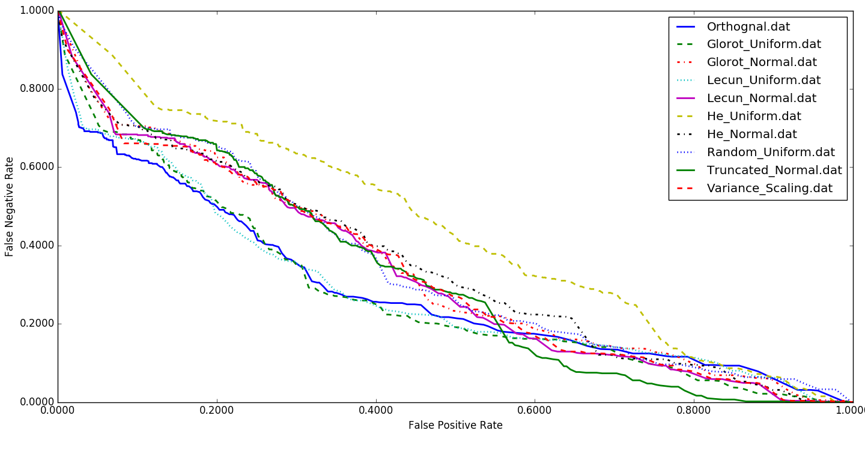Figure 26. A comparison of different initialization methods for CNN/LSTM

Table 14. A comparison of performance for different regularizationsFigure 26. A comparison of different initialization methods for CNN/LSTM

Table 14. A comparison of performance for different regularizations
System | Sensitivity | Specificity | FA/24 Hrs.
L1/L2 | 30.8% | 97.1% | 6
Dropout | 30.8% | 96.9% | 7
Gaussian | 30.8% | 95.8% | 9
L2 | 30.2% | 95.6% | 10
L1 | 30.0% | 43.7% | 276

Table 14. A comparison of performance for different regularizationsFigure 26. A comparison of different initialization methods for CNN/LSTM

Table 14. A comparison of performance for different regularizationsFigure 26. A comparison of different initialization methods for CNN/LSTM
Best performance is achieved using orthogonal initialization (Zaheer et al., 2018). This method is a simple yet effective way of combatting exploding and vanishing gradients. In orthogonal initialization, the weight matrix is chosen as a random orthogonal matrix, i.e., a square matrix $W$ for which $W^{T}W=I$. Typically, the orthogonal matrix is obtained from the QR decomposition of a matrix of random numbers drawn from a normal distribution. Orthogonal matrices preserve the norm of a vector ‎and their eigenvalues have an absolute value of one. This means that no matter how many times we perform repeated matrix multiplication, the resulting matrix doesn't explode or vanish. Also, in orthogonal matrices, columns and rows are all orthonormal to one another, which helps the weights to learn different input features. For example, if we apply orthogonal initialization on a CNN architecture, in each layer, each channel has a weight vector that is orthogonal to the weight vectors of the other channels.
Table 14. A comparison of performance for different regularizations
System | Sensitivity | Specificity | FA/24 Hrs.
L1/L2 | 30.8% | 97.1% | 6
Dropout | 30.8% | 96.9% | 7
Gaussian | 30.8% | 95.8% | 9
L2 | 30.2% | 95.6% | 10
L1 | 30.0% | 43.7% | 276

Table 14. A comparison of performance for different regularizations
System | Sensitivity | Specificity | FA/24 Hrs.
L1/L2 | 30.8% | 97.1% | 6
Dropout | 30.8% | 96.9% | 7
Gaussian | 30.8% | 95.8% | 9
L2 | 30.2% | 95.6% | 10
L1 | 30.0% | 43.7% | 276

Table 14. A comparison of performance for different regularizations
System | Sensitivity | Specificity | FA/24 Hrs.
L1/L2 | 30.8% | 97.1% | 6
Dropout | 30.8% | 96.9% | 7
Gaussian | 30.8% | 95.8% | 9
L2 | 30.2% | 95.6% | 10
L1 | 30.0% | 43.7% | 276

Table 14. A comparison of performance for different regularizations
System | Sensitivity | Specificity | FA/24 Hrs.
L1/L2 | 30.8% | 97.1% | 6
Dropout | 30.8% | 96.9% | 7
Gaussian | 30.8% | 95.8% | 9
L2 | 30.2% | 95.6% | 10
L1 | 30.0% | 43.7% | 276

Overfitting is a serious problem in deep neural nets with many parameters. We have explored five popular regularization methods to address this problem. These techniques are L1, L2, L1/L2, dropout and zero-centered Gaussian noise (Goodfellow et al., 2016). All of these regularization techniques are explained in Section 3.1.5. The results of these experiments are presented in Table 14 along with a DET curve in Figure 27. While L1/L2 regularization has the best overall performance, in the region where FA rates are low, the dropout method delivers a lower FA rate. The primary error modalities observed were false alarms generated during brief delta range slowing patterns such as intermittent rhythmic delta activity (von Weltin et al., 2017). Our closed-loop experiments demonstrated that all regularization methods presented in Table 14, unfortunately, tend to increase the false alarm rate for slowing patterns.
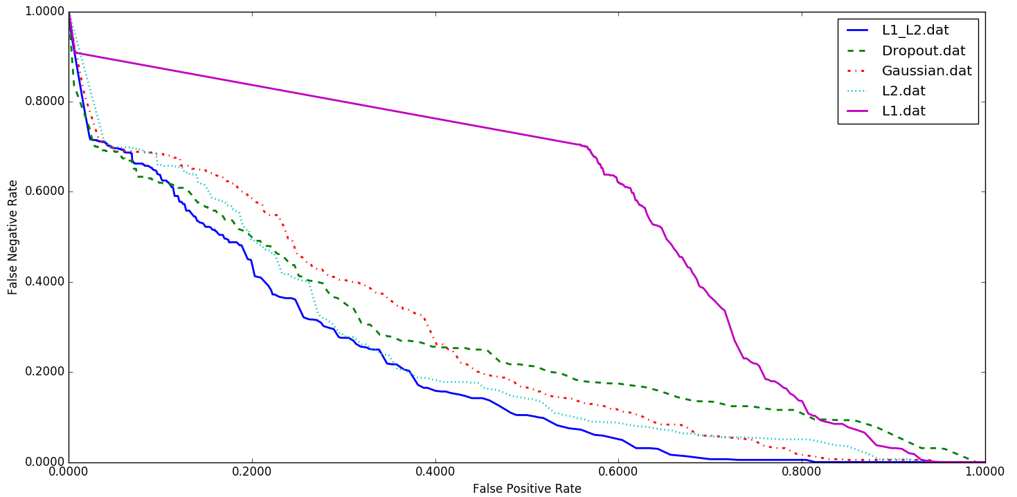Figure 27. A comparison of different regularization methods for CNN/LSTM.

Figure 27. A comparison of different regularization methods for CNN/LSTM.

Figure 27. A comparison of different regularization methods for CNN/LSTM.

Figure 27. A comparison of different regularization methods for CNN/LSTM.
Finally, in Figure 28, an example of an EEG that is generated by the DCGAN structure of Figure 9 is shown. Note that to generate these EEGs, we use a generator block in DCGAN in which each EEG signal has a 7 sec duration. We apply a 25 Hz low pass filter on the output of DCGAN, since most of the cerebral signals observed in scalp EEGs fall in the range of 1–20 Hz (in standard clinical recordings, activity below or above this range is likely to be an artifact). Unfortunately, in a simple pilot experiment in which we randomly mixed actual EEGs with synthetic EEGs, expert annotators could easily detect the synthetic EEGs, which was a bit discouraging. Seizures in the synthetic EEGs were sharper and more closely resembled a slowing event. Clearly, more work is needed with this architecture.
However, our expert annotators also noted that the synthetic EEGs did exhibit focality. An example of focality is when activity is observed on the CZ-C4 channel, we would expect to observe the inverse of this pattern on the C4-T4 channel. As can be seen in Figure 28, in last two seconds of the generated EEG, we observe slowing activity on the CZ-C4 channel and the inverse pattern of the same slowing activity on the C4-T4 channel. Hence, it is possible to generate synthetic multi-channel EEG signals with DCGAN that resemble clinical EEGs. However, DCGAN is not yet at the point where it is generating data that is resulting in an improvement in the performance of our best systems.
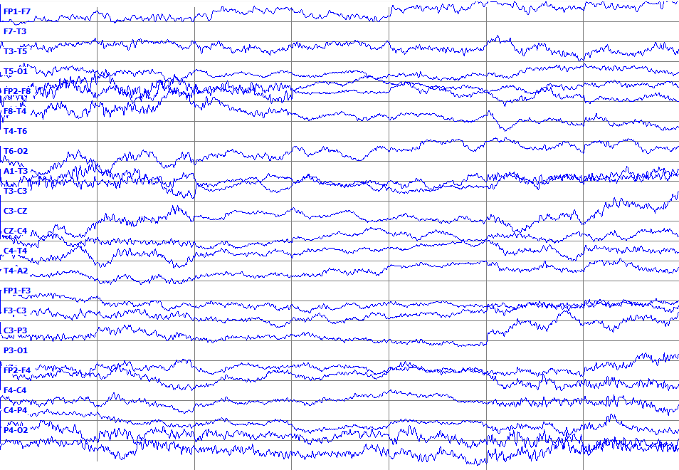
Figure 28. Synthetic EEG waveforms generated using DCGAN

CHAPTER 7

FUTURE WORK
In previous chapters, we introduced a variety of deep learning architectures for automatic classification of EEGs and we investigated what the impact of deep learning design choices are on the performance. We discussed the overall network architecture and other critical design choices such as the optimization method. To complete this dissertation work, we need to address three more questions:
- What do deep learning architectures learn from EEG datasets? Despite the fact that these deep learning architectures perform better than our previous HMM-based systems, we do not have much insight into the internal behavior of these complex models, such as how do they achieve such good performance. The main goal in our future work is to gain insight into the behavior of these structures using visualization tools.
- What is the benefit of training on “crops”? Currently, our training strategy for a system like CNN/LSTM is to train on the entire seizure event and to use a comparable amount of background data. The reason behind sampling background is to have a balanced dataset. In an alternative training strategy, we can train a system on multiple crops of the data. Using multiple crops is promising since it increases the amount of training examples by generating time-shifted variants of the original data. Using multiple crops has become standard procedure for CNNs on image recognition tasks (He et al., 2015). Our goal is examining the usefulness of cropped training in automatic analysis of EEGs.
- What is the benefit of training on different EEG datasets? We have presented results on seizure detection for two datasets: DUSZ and TUSZ. We have acquired another EEG dataset from Emory University which we refer to as EUSZ. We will investigate how performance varies when we have mismatched conditions (e.g., train on TUSZ, evaluate on EUSZ). We will investigate what the system has learned differently our visualization techniques developed previously and hopefully better understand the critical elements of a high-performance seizure detection system.
In the following sections, we will present our detailed plans for these tasks.

Problem Statement
Classification performance and interpretability are important aspects of a machine learning model. Generally, there is a trade-off between interpretability and classification performance. Deep learning architectures have long been known as “black boxes” because it is difficult to understand exactly how any particular, trained deep neural network functions due to the large number of interacting, nonlinear parts. In previous chapters, we introduced a variety of deep learning architectures for automatic classification of EEGs. Our results showed that a deep recurrent convolutional architecture for two-dimensional decoding of EEG signals that integrates 2D CNNs, 1D CNNs and LSTM networks has better performance than other deep architectures. However, our understanding of how these models work, especially what computations they perform at intermediate layers, needs more exploration. In the healthcare domain, it is critical for medical doctors and researchers that use these models to understand how the models make predictions or classifications in such acute situations. In this chapter, we introduce visualization techniques that reveal the input stimuli that excite individual feature maps at any layer in our models. These techniques also allow us to observe the evolution of features during training and to diagnose potential problems with the models.

Related Work
Despite the demonstrated excellent performance of deep learning structures in a variety of domains. there is still little insight into the internal operation and behavior of these complex models, or how they achieve such good performance. (Cashman et al., 2018). Without clear understanding of how and why they work, the development of better models is reduced to trial-and-error.
In the case of CNNs, visualizing features to gain intuition about the network is common practice, but mostly limited to the first layer where projections to the pixel space are possible. In higher layers, alternate methods must be used (Qin et al., 2018). For example, (Erhan et al., 2009) finds the optimal stimulus for each unit by performing gradient descent in the image space to maximize the unit’s activation. This requires a careful initialization and does not give any information about the unit’s invariances. Le et al. (2010) show how the Hessian of a given unit may be computed numerically around the optimal response, giving some insight into invariances. The problem is that for higher layers, the invariances are extremely complex and are poorly captured by a simple quadratic approximation. Zeiler et al. (2014) proposes a visualization technique that uses a multi-layered Deconvolutional Network (deconvnet) to project the feature activations back to the input pixel space. Their approach provides a non-parametric view of invariance, showing which patterns from the training set activate the feature map. This method demonstrates how saliency maps can be obtained from a convolutional network by projecting back from the fully connected layers of the network, instead of the convolutional features that they use.
In case of recurrent neural networks, models that use LSTM, perform more complex operations on data, which are less interpretable than CNN-based models. (Li et al., 2016) visualized RNN embedding vectors to show how RNNs achieve compositionality in natural language for sentiment analysis as well as visualizing the influence of input words on classification. Karpathy et al. (2015) analyzed the interpretability of RNNs for language modeling, demonstrating the existence of interpretable neurons which are able to focus on specific language structures such as quotation marks in text. Lanchantin et al. (2015) explored inference of important local sequences of DNA for classification based on what is salient for the DNN models. In both the text-based studies, the aim was to improve the understanding of LSTMs based on knowledge of the structured language. In the DNA-based study, as with medicine in general, we are uncertain about the underlying biological processes and DNNs can play a vital role in illuminating new assertions.
Cashman et al. (2018) employs techniques used in CNNs to elucidate the operations that LSTMs perform on time series. The visualization techniques include input saliency by means of occlusion and derivatives, class mode visualization, and temporal outputs. Moreover, it demonstrates that LSTMs appear to extract features similar to those extracted by wavelets. Their approach is to find a signal processing intuition for the analysis performed by LSTMs with a specific focus on interpretability for the medical field. This is achieved by demonstrating that the first layer of an LSTM learns filters such as the wavelet transform to extract features from signals, and depicting what LSTMs focus on when analyzing time series by means of first derivatives, class mode visualization, sequence propagation, and occlusion filters.

Proposed Approach
In this chapter, we discuss the plans for feature visualization that we will use to gain insights into our designed model. We will explore what these models learn. The aim of our work is to contribute both to a better understanding of the important underlying biological processes, when making medical predictions, and to broaden the understanding of CNNs and LSTMs, by means of EEG dataset.
In first step, we will start with deep 2D convolutional neural network structure that has been presented in Section 3.2. We want to delineate what EEG features, the CNN/MLP structure used, and in which layers it extracted these features. We will use two methods for feature visualization to gain insights into what CNN/MLP learns from EEGs.
In first method, we concentrate on using domain-specific prior knowledge, and investigating whether known class-discriminative features are learned by CNN/MLP. Then, it is possible to compute a feature value, for all receptive fields of all individual units, for each of these class-discriminative features, and to measure how much this feature affects the unit output. One approach can be computing the correlation between feature values and unit outputs. For example, one of the most widely used method to analyze EEG data is to decompose the signal into functionally distinct frequency bands, such as delta (0.5–4 Hz), theta (4–8 Hz), alpha (8–12 Hz), beta (12–30 Hz), and gamma (30–100 Hz). In consultation with our EEG experts, we will develop hypotheses on which band power features are discriminative for seizure detection. Next, we focus on these band power features as a target for visualizations. Then we will gain insights into CNN/MLP behavior, e.g., what EEG features the CNN/MLP uses to detect seizures.
In this spirit, we propose input-feature unit-output correlation maps as a method to visualize how networks learn spectral features. To select discriminative features for accurate and reliable seizure detection, understanding of characteristics of seizure by phase change is a critical issue on early seizure detection. In a common approach, the ictal phases are divided into ictal onset, ictal established and late ictal periods (Lee et al., 2017). The ictal onset phase was characterized by relatively prominent beta activity apparent. The late ictal phase was characterized by prominent gamma frequency band (Lee et al., 2017). By developing such hypotheses, we will investigate the performance of CNN/MLP in detecting different phases of seizures in different frequency bands.
Our first method can be used to show how much information about a specific feature is retained in CNN/MLP in different layers; however, it does not evaluate whether the feature causally affects the CNN/MLP outputs. Therefore, we design our second method to directly investigate causal effects of the feature values on the CNN/MLP outputs. For example, to investigate the causal effect of changes in power on CNN/MLP, we will study changes in the CNN/MLP predictions with changes in amplitudes by perturbing the original trial amplitudes. We will transform all training trials into the frequency domain by a Fourier transformation. Then we will randomly perturb the amplitudes by adding Gaussian noise (with mean 0 and variance 1) to them. The phases will be kept unperturbed. After the perturbation, we will retransform them to the time domain by the inverse Fourier transformation. We will compute predictions of the CNN/MLP for these trials before and after the perturbation.
With these kind of visualization methods, it is possible to derive conclusions that either show how much information about the band power in different frequency bands is retained in the outputs of the trained CNN/MLP and how much they affect its output. Then we will apply the same methods to other structures such as CNN/LSTM. Through these approaches, for example, we can compare the output of visualization of a long feature that we detected correctly with a long feature that we missed and find why we missed the second one. As we mentioned before, the primary error modalities observed were false alarms generated during brief delta range slowing patterns such as intermittent rhythmic delta activity. Using these approaches, we can compare the output of visualizations modules for these artifacts with seizures and explain why we detect these artifacts as seizures.

CHAPTER 8

Research plan
Dec 15 - Dec 31:
- Run experiments using the existing visualization algorithms for image recognition tasks.
- Train CNN/LSTM on new version of TUSZ and report results on TUSZ and DUSZ.
- Start preparing cropped TUSZ training dataset.
Jan 1 - Jan 15:
- In consultation with our EEG experts, we will develop hypotheses that which band power features (or other features) are discriminative for seizure detection task. In this process, we can validate ideas such as focusing on the band power features as a target for visualizations. In other word, in this step, we design class-discriminative features using domain-specific prior knowledge, for seizure detection task.
- Train CNN/LSTM on TUSZ and evaluate on EUSZ dataset.
- Continue preparing cropped TUSZ training dataset.
Jan 15 - Jan 31:
- Start data preparation, necessary for visualization experiments, for seizure detection task, based on designed class discriminative features.
- Train CNN/LSTM on DUSZ and evaluate on EUSZ and TUSZ dataset.
- Start running experiments on cropped TUSZ experiments.
Feb 1 - Feb 15:
- Start designing visualization algorithm for seizure detection task, based on class discriminative features.
- Train CNN/LSTM on EUSZ and evaluate on DUSZ and TUSZ dataset.
- Diagnose and debug problems related to the cropped TUSZ experiments.
Feb 15 - Feb 30:
- Diagnose and debug problems related to the visualization experiments.
- Wrap up the comparison of training on TUSZ vs. DUSZ and EUSZ.
- Wrap up the experiments using cropped dataset.
March 1 - March 15:
- Start analysis of different trials using visualization experiments.
- Write down the results of training on TUSZ vs. DUSZ and EUSZ.
- Write down the results of training on cropped dataset.
March 16 -March 30:
- Wrap up visualization experiments.
April 1 - April 15:
- Write down the results of visualization experiments.
- Finalize the draft of the dissertation.

REFERENCES
Ahmedt-Aristizabal, D., Fookes, C., Denman, S., Nguyen, K., Sridharan, S., & Dionisio, S. (2019). Aberrant epileptic seizure identification: A computer vision perspective. Seizure: European Journal of Epilepsy, 65, 65-71. https://doi.org/10.1016/j.seizure.2018.12.017.
Alphonso, I., & Picone, J. (2004). Network Training for Continuous Speech Recognition. Proceedings of the 12th European Signal Processing Conference, 553-556. ﻿https://ieeexplore.ieee.org/document/7080023.
American Clinical Neurophysiology Society. (2012). ACNS Standardized ICU EEG Nomenclature v. 2012. https://www.acns.org/pdf/guidelines/Guideline-14-pocket-version.pdf.
Baldassano, S., Wulsin, D., Ung, H., Blevins, T., Brown, M.-G., Fox, E., & Litt, B. (2016). A novel seizure detection algorithm informed by hidden Markov model event states. Journal of Neural Engineering, 13(3), 036011. https://doi.org/10.1088/1741-2560/13/3/036011.
Bastien, F., Lamblin, P., Pascanu, R., Bergstra, J., Goodfellow, I., Bergeron, A., … Bengio, Y. (2012). Theano: new features and speed improvements. Neural Information Processing Systems (NIPS), 1-10. http://arxiv.org/abs/1211.5590.
Baumgartner, C., & Koren, J. P. (2018). Seizure detection using scalp-EEG. Epilepsia, 59(S1), 14-22. https://doi.org/10.1111/epi.14052.
Baumgartner, C., Koren, J. P., & Rothmayer, M. (2018). Automatic Computer-Based Detection of Epileptic Seizures. Frontiers in Neurology, 9, 639. https://doi.org/10.3389/fneur.2018.00639.
Bengio, Y., Lamblin, P., Popovici, D., & Larochelle, H. (2006). Greedy Layer-Wise Training of Deep Networks. Advances in Neural Information Processing Systems 20 (NIPS), 153-160. ﻿https://papers.nips.cc/paper/3048-greedy-layer-wise-training-of-deep-networks.pdf.
Bergstra, J., Breuleux, O., Bastien, F., Lamblin, P., Pascanu, R., Desjardins, G., … Bengio, Y. (2010). Theano: a CPU and GPU Math Expression Compiler. Proceedings of the Python for Scientific Computing Conference (SciPy), 1-7. http://conference.scipy.org/proceedings/scipy2010/bergstra.html.
Biasiucci, A., Franceschiello, B., & Murray, M. M. (2019). Electroencephalography. Current Biology, 29(3), R80-R85. https://doi.org/10.1016/J.CUB.2018.11.052.
Bishop, C. (2011). Pattern Recognition and Machine Learning (2nd ed.). New York, New York, USA: Springer. https://www.springer.com/us/book/9780387310732.
Bonaccorso, G. (2017). Machine Learning Algorithms: A Reference Guide to Popular Algorithms for Data Science and Machine Learning. https://www.packtpub.com/big-data-and-business-intelligence/machine-learning-algorithms.
Capp, N., Krome, E., Obeid, I., & Picone, J. (2017). Facilitating the annotation of seizure events through an extensible visualization tool. In I. Obeid & J. Picone (Eds.), Proceedings of the IEEE Signal Processing in Medicine and Biology Symposium (p. 1). Philadelphia, Pennsylvania, USA: IEEE. https://doi.org/10.1109/SPMB.2017.8257043.
Cardot, H., & Degras, D. (2017). Online Principal Component Analysis in High Dimension: Which Algorithm to Choose? International Statistical Review, 86(1), 29-50. https://doi.org/10.1111/insr.12220.
Cashman, D., Patterson, G., Mosca, A., Watts, N., Robinson, S., & Chang, R. (2018). RNNbow: Visualizing Learning Via Backpropagation Gradients in RNNs. IEEE Computer Graphics and Applications, 38(6), 39-50. https://doi.org/10.1109/MCG.2018.2878902.
Cheng, J., Dong, L., & Lapata, M. (2016). Long Short-Term Memory-Networks for Machine Reading. Proceedings of the 2016 Conference on Empirical Methods in Natural Language Processing, 551-561. https://doi.org/10.18653/v1/d16-1053.
Cho, K., Merrienboer, B. Van, Gulcehre, C., Bahdanau, D., Bougares, F., Schwenk, H., & Bengio, Y. (2014). Learning Phrase Representations using RNN Encoder-Decoder for Statistical Machine Translation. Proceedings of the 2014 Conference on Empirical Methods in Natural Language Processing (EMNLP), 1724-1734. https://doi.org/10.3115/v1/D14-1179.
Cho, O. M., Kim, H., Lee, Y. W., & Cho, I. (2016). Clinical alarms in intensive care units: Perceived obstacles of alarm management and alarm fatigue in nurses. Healthcare Informatics Research, 22(1), 46-53. https://doi.org/10.4258/hir.2016.22.1.46.
Clevert, D., Unterthiner, T., & Hochreiter, S. (2016). Fast and Accurate Deep Network Learning by Exponential Linear Units (ELUs). Proceedings of the International Conference on Learning Representations (ICLR) (pp. 1-14). San Juan, Puerto Rico. https://scinapse.io/papers/2176412452.
Cohen, J. F., Korevaar, D. A., Altman, D. G., Bruns, D. E., Gatsonis, C. A., Hooft, L., … Bossuyt, P. M. M. (2016). STARD 2015 guidelines for reporting diagnostic accuracy studies: explanation and elaboration. BMJ Open, 6(11), e012799. https://doi.org/10.1136/bmjopen-2016-012799.
Eichler, M., Dahlhaus, R., & Dueck, J. (2017). Graphical Modeling for Multivariate Hawkes Processes with Nonparametric Link Functions. Journal of Time Series Analysis, 38(2), pp.225-242. https://onlinelibrary.wiley.com/doi/full/10.1111/jtsa.12213.
Ercegovac, M., & Berisavac, I. (2015). Importance of EEG in intensive care unit. Clinical Neurophysiology, 126(9), e178-e179. https://doi.org/10.1016/j.clinph.2015.04.027.
Erhan, D., Bengio, Y., Courville, A., & Vincent, P. (2009). Visualizing higher-layer features of a deep network. In Technical Report, University of Montreal, 1-13. http://www.iro.umontreal.ca/~lisa/publications2/index.php/publications/show/247.
Fiscus, J. G., & Chen, N. (2013). IEEE Speech and Language Processing Technical Committee. IEEE Signal Processing Society - SLTC Newsletter, pp. 1-3. https://tsapps.nist.gov/publication/get_pdf.cfm?pub_id=914517.
Fiscus, J., Ajot, J., Garofolo, J., & Doddingtion, G. (2007). Results of the 2006 Spoken Term Detection Evaluation. Proceedings of the SIGIR 2007 Workshop: Searching Spontaneous Conversational Speech. Amsterdam, Netherlands. https://doi.org/978-90-365-2542-8.
Goldberger, A. L., Amaral, L. A. N., Glass, L., Hausdorff, J. M., Ivanov, P. C., Mark, R. G., … Stanley, H. E. (2000). Physiobank, physiotoolkit, and physionet components of a new research resource for complex physiologic signals. Circulation, 101(23), e215-e220. http://circ.ahajournals.org/content/101/23/e215.short.
Golmohammadi, M., Harati Nejad Torbati, A., Lopez, S., Obeid, I., & Picone, J. (2019). Automatic Analysis of EEGs Using Big Data and Hybrid Deep Learning Architectures. Frontiers in Human Neuroscience, 13, 1-30. https://doi.org/10.3389/fnhum.2019.00076.
Golmohammadi, M., Ziyabari, S., Shah, V., Obeid, I., & Picone, J. (2017). Gated Recurrent Networks for Seizure Detection. I. Obeid & J. Picone (Eds.), Proceedings of the IEEE Signal Processing in Medicine and Biology Symposium (pp. 1-5). Philadelphia, Pennsylvania, USA: IEEE. https://doi.org/10.1109/SPMB.2017.8257020.
Golmohammadi, M., Ziyabari, S., Shah, V., Obeid, I., & Picone, J. (2018). Deep Architectures for Spatio-Temporal Modeling: Automated Seizure Detection in Scalp EEGs. Proceedings of the IEEE International Conference on Machine Learning and Applications (ICMLA), 745-750. ﻿https://ieeexplore.ieee.org/document/8614143.
Goodfellow, I. (2016). Generative Adversarial Networks. Advances in Neural Information Processing Systems 29 (NIPS), 1–86. ﻿https://media.nips.cc/Conferences/2016/Slides/6202-Slides.pdf.
Goodfellow, I., Bengio, Y., & Courville, A. (2016). Deep Learning (1st ed.). Cambridge, Massachusetts, USA: MIT Press. https://mitpress.mit.edu/books/deep-learning.
Gotman, J. (1982). Automatic recognition of epileptic seizures in the EEG. Electroencephalography and Clinical Neurophysiology, 54(5), 530-540. https://doi.org/10.1016/0013-4694(82)90038-4.
Gotman, J. (1999). Automatic detection of seizures and spikes. Journal of Clinical Neurophysiology: Official Publication of the American Electroencephalographic Society, 16(2), 130-140. https://journals.lww.com/clinicalneurophys/Abstract/1999/03000/Automatic_Detection_of_Seizures_and_Spikes.5.aspx.
Gotman, J., Flanagan, D., Zhang, J., & Rosenblatt, B. (1997). Automatic seizure detection in the newborn: Methods and initial evaluation. Electroencephalography and Clinical Neurophysiology, 103(3), 356-362. https://doi.org/10.1016/S0013-4694(97)00003-9.
Grunau, G., & Linn, S. (2018). Commentary: Sensitivity, Specificity, and Predictive Values: Foundations, Pliabilities, and Pitfalls in Research and Practice. Frontiers in Public Health. https://doi.org/10.3389/fpubh.2018.00256.
Haider, H. A., Esteller, R. D., Hahn, C. B., Westover, M. J., Halford, J. W., Lee, J. M., & LaRoche, S. (2016). Sensitivity of quantitative EEG for seizure identification in the intensive care unit. Neurology, 87(9), 935-944. https://doi.org/10.1212/WNL.0000000000003034.
Halford, J. J., Shiau, D., Desrochers, J. A., Kolls, B. J., Dean, B. C., Waters, C. G., … LaRoche, S. M. (2015). Inter-rater agreement on identification of electrographic seizures and periodic discharges in ICU EEG recordings. Clinical Neurophysiology, 126(9), 1661-1669. https://doi.org/10.1016/J.CLINPH.2014.11.008.
Hambling, B. (2013). User Acceptance Testing: A step-by-step guide. (P. van Goethem, Ed.), User Acceptance Testing. Swindon, United Kingdom: BCS Learning & Development Limited. https://www.amazon.com/User-Acceptance-Testing-Step-Step/dp/1780171676.
Hara, K., Saito, D., & Shouno, H. (2015). Analysis of function of rectified linear unit used in deep learning. Proceeding of International Joint Conference on Neural Networks (IJCNN), 1-8. https://doi.org/10.1109/IJCNN.2015.7280578.
Harati Nejad Torbati, A. H., Golmohammadi, M., Jacobson, M., Lopez, S., Obeid, I., Picone, J., & Tobochnik, S. (2016). Automatic Interpretation of EEGs for Clinical Decision Support. In American Clinical Neurophysiology Society (ACNS) Annual Meeting (p. 1). Orlando, Florida, USA. https://www.acns.org/UserFiles/file/AM16PosterAbstracts.pdf.
Harati, A., Golmohammadi, M., Lopez, S., Obeid, I., & Picone, J. (2015). Improved EEG Event Classification Using Differential Energy. I. Obeid & J. Picone (Eds.), Proceedings of the IEEE Signal Processing in Medicine and Biology Symposium (pp. 1-4). Philadelphia, Pennsylvania, USA. https://doi.org/10.1109/SPMB.2015.7405421.
Harati, A., Lopez, S., Obeid, I., Jacobson, M., Tobochnik, S., & Picone, J. (2014). The TUEG Corpus: A Big Data Resource for Automated EEG Interpretation. I. Obeid & J. Picone (Eds.), Proceedings of the IEEE Signal Processing in Medicine and Biology Symposium (pp. 1-5). Philadelphia, Pennsylvania, USA. https://doi.org/10.1109/SPMB.2014.7002953.
He, K., Zhang, X., Ren, S., & Sun, J. (2016). Deep Residual Learning for Image Recognition. In Proceedings of the IEEE Conference on Computer Vision and Pattern Recognition (CVPR) (pp. 770-778). Las Vegas, Nevada, USA. https://doi.org/10.1109/CVPR.2016.90.
Hindarto, H., Muntasa, A., & Sumarno, S. (2018). Feature Extraction ElectroEncephaloGram (EEG) using wavelet transform for cursor movement. IOP Conference Series: Materials Science and Engineering, 434, 12261. https://doi.org/10.1088/1757-899x/434/1/012261.
Hjelm, D., Fedorov, A., Lavoie-Marchildon, S., Grewal, K., Bachman, P., Trischler, A., & Bengio, Y. (2019). Learning deep representations by mutual information estimation and maximization. Proceedings of International Conference on Learning Representations (ICLR), 1-24. https://openreview.net/forum?id=Bklr3j0cK.
Huang, K., & Picone, J. (2002). Internet-Accessible Speech Recognition Technology. In Proceedings of the IEEE Midwest Symposium on Circuits and Systems (p. III-73-III-76). Tulsa, Oklahoma, USA. https://doi.org/10.1109/MWSCAS.2002.1186973.
Ilmoniemi, R., & Sarvas, J. (2019). Brain Signals: Physics and Mathematics of MEG and EEG (1st ed.). Boston, Massachusetts, USA: The MIT Press. https://mitpress.mit.edu/books/brain-signals.
Ioffe, S., & Szegedy, C. (2015). Batch Normalization: Accelerating Deep Network Training by Reducing Internal Covariate Shift. Proceedings of the International Conference on Machine Learning (ICML) (pp. 448-456). Lille, France. https://arxiv.org/abs/1502.03167.
Jacob, J. E., Nair, G. K., Iype, T., & Cherian, A. (2018). Diagnosis of Encephalopathy Based on Energies of EEG Subbands Using Discrete Wavelet Transform and Support Vector Machine. Neurology Research International. https://doi.org/10.1155/2018/1613456.
Jastrz, S., Kenton, Z., Arpit, D., Ballas, N., Fischer, A., Bengio, Y., & Storkey, A. (2018). Width of Minima Reached by Stochastic Gradient Descent is Influenced by Learning Rate to Batch Size Ratio. International Conference on Artificial Neural Networks (ICANN), 392-402. https://doi.org/https://doi.org/10.1007/978-3-030-01424-7_39.
Karpathy, A., Johnson, J., & Fei-Fei, L. (2015). Visualizing and Understanding Recurrent Networks. ArXiv, 1-13. https://doi.org/10.1007/978-3-319-10590-1_53.
Kemp, R. (2013). European Data Format. http://www.edfplus.info.
Kingma, D. P., & Ba, J. L. (2015). Adam: A Method for Stochastic Optimization. In Proceedings of the International Conference on Learning Representations (pp. 1-15). San Diego, California, USA. https://arxiv.org/abs/1412.6980.
Kubota, Y., Nakamoto, H., Egawa, S., & Kawamata, T. (2018). Continuous EEG monitoring in ICU. Journal of Intensive Care, 6(1), 39. https://doi.org/10.1186/s40560-018-0310-z.
Lanchantin, J., Singh, R., Wang, B., & Qi, Y. (2017). Deep motif dashboard: Visualizing and understanding genomic sequences using deep neural networks. Proceedings of Pacific Symposium on Biocomputing, 254-265. https://doi.org/10.1142/9789813207813_0025.
Lazarou, I., Nikolopoulos, S., Petrantonakis, P. C., Kompatsiaris, I., & Tsolaki, M. (2018). EEG-Based Brain-Computer Interfaces for Communication and Rehabilitation of People with Motor Impairment: A Novel Approach of the 21st Century. Frontiers in Human Neuroscience, 12, 14. https://doi.org/10.3389/fnhum.2018.00014.
LeCun, Y., Bengio, Y., & Hinton, G. (2015). Deep learning. Nature, 521(7553), 436-444. http://dx.doi.org/10.1038/nature14539%5Cn10.1038/nature14539.
Lee, J., Park, J., Yang, S., Kim, H., Choi, Y. S., Kim, H. J., Lee, B. U. (2017). Early seizure detection by applying frequency-based algorithm derived from the principal component analysis. Frontiers in Neuroinformatics, 11. https://doi.org/10.3389/fninf.2017.00052.
Li, J., Chen, X., Hovy, E., & Jurafsky, D. (2016). Visualizing and understanding neural models in NLP. Association for Computational Linguistics (ACL). https://doi.org/10.18653/v1/n16-1082.
Li, P., Wang, X., Li, F., Zhang, R., Ma, T., Peng, Y., … Xu, P. (2015). Autoregressive model in the Lp norm space for EEG analysis. Journal of Neuroscience Methods, 240, 170-178. https://doi.org/10.1016/j.jneumeth.2014.11.007.
Li, Y., Luo, M.-L., & Li, K. (2016). A multiwavelet-based time-varying model identification approach for time-frequency analysis of EEG signals. Neurocomputing, 193, 106-114. https://doi.org/10.1016/j.neucom.2016.01.062.
Liu, G., Su, Y., Liu, Y., Jiang, M., Zhang, Y., Zhang, Y., & Gao, D. (2016). Predicting Outcome in Comatose Patients: The Role of EEG Reactivity to Quantifiable Electrical Stimuli. Evidence-Based Complementary and Alternative Medicine, 2016, 1-7. ﻿https://doi.org/10.1155/2016/8273716.
Lopez, S. (2017). Automated Identification of Abnormal EEGs (Temple University). https://www.isip.piconepress.com/publications/ms_theses/2017/abnormal.
Lopez, S., Golmohammadi, M., Obeid, I., & Picone, J. (2016). An Analysis of Two Common Reference Points for EEGs. In I. Obeid & J. Picone (Eds.), Proceedings of the IEEE Signal Processing in Medicine and Biology Symposium (pp. 1-4). Philadelphia, Pennsylvania, USA. https://doi.org/10.1109/SPMB.2016.7846854.
Lu, S., & Picone, J. (2013). Fingerspelling Gesture Recognition Using A Two-Level Hidden Markov Model. Proceedings of the International Conference on Image Processing, Computer Vision, and Pattern Recognition (ICPV), 538-543. http://www.isip.piconepress.com/publications/conference_proceedings/2013/ipcv/asl_hmm/.
Lyons, J. (2015). Mel Frequency Cepstral Coefficient (MFCC) tutorial. http://practicalcryptography.com/miscellaneous/machine-learning/guide-mel-frequency-cepstral-coefficients-mfccs.
Lyu, S., & Ying, Y. (2018). A univariate bound of area under ROC. In 34th Conference on Uncertainty in Artificial Intelligence 2018, UAI 2018 (Vol. 1, pp. 43-52). Association for Uncertainty in Artificial Intelligence (AUAI). http://auai.org/uai2018/proceedings/papers/32.pdf.
Martin, A., Doddington, G., Kamm, T., Ordowski, M., & Przybocki, M. (1997). The DET curve in assessment of detection task performance. Proceedings of the European Conference on Speech Communication and Technology (Eurospeech), 1895–1898. https://doi.org/10.1.1.117.4489.
Mathieson, S. R., Stevenson, N. J., Low, E., Marnane, W. P., Rennie, J. M., Temko, A., Boylan, G. B. (2016). Validation of an automated seizure detection algorithm for term neonates. Clinical Neurophysiology, 127(1), 156-168. https://doi.org/10.1016/J.CLINPH.2015.04.075.
McHugh, M. L. (2012). Interrater reliability: the kappa statistic. Biochemia Medica, 22(3), 276-282. https://doi.org/10.11613/BM.2012.031.
Mehrabi, S., Krishnan, A., Sohn, S., Roch, A. M., Schmidt, H., Kesterson, J., … Palakal, M. (2015). DEEPEN: A negation detection system for clinical text incorporating dependency relation into NegEx. Journal of Biomedical Informatics, 54, 213-219. https://doi.org/10.1016/j.jbi.2015.02.010.
Michel, M., Joy, D., Fiscus, J. G., Manohar, V., Ajot, J., & Barr, B. (2017). Framework for Detection Evaluation (F4DE). https://github.com/usnistgov/F4DE.
Natus Medical. (2019). Nicolet® NicVue Connectivity Solution. March 1, 2019. https://neuro.natus.com/products-services/nicolet-nicvue-connectivity-solution.
Ney, J. P., van der Goes, D. N., Nuwer, M. R., Nelson, L., & Eccher, M. A. (2013). Continuous and routine EEG in intensive care. Neurology, 81(23), 2002-2008. https://doi.org/10.1212/01.wnl.0000436948.93399.2a.
Ngiam, J., Chen, Z., Chia, D., Koh, P. W., Le, Q. V., & Ng, A. Y. (2010). Tiled convolutional neural networks. Advances in Neural Information Processing Systems 23 (NIPS), 1279-1287. https://papers.nips.cc/paper/4136-tiled-convolutional-neural-networks.
Nihon Kohden Corporation. (March 1, 2019). https://us.nihonkohden.com/products/eeg-1200.
Obeid, I., & Picone, J. (2016). The Temple University Hospital EEG Data Corpus. Frontiers in Neuroscience, 10, 196. http://dx.doi.org/10.3389/fnins.2016.00196.
Obeid, I., & Picone, J. (2018). Machine Learning Approaches to Automatic Interpretation of EEGs. In E. Sejdik & T. Falk (Eds.), Signal Processing and Machine Learning for Biomedical Big Data (1st ed., p. 30). Boca Raton, Florida, USA: Taylor & Francis Group. https://doi.org/10.1201/9781351061223.
Obeid, I., Harati, A., Jacobson, M., & Picone, J. (2014). A Big-Data Approach to Automated EEG Labeling. In Proceedings of Neuroinformatics. Leiden, The Netherlands. https://www.frontiersin.org/10.3389/conf.fninf.2014.18.00094/event_abstract.
Parker, D., Picone, J., Harati, A., Lu, S., Jenkyns, M., & Polgreen, P. (2013). Detecting paroxysmal coughing from pertussis cases using voice recognition technology. PLoS ONE, 8(12), e82971. https://doi.org/10.1371/journal.pone.0082971.
Pascanu, R., Mikolov, T., & Bengio, Y. (2013). On the difficulty of training recurrent neural networks. Proceedings of the International Conference on Machine Learning (ICML), (2), 1310–1318. https://doi.org/http://jmlr.org/proceedings/papers/v28/pascanu13.pdf.
Persyst Development Corporation (2017). Seizure Detection (P13 rev. B). https://www.persyst.com/ technology/seizure-detection/.
Picone, J. (1990). Continuous Speech Recognition Using Hidden Markov Models. IEEE Acoustics, Speech, and Signal Processing Society (ASSP), 7(3), 26-41. https://doi.org/10.1109/53.54527.
Picone, J. (1993). Signal modeling techniques in speech recognition. Proceedings of the IEEE, 81(9), 1215-1247. https://doi.org/10.1109/5.237532.
Picone, J., Doddington, G., & Pallett, D. (1990). Phone-mediated word alignment for speech recognition evaluation. IEEE Transactions on Acoustics, Speech and Signal Processing, 38(3), 559-562. https://doi.org/10.1109/29.106877.
Qaiser, S., & Ali, R. (2018). Text Mining: Use of TF-IDF to Examine the Relevance of Words to Documents. International Journal of Computer Applications, 181(1), 25-29. https://doi.org/10.5120/ijca2018917395.
Qin, Z. (2018). How convolutional neural networks see the world – A survey of convolutional neural network visualization methods. Mathematical Foundations of Computing, 1(2), 149-180. https://doi.org/10.3934/mfc.2018008.
Radford, A., Metz, L., & Chintala, S. (2016). Unsupervised Representation Learning with Deep Convolutional Generative Adversarial Networks. Proceedings of the International Conference on Learning Representations (ICLR) (pp. 1-16). San Juan, Puerto Rico. https://arxiv.org/pdf/1511.06434.pdf.
Raghu, S., Sriraam, N., Vasudeva Rao, S., Hegde, A. S., & Kubben, P. L. (2019). Automated detection of epileptic seizures using successive decomposition index and support vector machine classifier in long-term EEG. Neural Computing and Applications, 1-20. https://doi.org/10.1007/s00521-019-04389-1.
Rodrıguez-Bermudez, G., & Pedro J. Garcıa-Laencina. (2015). Analysis of EEG Signals using Nonlinear Dynamics and Chaos: A review. Applied Mathematics and Information Science, 9(5), 2309-2321. https://doi.org/10.12785/amis/090512.
Rosgen, J., Pettitt, B. M., & Bolen, D. W. (2018). Applied Text Analysis with Python. In O’Reilly Media. 332. https://www.amazon.com/Applied-Text-Analysis-Python-Language-Aware/dp/1491963042.
Salimans, T., Goodfellow, I., Zaremba, W., Cheung, V., Radford, A., & Chen, X. (2016). Improved Techniques for Training GANs. Proceedings of Neural Information Processing Systems (NIPS), 1-9. https://papers.nips.cc/paper/6125-improved-techniques-for-training-gans.
Saon, G., Sercu, T., Rennie, S., & Kuo, H. K. J. (2016). The IBM 2016 English conversational telephone speech recognition system. Proceedings of the Annual Conference of the International Speech Communication Association (INTERSPEECH), 7-11. https://doi.org/10.21437/Interspeech.2016-1460.
Selvaraj, T. G., Ramasamy, B., Jeyaraj, S. J., & Suviseshamuthu, E. S. (2014). EEG database of seizure disorders for experts and application developers. Clinical EEG and Neuroscience, 45(4), 304-309. https://doi.org/10.1177/1550059413500960.
Selvaraj, T. G., Ramasamy, B., Jeyaraj, S. J., & Suviseshamuthu, E. S. (2014). EEG database of seizure disorders for experts and application developers. Clinical EEG and Neuroscience, 45(4), 304-309. https://doi.org/10.1177/1550059413500960.
Shah, V., & Picone, J. (2019). NEDC Eval EEG: A Comprehensive Scoring Package for Sequential Decoding of Multichannel Signals. https://www.isip.piconepress.com/projects/tuh_eeg/downloads/nedc_eval_eeg/.
Shah, V., Anstotz, R., Obeid, I., & Picone, J. (2018). Adapting an Automatic Speech Recognition System to Event Classification of Electroencephalograms. I. Obeid & J. Picone (Eds.), Proceedings of the IEEE Signal Processing in Medicine and Biology Symposium (SPMB) (p. 1). Philadelphia, Pennsylvania, USA. https://doi.org/10.1109/SPMB.2018.8615625.
Shah, V., Golmohammadi, M., Ziyabari, S., von Weltin, E., Obeid, I., & Picone, J. (2017). Optimizing Channel Selection for Seizure Detection. In I. Obeid & J. Picone (Eds.), Proceedings of the IEEE Signal Processing in Medicine and Biology Symposium (pp. 1-5). Philadelphia, Pennsylvania, USA: IEEE. https://doi.org/10.1109/SPMB.2017.8257019.
Shah, V., von Weltin, E., Lopez, S., McHugh, J. R., Veloso, L., Golmohammadi, M., … Picone, J. (2018). The Temple University Hospital Seizure Detection Corpus. Frontiers in Neuroinformatics, 12, 83. https://doi.org/10.3389/fninf.2018.00083.
Shoeb, A., & Guttag, J. (2010). Application of Machine Learning to Epileptic Seizure Detection. Proceedings of the International Conference on Machine Learning (ICML), 975-982. https://doi.org/10.1016/j.jneumeth.2010.05.020.
Simonyan, K., & Zisserman, A. (2015). Very Deep Convolutional Networks for Large-Scale Image Recognition. Proceedings of the International Conference on Learning Representations (ICLR), 1-14. https://doi.org/10.1016/j.infsof.2008.09.005.
Srivastava, N., Hinton, G., Krizhevsky, A., Sutskever, I., & Salakhutdinov, R. (2014). Dropout: A Simple Way to Prevent Neural Networks from Overfitting. Journal of Machine Learning Research, 15, 1929-1958. https://doi.org/10.1214/12-AOS1000.
Sundermeyer, M., Ney, H., & Schluter, R. (2015). From Feedforward to Recurrent LSTM Neural Networks for Language Modeling. IEEE Transactions on Audio, Speech and Language Processing, 23(3), 517-529. https://doi.org/10.1109/TASLP.2015.2400218.
Swisher, C. B., White, C. R., Mace, B. E., & Dombrowski, K. E. (2015). Diagnostic Accuracy of Electrographic Seizure Detection by Neurophysiologists and Non-Neurophysiologists in the Adult ICU Using a Panel of Quantitative EEG Trends. Journal of Clinical Neurophysiology, 32(4), 324-330. https://doi.org/10.1097/WNP.0000000000000144.
Szegedy, C., Wei Liu, Yangqing Jia, Sermanet, P., Reed, S., Anguelov, D., … Rabinovich, A. (2015). Going deeper with convolutions. Proceedings of the IEEE Conference on Computer Vision and Pattern Recognition (CVPR), 1-9. https://doi.org/10.1109/CVPR.2015.7298594.
Thai, D., Harsha Ramesh, S., Murty, S., Vilnis, L., & Mccallum, A. (2018). Embedded-State Latent Conditional Random Fields for Sequence Labeling. Proceedings of the 22nd Conference on Computational Natural Language Learning, 1-10. https://doi.org/10.18653/v1/K18-1001.
Thodoroff, P., Pineau, J., & Lim, A. (2016). Learning Robust Features using Deep Learning for Automatic Seizure Detection. Proceedings of Machine Learning Research (PMLR), 178-190. http://proceedings.mlr.press/v56/Thodoroff16.html.
Vincent, P., Larochelle, H., Bengio, Y., & Manzagol, P.-A. (2008). Extracting and composing robust features with denoising autoencoders. Proceedings of the International Conference on Machine Learning (ICMLA) (pp. 1096-1103). New York, New York, USA. https://doi.org/10.1145/1390156.1390294.
Vincent, P., Larochelle, H., Lajoie, I., Bengio, Y., & Manzagol, P.-A. (2010). Stacked Denoising Autoencoders: Learning Useful Representations in a Deep Network with a Local Denoising Criterion Pierre-Antoine Manzagol. Journal of Machine Learning Research, 11, 3371-3408. https://doi.org/10.1111/1467-8535.00290.
von Weltin, E., Ahsan, T., Shah, V., Jamshed, D., Golmohammadi, M., Obeid, I., & Picone, J. (2017). Electroencephalographic Slowing: A Primary Source of Error in Automatic Seizure Detection. I. Obeid & J. Picone (Eds.), Proceedings of the IEEE Signal Processing in Medicine and Biology Symposium (pp. 1-5). Philadelphia, Pennsylvania, USA: IEEE. https://doi.org/10.1109/SPMB.2017.8257018.
Wang, L., Arends, J., Long, X., Cluitmans, P. J. M., & van dijk, J. (2017). Seizure pattern-specific epileptic epoch detection in patients with intellectual disability. Biomedical Signal Processing and Control, 35, 38-49. https://doi.org/10.1016/j.bspc.2017.02.008.
Wegmann, S., Faria, A., Janin, A., Riedhammer, K., & Morgan, N. (2013). The TAO of ATWV: Probing the mysteries of keyword search performance. Proceedings of the IEEE Workshop on Automatic Speech Recognition and Understanding (ASRU), pp. 192-197. https://doi.org/10.1109/ASRU.2013.6707728.
Wilson, A. C., Roelofs, R., Stern, M., Srebro, N., & Recht, B. (2017). The marginal value of adaptive gradient methods in machine learning. Neural Information Processing Systems (NIPS), 2017-Decem, 4149-4159. https://papers.nips.cc/paper/7003-the-marginal-value-of-adaptive-gradient-methods-in-machine-learning.
Wilson, S.B., Scheuer, M. L., Plummer, C., Young, B., & Pacia, S. (2003). Seizure detection: Correlation of human experts. Clinical Neurophysiology, 114(11), 2156-2164. https://doi.org/10.1016/S1388-2457(03)00212-8.
Winterhalder, M., Maiwald, T., Voss, H. U., Aschenbrenner-Scheibe, R., Timmer, J., & Schulze-Bonhage, A. (2003). The seizure prediction characteristic: a general framework to assess and compare seizure prediction methods. Epilepsy and Behavior, 4(3), 318-325. https://doi.org/10.1016/S1525-5050(03)00105-7.
Wolf, M. E., Ebert, A. D., & Chatzikonstantinou, A. (2017). The use of routine EEG in acute ischemic stroke patients without seizures: generalized but not focal EEG pathology is associated with clinical deterioration. International Journal of Neuroscience, 127(5), 421-426. https://doi.org/10.1080/00207454.2016.1189913.
Wu, Z., & King, S. (2016). Investigating gated recurrent networks for speech synthesis. Proceedings of the International Conference on Acoustics, Speech and Signal Processing (ICASSP), 5140–5144. https://ieeexplore.ieee.org/document/7472657.
Xiong, W., Wu, L., Alleva, F., Droppo, J., Huang, X., & Stolcke, A. (2017). The Microsoft 2017 Conversational Speech Recognition System. Proceedings of the IEEE International Conference on Acoustics, Speech, and Signal Processing (ICASSP), ﻿5255-5259. https://doi.org/10.1109/ICASSP.2018.8461870.
Yamada, T., & Meng, E. (2017). Practical guide for clinical neurophysiologic testing: EEG (E. Meng & R. L. (Online Service), eds.). https://doi.org/10.1111/j.1468-1331.2009.02936.x.
Yang, S., López, S., Golmohammadi, M., Obeid, I., & Picone, J. (2016). Semi-automated annotation of signal events in clinical EEG data. In I. Obeid & J. Picone (Eds.), Proceedings of the IEEE Signal Processing in Medicine and Biology Symposium (SPMB) (pp. 1-5). Philadelphia, Pennsylvania, USA: IEEE. https://doi.org/10.1109/SPMB.2016.7846855.
Yu, D., & Deng, L. (2016). Automatic Speech Recognition: A Deep Learning Approach. Springer, London. https://doi.org/10.1007/978-1-4471-5779-3.
Zaheer, M., Reddi, S. J., Sachan, D., Kale, S., Research, G., & Kumar, S. (2018). Adaptive Methods for Nonconvex Optimization. Advances in Neural Information Processing Systems 31 (NIPS), 9815–9825. ﻿https://papers.nips.cc/paper/8186-adaptive-methods-for-nonconvex-optimization.
Zeiler, M. D., & Fergus, R. (2014). Visualizing and understanding convolutional networks. Proceedings of European Conference on Computer Vision, 818-833. https://doi.org/10.1007/978-3-319-10590-1_53.

