Improved Segmentation for Automated Seizure Detection
using Channel-Dependent Posteriors

A Dissertation
Submitted to
the Temple University Graduate Board

In Partial Fulfillment
of the Requirements for the Degree
DOCTOR OF PHILOSOPHY

by
Vinit Shah
August 2021
Examining Committee Members:
Dr. Joseph Picone, Adv. Chair, Department of Electrical and Computer Engineering
Dr. Iyad Obeid, Department of Electrical and Computer Engineering
Dr. Yimin Zhang, Department of Electrical and Computer Engineering
Dr. Pallavi Chitturi, Department of Statistics
Dr. Mercedes Jacobson, Department of Neurology
Dr. Georgios Lazarou, External Reader, Texas A&M University Kingsville

©
Copyright
2021
By
Vinit Shah
------------------------
All Rights Reserved

ABSTRACT
Improved Segmentation for Automated Seizure Detection
using Channel-Dependent Posteriors
Vinit Shah
Temple University, August 2021
Advisor: Dr. Joseph Picone
The electroencephalogram (EEG) is the primary tool used for the diagnosis of a variety of neural pathologies such as epilepsy. Identification of a critical event, such as an epileptic seizure, is difficult because the signals are collected by transducing extremely low voltages, and as a result, are corrupted by noise. Also, EEG signals often contain artifacts due to clinical phenomena such as patient movement. These artifacts are easily confused as seizure events. Factors such as slowly evolving morphologies make accurate marking of the onset and offset of a seizure event difficult. Precise segmentation, defined as the ability to detect start and stop times within a fraction of a second, is a challenging research problem. In this dissertation, we improve seizure segmentation performance by developing deep learning technology that mimics the human interpretation process.
The central thesis of this work is that separation of the seizure detection problem into a two-phase problem – epileptiform activity detection followed by seizure detection – should improve our ability to detect and localize seizure events. In the first phase, we use a sequential neural network algorithm known as a long short-term memory (LSTM) network to identify channel-specific epileptiform discharges associated with seizures. In the second phase, the feature vector is augmented with posteriors that represent the onset and offset of ictal activities. These augmented features are applied to a multichannel convolutional neural network (CNN) followed by an LSTM network.
The multiphase model was evaluated on a blind evaluation set and was shown to detect $106$ segment boundaries within a $2$-second margin of error. Our previous best system, which delivers state-of-the-art performance on this task, correctly detected only 9 segment boundaries. Our multiphase system was also shown to be robust by performing well on two blind evaluation sets. Seizure detection performance on the TU Seizure Detection (TUSZ) Corpus development set is $41.60\%$ sensitivity with $5.63$ false alarms/$24$ hours (FAs/24 hrs). Performance on the corresponding evaluation set is $48.21\%$ sensitivity with $16.54$ FAs/$24$ hrs. Performance on a previously unseen corpus, the Duke University Seizure (DUSZ) Corpus is $46.62\%$ sensitivity with $7.86$ FAs/$24$ hrs. Our previous best system yields $30.83\%$ sensitivity with $6.74$ FAs/$24$ hrs on the TUSZ development set, $33.11\%$ sensitivity with 1$9.89$ FAs/$24$ hrs on the TUSZ evaluation set and $33.71\%$ sensitivity with $40.40$ FAs/$24$ hrs on DUSZ.
Improving seizure detection performance through better segmentation is an important step forward in making automated seizure detection systems clinically acceptable. For a real-time system, accurate segmentation will allow clinicians detect a seizure as soon as it appears in the EEG signal. This will allow neurologists to act during the early stages of the event which, in many cases, is essential to avoid permanent damage to the brain. In a similar way, accurate offset detection will help with delivery of therapies designed to mitigate postictal (after seizure) period symptoms. This will also help reveal the severity of a seizure and consequently provide guidance for medicating a patient.

Dedication

To my family & loved ones.

ACKNOWLEDGMENTS
This dissertation could not have been completed without the influence of countless people and resources I fortunately encountered during my tenure as a graduate student. First and foremost, I would like to thank my advisor Dr. Joseph Picone for his support, commitment, and intellectual guidance during my research. I have acquired a great deal of leadership, and interpersonal skills under his tutelage.
I am grateful to all my committee members: Dr. Obeid, Dr. Zhang, Dr. Chitturi, Dr. Jacobson and Dr. Lazarou. I owe a great deal of gratitude to Dr. Jacobson who helped me learn how to interpret EEGs. This unique learning experience gave me better insight into the clinical side of the research which, in turn, helped me develop technologies that could be deployed in the real world. On the academic side, I would like to specifically thank Dr. Dennis Silage and Dr. Fauzia Ahmad for designing and teaching crucial courses which significantly enhanced my research.
I am grateful to receive research funding from the National Science Foundation (NSF) and the National Institutes of Health (NIH). I am thankful to the Temple University Graduate School for providing a well-needed dissertation completion grant that allowed me to finish my dissertation.
I cordially thank our research collaborators at IBM and Johns Hopkins University for their guidance in the development of state-of-the-art technologies. I would also like to thank my previous and current colleagues, undergraduate software developers, and data teams for their contributions and for being excellent members of the ISIP team. In addition, I would like to thank my friends and roommates for being supportive over the years. Finally, I am thankful to my family for their lifelong unconditional love and support.

Table of Contents
ABSTRACT iii
Dedication v
ACKNOWLEDGMENTS vi
LIST OF TABLES x
LIST OF FIGURES xi
- INTRODUCTION 1
  - Recent Advances in Automated Seizure Detection 2
  - Recent Advances in Automatic Segmentation Algorithms 4
  - Research Plans and Contributions 8
  - Dissertation Outline 9
- THE ELECTROENCEPHALOGRAM 13
  - The Electroencephalogram’s Role in Neurology 13
  - Normal and Abnormal EEGs 15
  - The TCP Montage and 10/20 Electrode Placement 18
- CHALLENGES IN EEG INTERPRETATION 20
  - Contemporary Visualization Tools 24
    - Ictal Epileptiform Features 26
    - Periodic Discharges 27
    - Slowing 28
    - Artifacts 28
  - ACNS Standards for Seizure Identification 29
  - Ictal Discharges and EEG Gray Zone Events 30
  - Interrater Agreement Among Experts 32
- NEURAL NETWORK MODELS 33
  - Relevant Neural Network Architectures 34
    - The Multilayer Perceptron 35
    - Convolutional Neural Networks 37
    - Long Short-Term Memory Networks 40
  - Features 42
  - A Multiphase Recognition System 43
    - Data Flow Considerations 46
    - Channel-based Long Short-Term Memory Networks 48
    - A CNN-LSTM Network for Modeling Context 49
  - Network Optimization 53
  - Postprocessing Steps 55
- POSTERIOR FEATURES 58
  - Feature Augmentation 60
  - Estimating the Scaling Function 63
    - Heuristic Scaling 64
    - Data-dependent Scaling 64
    - Data-driven Scaling 67
- EVALUATION METRICS 73
  - Fundamental Scores and Derived Measures 74
  - Evaluation Metrics 75
    - NIST Actual Term Weighted Value (ATWV) 76
    - Dynamic Programming Alignment (DPALIGN) 78
    - Epoch-Based Sampling (EPOCH) 79
    - Any-Overlap Method (OVLP) 81
    - Time-Aligned Event Scoring (TAES) 81
  - A Comparison of Metrics 84
- EXPERIMENTAL RESULTS 88
  - Database 88
  - Evaluation of the P2 Models 89
  - An Assessment of Overall System Performance 94
  - Receiver Operating Characteristic (ROC) Analysis 97
  - Segmentation Analysis 100
  - Causes of Poor Segmentation 106
  - Seizure Boundary Detections Within Segment Guard Bands 109
- OPTIMIZATION 112
  - Dynamic Neural Networks 113
  - Random Sampling 115
  - The DCLP Network Architecture 116
  - Decoding Results 117
- ERROR ANALYSIS 122
  - Statistical Analysis 122
  - Feature Importance 126
  - P2 Kernels 128
  - Error Modalities 132
- CONCLUSION 136
REFERENCES 139

LIST OF TABLES
- Normal brain rhythms 14
- Performance of machine learning architectures according to derived metrics 86
- TUSZ v1.2.1 statistics 88
- P2 model performance on the TUSZ dev set (P2 variants) 90
- P2 model performance on the TUSZ eval set (P2 variants) 90
- P2 model performance on the DUSZ eval set (P2 variants) 90
- P3 model performance on the TUSZ dev set (P2 variants) 91
- P3 model performance on the TUSZ eval set (P2 variants) 91
- P3 model performance on the DUSZ eval set (P2 variants) 91
- Performance on the TUSZ dev set (multiphase model) 95
- Performance on the TUSZ blind evaluation set (multiphase model) 95
- Performance on the DUSZ blind evaluation set (multiphase model) 95
- Sensitivity of the baseline model as a function of event duration 108
- Sensitivity of the P2 model 108
- Performance of DCLP (TUSZ dev) 118
- Performance of DCLP (TUSZ eval) 118
- Performance of DCLP (DUSZ eval) 118
- Statistical analysis of sensitivity using $T$-test 125
- Statistical analysis of specificity using $T$-test 125
- Feature importance analysis of the P2 model 127

LIST OF FIGURES
- An industry-standard 10-20 electrode placement with a temporal central parasagittal montage 15
- A decision tree that depicts the process used to identify an abnormal EEG 17
- 3-4 Hz spike and slow wave complexes (absence discharges) 18
- Secondary generalized seizure 22
- A typical seizure event 25
- A spectrogram of a clean seizure 25
- qEEG analysis tools used for identifying seizures 26
- The ictal-interictal continuum (IIC) frequency range for periodic discharges 31
- A continuum of events related to neuronal injury 31
- Diagram of a multilayer perceptron network 35
- A typical CNN network topology (Goodfellow et al., 2016; Jordan, 2017) 37
- An example of feature maps generated by CNN kernels (Lee et al., 2009) 38
- A typical recurrent neural network 40
- Architecture of an LSTM cell (Hochreiter & Schmidhuber, 1997) 41
- The proposed multiphase model 45
- A channel-based long short-term memory network architecture 49
- A CNN-LSTM network architecture 50
- The learning rate schedule 54
- Postprocessing steps 56
- Feature augmentation using the P1 posteriors 63
- Onset/offset distance distribution of TUSZ train set v1.5.2 65
- Algorithm for estimating base of the exponential scaler 66
- Heuristic (red) and data-dependent (green) scaling functions 67
- Range of the scaling function optimized via the data-driven approach 69
- Data-driven scalar estimator 70
- Mean absolute error for each class of the estimator for $ϕ$ 72
- ATWV scores this segment as 1 TP and 5 FPs. 78
- ATWV scores this segment as 0 TP and 3 FN events. 78
- DPALIGN aligns symbol sequences based on edit distance, ignoring the actual time alignments present in the reference annotation and the system output 79
- EPOCH scoring directly measures the similarity of the time-aligned annotations. TP, FN and FP are 5, 2 and 1 respectively. 80
- OVLP scoring is very permissive about the degree of overlap between the reference and hypothesis. The TP score for Example 1 is 1 with no false alarms. In Example 2, the system detects 2 out of 3 seizure events, so the TP and FN scores are 2 and 1 respectively. 82
- TAES scoring accounts for the amount of overlap between the reference and hypothesis. TAES scores Example 1 as 0.71 TP, 0.29 FN and 0.14 FP. Example 2 is scored as 1 TP, 1 FN and 1 FP. 83
- An example that summarizes the differences between scoring metrics 84
- ROC curves of P2 variants on TUSZ dev set 93
- ROC curves of P2 variants on TUSZ eval set 93
- ROC curves of P2 variants on DUSZ eval set 93
- ROC curves on the TUSZ dev set using the OVLP metric 98
- ROC curves on the TUSZ eval set using the OVLP metric 98
- ROC curves on the DUSZ eval set using the OVLP metric 98
- ROC curves on the TUSZ dev set using the TAES metric 99
- ROC curves on the TUSZ eval set using the TAES metric 99
- ROC curves on the DUSZ eval set using the TAES metric 99
- Baseline model segmentation for the TUSZ dev set is shown. Over-detection is shown on the left while under-detection is shown on the right. Onset boundary behavior is shown in red while offset boundary behavior is shown in green. 101
- Baseline model segmentation for TUSZ eval 103
- Baseline model segmentation for DUSZ eval 104
- P2 model segmentation for TUSZ dev 105
- P2 model segmentation for TUSZ eval 106
- P2 model segmentation for DUSZ eval 107
- Event detections within the guard bands of the reference annotation boundaries 110
- A CNN-LSTM postprocessor using dynamic windows and static unrolling 117
- ROC curves for the multiphase model with DCLP (TUSZ dev) 120
- ROC curves for the multiphase model with DCLP (TUSZ eval) 120
- ROC curves for the multiphase model with DCLP (DUSZ eval) 120
- Comparison between false positive (FP) values and specificity for OVLP. There is 1 FP for both examples, but specificity is 0.80 for example 1 and 0.83 for example 2. 124
- Layer-1 CNN kernels for recurring seizures (during the event) 129
- Layer-1 CNN kernels for recurring seizures (between the event) 130
- Layer-1 CNN kernels for subtle seizures 132
- Epoch posterior distribution of the multiphase model on TUAR v1.0.0 134
- An ROC comparison after artifact reduction 135

INTRODUCTION
The electroencephalogram (EEG) is the primary tool used for the diagnosis of a variety of neural pathologies such as epilepsy. Identification of epileptic seizures from an EEG is a challenging and time-consuming process. Due to a growing number of epilepsy patients worldwide, neurologists are under an immense workload in hospitals (Wyllie, 2015). Further, there has been a tremendous increase in the amount of recorded data that needs review due to recent advances in EEG equipment such as low-cost consumer grade devices (Pathirana et al., 2018), comfortable scalp electrodes that facilitate long-term data collection (Grozea et al., 2011), as well as extended recording sessions using continuous EEG (cEEG) monitoring (Kubota et al., 2018).
Not surprisingly, within the last decade, an increasing number of researchers have proposed solutions to expedite the diagnosis process by either automating EEG event detection or providing a means by which diagnosis can be done quickly. Tools developed based on rudimentary signal processing techniques such as the quantitative EEG (qEEG) also known as trend analysis (Persyst Development Corporation, 2020; Encevis, 2020) and machine learning-based spike detection (Persyst Development Corporation, 2020; Encevis, 2020; Brain Electrical Source Analysis, 2020) are examples of successful commercialization (Jing et al., 2018; Persyst Development Corporation, 2017). Automatic interpretation of an EEG using advanced machine learning techniques (Golmohammadi et al., 2018; Roy et al., 2020; Scheuer et al., 2020) that leverage big data resources (Obeid & Picone, 2016; Seizure Prediction Project Freiburg, 2020) offers a potential solution for increasing a neurologist’s productivity so that this abundance of data can be managed.

Recent Advances in Automated Seizure Detection
EEG signals originate from the simultaneous firing of the brain’s pyramidal cells which are oriented perpendicular to the surface of the skull. These signals are captured using scalp-mounted electrodes, resulting in very low voltage signals contaminated by noise. These signals are also corrupted by environmental noise, patient movement and other physiological and biological changes that make the EEG signal extremely noisy. Such low fidelity signals make identification of EEG events a difficult problem. In many cases, identification of these events is subjective. This subjective interpretation is not simply limited to the identification of the presence of an event, but also the determination of the duration of an event and the onset/offset times of the event.
These differences in the annotation process can be attributed to the type of training that a neurologist has received, different clinical methodologies employed by healthcare providers and a natural ambiguity in the signal that is not completely addressed by standard interpretation guidelines (American Clinical Neurophysiology Society, 2021). The diagnosis process is conservative to avoid overdosing patients or administering unnecessary medications since in many cases these medications can cause more harm than good to patients (Benbadis, 2010). Interrater agreement (IRA) among experts for identifying key events such as spike and wave events or periodic discharges is very low for critically ill ICU patients (Halford et al., 2015; Shah et al., 2021). Similarly, IRA for seizure events is low as well (Haider et al., 2016; Halford et al., 2015; Swisher et al., 2015).
With the recent explosive growth in the field of machine learning, and related fields such as data science, there has been renewed interest in applying machine learning techniques based on big data to the automated seizure detection problem. Yuan et al. (2018) proposed a channel-aware attention network to weight the EEG channels based on their contribution to the seizure events. The fused attention networks implemented using local (channel) and global information performed at an accuracy of $96.6\%$ with an F1-score of $97.9\%$. The evaluation metrics used in this study are a single quantity (e.g., accuracy) and did not separate sensitivity and specificity. Hence, it is difficult to estimate specific quantities such as the false alarm (FA) rate and the miss rate of the seizure class from these measures. In fact, this study was performed on the Children’s Hospital of Boston, Massachusetts Institute of Technology (CHB-MIT) database (Shoeb, 2009) which contains only $25$ subjects and includes an evaluation subset that consists of only $9$ patients and $4,063$ frames of data.
Hosseini et al. (2016) performed real-time seizure detection with the aid of a high-performance computing cluster by separating the real-time seizure detection problem into three stages: (1) feature extraction, (2) independent component analysis (ICA), and (3) Support Vector Machine (SVM) ensemble learning. In the first stage, the model extracts spectral and statistical features such as signal/frequency energies, entropy, and skewness. These features are transformed via an infinite-ICA algorithm (Knowles & Ghahramani, 2007) and applied as inputs into multiple SVM classifiers. A final decision is made by taking a majority vote among all the SVM classifiers. This model yielded $96\%$ sensitivity with $94\%$ specificity on the CHB-MIT database. The FA rate for these ensemble models was $6\%$, which is quite high given that clinically acceptable performance requires an $FP$ rate less than $1\%$ (Golmohammadi et al., 2018).
Vidyaratne & Iftekharuddin (2017) used a harmonic wave packet transform (HWPT) and fractal dimension estimates of the EEG signal as features to find repetitive morphologies of a seizure event. A Relevance Vector Machine (RVM) was trained using these feature vectors which yielded a $97\%$ sensitivity with 0.243 FAs per hour.
Golmohammadi et al. (2018) used a hybrid neural network model which combines convolutional neural networks (CNNs) and long-short term memory (LSTM) networks to learn spatio-temporal features of the seizures. This state-of-the-art model yielded a sensitivity of $30.83\%$ with an $FP$ rate of $6.74$/$24$ hours on the development set of the Temple University Hospital Seizure Detection Corpus (TUSZ) (Shah et al., 2018).
Scheuer et al. (2020) performed an interrater agreement study between three expert neurologists and their state-of-the-art seizure detection model to compare the performance of a popular commercial software package, P14 Persyst – The Seizure Detector (Persyst Development Corporation, 2020), to human experts. The authors address the real-time seizure detection problem using multiple approaches including: (1) artifact reduction, (2) per-channel processing to identify focal seizures, (3) empirical null technology to better capture the non-normal statistics of the EEGs and (4) spike detection. A total of $118$ different features were selected and integrated using convolutional neural networks (CNNs). The algorithm was able to detect seizures at a sensitivity of $78.2\%$ with $1$ $FP$/24 hours. The median latency for their software was $30$ secs. Latency is a very important figure of merit for this type of technology because it impacts how the technology can be applied in clinical settings such as critical care.

Recent Advances in Automatic Segmentation Algorithms
A major challenge in the seizure detection problem is the problem of accurately determining the onset and offset of a seizure. We refer to this as the segmentation problem. Limited research has been conducted on segmentation and it is often restricted to databases which do not represent real-world scenarios or contain many of the challenging artifacts observed in clinical data. Shoeb et al. (2011) focused on seizure offset detection, which is referred to as post-ictal detection. In this study, the authors created $25$ different frequency bands using all available channels of the EEG signal. They created a feature vector from $5$-second long segments of the signal. An offset point was estimated using these feature vectors and used as input to an SVM algorithm. An accuracy of $90\%$ with a mean absolute error of $10.3 ± 5.5$ secs for the offset detection was measured using the CHB-MIT database.
Klatchko et al. (1998) focused on only the onset of the seizure event where they used directed graphs which use conjunctive subsets of EEG wave shapes. The wave shape’s contribution was calculated across multiple channels via affine transforms. The resulting feature vectors are calculated using a duration of $3$ secs. The overlap between the waveform mappings and predefined seizure clusters was used to provide a probability of a seizure: a higher overlap means higher probability. These probabilities are further fused with an EEG event classifier such as a spike detector. The fusion process reduced the FA rate by $60\%$ and the false negative rate by $50\%$. Similar to the previous study by Shoeb et al., this study was conducted on the CHB-MIT database and only examined seizures with a duration between six and $90$ secs.
Orosco et al. (2016) proposed a seizure detection model using linear discriminant analysis (LDA) and neural network (NN) classifiers. The discrete wavelet transform and power spectral density were used to generate features of an EEG signal below $30$ Hz in frequency. The authors reported a mean deviation of $1.4$ secs from onset boundaries and $3.4$ secs from the offset boundaries. The maximum deviation ranged from $-68$ to $180$ secs for detected seizures. This study was also performed on the CHB-MIT database.
Garcés Correa et al. (2015) also performed real-time seizure detection using a thresholding technique with a wavelet decomposition model. The input to the model was a feature vector derived from the power spectrum of various EEG rhythms (e.g., alpha, beta, theta) and their temporal derivatives. The hypothesis onsets were detected $10$ to $38$ secs away from the reference onsets. The hypothesis offsets were detected $7$ to $23$ secs away from the reference offsets.
Common flaws among many of these studies include databases that contain a limited number of subjects, a lack of evaluation data that is a good representation of the types of common artifacts seen in clinical data, and a lack of a standard scoring methodology. For example, studies performed by Shoeb et al. (2011) and Yuan et al. (2018) use subjects ranging in age from $5$ to $23$, which is very limited compared to the age range seen in a typical urban public hospital. Further, in the study from Klatchko et al. (1998), an open-set testing methodology was not observed. Patients are included in both the training and evaluation sets. Shoeb et al. (2011) only evaluates the performance of their model in terms of offset where as Klatchko et al. (1998) evaluates in terms of onset. Focusing on only one of these measures only partially reflects the quality of the segmentation. Performance was evaluated based on either smaller fixed-sized intervals or the amount of overlap between the reference and detected events.
There is a lack of FDA approved software in the commercial marketplace that can detect seizures with an accuracy that is clinically acceptable (Haider et al, 2016). This is due, in part, to the difficulties related to the interpretation process, inconsistencies in annotation standards and low IRA among experts. Consequently, many publications use lenient scoring metrics such as the Any-Overlap (OVLP) method (Wilson et al., 2003) for evaluating performance of their systems. This method, as the name suggests, incorporates any amount of overlap between a detected event and ground truth to call the hypothesis event a true positive (TP). Recognition systems which use such lenient metrics tend to yield very good performance since this metric ignores the accuracy of segment onset and offset times. Models optimized using such metrics tend to start detecting seizure events at the middle or the end of the event when they have already evolved substantially. This type of scoring does not accurately reflect the needs of clinicians. Systems evaluated using such generous metrics do not accurately assess the quality of the segmentations of the detected events. The segmentation problem has not been adequately addressed in the literature.
On the other hand, there has been increasing interest in the development of computerized seizure detection algorithms in the machine learning community. A variety of supervised and unsupervised machine learning algorithms such as K-nearest neighbors (KNN), SVMs and NNs have been proposed to identify the seizure events (Roy et al., 2019; Golmohammadi et al., 2018; Shoeb et al., 2011). Since EEGs contain information in both the temporal and spatial domain, sequential algorithms such as recurrent neural networks (RNN) or hidden Markov models (HMMs) and structural algorithms such as convolutional neural networks (CNNs) are perfect candidates for seizure classification. Seizure events can last from 3 secs (e.g., absence discharges) to days (e.g., refractory status epilepticus). Although these algorithms can learn short-term dependencies of an EEG signal, capturing long-term information becomes expensive. Systems often integrate features at multiple time scales or use networks with extended memory to model such behavior. However, the impact of these approaches on the segmentation problem has not been adequately studied, and hence, is the focus of this dissertation.

Research Plans and Contributions
In this dissertation, we mimic the human interpretation process. The three major contributions of this work are: (1) dividing the seizure identification process into two phases, (2) integrating the history of an EEG record by augmenting the feature vector, and (3) improving seizure segmentation and detection performance across several EEG corpora that reflect clinical recording conditions.
We address the problem of seizure segmentation by dividing it into a two-phase problem – epileptiform activity detection followed by seizure detection. We use linear frequency cepstral coefficients (LFCC) and their derived features, such as temporal derivatives, in both phases of the model. In the first phase, we use a sequential neural network algorithm known as a long short-term memory (LSTM) network to identify channel-specific epileptiform discharges associated with seizures. In the second phase, the LFCC-based feature vectors are augmented with the first phase’s posteriors which represent the onset and offset of ictal activities. The augmented feature vectors derived to convey information about the onset and offset of ictal activities are scaled using an exponential function. The decay rate of this exponential scaling function is estimated via heuristic and data-driven methods.
We use a multichannel convolutional neural network (CNN) followed by an LSTM network in the second phase of the model. This network is designed such that the number of input channels of the CNN is equal to the dimensionality of a feature vector. During the first layer, the CNN kernels of each channel are optimized separately which means the network optimization is done on each dimension of the feature vector independently. We observe that the kernel outputs, known as feature maps, show boundaries clustered together for easily detected seizures and dispersed for the subtle seizures. The feature maps created in the first layer are combined at the output, which forces the remaining layers of the model to compete for the localization of a seizure boundary. We aggregate the output of both phases of the model and perform additional postprocessing to achieve high performance for seizure detection.
Once all the hypotheses are generated, we train a small-scale neural network as a postprocessing step. We use a small dynamic CNN-LSTM network to process seizure segments of varying duration collected from the hypothesis. This model uses a long temporal context to allows it to learn the evolution of a seizure event. The remaining part of the dissertation will be focused on understanding the benefits of the proposed model for the segmentation process and the impact this model has on performance.

Dissertation Outline
The remainder of this dissertation is organized into ten chapters. In Chapter 2, we discuss the basics of the EEG signal and introduce key concepts such as a montage. We review relevant standard terminology used by neurologists to analyze an EEG signal. This chapter explains the difference between a normal and abnormal EEG signal. We will apply this knowledge to characterize the segmentation problem discussed in the following chapters.
In Chapter 3, we discuss a few standard EEG interpretation guidelines, our annotation process and what makes the EEG interpretation process difficult. We discuss the primary epileptiform features that are observed in epileptic patients. We review the types of artifacts that make annotation of a seizure event challenging. We discuss the gray zone areas during ictal-interictal continuum (IIC) where the identification of segment boundaries of the epileptiform and seizure events becomes very difficult. This chapter provides a detailed understanding of the challenges in identifying seizure events and explains why IRA among experts on such epileptiform events is typically low.
In Chapter 4, we provide a mathematical background for the algorithms used for seizure detection. We discuss the motivations behind the proposed multiphase system. In the first phase of the model, we detect the epileptiform activities associated with a seizure. The second phase of the model incorporates first phase’s detections as additional spectral feature vectors. The first phase’s hypotheses and LFCC feature vectors used in the multiphase model fine tune seizure segment boundaries. The motivation behind the design of first and second phase models are discussed in detail.
In Chapter 5, we discuss how posterior features of the first phase model are used to convey information about previously identified epileptiform activities. Three different variants of the second phase models are introduced in which scaling of these newly derived features is modeled both heuristically and statistically. We establish a mathematical framework for the feature augmentation process and discuss an algorithm for modeling distribution of the recurrent seizures.
In Chapter 6, we discuss the deficiencies of traditional scoring metrics. The rationale behind our preferred choices for metrics and the drawbacks of these metrics are discussed. We demonstrate the analysis and insight that can be obtained when the proper metric is chosen. We introduce a new metric, Time-aligned Event Scoring (TAES), which generates fractional scores that are proportional to the amount of overlap between the reference and hypothesis events. Such a metric is more appropriate for evaluating the segmentation performance of a system since it accurately measures partially detected events. We provide examples for each metric and end this chapter with an example showing how combining multiple scoring metrics gives insight into the performance of a system. Using these metrics, the behavior of a sequential pattern recognition system can be understood without the need for a manual error analysis step. This allows the system to be automatically tuned to optimize this objective metric.
In Chapter 7, we first compare the variants of the second phase of the model discussed in Chapter 5. We select the best performing model and integrate this model with the multiphase model. We compare the results of the proposed approach with a previously developed state-of-the-art seizure detection system on three separate databases. We compare the segmentation performance of the two best performing systems and show that our proposed approach gives promising results in terms of accurately detecting segmentation boundaries.
In Chapter 8, we discuss a postprocessing approach to improve the seizure detection performance of our proposed model. We develop a dynamic neural network model which is trained directly from hypotheses generated by our multiphase model. We collect seizure segments of different sizes and train our model such that it can learn evolution and devolution of a seizure event. The efficacy of this postprocessor is discussed by comparing its results with the multiphase model.
In Chapter 9, we take a deeper look into performance and analyze error modalities. We perform statistical tests to measure the statistical significance of error rates for various models proposed in this study. We analyze the importance of LFCC and posterior-derived features. We also visualize what the models learn during the first layer of the network by projecting feature maps of the CNN kernels.
Finally, in Chapter 10, we present our conclusions and suggest some promising future directions for this research.
The impact of this dissertation is to better understand the importance of incorporating EEG history features in an augmented feature vector. Neural network models which can efficiently learn the distribution of the rate at which recurrent seizures occur improve the overall performance of the model significantly. Our multiphase model will allow clinicians to see the results of the automated seizure detection process in real time. This will allow neurologists to act during the early stages of an event. This is essential to avoid permanent damage to the brain. In a similar way, accurate offset detection will help with the delivery of therapies designed to mitigate postictal (after seizure) period symptoms. This will also help reveal the severity of a seizure and consequently provide guidance for medicating a patient.

THE ELECTROENCEPHALOGRAM
This chapter introduces the science of electroencephalograms (EEGs). We briefly discuss scalp EEG electrode placement methods and the type of signal preprocessing that is commonly performed. We discuss ways to better visualize and interpret EEG signals via differencing these electrode signals. This is followed by a discussion on how identification and annotation of specific EEG events is performed.

The Electroencephalogram’s Role in Neurology
An EEG is a primary tool for capturing brain’s electrical activity. Over the years, new technologies such as fMRI (Szaflarski et al., 2017) and MEG (Liu et al., 2000) have emerged for capturing neural functioning but the EEG remains the primary technique for diagnosis due to its cost-effectiveness and convenience. Non-invasive scalp EEG recording methods are the preferred way for collecting data in clinical settings. The most common use of an EEG is in the diagnosis of epilepsy. This disease affects approximately 40 million individuals worldwide (Wyllie, 2015). Epilepsy patients are under the constant threat of experiencing an epileptic seizure. This is a life-changing diagnosis because it affects the quality of life of a patient (e.g., loss of driving privileges).
In recent years, long-term and continuous EEG (cEEG) monitoring are increasingly being used in hospitals (Kubota et al., 2018). Due to advancements in the EEG technology, these monitoring technologies allow the EEG signal to be recorded for durations ranging from several hours to days. Increasing the number of EEG records that require manual review has significantly increased the workload for the neurophysiologists. The delay between an EEG test and interpretation by a trained healthcare provider has further impacted the ability to provide high quality patient care. The need to reduce the amount of data that needs manual review and the lag between testing and interpretation has created a major market opportunity for automatic seizure detection software in clinical settings (Golmohammadi et al., 2018; Persyst Development Corporation, 2020).
Table 1. Normal brain rhythms
Rhythm | Frequency (Hz) | Amp. Range (μv) | Activity
Delta | 0-4 | 20-200 | Deep sleep
Theta | 4-7 | 20-100 | Creativity, intuition
Alpha | 8-13 | 20-60 | Relaxation
Beta | 13-30 | 2-20 | Memory
Gamma | 30-100 | 20-70 | Cognition, learning

Scalp EEG signals contain information related to cerebral activity within a frequency range of $0.5$ to $100$ Hz. Most of the information resides below $25$ Hz in the spectrum (Shoeb et al, 2011). The frequency content of normal brain rhythms is summarized in Table 1. Electrical signals are measured from an array of electrodes placed around the scalp, as shown in Figure 1. These signals are typically sampled at $250$ Hz, a common sample frequency used in clinical settings because it captures all the significant information about brain activity but is low enough to minimize file storage requirements. These signals have amplitudes in the microvolt range making them extremely susceptible to noise. As a result, these signals are filtered and amplified prior to digitization.
The information captured within $100$Hz is further divided into frequency bands called “EEG rhythms.” EEG rhythms are frequency bands which are separated based on the cognitive and behavioral activities observed from a human brain. To identify specific types of activities, EEG signals are divided into $5$ different frequency bands (Tatum et al., 2014). The frequency ranges of these rhythms are:
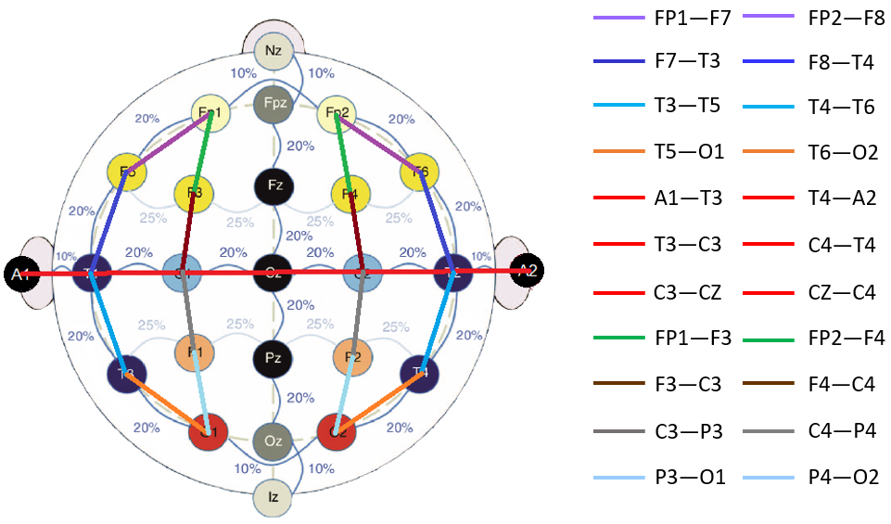
Figure 1. An industry-standard 10-20 electrode placement with a temporal central parasagittal montage (TCP) overlaid

delta: $<3$ Hz, theta: $3 –9$ Hz, alpha: $9 –13$ Hz,
beta: $13 –30$ Hz, gamma: $>30$ Hz.
These rhythms play an important role in the diagnostic process because each rhythm conveys specific information related to a subject’s mental status and the environmental conditions around it. One of the first steps during the diagnosis process is to identify if an EEG signal depicts a normally functioning brain.

Normal and Abnormal EEGs
For normal EEGs, each of these rhythms are expected to have specific amplitude ranges and focal regions. For example, an alpha rhythm can range from $50 –100$ µV and can be observed mainly in the occipital region of the brain (the back portion of the brain) or any other region other than the front. Activities within this rhythm are normally observed during eye blinks, when eyes are closed (also known as a posterior dominant rhythm) or during resting conditions (e.g., sleep spindles). A beta rhythm can have an amplitude around $20$ µV and can be mainly observed in the motor cortex region of the brain during mental or physical activities. Delta and theta rhythms exhibit amplitudes greater than $50$ µV and can be observed during deep sleep or when a patient is drowsy. The normal amplitude range for these rhythms is within $30 –100$ µV (Krauss & Fisher, 2011). Activities observed below this range can be attributed to various factors such as medication effects or poor data acquisition system. Activity observed above this range can be identified as normal (e.g., drowsiness), abnormal (e.g., rhythmic delta activity) or artifactual (e.g., muscle movements).
Of course, these amplitude and frequency ranges are merely examples of activities associated with the rhythms observed in normal patients. Since scalp EEG electrodes capture multiple frequencies originating from multiple sources, a mix of all these rhythms can be observed everywhere on the scalp, especially if the patient possesses abnormal brain behavior. These activities can be separated into mild abnormalities (e.g., EEG asymmetry between hemispheres, a lack of reactivity) and severe abnormalities (e.g., signals exhibiting epileptiform/ictal features, burst suppression).
There are also exceptions to the definition of an abnormal event. For example, an alpha rhythm can have as much as a $50\%$ asymmetry between hemispheres. Even the complete absence of an alpha rhythm is considered normal behavior among adults (Krauss & Fisher, 2011). A basic decision tree summarizing the diagnostic process used to identify an abnormal EEG is shown in Figure 2. The normal/abnormal EEG event classification problem is discussed in more detail in Lopez de Diego (2017).
It is important to note that the interpretation of EEG signals based on their frequency ranges (rhythms) is done quite differently than other disciplines in signal processing. The focus for EEG interpretation is on the dominant frequencies in the lower part of the spectrum. The frequency content in an EEG rhythm is measured based on the number of cycles per second observed in the waveform – a process often called peak-picking in the signal processing literature. For example, morphologies such as a $3$ Hz spike and wave (absence) complexes usually show significant energy in its lower frequency components.
The most prominent frequencies in this morphology are $3$ Hz slow wave delta rhythms which complete three cycles per second. Hence, the name “$3$ Hz” as a prefix regardless of the abundance of much higher frequency components associated with the spikes and complexes. In Figure 3, examples of $34$ Hz spike and wave complexes are shown. This can be considered a type of seizure referred to as an “absence seizure” (petit-mal) (Unterberger et al., 2018). From the plot, it can be seen that there are many other sharper activities evolving from the first channel (FP1-F3) and fifth channel (FP2-F4). But each of these small events repeat at a rate of approximately $3$ Hz in frequency and hence the term “$34$ Hz spike and slow wave complexes/discharges” is used to describe this type of waveform.
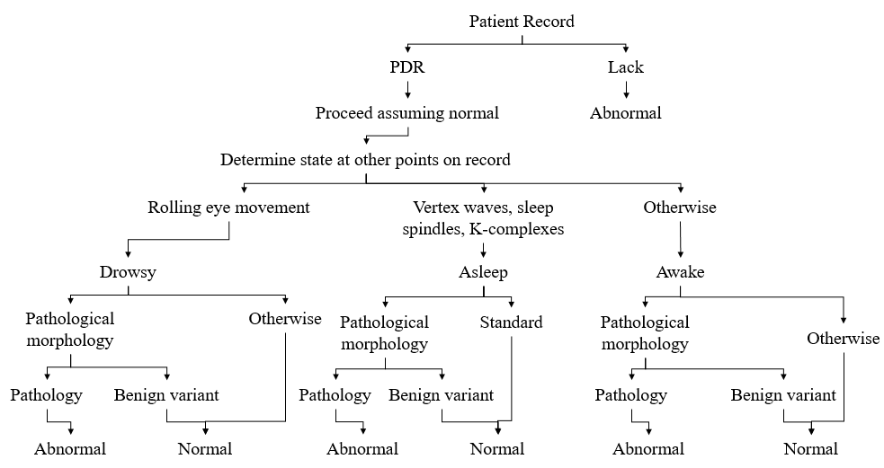
Figure 2. A decision tree that depicts the process used to identify an abnormal EEG

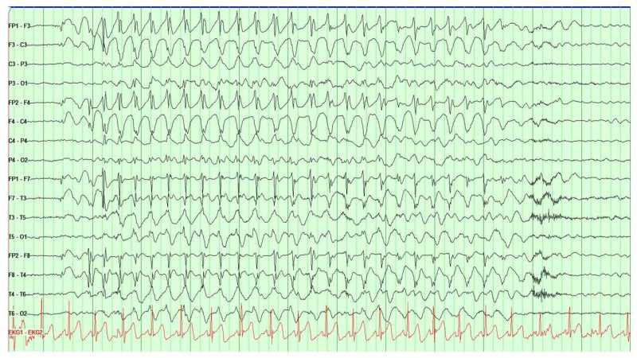
Figure 3. 3-4 Hz spike and slow wave complexes (absence discharges)
(Unterberger et al., 2018)

The TCP Montage and 10/20 Electrode Placement
A scalp EEG recording is most frequently collected in clinical settings using a $1020$ electrode placement (Tatum et al., 2014), as shown in Figure 1. A $1010$ placement is also popular (American Clinical Neurophysiology Society, 2012). Most expert clinicians are trained to interpret signals collected using these two standards. Interpretation is usually preferred to be done on a noise-reduced version of the signal known as a montage (Tatum et al., 2014). In a typical montage, signals are differenced to reduce noise and localize the EEG activities. This aids interpretation process by removing common noise from adjacent or reference electrodes.
There are two types of montages commonly used: unipolar and bipolar. Unipolar montages are created by simply subtracting signals collected from each electrode with only one reference electrode. A bipolar montage, on the other hand, subtracts signals from adjacent electrodes. This aids in localization of an EEG event – determining the location in the brain where the event originated. Identification of such focal regions is done by checking phase reversals between EEG channels. The montages are created in a way that signal subtraction is done in two directions: (1) a longitudinal direction (nasion to inion) and (2) a transverse direction (left to right ear). Both these directions help in identifying specific EEG events. For example, a triphasic waves can be observed from the longitudinal direction since they tend to propagate from the frontal lobe to occipital lobe of the brain. On the other hand, vertex waves are best seen from the transverse direction because they appear at the midline of the skull from where the transverse montage is created.
Popular montages are discussed in detail in Ferrell et al. (2020) and Lopez de Diego et al. (2016). For our research, we have always preferred the popular temporal central parasagittal (TCP) bipolar montage. The $1020$ electrode placement system with a TCP montage is shown in Figure 1. There are four segments focused in the longitudinal direction (front to back / vertical line) and one in the transverse direction (red horizontal line).

CHALLENGES IN EEG INTERPRETATION
With a growing interest in machine learning approaches to EEG interpretation, the literature has evolved significantly in recent years to the point where standardized literature on the interpretation process is openly available (American Clinical Neurophysiology Society, 2021; American Clinical Neurophysiology Society, 2012; American Academy of Neurology, 2020). One of the most difficult aspects of building a machine learning system is understanding the process experts use to interpret the data. With recent interest in computer automated interpretation, the literature describing the manual interpretation process has become much richer.
There are multiple factors that play an important role in deciding about a diagnosis. In addition to evidence in the EEG signal, clinicians incorporate information such as a patient’s medication history, physiological condition, and clinical correlates during a recording session (e.g., a video recording, an EMG signal) (Krauss & Fisher, 2011). See Ferrell et al. (2020) for a more complete discussion of the types of physiological signals collected during a clinical EEG. More recently, fMRI technology has played an important role in pinpointing asymmetry and abnormalities in the brain (Szaflarski et al., 2017; Kesavadas & Thomas, 2008).
In this chapter, we will examine the EEG interpretation process and demonstrate that the interpretation process is quite subjective. EEG interpretation requires extensive clinical training. Board certified neurologists complete a one-year internship and three years of clinical training. During this time, they are required to experience both inpatient (e.g., in a hospital) and outpatient (e.g., in a clinic) care. These candidates are exposed to patients in intensive care units (ICU), emergency rooms (ER), neuroimaging units (e.g., a department of neurology), child neurology units (e.g., hospitals specializing in pediatric care) and psychiatry (Benbadis, 2010).
Subclinical seizures, also known as electrographic seizures, do not present any clinical (physical or consciousness related) signs. These types of seizures are usually observed via EEGs for a short period of time. Subclinical seizures are typically visualized using a tool that displays the multichannel signal in $10$-sec (or $20$-sec) segments (Capp et al., 2017). Neurophysiologist training includes studying EEG signal morphologies observed during subclinical seizures and learning how to integrate clinical correlates and medical histories. Clinical seizures often require observing a patient’s mental state (e.g., consciousness). Typical examples of subclinical seizures are simple partial seizures (conscious state) or a sedated ICU patient showing no outward physical signs of a seizure. On the other hand, patients with generalized tonic-clonic seizures show extreme physical activity. Patients with complex partial seizures show a lack of consciousness. In this study, we only focus on subclinical seizures.
The two major types of epilepsy that influence the type of seizure are generalized epilepsy and partial (or focal) epilepsy. The localization of an event often determines the difference between these two. Generalized epilepsy can cause tonic-clonic, absence, myoclonic, clonic, tonic, and atonic seizures. Partial epilepsy, on the other hand, can cause simple partial and complex partial seizures. Secondary generalized epilepsy is the combination of these two types where a focal seizure evolves into a generalized seizure or spreads across the lobes. An example of a generalized epileptic seizure can be seen in Figure 3. An example of a partial seizure evolving into a generalized seizure can be seen in Figure 4.
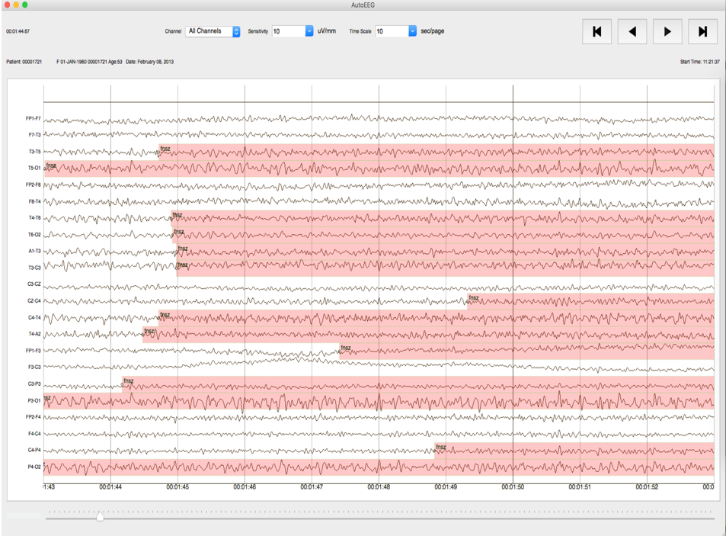
Figure 4. Secondary generalized seizure
The first question that arises is why is the seizure interpretation task difficult? The following reasons are just a few of the many reasons this is a challenging task:
- In a clinical setting, seizure events are identified based on the information collected from the encephalogram as well as from the clinical sense.
- Seizure morphologies can vary drastically and, in many cases, are specific to the patients.
- The EEG event classification problem is similar to an array processing or video processing problem in which temporal and spatial context plays an important role.
- The signals are extremely noisy due to the low voltage levels of the electrical signals and the presence of artifacts introduced by the ambient recording environment.
- Poor interrater agreement among the experts makes it difficult to establish standards.
Points 1 and 5 are a challenge to deal with when developing computer-based algorithms. To incorporate information collected from a variety of information sources (e.g., clinical reports, video recordings, vital signs), sophisticated information processing technologies are required. For example, information about a patient’s medications and medical history is often embedded in unstructured text documents, making it difficult to extract useful information without advanced natural language processing (NLP) algorithms (Picone et al., 2018; Chapman et al., 2001). Development of such algorithms requires a large carefully annotated corpus of deidentified clinical reports.
There are, however, specific features which confirm the existence of a seizure (or at least ictal discharges), including:
- existence of epileptiform discharges such as a train of spike and wave discharges/complexes;
- periodic or rhythmic discharges in the frequency range of $2.5 –30$ Hz with durations greater than $10$ secs;
- evolution in amplitude and frequency (evolution is described below);
- the locality of an event (e.g., originating from the frontal or parietal lobes).
The latter point plays an important role in determining whether an event is cerebral (e.g., a seizure event) or an artifact.
“Evolution in frequency is defined as at least $2$ consecutive changes in the same direction by at least $0.5$ Hz, e.g., from 2 to 2.5 to 3 Hz, or from 3 to 2 to 1.5 Hz” (American Clinical Neurophysiology Society, 2021). Development of any EEG event detection algorithm should incorporate such knowledge. In the following sections, we briefly explore the EEG event interpretation process and discuss important edge conditions that make this a challenge.

Contemporary Visualization Tools
EEG event classification requires characterization of a variety of events including cerebral activities emanating from the surface of the scalp, biological or mechanical/external artifacts and ambient or electrical noise. In this section, we will focus on epileptiform ictal discharges and artifacts. The most common events in this category include spike and wave discharges, periodic discharges, biological artifacts, and mechanical artifacts (Krauss & Fisher, 2011). The evolution of such events with respect to time can give us an indication of a seizure event.
Typical seizure events are comprised of ictal epileptiform discharges such as spike and wave discharge/complexes, sharp and wave discharges/complexes, generalized polyspikes, hypsarrhythmia, and lateralized/generalized periodic discharges. When such discharges evolve with an increasing rate in amplitude and a decreasing rate in frequency, a seizure has occurred.
Two typical seizure waveforms are shown in Figure 5. The signals are captured at the onset of a seizure (top) and at the offset of a seizure (bottom). Figure 6 shows the spectral properties of a seizure event captured on a subset of channels. The time axis (horizontal) for the spectrogram covers $60$ secs while the frequency scale (vertical) is truncated to $030$ Hz so that the most meaningful aspects of the seizure event can be observed.
In practice, this information is typically visualized using an approach known as a quantitative EEG (qEEG) (Nuwer, 1997). The qEEG is also known as a trend analysis technique that helps experts rapidly analyze EEG records and localize specific events. Recently there have been multiple studies validating the reliability of qEEG trend analysis methods (Haider et al., 2016; Swisher et al., 2015), and hence, this tool has been rapidly growing in popularity. Tools related to the qEEG include an amplitude integrated EEG (aEEG) (Scheuer et al., 2004), asymmetry index, spectrograms, rhythmicity spectrograms and envelope trends (Hirsch et al., 2010). These tools essentially aggregate information collected from the left and right hemispheres of the brains. Examples of seizures identified using these tools are shown in Figure 7. These examples came from a study conducted by Haider et al. (2016).
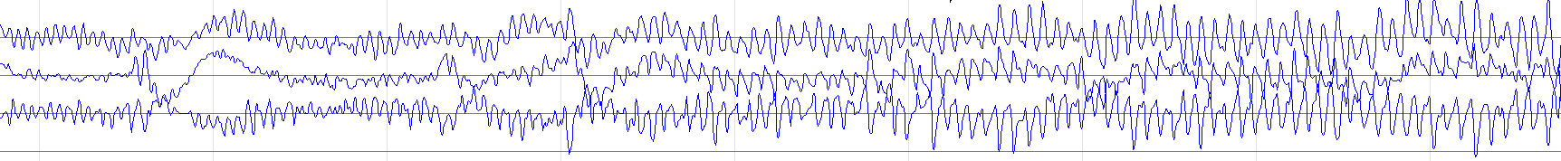
- after onset
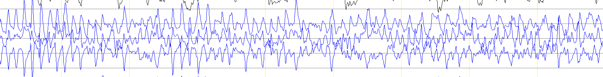
- near offset
Figure 5. A typical seizure event
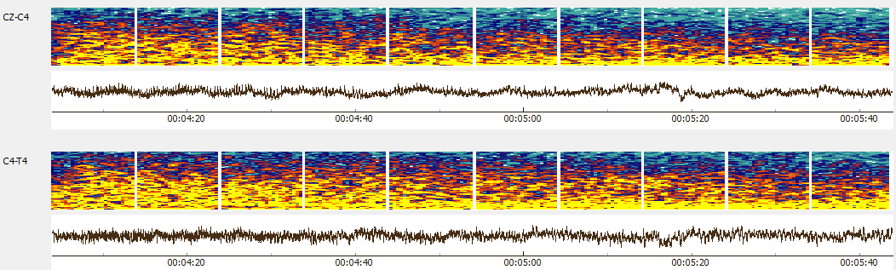
Figure 6. A spectrogram of a clean seizure

Although such tools save time, they are not able to detect subtle seizure events which are extremely focal, small in amplitude or very brief in duration (Haider et al., 2016). Human intervention is often required (Swisher et al., 2015). Consequently, qEEG analysis is considered an auxiliary tool to be used alongside the analysis of the raw EEG signal.
Commercially available seizure detection software, such as an industry-leading product offered by Persyst Development Corporation (2016), perform poorly in clinical settings. Common complaints from users include low sensitivity and large latency (Haider et al., 2016). To understand how to design an efficient automated seizure detection algorithm, we first need to understand what makes the seizure identification problem difficult. We will specifically examine the morphologies that comprise a seizure. Specifically, we will discuss the two most prominent ictal morphologies: spike and wave discharges and lateralized/generalized periodic discharges: We will also discuss two morphologies that contribute most prominently to a high FA rate: slowing and artifacts.

Ictal Epileptiform Features
Epileptic seizures consist of epileptiform events such as spikes, sharps, spike/sharp and wave discharges/complexes, spike and slow wave discharges/complexes, polyspikes and hypsarrhythmia. In our research, we decided to consider all these events as variants of spike and wave discharges except for hypsarrhythmia. We exclude hypsarrhythmia because the event morphologies observed during hypsarrhythmia lack any periodic or rhythmic structure. Rather, hypsarrhythmia event morphologies are a chaotic mixture of high amplitude slow waves, multifocal spikes, and asynchrony (Scher, 2017). The identification of a seizure event is confirmed based on the evolution of frequency, amplitude, affected (focal or hemispheric) regions and spread of epileptiform events (Stefan & Theodore, 2012). Trains of small duration ictal discharges (less than $90$ msec for spikes and $90300$ msec for sharps) are observed during most seizure events. These discharges with frequencies greater than $2.5$ Hz and a duration of at least $10$ secs confirm the existence of a seizure event (American Clinical Neurophysiology Society, 2021). Potential seizure events with parameters outside these ranges require additional information such as a determination of the epilepsy type (e.g., absence seizures).
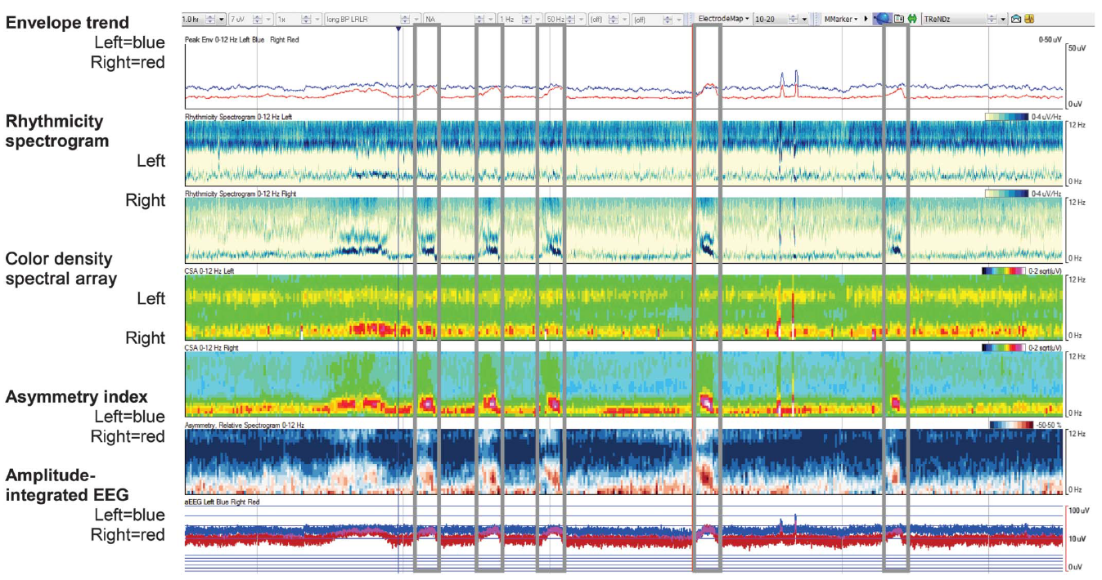
Figure 7. qEEG analysis tools used for identifying seizures (Haider et al, 2016)
On the other hand, epileptiform discharges that satisfy these criteria are automatically confirmed as seizure events. Other epileptiform events which are not covered by this definition require further evidence (e.g., absence seizures lasting for $2$ secs or periodic discharges occurring at a frequency of $1$ Hz). Since identification of ictal features is the first step towards confirming a seizure event, in our automated system we add an additional step for detecting epileptiform features on a per-channel basis.

Periodic Discharges
Periodic discharges such as generalized periodic discharges (GPD) or lateralized periodic discharges (LPD) are abnormalities which occur at a constant interval. If these discharges are confirmed as epileptiform, high frequency trains or evolution of these events can be indicative of a seizure event. However, the periodicity at which the GPDs are considered as epileptic seizures is not clear and highly disputed in the literature (Kubota et al., 2018). This makes identification of these events challenging.

Slowing
Slowing includes a broad set of EEG events which can indicate normal, mildly abnormal, and abnormal EEGs depending on a number of factors. We specifically focus on post-ictal slowing events which occur after the offset of a seizure. Annotation of post-ictal slowing is not easy since it can range in duration from a couple seconds to a week (von Weltin et al., 2017). This adds additional difficulty in marking the offset of a seizure event. We have applied a stringent set of rules for determining slowing in the TUSZ Corpus (Ochal et al., 2020; Shah et al., 2018): an offset is annotated when consistent evolution is phased out and small attenuated gaps between the slow waves are found.

Artifacts
Since scalp EEG recordings are non-invasive, extraneous activities from surface and environmental disturbances can be observed throughout the record. These events are referred to as artifacts. Artifacts are events observed in EEG signals which are not related to actual brain activity. EEG artifacts may resemble activities similar to cerebral morphologies (e.g., epileptiform discharges and intermittent rhythmic delta activity). While some artifacts resemble actual brain activity, others introduce severe noise into a signal, making interpretation of the record difficult.
Clinical settings such as a neurological intensive care unit (NICU) or a cardiac intensive care unit (CICU) contain a great deal of ambient electronic noise. In such environments, the introduction of noise due to patient movement, such as an agitated patient, are common (Krauss & Fisher, 2011). Such settings produce intermittent or continuous electromyogram (EMG) high-frequency artifacts which can completely obscure underlying brain activity. These high frequency high amplitude irregular activities can appear in a frequency band ranging from $20$ to $50$ Hz. Other artifacts may include chewing, electrode pop/shake, shivering and eye movements.

ACNS Standards for Seizure Identification
The American Clinical Neurophysiology Society (ACNS) has produced a standard set of guidelines for identifying seizure events for intracranial and scalp EEG recordings (American Clinical Neurophysiology Society, 2021; American Clinical Neurophysiology Society, 2012). Clinicians are encouraged to research, interpret, and diagnose patients using this nomenclature and these guidelines.
Spike and wave discharges at $2.5$ Hz or faster and clearly evolving discharges of any type that reach a frequency of $4$ Hz can be considered as seizures (Hirsch et al., 2013). There is also the $2.5$ Hz-$10$ second rule previously discussed. Although these definitions are straightforward, other morphologies which do not meet these criteria introduce ambiguity. The ACNS guidelines state: “Generalized spike and wave patterns slower than $3/$s; and evolving discharges that remain slower than or equal to $4/$s does not imply that these patterns are not ictal, but simply that they may or may not be.” Additional information is necessary to make a final decision about a seizure event. Such decisions are usually dependent on a clinician’s experience, institutional conventions, and a patient’s condition. IRA among experts on such seizure events is very low (Haider et al., 2016; Swisher et al., 2015).

Ictal Discharges and EEG Gray Zone Events
Based on the evolution of the epileptiform events, seizure events can be divided into two classes: isomorphic and metamorphic. Isomorphic events show little to no change throughout the phase (e.g., absence seizure) of the event whereas metamorphic events show multiple phases of an event evolving through time (e.g., tonic-clonic seizure). Figure 3 and Figure 5 show easily identifiable examples of isomorphic and metamorphic seizure events respectively. Although the example shown in Figure 3 shows a clear distinction between its onset and offset marks, in many cases, for patients with other epilepsy syndromes such as Lennox-Gastaut syndrome (LGS) or patients showing hypsarrhythmia, there is little to no changes in their electrographic signals. Patients with LGS can show multiple types of epilepsies in different focal regions. As a result, multiple types of seizure events can be observed throughout the record with subtle transitions in the signal morphologies. This makes determination of the onset or offset of a seizure difficult. The determination of the onset and offset for isomorphic seizures is also quite challenging and requires additional insight about the clinical correlates and patient history.
Periodic discharges such as LPDs and GPDs are heterogeneous and multifactorial (attributed to variety of causes such as metabolic, infectious, or epileptic disorders) which makes some sort of generalized rule for seizure detection difficult (Chong & Hirsch, 2005). These periodic discharges are often observed in an ictal-interictal continuum (IIC) where seizure identification becomes subjective (Sivaraju et al., 2016; Persyst Development Corporation, 2020). In Figure 8, we can see the ambiguous “gray zone” region associated with the periodic discharges with periodicity less than 3/s. Similarly, Figure 9 shows a clear depiction of the uncertainty involved in determining whether periodic discharges due to a cortical injury are determined to be a seizure event. Both these examples often require additional information about the patient and remain a very subjective decision.
These are a few examples of why the identification of a seizure event from an EEG signal is a challenging problem. There are additional challenges in interpreting scalp EEG recordings in clinical settings that include a lack of a medical history, a lack of video recordings, mechanical artifacts, and other pathological complications such as triphasic waves observed in encephalopathic patients. Also, sedative medications reduce the energy of the cerebral signals and hence the quality of the recordings.
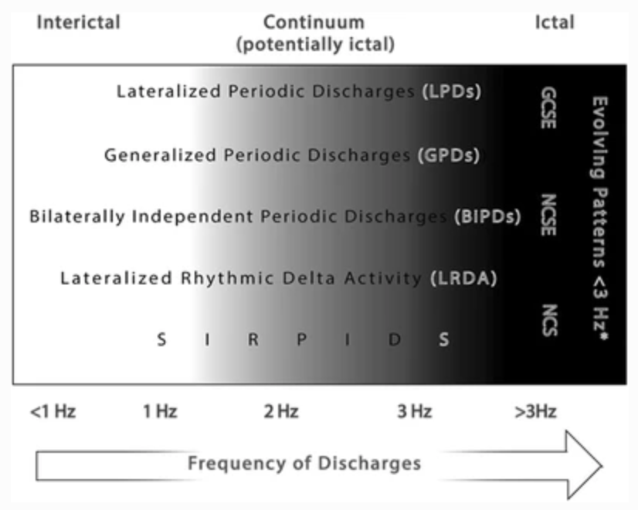
Figure 8. The ictal-interictal continuum (IIC) frequency range for periodic discharges
(Sivaraju & Gilmore, 2016)
Figure 9. A continuum of events related to neuronal injury (Chong & Hirsch, 2005)

Interrater Agreement Among Experts
For many of the reasons previously discussed, and to avoid over-medicating patients (which can cause long-term damage), neurologists tend to annotate EEGs conservatively (Benbadis, 2010). Not surprisingly, there are often disagreements among the experts. Consequently, interrater agreement (IRA) among experts remains quite low (a typical kappa statistic is approximately $0.5$) (Haider et al., 2016; Swisher et al., 2015; Ronner et al., 2009). Poor IRA makes annotation of large corpora a challenge because the annotations will not be consistent when multiple annotators are involved. Models developed and evaluated on such databases tend to yield lower performance, especially with harsher scoring metrics.
We typically employ undergraduates to annotate data. These student experts were responsible for creating the TUSZ Corpus (Shah et al., 2018). These students were trained to annotate data based on the principles previously discussed. We conducted an IRA study between the student annotators and expert clinicians to evaluate their consistency for annotating seizures. We established some specific rules for these annotations since the ACNS guidelines are a bit vague in places. Examples of rules we needed to refine address (1) frequency evolution of periodic lateralized discharges (PLDs) and generalized periodic discharges (GPDs) appearing in long bursts, (2) post-status epilepticus stages and “gray zone” Ictal Interictal Continuum (IIC) phases, and (3) low frequency (1-2.5 Hz) spike and wave discharges lasting more than 10 secs.
To solve (1), annotators were required to annotate periodic discharges greater than $2.5$ Hz in frequency and lasting more than $10$ secs regardless of their waxing (bursty) and waning (slow) patterns. If the frequency is lower than $2.5$ Hz, evolution of the discharges was considered to confirm a seizure.
For (2), we mark the offset of an event when the first suppressed or attenuated background is observed during the post-ictal slow waves. Like (1), we incorporate evolution of the discharges prior to deciding about (3). Despite these very specific guidelines, there are still many cases for which determination of a seizure is ambiguous. To make sure the final annotations are consistent, we submit these cases to group review and achieve a consensus.
Although student annotators rely heavily on the reports for the annotation process, for this IRA study they were not permitted to use the reports. Their performance was compared to “gold-standard” annotations derived from annotations provided by multiple expert neurologists. Data was drawn from three databases collected at three different hospitals: TUSZ (Shah et al, 2018), the Duke University Seizure Corpus (DUSZ) (Swisher et al, 2015), and the Emory University Seizure Corpus (EUSZ) (Haider et al., 2016). We evaluated the performance of our annotators using Cohen’s kappa statistic (McHugh, 2012) The final annotations delivered by our student annotation workflow yielded a kappa statistic of $1.0$ for TUSZ, $0.73$ for DUSZ and $0.83$for EUSZ. This demonstrated the viability of using student annotators for the seizure detection task and enabled the development of a large corpus annotated data necessary for this study.

NEURAL NETWORK MODELS
Advances in computer technology and big data resources have allowed researchers to develop a new generation of machine learning technology, often referred to as deep learning, that has significantly advanced performance in traditional disciplines like speech, image, and text analysis. Multiple machine learning algorithms have been proposed for EEG event classification in the past two decades. Shoeb & Guttag et al. (2011) used support vector machines (SVM). Roy et al. (2019) used k-nearest neighbors (kNN) and convolutional neural networks (CNN) for classification of various types of seizures. Golmohammadi et al. (2018) used various hybrid machine learning architectures to establish baseline performance on TUSZ. The best performing model from this study will serve as a baseline system in this study. In this chapter, we introduce a new two-phase model design for improved segmentation performance.

Relevant Neural Network Architectures
EEG interpretation requires integrating information from both the temporal and spatial domains. Algorithms that can efficiently process this type of information are ideal candidates for seizure detection. Sequential algorithms such as hidden Markov models (HMM) (Picone, 1990) and long short-term memory (LSTM) neural networks (Hochreiter & Schmidhuber, 1997) are well-known algorithms that can model temporal sequences. Similarly, convolutional neural networks (CNNs) (Goodfellow et al., 2016) can learn structural information from the data. Various hybrid architectures involving combinations of these algorithms will be discussed extensively in the following sections. However, prior to discussing such complex networks, it is important to understand the structure of a generic feedforward neural network known as a multilayer perceptron (MLP). This network forms the basis for the more complex networks discussed later in this chapter and serves as an important baseline.

The Multilayer Perceptron
A multilayer perceptron (MLP) is a fundamental type of neural network. Each layer of the network performs an affine transform on the input data followed by a nonlinear transformation of that result (Goodfellow et al., 2016). An affine transform can be represented as:
$y =Wx+b$, (1)
where the matrix $W$ and the vector $b$ represent parameters that are usually set by optimizing some objective function. Figure 10 shows a diagram of a multilayer perceptron network with a single hidden layer. The number of nodes associated with the input layer (green), two hidden layers (blue) and output layer (red) are $3$, $5$, $5$ and $2$ respectively. Connections between the nodes, represented by arrows pointing from left to right, are assigned specific weights and are the parameters of the network that must be optimized during training. Note that in a typical MLP network, each neuron in each layer is connected to all neurons in the predecessor layer. Therefore, an MLP network is often referred to as a fully connected or dense network.
Figure 10. Diagram of a multilayer perceptron network
An MLP network exhibits powerful learning capabilities through the introduction of a nonlinearity. To introduce a nonlinearity, we transform $y$using a nonlinear function, also known as an activation function. Typical examples of activation functions include a rectified linear unit (ReLU), a hyperbolic tangent (Tanh), or a sigmoid (Goodfellow et al., 2016). These nonlinearities control the amount of information transfer to the following sections of the network. The output of a complete MLP network can be represented as:
$MLP\left(x,W\right)= f\left(x,W\right) =f^{\left(L-1\right)}$ $\left(… f^{\left(0\right)} \left(x, W^{\left(0\right)}\right)… , W^{\left(L-1\right)} \right)$, (2)
where $W$, which includes the bias term in equation (1), represents the weights, or parameters of the network, and $f()$ represents an activation function. The superscript $L$ represents the number of layers in the network. For example, output of the first layer of an MLP network can be represented by $f^{\left(0\right)} \left(x^{\left(0\right)}, W^{\left(0\right)}\right)$. Similarly, $x^{\left(0\right)}$ can be considered as the input to the first layer.
In many hybrid classifiers, the final layer is an MLP network where the activation function is a sigmoid or softmax function (Goodfellow et al., 2016). A sigmoid function can be represented as:
$σ\left(x\right) = \frac{1}{1+e^{-x}}$ , (3)
while a softmax function can be defined as:
$σ\left(x_{i}\right) = \frac{e^{x_{i}}}{\sum_{j=1}^{n}{e^{x_{j}}}}$ . (4)
Both these functions yield an output in the range $[0,1]$. These functions compress the unbounded output of the network to a fixed range so that the output value can be used as a proxy for a posterior probability (Goodfellow et al., 2016). This final layer design is employed by many hybrid networks including the CNNs and LSTMs discussed here.

Convolutional Neural Networks
A convolutional neural network (Goodfellow et al., 2016; Jordan, 2017) is a popular neural network variant which is efficient at learning local correlations in structured data. Unlike the fully connected MLP network discussed in the previous section, CNNs operate on data on a block-by-block basis using a specific local parameter matrix called a convolutional kernel. Figure 11 shows the basic CNN network topology. The nodes associated with the convolutional layer in this figure are transformed vectors generated by a $2×2$ kernel. That is why they share the same parameters ($θ_{i,j}$) across all input vectors.
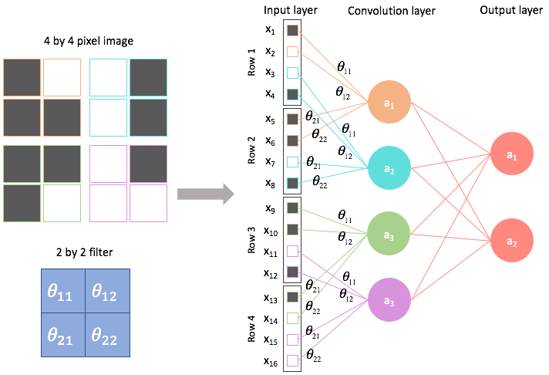
Figure 11. A typical CNN network topology (Goodfellow et al., 2016; Jordan, 2017)
Convolutional kernels are designed to learn abstract local patterns in data. This is best demonstrated through a simple image classification example. The outputs of the kernels associated with the initial layers of the network are designed to learn low-level properties of the image such as edges, curves, and color gradients. The kernels at the later stages learn global patterns and shapes in the data such as whether the edges or curves are associated with specific objects or properties of the image. Figure 12 shows an example of how facial features are learned by the kernels as we move deeper and deeper into the network.
The outputs of the convolutional kernels are called feature maps. This is because during training, kernels attempt to learn the features associated with the data. A channel of a convolutional network, different from an EEG channel, can focus on a specific dimension of the data such as pixel color. For example, a $3$-channel image classification system could have three sets of convolutional neural networks – one associated with each color (e.g., red, green, and blue) if color was determined to be an important feature for classification.
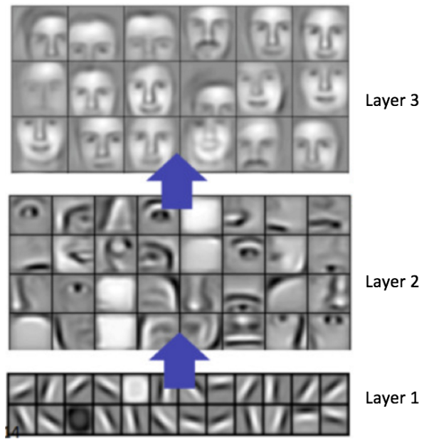
Figure 12. An example of feature maps generated by CNN kernels (Lee et al., 2009)
Mathematically, output of a CNN layer can be defined as:
$x^{\left(l+1\right)}= f\left(x^{\left(l\right)}, W^{\left(l\right)}\right)= f\left(x^{\left(l\right)} * k^{\left(l\right)}+ b^{\left(l\right)}\right)$ , (5)
where the operator ‘$*$’ indicates a convolution operation, $k$ represents the kernels of layer $l$, and $b$ represents the bias vectors associated with the kernels. In some of the models developed in this study, we will be using 2D CNN networks. In this case, the output of a 2D CNN network at layer $l$ for one kernel, $d$, of channel $c$, is:
$f\left(\sum_{x=1}^{X^{\left(l\right)}}{\sum_{y=1}^{Y^{\left(l\right)}}{{ x}_{c, i+X^{\left(l\right)}-x,j+Y^{\left(l\right)}-y }^{(l)}· k_{c,d, x,y }^{(l)}+b_{cd }^{(l)}}}\right), 1≤d≤D^{(l)}.$ (6)
The variable $D$ represents the total number of kernels while $D^{(l)}$ represents the number of kernels for the $l^{th}$ layer. The indices $i$ and $j$ refer to the coordinates of the starting position of the current frame.
Equation (6) transforms the input tensor using a single kernel of a specific channel. A CNN operation is performed with a sliding window by iterating over values of $i$ and $j$ until the entire image has been processed. The subscript $i+X^{\left(l\right)}-x$ represents the reverse indexing portion of the convolution operation. The specific CNN channel and kernel are represented by the variables $c$ and $d$ respectively. A bias operator, $b_{cd }^{(l)}$, which represents a bias term for the $l^{th}$ layer, is added at the end of the convolution operation.
It is important to note that the operations performed in equation (6) are for a single kernel associated with a CNN channel. The outputs from each channel are concatenated and passed to the next layer. This is a simplified version of the core CNN operation. It does not incorporate strides, batches or zero padding operations that are essential for operating efficiently on big data sets (Vesely´ et al., 2013). We can exploit this image processing approach for EEG signals by treating the multichannel EEG signal as a 2D signal that is a function of time (e.g., sample number or frame number) and space (e.g., channel number).

Long Short-Term Memory Networks
A long short-term memory (LSTM) network is a class of recurrent neural networks (RNN) which is popular due to its ability to learn long-term relationships in sequential data (Hochreiter & Schmidhuber, 1997). A typical network layout for an RNN is shown in Figure 13. Comparing this to the MLP network shown in Figure 10, we can observe that along with adjacent layers, nodes of RNNs also have connections within the layers. This suggests that the RNN networks are influenced by a node’s recurrent path (self-loops) and the state of the remaining nodes within the layer. Note that the hidden layer shown in Figure 10 flows information in both directions. In practice, such bi-directional networks perform better than the unidirectional networks at the expense of more parameters (Goodfellow et al., 2016)
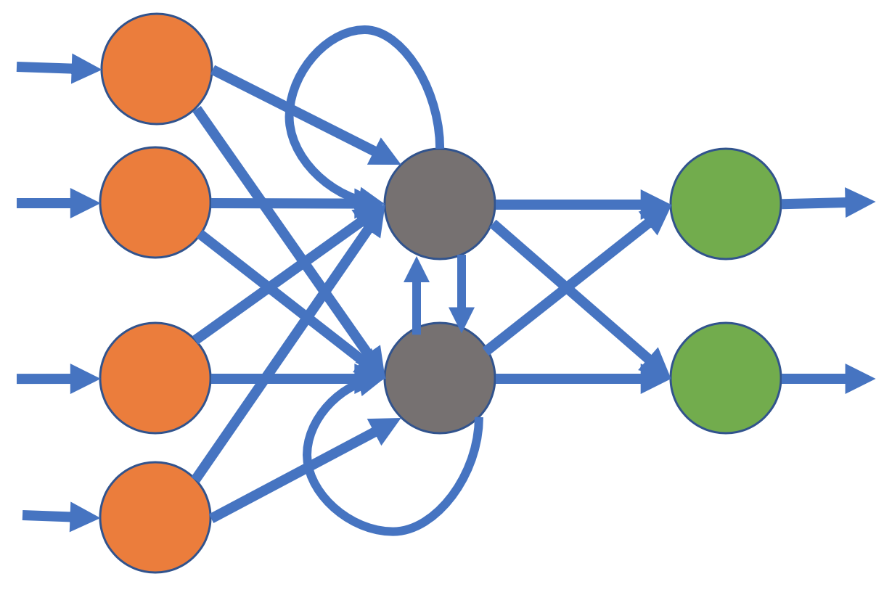
Figure 13. A typical recurrent neural network
The architecture of an LSTM cell is shown in Figure 14. An LSTM network is designed to control information flow within the network by introducing additional states which can remember (or forget) a sample of a sequence vector. These networks add an additional state vector called a cell state which aids in controlling the emphasis of new information given to its memory. Cell states are computed via following equation:
$\left[\begin{matrix}i \\ f \\ \begin{matrix}o \\ g\end{matrix}\end{matrix}\right]$ = $\left[\begin{matrix}σ \\ σ \\ \begin{matrix}σ \\ tahh\end{matrix}\end{matrix}\right]$ $W \left[\begin{matrix}h_{t-1} \\ x_{t}\end{matrix}\right]$ , (7)
$c_{t}=f ⊙ c_{t-1}+ i ⊙$ g, (8)
$h_{t}=o ⊙ {tanh(c}_{t})$, (9)
where $i$, $f$, $o$ and $g$ are internal gates which are used to compute the cell state of the LSTM network. The symbol $⊙$ is the element-wise multiplication operator.
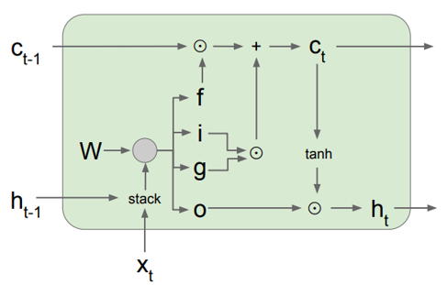
Figure 14. Architecture of an LSTM cell (Hochreiter & Schmidhuber, 1997)
Element-wise multiplication, also known as a Hadamard product, performs multiplication on two matrices of the same dimension where the element at position $(i,j)$ of the first operand is multiplied by the element at position $(i,j)$ of the second operand. In equations (7)-(9), this operator is used to control the information flowing through the input gate, the output gate and the cell states. We can see from equation (8) that the gate $f$ controls the information coming from the previous state. Similarly, gate $g$ controls the information coming from the new input step. This weighting mechanism helps LSTMs learn patterns in longer sequences.

Features
There are two general types of inputs used in modern machine learning systems: knowledge-based features or sampled data. While it is possible to input sampled data directly into a system, this approach has not shown to be particularly promising for EEG signal classification in our preliminary experiments. In this study, we will focus on knowledge, or model-based, features known as linear frequency cepstral coefficients (LFCCs) (Harati et al., 2015). LFCCs are similar to the mel-scaled cepstral coefficients, known as MFCCs, historically used in speech recognition (Xu et al., 2005).
For EEG signals, however, our LFCC features use linearly scaled filter bank outputs across the entire frequency range of the signal. MFCCs use logarithmically scaled features in the high frequency range of the spectrum. The motivation for this is based on knowledge of the human auditory system, which is known to be sensitive to frequency on a logarithmic scale (Picone, 1990). An EEG signal, as explained previously, includes periodic discharges that have a fundamental frequency in the range of $1–2.5$ Hz. EEG signals are most often sampled at $250$ Hz. The frequency range from $0 –25$ Hz contains most of the useful information. A linear frequency representation for this range has proven to be slightly better than a logarithmic representation (Harati et al., 2015).
In our standard feature extraction process, the first $7$ cepstral coefficients excluding the zeroth order coefficient are computed. A frequency domain energy term is added as the $8th$ feature:
$E_{f}=\log{(\sum_{k=0}^{N-1}{{\left|X(k)\right|}^{2}})}$ . (10)
We also include a differential energy term which has been proven effective in identification of spike-like activity that can indicate epileptiform activity. This differential energy term is computed using a sliding window approach:
$E_{d}=\max_{m}\left(E_{f}\left(m\right)\right)-\min_{m}\left(E_{f}\left(m\right)\right)$ , (11)
where differential energy $E_{d}$ is calculated over $9$ frames ($0.9$ secs). This term attempts to model long-term change in energy of a signal.
Another computation we borrow from a classical speech recognition front end is the use of first and second order differential features (Young et al., 2006; Harati et al., 2015). We augment the $9$ base features, which we often refer to as absolute features, with first derivatives of these features, referred to as delta features, and second derivatives, referred to as delta-delta features. Note that the second derivative of the differential energy term is not used. This brings the total dimension of our feature vector to $9 + 9 + 8 = 26$.
Rather than attempt to compute spatial features, we leave the task of learning spatial correlations of the features to the deep learning system. We will also explore better ways to select features, order features, combine features and reduce dimensionality via neural network architectures.

A Multiphase Recognition System
Often algorithms designed to solve the seizure detection problem analyze the signals (or its derived features) in a single iteration using a single stream. The models which can classify directly from the raw input information (no feature extraction) are known as the “end-to-end” models (Goodfellow et al., 2016;). Regardless of the models being end-to-end or feature extraction-based, they are expected to learn the traits of a seizure event without any knowledge of important underlying components of these events such as spike and wave discharges. Commercially available technology (Golmohammadi et al., 2018; Persyst Corporation, 2016; Haider et al., 2016) yield extremely low performance on seizure detection tasks $(2030\%$ sensitivity with $2 –7$ FAs/$24$ hrs). These models self-organize information without direct knowledge of underlying cerebral activities. In this study, we attempt to mimic the human annotation process by splitting the seizure detection problem into two separate phases.
We develop a model which focuses on underlying epileptiform morphologies in the first phase (P1) of the system and localizes events in the second phase (P2). Specifically, the primary model learns temporal context via a channel-specific LSTM model. This is followed by learning the spatial/temporal context using a CNN-LSTM model. The second phase CNN-LSTM model uses features collected from the first phase. The results from this approach suggest that multiphase systems can outperform traditionally developed models.
Multiphase models have traditionally been used in many machine learning disciplines such as speech recognition. Automatic speech recognition (ASR) tools such as Kaldi (Povey et al., 2011) use multiphase models (also known as a multi-pass system) to improve system performance by iteratively increasing the complexity of the model in each phase. We follow a similar approach for our seizure detection models. Instead of emphasizing a purely data-driven approach, we separate the problem into two separate event detection tasks motivated by domain knowledge.
A very common indication of a seizure event is the existence of an epileptiform event called a spike and wave discharge (Tatum et al., 2014). These events can be observed throughout all the channels of an EEG for a generalized event or on a specific set of channels for a focal event. Sometimes a focal event can spread to other parts of the brain, which is referred to as a secondary generalized seizure. The evolution of these activities across time helps identify a seizure event. Once these activities are observed, seizures can be confirmed based on their focality, signal energy and polarities across electrodes.
The seizure detection task can be divided into two separate tasks as shown in the block diagram in Figure 15. A channel-based LSTM model is used to detect epileptiform activities associated with various types of seizures. Since there is no way of confirming a seizure event without examining multiple channels of an EEG, this model only learns the shape and evolution of the discharges associated with the seizures. With this approach, seizures evolving with time (indicated by an increase in signal amplitude) are easier to identify compared to seizures with discharges with a constant amplitude and frequency.
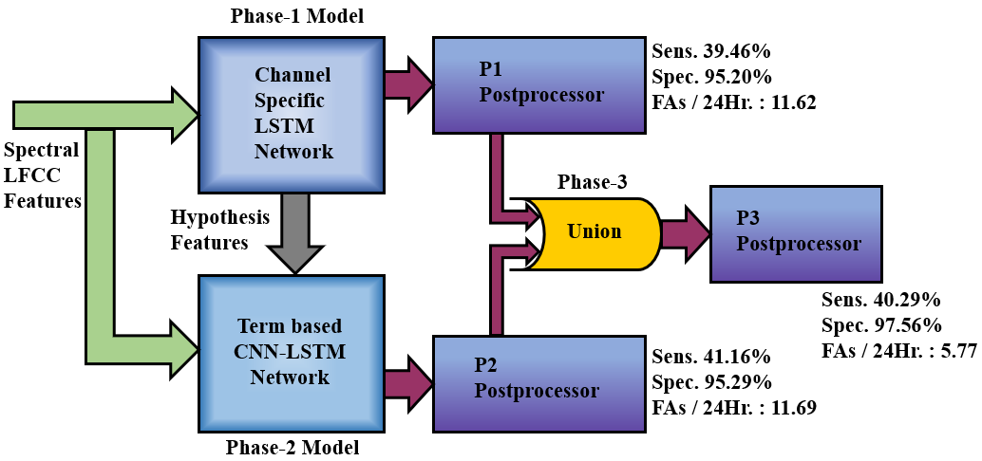
Figure 15. The proposed multiphase model
This channel-based LSTM is followed by a CNN-LSTM seizure detection model which incorporates temporal and spatial context (EEG channels). This model uses two sets of features: (1) LFCC features described in Section 4.2, and (2) augmented features collected from P1. The augmented features of the P2 model are created using the posteriors of the P1 model.

Data Flow Considerations
Both models are optimized to perform a binary classification – seizure or background. This decision is made on a frame-by-frame basis using a predefined sliding analysis window. The P1 model was developed to identify epileptiform activities. Epileptiform activity can be associated with a seizure event, so we expect our P1 model to be confident for epileptiform morphologies belonging to a seizure but confused when the seizure is absent. We will abbreviate a seizure label as “seiz” and non-seizure label as “bckg” (short for background EEG) even though for the P1 model we are detecting epileptiform events.
Training is performed on minibatches (Goodfellow et al., 2017) using a variant of stochastic gradient descent (SGD) algorithm called Nesterov momentum (Sutskever et al., 2013). Nesterov momentum attempts to increase the speed of training by introducing a momentum term based on accumulated gradients of its previous steps and a correction term in the direction of the current gradient. This tends to reduce the amount of overshoot during the optimization.
The models are trained and evaluated using LFCC feature vectors discussed in Section 4.2. We use a frame duration, $T_{f}$, of $0.1$ secs to represent how often features are computed. We use a window duration, $T_{w}$, of $0.2$ secs to denote the amount of data used to compute the features. Windows are usually centered about frames and overlap into the preceding and future frame to provide continuity. We will denote a feature vector as $r_{f}$. We train deep learning models using a sliding window approach with a window $W$ of duration $L$ (in seconds) and frame duration $epk$. This is the time interval over which the deep learning system will output a decision. This is set to a constant value of $1$ sec for all our experiments. This is equivalent to 10 frames ($r_{epk}={r_{f}}/{T_{f}}$).
Furthermore, we pass a window $W$ consisting multiple epochs to the models. Window sizes for the P1 model and P2 model are $7$ secs and $11$ secs respectively ${(L}_{p1}=7∙r_{epk}, L_{p2}=11∙r_{epk}$). These windows incorporate sufficient temporal context to learn the differences between the classes.
We can represent the reference annotations, often referred to as ground truth labels, using a categorical vector:
$P_{W}= \left[1(x_{W}=s_{1}\text{)}; 1(x_{W}=s_{2}\text{)} \right]$ , (12)
where $1(\text{)}$ is the indicator function which represents binary values $0/1$ based on the index of the label and the variables $s_{1}$ and $s_{2}$ correspond to the labels “seiz” and “bckg.” For a seizure event, $P_{W}=\left[1, 0\right]$; for a background event, $P_{W}=\left[0, 1\right]$.
Once the feature vectors $r_{W}$ and their labels $P_{W}$ are created, we can define the training set for the model as:
$\left\{\left( P_{epk 0}, r_{epk 0}\right),\left( P_{epk 1}, r_{epk 1} \right), …, {(P}_{epk N-1}, r_{epk N-1}) \right\}$ . (13)
Note that the training samples are created with a sliding window approach with a window duration of $W$ and frame duration of $epk.$ Each epoch serves as a center of the window $W$ (a center aligned window). For example, for the P1 model, training samples are created using a sliding window approach with a window duration of $7$ secs and frame duration of $1$ sec. The label for each epoch is chosen from the center epoch of the window – epoch no. 4 in this case. Epochs at the beginning and end of the EEG record do not typically contain enough samples fill a window. In such cases, the windows are zero padded when the values are missing.
The output of the neural network can be considered as an estimated probability mass function (PMF) of the input data distribution. The output of the neural network provides posterior values. The class estimation is done by selecting the maximum posterior values from the output neurons:
$ŝ_{W}= \underset{s_{W}∈S}{argmax}{{\hat{P}}_{W}}$ . (14)
Note that ${\hat{P}}_{W}$ contains the posteriors of the model which should be in the range $[0, 1]$. Since, the classification is binary, the posterior distribution of training samples simply becomes a Bernoulli distribution.

Channel-based Long Short-Term Memory Networks
The P1 model of the recognition system uses a $3$-layer LSTM model to learn variants of the spike and wave discharges occurring during a seizure event. There are $256$, $64$ and $16$ LSTM neurons in three hidden layers of this network. This is followed by two dense neurons at the output layer. The activation function used for each layer is a hyperbolic tangent function, $tanh()$, except for the final layer which uses a softmax nonlinearity. The complete architecture of the model is shown in Figure 16.
We use a $26$-dimensional LFCC feature vector discussed in Section 4.2 for this model. This vector is concatenated by adding $10$ frames of context on both sides of the frame. The output dimensionality for each frame becomes $10 × 26 (left) + 26 (center) + 10 × 26 (right) = 546$. The static LSTM cells are used with a fixed batch size of $64$ and a window duration of $7$ secs. The data is randomly split into subsets where $80\%$ is used for training and $20\%$ is used for cross-validation during optimization. The features are normalized and scaled down to a range of $[-1, 1]$ on a file basis, which helps the gradient descent algorithm (and its variants) to converge much faster (Ioffe & Szegedy, 2015). Shuffling was performed on batches to avoid training biases.
The output of a window sequence of the channel-based LSTM model can be represented as:
${\hat{P}}_{W}= \left[\begin{matrix}P_{Ch-LSTM} ({x_{epk}=s1 }/{ r_{L-1, }r_{L-2},…,r_{0 }} ) \\ P_{Ch-LSTM} ({x_{epk}=s2 }/{ r_{L-1, }r_{L-2},…,r_{0 })}\end{matrix}\right]$ . (15)
${\hat{P}}_{W}$ serves as posterior value for epoch $x_{epk}$. This per-channel posterior vector is used to create an augmented feature vector for the P2 model. We use three approaches to scale and augment the feature vectors using these posteriors. This will be discussed in the following chapter.

A CNN-LSTM Network for Modeling Context
Spatial information plays an essential role in identification of an EEG event. The P2 model is a hybrid network which consists of a $3$-layer CNN network followed by two bidirectional LSTM layers and a $2$-neuron MLP network. The model design is shown in Figure 17. A 2D CNN network deals with data in three dimensions: samples representing time-steps of the EEG record, EEG channels, and feature dimensions. The input shape of the model is set so that kernels can stride (slide) through timesteps and EEG channels. The channels of the CNN network are associated with the dimensions of the feature vector $r_{f}$ (similar to the RGB channels of an image).
Figure 16. A channel-based long short-term memory network architecture
Generic CNN networks are incapable of learning translation and rotation invariance (Dieleman et al., 2016). Translation and rotation invariant systems should be able to detect a target object (such as face detection in image recognition) regardless of its location, shift or rotation in its geometry. Electrode positions correspond to specific regions of the brain. Each region behaves differently and plays an important role during the interpretation process. We also avoid zero padding in the first layer of the network so it can remember the channel locations more effectively. This is because lower elements of the kernels are never exposed to the upper channels and vice versa. This way, kernels do not generalize over different brain lobes which is beneficial because brain lobes behave differently. Additionally, this also reduces the size of the feature maps generated from the first layer.
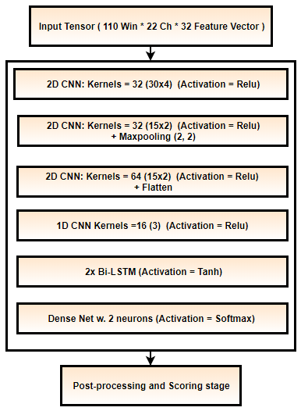
Figure 17. A CNN-LSTM network architecture for modeling context
In the P2 model, we use the original $26$-dimensional LFCC features augmented with six history features collected from the P1 model, making the input feature vector a $32$-dimensional feature vector. The additional six features consist of posteriors, onset and offset history for both the seizure and background classes. The posterior values for the onset and offset history features are scaled using an exponential function where the base of the function is estimated using three methods: one based on the domain knowledge, and two based on statistics of the training data. This feature augmentation process will be discussed in detail in the following chapter.
Hyperparameters associated with the kernel sizes of the CNN network are selected based on domain knowledge. The input shape of the network is $(110, 22, 32)$ because the input signal contains $11$ secs ($110$ frames) of data, $22$ TCP montage channels and $32$ features. We use $11$ secs of temporal context following the $2.5$ Hz-$10$ second rule discussed in Chapter 3. We use $32$ kernels during the first layer with a size of $(30, 4)$ where kernels operate on $30$ samples in the temporal dimension and $4$ electrode samples in the spatial dimension. The minimum duration that a seizure can have is $3$ secs (e.g., absence seizures). Since there are $10$ feature vectors per second, the temporal dimension is set to $30$. We focus on $4$ channels at a time in the spatial dimension to mimic how experts divide channels while visually reviewing an EEG signal. Note that the kernel size in the temporal domain is kept high to analyze a bigger window each iteration. But this approach can make the training process a bit unstable due to the non-stationary patterns present in the signal.
The output from the first layer of the 2D-CNN layer is learned using $32×32=1024$ kernels. The feature maps generated by the first layer are learned by the second layer with the same number of kernels but with half the size used in first layer. The second layer uses $(15, 2)$ kernels. Maxpooling (Goodfellow et al., 2017) is performed on the feature map outputs using a kernel size of $2×2$ samples. The third 2D-CNN layer is identical to the second layer but uses $64$ convolutional kernels. The fourth layer of the network is a $1$-dimensional (1D) CNN network. Output of the third layer is a $3$D tensor which is reshaped to a $2$D tensor by concatenating the vectors of last two dimensions. This reshaped data is passed to a 1D-CNN layer which has $16$ kernels of size $3$. All CNN layers use a ReLU nonlinearity function (Goodfellow et al., 2017). The output of the 1D-CNN layer is further reshaped to a 1D array and passed to the LSTM sequential layers. Two LSTM layers with sizes of $64$ and $128$ are used at the end of the network. The activation used for these sequential layers is a hyperbolic tangent function.
The CNN approach used here is different from conventional approaches used for image classification. We keep the kernel size large in the beginning and avoid maxpooling to allow first two layers to learn all the underlying EEG signal properties without loss of information. Channels of the CNN network are mapped to the $32$-dimensional feature vector. Since channels of the CNNs are optimized independently, the set of CNN kernels assigned to each feature are optimized independently during the first layer of the network. From Figure 17, we can see that there are $32$ kernels assigned to the first layer of the network. Because the dimensionality of the feature vector is $32$, we have total of $32×32=1024$ kernels. Each set of $32$ kernels is assigned to a dimension of the feature vector. Since we use $6$ history features, there are $32×6=192$ kernels learning solely the history collected from the P1 model’s detections.
Note that the network learns dependencies between the temporal and spatial dimensions via its convolutional kernels. The operations between kernels and input data are linear (e.g., convolution, affine, correlation). On the other hand, the onset-offset features along with each LFCC feature are processed independently in the first layer of the P2 model. Feature maps from the first layer are then combined for all convolutional channels where remaining network competes to better align the segment boundaries. This will be discussed in detail in Chapter 5.
Embedding the history of the previous system’s detection in this way helps the following model highlight the regions of interest and specifically focus on its deficiencies. For example, we know that the model can learn duration and distance from the previously detected event directly from the history features. These augmented features force the P2 model to put more emphasis on the P1 model’s low confidence detections. From the distance information of the recently detected events, the P2 model also learns the distribution of the recurrent seizures. Depending on how far the P2 model is from the previously detected event, it should (in theory) be able to predict seizures appearing in the near future.

Network Optimization
Optimization of a neural network involves minimization of a loss function, typically by using some variant of a gradient descent algorithm. The optimal set of parameters for a network, denoted, $W^{*}$, can be represented as:
$W^{*}= \underset{W}{argmin}{L\left(P_{W}, \hat{P_{W}}\right)}$ , (16)
where $L$ is the loss function. We choose our loss function based on cross-entropy. For our categorical labels shown in equation (12) and equation (14), categorical cross-entropy loss becomes:
$L_{cross-entropy}= H\left(P_{W}, \hat{P_{W}}\right)= H\left(P_{W}\right)+ D_{KL}(P_{W}, \hat{P_{W}})$ . (17)
The cross-entropy is estimated using the Kullback-Leibler divergence (Goodfellow et al., 2017).
During the training process, learning rate schedules are modified in three stages. The algorithm for doing this is summarized in Figure 18. During the first stage, we keep the learning rate high at $0.1$ and train the model for $4$ iterations. At this stage, the model avoids any spurious starting points and explores the error space. The model either escapes the area of convergence or settles near more stable regions of the error surface. During the second stage, we keep the learning rate constant but keep track of the training and cross-validation losses. Assuming that the cross-validation set and training set are similar, variation in the model’s training and cross-validation losses should be within expected ranges, if the model is not overtrained.
Algorithm 1: An annealing learning rate with backoff
Input: data trX, cvX , size seqLen × featDim
Stage1: Exploration of the error space
Initialize initLR, minValError , annealFactor
for i = 1, 2, 3, 4
scoreHistory ⟵ train w. high LR
end for
Stage 2: Stagnate w. Backoff
repeat
scoreHistory ⟵ train & crossvalidate w. high initLR
relativeTrLoss ⟵ TrLoss[-2] – TrLoss[-1]
relativeCvLoss ⟵ CvLoss[-2] – CvLoss[-1]
if CvLoss > $Δ^{Tol}$
Load previous epoch weights & Shuffle
end if
until relativeCvLoss > minValError
Stage 3: Anneal
repeat
scoreHistory ⟵ train w. learningRate
learningRate *= annealFactor
until learningRate == ∈
Figure 18. The learning rate schedule
The expected range is represented as $Δ^{Tol}$. If the model shows a huge difference between the train and cross-validation set losses, we backtrack and load the previous epoch’s weights. If two consecutive cross-validation losses are close, we can infer that the model’s performance has stagnated for the current learning rate, and we move to the third stage of training known as the annealing stage. In this stage, the learning rate, is reduced by half after each iteration until it reaches to some preset minimum value $ϵ$ (e.g., $1e06$). Note that, this annealing stage is different from the “learning rate annealing” method where each layer of the network is frozen and optimized with a different learning rate (Brock et al., 2017).
This technique was slightly modified for P2 models since there was no cross-validation set used. We skip stage $2$ of the algorithm and simply move to the annealing stage after exploring the error space for 4 iterations.

Postprocessing Steps
It is well known in machine learning research that a good heuristic can be very powerful tool to filter out statistical model errors. We apply a series of heuristics, summarized in Figure 19, to improve the system performance. These heuristics are very important in reducing the FA rate to an acceptable level. The first heuristic we apply is a popular method that focuses on a model’s confidence in its output. Probabilistic filters are implemented to only consider target events which are detected above a specified probability threshold. This method tends to suppress spurious long duration events (e.g., slowing) and extremely short duration events (e.g., muscle artifacts). This decision function is applied on the seizure (target) labels only. We compare each seizure label’s posterior with the threshold value. If the posterior is above the threshold, the label is kept as is. Otherwise, it is changed to the non-seizure label, which we denote as “background.”
Our second heuristic was developed after performing extensive error analysis. The most common types of errors we observed were false detections of background events as seizures ($FPs$) which tend to occur in bursts. Usually, these erroneous bursts occur for a very small duration of time (e.g., $3$ to $7$ secs). To suppress these, any seizure event whose duration is below a specified threshold is automatically considered as a non-seizure, or background event.
Figure 19. Postprocessing steps
Finally, we also implement a smoothing method that collapses sequences of two seizure events separated by a background event into one long seizure event. This is typically used to eliminate spurious background events. If seizures are observed in clusters separated by small intervals of time classified as background events, these isolated events are most likely part of one longer seizure event. In this method, we apply a nonlinear function that computes a pad time to extend the duration of an isolated event. If the modified endpoint of that event overlaps with another seizure event, the intervening background event is eliminated. We used a simple regression approach to derive a quadratic function that produces a padding factor:
$w(x) = -0.0083d 2 +0.45d - 0.66$ , (18)
where 𝑑 is the duration of the event. This method tends to reduce isolated background events when they are surrounding by seizure events, thereby increasing the specificity. Note that we can use functions such as hyperbolic tangent or sigmoid function with an offset to design a similar postprocessing approach.
The combination of these three postprocessing methods tends to decrease sensitivity slightly and reduce FAs by two orders of magnitude, so their impact is significant. The ordering in which these methods is applied is important. We apply them in the order described above to achieve optimal performance.

POSTERIOR FEATURES
In machine learning applications, we select the window size of a model to ensure that there is enough context to make an informed decision about the class label. This, in turn, minimizes the overall classification error. For example, in a speech recognition system, a sliding window approach is used to compute posterior probabilities of feature vectors and classify segments. These window durations are sufficiently long so dynamics of the spectrum can be used identify the fundamental acoustic unit of the language: a phone. Once phones are identified, a language model is applied as a prior probability to complete the Bayesian estimate. The language model converts phone probabilities into word probabilities, which in turn, are converted to N-gram or sentence probabilities to further postprocess the acoustic scores (Jelinek et al., 2001).
Similarly, in image classification, there are a known number of frames through which the model strides (slides), classifying each frame. Higher level knowledge about the image can be exploited in a manner like the way the language model is used to postprocess phone hypotheses (Litjens et al., 2017). In both these examples, evaluation is executed on segments, such as a phrase separated by silence in speech recognition or an image file. This is not practical for identifying seizure events because a seizure event can last as little as $3$secs or as long as several days. For a system to be useful, it must output a hypothesis shortly after the beginning of an event. A system cannot wait until the event has ended. This requirement is similar to the need for speech recognition systems to output hypotheses in real time for closed caption applications.
Our goal is to detect seizure events with as little latency as possible. Posterior features can be used to improve our ability to accurately estimate segments. The duration of a seizure event depends on a variety of factors (e.g., epilepsy type, medication). Modeling duration directly in a deep learning system, processing samples directly, or even using feature vectors, requires too high a dimensionality for the input because these segments can have very long durations. To learn the patterns related to a seizure segment, models use a sliding window approach and classify seizure events on a frame-by-frame basis. Each of these frames can be considered as an independently identically distributed (IID) variable that has no knowledge of its context. Consequently, this approach makes it more difficult for models to classify seizure events which evolve very slowly.
When we observe human annotators labeling data, it is clear they incorporate significant amounts of context before making a decision. A deep learning system needs to somehow incorporate similar information. We attempt this by augmenting the standard feature vector with posteriors from the P1 phase of processing. We refer to these new features as augmented history features.
A patient’s medical history and baseline activities in the EEG signal play an important role in a patient’s diagnosis (Tatum et al., 2014). In most cases, seizures in epilepsy patients occur in clusters. We hypothesize that the frequency of such recurrent seizures can be estimated based on their seizure types and signal morphologies. For example, when the first seizure event in a cluster is observed, the time and frequency evolution of its ictal discharges can help us predict subsequent seizure events. In P2 of the multiphase model, we indirectly incorporate this type of information about the history and frequency of occurrence of an event by adding posteriors from P1.
We convert posteriors from P1 into three types of features that provide information related to the probability of the current frame being epileptic. The difference in time between the most recent activity and the most recent previous seizure onset and offset is useful in predicting the current event. Since we need our system to be causal (and low latency), we only incorporate detected events from the past.

Feature Augmentation
Prior to training the P2 model, which can learn spatio-temporal properties of a seizure, we augment the existing feature vectors with the previous model’s hypotheses (e.g., P1). The P1 model learns ictal discharges on a per-channel basis. Features generated by the previous model’s posteriors can provide more insight into properties of the signal. These posteriors are used to create three types of augmented features. The first type of augmented feature is the posterior probability of each individual class estimated using equation (15). The second type of augmented feature is created from the estimated onset of a detected event. For each frame of the feature vector, we calculate the distance in time from the onset of a recently detected seizure event and bound it within the range $[0,1]$ by applying an exponential scaling function. The third type of augmented feature is created from the estimated offsets of the detected events. These features are bound between $[0,1]$ using the same method used for the second type of augmented feature.
The last two types of augmented features capture temporal information about the distance (in time) from a detected event’s onset and offset. These features indicate how far the current epoch/frame is from the previously detected event and how far the current epoch/frame is in the current event. That is why we will refer to these features as “history features.” The range of values for these duration measurements can vary significantly. For instance, a seizure event can last from 3 secs to several days. On the other hand, background events can last indefinitely (days to months if a patient is not seizing).
Patients with long duration or frequently occurring seizures are diagnosed differently than patients showing brief seizures. This is because longer or recurrent seizures are considered more severe and require immediate attention. Very brief seizures not associated with autonomic instability (loss of or nonvoluntary bodily functions) may differ unless a seizure interferes with a patient’s breathing process (Stafstrom & Carmant, 2015).
Recurrent seizures are expected to occur more frequently over a long period of time (e.g., hours or days). In some cases, recurrent seizures can occur every couple of minutes which add up to hundreds of seizures per $24$ hours (Yuan et al., 2013). That means when the first seizure is identified, we can expect more seizures soon. Recently detected events carry more information than an event detected further back in time. We use our P1 model’s detections to include this information as features. We mark these detections as a binary vector:
${\hat{s}}_{w}^{\left(n\right)}= \left[1_{sn}({\hat{x}}_{w}^{\left(0\right)}={sn}^{\left(0\right)}\text{)}\text{,}1_{sn}({\hat{x}}_{w}^{\left(1\right)}={sn}^{\left(1\right)}\text{)}\text{,}\text{…}\text{,}1_{sn}({\hat{x}}_{w}^{\left(N-1\right)}={sn}^{\left(N-1\right)}\text{)} \right]$ , (19)
where $n$ is the timestep in the record (or file) of duration $N$ epochs. The event distance from the previous onset/offset mark is captured via the cumulative function:
${\hat{Δ}}_{w}^{(n)}= \sum_{event_dist}{ŝ_{w}^{(n)}}$ , (20)
where$event_dist$represents the distance from the previous onset or offset mark. We perform this operation for both classes.
The detections are further converted into segments where each segment contains the distance from the last detected onset. If a new onset is not detected, the segment extends until the end of the record. This same approach is used for the offset segments. These segments representing the distance from last detected onsets and offsets are weighted by the equation:
${\hat{Δ}}_{w}^{(n)}weighted={\hat{ϕ}(d)}^{-{\hat{Δ}}_{w}^{(n)}}+ eps$ , (21)
where $n$ is the time step of the segment indicating distance of the current frame, and $\hat{ϕ}(d)$ is the estimated base value for the given frame. This estimated function is optimized from one of the three methods which learn the distributions of recurrent seizures with respect to the distance $d$ between two adjacent onsets or offsets. These methods are discussed in the following section. Finally, $eps$ is an offset value set to 1e-08 to introduce some denseness to the array.
The offset value, $eps$, is introduced because we feed the scaled history features to a CNN network in the P2 model. CNNs are designed to work with dense data. The generic CNNs used in P2 are not optimized for sparse data. In the image recognition field, to deal with the sparse representation of the data, preprocessing steps such as adding validity masks (Jaritz et al., 2018) have been developed. New variants of CNNs such as sparsity invariant CNNs have been proposed as well (Uhrig et al., 2017). In our case, adding a small offset value $eps$ avoids a degradation in performance.
Equation (21) is used to scale the onset and offset feature dimensions for both classes. Not only does it scale the value of the feature dimension based on its distance from the event, but also bounds it within the range $[0,1]$. This normalization helps the neural network learn faster (Ioffe & Szegedy, 2015). This feature augmentation process is summarized in Figure 20. We combine three derived history features for the seizure class, three derived history features for the background class and $26$ LFCC features discussed in the Section 4.2 for our P2 model.

Estimating the Scaling Function
Once the temporal information related to the onset and offset of the recently detected events is captured via the cumulative function as described in equation (20), we limit the range of this unbounded function to $[0,1]$ using a scaling function. This scaling function targets the frequency of recurrent seizures (e.g., seizures occurring every 50 secs). Although there are no ground-truth labels for this task, we try to estimate these values following a few heuristics and setting a lower bound for the decay rates.
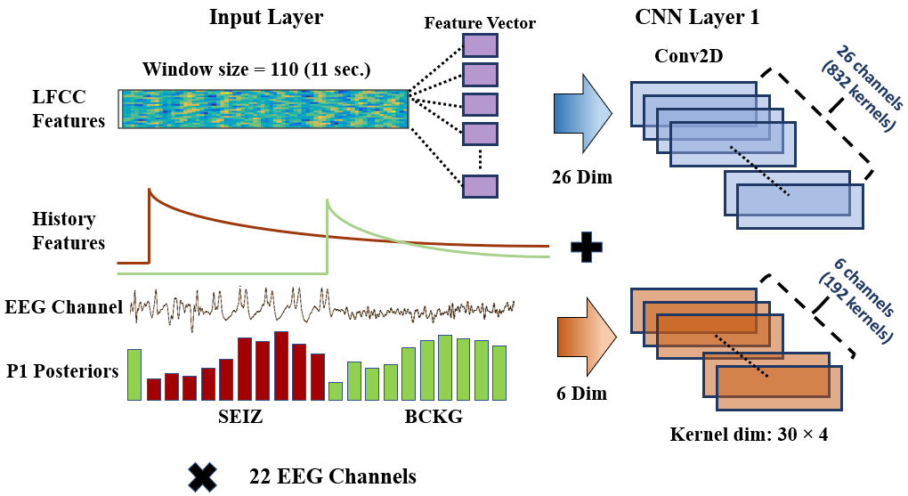
Figure 20. Feature augmentation using the P1 posteriors
From equation (21) we can see that $ϕ$ is important because it controls the decay rate. The intuition behind estimating this value is that, given the statistics of the signal morphologies, a model should be able to estimate the likelihood of the next recurring seizure (future ictal activities). At one point, this decay rate becomes so small that the difference between two adjacent datapoints approaches a small value (e.g., $1e^{-05}$). These datapoints represent the upper limit of the recurrence rate of a seizure as measured in time (e.g., duration in seconds). Small changes in the sequence of feature values makes it difficult for the models to learn events separated by long distances. We used three different approaches to estimate the value of $ϕ$: (1) heuristic scaling, (2) data-dependent scaling and (3) data-driven scaling.
We impose one common constraint in all three methods. Recurrent seizures occurring after 10 minutes are treated as outliers and ignored. Seizures recurring at such great intervals are less common and should be more difficult to model. The three methods for estimating the exponential scaling function are explained in detail in the following section.

Heuristic Scaling
A heuristically optimized method based on domain knowledge gives us an important starting point for benchmarking our baseline model. After gaining extensive experience in the EEG interpretation process, we hypothesize that most recurring seizures separated between a duration that ranges between 10 secs to 2 minutes can be predicted by observing their inter-ictal activities. This difference in time corresponds to a value $ϕ=1.035$ for the seizure class. We assign a value of 1.05 for other events such as artifacts and background events as their importance over time decreases rapidly. For instance, events such as eye blinks and chewing occur every one second or less. Some common background events such as a posterior dominant rhythm (PDR) or theta drowsiness only last for a few seconds. In the heuristic scaling approach, the long-term influence of recurring seizure events beyond two minutes are weighted very lightly (e.g., by assigning a scaling factor of $1e^{-03}$).

Data-dependent Scaling
For estimating the base $ϕ$ value of the exponential function defined in equation (21), we collect all the files of the TUSZ train set with recurrent seizures. We calculate the distances between the onsets and offsets for two adjacent seizures and plot their distribution. The TUSZ train set v1.2.1 contains only 198 files with recurring seizures. This is a fairly small amount of data. For this reason, we use the TUSZ train set v1.5.2, which has total of 356 files with recurrent seizures. Note that we only use statistics of the v1.5.2 training set to estimate the value of $ϕ$. We still use TUSZ v1.2.1 for training and evaluating all our seizure detection models.
The distribution of the distances between the onsets and offsets for a recurrent seizure can be seen in Figure 21. The majority of this distribution is below 100 secs. We set a duration threshold such that 80% of all recurrent seizures are included. The cumulative distribution function used to estimate the duration point corresponding to the 80th percentile can be defined as:
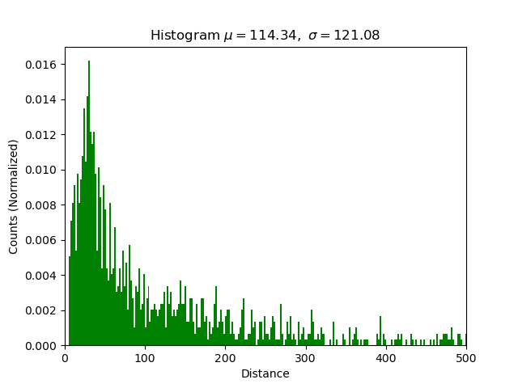
Figure 21. Onset/offset distance distribution of TUSZ train set v1.5.2
$F_{D}\left(d\right)= \sum_{d_{k}⩽d}{P_{D}\left(d_{k}\right)}$ , (22)
${\hat{Δ}}_{d-dep}=\arg_{d} F_{D}\left(d=0.8 × N\right)$ , (23)
where $P_{D}\left(d_{k}\right)$ is the probability mass function ($pmf$) of the distribution $D$, $F_{D}\left(d\right)$ is the cumulative function, $N$ is the total number of samples used in the distribution (e.g., $1476$ in our case), and ${\hat{Δ}}_{d-dep}$ is the estimated time difference that covers the 80th percentile. In this case, we estimate the value of and ${\hat{Δ}}_{d-dep}$ to be $187$ secs.
To estimate the base $ϕ$ value in equation (21), we use algorithm no. 2 shown in Figure 22. Using equation (21), we iterate through$ϕ$values in the range [1.0001, 1.5] (using 1,000 steps) and $Δ_{d}$ values in the range $0\text{-} 600$ secs. We calculate the difference between two scaled values by sweeping through $ϕ$ values. The $ϕ$ value which yields a difference of ${\hat{Δ}}_{w}^{(n)}$ weighted below some predefined value ${\breve{Δ}}_{dt}$ (e.g., $5e^{-04}$) at ${\hat{Δ}}_{d-dep}=187 \text{secs}$ is considered as the target base value of the exponential function. Following this data dependent approach based on the TUSZ training set, we estimate optimal value of $ϕ$ as $1.0161$ using the function $\hat{ϕ}\left(d\right)$.
Algorithm 2: Estimation of base $ø$
Input:
onset/offset_t-diff ${\hat{Δ}}_{d-dep}⟵187.0$,
min_decay_rate ${\breve{Δ}}_{dt}⟵5e-4$,
floor_offset $eps⟵1e-8$
Initialize
T-diff_range, $ø_range$, hit
for $ø$ in $ø$_range
do
$scaled_arr⟵ø^{T-diff_range}+ eps$ # Eq. 21
deltas_arr ⟵ calc_diff(scaled_arr) # Difference between two adjacent elements
hit = $ø$
until deltas_arr[${\hat{Δ}}_{d-dep}$] ⩾ ${\breve{Δ}}_{dt}$
estimated_$ø$ ⟵ hit
Figure 22. Algorithm for estimating base of the exponential scaler
The exponential curves scaled via the heuristic and data-dependent approaches are shown in Figure 23. We observe that the heuristic scaling function decays rapidly. Its decay rate reaches a small value, ${\breve{Δ}}_{dt}$, at 120 secs. Similarly, the data dependent scaling function has a relatively slower decay rate which reaches ${\breve{Δ}}_{dt}$ at $187 \text{secs}$. Even though the values of the data dependent scaling function are higher at the threshold of $187 \text{secs}$, the rate ${\breve{Δ}}_{dt}$ at which the following history features are scaled is extremely small for a neural network.

Data-driven Scaling
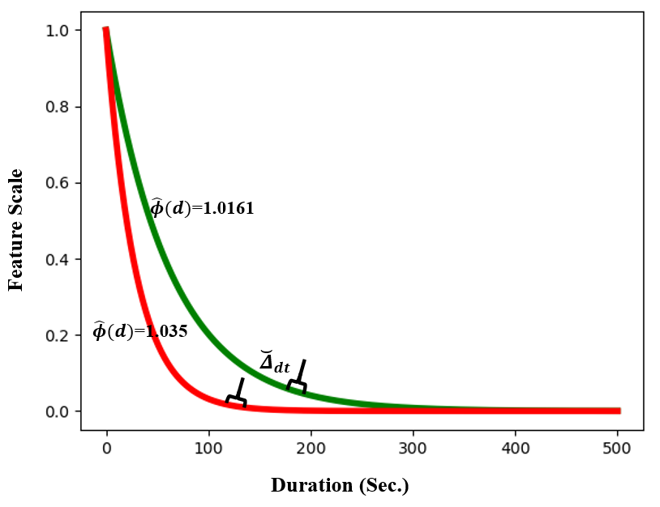
Figure 23. Heuristic (red) and data-dependent (green) scaling functions
In previous sections we estimated the base $ϕ$ value for equation (23) as a scalar. In this section, we will consider the frequency of the recurrent seizures as a distribution function. The rate of recurrence can be estimated based on the type of the seizure (e.g., absence) and its signal morphologies (e.g., 3-4 spike and wave complexes). In this section, instead of looking for a single optimal scalar value, we model a range of base values for the scaling function and normalize the P1 history features via a neural network density function. In contrast to the previous section, we estimate $ϕ$ for individual files/records. Each file in the database is assigned a label which corresponds to the rate at which recurrent seizures are observed. Similar to estimating values in a data-dependent manner (described in the previous section), we estimate optimal $ϕ$ values for each file using algorithm no. 2 described in Figure 22. We use these estimations as labels for modeling our class density function.
The distance between two adjacent seizures’ onset/offsets in a file may not be separated by a constant value. Additionally, the differences between two onset marks can be different than the differences between two offset marks. To resolve this, we ignore offset values and only use the differences between two adjacent onset marks. This is consistent with our observation that in practice, onsets should be given more importance. After collecting these differences, we take the mean among all onset time differences in a file. Unlike the data-dependent approach, we sample $ϕ$ values in the range $[1.01, 1.05]$ linearly using $41$ steps so that we limit the total number of classes and keep the complexity of our model manageable.
After collecting the time differences, we estimate $ϕ$ with a higher precision and round it so that it fits with the closest value in the 41 linearly split classes. We map these values to a set of numeric classes $S_{d}=\left(0,1,..,40\right)⟵(1.01, 1.015,..,1.05)$. Any estimates of $ϕ$ falling outside the higher range are given a default value of $1.035$. Any $ϕ$ estimates falling below the lower range are given a default value of $1.01$. Figure 24 shows the range of $ϕ$ for estimating the scaling function via the data-driven approach.
To train our neural network model, we select the seizure segments and add an additional $10$ sec offset to their onset and offset values to include some context. We perform a sliding window operation on these segments with a window size of $10$ secs and a frame size of $1$ sec with no zero-padding. We use $26$ dimensional LFCC feature vectors collected from these samples as inputs to our model. These samples are shuffled among all the seizure segments of the database and separated into minibatches of $64$ samples. No zero-padding is added to any of the segments or at the end of the file.
The network architecture for classifying the scaling factor can be seen in Figure 25. We use two 2D convolutional layers with batch normalization followed by a ReLU non-linearity. This is followed by an average-pooling layer which performs dimensionality reduction by a factor of 2 in the temporal dimension. The output is further reshaped so that the resultant vector is one dimensional. To learn these one-dimensional patterns, two hidden dense layers with sizes $128$ and $64$ with an ReLU activation function are added. Finally, the output dense layer with the softmax activation function has $41$ neurons which correspond to the $ϕ$ labels. The output of the model becomes:
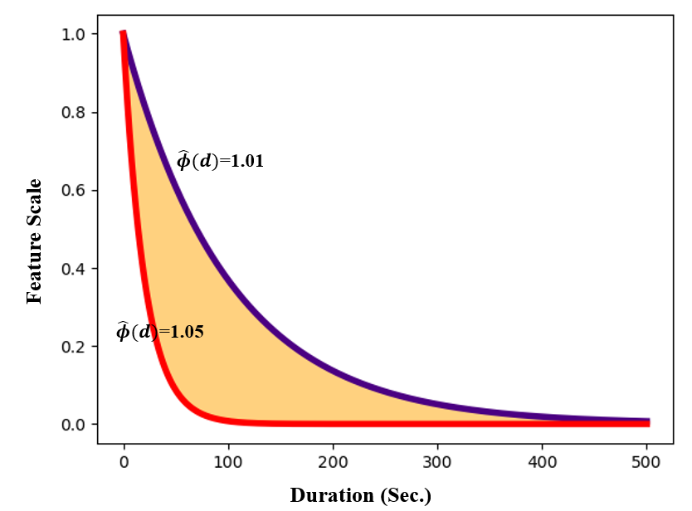
Figure 24. Range of the scaling function optimized via the data-driven approach
$ŝ_{D}=\underset{s_{D}∈S}{argmax}{{\hat{P}}_{D}}$ , (24)
where ${\hat{P}}_{D}$ is the output of the softmax function. The values of $ŝ_{D}$ are estimated classes ranging from $[0, 40]$. We obtain the corresponding $ϕ$ value associated with the class labels via:
$\hat{ø}=S_{d}(ŝ_{D})$ . (25)
We evaluated our model on the dev set for TUSZ v1.2.1 and compare its performance with the labels generated by algorithm no. 2. We collected hypotheses from all the frames of the seizure segments and consider one estimated $ϕ$ value as the final hypothesis for the segment. Since the default lower and upper bound $ϕ$ values of $1.01$ and $1.035$ were ubiquitous for the seizure segments, we give values other than these a higher priority. We collect the number of times each label is detected for a particular seizure segment. If the detections only include two default values, we consider the one which is observed more. If detections over a segment exceed these two values, we remove the default values from the list of detections and consider the most observed detection as a segment’s hypothesis. This is an attempt to spread out the output distribution of the model instead of over-detecting specific sets of labels. Nevertheless, our model tends to over-detect the default values of $1.01$ and $1.035$ for a majority of seizure segment.
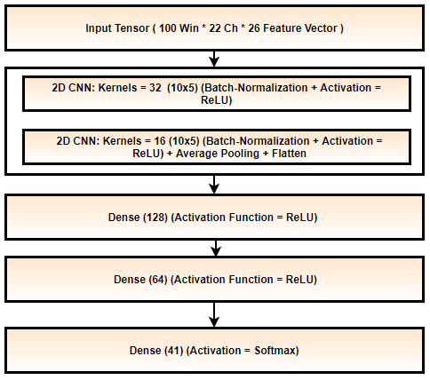
Figure 25. Data-driven scalar estimator
To model the density of the scaling factors, we use a range of values as labels to scale the posterior features. This problem is a multiclass classification problem where the labels represent the degree to which they are correct instead of simple binary hit/miss classification. The evaluation metric which scores these classes should be able to calculate the difference between the reference and hypothesis, which represents the degree to which a hypothesis was misclassified. We use a metric which evaluates the extent to which our model fails to detect a particular class. For example, a label corresponding to a $ϕ$ value of $1.13$ classified as $1.14$ should be penalized less than a value of $1.5$. For that reason, we use mean absolute error (MAE) for each class to analyze model’s performance.
There is a huge disparity between the number of samples associated with the specific labels (e.g., the label $1.01$ has $10,853$ instances whereas label $1.04$ has only $96$). We normalize the error based on the number of reference samples observed for a fair comparison. The MAE for each class can be seen in Figure 26. The model performs well within for $ϕ$ values ranging from $1.015$ to $1.038$ ($MAE=\sim 0.01$) whereas the error rates around the edges of the range for $ϕ$ are very high ($MAE=\sim 0.02).$ This means the model poorly classified the frequency of recurrent seizures occurring very frequently or occurring after a very long period of time. The values of $ϕ$ in the middle of this range are close to our estimates for the heuristic and data-dependent approaches.
We should be stricter about lower extremes for $ϕ$ than for higher extremes because labels corresponding to the lower extreme values (e.g., $1.01$) correspond to seizures recurring after a long period of time. If the exponential scaling function’s decay rate is higher, the influence of the history of the seizure drops significantly.
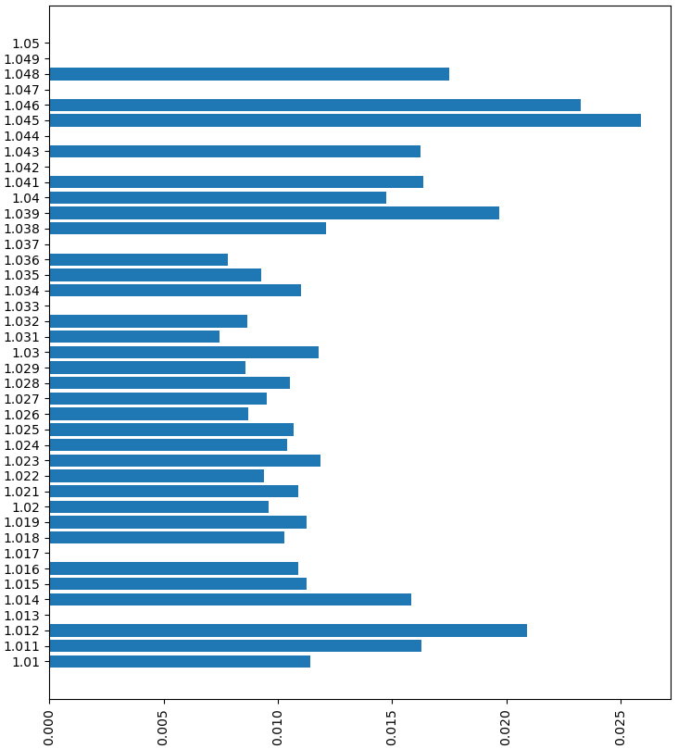
Figure 26. Mean absolute error for each class of the estimator for $ϕ$

EVALUATION METRICS
Machine learning model optimization is typically performed in four steps: (1) feature extraction, (2) training, (3) decoding, and (4) scoring. Feature extraction is performed by designing well-engineered, and in most cases reduced, quantities of variables which effectively represent the data in question. In machine learning, training is done in both supervised and unsupervised fashion. Supervised learning requires ground truth labels (e.g., support vector machine) while unsupervised learning doesn’t (e.g., k-nearest neighbors). Decoding is performed to classify unknown data samples. The evaluation, or scoring, step assesses the performance of the model against the reference data. Reference data is typically ‘held-out’ or blind, meaning it was not used in the training process.
There are, in general, two ways to score or evaluate machine learning technology: user acceptance testing (von Goethem & Hambling, 2013; Banchs et al., 2006) and objective performance metrics based on annotated reference data (Picone et al., 1990; Michel et al., 2017). User acceptance testing is slow, time-consuming, and expensive. It has never been a practical way to guide technology development because algorithm developers need rapid turnaround times on evaluations. Hence evaluations using objective performance metrics, such as sensitivity and specificity, are common in the machine learning field. With this approach, it is very important to have a rich evaluation dataset and a performance metric that correlates well with user and application needs. The metric must have a certain level of granularity so that small differences in algorithms can be investigated and parameter optimizations can be evaluated.

Fundamental Scores and Derived Measures
In machine learning research, performance of a system is assessed using four fundamental quantities: true positives (TP), true negatives (TN), false positives (FP) and false negatives (FN). The quantities TP and TN represent the correct detections and rejections whereas FP and FN represent errors (false alarms and misses). These fundamental scores can be used to calculate further derived measures such as sensitivity, specificity, accuracy, F-scores, etc. In this work, we prefer the use of the quantity false alarm (FA) rate per 24 hours to characterize the FP performance since this is an important metric in clinical applications.
Most supervised machine learning algorithms output different types of bounded (class probability) or unbounded (log-likelihood) confidence measures for the hypotheses. It is possible to put a constraint on one of the performance measures, such as TP, and evaluate it against the other (e.g., FP). A Receiver Operating Characteristic (ROC) (Hajian-Tilaki, 2013) or a Detection Error Trade-off (DET) curve (Martin et al., 1997) calculates TPs and TNs respectively by sweeping through a range of operating points. An ROC or DET curve provides a complete view of performance.
In subsequent sections, we will discuss various metrics which are traditionally used for scoring temporal sequences. We have adapted these to the EEG problem and discuss their relative merits. We introduce a new metric, Time Aligned Event Scoring (TAES), that is specifically designed to measure the accuracy of EEG events by carefully considering the accuracy of the segmentation information.

Evaluation Metrics
Researchers design algorithms to optimize fundamental metrics such as TP. This is an unavoidable component of machine learning research. For example, evaluation of voice keyword search technology was carefully studied in the Spoken Term Detection (STD) evaluations conducted by NIST (Wegmann et al., 2013; Fiscus et al., 2006). FA rate played an important role in these evaluations. On the other hand, EEG research groups often consider an EEG event as a single target or split the time axis into fixed-sized frames where each frame is considered an individual target (Vidyaratne & Iftekharuddin, 2017; Knowles & Ghahramani, 2007). This tends to over-emphasize the importance of a single long event.
We will discuss five different scoring metrics: two of which were adapted from the speech recognition community; two of which are drawn from the EEG community; and one which was developed for this study. The metrics are briefly described below:
- NIST Actual Term-Weighted Value (ATWV): based on NIST’s popular scoring package (F4DE v3.3.1), this metric uses an objective function that accounts for temporal overlap between the reference and hypothesis.
- Dynamic Programming Alignment (DPALIGN): similar to the NIST package known as SCLite (Fiscus, 2017), this metric uses a dynamic programming algorithm to align terms.
- Epoch-Based Sampling (EPOCH): treats the reference and hypothesis as temporal signals, samples each at a fixed epoch duration, and counts errors accordingly.
- Any-Overlap (OVLP): assesses the overlap in time between a reference and hypothesis event, and counts errors using binary scores for each event.
- Time-Aligned Event Scoring (TAES): similar to (4) but considers the percentage overlap between the two events and weights errors accordingly.
We demonstrate the differences between these approaches using several carefully selected examples that illustrate their strengths and weaknesses. These examples are drawn on a compressed timescale for illustrative purposes.

NIST Actual Term Weighted Value (ATWV)
ATWV is a measure that balances sensitivity and FAs. ATWV assigns an application-dependent reward to each correct detection and penalizes each incorrect detection. A perfect system results in an ATWV of 1.0, while a system with no output results in an ATWV of 0. It is possible for ATWV to be less than zero if a system is doing very poorly (for example a high FA rate). Experiments in voice keyword search have shown that an ATWV greater than 0.5 typically indicates a promising or usable system for information retrieval by voice applications. A similar range is applicable to EEG analysis.
The metric accepts as input a list of N-tuples representing the hypotheses for the system being evaluated. Each of these N-tuples consists of a start time, end time and system detection score. These entries are matched to the reference annotations using an objective function that accounts for both temporal overlap between the reference and hypotheses and the detection scores assigned by the system being evaluated. These detection scores are often likelihood or confidence scores (Wegmann et al., 2013). The probabilities of misses and FAs at a detection threshold θ are computed using:
$P_{Miss\left(kw,θ\right)}=1- {N_{Correct\left(kw,θ\right)}}/{N_{Ref\left(kw\right)}} ,$ (26)
$P_{FA\left(kw,θ\right)}={N_{Spurious\left(kw,θ\right)}}/{N_{NT\left(kw\right) }},$ (27)
where $N_{Correct\left(kw,θ\right)}$ is the number of correct detections of terms with a detection score greater than or equal to $θ$, $N_{Spurious\left(kw,θ\right)}$ is the number of incorrect detections of terms with a detection score greater than or equal to $θ$, and $N_{NT\left(kw\right)}$ is number of non-target trials for the term $kw$ in the data. The number of non-target trials for a term is related to the total duration of the source signal,$T_{Source}$, measured in seconds. It is computed as $N_{NT\left(kw\right)}= T_{Source}-N_{Ref\left(kw\right)}.$
A term-weighted value is then computed that specifies a trade-off between misses and FAs. ATWV is defined as the value of TWV at the system’s chosen detection threshold. Using a predefined constant, $β$, that was optimized experimentally ($β = 999.9$) (Fiscus et al., 2007), ATWV is computed using:
${TWV}_{\left(kw,θ\right)}=1- P_{Miss\left(kw,θ\right)}- {β P}_{FA\left(kw,θ\right)} .$ (28)
A standard implementation of this approach is available at (Fiscus, 2017). This metric has been widely used throughout the human language technology community for many years.
To demonstrate the features of this approach, consider the case shown in Figure 27. The hypothesis for this segment consists of several short seizure events while the reference consists of one long event. The ATWV metric will assign a TP score of $100\%$ because the midpoint of the first event in the hypothesis annotation is mapped to the long seizure event in the reference annotation. This is somewhat generous given that $50\%$ of the event was not detected. The remaining $5$ events in the hypothesis annotation are counted as false positives. The ATWV metric is relatively insensitive to the duration of the reference event, though the 5 false positives will lower the overall performance of the system. The important issue here is that the hypothesis correctly detected about $70\%$ of the seizure event, and yet because of the large number of false positives, it will be penalized heavily.
In Figure 28 we demonstrate a similar case in which the metric penalizes the hypothesis for missing three seizure events in the reference. Approximately $50\%$ of the segment is correctly identified. This type of scoring penalizing repeated events that are part of a larger event in the reference might make sense in an application like voice keyword search because in human language each word hypothesis serves a unique purpose in the overall understanding of the signal. However, for a two-class event detection problem such as seizure detection, such scoring too heavily penalizes the hypothesis for splitting a long event into a series of short events.

Dynamic Programming Alignment (DPALIGN)
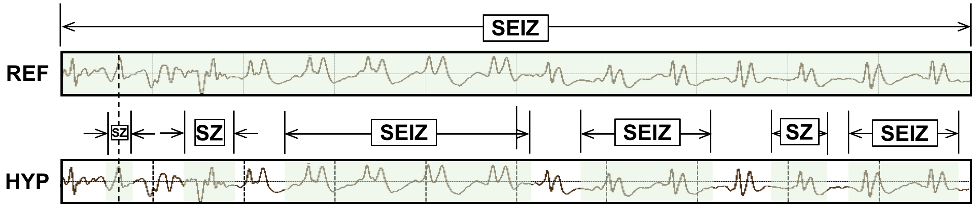
Figure 27. ATWV scores this segment as 1 TP and 5 FPs.
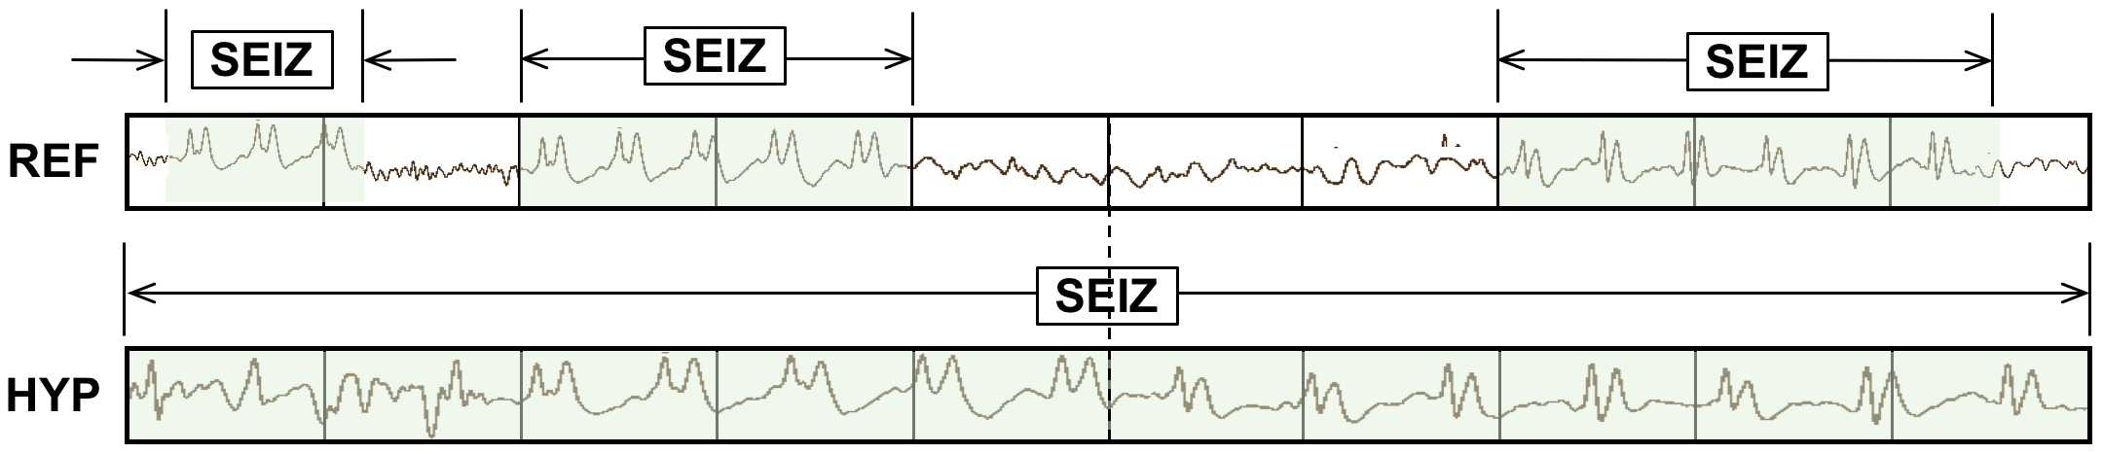
Figure 28. ATWV scores this segment as 0 TP and 3 FN events.
The DPALIGN metric essentially performs a minimization of an edit distance (the Levenshtein distance) (Picone et al., 1990) to map the hypothesis onto the reference. DPALIGN determines the minimum number of edits required to transform the hypothesis string into the reference string. Given two strings, the source string $X = [x_{1}, x_{2}, ..., x_{n}]$ of length $n$, and target string $Y = [y_{1}, y_{2}, ..., y_{m}]$ of length $m$, we define $d_{i,j}$, which is the edit distance between the substring $x_{1}:x_{i}$ and $y_{1}:y_{j}$, as:
$d_{i,j}= \left\{\begin{matrix}d_{i-1,j}+del \\ d_{i,j-1}+ins \\ d_{i-1,j-1}+sub\end{matrix}\right. .$ (29)
The quantities being measured here are often referred to as substitution (sub), insertion (ins) and deletion (del) penalties. For this study, these three penalties are assigned equal weights of $1$. A dynamic programming algorithm is used to find the optimal alignment between the reference and hypothesis based on these weights. Though there are versions of this metric that perform time-aligned scoring in which both the reference and hypothesis must include start and end times, this metric is most commonly used without time alignment information.
The metric is best demonstrated using the two examples shown in Figure 29. In the first example, the reference annotation has a series of $7$ events, while the hypothesis contains $5$ events. The hypothesis substitutes background for the second seizure event, omits the third seizure event and the last background event. Hence, there are a total of three errors: two deletions and one substitution. In the second example, the reference annotation and hypothesis have been swapped to demonstrate the symmetry of the error calculations. The hypothesis generated two insertions and one substitution.
Ref: bckg seiz SEIZ SEIZ bckg seiz bckg
Hyp: bckg seiz BCKG **** bckg seiz ****
(Hits: 4 Sub: 1 Ins: 0 Del: 2 Total Errors: 3)
Ref: bckg seiz BCKG **** bckg seiz ****
Hyp: bckg seiz SEIZ SEIZ bckg seiz bckg
(Hits: 4 Sub: 1 Ins: 2 Del: 0 Total Errors: 3)
Figure 29. DPALIGN aligns symbol sequences based on edit distance, ignoring the actual time alignments present in the reference annotation and the system output.

Epoch-Based Sampling (EPOCH)
Epoch-based scoring uses a metric that treats the reference and hypothesis as signals. These signals are sampled at a fixed epoch duration. The corresponding label in the reference is compared to the hypothesis. This process is depicted in Figure 30. Epoch-based scoring requires that the entire signal be annotated (every second of the signal must be accounted for in the reference and hypothesis annotations), which is normally the case for sequential decoding evaluations. It attempts to account for the amount of time the two annotations overlap, so it directly addresses the inconsistencies demonstrated in Figure 27 and Figure 28.
One important parameter to be tweaked in this algorithm is the frequency with which we sample the two annotations, which we refer to as the scoring epoch duration. It is ideally set to an amount of time smaller than the unit of time used by the classification system to make decisions. For example, the hypothesis in Figure 30 contains decisions made for every $1$ sec of data. The scoring epoch duration should be set less than $1$ sec. We set this parameter to $0.25$ sec for most of our work because our analysis system epoch duration is typically $1$ sec. We find in situations like this the results are not overly sensitive to the choice of the epoch duration as long as it is below $1$ sec. This parameter simply controls the precision used to assess the accuracy of segment boundaries.
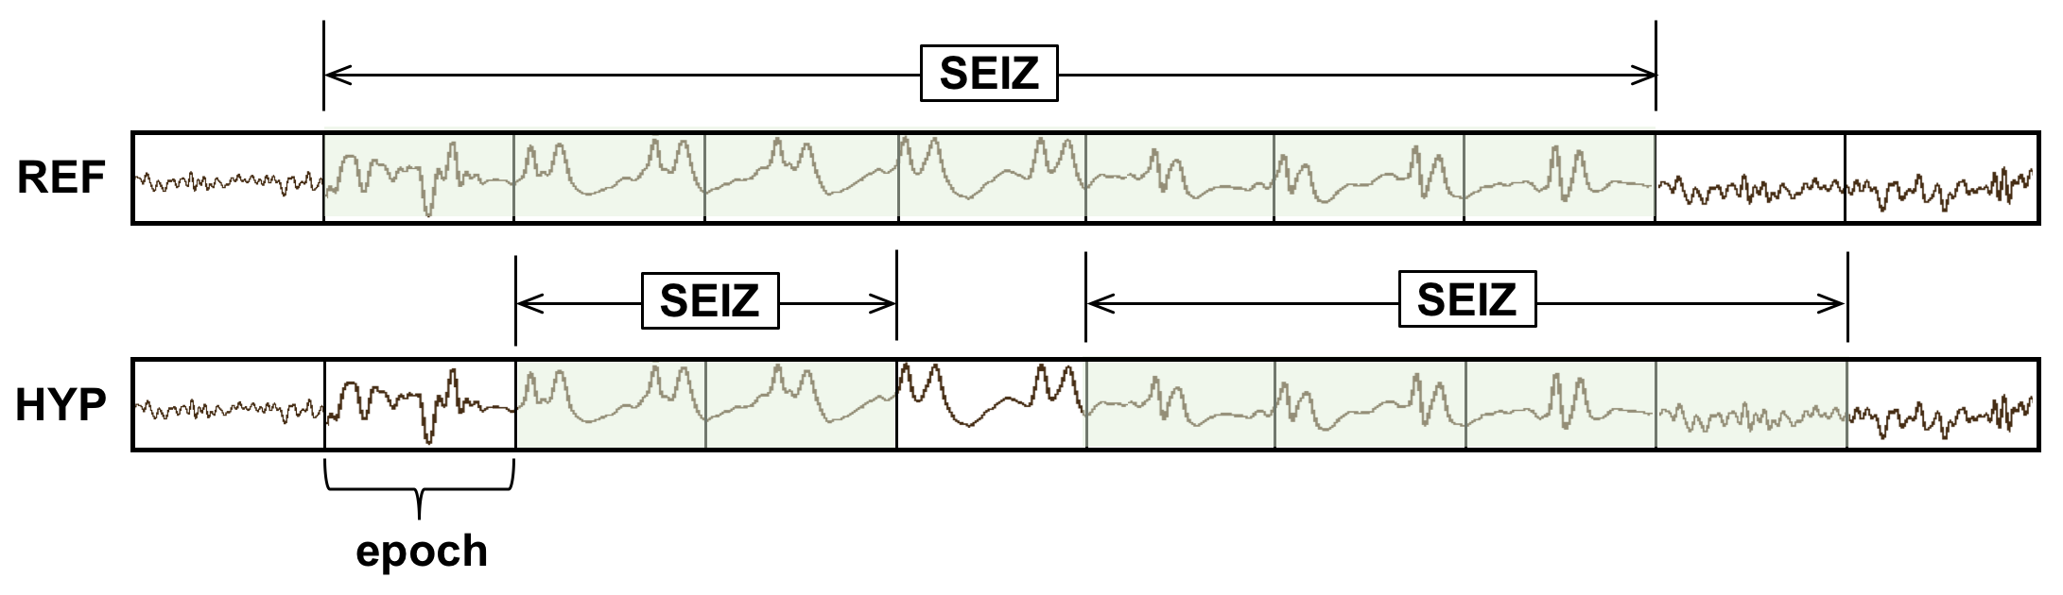
Figure 30. EPOCH scoring directly measures the similarity of the time-aligned annotations. TP, FN and FP are $5$, $2$ and $1$ respectively.
Because EPOCH scoring samples the annotations at fixed time intervals, it is inherently biased to weigh long seizure events more heavily. For example, if a signal contains one extremely long seizure event (e.g., $1,000$ secs) and two short events (e.g., each $10$ secs in duration), the accuracy with which the first event is detected will dominate the overall scoring. Since seizure events can vary dramatically in duration, this is a cause for concern.

Any-Overlap Method (OVLP)
The OVLP metric is a popular choice in the neuroengineering community (Gotman et al., 1997; Wilson et al., 2003) due to difficulties associated with the accurate annotations of targets. OVLP is a more permissive metric that tends to produce much higher sensitivities. If an event is detected in close proximity to a reference event, the reference event is considered correctly detected. If a long duration event in the reference annotation is detected as multiple shorter duration events in the hypothesis, the reference event is also considered correctly detected. Multiple events in the hypothesis annotation corresponding to the same event in the reference annotation are counted as detected for the overlapping reference event. Duration of the events or partial overlaps are ignored during scoring which tends to yield higher sensitivities.
The OVLP scoring method is demonstrated in Figure 31. It has one significant tunable parameter – a guard band that controls the degree to which a misalignment is still considered as a correct match. In this study, we use a guard band of zero. The guard band needs to be tuned based on the needs of the application. Sensitivity generally increases as the guard band is increased.

Time-Aligned Event Scoring (TAES)
Though EPOCH scoring directly measures the amount of overlap between the annotations, there is a tendency for this metric to too heavily weight single long duration events. Seizure events can vary in duration from a few seconds to days. In some applications, correctly detecting the number of events is as important as their duration. Hence, the TAES metric was designed as a compromise between these competing constraints. The essential parameters for calculation of sensitivity and specificity such as TP, TN, and FP for the TAES scoring metric are defined as follows:
$TP=\frac{H_{stop}-H_{start}}{{Ref}_{dur}}, where R_{start} ≤H ≤ R_{stop },$ (30)
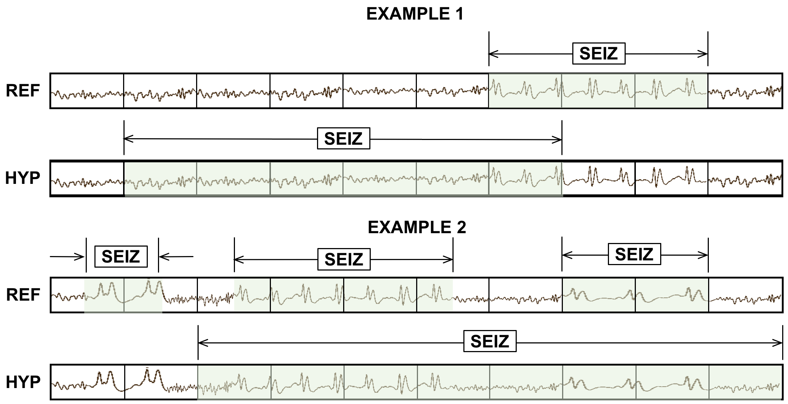
Figure 31. OVLP scoring is very permissive about the degree of overlap between the reference and hypothesis. The TP score for Example 1 is 1 with no false alarms. In Example 2, the system detects 2 out of 3 seizure events, so the TP and FN scores are 2 and 1 respectively.
$TN=\frac{{1-(TH}_{stop}-{TH}_{start})}{{Ref}_{dur}}, where R_{start} ≤H ≤ R_{stop} ,$ (31)
$FP=\left\{\begin{matrix}\frac{H_{stop}- R_{stop}}{{Ref}_{dur}}, & if H_{stop}≥ R_{stop}{, H}_{start}≥ R_{start} and H_{stop}- R_{stop}≤1, \\ \frac{R_{start}- H_{start}}{{Ref}_{dur}}, & if R_{start}≥ H_{start}, R_{stop}≥ H_{stop} and R_{start}- H_{start}≤1, \\ 1, & otherwise.\end{matrix}\right.$ (32)
where $H$ and $R$ represent the reference and hypothesis events respectively, and ${Ref}_{dur}$ represents the duration of the reference events.
TAES gives equal weight to each event, but it calculates a partial score for each event based on the amount of overlap. The TP score is the total duration of a detected term divided by the total duration of the reference term. The FN score is the fraction of the time the reference term was missed divided by the total duration of the reference term. The FP score is the total duration of the inserted term divided by total amount of time this inserted term was incorrect according to the reference annotation. False positives are limited to a maximum of one per event. Therefore, a single FP event contributes only a fractional amount to the overall FP score if it correctly detects a portion of the same event in the reference annotation (partial overlap). Moreover, if multiple reference events are detected by a single long hypothesis event, all but the first detection are considered as FNs. These properties of the metric help manage the tradeoff between sensitivity and FAs by balancing the contributions from short and long duration events. An example of TAES scoring is depicted in Figure 32.
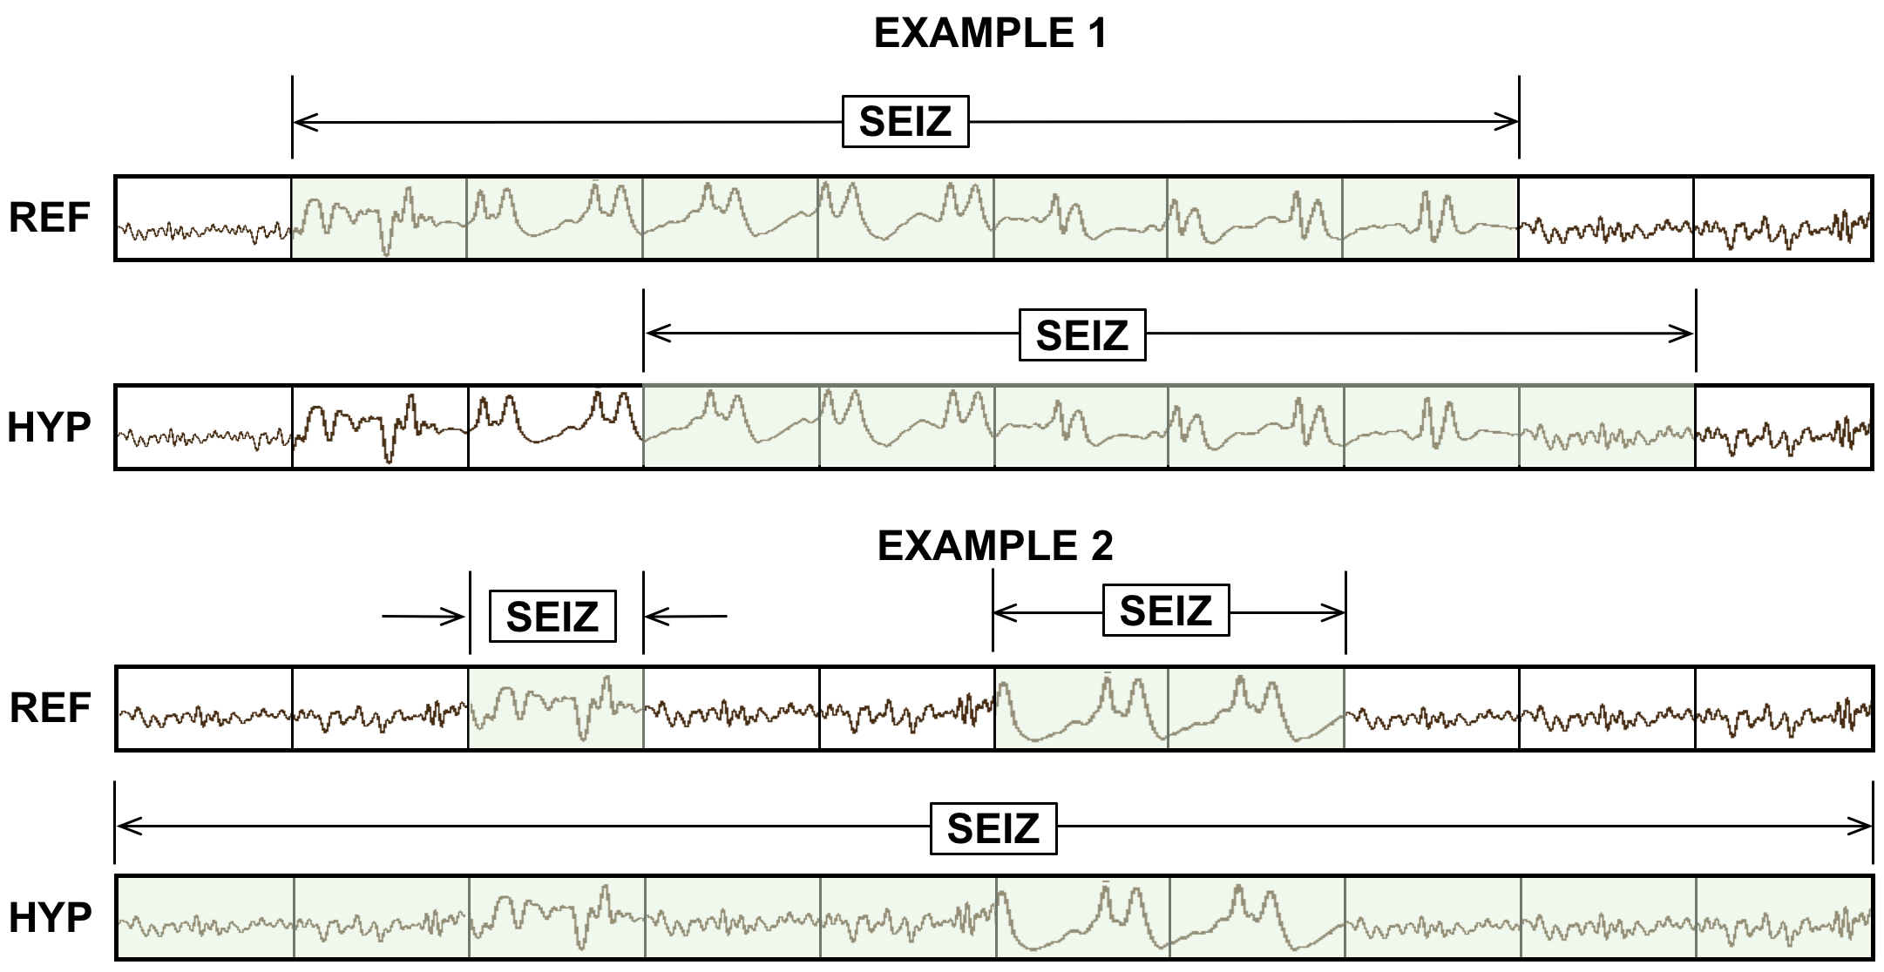
Figure 32. TAES scoring accounts for the amount of overlap between the reference and hypothesis. TAES scores Example 1 as 0.71 TP, 0.29 FN and 0.14 FP. Example 2 is scored as 1 TP, 1 FN and 1 FP.

A Comparison of Metrics
A simple example of how these metrics compare on a specific segment of a signal is shown in Figure 33. A $10$-sec section of an EEG signal is shown subdivided into $1$-sec segments. The reference has three isolated events. The system being evaluated outputs one hypothesis that starts in the middle of the first event and continues through the remaining two events.
ATWV scores the system as $1$ TP and $2$ FNs since it assigns the extended hypothesis event to the center reference event and leaves the other two undetected. The ATWV score is $0.33$ for seizure events, 0.25 for background events, resulting in an average ATWV of $0.29$. The sensitivity and FAs for this metric are $33\%$ and $0$ respectively.
DPALIGN scores the system the same way since time alignments are ignored and the first event in each annotation are matched together, leaving the other two events undetected.
The EPOCH method scores the alignment $5$ TP, $3$ FP and $1$FN using a $1$-sec epoch duration because there are $4$ epochs for which the annotations do not agree and $5$ epochs where they agree. The sensitivity is $83.33\%$ and FAs are very high because of the $3$ FPs.
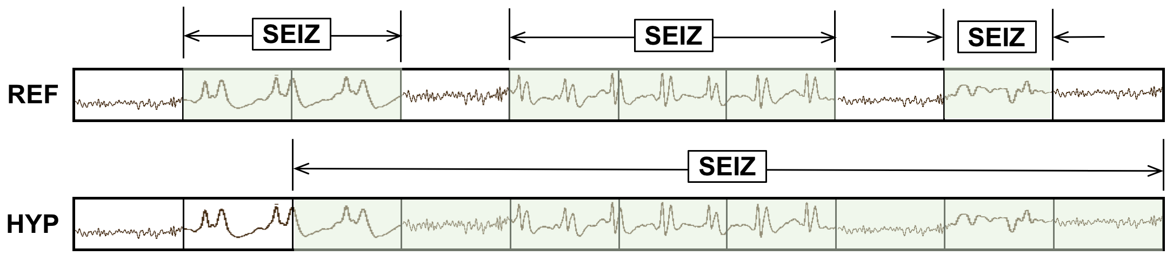
Figure 33. An example that summarizes the differences between scoring metrics
The OVLP method scores the segment as $3$ TP and $0$ FP because detected events have partial to full overlap with all the reference events, giving a sensitivity of $100\%$ with$0$ FAs. TAES scores this segment as $0.5$ TP and $2.5$ FN because the first event is only $50\%$ correct and there are FN errors for the 5th-9th epochs (an example of multiple overlapping reference events), giving a sensitivity of $16.66\%$ and a high FA rate.
It is difficult to conclude from this example which of these measures are most appropriate for EEG analysis. However, we see that ATWV and DPALIGN generally produce similar results. The EPOCH metric produces larger counts because it samples time rather than events. OVLP produces a high sensitivity while TAES produces a low sensitivity but relatively higher FAs.
Comparing performance on real data provides a more informative view of the differences between these metrics. In Table 2, we evaluated five hybrid architectures. We adjusted each model so that each model performed at approximately the same operating point according to OVLP (sensitivity close to $35\%$). Even though the systems performed similarly according to OVLP, the other metrics show significant differences between the systems. For example, the IPCA/LSTM and HMM/LSTM systems have relatively higher sensitivities according to the EPOCH metric, indicating that these systems tend to detect longer seizure events. The CNN/LSTM system has a relatively low sensitivity according to the TAES and EPOCH metrics, which indicates that it misses longer seizure events. Similarly, if the sensitivity is relatively high for TAES and relatively low for EPOCH, this is an indication that the system tends to detect a majority of smaller to moderate events precisely regardless of the duration of an event.
A comparison of ATWV scores with the other metrics gives diagnostic information such as whether a system accurately detects the midpoint of an event and whether the system splits long events into multiple short events. This type of analysis helps us understand alignments between the reference and hypothesis events and whether multiple short bursts of seizure events need to be aggregated into a single unique event.
We use the CNN-LSTM model from Table 2 as our baseline model in this dissertation. It is worth understanding its behavior via different scoring metrics. Our baseline model sensitivities according ATWV, DPALIGN and OVLP are within a range of $30$% to $33$%. The sensitivities according to the EPOCH and TAES sensitivities are in the range of $9$% to $13$%. Since the EPOCH and TAES metrics score events by considering partial overlaps, this drastic difference between sensitivities suggests that the baseline system detects seizure events that have a very short duration.
Table 2. Performance of machine learning architectures according to derived metrics
Metric | Measure | HMM/  SdA | HMM/  LSTM | IPCA/  LSTM | CNN/  MLP | CNN/  LSTM
ATWV | Sensitivity | 30.35% | 26.73% | 24.73% | 29.52% | 30.34%
 | Specificity | 61.38% | 68.93% | 64.51% | 65.87% | 93.15%
 | FA/24 hr. | 98.65 | 75.59 | 94.41 | 94.25 | 12.78
 | ATWV | -0.8392 | -0.8469 | -0.4628 | -0.7971 | 0.1737
DPALIGN | Sensitivity | 44.11% | 33.77% | 35.77% | 43.35% | 32.46%
 | Specificity | 66.87% | 72.99% | 69.59% | 71.49% | 95.17%
 | FA/24 hr. | 86.15 | 66.98 | 81.17 | 77.67 | 10.19
EPOCH | Sensitivity | 20.71% | 50.46% | 51.02% | 65.03% | 9.784%
 | Specificity | 98.22% | 94.82% | 94.09 | 91.55% | 99.84%
 | FA/24 hr. | 1418.02 | 4133.34 | 4711.58 | 6738.82 | 125.79
OVLP | Sensitivity | 35.35% | 30.05% | 32.97% | 39.09% | 30.83%
 | Specificity | 73.35% | 80.53% | 77.57% | 76.84% | 96.86%
 | FA/24 hr. | 77.39 | 60.92 | 73.52 | 77.19 | 6.75
TAES | Sensitivity | 17.29% | 22.84% | 22.12% | 31.58% | 12.48%
 | Specificity | 66.04% | 70.41% | 66.64% | 64.75% | 95.24%
 | FA/24 hr. | 82.26 | 68.31 | 83.01 | 91.53 | 7.54

On the other hand, the baseline model yields a very small false alarm rate according to all the metrics. Since the EPOCH and TAES false alarm rate is very low, we can conclude that model doesn’t hypothesize events outside of the boundaries of an event defined in the reference annotations. These findings are further confirmed in the following chapter where we analyze our baseline model’s performance as a function of the duration of a seizure event.
We can also see that ATWV and DPALIGN metrics produce FA rates higher than OVLP and TAES ($10$-$13$ FAs according to ATWV and DPALIGN compared to $6$ to $8$ FAs according to OVLP and TAES). This suggests that the baseline model has many instances where multiple hypothesis events overlap with a unique reference event. In contrast, the HMM-LSTM system shows the opposite trend where its EPOCH and TAES sensitivities are relatively higher ($50$% and $23$%, respectively) with a very high FA rate ($68$ and $4,133$, respectively). These higher sensitivities and FA rates suggest that the hypotheses produced by this model extend beyond the boundaries of the reference event. The significant difference between the EPOCH and TAES sensitivities suggests that the model favors extremely long seizure events since the EPOCH matric is inherently biased towards longer seizure events. This is one of the major reasons why the TAES metric was developed – we want to weigh each seizure event equally regardless of its duration.

EXPERIMENTAL RESULTS
In Chapter 4, we introduced the multiphase model. In this chapter we evaluate performance of the multiphase model for seizure detection and segmentation. We will demonstrate that the P2 model (CNN-LSTM) is able to learn deficiencies of the P1 model and improve performance by delivering better segmentation. We will support this claim by providing numerical comparisons with our previous best system (Golmohammadi et al., 2018). Performance will be analyzed in terms of sensitivity and specificity using two scoring metrics, OVLP and TAES. Receiver Operating Curve (ROC) plots will also be used to confirm our findings.
Table 3. TUSZ v1.2.1 statistics
Description | Train | Dev | Eval
Patients | 264 | 50 | 50
Sessions | 581 | 239 | 229
Files | 1989 | 1015 | 985
#Seizure events | 1254 | 679 | --
Seizure Dur (sec.) | 78,838 | 58,322 | --
Total Dur (sec.) | 1,188,313 | 617,102 | 647,948

Database
We will use the TUH EEG Seizure Corpus (TUSZ) v1.2.1 (Shah et al., 2018) to evaluate performance. The corpus is partitioned into training (train), development test data (dev) and blind evaluation data (eval), which makes it ideal for machine learning research. Some summary statistics for TUSZ v1.2.1 are shown in Table 3. The number of seizures and their total duration are not provided for the eval set to observe the integrity of this set as a blind evaluation set. No parameters were tuned based on results on the evaluation set.
TUSZ v1.2.1 consists of a variety of seizure types including absence, tonic-clonic and myoclonic. There are two types of annotations available – channel-based and term-based. Term-based annotations are formed by making an aggregate decision for a segment based on the channel-based annotations (Ferrell et al., 2020). We used channel-based annotations to develop the P1 model, which includes channel-based LSTM decoders, and term-based annotations to develop the P2 model.

Evaluation of the P2 Models
The P2 models are designed to use augmented features generated by the P1 model. The P1 model learns epileptiform events related to seizures. These posterior features are updated to embed temporal history of previously detected events. In Chapter 5, we discussed three different methods to scale the history features so that they can be bound between the range $[0, 1]$. The three P2 models, namely P2 heuristic, P2 data-dependent, and P2 data-driven, were developed using specific scaling techniques. These P2 models using augmented features were trained on the TUSZ v1.2.1 train and evaluated on the TUSZ v1.2.1 dev. In this section, we will compare all three model’s performance and pick one as the final P2 model for the multiphase model. Since we are primarily interested in the model’s capability in identifying seizure events, we will consider the OVLP method as the primary evaluation metric for making these decisions.
The performance of the P2 models on TUSZ dev, TUSZ eval and DUSZ eval sets are tabulated in Table 4, Table 5 and Table 6 respectively. We can see that average sensitivity for the P2 Heuristic is approximately $42\%$. Similarly, FAs are in the range of $10\text{-}16$ per $24$ hours. On the other hand, the P2 Data-dependent model delivers a much lower sensitivity with a significantly lower FA rate. The data-dependent model performs very well on the DUSZ eval set yielding a sensitivity of $37. 44\%$ with only $7.73$ FAs per $24$ hours. Finally, the P2 Data-driven model delivers very high FA rates ($9\text{-}23$ per $24$ hours).
The P2 Heuristic model performs equally well on all three data sets and consistently yields relatively lower FA rates except for the DUSZ eval set. However, it is hard to select the best performing system among the three because they are operating at different points on their respective ROC curves. Later we will analyze performance using ROC curves.
Table 4. P2 model performance on the TUSZ dev set (P2 variants)
Metric | Measure | P2 Heuristic | P2 Data-dependent | P2 Data-driven
OVLP | Sensitivity | 41.16% | 28.02% | 38.24%
 | Specificity | 95.29% | 97.62% | 94.41%
 | FAs/24 hrs | 11.69 | 5.77 | 14.08

Table 5. P2 model performance on the TUSZ eval set (P2 variants)
Metric | Measure | P2 Heuristic | P2 Data-dependent | P2 Data-driven
OVLP | Sensitivity | 42.02% | 21.20% | 34.14%
 | Specificity | 96.09% | 98.35% | 96.40%
 | FAs/24 hrs | 10.02 | 4.136 | 9.22

Table 6. P2 model performance on the DUSZ eval set (P2 variants)
Metric | Measure | P2 Heuristic | P2 Data-dependent | P2 Data-driven
OVLP | Sensitivity | 41.75% | 37.44% | 40.60%
 | Specificity | 85.71% | 92.72% | 81.03%
 | FAs/24 hrs | 16.4 | 7.73 | 23.06

After developing the P2 model, we also integrated a P3 model to assess the overall performance of the multiphase model for each P2 variant. The P3 model was optimized on the dev set only after the optimum P1 and P2 models were selected. From the dev set analysis, we concluded that the posterior features scaled using the heuristic approach yields best performance. For that reason, our final multiphase model uses the P2 heuristic as the optimizing criterion. However, for completeness, we integrated the P3 model with all three variants of the P2 model and evaluated these on our blind evaluation sets. Note that our results on eval sets are considered only for evaluation purposes and were used to make decisions about the P2 or P3 models.
In the P3 model, we take the average of P1 and P2 model’s seizure probabilities and postprocess using the heuristic postprocessor discussed in Chapter 4. P3 performance corresponding to each P2 variant is shown in Table 7, Table 8 and Table 9. We can see consistent improvement in the performance for the P3 Heuristic model for all seizure datasets. The P3 Data-dependent model’s performance was also improved by $10\text{-}15\%$ in sensitivity while keeping the FA rates below $10$. The P3 Data-dependent model improves P2’s performance by improving sensitivity by $10\%$ with a very small increase 0f $0.27$ in the FA rate. Finally, the P3 Data-driven model’s performance also improves sensitivity while maintaining the same FA rate for TUSZ dev and eval. This model’s performance on DUSZ eval improves drastically by decreasing the FA rate to $17.73$ while only sacrificing $4\%$ absolute in sensitivity.
Table 7. P3 model performance on the TUSZ dev set (P2 variants)
Metric | Measure | P3 Heuristic | P3 Data-dependent | P3 Data-driven
OVLP | Sensitivity | 40.29% | 38.10% | 40.29%
 | Specificity | 97.56% | 97.46% | 96.42%
 | FAs/24 hrs | 5.77 | 6.05 | 8.59

Table 8. P3 model performance on the TUSZ eval set (P2 variants)
Metric | Measure | P3 Heuristic | P3 Data-dependent | P3 Data-driven
OVLP | Sensitivity | 42.96% | 36.02% | 38.27%
 | Specificity | 95.53% | 96.98% | 96.20%
 | FAs/24 hrs | 11.45 | 7.63 | 9.7

Table 9. P3 model performance on the DUSZ eval set (P2 variants)
Metric | Measure | P3 Heuristic | P3 Data-dependent | P3 Data-driven
OVLP | Sensitivity | 43.75% | 44.47% | 35.58%
 | Specificity | 91.01% | 90.85% | 94.71%
 | FAs/24 hrs | 9.33 | 9.6 | 5.33

P3 postprocessors improve overall performance for all P2 variants and decrease the difference in performance between these variants. The improvements of the P3 Data-dependent and P3 Data-driven models compared to the P3 heuristic model suggest that the model trained with the heuristic approach detects events similar to the P1 model. This explains why averaging the probabilities in the P3 phase does not improve the overall performance as dramatically as it does for the other approaches. Nevertheless, the better performance and consistency among all seizure sets due to P3 postprocessing suggests that the P2 Heuristic model generalizes well.
An ROC analysis of the P2 variants and the CNN-LSTM baseline model can be seen in Figure 34, Figure 35, and Figure 36 for the TUSZ dev, TUSZ eval and DUSZ eval sets respectively. To save space on the plots, we use labels a, b and c for denoting the heuristic, data-dependent and data-driven variants of the P2 model. The performance of all P2 variants on the dev set is above the baseline CNN-LSTM baseline model; a general trend which will be observed throughout all future analyses. We can see that P2 Heuristic model performs comparable or better to the other variants in the low FA range. The P2 Data-driven model performs better than the P2 Data-dependent model on the dev set. This trend
is opposite for the DUSZ eval set, for which the data-dependent model outperforms the data-driven model. Both variants have similar performance on the TUSZ eval set.
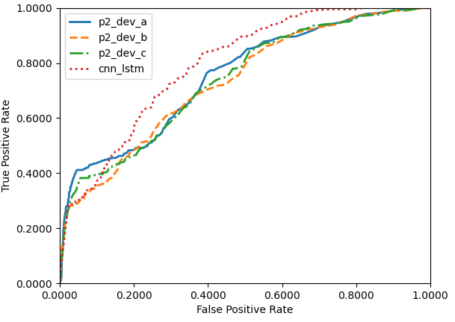
Figure 34. ROC curves of P2 variants on TUSZ dev set
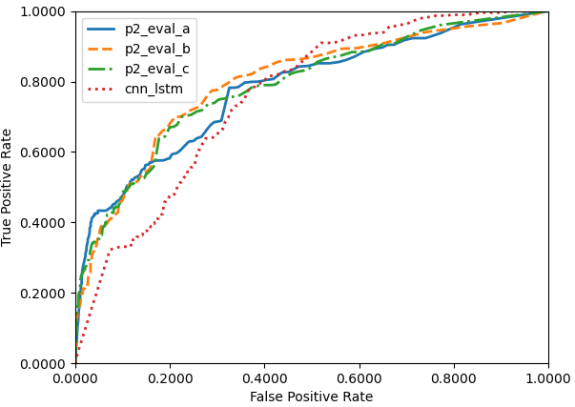
Figure 35. ROC curves of P2 variants on TUSZ eval set
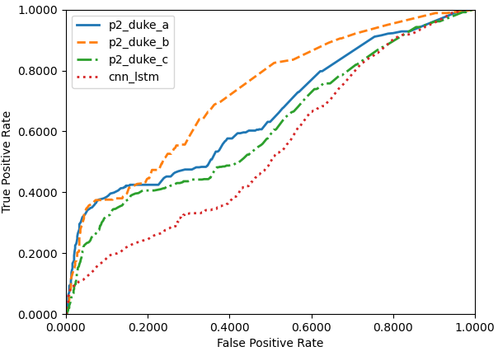
Figure 36. ROC curves of P2 variants on DUSZ eval set

When we rank the models based on their performance on the dev set, we can see the superiority of the P2 heuristic model. The data-driven model is the second-best model. We compare P2 models on the eval sets to provide a broader perspective on the generalization properties of these models. This gives us an indication of the effectiveness of the feature scaling techniques. We can conclude that the posterior features of the P2 Data-dependent model were overfit on the training set. The optimal scaling factor was selected by collecting statistics of the training set which has no overlap with the eval sets.

An Assessment of Overall System Performance
The overall seizure detection system uses three distinct types of processing: P1, P2 and a final heuristic postprocessor (P3). A block diagram of the multiphase model is shown in Figure 15 along with the performance of each state of processing. Since the P1 and P2 models are different network designs, averaging posteriors and pooling their information allows detection of a more diverse set of seizure morphologies, building on the strengths of each model. According to the OVLP metric, the multiphase model yields a $40.29\%$ sensitivity with $5.7$ FAs per $24$ hours compared to the previous CNN/LSTM model with a sensitivity of $30.83\%$ with $6.74$ FAs per $24$ hours. At the same operating point, according to the TAES metric, the multiphase model yields a sensitivity of $32.59\%$ with $17.03$ FAs compared to the previous CNN/LSTM model ($11.33\%$ sensitivity with $7.62$ FAs per $24$ hours).
These two systems were also evaluated on two different blind evaluation sets: TUSZ and DUSZ. The performance of the two systems is tabulated in Table 10, Table 11 and Table 12 for TUSZ dev, TUSZ eval and DUSZ eval respectively. EEGs from these databases were collected using different instrumentation and environmental conditions. The TUSZ data was collected with several generations of the Natus Medical Incorporated EEG equipment (Natus, 2018) while DUSZ was collected using Nihon Kohden equipment (Nihon Kohden, 2019). These two corpora were selected to evaluate the robustness and reliability of the system. The models were not previously exposed to DUSZ training data. The baseline system’s performance is lower, yielding a very high FA rate of $19.89$ FAs per $24$ hours and $40.04$ FAs per $24$ hours for a similar level of sensitivity. The multiphase system, on the other hand, maintains an FA rate of $10$ while yielding a sensitivity greater than $40\%$. This demonstrates the robustness of the multiphase system design.
Table 10. Performance on the TUSZ dev set (multiphase model)
Metric | Measure | CNN/LSTM  Baseline | P1:  Channel-Based  LSTM | P2: CNN/LSTM | P3:  Heuristic Postprocessor
OVLP | Sensitivity | 30.83% | 39.46% | 41.16% | 40.29%
 | Specificity | 97.10% | 95.20% | 95.29% | 97.56%
 | FAs/24 hrs | 6.74 | 11.62 | 11.69 | 5.77
TAES | Sensitivity | 11.33% | 32.57% | 32.87% | 32.59%
 | Specificity | 95.58% | 85.48% | 89.28% | 90.72%
 | FAs/24 hrs | 7.62 | 27.44 | 20.85 | 17.03
Table 11. Performance on the TUSZ blind evaluation set (multiphase model)
Metric | Measure | CNN/LSTM  Baseline | P1:  Channel-Based  LSTM | P2:  CNN/LSTM | P3:  Heuristic Postprocessor
OVLP | Sensitivity | 33.11% | 36.39% | 42.02% | 42.96%
 | Specificity | 92.54% | 96.55% | 96.09% | 95.53%
 | FAs/24 hrs | 19.89 | 8.74 | 10.02 | 11.45
TAES | Sensitivity | 5.01% | 30.97% | 30.27% | 35.55%
 | Specificity | 90.43% | 93.05% | 93.87% | 91.79%
 | FAs/24 hrs | 19.89 | 13.98 | 12.75 | 17.22
Table 12. Performance on the DUSZ blind evaluation set (multiphase model)
Metric | Measure | CNN/LSTM  Baseline | P1:  Channel-Based  LSTM | P2:  CNN/LSTM | P3:  Heuristic Postprocessor
OVLP | Sensitivity | 33.71% | 42.32% | 41.75% | 43.75%
 | Specificity | 70.72% | 86.93% | 85.71% | 91.01%
 | FAs/24 hrs | 40.4 | 14.26 | 16.4 | 9.33
TAES | Sensitivity | 19.77% | 36.47% | 35.46% | 37.13%
 | Specificity | 45.46% | 46.43% | 64.57% | 54.03%
 | FAs/24 hrs | 43.75 | 33.03 | 22.45 | 26.92

Performance according to the TAES metric shows the extent to which the seizure events are detected. In all three sets, the baseline system shows significant under-detection of the events. On the other hand, multiphase systems tend to maintain sensitivities around the same range but with increased FA rates. For example, from Table 10 we can see that the OVLP score for the baseline model is approximately $33\%$ sensitivity with $19.89$ FAs per $24$ hours. The same operating point evaluated by the TAES metric is $5.01\%$ sensitivity with $19.89$ FAs per $24$ hours. On the other hand, the multiphase model exhibits a decrease in sensitivity by $7\%$ absolute ($42.96\%$ to $35.55\%$) with an increase in FAs of $6$ FAs per $24$ hours. Table 12 shows an extreme case for both models where the baseline system yields a much higher FA rate (approximately five times higher).
The multiphase system has approximately double the FA rate (e.g., $9.33$ vs. $5.7$) but with a much higher sensitivity ($43.75\%$). TAES scores for the baseline model suffer from a decrease of $14\%$ in sensitivity ($19.77\%$) at a similar FA rate ($43.75$) whereas the multiphase model suffers from a $6\%$ decrease in sensitivity ($37.13\%$) with a three-fold increase in FAs ($26.92$). An analysis of performance using ROC curves is presented next.

Receiver Operating Characteristic (ROC) Analysis
ROC plots for the baseline system and multiphase system are shown in Figure 37, Figure 38 and Figure 39. Though performance of all three systems in Figure 37 seems similar, if we focus on the region where FPs are low (e.g., $[0,0.2]$), we see that the multiphase system generally outperforms all other systems. These results are confirmed in Table 10.
In Figure 38, we see the difference is more pronounced on the TUSZ blind evaluation set. In Figure 39, we see that the multiphase system is clearly superior over a much wider range of the ROC curve. Since neither of these systems had been previously exposed to DUSZ data, this is a strong indication that the multiphase system generalizes better. These findings are consistent with the tabulated results of Table 10 through Table 12.
ROC curves for the TAES metric are shown in Figure 40 to Figure 42. The TAES metric places more emphasis on the accuracy of segment boundaries. Performance of the baseline model is below the multiphase system for the entire range of the curve. The difference between P2 and P3 is very close throughout the entire FA range. The best operating point is observed around $35\%$ sensitivity with an FA rate of $10$.
This trend is further supported by the results on the blind evaluation sets in Figure 41 and Figure 42. Performance of the multiphase model is relatively low for DUSZ, which suggests that this database consists multiple prolonged isomorphic or subtle events. The recognition systems are detecting prolonged events as multiple short events. However, the multiphase model consistently outperforms the baseline system.
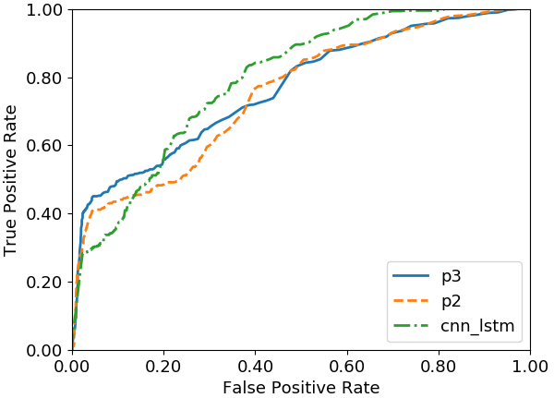
Figure 37. ROC curves on the TUSZ dev set using the OVLP metric
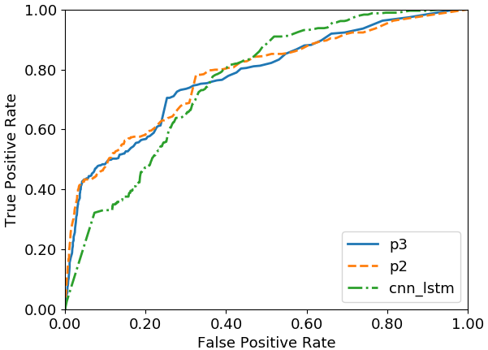
Figure 38. ROC curves on the TUSZ eval set using the OVLP metric
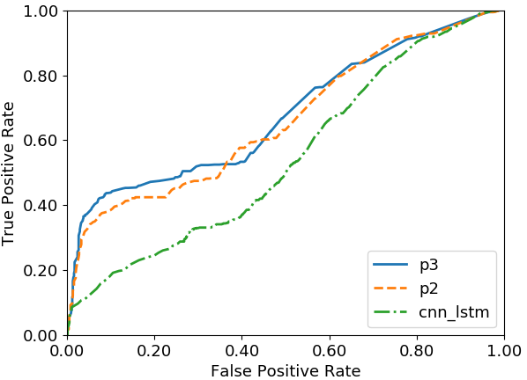
Figure 39. ROC curves on the DUSZ eval set using the OVLP metric

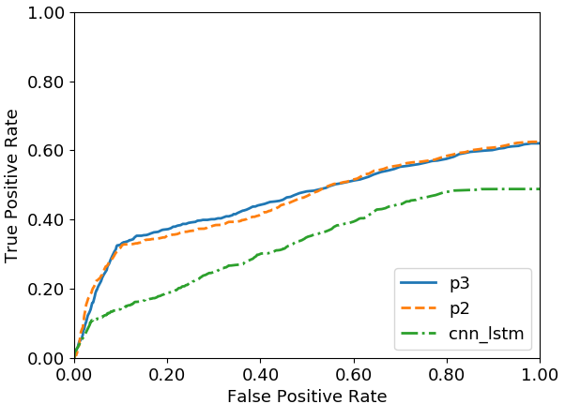
Figure 40. ROC curves on the TUSZ dev set using the TAES metric
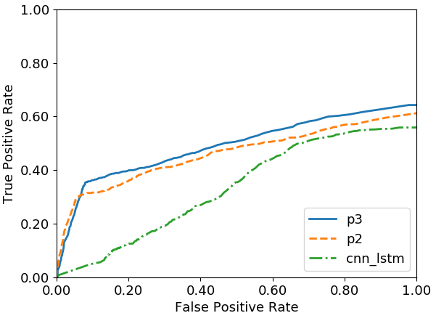
Figure 41. ROC curves on the TUSZ eval set using the TAES metric
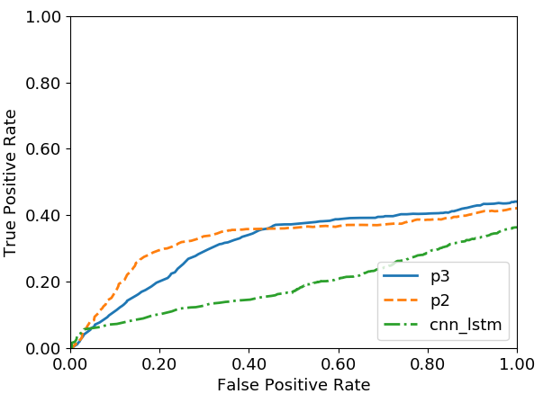
Figure 42. ROC curves on the DUSZ eval set using the TAES metric

Segmentation Analysis
Although the TAES metric can provide a gross approximation of the amount of overlap between the reference and hypotheses events, certain aspects of this metric limit its ability to precisely characterize differences in performance. For instance, the TAES metric penalizes multiple overlapping events in a hypothesis as miss events. Once the duration of the detected event exceeds the reference event, the additional duration of the hypothesis event is ignored. Also, our miss rate or FA rate cannot exceed a value of one because the metric calculates per event scores.
Accurate determination of onset and offset behavior of a seizure event pose different challenges and bear closer examination. The TAES metric, by design, does not clearly analyze the number of over/under-detections of hypothesis events at the event boundaries. To gain better insight into the differences between these algorithms, we need an alternate approach to the analysis of segmentation performance.
We will visualize the performance of the systems as histograms where the onset and offset of an event will be analyzed independently. We will call detection an “over-detection” if it falls outside the boundary of a seizure event (reference annotation) and an “under-detection” if it falls inside the reference annotation boundary. Figure 43 presents an example of this analysis. The first row of the histogram shows performance based on the onset and offset boundaries. This row is the aggregate performance of detected events based on the detected event’s distance with respect to the duration of the event.
For example, let’s consider a reference event with a duration of $10$ secs. If a detected event’s onset is observed outside the reference segment’s onset by one second, the over-detection value is calculated as $0.1$ (distance from the onset mark / duration of the reference segment). Rows 2 and 3 separate performance into onsets and offsets. Over- and under-detections are separated in the left and right side of the histograms respectively. For example, row 2 and column 1 indicates the over-detection for the onset boundary and row 3 and column 1 indicates the over-detection of the offset boundary. Finally, the total under and over-detections are shown numerically for each model in the last (4th) row.
Figure 43 displays an analysis of the behavior of the baseline system. It clearly indicates that the model tends to detect a very small portion of the seizure events correctly with $22$ over-detected and $354$ under-detected event boundaries. Overall, the model is $32\%$ off in terms of onset boundary detections and $23\%$ off in terms of offset boundary detections. This is clear from the first row in Figure 43, where the mean values are $\text{-}0.32$ and $\text{-}0.23$ respectively. The smaller standard deviation values of $0.22$ and $0.34$ for onset and offset boundaries suggest that most of these hypothesis events are closer to these mean values.
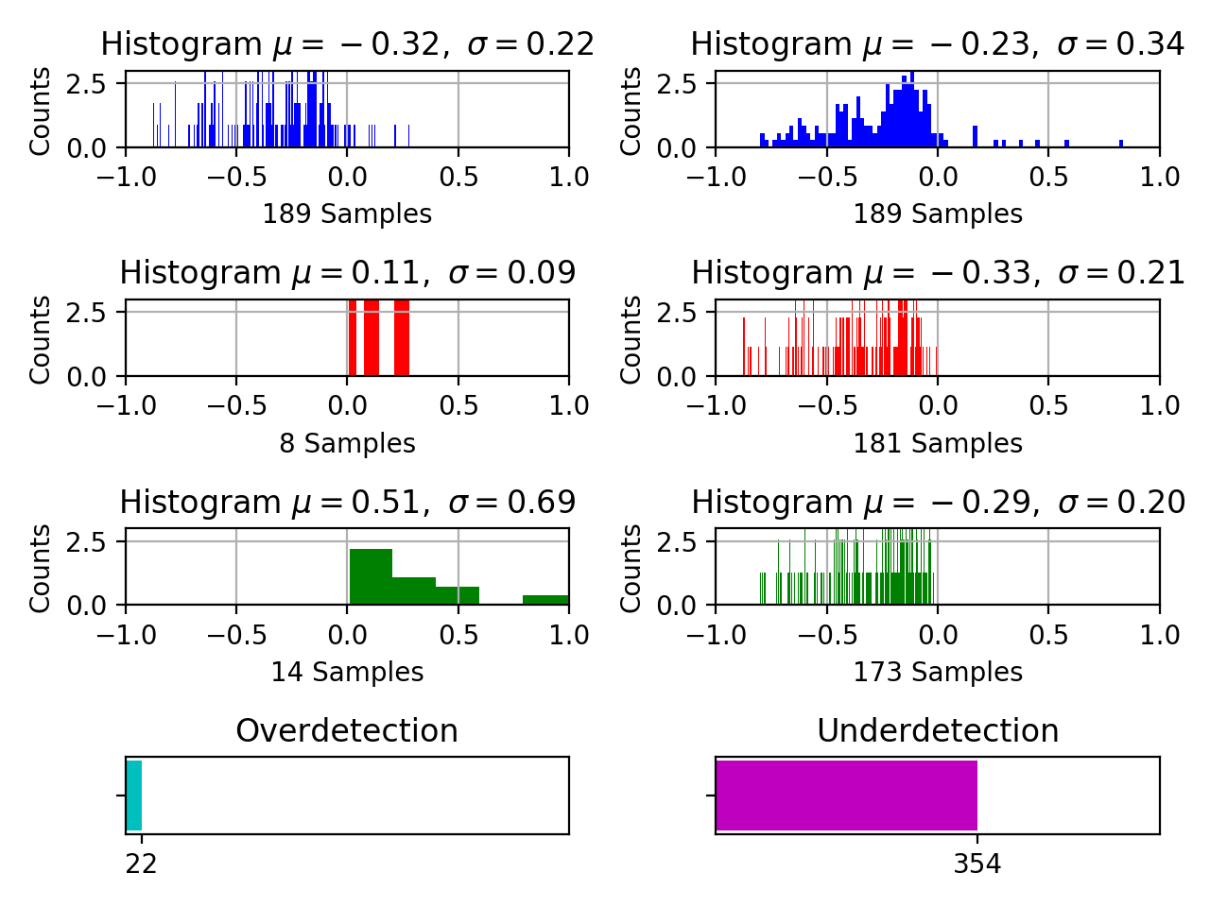
Figure 43. Baseline model segmentation for the TUSZ dev set is shown. Over-detection is shown on the left while under-detection is shown on the right. Onset boundary behavior is shown in red while offset boundary behavior is shown in green.
The higher mean values suggest that the events are further from the event boundaries. Specifically, under-detection of the model is far from the edge of the events which can be observed from the right columns of row 2 and 3 of the plot. The under-detected events of the model have a mean value of $\text{-}0.33$ and $\text{-}0.29$ from the onset and offset boundaries (with small standard deviation of 0.21 and 0.2) respectively. This suggests that the model detects a very small portion of the event when a seizure event is present, and the detections seem to be around the middle of the event segment (far from the segment boundaries).
Figure 44 shows performance of the baseline model on the TUSZ evaluation set. The model yields $308$ under-detected seizure events. These under-detected segments are off by 33% for onsets and 39% for offsets. The standard deviations of these distributions are 20% and 25%, which are lower than the standard deviations shown in Figure 43 for the dev set, suggesting the behavior is even more conservative in detecting seizure events.
This trend is a bit different for the DUSZ evaluation set, where the baseline model manages to over-detect $98$ and under-detect $353$ seizure events. This is shown in Figure 45. The seizure events which are over-detections have mean values of $0.47$ and $0.62$ with a standard deviation of $0.79$ and $0.90$. This suggests most detected events are off by $80\%$-$90\%$ of the total duration of the event. However, the higher standard deviation suggests that these detections are separated from the mean of the hypothesis boundaries. On the other hand, under-detections have the mean values of $25\%$ for the onset and $26\%$ for the offset of the segment boundaries.
Since P2 is designed to optimize the segment boundaries, we expect it to show better performance. Figure 46 shows performance of the P2 model on the dev set. This model seems to detect over- and under-detected events comparably. The total number of under-detections are $295$ and over-detections are $269$. However, the mean over-detection performance of this model is significantly larger (e.g., more than 200% of the duration of seizure events). The standard deviation of the model onset over-detection is also very high which suggests that there is a significant spread in the errors. Onset boundary over-detections, shown in row 2 column 1 in red, have a maximum mean ($4.08$) and standard deviation ($14.81$) suggesting that some of the events are detected too far in advance. The under-detections on the other hand are very close to the edges of the reference events (rows 2 and 3 of column 2) yielding mean values of only $0.14$ and $0.16$ with standard deviations of only $0.16$ and $0.18$ for the onset and offset boundaries respectively. The reasons for the poor performance of the model for over-detections is the detection of extreme duration events such as very short and very long events.
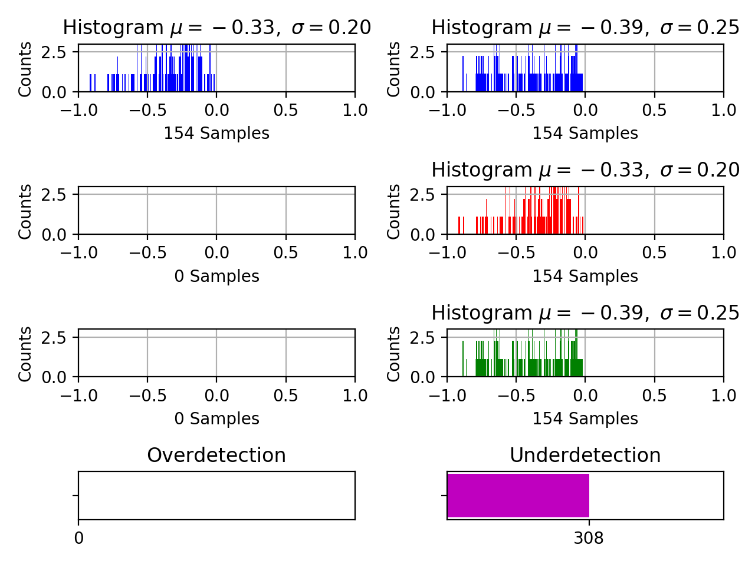
Figure 44. Baseline model segmentation for TUSZ eval
Figure 47 shows performance of the P2 model on the TUSZ evaluation set. The number of over- and under-detected events are $129$ and $319$ respectively. Overall, the means of the onset and offset boundary detections are off by $0.14$ and $0.01$. The mean values are between $14\%$ and $20\%$ of the event duration with a small standard deviation of $0.17$ (onset) and $0.16$ (offset) for the under detection (column 2) and $0.20$ (onset) and $0.40$ (offset) for the over-detection (column 1). This suggests that the P2 model detects seizure segment boundaries very close to the actual reference boundaries.
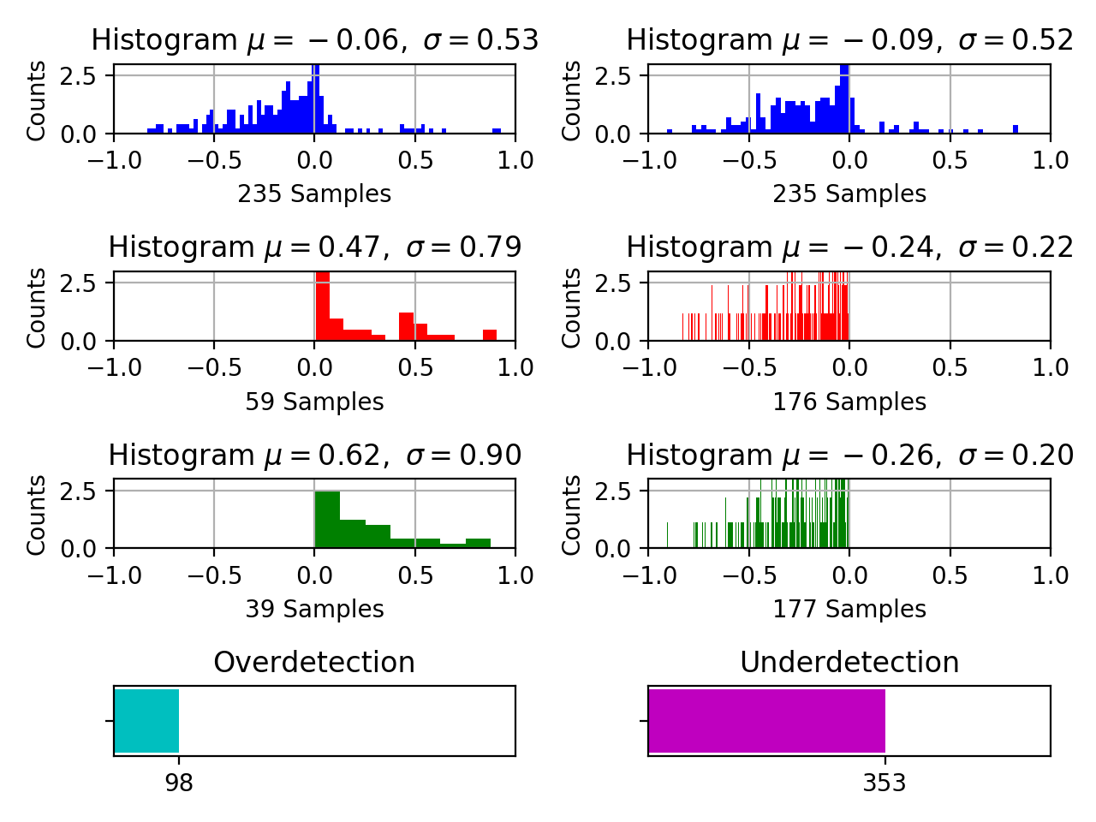
Figure 45. Baseline model segmentation for DUSZ eval
Finally, we evaluate performance of the P2 model on DUSZ eval in Figure 48. The performance on DUSZ eval follows what was observed on the TUSZ datasets. The onset over-detections are off by a mean value of $0.62$ from the reference event’s start time with a high standard deviation. Mean values of all the other over- and under-detections are very close to the segment boundaries ($0.18$ for offset over-detection; $0.14$ and $0.13$ for the under-detections for the onset and offsets respectively) with a very low standard deviation. The total number of over and under-detections are very close – $266$ and $284$ respectively. The overall mean of the onset/offset detections shown in row one (in blue) are well centered around the zero point, which is consistent with all previous datasets.
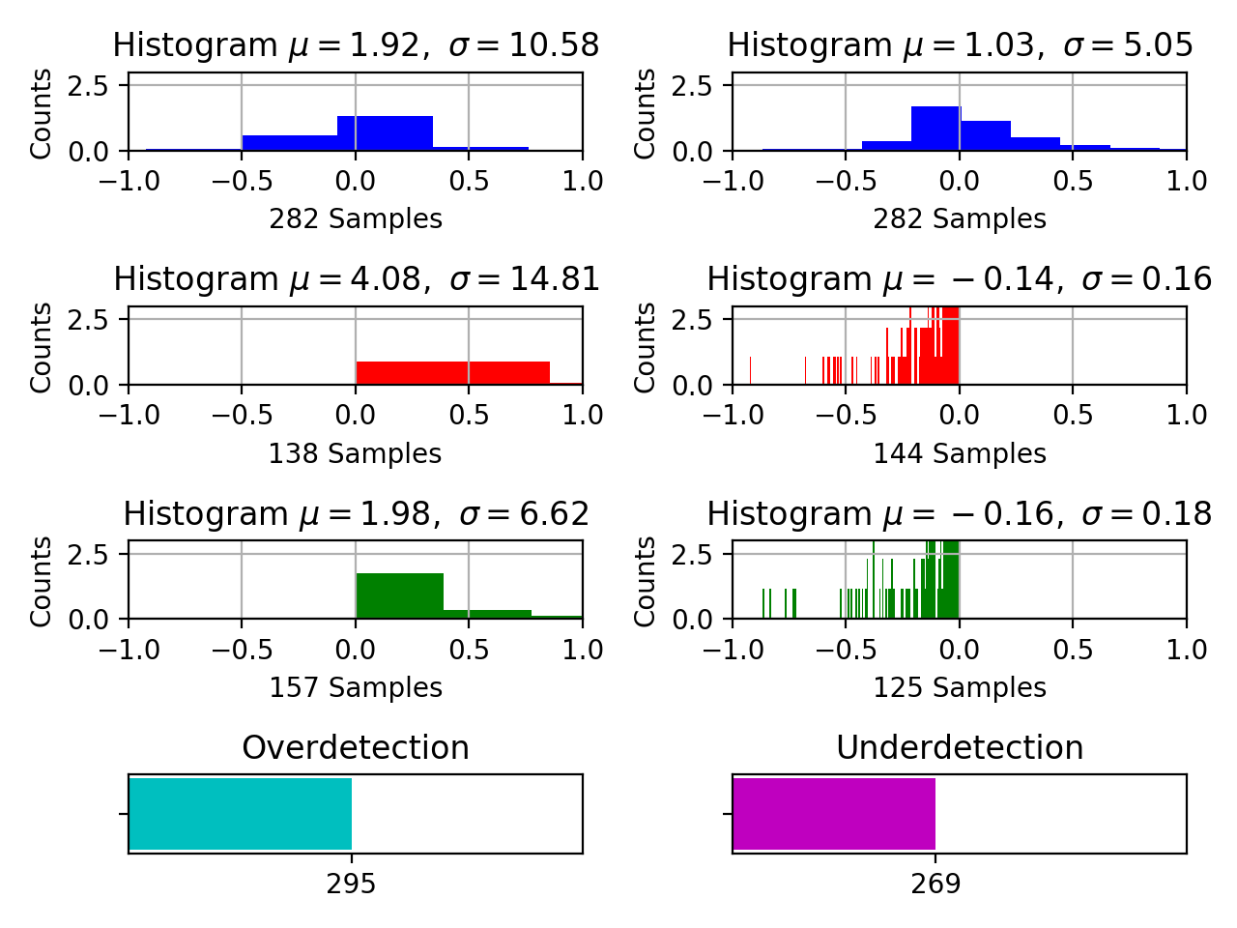
Figure 46. P2 model segmentation for TUSZ dev

Causes of Poor Segmentation
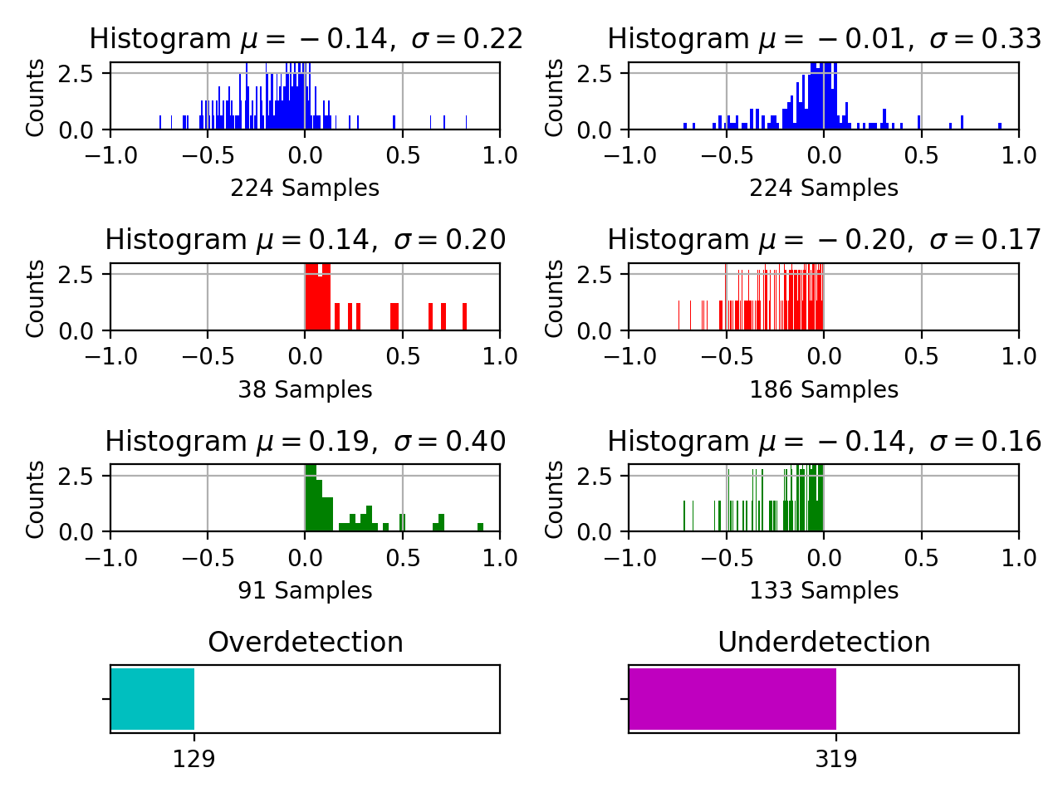
Figure 47. P2 model segmentation for TUSZ eval
It is important to determine the underlying causes of over- and under-detections. The potential reasons for the drastic differences lie within the annotation process/standards and the duration of the event. For example, if a seizure $5$ secs in duration has an estimated event boundary that is off by $1$ sec, then the performance is penalized by $20\%$. If this was an event $100$ secs in duration, the event is penalized by only $1\%$. For this reason, it is important to incorporate the duration of the detected events into the evaluation process. In this section, we analyze the detection rates of the target events within specific durations and their sensitivities.
The seizure event durations are separated into $5$ different sets: (1) less than $10$ secs, (2) $10$-$30$ secs, (3) $30$-$120$ secs, (4) $120$-$300$ secs and (5) over $300$ secs. Other error measures such as FN and FP are not incorporated into this analysis because the segmentation quality is only analyzed for the detected events.
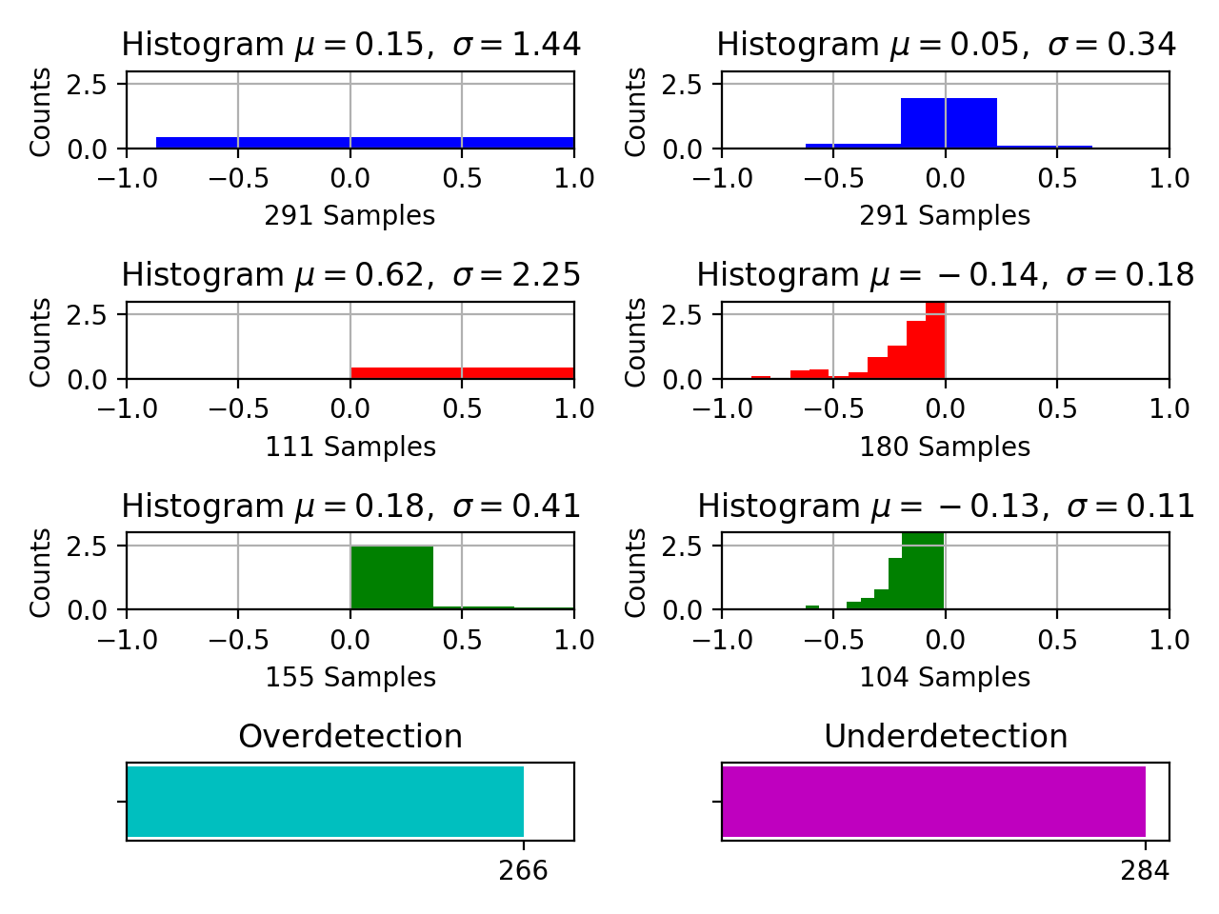
Figure 48. P2 model segmentation for DUSZ eval
Performance of the baseline model and the P2 model on the seizure events based on their duration can be seen in Table 13 and Table 14 respectively. Note that the baseline model demonstrates poor performance on shorter events. Similarly, the performance of the model on extremely long seizure events, shown in the last row of these tables, is relatively low as well. Comparing these sensitivities with the P2 model demonstrates that both models have similar tendencies to poorly detect shorter seizure events. On the other hand, the P2 model demonstrates much higher performance on the longer duration seizure events. For the subset of seizures with durations greater than $300$ secs, P2 performs at $51.72\%$ on the dev set compared to baseline model’s performance of $37.93\%$. On TUSZ eval, the P2 model’s performance is $83.33\%$ compared to the baseline model’s performance of $54.54\%$. On DUSZ eval, the P2 model’s performance is $69.23\%$ compared to the baseline model’s performance of $53.84\%$.
It is important to note that performance of the P2 model on short duration seizure events for TUSZ dev ($27.82\%$) contributes heavily to the segment over-detection errors observed in Figure 46. Similarly, longer events are usually slowly evolving seizure events, which, as was discussed in Chapter 3, are highly ambiguous. Our seizure detection model is expected to perform poorly on these subtle events due to uncertainties involved in slowly evolving borderline seizures.
Table 13. Sensitivity of the baseline model as a function of event duration
Score/Duration (sec.) | TUSZ Dev  Sens. | TUSZ Eval  Sens. | DUSZ  Sens.
0 – 10 | 10.71% | 9.75% | 0.00%
10 - 30 | 28.49% | 16.83% | 15.13%
30 - 120 | 32.09% | 45.87% | 34.76%
120 - 300 | 56.25% | 43.39% | 59.30%
> 300 | 37.93% | 54.54% | 53.84%
Table 14. Sensitivity of the P2 model
Score/Duration (sec.) | TUSZ Dev  Sens. | TUSZ Eval  Sens. | DUSZ  Sens.
0 – 10 | 27.82% | 0.00% | 0.00%
10 - 30 | 27.31% | 14.28% | 16.44%
30 - 120 | 53.42% | 58.62% | 44.46%
120 - 300 | 48.57% | 69.23% | 69.76%
> 300 | 51.72% | 83.33% | 69.23%

An increase in sensitivity for this type of event also contributes to the increased segmentation error rates of the P2 model. For example, a $1,000$-sec seizure detected for only $100$ secs or in clusters of $100$ secs in duration adds significantly to the miss rate. Additionally, the increased sensitivity of the P2 model suggests that the system tends to over-detect the events. Slowly evolving isomorphic events pose real challenges for this type of technology.

Seizure Boundary Detections Within Segment Guard Bands
Finally, we evaluate the segmentation performance based on the margin within which the seizure boundaries are estimated. We calculate number of seizure boundaries closer to the reference boundary marks. Quantitatively, we measure the duration in time, which we refer to as distance, from which the hypothesis boundaries are detected and check if that distance falls within a specific range. We refer to this range as a guard band. A guard band is defined as the acceptable distance from the hypothesis to the reference boundary. For instance, a guard band of $+/-1$indicates that a detection falls within a margin of $1$ sec of the reference annotation. This measure calculates the number of seizures detected in close proximity to the reference annotation.
We evaluate performance of the detected events based on $6$ different values of guard bands, as shown in Figure 49. The main comparison presented is between the baseline model and P2 (blue vs. orange). Not surprisingly, the bar plots show a clear increase in performance as the guard band duration is increased. But the rate at which the performance increases for each model is drastically different. P2 consistently outperforms the baseline
model in all cases. For example, for a guard band of $2$ secs on the dev set, the P2 model detects $132$ events compared to only $40$ events for the baseline model. This difference becomes even more dramatic for the evaluation set where the P2 model detects $106$ events as opposed to only $9$ events for the baseline system. This trend holds for all other values of the guard bands. Interestingly, differences between the models are not as great on the DUSZ data.
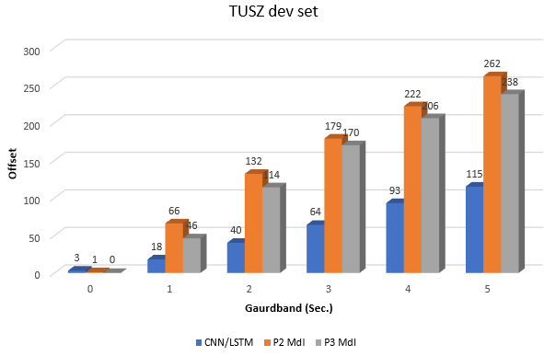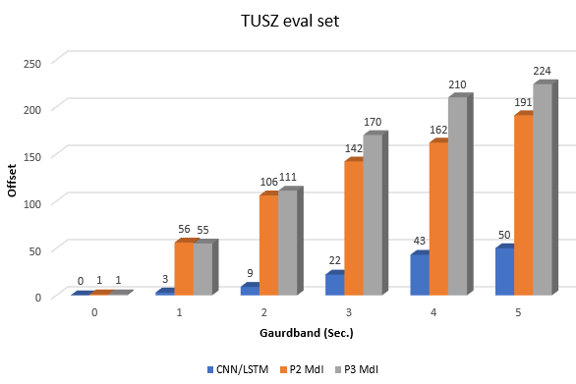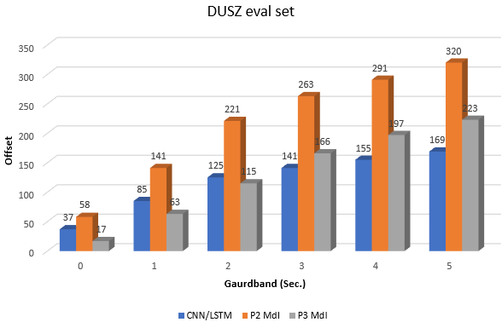
Figure 49. Event detections within the guard bands of the reference annotation boundaries
The results presented in this chapter validate our hypothesis that the posteriors and their derived features carry important temporal information and can be exploited to deliver improved segmentation performance. Such a design alleviates the need for complicated models that focus on long-term dependencies. When the variance of event durations is high, embedding the posterior information into a feature vector tends to overcome the issues associated with long-term dependencies. Additionally, the multiphase model tends to fine tune the segment boundaries of seizure events by learning the deficiencies of the earlier stages of the models.

OPTIMIZATION
Reducing the false alarm rate becomes exponentially harder at very low FA rates (e.g., below $10$ per $24$ hours). We briefly discussed heuristic postprocessing techniques which can efficiently reduce the FA rate in Section 4.5. During the postprocessing stage, a significant amount of sensitivity is sacrificed in order to reduce the FA rate. These algorithms use fixed-size windows and can be easily implemented in a real-time system. In this section, we attempt to develop a postprocessor model which improves the overall performance of the model without sacrificing sensitivity.
Once all three phases of the multiphase model are optimized, we further optimize its performance by developing a smaller neural network-based postprocessor that reduces the FA rate. We use hypotheses generated from the entire corpus as training data for our models, but we do not use reference annotations from the eval set. We investigated two neural network architectures to achieve these goals: (1) a dynamic CNN+LSTM hybrid postprocessor (DCLP) and (2) an MLP segment optimizer (MLP-SO). Only the DCLP approach appeared promising.
Seizure events are sometimes subtle and very slow in their evolution. Identifying such events is challenging and requires a more global view of the data across an entire session. In Chapter 4, we discussed two models which had an analysis window size of 7 secs (for P1) and 11 secs (for P2). These models were developed so that we could perform seizure detection in real time with a small amount of delay. However, due to the limited duration of these windows, these models cannot incorporate subtle changes in behavior that occur over much longer time frames. In the following section, we train and evaluate a DCLP model using long-term information so that it can learn the complete evolution (or devolution) of the event. This approach is similar to a multi-pass rescoring strategy used in speech recognition systems for applications such closed captioning (Huang et al., 2019)
We also attempted to implement an alternate approach, MLP-SO, for this postprocessor. The onset/offset signal morphologies and spectral energy of a seizure event can be seen in Figure 5 and Figure 6. The energy around the onset and offset of a seizure play an important role in accurately identifying its boundary. MLP-SO needs to identify a point as a seizure onset boundary if the rate of change of energy decreases on the left side and increases on the right side of the operating frame. For an offset boundary, the trend in the rate of change of energy reverses: the left side shows an increase in the rate of change while the right side shows a decrease in the rate of change of energy. Unfortunately, preliminary results from this approach were not promising, so we did not include this approach in this chapter.

Dynamic Neural Networks
A dynamic neural network is a type of model developed for modeling input sequences that vary in duration. Traditionally, hierarchical machine learning models such as decision trees or sequential algorithms such as HMMs were used to address inputs with variable durations (Duda et al., 2001). A new generation of machine learning models such as dynamic recurrent neural networks (Giles et al., 1994) have been introduced that perform well on many these types of tasks (Sutskever et al., 2014).
Typically, neural networks are optimized using some variant of a stochastic gradient descent algorithm such as an Adam optimizer. During this optimization process, inputs to the network are expected to have fixed lengths so there are a constant number of forward and backward iterations (Goodfellow et al., 2016). These networks are also known as graphs with static declaration, which allows data to be represented in fixed-sized matrices. These fixed sized matrices speed up GPU training (Zhu et al., 2021). Most deep learning frameworks (e.g., TensorFlow) are optimized for this type of data. Samples with a variable number of time steps are typically fed to a network using one of three methods: (1) static unrolling (Giles et al., 1994), (2) bucketing (Variani et al., 2017), and (3) graph-based dynamic declaration (Giles et al., 1994; Povey et al., 2011).
The static unrolling method uses a fixed-size network. The window size chosen for the model is usually equal to the input sample with the maximum possible sequence length. The window size is typically chosen from the training set. Samples smaller than this window size are pre- or post-padded to match the network size. Bucketing is similar to the static unrolling method but creates multiple fixed-size networks and input buckets. If the input samples do not match any of the input dimensions available in these buckets, the input is padded such that it fits the network with the nearest input dimension.
Networks with dynamic declaration are trained for the exact number of steps required for each input sequence. These kinds of networks unroll themselves $N$ times to match the number steps needed to process the input. Recurrent neural networks are the most common choice for this method due to their ability to unroll an infinite number of times. Dynamic networks work well for applications such as NLP but add an unpredictable amount of overhead because for every input sample a new network needs to be created. A very popular network architecture used for such applications is known as a sequence-to-sequence model (seq2seq) (Sutskever et al., 2014). Seq2seq models have performed well in human language technology applications. Unfortunately, neural networks with dynamic declaration are not optimized in TensorFlow and can result in performance degradations when the number of steps vary significantly (Looks et al., 2017). Seizure segments can have durations lasting from a few seconds to days. For these reasons, we will optimize seizure segments using the static unrolling method.

Random Sampling
Representing data efficiently is a very important factor for minimizing the computational requirements of a good classifier. The efficiency of a data representation also impacts performance for a variety of practical issues such as the accumulation of roundoff error. This is especially true for the deep learning models where the sequential order in which data is presented to the model plays an important role (Ziyabari et al., 2018).
Each input sample to the model corresponds to a fixed duration subsegment of $70$ secs, which corresponds to $700$ sequential features. The window size used for this model is ten times larger than the window size used for the P1 phase of the model. Any detections below $70$ secs were pre-padded by a constant value so that a loss value can be zeroed out by the bias vectors of the neural network. Any segment above $70$ secs was further split into multiple subsegments so that there is a minimal amount of overlap between adjacent samples. For instance, if a detected seizure segment is $130$ secs long, samples collected from this detection were splits into two segments, one extending from $070$ secs and a second segment extending from $60130$ secs. There are only 10 secs of overlap between these segments. Any samples around the edge of the detected segment were given higher priority because these are regions where seizures show maximum evolution or devolution in frequency and amplitude.
Since the total number of input samples for the network are limited to the number of seizure segments detected by the multiphase model, we add additional samples by randomly sampling from the hypothesis segments. The duration and the start times of these randomly generated samples are drawn from a uniform distribution. The input samples are drawn from a range of $30\text{-70}$ secs. These samples were selected so that they fall within the hypothesis segment and do not have more than a 50% overlap with the samples collected at the onset or offset boundaries. This sampling process increases the total number of input samples from $20,548$ to $36,431$. This almost doubles size of the training data without adding too many redundant or correlated input frames. Increasing the amount of training data for the model improves its ability to learn.

The DCLP Network Architecture
Similar to the P2 model, we use a CNN followed by an LSTM for this task. The network architecture is shown in Figure 50. Typically for dynamic window sizes, recurrent neural networks are chosen in most applications due to their ability to unfold themselves. Since we are already using fixed-size input samples, we include CNNs prior to the LSTM network. CNNs are able to learn spatial information embedded in EEG channels more efficiently (Golmohammadi et al., 2018). The DCLP network uses our traditional 26-dimensional LFCC feature vectors as inputs.
The input size of the model is set to $(700, 22, 26)$ for time steps, the number of EEG channels and the dimension of the feature vector, respectively. The minibatch size is kept low ($32$ samples) because we have a limited amount of input data. To compensate for this, we do more iterations during training ($18$ epochs). The convolutional kernel sizes are set to $10x5$for learning one second of data using five adjacent EEG channels. Batch normalization is applied to the output of each convolutional layer prior to adding an ReLU nonlinearity to the output of the layers. Batch normalization keeps the output of the layer in the range $[-1,1]$ which forces the model to give equal importance to all feature dimensions.
The output of this layer, which we view as learned features, are fed to an LSTM network after average pooling is applied. The activation function used for LSTM layers is a hyperbolic tangent function. The model is trained for $18$ epochs with a constant learning rate of $0.002$ for a cross-entropy loss function. The loss function is minimized using an Adam optimizer.
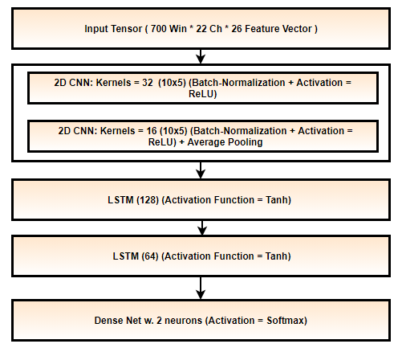
Figure 50. A CNN-LSTM postprocessor using dynamic windows and static unrolling

Decoding Results
For the decoding problem, we only consider seizure segments with little to no overlap. Similar to the training process, hypotheses describing the onset or offset of an event are given higher priorities. If there is an overlap between two hypotheses, the higher probability among the two is chosen as model’s hypothesis. Finally, we take a union between the hypotheses for the P1 model and our NN postprocessor. No heuristic postprocessing is performed after this postprocessing step is completed.
The performance of the DCLP postprocessor for TUSZ dev, TUSZ eval and DUSZ eval is shown in Table 15, Table 16, and Table 17, respectively. Since these experiments focused on decreasing FA rates, we use the OVLP metric. The OVLP results on TUSZ dev (Table 15) indicate that the postprocessor improves the overall performance of the multiphase model from $40.29\%$ to $41.60\%$ in sensitivity and reduces FAs from $5.77$ to $5.63$ per $24$ hours. The performance on TUSZ eval indicates sensitivity improved by $5.25\%$ absolute (from $42.96\%$ to $48.21\%$). However, FAs also increased by $5.09$ per $24$ hours (from $11.45$ to $16.54$). The performance on DUSZ eval shows a similar trend – sensitivity improved by $2.87\%$ (from $43.75\%$ to $46.62\%$) while the FA rate decreased by $1.47$ (from $9.33$ to $7.86$). DCLP improved performance across all sets using the OVLP metric while performance according to the TAES metric dropped.
Table 15. Performance of DCLP (TUSZ dev)
Metric | Measure | Multiphase Baseline | + DCLP
OVLP | Sensitivity | 40.29% | 41.60%
 | Specificity | 97.56% | 97.57%
 | FAs/24 hrs | 5.77 | 5.63
TAES | Sensitivity | 32.59% | 32.08%
 | Specificity | 90.72% | 90.45%
 | FAs/24 hrs | 17.03 | 17.30
Table 16. Performance of DCLP (TUSZ eval)
Metric | Measure | Multiphase Baseline | + DCLP
OVLP | Sensitivity | 42.96% | 48.21%
 | Specificity | 95.53% | 93.10%
 | FAs/24 hrs | 11.45 | 16.54
TAES | Sensitivity | 35.55% | 36.17%
 | Specificity | 91.79% | 86.62%
 | FAs/24 hrs | 17.22 | 27.11
Table 17. Performance of DCLP (DUSZ eval)
Metric | Measure | Multiphase Model | + DCLP
OVLP | Sensitivity | 43.75% | 46.62%
 | Specificity | 91.01% | 91.81%
 | FAs/24 hrs | 9.33 | 7.86
TAES | Sensitivity | 37.13% | 33.91%
 | Specificity | 54.03% | 53.94%
 | FAs/24 hrs | 26.92 | 25.35

An ROC analysis can give us a better understanding of the differences between the models. Figure 51, Figure 52 and Figure 53 show an ROC analysis of the multiphase model with and without DCLP for both the OVLP and TAES metrics.
OVLP performance on TUSZ dev with DCLP outperforms the multiphase model by a small margin throughout all operating ranges. The performance of the model on TUSZ eval and DUSZ eval displays different trends, however. Multiphase + DCLP performs poorly in the very low FPR ranges but quickly starts outperforming the baseline multiphase model in the neighborhood of [$0.42$ TPR, $0.05$ FPR]. This indicates that for the eval sets our postprocessor improved the multiphase model.
On the other hand, the ROC curve analysis shows poor performance across all the seizure sets for the TAES metric. If a single reference event is detected as multiple overlapping seizure events in hypotheses, OVLP does not penalize it whereas TAES introduces partial penalties for the missing parts of the reference segment. Since our analysis frames are fed with little to no overlap, TAES sensitivity suffers very heavily if any of the frames are
missing. Additionally, typically the middle of a longer seizure event
does not show any significant changes in their signal morphologies which makes it harder for DCLP to detect this event as a seizure. This causes seizure segments correctly identified by the multiphase model to be missed by the DCLP postprocessor. This reduces the TAES sensitivity.
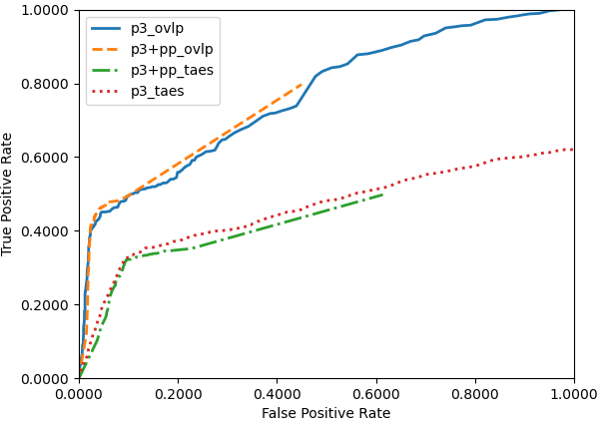
Figure 51. ROC curves for the multiphase model with DCLP (TUSZ dev)
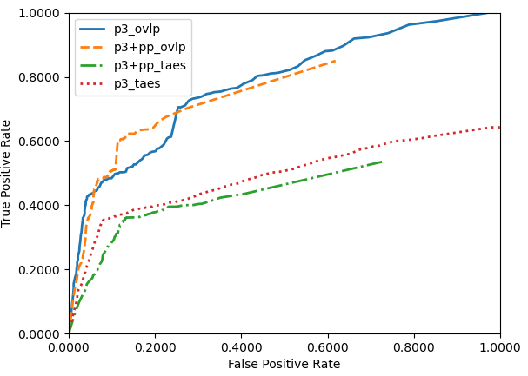
Figure 52. ROC curves for the multiphase model with DCLP (TUSZ eval)
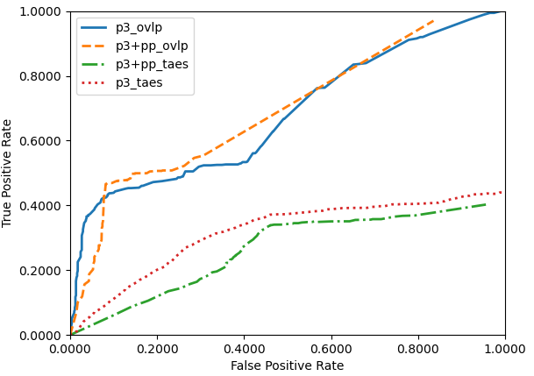
Figure 53. ROC curves for the multiphase model with DCLP (DUSZ eval)

ERROR ANALYSIS
Augmented features have been traditionally used in machine learning to either increase the size of the training data or to make the model more robust (Goodfellow et al., 2016). We proposed a method which was specifically designed to mimic the human interpretation process that added context based on previously detected seizures as features. The P2 model used these features and improved performance significantly. In this chapter, we examine performance from a statistical significance point of view. We also evaluate the importance of augmented features and gain insight into the model’s primary error modalities by visualizing feature maps.

Statistical Analysis
In this section, we analyze five different models for stability and significance:
- CNN-LSTM: our baseline system which was optimized using smaller input kernel sizes of ($3×3$) for the EEG channels and a 26-dimensional LFCC feature vector. This model uses only one CNN channel in its network.
- P2 Null (P2-N): the P2 CNN-LSTM model which was optimized using larger input kernel sizes of ($30×4$) for the time steps and EEG channels, respectively. This model also uses 26-dimensional LFCC feature vectors. Each dimension of the LFCC feature vector corresponds to a CNN channel in the first layer.
- P2 Heuristic (P2-H): similar to P2-N, but a total of $32$ CNN channels are used – $26$ channels associated with the LFCC feature vectors and the remaining $6$ for the history features derived from P1. Posterior features are created to capture information related to class confidence and the distance of the current frame from the previously observed event’s onset/offset. The base of the exponential function for scaling the onset/offset features is derived heuristically.
- P2 Data-Dependent (P2-DP): similar to P2-H but the base of the exponential scaling function is estimated from the statistics of the training set.
- P2 Data-Driven (P2-DD): similar to P2-H but the base of the exponential scaling function is estimated on a per-file basis. The decay rate of the exponential function changes based on how frequently recurrent seizures occur.
The error space for a deep learning system is non-convex and contains many local minima. It is difficult to find the global minimum. During the optimization process, algorithms such as stochastic gradient descent can easily get stuck in one of these local minima, resulting in a plateau in performance for the model (Duda et al., 2001). Consequently, model performance is heavily dependent on the initialization point. Usually, parameter initialization is done via a random distribution function such as a uniform distribution function over the range $[-1,1]$ (Goodfellow et al., 2016). All five model architectures were trained from different initial points selected randomly and evaluated on the dev set. This was repeated $6$ to $9$ times for each model architecture to mitigate the impact of a randomly selected starting point. To evaluate a model’s efficacy, we compare the distributions of the sensitivity and specificity values. We do a pairwise comparison of the models and perform single tailed $T$-tests. The distribution of the sensitivity and specificity values were collected from the OVLP metric.
We perform analysis on the specificity instead of the FA rate for the following reason. Specificity is defined as TN/(TN+FP). The TN value in this formula adds more insight into a model’s performance compared to evaluating performance via raw FP values. Figure 54 compares two scenarios where the first two reference events were detected as a single event in example $1$, but detected as separate events in example $2$. There is only $1$ FP for both scenarios. However, in example $1$, there are $4$ TNs whereas example $2$ has $5$ TNs. This is because the first two reference events were identified separately in example $2$. Consequently, the $FP$ score remains the same for both examples, but specificity changes from $0.80$ to $0.83$.
Although the examples shown in Figure 54 are specific to the OVLP metric, the other evaluation metrics exhibit similar behaviors. Scenarios like these are commonly ignored in practice when models are only evaluated using false alarm (false positive) values.
As previously discussed, we use a range of performance values collected from each model for our statistical analysis. We do not perform statistical analysis for P3 and its postprocessor. The P3 model forms a union of the seizures detected by the first two phases (P1 and P2). This optimization step is applied only once when the optimal P2 models are selected. We do not collect a range of performance values for P3 and its postprocessor. All the P2 postprocessors discussed above are analyzed using the dev set results.
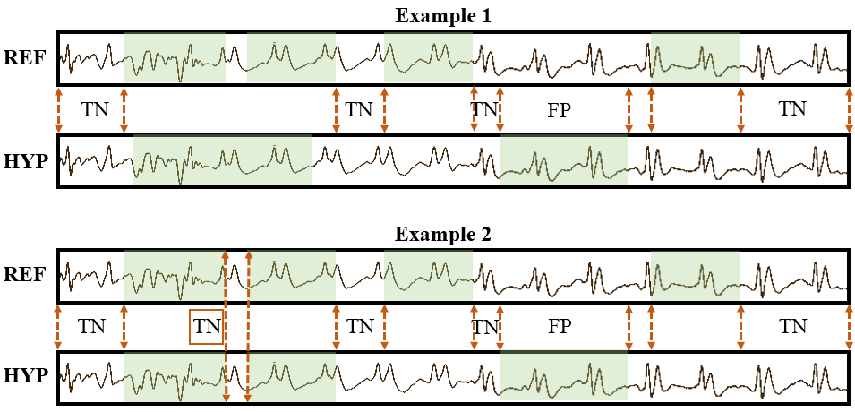
Figure 54. Comparison between false positive (FP) values and specificity for OVLP. There is $1$ FP for both examples, but specificity is $0.80$ for example $1$ and $0.83$ for example $2$.
To meet the clinical acceptance criteria, we develop models to keep our false alarm rates as low as possible (e.g., less than 10 FAs per 24 hours). In this operating range, specificity is approximately 95% (or higher). From Table 18 and Table 19, we can see that the means of the distributions are very close ($93.14\%–96.47\%$). Sensitivity, on the other hand, varies from $12.86\%\text{–}37.29$%. Since specificity is observed to be in a similar operating range, comparisons between models become easier using sensitivities.
We performed a single tailed $T$-test to understand the statistical significance of the differences in performance between the models. In the machine learning literature, confidence intervals used range from $0.80$ to $0.95$ depending on the size of the evaluation databases. The machine learning issues related to popular statistical significance tests are discussed in Gillick and Cox (1989). Since our mean specificities are very high and tend to cluster, we used an $80\%$ confidence for specificity. Our sensitivity scores, however, fluctuate more significantly with the choice of algorithm, so we used a much higher confidence value of $95\%$ for our analysis.
Table 18. Statistical analysis of sensitivity using $T$-test
Model (mean %, std %) | Baseline | P2-N | P2-H | P2-DP | P2-DD
Baseline (30.5816, 0.840) | – | p < 0.001 | p = 0.030 | p = 0.186 | p < 0.001
P2-N (12.868, 4.816) |  | – | p < 0.001 | p < 0.001 | p < 0.001
P2-H (35.459, 4.219) |  |  | – | p = 0.377 | p = 0.377
P2-DP (32.8025, 3.208) |  |  |  | – | p = 0.022
P2-DD (37.293, 1.067) |  |  |  |  | –
Table 19. Statistical analysis of specificity using $T$-test
Model (mean %, std %) | Baseline | P2-N | P2-H | P2-DP | P2-DD
Baseline (93.146, 3.528) | – | p = 0.093 | p = 0.142 | p = 0.137 | p = 0.540
P2-N (95.86, 0.640) |  | – | p = 0.745 | p = 0.260 | p = 0.001
P2-H (96.0, 0.671) |  |  | – | p = 0.440 | p = 0.003
P2-DP (96.472, 0.876) |  |  |  | – | p = 0.003
P2-DD (94.165, 0.685) |  |  |  |  | –

The $T$-test results are shown in Table 18 and Table 19. We can see that the CNN-LSTM baseline performs significantly better than P2-N, but both models perform significantly worse than the other approaches. The difference in sensitivity of P2-N is not significant compared to P2-DP. There are no statistically significant differences between the P2-H and P2-DP. P2-H performs better than P2-DD in terms of specificity because of the high false alarm rate of the P2-DD model. Finally, a comparison between P2-DP and P2-DD is inconclusive because P2-DD’s specificity is significantly worse while its sensitivity is significantly better than P2-DD. Overall, we can conclude that the differences in the P2 variants are not statistically significant. All P2 variants which use posterior features (P2-H, P2-DP and P2-DD) perform better than the ones which do not (the CNN-LSTM baseline and P2-N) and these differences are statistically significant.

Feature Importance
The previous analysis of the multiphase model demonstrated the importance of posterior features in modeling the temporal context of an EEG signal. In this section, we analyze the importance of each feature. We use a simple diagnostic test (Fisher et al., 2018) based on a permutation algorithm in which a trained model is fed features with zero-padded or shuffled indices.
Instead of making changes and evaluating each dimension of our feature vector individually, we alter them in smaller subsets. We modify subsets of $32$-dimensional feature vector in five ways. We refer to all posterior derived features as “Post” ($6$ dimensions), class posteriors as “Conf” ($2$ dimensions) and features representing distance from the previously detected events as “Onset/Offsets” ($4$ dimensions). Note that Conf and Onsets/Offsets are subsets of Post. We zero pad these subsets individually and run our P2-H model on the modified features. We also swap the indices of the Onset/Offset features to understand their importance. The performance of the modified features is shown in Table 20 where zero padding is indicated as “Z-padded” due to space constraints. For example, “Z-padded Post” indicates zero-padded posterior features.
In Table 20, results for the modified features are compared in the first row which represents the baseline P2 performance of the multiphase system. We compare results using the OVLP metric. However, the TAES metric displays a similar trend. When class posteriors are zero padded (row $2$), there is a$30.07\%$ absolute reduction in sensitivity (from $41.16$ to $11.09$) and a $4.09$ absolute reduction in FAs (from $11.69$ to $7.60$). Zero padding feature dimensions related to Onsets/Offsets results in a reduced sensitivity of $27.73\%$ with $5.07$ FAs (row $3$). When all the posterior-derived features are zero padded (row $4$), the P2 model performs very poorly, yielding a sensitivity of only $0.29\%$ with $2.11$ FAs. Zero padding the $26$-dimensional LFCC feature vector (row $5$) reduces both sensitivity and FAs, yielding $33.57\%$ sensitivity with $7.32$ FAs. When we swap the indices related to the onset and offset features (row $6$), sensitivity decreases by $9.49\%$ (from $41.16$ to $31.67$) and FAs drop by $1.27$ absolute.
Table 20. Feature importance analysis of the P2 model
Feature Description | OVLP Sens. | OVLP  FAs/24Hr | TAES Sens. | TAES  FAs/24Hr
LFCC + Post | 41.16 | 11.69 | 32.87 | 20.84
Z-padded Conf | 11.09 | 7.60 | 7.99 | 10.17
Z-padded Onset/Offset | 27.73 | 5.07 | 20.45 | 9.53
Z-padded Post. | 0.29 | 2.11 | 0.01 | 2.23
Z-padded LFCC | 33.57 | 7.32 | 25.52 | 12.36
Onset/Offset Swapped | 31.67 | 10.42 | 22.36 | 16.30

This analysis shows the importance of the posterior features in boosting P2’s performance while LFCC features contribute very little to the overall performance. The detected epileptiform discharges from the P1 model play a crucial role in identifying seizure events. This analysis indicates that our multiphase model mimics the human interpretation process by identifying epileptiform activities first and then identifying seizure events associated with these activities.

P2 Kernels
As described in Chapter 4, P2 utilizes posteriors from the P1 model and their derived augmented features. In the P2 model, each feature dimension of the augmented feature vector is assigned to a channel in a CNN. Since each CNN channel is processed independently during the first layer of the model, we can visualize their feature maps to observe what a trained kernel has learned. The total number of channels for P2 is $32$ which includes $26$ LFCC-based features and $6$ posterior-derived features. Therefore, there are $32$ types of kernels learning CNN features independently. In this section, we visualize the feature maps generated by the CNN kernels.
However, prior to visualizing such data, we focus on a few seizures that were not well represented by the CNN-LSTM model when only LFCC features were used. Two sets of experiments were conducted for this study. The first set of models were trained using conventional $26$-dimensional LFCC feature vectors. The second set used the $32$dimensional augmented feature vector in our P2 model. The model with only LFCC features, also known as P2-N from the previous sections, delivers a sensitivity of $19.17\%$ with $11.9$ FAs. The P2 model delivers an improvement in sensitivity ($41.16\%$) while maintaining a comparable FA rate ($11.69$). For visualization purposes, we will use seizure events which were only detected by the P2 model for this analysis.
After the P2 model is optimized, we pass two different examples of seizure events through the model. These examples were the seizure events that were only detected when posterior features were used. Feature maps generated by posterior kernels for the first seizure example are shown in Figure 55 and Figure 56. These generalized seizure morphologies last for about $7$-$8$ secs and recur every $30$-$40$ secs suggesting that the patient was suffering from a status epilepticus at the time of recording. The spectrogram-like plots from Figure 55 contain kernel outputs where each kernel is associated with the index of the feature dimension. Kernels are abbreviated with the letter $K$ which is followed by an index of the feature dimension. For example, $K0$ indicates the kernel $0$ associated with feature $0$, which in this case is the energy of the signal. Kernel $K1$ is associated with the first cepstral coefficient. Similarly, the last six dimensions (from $26$ to $31$) are associated with the posterior-derived history features.
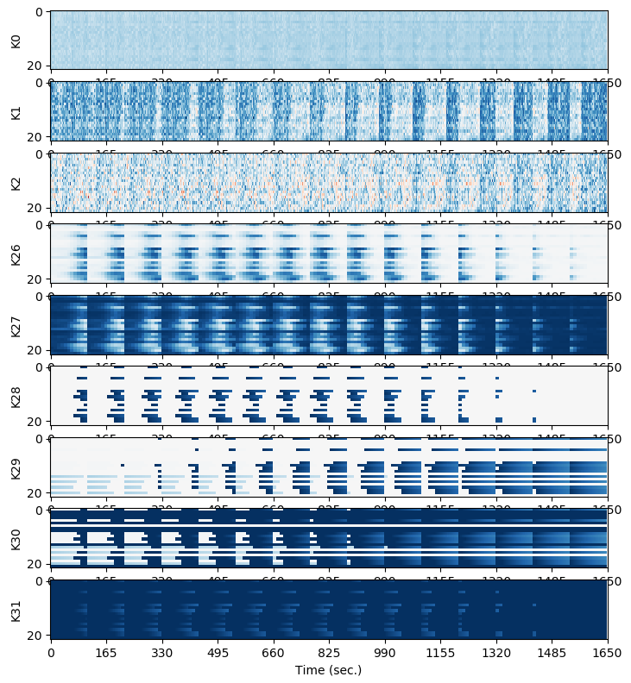
Figure 55. Layer-1 CNN kernels for recurring seizures (during the event)
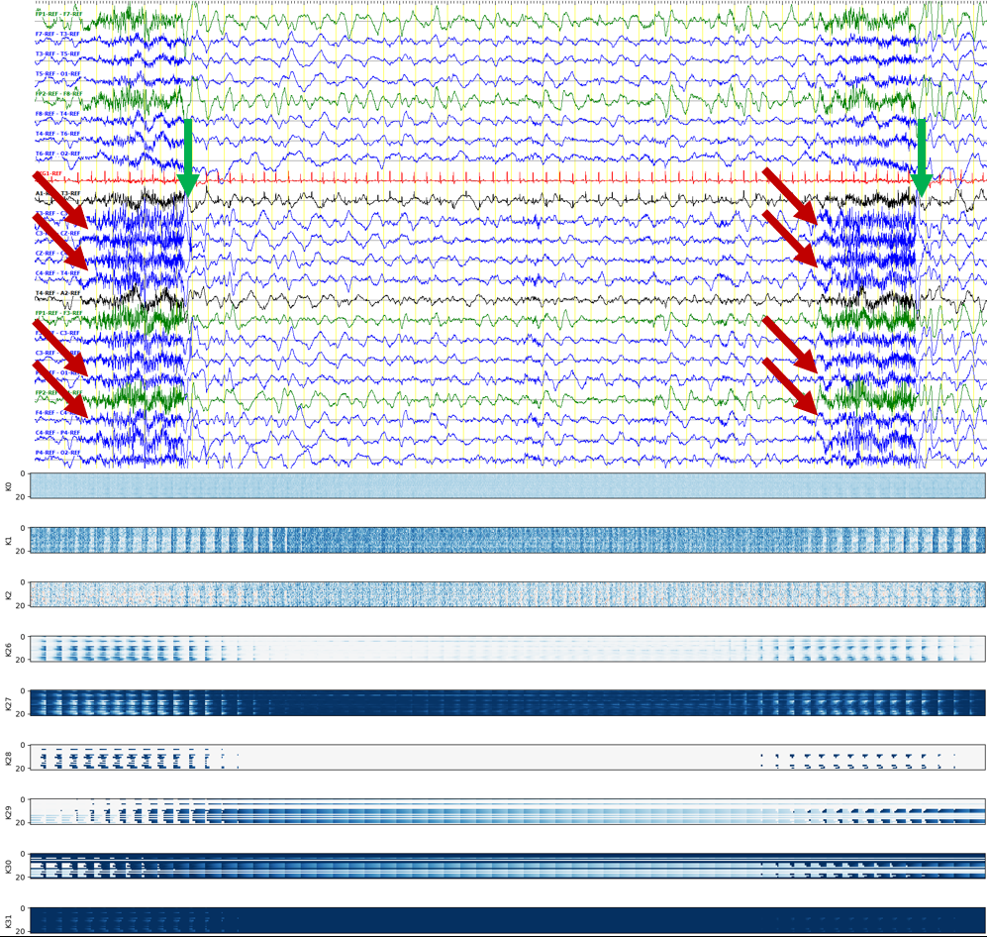
Figure 56. Layer-1 CNN kernels for recurring seizures (between the event)

It is clear from Figure 55 that both types of kernels, the ones associated with the LFCC features and the ones with the posterior features, learn seizure morphologies quite well and they also align well with the actual seizure onset and offset marks. This is apparent by examining the vertical strips of feature maps created by each kernel. These vertical strips can be observed in the feature maps from sample $165$ to $1,320$.
Figure 56 shows the same recurring seizure events with their feature maps using a $60$-sec window. There are two seizure events in this plot. The onset and offset are indicated by the red and green arrows respectively. The signal waveform and their feature maps for spectral features ($K0$-$K2$), posteriors ($K26$ and $K27$), onset/offset history features ($K28$-$K31$) are well aligned with both seizure events. There is a clear difference between background and seizure events. The transformed feature maps show a gradual increase in the probability of the seizure (viewed as wider vertical strips) which is consistent with the posterior values observed in the hypothesis generated by the P1 model. It is important to note that such seizures are easy to segment visually because there are clear abrupt changes in the morphologies.
The seizure morphology shown in Figure 57 represents a subtle seizure. These types of seizures are difficult to annotate. This plot is made on the same scale ($60$ secs) used in Figure 56. This seizure is observed on only $4$ EEG channels and very slowly transforms to a seizure (the onset is identified by the red arrows) from a background state. The feature maps shown in Figure 57 show no apparent patterns learned by their LFCC kernels (rows $K0$-$K2$). Although only the first three dimensions of the feature vector are shown, this is consistent for all LFCC features. In contrast, posterior kernels $K26$-$K30$ show a clear gradual change in their feature maps.
It is important to note the misalignments created by the posterior kernels. Such misalignments convey the confusion inherent in the P1 model. Compared to the seizures observed in Figure 56, strips observed from the feature maps created by the onset versus offset kernels (e.g., $K28$ versus $K29$) in Figure 57 are sparse (focal to only $4$ channels) and dispersed in the temporal domain. These misaligned feature maps behave as intermediate features of the network, which force the following layers to further fine tune segment boundaries. Such misalignments are observed during subtle seizures.

Error Modalities
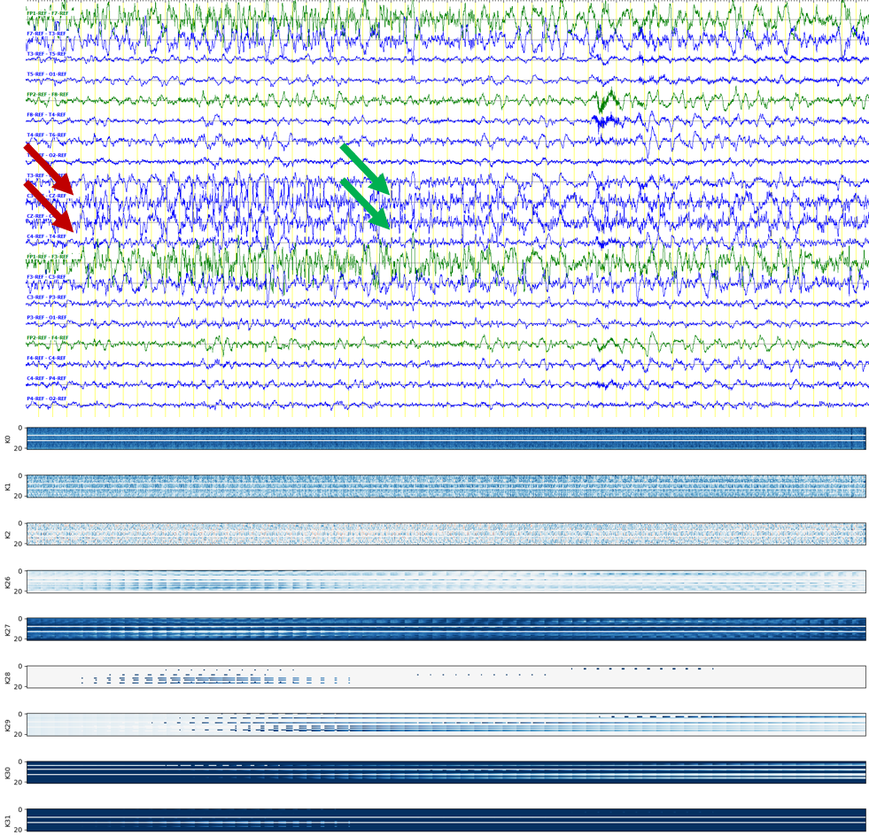
Figure 57. Layer-1 CNN kernels for subtle seizures

Finally, we identify error modalities related to the false alarm rates of the multiphase models. We manually examined dev set hypotheses for false alarms. We separated errors based on evidence of artifacts such as bursts, artifacts, interictal and postictal slowing, benign variants, and disconnected electrodes. Error analysis on the dev set suggests that $34\%$ of the files with FAs contained muscle artifacts. Similarly chewing and shivers contributed to $7\%$ of the overall FAs for the multiphase model. Post-ictal slowing and long bursts identified as seizure events contributed $20\%$ of the files with errors. The remaining $39\%$ were inconclusive. These remaining errors were potentially related to epileptic patterns observed during the interictal phase, disconnected electrodes, and other normal/abnormal variants.
From the error analysis, we conclude that a majority of the false alarms for the multiphase model were due to muscle artifacts. To understand if the model was able to distinguish between a seizure morphology and background events, we evaluated our model on TUAR 1.0.0 (Hamid et al., 2020) which contains partially annotated artifact events. We collected the posteriors of the multiphase model prior to the final postprocessing stage and compared the epochs corresponding to background events and muscle artifacts. From Figure 58, we can see that the true detections for the background class (muscle artifacts identified as the background class are shown in green) and the false alarms for the seizure class (muscle artifacts identified as the seizure class are shown in red) overlap. This suggests that the multiphase model is completely confused between the seizure and muscle artifact classes.
In order to address this problem, we can either (1) introduce additional new sets of features which can efficiently separate the two classes (muscle artifact and seizures), or (2) we can filter the artifact events prior to generating our traditional features from the signals. We attempted the second approach using ICLabel, a MATLAB artifact reduction plugin (Pion-Tonachini et al., 2019). We performed artifact reduction on the dev set of TUSZ v1.2.1 and applied our multiphase model on the filtered signals. The multiphase model applied after artifact reduction (without retraining) yielded a sensitivity of $42.62\%$ with $7.04$ FAs. This is a slight improvement over the unfiltered signals – a $2.33\%$ improvement in sensitivity with a $1.27$ absolute increase in FA rate. A better comparison can be seen in the ROC analysis presented in Figure 59, which shows the similarity between the two approaches.
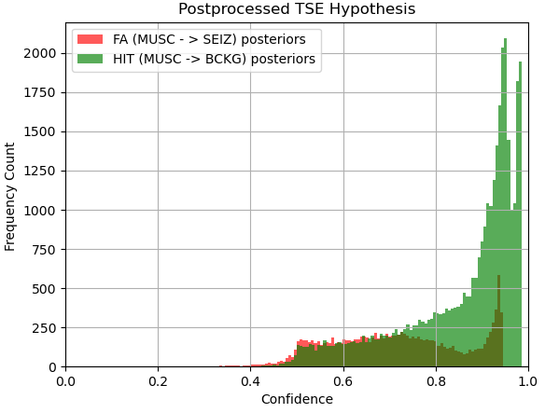
Figure 58. Epoch posterior distribution of the multiphase model on TUAR v1.0.0

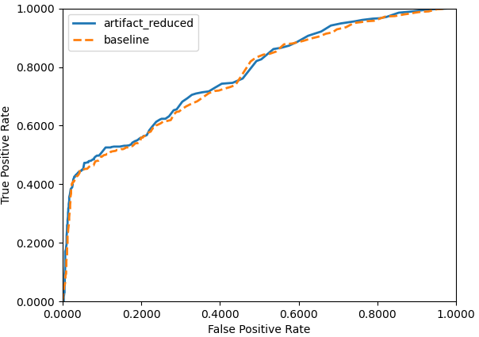
Figure 59. An ROC comparison after artifact reduction

CONCLUSION
Seizure segmentation, a subset of the seizure detection problem, is an underappreciated problem in the EEG community. To improve segmentation performance, we mimicked the human interpretation process and developed a two-phase model. In the first phase, we develop a channel-specific model to learn epileptiform activities associated with the seizures. We derived new features from the posteriors of the first model and augment them so that they can convey information about recently detected events. We defined a scaling function to bound the temporal information embedded in these “history” features using methods which can help the model learn the underlying distribution of the frequency of the seizures. Models developed based on heuristically derived scaling functions outperform P2 models developed based on the statistics of the data. However, these changes in performance are small and not statistically significant. Regardless, the high variance in performance suggests that more training data is required.
The performance of the system after integration of the posterior features improved compared to the baseline model. The multiphase model with a dynamic neural network postprocessor yields a sensitivity of $41.60\%$ and an FA rate of $5.63$. This is a $10.77\%$ absolute improvement in sensitivity and a reduction of $1.11$ FAs. Our multiphase model also improved segmentation performance. The multiphase model detected $106$ segment boundaries within a $2$-second margin compared to $9$ segments for the baseline model. Visualizations of the kernels of the initial CNN layers indicate that the CNN channels associated with the posterior features focus on localizing the segment boundaries.
The P1 model, responsible for identifying epileptiform activities related to seizure events, plays a crucial role in identifynig localized channel specific events. When we create posterior features from the P1 hypotheses, the information related to epileptiform activities was embedded in the posterior features. All P2 architectures which use posterior features outperform the ones that do not use posterior features. The differences in performance are statistically significant.
We modify P2’s input feature vectors by zero padding or swapping a subset of feature dimensions. This analysis was done to understand the importance of the spectral and posterior features. The results indicate that posterior-derived features generated from P1 contribute the most to improving P2’s performance. Zero-padded posterior-derived features reduce P2 sensitivity to $0.29\%$ with $2.11$ FAs. On the other hand, zero padding LFCC features yields a sensitivity of $33.57\%$ with $7.32$FAs. This suggests that spectral features contribute a very little to the overall performance of the P2 model.
Error analysis on the multiphase model indicates that $34\%$ of the total false alarms were associated with the muscle artifacts. Other apparent error modalities were shivers and post-ictal slowing which contributed to $7\%$ and $20\%$ of the false alarms. Diagnostic experiments suggest that spectral features were unable to differentiate between seizure and muscle artifact events. After removing muscle artifacts and bursts, we see a slight increase in sensitivity ($2.33\%$) with a $1.27$increase in FAs. Pion-Tonachini et al. (2019) discuss an independent components analysis (ICA) algorithm developed in association with deep learning approaches. Our future research will be focused on adapting such approaches to remove spurious events such as muscle artifacts, bursts and slowing.
We developed our multiphase model in a sequence of steps where the final P3 phase of the model averages seizure probabilities of the P1 and P2 models. In the future, we intend to replace the P3 model with a mixture of experts (MoE) manager model (Shazeer et al., 2017). In MoE, typically multiple “expert” systems decode a single decoding frame and their outputs are weighted via a manager model. The manager model has the abilitiy to activate only a few experts and linearly or non-linearly weigh their outputs before making a final decision. This weighting mechanism can force the MoE model to focus on specific EEG morophologies. Expert models developed for the post-ictal or interictal slowing should be useful in further reducing FAs.
We briefly discussed a segment fine-tuner algorithm in Chapter 8. This algorithm fails to improve the segment alignments due to a poor localization algorithm. The model is not able to identify the channels where seizure events occur and fails to learn the rate of change of energy of a seizure segment. Future research will focus on implementing a better channel selection algorithm using class specific statistical models based on linear discriminant analysis (LDA) and/or autoencoders (Vincent et al., 2008).
Finally, there is a great need for artifact reduction and segmentation algorithms that run in real-time with minimal latency. This is a very important and promising area of research that can have significant clinical impact.

REFERENCES
American Academy of Neurology (2020). Policy & Guidelines for EPILEPSY. Retrieved July 1, 2020, from https://www.aan.com/Guidelines/home/ByTopic?topicId=23.
American Clinical Neurophysiology Society. (2012). ACNS Standardized ICU EEG Nomenclature v. 2012. Retrieved December 4, 2018, from https://www.acns.org/pdf/guidelines/Guideline-14-pocket-version.pdf.
Banchs, R., Bonafonte, A., & Perez, J. (2006). Acceptance Testing of a Spoken Language Translation System. In Proceedings of the International Conference on Language Resources and Evaluation (LREC) (p. 106). Genoa, Italy.
http://www.lrec-conf.org/proceedings/lrec2006/pdf/60_pdf.pdf.
Benbadis, S. R. (2010). The tragedy of over-read EEGs and wrong diagnoses of epilepsy. Expert Review of Neurotherapeutics, 10(3), 343–346. https://doi.org/10.1586/ern.09.157.
Brain Electrical Source Analysis (BESA Research 7.0). (2020). Retrieved from https://www.besa.de/.
Brock, A., Lim, T., Ritchie, J., & Weston, N. (2017). FreezeOut: Accelerate Training by Progressively Freezing Layers. In NIPS 2017 Workshop on Optimization: 10th NIPS Workshop on Optimization for Machine Learning (p. 7). Long Beach, California, USA.
https://doi.org/https://opt-ml.org/papers/OPT2017_paper_32.pdf.
Capp, N., Krome, E., Obeid, I., & Picone, J. (2017). Facilitating the Annotation of Seizure Events Through an Extensible Visualization Tool. In I. Obeid & J. Picone (Eds.), Proceedings of the IEEE Signal Processing in Medicine and Biology Symposium (SPMB) (p. 1).
https://doi.org/10.1109/SPMB.2017.8257043.
Chapman, W. W., Bridewell, W., Hanbury, P., Cooper, G. F., & Buchanan, B. G. (2001). A simple algorithm for identifying negated findings and diseases in discharge summaries. Journal of Biomedical Informatics, 34(5), 301–310. https://doi.org/10.1006/jbin.2001.1029.
Chong, D. J., & Hirsch, L. J. (2005). Which EEG Patterns Warrant Treatment in the Critically Ill? Reviewing the Evidence for Treatment of Periodic Epileptiform Discharges and Related Patterns. Journal of Clinical Neurophys., 22(2), 79–91.
https://doi.org/10.1097/01.WNP.0000158699.78529.AF.
Dieleman, S., Fauw, J.D. & Kavukcuoglu, K. (2016). Exploiting Cyclic Symmetry in Convolutional Neural Networks. In Proceedings of the 33rd International Conference on Machine Learning (PMLR), 1889–1898.
http://proceedings.mlr.press/v48/dieleman16.html.
Duda, R. O., Hart, P. E., & Stork, D. G. (2001). Pattern Classification. (2nd, Ed.). New York City, New York, USA: John Wiley & Sons, Inc. https://doi.org/10.1007/BF01237942.
Encevis Solutions. (2020). NeuroTrend: Trending for continuous EEG in critical care. Retrieved July 1, 2020, from https://www.encevis.com/solutions/eeg-trending-for-icu/.
Ferrell, S., Mathew, V., Ahsan, T., & Picone, J. (2020). The Temple University Hospital EEG Corpus: Electrode Location and Channel Labels. Philadelphia, Pennsylvania, USA. https://www.isip.piconepress.com/publications/reports/2020/tuh_eeg/electrodes.
Fiscus, J. G. (2017). Speech Recognition Scoring Toolkit. Retrieved May 1, 2021, from https://github.com/usnistgov/SCTK.
Fiscus, J., Ajot, J., Garofolo, J., & Doddingtion, G. (2007). Results of the 2006 Spoken Term Detection Evaluation. In Proceedings of the ACM Special Interest Group on Information Retrieval (SIGIR) Workshop “Searching Spontaneous Conversational Speech” (pp. 45–50). Amsterdam, Netherlands. https://www.nist.gov/publications/results-2006-spoken-term-detection-evaluation.
Fisher, A., Rudin, C., & Dominici, F. (2018). All Models are Wrong, but Many are Useful: Learning a Variable’s Importance by Studying an Entire Class of Prediction Models Simultaneously. Journal of Machine Learning Research, 20(177), 1–81.
https://jmlr.org/papers/volume20/18-760/18-760.pdf.
Garcés Correa, A., Orosco, L., Diez, P., & Laciar, E. (2015). Automatic detection of epileptic seizures in long-term EEG records. Computers in Biology and Medicine, 57, 66–73.
https://doi.org/10.1016/j.compbiomed.2014.11.013.
Giles, C. L., Kuhn, G. M., & Williams, R. J. (1994). Dynamic recurrent neural networks: Theory and applications. IEEE Transactions on Neural Networks, 5(2), 153–156. https://doi.org/10.1109/TNN.1994.8753425.
Gillick, L., & Cox, S. J. (1989). Some statistical issues in the comparison of speech recognition algorithms. In IEEE International Conference on Acoustics, Speech, and Signal Processing (pp. 532–535).
https://doi.org/10.1109/ICASSP.1989.266481.
Golmohammadi, M., Ziyabari, S., Shah, V., Obeid, I., & Picone, J. (2018). Deep Architectures for Spatio-Temporal Modeling: Automated Seizure Detection in Scalp EEGs. In Proceedings of the IEEE International Conference on Machine Learning and Applications (ICMLA) (pp. 745–750). Orlando, Florida, USA. https://doi.org/10.1109/ICMLA.2018.00118.
Gotman, J., Flanagan, D., Zhang, J., & Rosenblatt, B. (1997). Automatic seizure detection in the newborn: Methods and initial evaluation. Electroencephalography and Clinical Neurophysiology, 103(3), 356–362.
https://doi.org/10.1016/S0013-4694(97)00003-9.
Grozea, C., Voinescu, C. D., & Fazli, S. (2011). Bristle-sensors--low-cost flexible passive dry EEG electrodes for neurofeedback and BCI applications. Journal of Neural Engineering, 8(2).
https://doi.org/10.1088/1741-2560/8/2/025008.
Haider, H. A., Esteller, R. D., Hahn, C. B., Westover, M. J., Halford, J. W., Lee, J. M., & LaRoche, S. (2016). Sensitivity of quantitative EEG for seizure identification in the intensive care unit. Neurology, 87(9), 935–944. https://doi.org/10.1212/WNL.0000000000003034.
Hajian-Tilaki, K. (2013). Receiver Operating Characteristic (ROC) Curve Analysis for Medical Diagnostic Test Evaluation. Caspian Journal of Internal Medicine, 4(2), 627–635.
http://www.ncbi.nlm.nih.gov/pmc/articles/PMC3755824/.
Halford, J. J., Shiau, D., Desrochers, J. A., Kolls, B. J., Dean, B. C., Waters, C. G., … LaRoche, S. M. (2015). Inter-Rater Agreement on Identification of Electrographic Seizures and Periodic Discharges in ICU EEG Recordings. Clinical Neurophysiology: Official Journal of the International Federation of Clinical Neurophysiology, 126(9), 1661–1669.
https://doi.org/10.1016/j.clinph.2014.11.008.
Hamid, A., Gagliano, K., Rahman, S., Tulin, N., Tchiong, V., Obeid, I., & Picone, J. (2020). The Temple University Artifact Corpus: An Annotated Corpus of EEG Artifacts. In I. Obeid, I. Selesnick, & J. Picone (Eds.), Proceedings of the IEEE Signal Processing in Medicine and Biology Symposium (SPMB) (pp. 1–3). Philadelphia, Pennsylvania, USA: IEEE.
https://doi.org/10.1109/SPMB50085.2020.9353647.
Harati, A., Golmohammadi, M., Lopez de Diego, S., Obeid, I., & Picone, J. (2015). Improved EEG Event Classification Using Differential Energy. In I. Obeid & J. Picone (Eds.), Proceedings of the IEEE Signal Processing in Medicine and Biology Symposium (SPMB) (pp. 1–4). Philadelphia, Pennsylvania, USA. https://doi.org/10.1109/SPMB.2015.7405421.
Hirsch L., J., Laroche S., M., Gaspard N., T., Gerard E., F., Svoronos A., B., Herman S., W., … Drislane F., W. (2013). American Clinical Neurophysiology Society’s Standardized Critical Care EEG Terminology: 2012 version. Journal of Clinical Neurophysiology, 30(1), 1–27.
https://doi.org/10.1097/WNP.0b013e3182784729.
Hirsch, L. J. (2010). Urgent Continuous EEG (cEEG) Monitoring Leads to Changes in Treatment in Half of Cases. Epilepsy Currents, 10(4), 82–85. https://doi.org/10.1111/j.1535-7511.2010.01364.x.
Hirsch, L. J., Michael W.K. Fong, Leitinger, M., LaRoche, S. M., Beniczky, S., Abend, N. S., … Gaspard, N. (2021). American Clinical Neurophysiology Society’s Standardized Critical Care EEG Terminology: 2021 Version. Retrieved March 21, 2021, from https://www.acns.org/UserFiles/file/ACNSStandardizedCriticalCare
EEGTerminology_rev2021.pdf.
Hochreiter, S., & Schmidhuber, J. (1997). Long short-term memory. Neural Computation, 9(8), 1735–1780.
https://doi.org/10.1162/neco.1997.9.8.1735.
Hosseini, M.-P., Hajisami, A., & Pompili, D. (2016). Real-Time Epileptic Seizure Detection from EEG Signals via Random Subspace Ensemble Learning. In Proceedings of the IEEE International Conference on Autonomic Computing (ICAC) (pp. 209–218). Wurzburg, Germany.
https://doi.org/10.1109/ICAC.2016.57.
Huang, Y., Thomas, S., Suzuki, M., Tuske, Z., Sansone, L., & Picheny, M. (2019). Semi-Supervised Training and Data Augmentation for Adaptation of Automatic Broadcast News Captioning Systems. In 2019 IEEE Automatic Speech Recognition and Understanding Workshop (ASRU) (pp. 867–874). https://doi.org/10.1109/ASRU46091.2019.9003943.
Ian Goodfellow, Bengio, Y., & Courville, A. (2016). Deep Learning. Nature Methods (1st ed.). Cambridge, Massachusetts, USA: MIT Press. https://mitpress.mit.edu/books/deep-learning.
Ioffe, S., & Szegedy, C. (2015). Batch normalization: accelerating deep network training by reducing internal covariate shift. In Proceedings of the 32nd International Conference on Machine Learning (ICML) (pp. 448–456). Lille, France.
https://doi.org/10.5555/3045118.3045167.
Ismail Fawaz, H., Forestier, G., Weber, J., Idoumghar, L., & Muller, P. A. (2019). Deep learning for time series classification: a review. Data Mining and Knowledge Discovery, 33(4), 917–963.
https://doi.org/10.1007/s10618-019-00619-1.
Jaritz, M., de Charette, R., Wirbel, E., Perrotton, X., & Nashashibi, F. (2018). Sparse and Dense Data with CNNs: Depth Completion and Semantic Segmentation. In Proceedings of the International Conference on 3D Vision (pp. 52–60).
https://doi.org/10.1109/3DV.2018.00017.
Jean-Paul, S., Elseify, T., Obeid, I., & Picone, J. (2019). Issues in the Reproducibility of Deep Learning Results. In I. Obeid & J. Picone (Eds.), Proceedings of the IEEE Signal Processing in Medicine and Biology Symposium (SPMB) (pp. 1–4). Philadelphia, Pennsylvania, USA: IEEE.
https://doi.org/10.1109/SPMB47826.2019.9037840.
Jelinek, B., Zheng, F., Parihar, N., Hamaker, J., & Picone, J. (2001). Generalized Hierarchical Search in the ISIP ASR System. In Proceedings of the Asilomar Conference on Signals, Systems and Computers (pp. 1553–1556). Pacific Grove, California, USA.
https://doi.org/10.1109/ACSSC.2001.987747.
Jeremy Jordan. (2017). Convolutional neural networks. Retrieved July 1, 2020, from https://www.jeremyjordan.me/convolutional-neural-networks/.
Jing, J., D’Angremont, E., Zafar, S., Rosenthal, E. S., Tabaeizadeh, M., Ebrahim, S., … M. Brandon Westover. (2018). Rapid Annotation of Seizures and Interictal-ictal Continuum EEG patterns. In Annual International Conference of the IEEE Engineering in Medicine and Biology Society (EMBC). Honolulu, Hawaii, USA. https://doi.org/10.1109/EMBC.2018.8513059.
Juneja, P., & Kashyap, R. (2016). Energy based Methods for Medical Image Segmentation. International Journal of Computer Applications, 146(6), 22–27. https://doi.org/10.5120/ijca2016910808.
Kesavadas, C., & Thomas, B. (2008). Clinical applications of functional MRI in epilepsy. Indian Journal of Radiology Imaging, 18(3), 210–270.
https://doi.org/10.4103/0971-3026.41829.
Klatchko, A., Raviv, G., Webber, W., & Lesser, R. (1998). Enhancing the detection of seizures with a clustering algorithm. Electroencephalography and Clinical Neurophysiology, 106(1), 52–63.
https://doi.org/10.1016/S0013-4694(97)00092-8.
Knowles, D., & Ghahramani, Z. (2007). Infinite Sparse Factor Analysis and Infinite Independent Components Analysis. In M. Davies, C. James, S. Abdallah, & M. Plumbley (Eds.), Proceedings of the 7th International Conference on Independent Component Analysis and Signal Separation (pp. 381–388). Berlin, Germany: Springer Berlin Heidelberg.
https://doi.org/10.1007/978-3-540-74494-8_48.
Krauss, G. L., & Fisher, R. S. (2011). The Johns Hopkins Atlas of Digital EEG: An Interactive Training Guide (2nd ed.). Baltimore, Maryland, USA: Johns Hopkins University Press.
https://www.amazon.com/Johns-Hopkins-Atlas-Digital-EEG/dp/0801897335.
Kubota, Y., Nakamoto, H., Egawa, S., & Kawamata, T. (2018). Continuous EEG monitoring in ICU. Journal of Intensive Care, 6(1), 39. https://doi.org/10.1186/s40560-018-0310-z.
Lasitha S. Vidyaratne, & Khan M. Iftekharuddin. (2017). Real-Time Epileptic Seizure Detection Using EEG. IEEE Transactions on Neural Systems and Rehabilitation Engineering, 25(11), 2146–2156.
https://doi.org/10.1109/TNSRE.2017.2697920.
Lee, H., Grosse, R., Ranganath, R., & Ng, A. Y. (2009). Convolutional Deep Belief Networks for Scalable Unsupervised Learning of Hierarchical Representations. In International Conference on Machine Learning (ICML) (pp. 609–616). Montreal, Canada.
https://doi.org/10.1145/1553374.1553453.
Litjens, G., Kooi, T., Bejnordi, B. E., Setio, A. A. A., Ciompi, F., Ghafoorian, M., … Sánchez, C. I. (2017). A survey on deep learning in medical image analysis. Medical Image Analysis, 42 (December 2012), 60–88. https://doi.org/10.1016/j.media.2017.07.005.
Liu, J., Dai, T., Elster, T., Sahgal, V., Brown, R., & Yue, G. (2000). Simultaneous measurement of human joint force, surface electromyograms, and functional MRI-measured brain activation. Journal of Neuroscience Methods, 101(1), 49–57. https://doi.org/10.1016/S0165-0270(00)00252-1.
Looks, M., Herreshoff, M., Hutchins, D., & Peter Norvig. (2017). Deep Learning with Dynamic Computation Graphs. In Proceedings of the 5th International Conference on Learning Representations (ICLR) (pp. 1–12). Toulon, France.
https://openreview.net/forum?id=ryrGawqex.
Lopez de Diego, S. (2017). Automated Identification of Abnormal Adult Electroencephalograms. Temple University. https://www.isip.piconepress.com/publications/ms_theses/2017/abnormal.
Lopez de Diego, S., Golmohammadi, M., Obeid, I., & Picone, J. (2016). An analysis of two common reference points for EEGs. In I. Obeid & J. Picone (Eds.), Proceedings of the IEEE Signal Processing in Medicine and Biology Symposium (SPMB) (pp. 1–4). Philadelphia, Pennsylvania, USA.
https://doi.org/10.1109/SPMB.2016.7846854.
Martin, A., Doddington, G., Kamm, T., Ordowski, M., & Przybocki, M. (1997). The DET curve in assessment of detection task performance. In Proceedings of the European Conference on Speech Communication and Technology (Eurospeech) (pp. 1895–1898). Rhodes, Greece.
http://www.isca-speech.org/archive/eurospeech_1997/e97_1895.html.
McHugh, M. L. (2012). Interrater reliability: the kappa statistic. Biochemia Medica, 22(3), 276–282.
http://www.ncbi.nlm.nih.gov/pmc/articles/PMC3900052/.
Michel, M., Joy, D., Fiscus, J. G., Manohar, V., Ajot, J., & Barr, B. (2017). Framework for Detection Evaluation (F4DE). Retrieved May 16, 2017, from https://github.com/
usnistgov/F4DE.
Natus Medical. (2018). Nicolet® NicVue Connectivity Solution. Retrieved August 13, 2018, from https://neuro.natus.com/products-services/nicolet-nicvue-connectivity-solution.
Nihon Kohden Corporation. Neurofax EEG-1200 Diagnostic and Monitoring Platform. Retrieved July 1, 2020, from https://us.nihonkohden.com/products/eeg-1200.
Nuwer, M. (1997). Assessment of digital EEG, quantitative EEG, and EEG brain mapping: Report of the American Academy of Neurology and the American Clinical Neurophysiology Society. Neurology, 49(1), 277–292. https://doi.org/10.1212/WNL.49.1.277.
Obeid, I., & Picone, J. (2016). The Temple University Hospital EEG Data Corpus. In M. A. Lebedev (Ed.), Augmentation of Brain Function: Facts, Fiction and Controversy. Volume I: Brain-Machine Interfaces (1st ed., Vol. 10, pp. 394–398). Lausanne, Switzerland: Frontiers Media S.A.
https://doi.org/10.3389/fnins.2016.00196.
Ochal, D., Rahman, S., Ferrell, S., Elseify, T., Obeid, I., & Picone, J. (2020). The Temple University Hospital EEG Corpus: Annotation Guidelines. https://www.isip.piconepress.com/publications/reports/2020/tuh_eeg/annotations/.
Orosco, L., Correa, A. G., Diez, P., & Laciar, E. (2016). Patient non-specific algorithm for seizures detection in scalp EEG. Computers in Biology and Medicine, 71, 128-134.
https://doi.org/10.1016/j.compbiomed.2016.02.016.
Pathirana, S., Asirvatham, D., & Johar, G. (2018). A Critical Evaluation on Low-Cost Consumer-Grade Electroencephalographic Devices. In Proceedings of the 2nd International Conference on BioSignal Analysis, Processing and Systems (ICBAPS) (pp. 160-165).
https://doi.org/10.1109/ICBAPS.2018.8527413.
Persyst Development Corporation (2020). Seizure Detection: P14 Seizure Detection is shifting the curve. Retrieved June 18, 2020, from https://www.persyst.com/
technology/seizure-detection/.
Persyst Development Corporation. (2017). Seizure Detection (P13 rev. B). Retrieved January 1, 2017, from https://www.persyst.com/ technology/seizure-detection/.
Picone, J. (1990). Continuous Speech Recognition Using Hidden Markov Models. IEEE Acoustics, Speech, and Signal Processing Society (ASSP), 7(3), 26–41. https://doi.org/10.1109/53.54527.
Picone, J., Doddington, G., & Pallett, D. (1990). Phone-mediated word alignment for speech recognition evaluation. IEEE Transactions on Acoustics, Speech and Signal Processing, 38(3), 559–562.
https://doi.org/10.1109/29.106877.
Picone, J., Obeid, I., & Harabagiu, S. (2018). Automated Cohort Retrieval from EEG Medical Records. 26th Conference on Intelligent Systems for Molecular Biology, 1-7. https://www.isip.piconepress.com/publications/conference_presentations/2018/ismb/cohort_retrieval/.
Pion-Tonachini, L., Kreutz-Delgado, K., & Makeig, S. (2019). ICLabel: An automated electroencephalographic independent component classifier, dataset, and website. NeuroImage, 198, 181–197.
https://doi.org/10.1016/j.neuroimage.2019.05.026.
Povey, D., Ghoshal, A., Boulianne, G., Burget, L., Glembek, O., Goel, N., … Vesely, K. (2011). The Kaldi Speech Recognition Toolkit. In IEEE 2011 Workshop on Automatic Speech Recognition and Understanding (pp. 1–4). Hilton Waikoloa Village, Big Island, Hawaii, US: IEEE Signal Processing Society.
http://publications.idiap.ch/downloads/papers/2012/Povey_ASRU2011_2011.pdf.
Rocha, R. B., Freire, V. V., & Alencar, M. S. (2014). Voice segmentation system based on energy estimation. In Proceedings of the 22nd European Signal Processing Conference (EUSIPCO) (pp. 860–864).
https://www.eurasip.org/proceedings/eusipco/eusipco2014/html/papers/1569925339.pdf.
Ronner, H. E. E., Ponten, S. C. C., Stam, C. J. J., & Uitdehaag, B. M. J. M. J. (2009). Inter-observer variability of the EEG diagnosis of seizures in comatose patients. Seizure, 18(4), 257–263.
https://doi.org/10.1016/j.seizure.2008.10.010.
Roy, S., Asif, U., Tang, J., & Harrer, S. (2020). Seizure Type Classification Using EEG Signals and Machine Learning: Setting a Benchmark. In I. Obeid, I. Selesnick, & J. Picone (Eds.), Proceedings of the IEEE Signal Processing in Medicine and Biology Symposium (SPMB) (pp. 1–6). Philadelphia, Pennsylvania, USA: IEEE.
https://doi.org/10.1109/SPMB50085.2020.9353642.
Scher, M. S. (2017). Pediatric Neurophysiologic Evaluation. In K. Swaiman, S. Ashwal, D. Ferriero, N. Schor, R. Finkel, A. Gropman, … M. Shevell (Eds.), Swaiman’s Pediatric Neurology (sixth edition) (6th ed., pp. 1309–1403). China: Elsevier. https://doi.org/10.1016/B978-0-323-37101-8.00013-8.
Scheuer, L, M., & Wilson, B, S. (2004). Data Analysis for Continuous EEG Monitoring in the ICU: Seeing the Forest and the Trees. Journal of Clinical Neurophysiology, 21(5), 353–378.
https://doi.org/10.1097/01.WNP.0000147078.82085.D3.
Scheuer, M. L., Wilson, S. B., Antony, A., Ghearing, G., Urban, A., & Bagic, A. I. (2020). Seizure Detection: Interreader Agreement and Detection Algorithm Assessments Using a Large Dataset. Journal of Clinical Neurophysiology.
https://doi.org/10.1097/WNP.0000000000000709.
Shah, V., Golmohammadi, M., Obeid, I., & Picone, J. (2021). Objective Evaluation Metrics for Automatic Classification of EEG Events. In I. Obeid, I. Selesnick, & J. Picone (Eds.), Biomedical Signal Processing: Innovation and Applications (1st ed., pp. 223–256). New York City, New York, USA: Springer.
https://doi.org/10.1007/978-3-030-67494-6.
Shah, V., Golmohammadi, M., Ziyabari, S., von Weltin, E., Obeid, I., & Picone, J. (2017). Optimizing Channel Selection for Seizure Detection. In I. Obeid, I. Selesnick, & J. Picone (Eds.), Proceedings of the IEEE Signal Processing in Medicine and Biology Symposium (SPMB) (pp. 1–5). Philadelphia, Pennsylvania, USA: IEEE.
https://doi.org/10.1109/SPMB.2017.8257019.
Shah, V., von Weltin, E., Ahsan, T., Obeid, I., & Picone, J. (2021). On the Use of Non-Experts for Generation of High-Quality Annotations of Seizure Events. Clinical EEG and Neuroscience.
https://www.isip.piconepress.com/publications/unpublished/journals/2021/elsevier_cn/ira.
Shah, V., von Weltin, E., Lopez de Diego, S., McHugh, J. R., Veloso, L., Golmohammadi, M., … Picone, J. (2018). The Temple University Hospital Seizure Detection Corpus. Frontiers in Neuroinformatics, 12, 1–6.
https://doi.org/10.3389/fninf.2018.00083.
Shazeer, N., Mirhoseini, A., Maziarz, K., Davis, A., Le, Q., Hinton, G., & Dean, J. (2017). Outrageously Large Neural Networks: The Sparsely-Gated Mixture-of-Experts Layer. In Proceedings of the International Conference of Learning Representations (ICLR), 1-19.
http://dblp.unitrier.de/db/conf/iclr/iclr2017.html#ShazeerMMDLHD17.
Shoeb, A. H. (2009). Application of machine learning to epileptic seizure onset detection and treatment. Retrieved May 1, 2021, from https://dspace.mit.edu/handle/1721.1/
54669.
Shoeb, A. H., & Guttag, J. V. (2010). Application of machine learning to epileptic seizure detection. In Proceedings of the International Conference on Machine Learning (ICML), 975–982.
https://doi.org/10.1016/j.jneumeth.2010.05.020.
Shoeb, A., Kharbouch, A., Soegaard, J., Schachter, S., & Guttag, J. (2011). An algorithm for detecting seizure termination in scalp EEG. In Proceedings of the Annual International Conference of the IEEE Engineering in Medicine and Biology Society (pp. 1443–1446). https://doi.org/10.1109/IEMBS.2011.6090357.
Sivaraju, Adithya, J., & Gilmore, Emily, J. (2016). Understanding and Managing the Ictal-Interictal Continuum in Neurocritical Care. Current Treatment Options in Neurology, 18(2), 1–13.
https://doi.org/10.1007/s11940-015-0391-0.
Stafstrom, C. E., & Carmant, L. (2015). Seizures and epilepsy: an overview for neuroscientists. Cold Spring Harbor Perspectives in Medicine, 5(6): a022426. https://doi.org/10.1101/cshperspect.a022426.
Stefan, H., & William Theodore. (2012). Epilepsy, Part II, Treatment, Volume 108 (H. Stefan & T. William (eds.); 1st ed.). Elsevier.
https://www.elsevier.com/books/epilepsy-part-ii-treatment/stefan/978-0-444-52899-5.
Sutskever, I., Martens, J., Dahl, G., & Hinton, G. (2013). On the Importance of Initialization and Momentum in Deep Learning. In Proceedings of the International Conference on Machine Learning (ICML) (pp. 1139–1147). http://proceedings.mlr.press/v28/sutskever13.html.
Sutskever, I., Vinyals, O., & Le, Q. V. (2014). Sequence to Sequence Learning with Neural Networks. Advances in Neural Information Processing Systems 26 (NIPS), 3104–3112. https://doi.org/10.5555/2969033.2969173

Swisher, C. B., White, C. R., Mace, B. E., & Dombrowski, K. E. (2015). Diagnostic Accuracy of Electrographic Seizure Detection by Neurophysiologists and Non-Neurophysiologists in the Adult ICU Using a Panel of Quantitative EEG Trends. Journal of Clinical Neurophysiology, 32(4), 324–330. https://doi.org/10.1097/WNP.0000000000000144.
Szaflarski, J. P., Gloss, D., Binder, J. R., Gaillard, W. D., Golby, A. J., Holland, S. K., … Theodore, W. H. (2017). Practice guideline summary: Use of fMRI in the presurgical evaluation of patients with epilepsy. Neurology, 88(4), 395–402. https://doi.org/10.1212/WNL.0000000000003532.
Tatum, W. (2014). Handbook of EEG Interpretation. (W. Tatum, A. M. Husain, S. R. Benbadis, & P. W. Kaplan, Eds.) (2nd ed.). New York City, New York, USA: Demos Medical Publishing.
https://www.springerpub.com/handbook-of-eeg-interpretation-9781620700167.html.
Uhrig, J., Schneider, N., Schneider, L., Franke, U., Brox, T., & Geiger, A. (2017). Sparsity Invariant CNNs. In Proceedings of the International Conference on 3D Vision (3DV) (pp. 11–20).
https://doi.org/10.1109/3DV.2017.00012.
University of Freiburg. (2020). Seizure Prediction Project Freiburg. Retrieved July 1, 2020, from https://epilepsy.uni-freiburg.de/freiburg-seizure-prediction-project/eeg-database.
Unterberger, I., Trinka, E., Kaplan, P. W., Walser, G., Luef, G., & Bauer, G. (2018). Generalized nonmotor (absence) seizures - What do absence, generalized, and nonmotor mean? Epilepsia, 59(3), 523–529.
https://doi.org/10.1111/epi.13996.
Variani, E., Bagby, T., McDermott, E., & Bacchiani, M. (2017). End-to-End Training of Acoustic Models for Large Vocabulary Continuous Speech Recognition with TensorFlow. Proceedings of the Annual Conference of the International Speech Communication Association (INTERSPEECH), 1641–1645. https://doi.org/10.21437/INTERSPEECH.2017-1284.
Veselý, K., Ghoshal, A., Burget, L., & Povey, D. (2013). Sequence-discriminative training of deep neural networks. Proceedings of the Annual Conference of the International Speech Communication Association (INTERSPEECH), 2345–2349. https://www.isca-speech.org/archive/interspeech_2013/i13_2345.html.
Vidyaratne, L., Glandon, A., Alam, M., & Iftekharuddin, K. M. (2016). Deep recurrent neural network for seizure detection. In Proceedings of the International Joint Conference on Neural Networks (IJCNN), 1202–1207. https://doi.org/10.1109/IJCNN.2016.7727334.
Vincent, P., Larochelle, H., Bengio, Y., & Manzagol, P.-A. (2008). Extracting and composing robust features with denoising autoencoders. In Proceedings of the International Conference on Machine Learning (ICMLA) (pp. 1096–1103). New York, New York, USA.
https://doi.org/10.1145/1390156.1390294.
von Goethem, P., & Hambling, B. (2013). User Acceptance Testing: A step-by-step guide. (P. van Goethem, Ed.), User Acceptance Testing. Swindon, United Kingdom: BCS Learning & Development Limited. Retrieved May 1, 2021, from https://www.
oreilly.com/library/view/user-acceptance-testing/9781780171678/.
von Weltin, E., Ahsan, T., Shah, V., Jamshed, D., Golmohammadi, M., Obeid, I., & Picone, J. (2017). Electroencephalographic Slowing: A Primary Source of Error in Automatic Seizure Detection. In I. Obeid & J. Picone (Eds.), Proceedings of the IEEE Signal Processing in Medicine and Biology Symposium (SPMB) (pp. 1–5). Philadelphia, Pennsylvania, USA: IEEE. https://doi.org/10.1109/SPMB.2017.8257018.
Wegmann, S., Faria, A., Janin, A., Riedhammer, K., & Morgan, N. (2013). The TAO of ATWV: Probing the mysteries of keyword search performance. In Proceedings of the IEEE Workshop on Automatic Speech Recognition and Understanding (ASRU) (pp. 192–197). Olomouc, Czech Republic: IEEE. https://doi.org/10.1109/ASRU.2013.6707728.
Wilson, S. B., Scheuer, M. L., Plummer, C., Young, B., & Pacia, S. (2003). Seizure detection: Correlation of human experts. Clinical Neurophysiology, 114(11), 2156–2164.
https://doi.org/10.1016/S1388-2457(03)00212-8.
Wyllie, E. (2015). Wyllie’s treatment of epilepsy: principles and practice. (E. Wyllie, B. Gidal, H. Goodkin, T. Loddenkemper, & J. Sirven, Eds.), Wolters Kluwer (6th ed.). China: Wolters Kluwer.
https://doi.org/10.1016/j.yebeh.2015.08.030.
Xu, M., Duan, L.-Y., Cai, J., Chia, L.-T., Xu, C., & Tian, Q. (2005). HMM-Based Audio Keyword Generation. In K. Aizawa, Y. Nakamura, & S. Satoh (Eds.), Proceedings of Advances in Multimedia Information Processing (PCM 2004) (pp. 566–574). Springer Berlin Heidelberg.
https://doi.org/10.1007/978-3-540-30543-9_71.
Young, S., Evermann, G., Gales, M., Hain, T., Kershaw, D., Liu, X., … Woodland, P. (2006). The HTK Book. Cambridge, UK.
http://htk.eng.cam.ac.uk.
Yuan, G.-Q., Gao, D.-D., Jun Lin, S. H., & Lv, B.-C. (2013). Treatment of recurrent epileptic seizures in patients with neurological disorders. Experimental and Therapeutic Medicine, 5(1), 267–270.
https://doi.org/10.3892/etm.2012.788.
Yuan, Y., Xun, G., Ma, F., Suo, Q., Xue, H., Jia, K., & Zhang, A. (2018). A novel channel-aware attention framework for multi-channel EEG seizure detection via multi-view deep learning. In Proceedings of the IEEE EMBS International Conference on Biomedical & Health Informatics (BHI) (pp. 206–209). Las Vegas, Nevada, USA.
https://doi.org/10.1109/BHI.2018.8333405.
Zhu, K., Zhao, W., Zheng, Z., Guo, T., Zhao, P., Bai, J., Yang, J., Liu, X., Diao, L., & Lin, W. (2021). DISC: A Dynamic Shape Compiler for Machine Learning Workloads. Proceedings of the 1st Workshop on Machine Learning and Systems (EuroMLsys), 89–95.
https://doi.org/10.1145/3437984.3458838.
Ziyabari, S., Shah, V., Obeid, I., & Picone, J. (2018). Curriculum Learning Based on Sample Selection Using Posterior Probabilities. 26th Conference on Intelligent Systems for Molecular Biology (p. 1). Chicago, Illinois, USA. https://www.isip.piconepress.com/publications/conference_presentations/2018/ismb/cl/.

